# Question - 1:

**MA 323 - Monte Carlo Simulation Assignment - 3**

## Vishisht Priyadarshi

**180123053**

While generating the plot for frequency distribution, I have binned the complete set of random numbers for a size of 50, i.e, each interval on x axis is of size = 50 *(for better clarity and insights)*.

* **Plot when total number of random numbers generated = 50000**

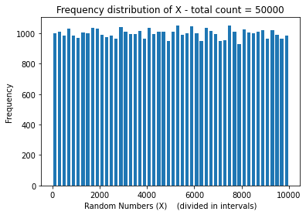 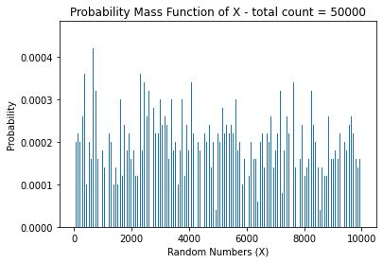

* **Plot when total number of random numbers generated = 100000**

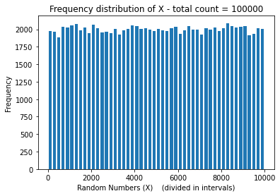 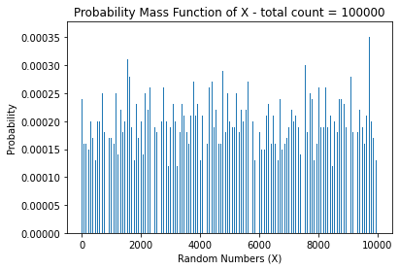

* **Plot when total number of random numbers generated = 500000**

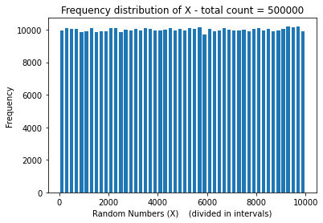 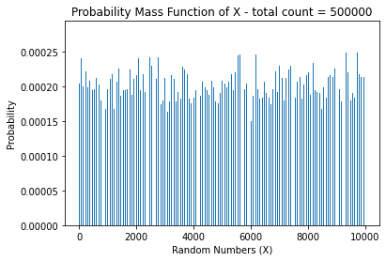

* **Plot when total number of random numbers generated = 1000000**

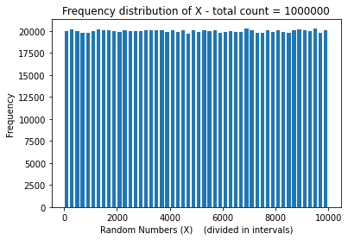 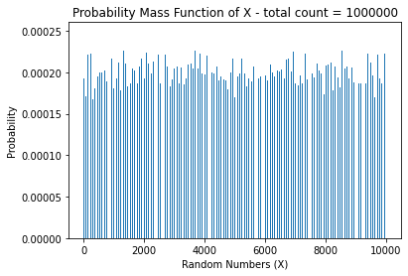

* **Plot when total number of random numbers generated = 5000000**

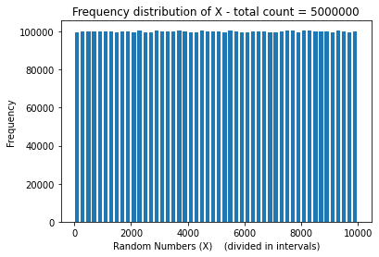 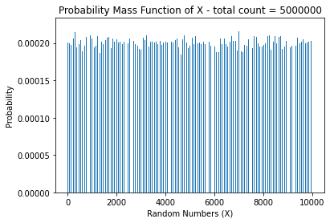

* **Observations:**

1. It is evident from the different plots that as the count of generated random numbers increases, the probability distribution of the generated number converges to the uniform distribution on {1, 3, 5, …, 999}. This is clearly shown by the plots since the height of each bar in both cases is almost uniform when total no of random numbers generated reaches 5000000.
2. Also, the probability of each random number converges to 1/5000 as the number of random numbers generated increases. This also supports the fact that the random numbers generated are uniformly distributed. (*Probability Mass Function* plot)

# Question - 2:

(a) The smallest value of c is **2.109375**.

Since g is uniform density function (i.e, g(x) = 1 , ∀ x in [0, 1] ), we need to find maximum value of f(x) in [0, 1]. It can be easily derived by taking derivative of f(x) and finding the maxima in the given interval. Empirically, we simply generate the values of f(x) in [0, 1] and take the maximum of those *(c is found empirically in the python code).*

(b) The plot showing convergence in distribution of the random variables is as follows:

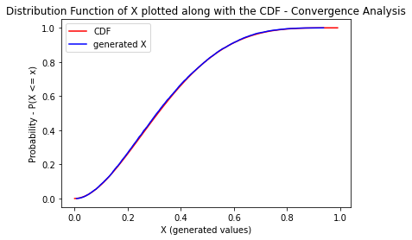

As we decrease the value of c to its minimum value and increase the number of random numbers generated, it converges in distribution to the theoretical cdf.

*(Further Plots are attached in q 2.(d))*

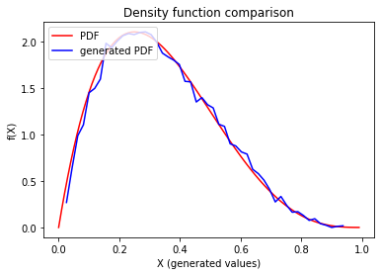 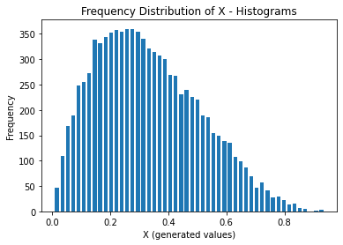

(c) Taking the average of the count of number of iterations (say as, sample_c) required to generate each random variable resulted in following :

**Sample_c (avg of count of no of iterations) = 1.90422**

*(as I have not seeded my random number generator, it may vary when code is executed at different times, but it will be close to theoretical c = 2.109375 value always)*

We can clearly see that sample_c (the required average value) is very close to the theoretical c. The closeness increases as the count of random numbers generated increases.

(d) **Plots for c = 15:**

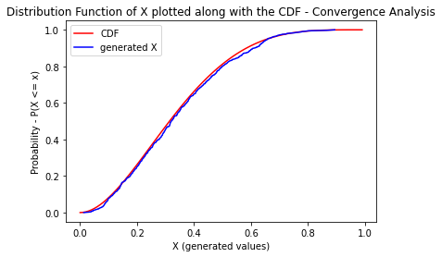

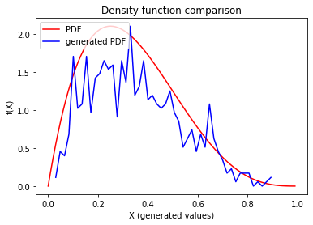 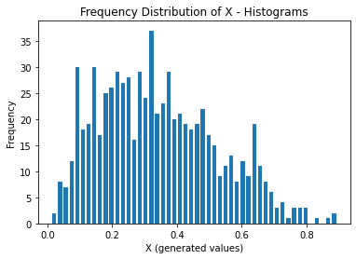

**Plots for c = 30:**

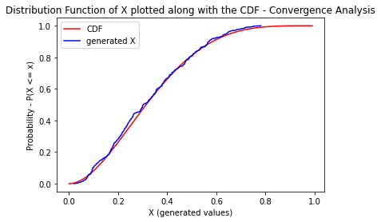

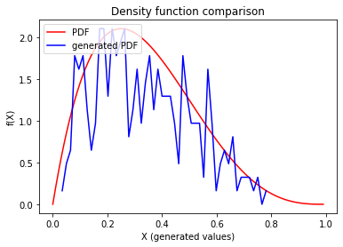 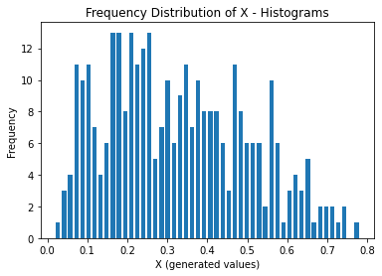

* **Observations:**

1. As we can see that when the value of c deviates (increases) from the smallest value, the errors in the random numbers increase, and it deviates from the distribution for which we are generating them. This deviation is more prominent when the distance of c is more from its smallest value.
2. Also, average of the count of number of iterations needed to generate each random variables for case c = 15 is 1.069, and for case c = 30 is 1.0356. So, clearly the deviation from the expected result, i.e, 2.109375 is more when we increase the value of c.

# Question – 3 :

The smallest c for all x in [1, 10] where x is an integer, s.t. f(x) <= cg(x) is **1.2**

The other 2 values of c that I chose is 10 and 25. I generated different plots each time varying the number of random numbers to be generated.

* **Case (i): Total no of generated random numbers = 1000 ; c = 1.2**

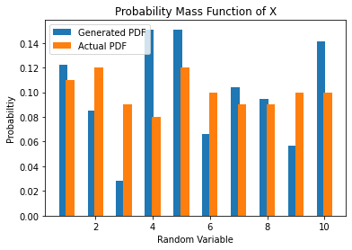

* **Case (ii): Total no of generated random numbers = 2000 ; c = 1.2**

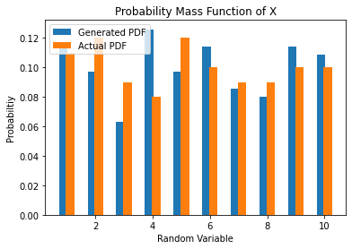

* **Case (iii): Total no of generated random numbers = 5000 ; c = 1.2**

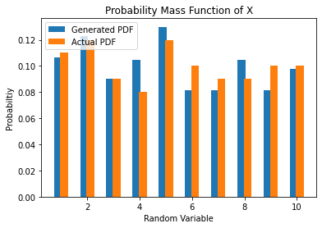

* **Case (iv): Total no of generated random numbers = 10000 ; c = 1.2**

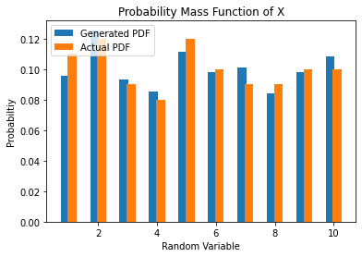

* **Case (v): Total no of generated random numbers = 25000 ; c = 1.2**

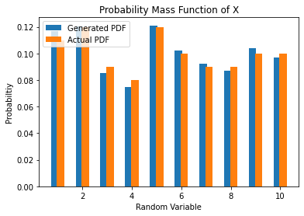

* **Case (vi): Total no of generated random numbers = 50000 ; c = 1.2**

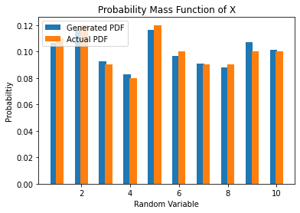

* **Different Plots by varying c when count of generated random numbers = 50000:**
* **c = 1.2:**



* **c = 10:**

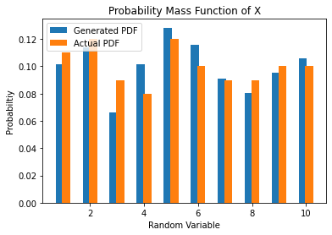

* **c = 25:**

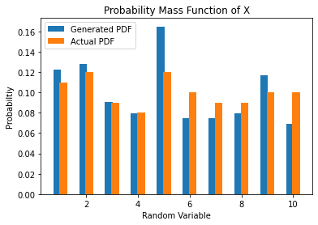

* **Observations:**

1. For fixed c, as the count of generated random numbers increases, the probability of each atom of the discrete random variable approaches its theoretical values (which was mentioned in the question).
2. For fixed count of generated random variable, as the value of c decreases to its minimum value for the inequality to hold, the probability mass function converges to the given PMF.
3. The tables below strengthen this argument that the PMF of generated random numbers converge to its actual PMF as c decreases to its smallest value.

The generator is not efficient for large value of c.

**Case 1: c = 1.2; count of generated random numbers = 50000**

|  |  |  |
| --- | --- | --- |
| **Value of RV (x)** | **Generated P(X = x)** | **Theoretical P(X = x)** |
| 1 | 0.10662824207492795 | 0.11 |
| 2 | 0.11771225892263357 | 0.12 |
| 3 | 0.092884061183773 | 0.09 |
| 4 | 0.08268676568388383 | 0.08 |
| 5 | 0.11638217690090889 | 0.12 |
| 6 | 0.0964309465750388 | 0.10 |
| 7 | 0.090888938151186 | 0.09 |
| 8 | 0.08778541343382842 | 0.09 |
| 9 | 0.10707160274883618 | 0.10 |
| 10 | 0.10152959432498337 | 0.10 |

**Case 2: c = 10; count of generated random numbers = 50000**

|  |  |  |
| --- | --- | --- |
| **Value of RV (x)** | **Generated P(X = x)** | **Theoretical P(X = x)** |
| 1 | 0.10144927536231885 | 0.11 |
| 2 | 0.11387163561076605 | 0.12 |
| 3 | 0.06625258799171843 | 0.09 |
| 4 | 0.10144927536231885 | 0.08 |
| 5 | 0.12836438923395446 | 0.12 |
| 6 | 0.11594202898550725 | 0.10 |
| 7 | 0.09109730848861283 | 0.09 |
| 8 | 0.08074534161490683 | 0.09 |
| 9 | 0.09523809523809523 | 0.10 |
| 10 | 0.10559006211180125 | 0.10 |

**Case 3: c = 25; count of generated random numbers = 50000**

|  |  |  |
| --- | --- | --- |
| **Value of RV (x)** | **Generated P(X = x)** | **Theoretical P(X = x)** |
| 1 | 0.12234042553191489 | 0.11 |
| 2 | 0.1276595744680851 | 0.12 |
| 3 | 0.09042553191489362 | 0.09 |
| 4 | 0.0797872340425532 | 0.08 |
| 5 | 0.16489361702127658 | 0.12 |
| 6 | 0.07446808510638298 | 0.10 |
| 7 | 0.07446808510638298 | 0.09 |
| 8 | 0.0797872340425532 | 0.09 |
| 9 | 0.11702127659574468 | 0.10 |
| 10 | 0.06914893617021277 | 0.10 |