# Question - 1:

**MA 323 - Monte Carlo Simulation Assignment - 4**

## Vishisht Priyadarshi

**180123053**

The chosen values of a1 and a2 are:

1. a1 = 1, a2 = 5
2. a1 = 2, a2 = 4
3. a1 = 3, a2 = 3
4. a1 = 4, a2 = 4
5. a1 = 5, a2 = 1

# Question - 2:

|  |  |  |  |
| --- | --- | --- | --- |
| **SI No** | **a1** | **a2** | **x\*** |
| **1.** | 1 | 5 | 0.0 |
| **2.** | 2 | 4 | 0.25 |
| **3.** | 3 | 3 | 0.5 |
| **4.** | 4 | 2 | 0.75 |
| **5.** | 5 | 1 | 1.0 |

# Question – 3 :

|  |  |  |  |
| --- | --- | --- | --- |
| **SI No** | **a1** | **a2** | **f(x*) OR c** |
| **1.** | 1 | 5 | 5.0 |
| **2.** | 2 | 4 | 2.109375 |
| **3.** | 3 | 3 | 1.875 |
| **4.** | 4 | 2 | 2.109375 |
| **5.** | 5 | 1 | 5.0 |

# Question – 5 :

**Case (i): a1 = 1, a2 = 5**

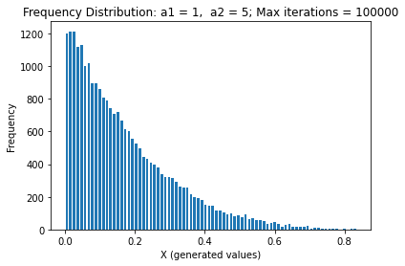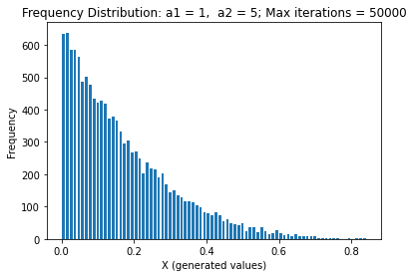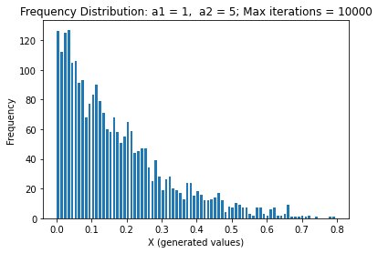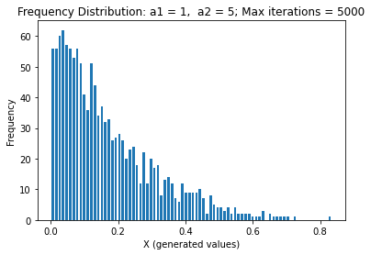

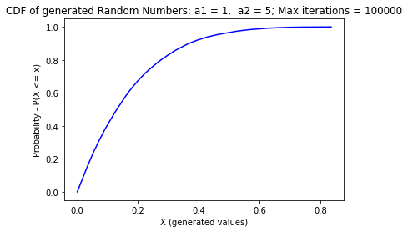

**Case (ii): a1 = 2, a2 = 4**

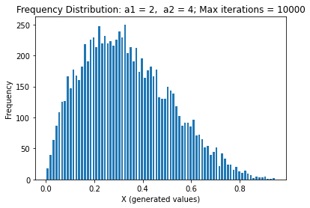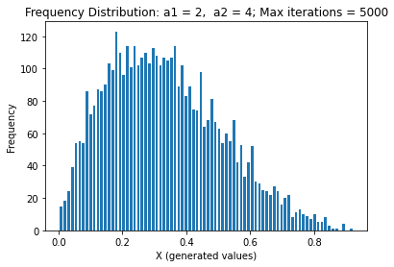

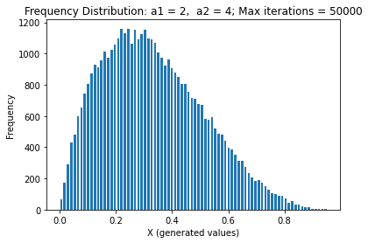 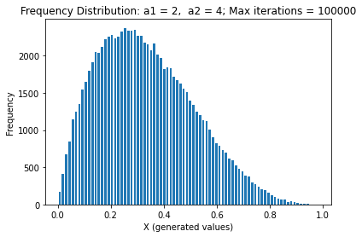

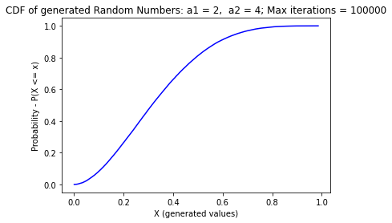

**Case (iii): a1 = 3, a2 = 3**

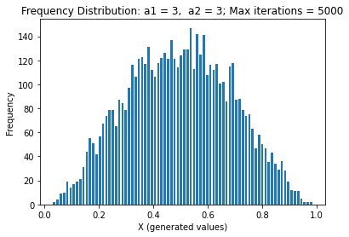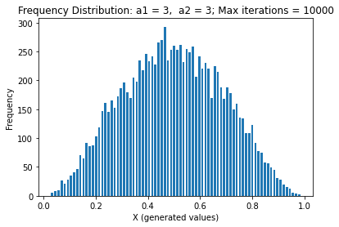

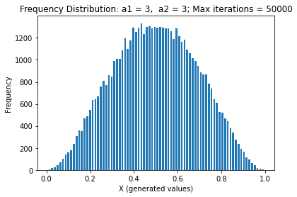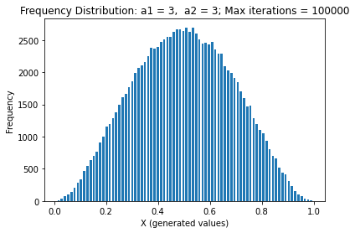

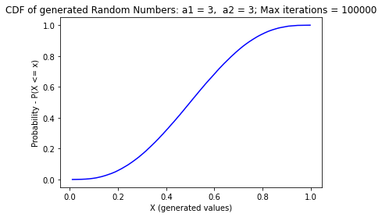

**Case (iv): a1 = 4, a2 = 2**

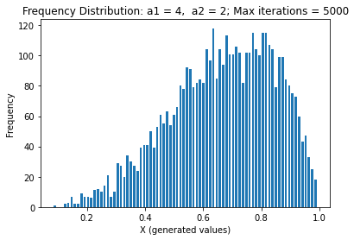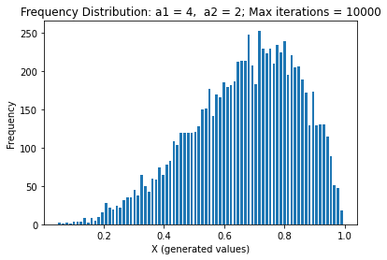

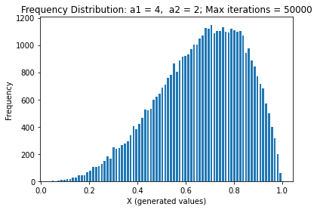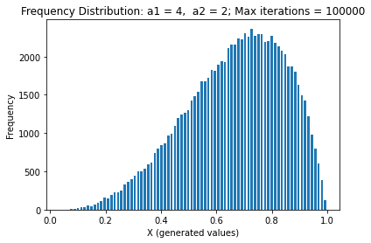

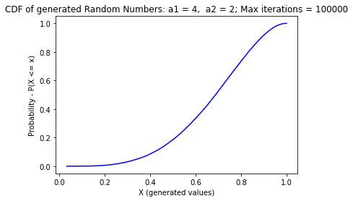

**Case (v): a1 = 5, a2 = 1**

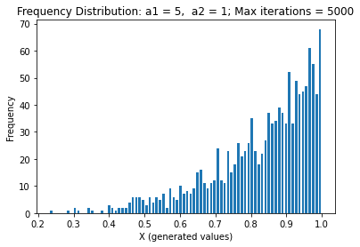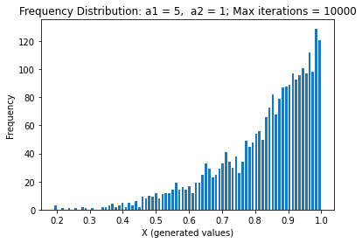

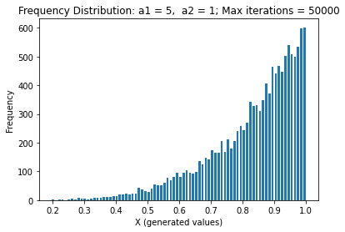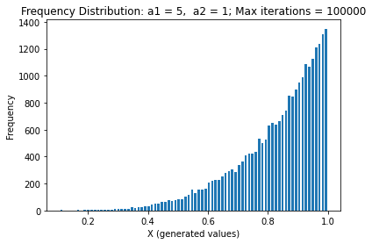

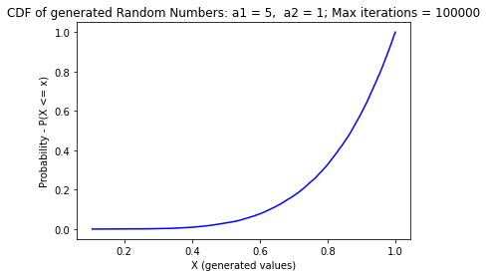

**Observations:**

1. Since at least one of a1 and a2 is greater than or equal to 1, the graph of beta density is unimodal, and it achieves its maxima at x*.
2. As the a1 and a2 varies, the nature of curve varies greatly. If a1 is less than a2, the curve is skewed towards left and vice-versa. When a1 = a2, the curve is symmetric with maxima attained at x* = 0.5.
3. As the count of random numbers are increased (by increasing the limit on max number of iterations possible), the curve approaches to the nature of the distribution of beta density function from which random numbers are generated.
4. The plots are symmetric with respect to the values of a1 and a2. When both values are exchanged, the nature of curve remains the same.
5. The total number of random numbers generated for a fixed number of iterations are more when a1 = a2. As the distance between a1 and a2 increases, the count of random numbers generated decreases.