# Question - 2:

**MA 323 - Monte Carlo Simulation Assignment - 6**

## Vishisht Priyadarshi

**180123053**

**Case (i):** a = -0.5

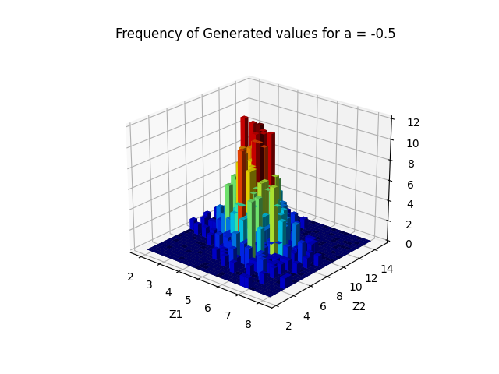

**Observations:**

1. Since correlation(a) between the two marginal distributions is negative, we can see that the spread of values is in direction parallel to the line y = -x on X-Y plane, since the random numbers on the two axes are negatively correlated.
2. The peak is achieved around its mean, i.e., at (5, 8) point.

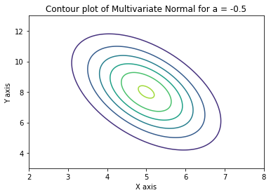

**Case (ii):** a = 0

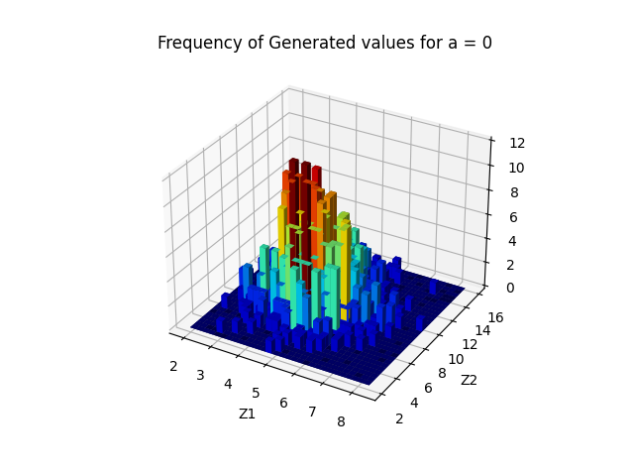

**Observations:**

1. Since correlation(a) between the two marginal distributions is zero, we can see that the spread of values is uniform. It is not in a specific direction like along the line y = x or y = -x. Rotating the 3D plot will help in better view of this nature of the plot. The spread of values is of this nature because the marginal distributions Z1 and Z2 are independent of each other.

Z1 = µ1 + 1 N1(0, 1) and Z2 = µ2 + 2 N2(0, 1)

where µ1 = 5, 1 = 1, and µ2 = 8, 2 = 2.

2. The peak is achieved at its mean, i.e., at (5, 8) point.

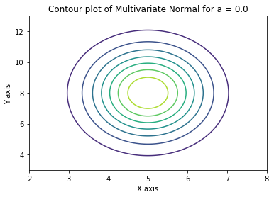

**Case (iii):** a = 0.5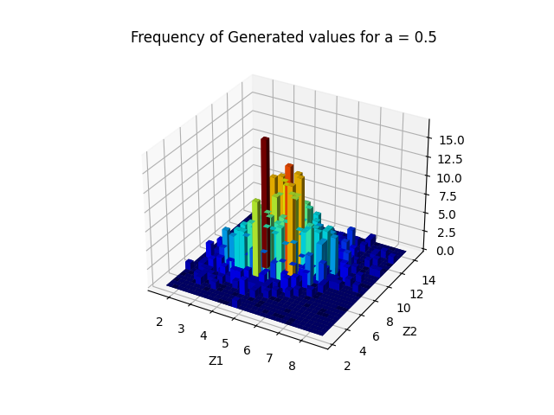

**Observations:**

1. Since correlation(a) between the two marginal distributions is positive, we can see that the spread of values is in direction parallel to the line y = x on X-Y plane, since the random numbers on the two axes are positively correlated.
2. The peak is achieved at its mean, i.e., at (5, 8) point.
3. The colours in the 3D plot helps in visualising the frequency of the numbers. Higher the frequency, more reddish the colour is.

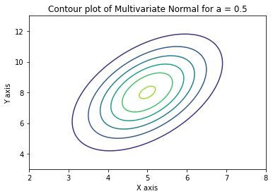

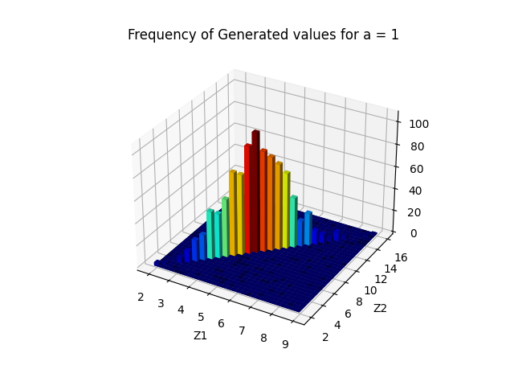**Case (iv):** a = 1

**Observations:**

1. This is a very interesting case. Here the determinant of the covariance matrix is 0, due to which the inverse of the covariance matrix doesn’t exist. As a result, the covariance matrix is not positive definite. Also, the density of the Normal Distribution of this Random Variable couldn’t be written in that special form.
2. The plot seems to be in 2D only, it has only its axes shifted. This is because of following mathematical observation obtained using **Cholesky Factorization**–

Z1 = µ1 + 1 N1(0, 1) and Z2 = µ2 + 2 N1(0, 1)

where µ1 = 5, 1 = 1, and µ2 = 8, 2 = 2.

We can see that the Z1 and Z2 are not independent, since N1(0, 1) is common to both of them. So, we see all the points of X = (Z1, Z2) along a particular line.

# Question - 3:

**Case (i):** a = -0.5

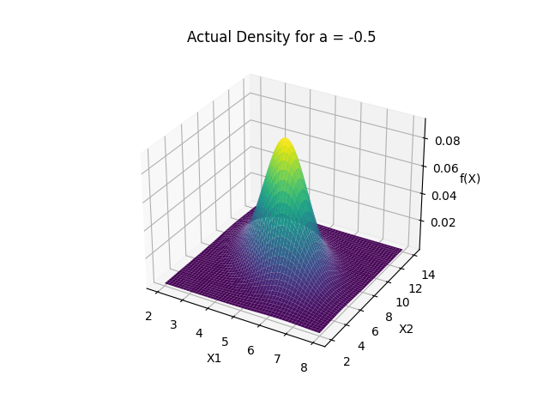

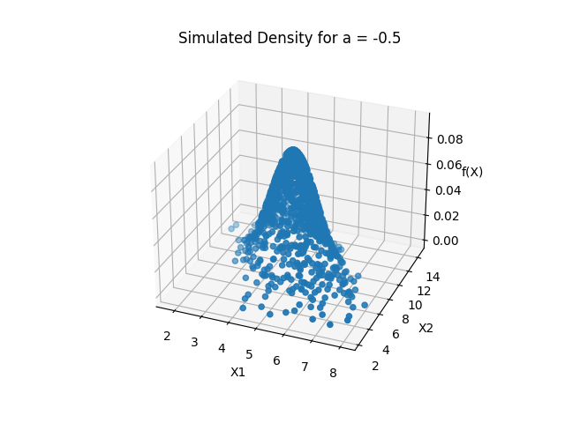

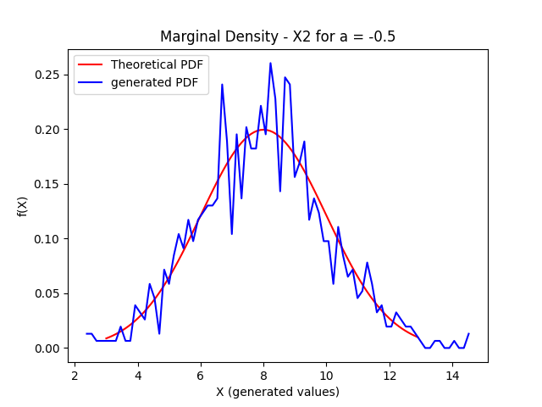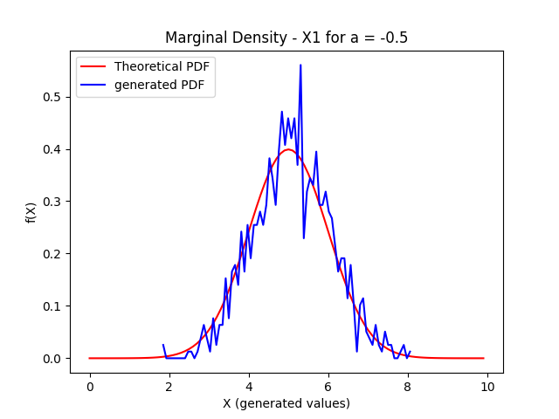

**Case (ii):** a = 0

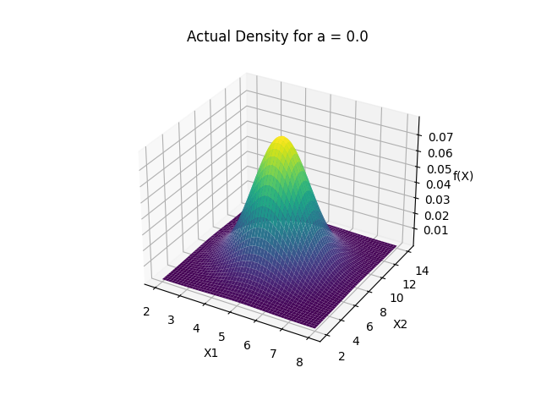

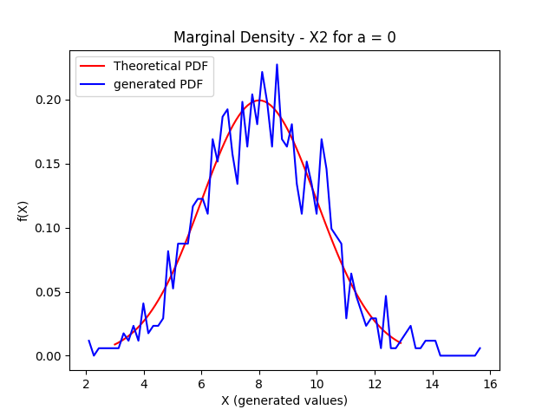 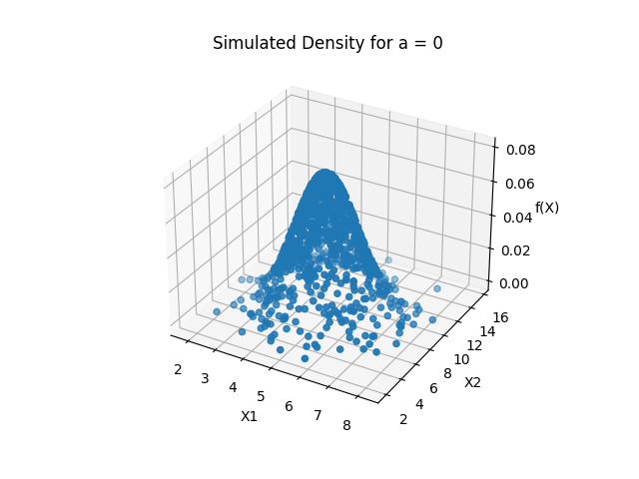

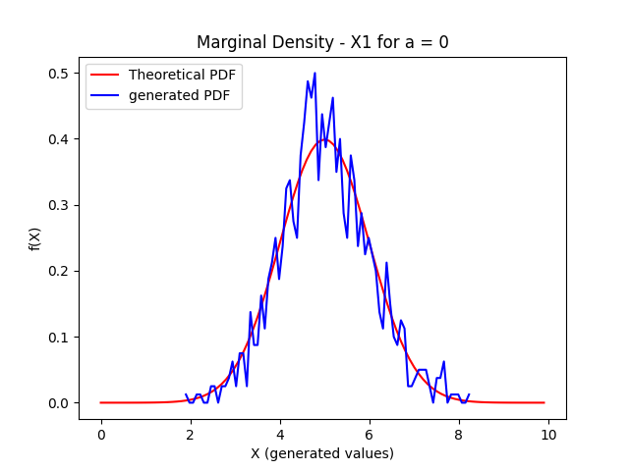

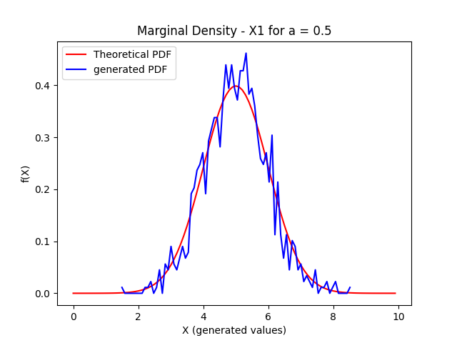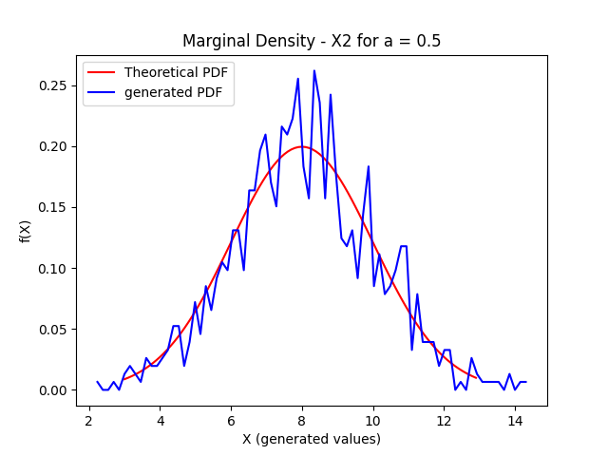**Case (iii):** a = 0.5

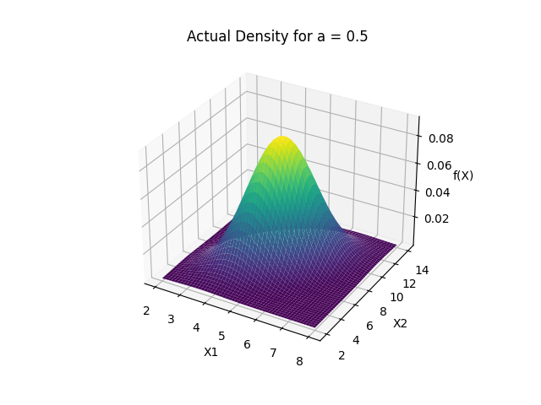

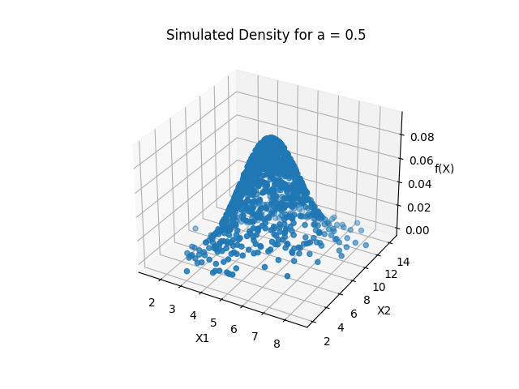

**Case (iv):** a = 1

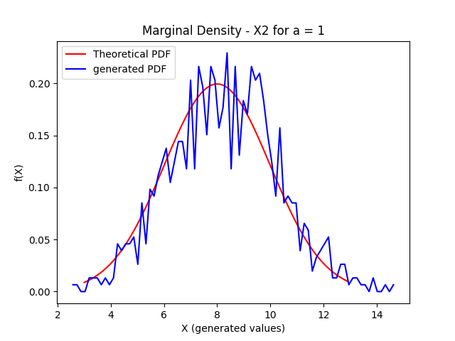

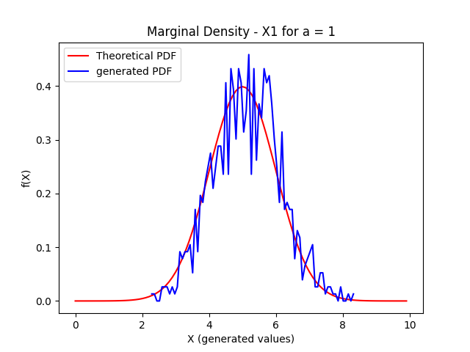

Since, the determinant of Covariance matrix is 0 when a = 1, hence its density function can’t be expressed using the same formula as that of the others.

**Observations:**

1. So, we can see that the actual density and the simulated density for all the cases matches with each other.
2. The marginal densities roughly coincide with their actual counterparts. But since there are fewer points (1000 values), the variation among the values is slightly higher. It can be dealt easily by generating more number of random samples.