# Question - 1:

**MA 323 - Monte Carlo Simulation Assignment - 8**

## Vishisht Priyadarshi

**180123053**

The mean, standard deviation, and S(0) are as follows :

$μ$ = 0.00029810607002

$σ$ = $√0.000496475360719$ = 0.0222817

S(0) = 185.40 (Price at 30th September, 2020)

The plots for various values of $λ$ are as follows:

$λ$**= 0.01 $λ$**  **= 0.05**

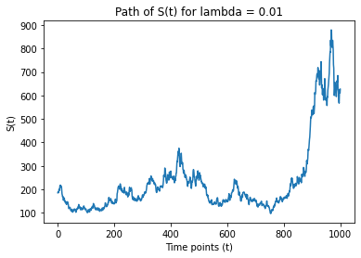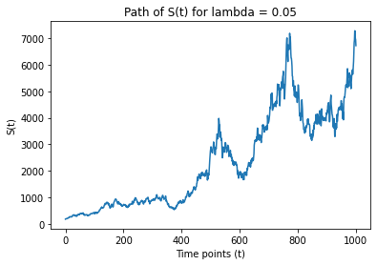

$λ$**= 0.1 $λ$**  **= 0.2**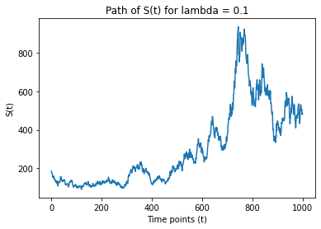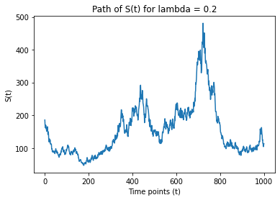

**Observations:**

1. The sample paths are generated using method – 1, i.e., simulation is done at fixed dates with value of ti – ti-1 taken as 4.
2. As we can observe that the sample path behaves very wildly, with lot of fluctuations, it hints at the fact that the sample path of Brownian motion is almost surely no-where differentiable and continuous everywhere.