Experiment No. 6 Output
Aim: Integrate ADF with Databricks for end to end data pipeline orchestration
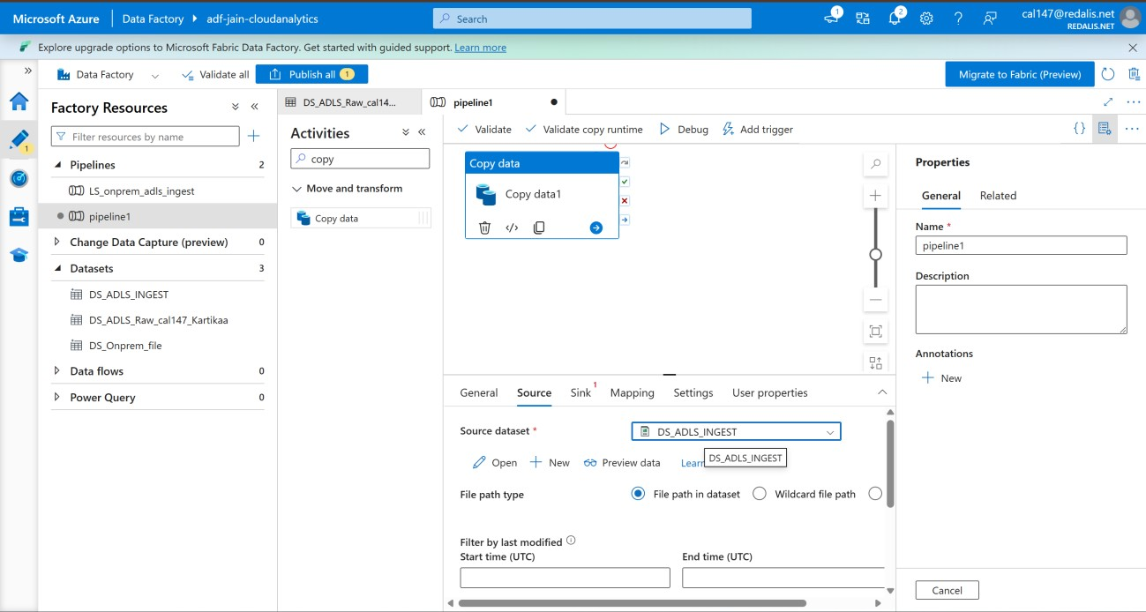

Figure 1: Copy data activity - Source configuration
Pipeline pipeline1 in ADF (adf-jain-cloudanalytics) with a Copy data activity added. The Source tab uses dataset DS_ADLS_INGEST with file path type set to 'File path in dataset'.
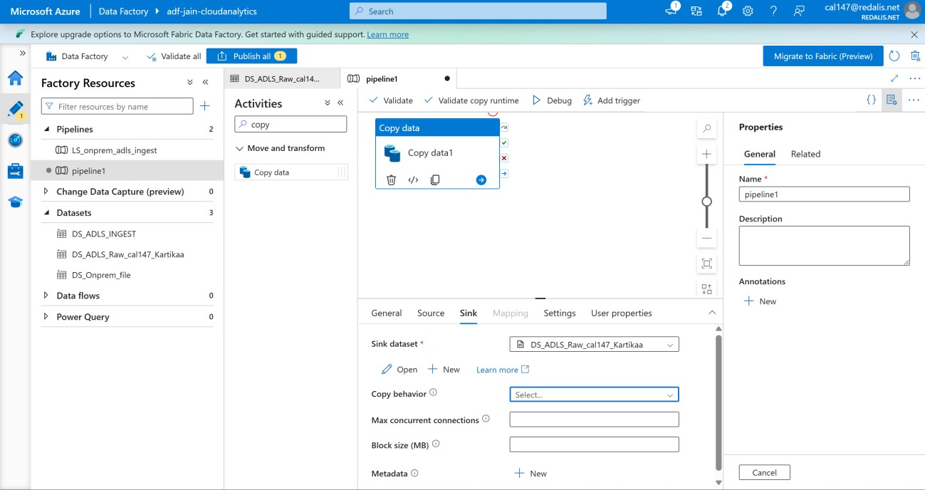

Figure 2: Copy data activity - Sink configuration
Sink tab of the Copy data activity pointing to dataset DS_ADLS_Raw_cal147_Kartikaa in ADLS. Copy behavior and other optional sink settings are left at default.
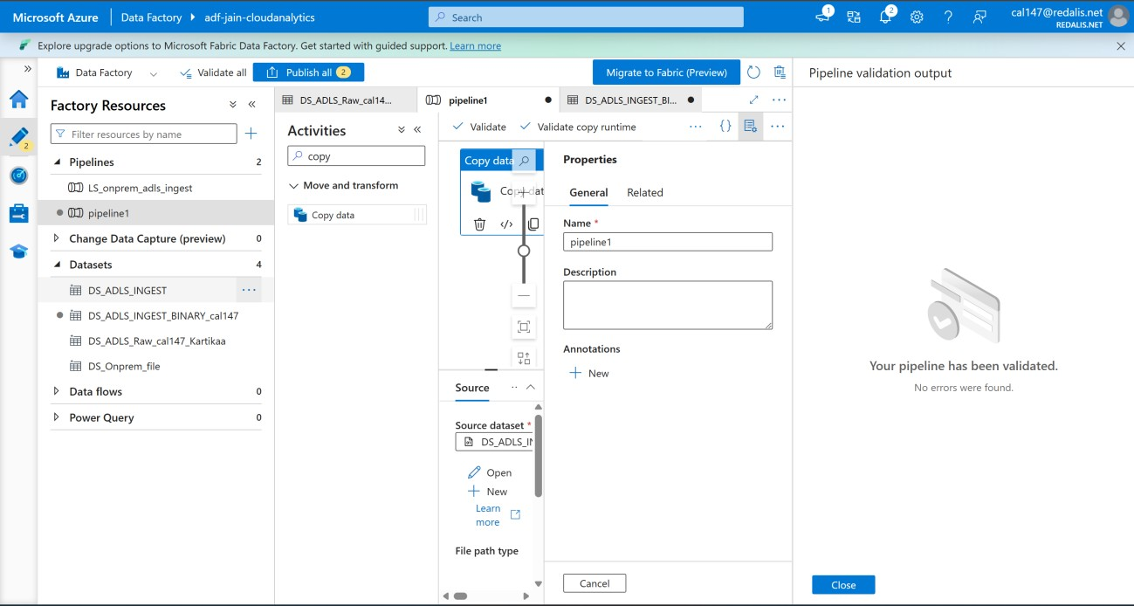

Figure 3: Pipeline validation with binary source dataset
A new dataset DS_ADLS_INGEST_BINARY_cal147 is created and used as source. Validate shows 'Your pipeline has been validated. No errors were found.'
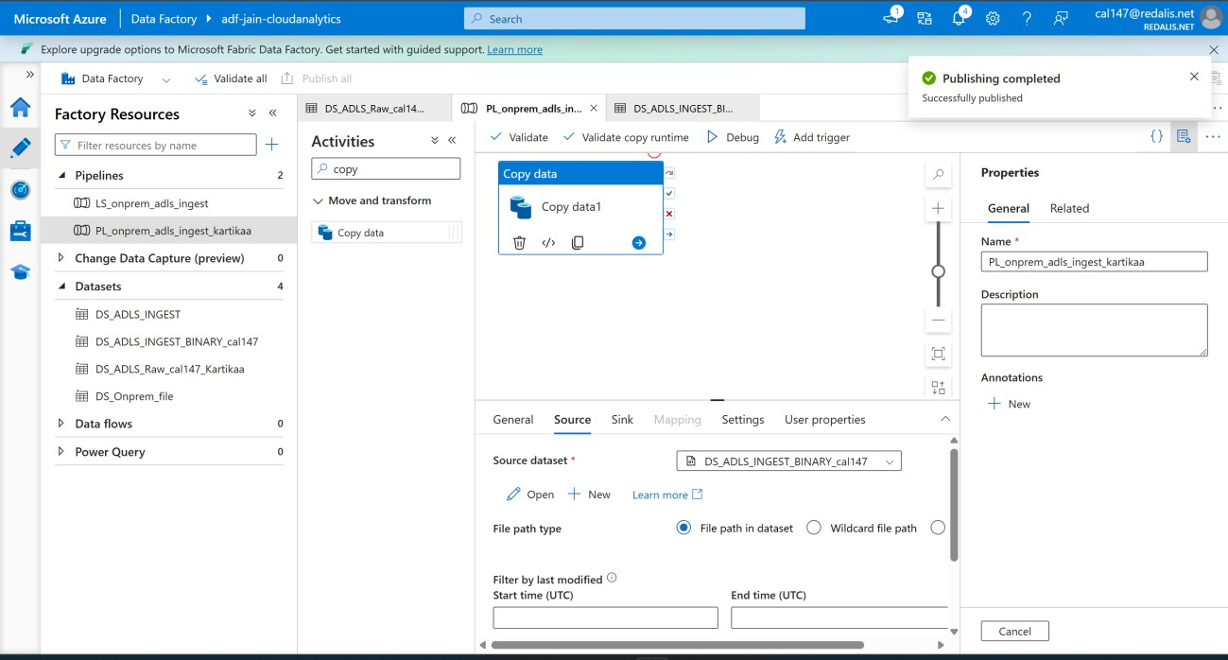

Figure 4: Pipeline renamed and published
Pipeline renamed to PL_onprem_adls_ingest_shivam with the binary dataset as source. The 'Publishing completed - Successfully published' message confirms the changes are saved to the factory.
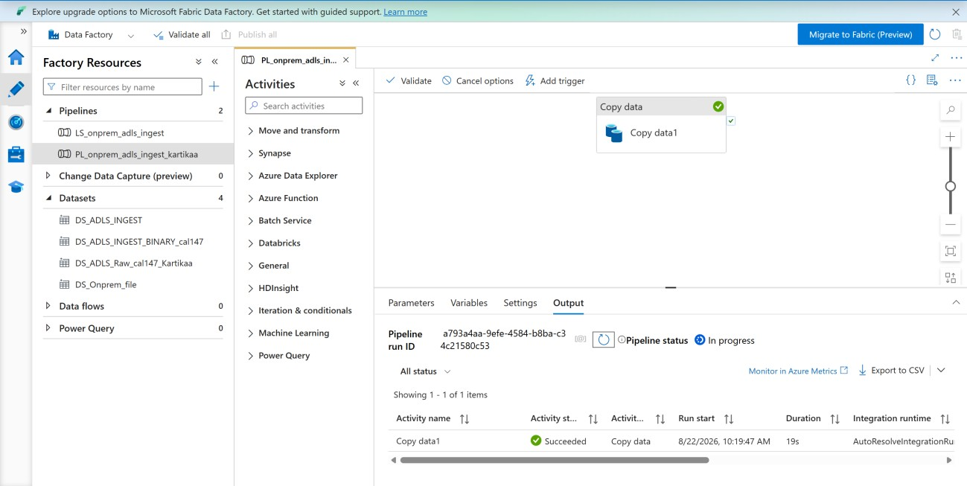

Figure 5: Pipeline debug run output
Debug run of the pipeline is triggered and the Output tab shows Copy data1 as Succeeded in 19s on AutoResolveIntegrationRuntime. The overall pipeline status shows In progress while the run id is displayed.
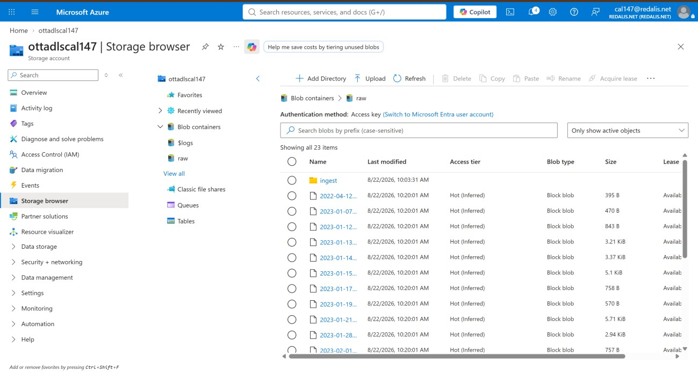

Figure 6: Data landed in ADLS raw container
Azure Storage browser of account ottadlscal147 showing the 'raw' container with 23 items. The ingest folder and the copied dated files (2022-2023) confirm the pipeline loaded the data into ADLS.

