IU2541230042 – CPP24 – PROJECT REPORT
Book Store Management
EnrollmentNo.:IU2541230042
Semester: 3 Subject: C++ Guided Project

1. Introduction
The Book Store Management project is a console-based C++ application designed to maintain book inventory, customer records, and sales transactions. It uses object-oriented programming to separate data entities, store operations, and file persistence. The program provides a menu-driven workflow suitable for demonstrating core C++ concepts in a small retail scenario.

2. Problem Statement
Manual book-store records can be difficult to search, update, and reconcile after a sale. A simple system is needed to store book details, maintain stock quantities, associate sales with customers, calculate transaction totals, and preserve records between program runs.

3. Objectives
• Create and manage book and customer records.
• Search, update, and delete book records by ID.
• Process a sale only when the book, customer, and quantity are valid and stock is sufficient.
• Calculate sale totals and show a basic revenue report.
• Demonstrate encapsulation, constructors, destructors, inheritance, runtime polymorphism, dynamic memory, validation, and file handling.
• Save and reload records using text files.

4. Functional Requirements
1. Add a book with a unique positive ID, title, author, price, and stock.
2. Display all stored books and customers.
3. Search for a book by ID.
4. Update book details and stock.
5. Delete a book by ID.
6. Add customer records with unique IDs.
7. Sell a quantity of a book to an existing customer; reject invalid IDs, non-positive quantities, or insufficient stock.
8. Display sales and calculate total recorded revenue.
9. Save and load books, customers, and sales from tab-separated text files.
10. Validate numeric input and handle invalid menu choices.

5. System / Project Flow
USER → MAIN MENU (main.cpp) → BookStore → Book / Customer / Sale records → sellBook() transaction → FileManager → Data/books.txt, Data/customers.txt, Data/sales.txt. Existing data is loaded at startup; updated data is saved when the user exits or selects Save.

6. Class Descriptions
Class | Data Members | Member Functions | Responsibility
Book | bookId, title, author, price, stock | Book(); display(); updateStock(); setDetails() | Stores book details and available stock.
Author | authorId, name, genre | Author(); display() | Represents author metadata; included for the OOP blueprint.
Customer | customerId, name, phone | Customer(); display(); getId() | Stores customer details used by a sale.
Sale | saleId, bookId, customerId, quantity, total | Sale(); calculateTotal(); display() | Represents a completed book sale.
BookStore | Book*, Customer*, Sale*; counts and capacities | addBook(); addCustomer(); findBook(); updateBook(); deleteBook(); sellBook(); printReport() | Coordinates inventory, customers, transactions, and reports.
FileManager | dataDirectory | save(); load() | Persists records in tab-separated text files.

7. OOP Concepts Used
Encapsulation: entity fields are private and exposed through public member functions. Constructors: default and parameterized constructors initialize objects. Destructor: BookStore releases all dynamically allocated arrays with delete[]. Inheritance: Book, Author, Customer, and Sale derive from abstract Entity. Runtime polymorphism: BookStore passes records through an Entity reference in displayEntity(), so the virtual display() call dispatches to each derived implementation. Dynamic memory: BookStore uses new[] arrays and expands capacity as needed. File handling: FileManager reads and writes persistent text records. Validation and exception handling: menu input is checked and file conversions are guarded against malformed records.

8. File Handling and Data Persistence
FileManager uses the C++ filesystem and fstream libraries. It creates the Data directory when saving and stores records in three tab-separated files: books.txt (ID, title, author, price, stock), customers.txt (ID, name, phone), and sales.txt (sale ID, book ID, customer ID, quantity, total). Existing records are loaded when the program starts. Data is saved on exit and can also be saved or loaded from menu option 8. Text fields should not contain tab characters because tabs separate file fields.

9. UML Diagrams
The four UML diagrams are provided in the UML appendix below. Original PNG images and editable Graphviz .dot source files are also included in the project ZIP.

10. Implementation Details
The application is split across main.cpp, Entity.h/.cpp, BookStore.h/.cpp, and FileManager.h/.cpp. main.cpp handles menu display, user input, and calls into BookStore; business logic is kept out of main. BookStore owns dynamically allocated arrays for books, customers, and sales and expands them when capacity is reached. FileManager is responsible for persistence. Build with a C++17 compiler using: g++ -std=c++17 -Wall -Wextra -pedantic main.cpp Entity.cpp BookStore.cpp FileManager.cpp -o BookStoreManagement. The program was compiled locally and smoke-tested for adding records, completing a sale, showing the report, and saving on exit.

11. Testing and Results
Test ID | Input / Operation | Expected | Actual | Status
T01 | Compile — C++17 build command | Build completes | Compiled successfully | Pass
T02 | Add book — Unique ID; valid details | Book added | Book added | Pass
T03 | Duplicate book ID — Reuse stored ID | Reject duplicate | Not run in smoke test | Pending
T04 | Display books — Option 2 after add | Book row displayed | Not run in smoke test | Pending
T05 | Search existing book — Known ID | Matching details displayed | Not run in smoke test | Pending
T06 | Search missing book — Unknown ID | Book not found | Not run in smoke test | Pending
T07 | Update book — Existing ID and valid values | Record updated | Not run in smoke test | Pending
T08 | Delete book — Existing ID | Record deleted | Not run in smoke test | Pending
T09 | Add customer — Unique ID and name | Customer added | Customer added | Pass
T10 | Valid sale — Existing book/customer, qty within stock | Sale total = price × qty | Sale successful; total Rs. 900.00 | Pass
T11 | Oversell — Quantity greater than stock | Reject sale | Not run in smoke test | Pending
T12 | Invalid quantity — Zero / negative quantity | Reject sale | Not run in smoke test | Pending
T13 | Revenue report — One successful sale | Correct count and revenue | Report showed 1 transaction; Rs. 900.00 | Pass
T14 | Persistence — Save, restart, reload | Records remain available | Save-on-exit confirmed; restart check pending | Pending
T15 | Invalid menu choice — Choice outside 1–12 | Validation message | Not run in smoke test | Pending

12. Sample Screens / Output
Sample console output from a local smoke test (sample IDs and values):
Book added.
Customer added.
Sale successful. Total = Rs. 900.00
--- STORE REPORT ---
Books: 1
Customers: 1
Transactions: 1
Total revenue: Rs. 900.00
Data saved. Goodbye.
The output is representative; prompts and values vary with the input entered during demonstration.

13. Limitations
This is a single-user educational console application. It does not implement authentication, role permissions, tax or discount calculations, supplier management, returns, or concurrent access. Text fields should not contain tab characters. Book deletion does not remove historical sales records, so sales may retain a book ID that no longer exists in inventory. The test plan includes cases that must be run and recorded in the student's own target environment.

14. Future Scope
Possible improvements include a graphical user interface, stronger input validation, safer escaped data formats such as CSV with quoting or JSON, customer search and update/delete operations, author management, returns and refunds, invoices, discount/tax support, low-stock alerts, user login, backups, and automated unit tests.

15. Conclusion
The Book Store Management project demonstrates a modular C++ console application for inventory, customer, and sales handling. It follows the provided class-oriented blueprint, uses inheritance and virtual functions to demonstrate runtime polymorphism, manages dynamic arrays responsibly, validates important transaction inputs, and persists data in text files. The program compiled and passed a basic local smoke test. The remaining test cases and screenshots should be verified and completed before final submission.

UML Diagram Appendix
Use Case Diagram
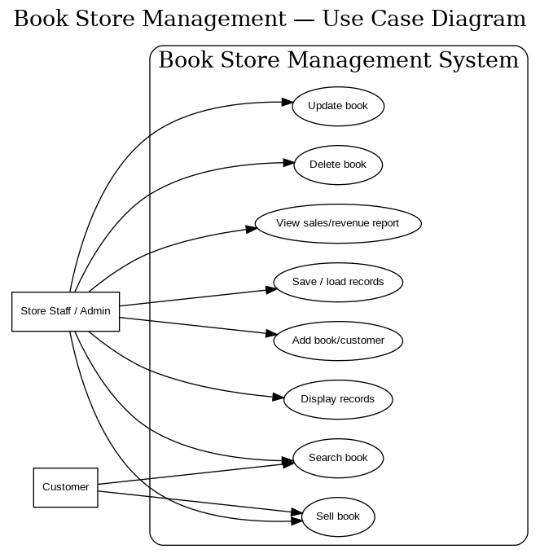

Class Diagram
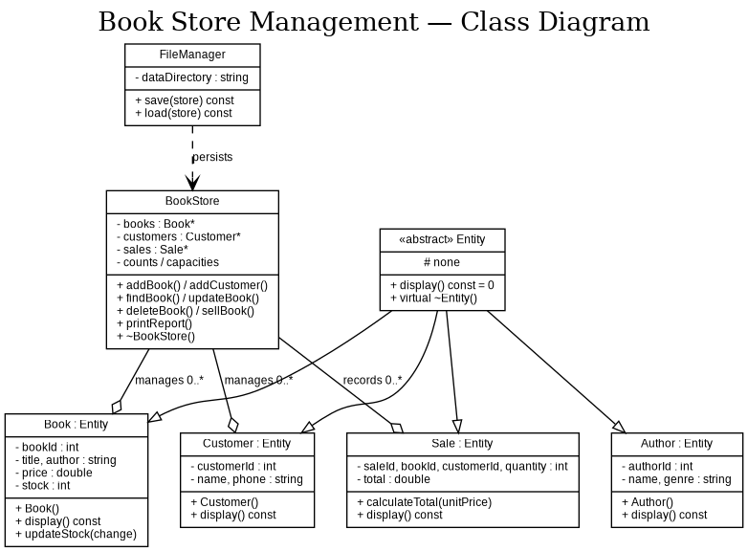
Sequence Diagram 1 — Sell Book
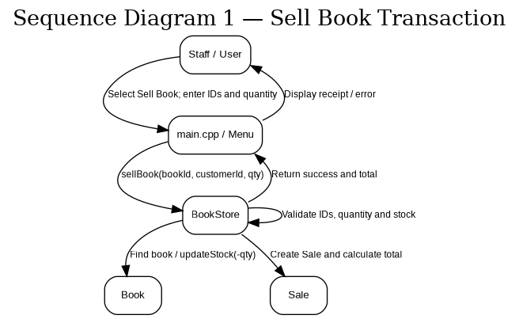

Sequence Diagram 2 — Search Book
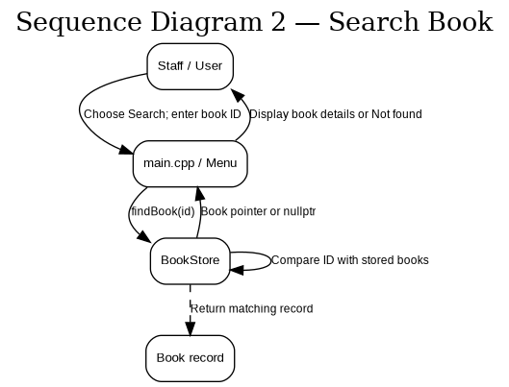

Sample Console Output
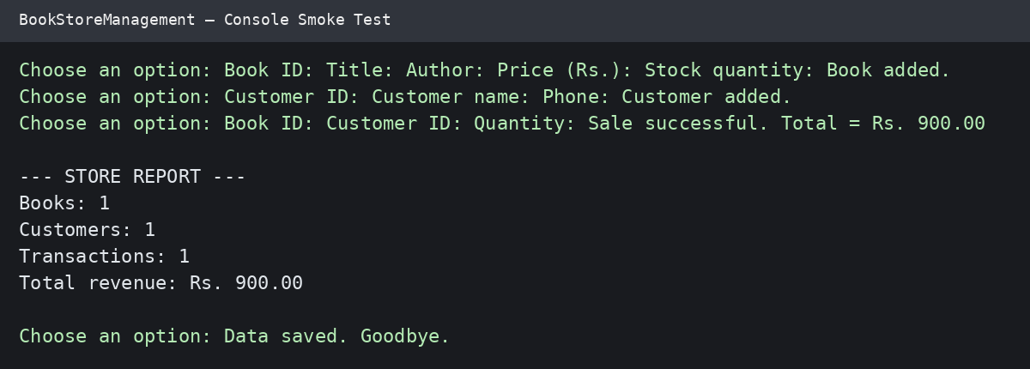
Illustrative rendering of output captured during the local console smoke test. Exact prompts and values depend on entered data.

