

# A PBL PROJECT

On

**ATTENDANCE LIST OF A CLASS**

Submitted By:

**B. SHIVAMANI 218R1A1208**

**A. VARUN KUMAR 218R1A1201**

**B. VENKAT TEJA 218R1A1207**

**E. MADHURI 218R1A1221**

**A. PRATHIBA 218R1A1206**

Under the Guidance of:

# Mr. B. SRINIVAS REDDY

Assistant Professor, Department of IT

# DEPARTMENT OF INFORMATION TECHNOLOGY

CMR ENGINEERING COLLEGE

**UGC AUTONOMOUS** (Approved by AICTE-New Delhi & J.N.T.U, Hyderabad) Kandlakoya (v), Medchal Road, Hyderabad-501 401, Telangana State India.



# CERTIFICATE

This is to certify that the project entitled “**ATTENDANCE LIST OF A CLASS”** is a bonafide work of carried out by:

B. SHIVAMANI 218R1A1208

A. VARUN KUMAR 218R1A1201

B. VENKAT TEJA 218R1A1207

E. MADHURI 218R1A1221

A. PRATHIBA 218R1A1206

In the part of innovative teaching methodology **PBL (Project Based Learning)** of Java Programming Laboratory under our guidance and supervision.

|  |  |
| --- | --- |
| **Project Coordinator Mr. B. Srinivas Reddy**  Assistant Professor, Department of IT,  CMR Engineering College,  Hyderabad | **Head of the Department Dr. Madhavi Pingili**  Professor & HOD, Department of IT,  CMR Engineering College, Hyderabad |

# DECLARATION

This is to certify that the work reported in the present project entitled “**ATTENDANCE LIST OF A CLASS”** is a record of Bonafide work done by us in the Department of Information Technology, CMR Engineering College, Hyderabad. The reports are based on the project work done entirely by us and not copied from any other source. We submit our project for further development by any interested students who share similar interests to improve the project in the future. The results embodied in this project report have not been submitted to any other University or Institute for the award of any degree or diploma to the best of our knowledge and belief.

B. SHIVAMANI 218R1A1208

A. VARUN KUMAR 218R1A1201

B. VENKAT TEJA 218R1A1207

E. MADHURI 218R1A1221

A. PRATHIBA 218R1A1206

# ACKNOWLEDGEMENT

We are extremely grateful to our Principal, **Dr. A. Srinivasula Reddy,** and our HOD, **Dr. Madhavi Pingili**, Department of IT, CMR Engineering College for their constant support. We are immensely thankful to **Mr. B. Srinivas Reddy**, Assistant Professor, Project Coordinator, Department of IT, for his constant guidance, encouragement, and moral support throughout the project. We will be failing in duty if we do not acknowledge with gratitude thanks to the authors of the references and other literate referred to in the Project. We express our thanks to the Department of Information Technology, CMR Engineering College, and friends for all the help and co-ordination extended in bringing out this project successfully in time. Finally we are very thankful to our parents who guided us every step.

B. SHIVAMANI 218R1A1208

A. VARUN KUMAR 218R1A1201

B. VENKAT TEJA 218R1A1207

E. MADHURI 218R1A1221

A. PRATHIBA 218R1A1206

**TABLE OF CONTENTS**

|  |  |
| --- | --- |
| **CONTENT** | **PAGE NUMBER** |
| DECLARATION | 3 |
| ACKNOWLEDGEMENT | 4 |
| ABSTRACT | 6 |
| INTRODUCTION | 7 |
| HARDWARE AND SOFTWARE REQUIREMENTS | 8 |
| ALGORITHM | 9 |
| SOURCE CODE | 10-14 |
| OUTPUT SCREEN | 15-17 |
| CONCLUSION | 18 |
| REFERENCES | 19 |

# ABSTRACT

An Attendance List of a Class Program is a computerized system used to track and manage attendance for individual classes such as schools, universities.The system can automate the process of recording attendance, making it easier and more efficient compared to manual methods. There are several advantages of an Attendance List:

* Easy to use: The Attendance List project in Java can be user-friendly and easy to use, providing a simple interface for tracking attendance.
* Efficient record-keeping: The system can store attendance data efficiently and keep records of attendance for each student, making it easier to manage and track attendance.
* Time-saving: The Attendance List project can automate the process of taking attendance and reduce the time and effort required to manually keep track of attendance.
* Accurate data: The system can provide accurate attendance data, reducing the chances of errors in manual attendance tracking.
* Customizable: The Attendance List project can be customized to meet the specific requirements of an organization or educational institution, making it a versatile solution.
* Improved organization: The Attendance List project can help improve the overall organization of attendance tracking and record-keeping, making it easier to access and analyze attendance data.

# INTRODUCTION

The attendance management system is an advanced Java project for tracking students’ attendance. The project contains a user side where a user can enter attendance. The user plays an important role in the management of this system.

Talking about the features of the Attendance Management System, the user has to enter range of the students in the class.The user can view all the attendance of class in records. This system is so vast and complete for universities and schools.

The design of this project is pretty simple so that the user won’t find any difficulties while working on it. This system helps the user in managing attendance records. The Records contains total number of students Present, absent ,and in progress.

# FUNCTIONAL REQUIREMENTS

## HARDWARE REQUIREMENTS:

* Processor - Quad core 2GHZ or Higher
* RAM - 4 GB minimum recommended
* Hard Disk - 250 GB SSD/HDD

## SOFTWARE REQUIREMENTS:

* Operating System - Windows 10/11
* Language - Java
* Software - Command Prompt

# ALGORITHM

Step 1: Start

Step 2: Create a class named “Attendance_List”

Step 3: Create local variables:

size1, size2, size3, size, total = 0, Progress =0 ,i, j, Presenties = 0,Absenties=0.

Step 4: Enter Branch and Section, then you can proceed to the attendance of a given class.

Step 5: Give input to the Range of Regular students in the given class.

Step 6: Enter Student attendance, if a student is present give P or if absent give A, give any other alphabet if the student is in progress.

Step 7: After the Range was completed, it displays total absenties, presenties, and total students in progress.

Step 8: After step 6 user should enter YES/NO

If Lateral Entry Students exist in a given class give YES/No.

Step 9: If step 8 is YES, repeat steps- 5,6,7 according to your requirements.

Step 10: If step 8 is NO, it displays Lateral Entries might not be there.

Step 11: After steps 9 or 10, user should enter YES/NO.

If Transfer Student exists in a given class give YES/NO.

Step 12: If step 11 is YES, repeat steps 5,6,7 according to the requirements.

Step 13: Final output is,

It displays Actual total strength of the class, total absenties, presenties, and total number of students in progress.

Step 14: End

# SOURCE CODE

import java.io.*;

import java.util.*;

class Attendence_List{

//Store data in a file

public static void storeFile(int total, int Ab, int Pr, int Progress, String branch, char section, String Date){

try{

FileWriter in = new FileWriter("C:\\Users\\shara\\Desktop\\Attendence.txt",true);

in.write("------------------------------------------------");

in.append("\nDATE : " + Date);

in.append("\nBRANCH : " + branch);

in.append("\nSECTION : " + section);

in.append("\nTOTAL CLASS STRENGTH IS : " + total);

in.append("\nTOTAL ABSENTIES : " + Ab);

in.append("\nTOTAL PRESENTIES : " + Pr);

in.append("\nTOTAL STUDENTS IN PROGRESS : " + Progress);

in.append("\n");

in.write("------------------------------------------------");

in.append("\n\n");

in.close();

System.out.println("Data was Stored in the record");

}catch(Exception e){

System.out.println(e);

}

}

public static void main(String args[]){

int i,j,Temp1=0,Temp2=0,Temp3=0,Temp4=0,Temp5=0,Temp6=0;

int total=0;

int progress=0;

Scanner sc=new Scanner(System.in);

System.out.println("\nENTER BRANCH NAME - ");

String branch=sc.nextLine();

System.out.println("ENTER SECTION - ");

char section=sc.next().charAt(0);

System.out.println("ENTER DATE(DATE/MONTH/YEAR): ");

int day=sc.nextInt();

int month=sc.nextInt();

int year=sc.nextInt();

String Date = day + "/" + month + "/" + year;

System.out.println("\nNOW PROCEED THE ATTENDENCE OF " + branch +"-" + section + ":" + "\n");

System.out.println("ENTER RANGE OF REG STUDENTS IN "+ branch +"-" + section + " CLASS");

int size1=sc.nextInt();

total+=size1;

char arr1[] = new char[size1];

char ch1='A';

char ch11='a';

char ch2='P';

char ch22='p';

int Absenties=0,Presenties=0;

System.out.println("\nPLEASE ENTER ATTENDENCE OF REG STUDENTS OF " + branch +"-" + section + ":\nIF STUDENT IS PRESENT GIVE 'P' , IF STUDENT IS ABSENT GIVE 'A' , IF STUDENT IS IN-PROGRESS GIVE ANY SYMBOL.....!! ");

System.out.println();

for(i=0;i<size1;i++){

System.out.print("Roll.No: "+(i+1)+"->");

arr1[i]=sc.next().charAt(0);

}

for(i=0;i<size1;i++){

if(arr1[i]==ch1 || arr1[i]==ch11){

Absenties++;

}

else if(arr1[i]==ch2 || arr1[i]==ch22){

Presenties++;

}

else

{

System.out.println("In progress--> Roll.No"+(i+1));

progress++;

}

}

System.out.println("\nTotal Absenties of REG STUDENTS: "+Absenties);

System.out.println("Total Presenties of REG STUDENTS: "+Presenties);

Temp1=Absenties;

Temp2=Presenties;

Absenties=0;

Presenties=0;

System.out.println();

System.out.println("IF ANY LATERAL-ENTRY(LE) STUDENTS ARE THERE(Y/N):");

char ch3='Y';

char ch33='y';

char str1=sc.next().charAt(0);

if(str1==ch3 || str1==ch33){

System.out.println("ENTER RANGE OF LATERAL-ENTRY(LE) STUDENTS:");

int size2=sc.nextInt();

total+=size2;

char arr2[]=new char[size2];

System.out.println("\nIF STUDENT IS PRESENT GIVE 'P' , IF STUDENT IS ABSENT GIVE 'A' , IF STUDENT IS IN-PROGRESS GIVE ANY SYMBOL.....!!\n");

for(i=0;i<size2;i++){

System.out.print("LATERAL-ENTRY(LE) "+(i+1)+"->");

arr2[i]=sc.next().charAt(0);

}

for(i=0;i<size2;i++){

if(arr2[i]==ch1 || arr2[i]==ch11){

Absenties++;

}

else if(arr2[i]==ch2 || arr2[i]==ch22){

Presenties++;

}

else

{

System.out.println("In progress--> LE "+(i+1));

progress++;

}

}

System.out.println("\nTotal LATERAL-ENTRY(LE) Absenties: "+Absenties);

System.out.println("Total LATERAL-ENTRY(LE) Presenties: "+Presenties +"\n");

}

else

{

System.out.println("\nMIGHT BE LATERAL-ENTRY(LE) STUDENTS ARE NOT THEIR!!\n");

System.out.println();

System.out.println();

}

Temp3=Absenties;

Temp4=Presenties;

Absenties=0;

Presenties=0;

System.out.println("IF ANY TRANSFOR STUDENTS ARE THERE(Y/N):");

char str2=sc.next().charAt(0);

if(str2==ch3 || str2==ch33){

System.out.println("ENTER RANGE OF TRANSFOR STUDENTS:");

int size3=sc.nextInt();

total+=size3;

char arr3[]=new char[size3];

System.out.println("\nIF STUDENT IS PRESENT GIVE 'P' , IF STUDENT IS ABSENT GIVE 'A' , IF STUDENT IS IN-PROGRESS GIVE ANY SYMBOL.....!! ");

for(i=0;i<size3;i++){

System.out.print("TRANSFOR STUDENT "+(i+1)+"->");

arr3[i]=sc.next().charAt(0);

}

for(i=0;i<size3;i++){

if(arr3[i]==ch1 || arr3[i]==ch11){

Absenties++;

}

else if(arr3[i]==ch2 || arr3[i]==ch22){

Presenties++;

}

else

{

System.out.println("In progress--> TRANSFORM STUDENT "+(i+1));

progress++;

}

}

System.out.println("\nTotal Absenties of TRANSFOR STUDENT: "+Absenties);

System.out.println("Total Presenties of TRANSFOR STUDENT: "+Presenties +"\n");

Temp5=Absenties;

Temp6=Presenties;

}

else

{

System.out.println("\nMIGHT BE TRANSFOR STUDENTS ARE NOT THEIR!!\n");

}

int Ab=Temp1 + Temp3 + Temp5;

int Pr=Temp2 + Temp4 + Temp6;

System.out.println("------------------------------------------------");

System.out.println("TOTAL CLASS STRENGTH IS:"+total);

System.out.println("TOTAL ABSENTIES: "+Ab);

System.out.println("TOTAL PRESENTIES: "+Pr);

System.out.println("TOTAL STUDENTS IN PROGRESS:"+progress);

System.out.println("------------------------------------------------");

//Calling store file method

storeFile(total, Ab, Pr, progress, branch, section, Date);

}

}

**OUTPUT SCREEN**

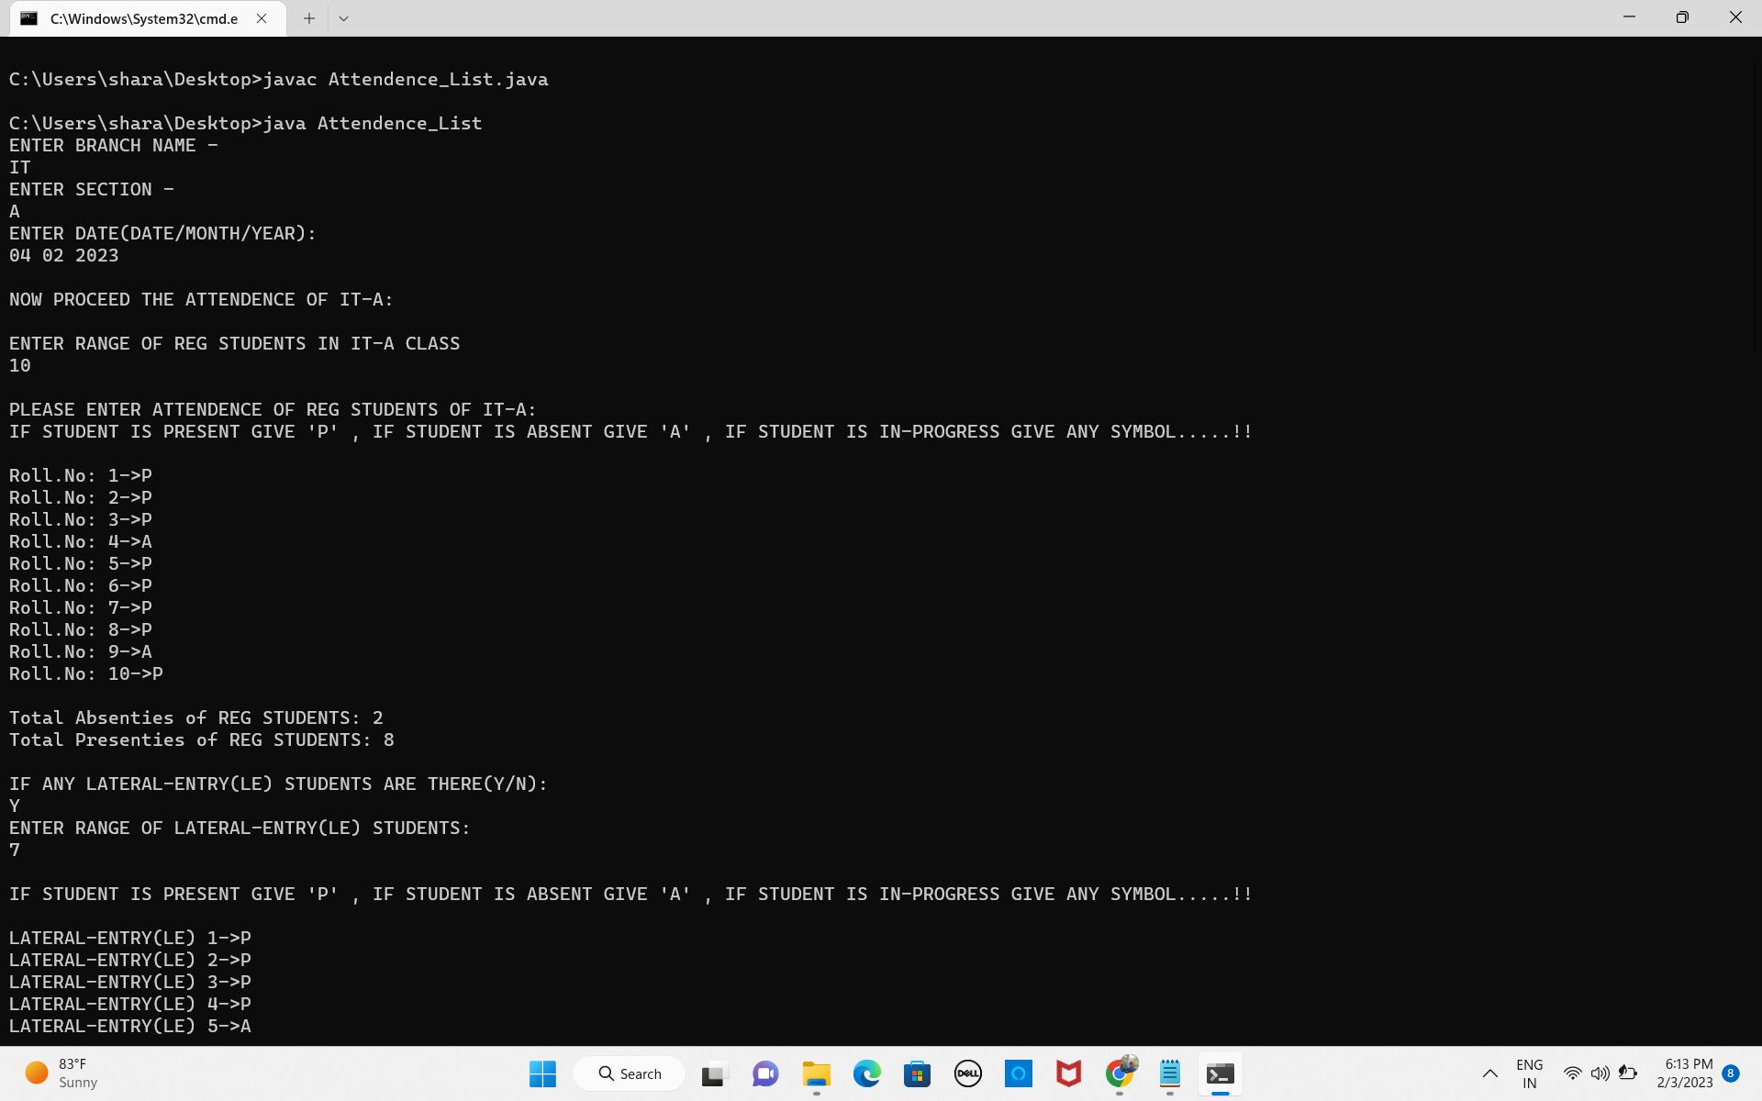

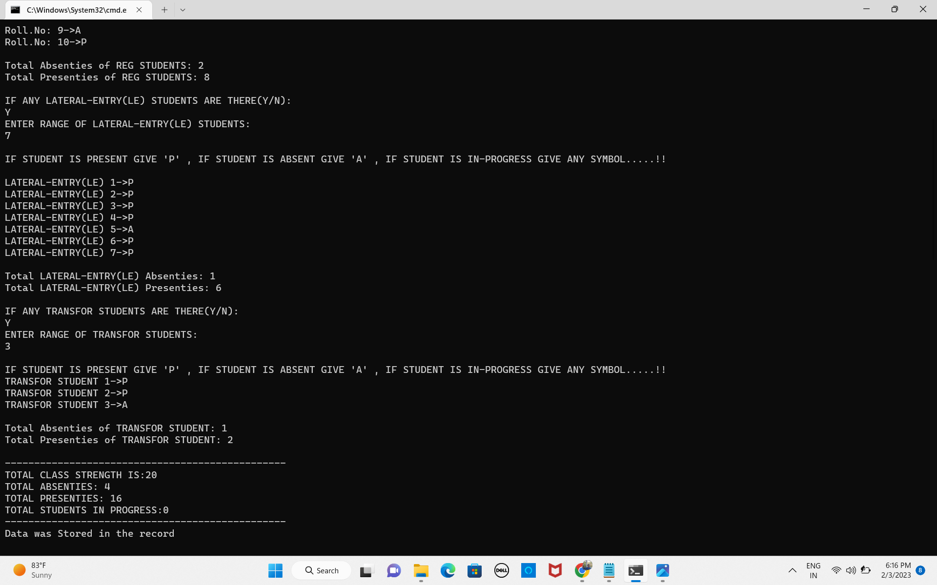

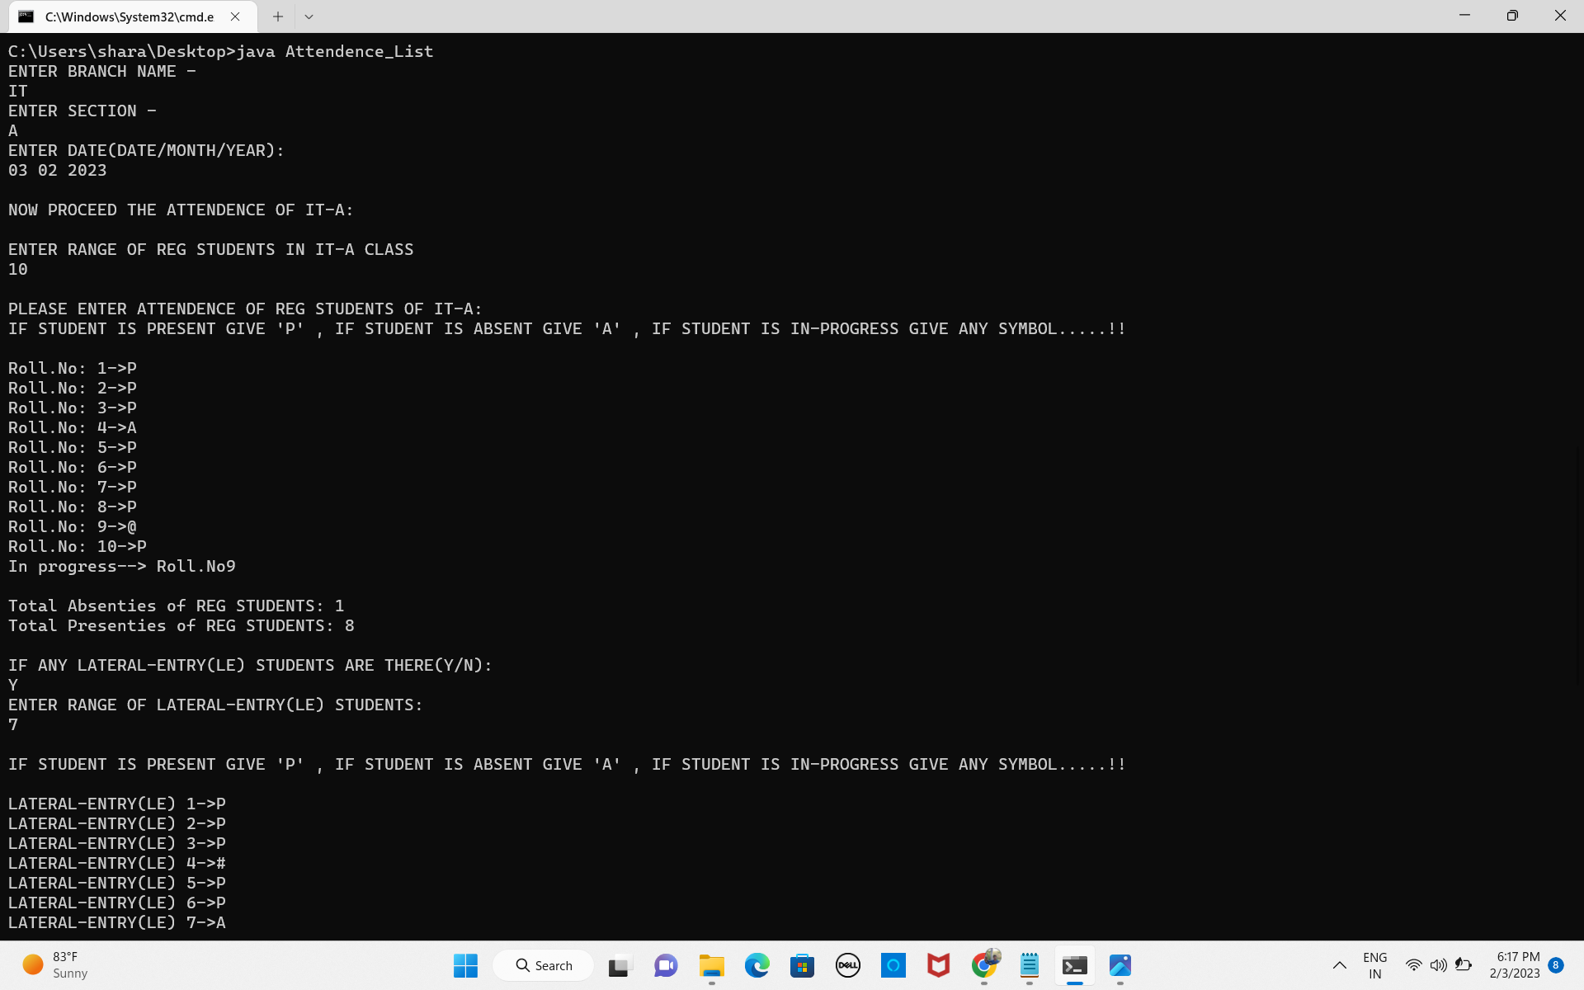

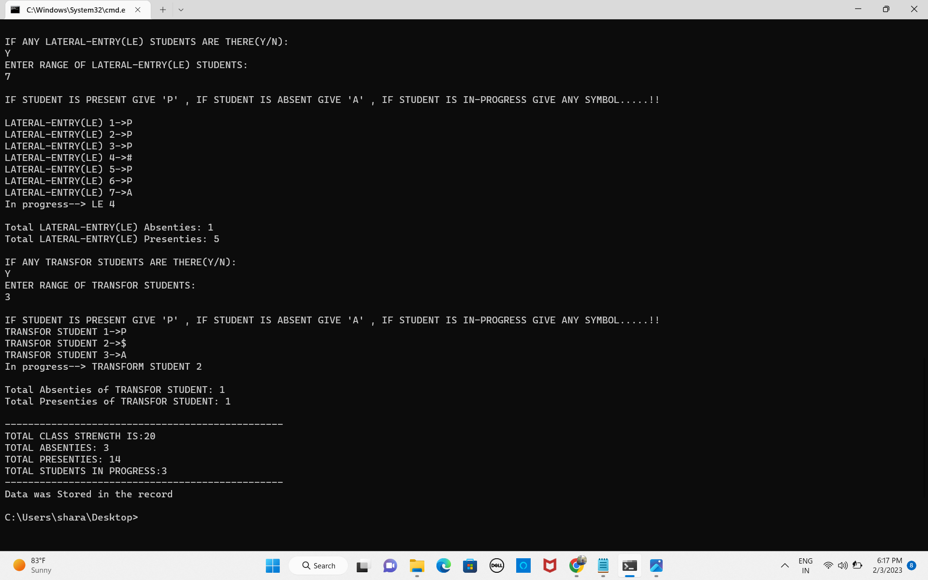

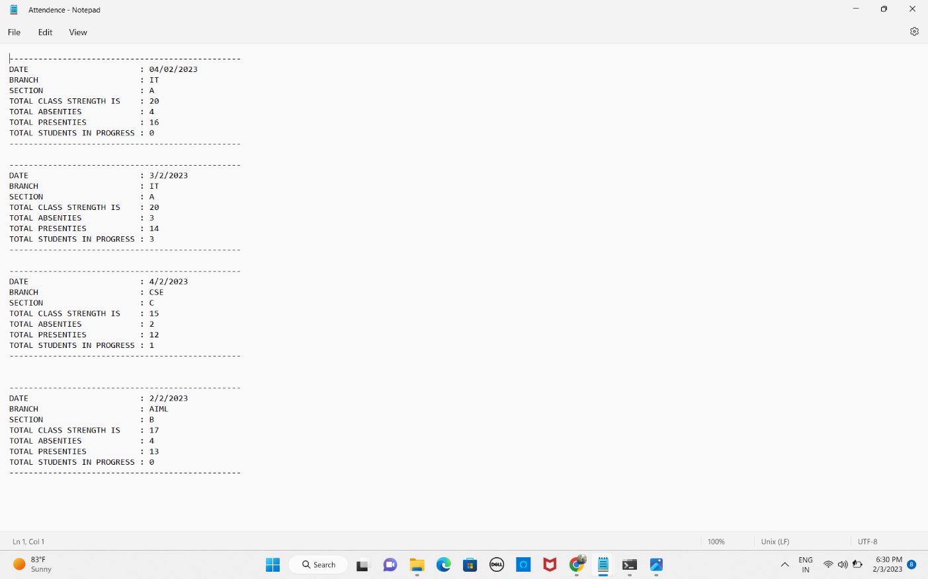

**CONCLUSION**

Thus, we conclude that Attendance List shows the strength of a specific class, it displays the total number of Presenties, Absenties, and students in progress. We have to give input in order to specify the range of the students in the class. The user has to give ‘P’, if the student is present, give ‘A’ if the student is absent,give any other alphabet , if the student is in progress. By giving input by the user, it performs its operations and displays the Status of the Specific Class. The output can be stored as records for further use and the user can view a particular date attendance list for any kind of work from records.

**REFERENCE**

* <https://www.geeksforgeeks.org/different-ways-reading-text-file-java/>
* <https://www.javatpoint.com/java-stringbuilder-append-method>
* <https://www.w3schools.com/java/java_classes.asp>

THANK YOU!