DATA SOURCING, IMPORT, AND TRANSFORMATION FOR CONSTRUCTION METRICS

DATA SOURCING, IMPORT, AND TRANSFORMATION FOR CONSTRUCTION METRICS
Power BI-Based Construction Industry Data Preparation and Analysis
Internship Project Report
Dataset Source:
UK Office for National Statistics (ONS)
Output in the Construction Industry

EXECUTIVE SUMMARY
This project, titled "Data Sourcing, Import, and Transformation for Construction Metrics," focuses on collecting, importing, examining, cleaning, and preparing construction industry data for analysis using Microsoft Power BI.
The project uses the publicly available Output in the Construction Industry dataset published by the UK Office for National Statistics (ONS). The dataset contains information about construction output across different periods, geographical areas, and types of construction work. It also includes different measurement categories, such as monetary output in million pounds, index numbers, and percentage changes.
Microsoft Power BI Desktop was used to import the CSV dataset, while Power Query was used to perform data preparation and transformation. The work included examining column structures, checking missing values, assigning appropriate data types, renaming technical column headings, and creating a new date column named MonthDate from the original time-period information.
During data quality assessment, the Value column was found to contain approximately 74% valid values and 26% empty values. The Data Marking column contained approximately 26% valid values and 74% empty values. These empty fields were examined as part of the data-quality process rather than being removed without justification. The transformed date column showed 100% valid values in the Power Query preview.
After preparing the data, an interactive Power BI dashboard was developed. It includes a construction output trend line chart, a comparison of construction output by type of work, and slicers for geography, series type, and construction work categories.
The project demonstrates how public construction statistics can be converted into a structured and useful analytical report. It also explains how prepared construction data can support industry-level trend monitoring, comparisons, and business intelligence activities.

PROJECT OVERVIEW
The construction industry generates a large amount of information related to construction activities, output, work categories, and changes over time. Analysing this information helps businesses and decision-makers understand industry trends and make better planning decisions.
The main purpose of this project is to understand the process of sourcing construction-related data and preparing it for analysis using Power BI. The project follows a practical data analytics workflow, starting with dataset selection and ending with the development of an interactive dashboard.
For this project, publicly available construction statistics were collected from the UK Office for National Statistics (ONS). The selected dataset, "Output in the Construction Industry," provides information about construction output in Great Britain across different time periods and categories of construction work.
The dataset was downloaded in CSV format and imported into Microsoft Power BI Desktop. Power Query Editor was used to inspect the dataset and perform the required transformations. Technical column names were renamed into more understandable names, data types were checked, and a new date column was created to support time-based analysis.
The project also involved examining missing values and checking the quality of important columns. Different measurement categories were kept identifiable because monetary values, index numbers, and percentage changes represent different types of information and should not be mixed during analysis.
After completing the data preparation process, an interactive dashboard was created in Power BI. The dashboard provides a visual representation of construction output trends and comparisons between different types of construction work. Users can interact with the dashboard through geography, series type, and work-type slicers.
This project mainly focuses on industry-level construction output analysis. It does not directly measure individual project budgets, contractor expenses, employee working hours, or project completion schedules. Such information would require additional project-level and workforce datasets.

OBJECTIVES
The main objectives of this project are:
- Data Sourcing: To identify and obtain reliable, publicly available construction industry data from the UK Office for National Statistics.
- Dataset Understanding: To examine the structure, columns, categories, and measurement types available in the selected construction dataset.
- Data Import: To import the CSV dataset into Microsoft Power BI Desktop for further processing and analysis.
- Data Cleaning: To identify missing values, inspect data quality, and understand the presence of incomplete records.
- Data Transformation: To rename technical column headings, assign suitable data types, and create a date column for time-based analysis.
- Data Validation: To check whether the transformed columns contain valid values and whether the prepared dataset is suitable for visualization.
- Construction Metrics Analysis: To examine construction output trends and compare different categories of construction work.
- Dashboard Development: To create an interactive Power BI dashboard using charts, a numerical card, and slicers.
- Business Intelligence Understanding: To understand how construction industry data can support trend monitoring, reporting, and informed business decisions.
- Future Integration Planning: To explore how additional construction project, cost, and workforce datasets could be integrated into Power BI in future implementations.
Through these objectives, the project aims to develop practical knowledge of data sourcing, data preparation, transformation, and visualization while understanding the role of Business Intelligence in the construction industry.

DATA SOURCE AND DATASET DESCRIPTION

1. Data Source
For this project, publicly available construction industry data was collected from the UK Office for National Statistics (ONS). ONS is an official statistical organisation that publishes reliable information about different sectors of the UK economy.
The dataset selected for this project is titled "Output in the Construction Industry." It provides statistical information about construction output in Great Britain over different reporting periods and categories of construction work.
The dataset was downloaded in CSV format from the official ONS data source.
Official Dataset Link:
https://www.ons.gov.uk/businessindustryandtrade/constructionindustry/datasets/outputintheconstructionindustry
Direct CSV Download:
https://static.ons.gov.uk/datasets/output-in-the-construction-industry-time-series-v52.csv

2. Dataset Description
The selected dataset contains approximately 37,856 records and originally includes 12 columns. It provides information about construction output, reporting periods, geographical coverage, seasonal adjustment, measurement types, and construction work categories.
The dataset contains both numerical and descriptive information. The numerical values represent different construction output measures, while the descriptive columns explain the time period, geographical area, measurement category, and type of construction work.
The dataset includes the following important fields:
Original Column | Description
v4_1 | Numerical observation or construction output value
Data Marking | Statistical marking or data flag
years-quarters-months | Time-period code
Time | Readable reporting period
administrative-geography | Geographical code
Geography | Geographical area
seasonal-adjustment | Seasonal adjustment code
SeasonalAdjustment | Seasonal adjustment description
construction-series-type | Measurement category code
SeriesType | Measurement category description
construction-classifications | Construction work classification code
TypeOfWork | Description of construction work category

3. Main Measurement Categories
The dataset contains four important measurement categories in the SeriesType column:
- Index Numbers (2019=100): Used to compare construction output against a base period where 2019 is equal to 100.
- Percentage Change on Period on Period: Shows the percentage change compared with the previous reporting period.
- Percentage Change on Period on Period a Year Earlier: Shows the percentage change compared with the corresponding period in the previous year.
- £million: Represents construction output measured in millions of pounds.
These categories were kept separate during analysis because they represent different measurement units and cannot be directly combined.

4. Dataset Suitability
The selected dataset is suitable for this project because it provides historical construction output information and different construction work categories. It supports the preparation of time-based reports, comparisons, and industry-level trend analysis.
However, it mainly represents aggregated construction industry statistics. It does not directly contain individual project budgets, contractor expenses, employee working hours, or project completion schedules. These measures would require additional datasets.

TOOLS AND TECHNOLOGIES USED

Several tools and technologies were used to complete the data sourcing, import, transformation, and visualization activities.

1. Microsoft Power BI Desktop
Microsoft Power BI Desktop was the main software used for this project. It provides facilities for importing datasets, preparing data, creating visualizations, and developing interactive dashboards.
It was used to:
- Import the ONS construction dataset.
- Create visual reports and charts.
- Compare construction output across different work categories.
- Add interactive slicers.
- Present construction output information in an understandable format.

2. Power Query Editor
Power Query Editor was used for data cleaning and transformation. It provides a user-friendly environment for preparing raw datasets before loading them into the Power BI data model.
It was used to:
- Inspect the imported dataset.
- Rename technical column headings.
- Assign appropriate data types.
- Examine missing and valid values.
- Create the new MonthDate column.
- Review transformation steps through the Applied Steps panel.

3. CSV File Format
CSV (Comma-Separated Values) was used as the source file format. It stores tabular data in a structured text format and can be imported into Power BI.
The CSV format was suitable because the ONS dataset was publicly available in this format and could be loaded directly without requiring a separate database system.

4. Power Query M Language
Power Query M is the language used by Power Query to describe data extraction and transformation operations.
In this project, M language was used to perform operations such as:
- Promoting the first row as column headers.
- Changing column data types.
- Renaming columns.
- Creating a new date column from the reporting period.
These transformations helped prepare the source data for further analysis.

5. Power BI Visualization Features
Power BI visualization features were used to present the prepared information through different visual elements.
The project includes:
- Line chart for construction output trends over time.
- Bar chart for comparing construction output by type of work.
- Card visual for displaying an aggregated numerical value.
- Geography slicer for geographical selection.
- SeriesType slicer for measurement selection.
- TypeOfWork slicer for construction category selection.

6. Summary of Technology Selection
Tool / Technology | Purpose
Microsoft Power BI Desktop | Data analysis and dashboard development
Power Query Editor | Data cleaning and transformation
Power Query M | Writing transformation steps
CSV | Source dataset format
Power BI Visualizations | Charts, cards, and interactive slicers
ONS Open Data | Public construction industry data source
The selected tools were appropriate for this project because they allowed the complete data preparation and visualization workflow to be performed within Power BI.

DATA IMPORT METHODOLOGY

The data import process was an important stage of the project because the original construction dataset needed to be loaded into Power BI before cleaning and analysis could begin.
The following steps were followed during data import.

1. Dataset Download
The construction output dataset was downloaded from the official UK Office for National Statistics website.
The downloaded file was available in CSV format and was stored in the project's data folder for use in Power BI Desktop.

2. Opening Power BI Desktop
Microsoft Power BI Desktop was opened to begin the data import process. The Get Data option was used to connect to the CSV source file.

3. Selecting the CSV File
The downloaded ONS construction dataset was selected from the local project folder.
Power BI identified the file as a CSV dataset and displayed a preview of its contents before loading.

4. Opening Power Query Editor
Instead of directly using the raw data for visualization, the Transform Data option was selected.
This opened Power Query Editor, where the dataset structure and individual columns could be examined before loading the prepared data into the Power BI model.

5. Checking Column Headers and Structure
The first row of the CSV file was promoted as the column header row. This ensured that the dataset fields were correctly identified.
The original dataset contained 12 columns covering numerical values, reporting periods, geography, seasonal adjustment, measurement categories, and construction work classifications.

6. Assigning Data Types
Suitable data types were checked and assigned to the columns.
For example:
- Numerical observation values were assigned the Decimal Number data type.
- Reporting period and descriptive fields were assigned the Text data type.
- The newly created MonthDate field was assigned the Date data type.
This helped Power BI interpret the information correctly during analysis and visualization.

7. Loading the Prepared Dataset
After the required import and transformation operations were completed, the Close & Apply option was used to load the prepared dataset into Power BI.
The imported table was named ONS_Construction_Output and was then available for creating charts, cards, and slicers.

DATA CLEANING AND TRANSFORMATION

Data cleaning and transformation were important parts of this project because the original dataset contained technical column names, different measurement categories, and some missing values.
Power Query Editor was used to prepare the dataset and make its structure more suitable for analysis.

1. Column Renaming
Several original column names were technical and difficult to understand. These names were changed into simpler and more meaningful names.
The following changes were made:
Original Column Name | New Column Name
v4_1 | Value
years-quarters-months | TimeCode
administrative-geography | GeographyCode
seasonal-adjustment | AdjustmentCode
construction-series-type | SeriesTypeCode
construction-classifications | WorkTypeCode
The descriptive columns such as Geography, Time, SeriesType, SeasonalAdjustment, and TypeOfWork were retained.
This improved the readability of the dataset and made it easier to identify fields while creating Power BI visuals.

2. Data Type Conversion
The data types of the columns were examined and adjusted where required.
The Value column was assigned the Decimal Number data type because it contains numerical observations, including decimal and negative values.
The descriptive fields were maintained as Text, while the new MonthDate column was assigned the Date data type.
Correct data types were important for ensuring that numerical calculations and date-based visualizations worked properly.

3. Handling Missing Values
The dataset contained missing values in some columns.
During data quality assessment, the following results were observed:
Column | Valid Values | Empty Values | Errors
Value | 74% | 26% | 0%
Data Marking | 26% | 74% | 0%
MonthDate | 100% | 0% | 0%
The missing values were examined using the Column Quality feature in Power Query Editor.
The empty Value records were not automatically deleted because removing them without understanding their meaning could result in the loss of useful observations.
Similarly, empty Data Marking fields were retained because they may represent records without an additional statistical marking.
This approach helped preserve the original dataset while identifying its data quality limitations.

4. Creation of MonthDate Column
The original dataset contained reporting periods in different formats, including monthly and quarterly periods.
To support time-based analysis, a new column named MonthDate was created using Power Query M language.
The transformation converted readable reporting periods into standard date values.
Examples include:
Original Time | MonthDate
2026 - Jan | 01-Jan-2026
2025 - Q3 | 01-Jul-2025
2025 - Q4 | 01-Oct-2025
2025 - Sept | 01-Sep-2025
For quarterly periods, the first month of the quarter was used as the representative date. This made the reporting periods easier to work with in Power BI.
The new MonthDate column showed 100% valid values and no errors in the Power Query column quality assessment.

5. Retaining Different Measurement Categories
The SeriesType column contains monetary values, index numbers, and percentage changes.
These measurements have different meanings and units. Therefore, they were kept identifiable instead of combining them into one calculation.
For the monetary construction output visuals, the £million category was selected.
This helped ensure that the monetary output charts displayed values from the appropriate measurement category.

6. Final Transformation Result
After completing the cleaning and transformation process, the dataset had a more understandable structure and was ready for visualization in Power BI.
The main improvements included:
- Simplified column names.
- Appropriate data types.
- Identification of missing values.
- Creation of a standardized MonthDate field.
- Retention of important construction classifications.
- Separation of different measurement categories.
These activities prepared the ONS construction dataset for further analysis and interactive dashboard development.

DATA QUALITY ASSESSMENT

Data quality assessment was performed to understand the condition of the original ONS construction dataset before using it for analysis. The purpose was to identify missing values, check data types, examine column structures, and ensure that the transformed data was suitable for visualization.
Microsoft Power Query Editor was used to examine the dataset through its Column Quality, Column Distribution, and Column Profile features.

1. Column Quality Analysis
The Column Quality feature was used to identify valid values, errors, and empty records in important columns.
The following results were observed during the assessment:
Column | Valid Values | Empty Values | Errors
Value | 74% | 26% | 0%
Data Marking | 26% | 74% | 0%
MonthDate | 100% | 0% | 0%
The Value column contained approximately 74% valid numerical observations and 26% empty values. The Data Marking column contained a larger proportion of empty records. The MonthDate column showed 100% valid values after the date transformation.
These results helped identify which fields required attention during data preparation.

2. Missing Value Assessment
Missing values were present in the Value and Data Marking columns.
Instead of automatically deleting all incomplete records, the missing fields were examined carefully. Empty values in the Value column were retained because removing them without understanding their meaning could lead to unnecessary data loss.
Similarly, empty Data Marking fields were retained because they may indicate that no additional statistical marking was supplied for those observations.
This approach helped preserve the original dataset while documenting its limitations.

3. Data Type Validation
The data types of the important columns were checked during the transformation process.
- Value was assigned the Decimal Number data type.
- Time and descriptive category fields were maintained as Text.
- MonthDate was assigned the Date data type.
This ensured that numerical values could be used in calculations and that reporting periods could be used in time-based visualizations.

4. Date Validation
The original Time column contained monthly and quarterly reporting periods. A new MonthDate column was created to convert these periods into standard date values.
The transformed column showed 100% valid values with no errors in the Power Query quality assessment.
For quarterly periods, the first month of the quarter was used as the representative date.

5. Measurement Consistency
The SeriesType column contains different measurement categories, including £million, index numbers, and percentage changes.
These categories were treated separately because they represent different units and meanings. The monetary dashboard visuals were restricted to the £million measurement category to avoid mixing incompatible values.

6. Data Quality Assessment Outcome
The data quality assessment helped identify missing observations, confirm the validity of the date transformation, and verify the numerical and descriptive fields.
Overall, the dataset was considered suitable for the intended industry-level construction output dashboard, subject to the limitations identified during the assessment.

CHALLENGES AND SOLUTIONS

During the project, several challenges were encountered while sourcing, importing, cleaning, and preparing the construction dataset. These challenges provided practical experience in handling real-world statistical data.

1. Understanding Technical Column Names
Challenge: The original dataset contained technical column names such as v4_1, years-quarters-months, and construction-classifications. These names were not easy to understand while working with the data.
Solution: The technical column names were renamed into more meaningful names, such as Value, TimeCode, and WorkTypeCode. This improved readability and made the fields easier to identify during dashboard development.

2. Handling Missing Values
Challenge: Some columns contained empty records. The Value column had approximately 26% empty values, while the Data Marking column had approximately 74% empty values.
Solution: Column Quality and Column Profile features in Power Query were used to examine missing values. The incomplete records were retained rather than removed without justification. This helped avoid unnecessary loss of potentially useful information.

3. Different Reporting Period Formats
Challenge: The Time column contained reporting periods in different formats, including monthly periods and quarterly periods. This made direct date-based analysis more difficult.
Solution: A new MonthDate column was created using Power Query M language. Monthly periods were converted into standard dates, while quarterly periods were represented by the first month of their respective quarters.

4. Different Measurement Units
Challenge: The dataset contained monetary values, index numbers, and percentage changes in the same Value column. Combining these measurements could produce misleading results.
Solution: The SeriesType field was used to distinguish between the different measurement categories. For the monetary output visuals, the £million category was selected so that unrelated measurement units were not combined.

5. Large Dataset and Data Preview
Challenge: The dataset contained approximately 37,856 records. Working with a large dataset required careful inspection of columns and transformation results.
Solution: Power Query's filtering, column profiling, and transformation features were used to examine the dataset. The original records were preserved while the required columns and data types were prepared.

6. Dashboard Presentation
Challenge: Presenting multiple construction categories and measurement types in one dashboard could make the report difficult to understand.
Solution: Separate visuals were created for construction output trends and output by type of work. Slicers were added for Geography, SeriesType, and TypeOfWork to allow users to explore the available information interactively.

7. Learning Power BI and Power Query
Challenge: Understanding Power Query transformations, data types, filters, and dashboard visualizations required practical learning.
Solution: The project was completed step by step using Power BI Desktop and its built-in features. The Applied Steps panel was used to review the transformation process and understand how each operation affected the dataset.

8. Overall Outcome
The challenges encountered during the project helped develop practical knowledge of data sourcing, data cleaning, transformation, validation, and visualization. The solutions improved the structure and usability of the dataset and supported the development of the final Power BI dashboard.

POWER BI INTEGRATION STRATEGY

Power BI can be used as a central Business Intelligence platform for collecting, preparing, combining, and presenting construction-related information.
In this project, the ONS construction output dataset was imported and transformed using Power BI Desktop. The following integration strategy describes how this approach could be extended in a real construction business by connecting additional data sources.

1.Proposed Data Integration Architecture
A construction organization may maintain information across different systems, such as project management software, financial spreadsheets, workforce records, and public industry statistics.
A proposed integration workflow is:
Data Sources → Power Query → Power BI Data Model → Power BI Service → Interactive Reports
The main stages are explained below.

Stage 1: Data Sources
Different sources can provide different types of construction information.
- ONS public statistics: Industry-level construction output and trends.
- Project management systems: Project schedules, milestones, and completion dates.
- Financial records: Approved budgets, actual expenditure, and cost variations.
- Workforce records: Employee working hours, attendance, and labour allocation.
- Procurement records: Material purchases, supplier details, and delivery information.
Only approved and relevant data should be connected to the reporting system.

Stage 2: Data Preparation Using Power Query
Power Query can be used to import and prepare information from different sources.
The preparation process may include:
- Removing unnecessary columns.
- Standardizing column names.
- Correcting data types.
- Handling missing and duplicate records where appropriate.
- Converting different date formats into a common format.
- Matching geographical and project identifiers.
- Checking data consistency between sources.
This stage helps make information from different systems suitable for analysis.

Stage 3: Power BI Data Model
After data preparation, the information can be organized into a structured data model.
A possible model could contain:
- Date Table: Reporting dates, months, quarters, and years.
- Project Table: Project identifiers, names, locations, and project categories.
- Cost Table: Approved budgets, actual expenditure, and cost variations.
- Workforce Table: Labour hours, employee allocation, and work categories.
- Construction Output Table: Industry-level output statistics from ONS.
Relationships between the tables can be created using common identifiers, such as project IDs, dates, and geographical codes.
The ONS dataset used in this project would provide industry benchmarks, while internal business datasets would provide project-specific information.

Stage 4: Dashboard Development
Power BI visuals can present information through:
- Construction output trend charts.
- Budget versus actual expenditure comparisons.
- Project progress and milestone reports.
- Labour-hour and productivity analysis.
- Construction category comparisons.
- Geographical performance reports.
The dashboard can include slicers and filters so that users can examine information according to their requirements.

Stage 5: Publishing Through Power BI Service
After developing the reports in Power BI Desktop, an organization can publish them to Power BI Service.
This can support:
- Centralized report access.
- Scheduled data refresh, where supported by the source and gateway configuration.
- Role-based access and permissions.
- Sharing dashboards with authorized employees.
- Monitoring updated business information.
Publishing and refresh were considered as proposed future integration activities; the current project was developed in Power BI Desktop.

2. Recommended Integration Technologies
Technology | Proposed Role
Microsoft Power BI Desktop | Report development and data modelling
Power Query | Data import, cleaning, and transformation
Power BI Service | Online report publishing and sharing
Excel / CSV | Simple source files and data exchange
SQL Database | Centralized storage for structured business data
Project Management Software | Project schedules and milestone information
Workforce Management System | Labour hours and workforce records

3. Data Refresh and Security
A construction organization should establish a suitable data refresh process so that dashboards reflect updated information.
Public statistical data can be refreshed when new ONS releases become available. Internal business data can be refreshed according to the organization's reporting schedule.
Access to financial, employee, and project information should be restricted to authorized users. Role-based permissions and suitable data protection practices should be applied before sharing reports.

4. Benefits of the Proposed Integration
The proposed integration strategy could provide several benefits:
- Reduce manual data collection and repeated spreadsheet work.
- Provide a common reporting platform for different departments.
- Improve visibility of construction output and project performance.
- Support comparisons between industry-level statistics and internal business information.
- Help managers identify changes and potential problems earlier.
- Support more consistent and informed decision-making.
The strategy is a proposed future implementation. The current project demonstrates the initial data preparation and dashboard development stage using the ONS dataset.

CONSTRUCTION INDUSTRY USE CASES

The prepared construction dataset and Power BI dashboard can support several industry-level reporting and monitoring activities.
The following use cases explain how construction organizations and analysts may use this type of information.

1. Construction Output Trend Monitoring
Purpose: To understand how construction output changes over time.
The line chart in the dashboard presents construction output trends across different reporting years.
Business Application: Construction analysts and managers can monitor changes in industry output and identify periods of growth or decline. This information can support industry research and high-level business planning.

2. Comparison of Construction Work Categories
Purpose: To compare output across different types of construction work.
The dashboard includes a bar chart showing construction output by categories such as private housing, public housing, infrastructure, and non-housing work.
Business Application: Analysts can compare construction sectors and identify which work categories contribute more to the reported industry output. This can support market research and business strategy discussions.

3. Construction Output Monitoring in Monetary Terms
Purpose: To examine construction output measured in million pounds.
The SeriesType slicer allows the monetary measurement category (£million) to be selected for the relevant dashboard visuals.
Business Application: Business analysts can review industry-level monetary output trends and use them as a broad reference when studying construction market conditions.
This measure represents industry output and should not be interpreted as an individual contractor's project budget or actual expenditure.

4. Construction Output Index Analysis
Purpose: To understand relative changes in construction output compared with the 2019 base year.
The dataset provides index numbers where 2019 is represented as 100.
Business Application: Analysts can use the index to compare changes in construction activity relative to the base period without confusing index values with monetary output.

5. Percentage Change Analysis
Purpose: To understand short-term and year-on-year changes in construction output.
The dataset contains percentage changes for both the previous reporting period and the corresponding period a year earlier.
Business Application: These measures can help analysts identify changes in construction activity and compare current trends with earlier periods.
The two percentage-change measures should be examined separately because they use different comparison periods.

6. Geographical Construction Analysis
Purpose: To examine construction output for the geographical areas available in the dataset.
The Geography slicer allows users to select the available geographical category. In the current dashboard, Great Britain is selected.
Business Application: Geographical information can help analysts understand the coverage of the statistics and support comparisons when additional geographical areas are available.

7. Future Use Case: Labour Productivity Analysis
Purpose: To understand the relationship between workforce input and construction output.
The current ONS dataset does not contain employee working hours or individual labour records. However, a future Power BI implementation could combine construction output with approved workforce data.
Business Application: If labour hours and completed work quantities were available, an organization could calculate output per labour hour and compare productivity across projects or work categories.
This would require an additional workforce dataset and should not be treated as a result of the current project.

8. Future Use Case: Project Cost and Schedule Monitoring
Purpose: To monitor project expenditure and completion progress.
A future integration could combine project budgets, actual expenditure, planned milestones, and actual completion dates from internal construction management systems.
Business Application: Project managers could compare planned and actual costs, identify schedule delays, and monitor project performance through a centralized dashboard.
These project-level measures are not directly available in the selected ONS dataset and would require additional internal business records.

9. Overall Business Value
The selected ONS dataset provides a useful foundation for industry-level construction output analysis. When combined with suitable internal project, financial, and workforce information in a future implementation, Power BI could support a broader construction business intelligence solution.
The current dashboard demonstrates how public construction statistics can be transformed into interactive visual reports that make industry information easier to understand and explore.

RESULTS AND DISCUSSION

After completing the data sourcing, import, cleaning, and transformation activities, the prepared ONS construction dataset was used to develop an interactive dashboard in Microsoft Power BI Desktop.
The project successfully demonstrated how publicly available construction statistics can be converted into meaningful visual information for industry-level analysis.

1. Data Preparation Results
The original ONS dataset contained approximately 37,856 records and 12 columns. After adding the MonthDate column, the prepared dataset contained 13 columns.
The main data preparation activities included:
- Importing the CSV dataset into Power BI Desktop.
- Renaming technical column headings into meaningful names.
- Checking and assigning appropriate data types.
- Examining missing values through Column Quality.
- Creating the MonthDate column from monthly and quarterly reporting periods.
- Retaining different measurement categories for separate analysis.
The MonthDate column showed 100% valid values in the Power Query quality assessment. The Value column showed approximately 74% valid values and 26% empty values.

2. Dashboard Development Results
An interactive dashboard titled "UK Construction Output Analysis" was developed using Power BI.
The dashboard contains the following visual elements:
1. Construction Output Trend
A line chart was created to display construction output trends over time. It helps users observe changes in reported construction output across different periods.
2. Construction Output by Type of Work
A horizontal bar chart was developed to compare construction output across different categories, including private housing, public housing, infrastructure, and non-housing work.
3. Construction Output Card
A card visual was added to display the aggregated value under the selected filters. In the current dashboard, it displays approximately 95.49M for the selected data and filters.
This figure represents an aggregated result from the selected dataset, not an individual construction project's budget or expenditure.
4. Interactive Slicers
Three slicers were included:
- Geography
- SeriesType
- TypeOfWork
These slicers allow users to explore the available geographical category, measurement type, and construction work categories.

3. Discussion of Results
The dashboard provides a visual way to examine construction output information without manually reviewing thousands of records.
The line chart makes historical trends easier to observe, while the bar chart provides a comparison between different construction work categories.
The SeriesType slicer is particularly important because the dataset contains monetary output, index numbers, and percentage changes. Selecting the appropriate measurement category helps users interpret the results correctly.
The project also demonstrated the importance of data preparation. Renaming columns, checking missing values, and creating a standardized date field made the original dataset easier to understand and use for reporting.
Overall, the project achieved its main objective of preparing public construction industry data and presenting it through an interactive Power BI dashboard.

LIMITATIONS

Although the project successfully demonstrated data sourcing, transformation, and dashboard development, some limitations were identified during the work.

1. Missing Values
The original dataset contained empty values in certain columns. Approximately 26% of the Value column and 74% of the Data Marking column were identified as empty during the quality assessment.
These records were retained rather than removed without understanding their meaning. However, missing observations may limit certain calculations and comparisons.

2. Industry-Level Data
The selected ONS dataset provides aggregated construction industry statistics. It does not provide detailed information about individual construction companies, contractors, or projects.
Therefore, the dashboard cannot directly evaluate the performance of a particular construction project or company.

3. No Individual Project Cost Information
The dataset includes construction output measured in million pounds, but it does not provide individual project budgets, actual expenditure, or contractor-level financial records.
As a result, the dashboard cannot directly calculate project budget overruns or compare planned and actual project expenditure.

4. No Workforce Information
The selected dataset does not contain employee working hours, labour costs, attendance, or workforce allocation details.
Therefore, actual labour productivity cannot be calculated using the current dataset alone.

5. No Project Schedule Information
The dataset provides industry reporting periods but does not contain project start dates, planned completion dates, milestone records, or actual project delays.
Consequently, project-level schedule performance cannot be measured through the current dashboard.

14.6 Limited Geographical Coverage
The current dashboard displays Great Britain as the selected geographical category. The dataset's geographical coverage limits the scope of geographical comparisons available in this implementation.

7. Data Refresh Dependency
The project uses a downloaded CSV file. Any new statistical releases from ONS would require the source data to be updated and refreshed to keep the report current.
Automated refresh and online publishing were not implemented as part of this project.

8. Dashboard Scope
The current dashboard focuses mainly on construction output trends and work-category comparisons. It does not include advanced forecasting, project-level cost control, or workforce productivity analysis.
These features would require additional data sources and further development.

FUTURE ENHANCEMENTS

The current project provides a foundation for construction industry data analysis. Several improvements could be introduced in the future to make the solution more comprehensive and useful for construction businesses.

1. Integration of Additional Data Sources
Future versions could combine the ONS construction dataset with additional datasets from project management systems, financial records, procurement systems, and workforce management platforms.
This would provide a broader view of construction industry conditions and internal project performance.

2. Project Cost Management Dashboard
Financial information such as approved budgets, actual expenditure, and cost variations could be integrated into Power BI.
This would allow project managers to compare planned and actual expenditure and identify possible cost overruns.

3. Labour Productivity Analysis
Workforce information, including labour hours and completed work quantities, could be added to the data model.
This would make it possible to calculate output per labour hour and compare productivity across different projects or construction activities.

4. Project Schedule Monitoring
Project start dates, planned completion dates, actual completion dates, and milestone information could be integrated into a future dashboard.
This would help managers monitor project progress and identify possible delays.

5. Automated Data Refresh
The current project uses a locally downloaded CSV file. In the future, the data connection could be improved using an appropriate online data source or scheduled refresh through Power BI Service.
This would reduce the need for repeated manual data imports whenever updated information becomes available.

6. Advanced Data Analysis
Additional analytical features could be introduced, such as:
- Construction output forecasting.
- Year-on-year and quarter-on-quarter comparisons.
- Trend analysis by construction category.
- Identification of unusual changes in output.
- More detailed geographical comparisons.
These features could help users understand historical patterns and explore possible future trends.

7. Improved Dashboard Design
The dashboard could be expanded with additional pages for different areas of construction analysis.
For example:
- Industry Output Overview.
- Construction Work Category Analysis.
- Cost Management.
- Workforce Productivity.
- Project Schedule Monitoring.
This would make the dashboard more useful for different departments and business users.

8. Publishing Through Power BI Service
A future version could be published through Power BI Service so that authorized users can access reports online.
Role-based permissions and appropriate data security controls could be introduced to protect business information.
These enhancements would help develop the current project into a more complete construction business intelligence solution.

CONCLUSION

The project titled "Data Sourcing, Import, and Transformation for Construction Metrics" provided practical experience in collecting, importing, cleaning, transforming, and visualizing construction industry data using Microsoft Power BI.
The project used the publicly available Output in the Construction Industry dataset published by the UK Office for National Statistics. The dataset was imported in CSV format and prepared using Power Query Editor.
During the data preparation process, technical column names were renamed, data types were checked, missing values were examined, and a new MonthDate column was created to support time-based analysis. Different measurement categories were also kept separate to ensure that monetary values, index numbers, and percentage changes were interpreted correctly.
After completing the transformation process, an interactive Power BI dashboard was developed. It includes a construction output trend chart, a comparison of construction output by type of work, a numerical card, and slicers for geography, measurement type, and construction work category.
The project demonstrated that proper data preparation is an important part of Business Intelligence because the quality and structure of the source data directly affect the reliability and usefulness of the final reports.
It also provided an understanding of how Power BI could be extended in the future by integrating project management, financial, and workforce information. Such integration could support more detailed construction business analysis, including project cost management, schedule monitoring, and labour productivity assessment.
Overall, the project achieved its primary objectives and improved practical understanding of data sourcing, Power Query, data transformation, data quality assessment, and interactive dashboard development. It also demonstrated the value of Business Intelligence tools in converting raw construction statistics into useful information for analysis and decision-making.

REFERENCES

The following sources were referred to during the completion of this project. They provided the construction industry dataset and information about the tools and technologies used for data preparation and visualization.
1. Office for National Statistics (ONS)
Title: Output in the Construction Industry
Description: Official dataset containing construction output statistics, reporting periods, geographical information, measurement categories, and types of construction work.
Website: https://www.ons.gov.uk/businessindustryandtrade/constructionindustry/datasets/outputintheconstructionindustry
2. ONS Direct Dataset Download
Title: Output in the Construction Industry – CSV Dataset
Description: CSV file used as the primary data source for importing and preparing construction industry statistics in Power BI.
Direct Link: https://static.ons.gov.uk/datasets/output-in-the-construction-industry-time-series-v52.csv
3. Microsoft Power BI Documentation
Title: Power BI Documentation
Description: Official Microsoft documentation referred to for understanding Power BI Desktop, data modelling, report development, and dashboard visualizations.
Website: https://learn.microsoft.com/en-us/power-bi/
4. Microsoft Power Query Documentation
Title: Power Query Documentation
Description: Documentation related to data import, data cleaning, column transformations, data types, and Power Query functionality.
Website: https://learn.microsoft.com/en-us/power-query/
5. Microsoft Power Query M Language Documentation
Title: Power Query M Formula Language
Description: Reference material for understanding and using M language for data transformation operations.
Website: https://learn.microsoft.com/en-us/powerquery-m/
6. Microsoft Power BI Visualizations
Title: Visualizations in Power BI
Description: Reference material for creating and formatting charts, cards, slicers, and other report visuals.
Website: https://learn.microsoft.com/en-us/power-bi/visuals/

SCREENSHOTS APPENDIX

This appendix contains screenshots captured during the implementation of the project. These screenshots provide visual evidence of the data import, cleaning, transformation, quality assessment, and dashboard development activities performed using Microsoft Power BI Desktop.

1. Final Power BI Dashboard
Figure 1: UK Construction Output Analysis Dashboard
Description: This screenshot shows the final interactive Power BI dashboard developed using the ONS construction output dataset. It includes a line chart for construction output trends, a bar chart for construction work categories, a numerical card, and interactive slicers for Geography, SeriesType, and TypeOfWork.
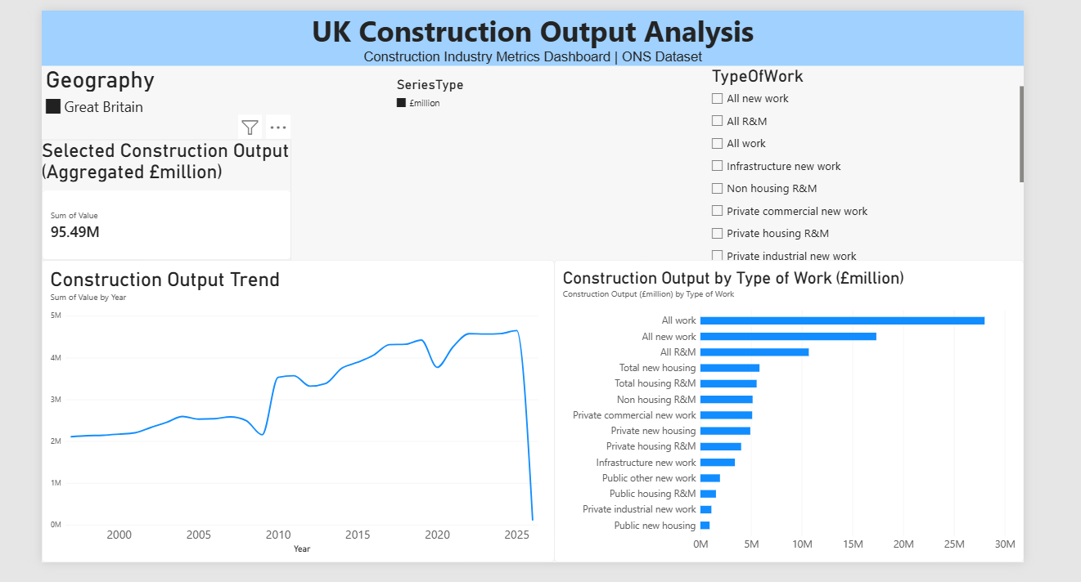

2. Imported Dataset in Power Query
Figure 2: Imported ONS Construction Dataset
Description: This screenshot shows the original CSV dataset imported into Power Query Editor. It displays the dataset columns and sample records before and during the data preparation process.
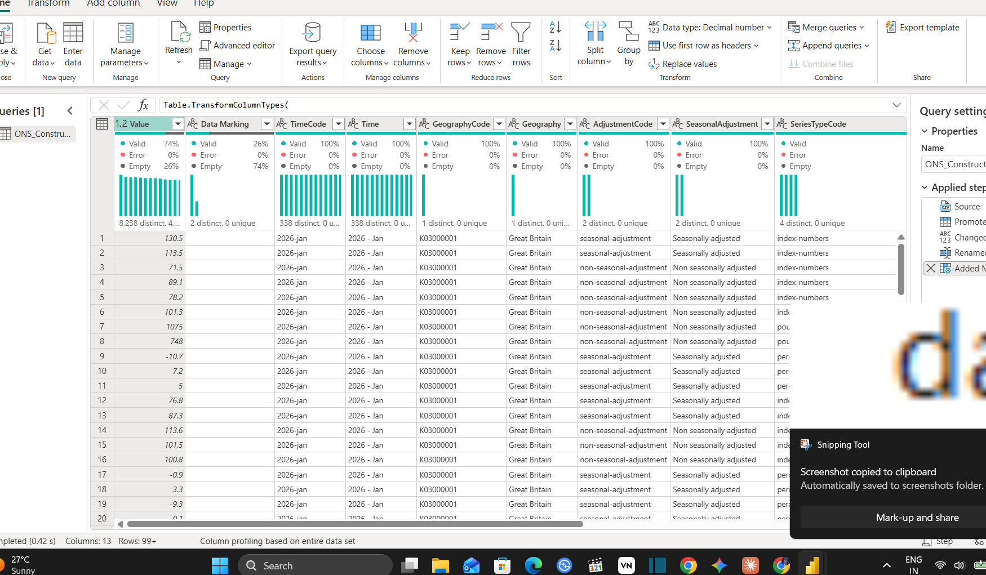

3. Data Quality Assessment
Figure 3: Column Quality Analysis in Power Query
Description: This screenshot shows the Column Quality results used to examine valid values, empty values, and errors in the dataset. It demonstrates the assessment of missing values in important fields such as Value and Data Marking.
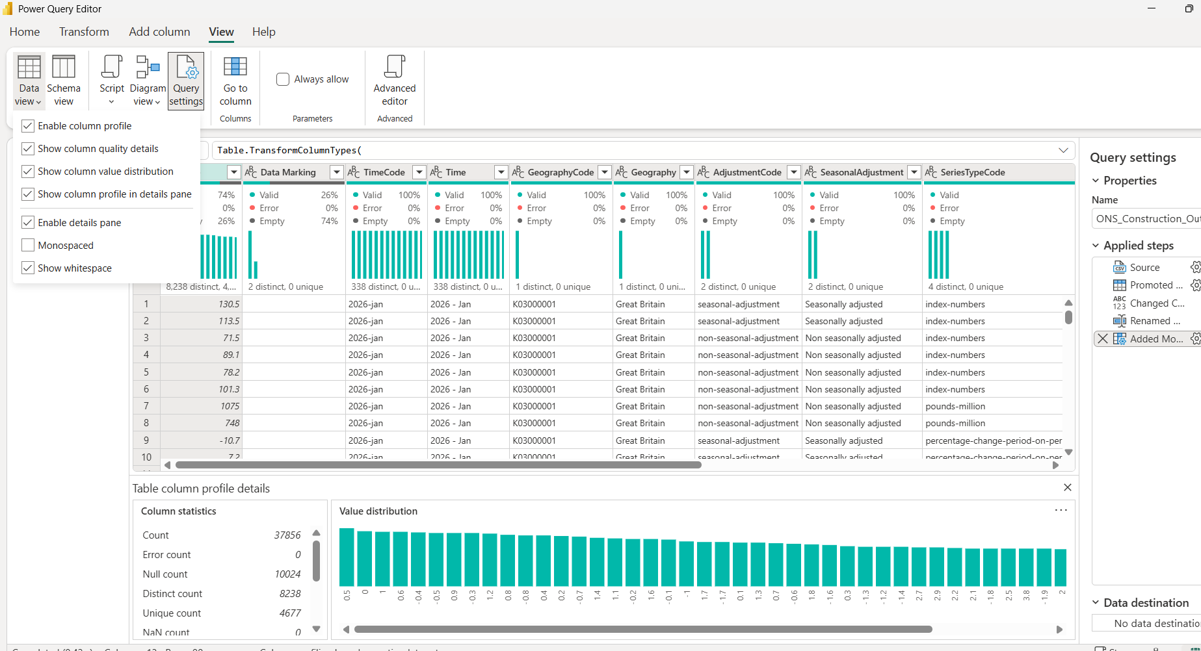

4. Data Cleaning and Transformation
Figure 4: Renamed Columns and MonthDate Transformation
Description: This screenshot shows the transformed dataset in Power Query Editor. It displays the descriptive fields, construction work categories, SeriesType information, newly created MonthDate column, and Applied Steps used during the transformation process.
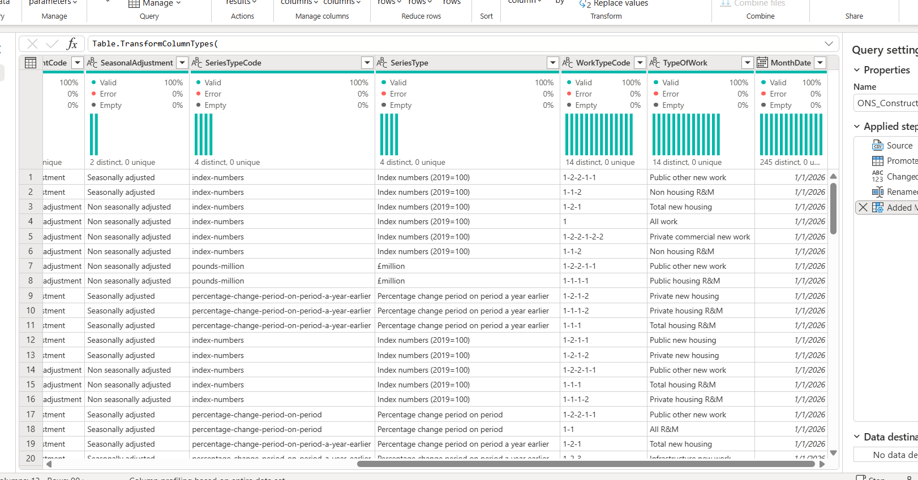

5. Dashboard Visualizations and Interactive Filters
Figure 5: Construction Output Charts and Slicers
Description: This screenshot provides additional evidence of the report visuals and interactive filtering features developed in Power BI. It demonstrates how users can explore construction output information using different measurement categories, geographical selections, and construction work types.
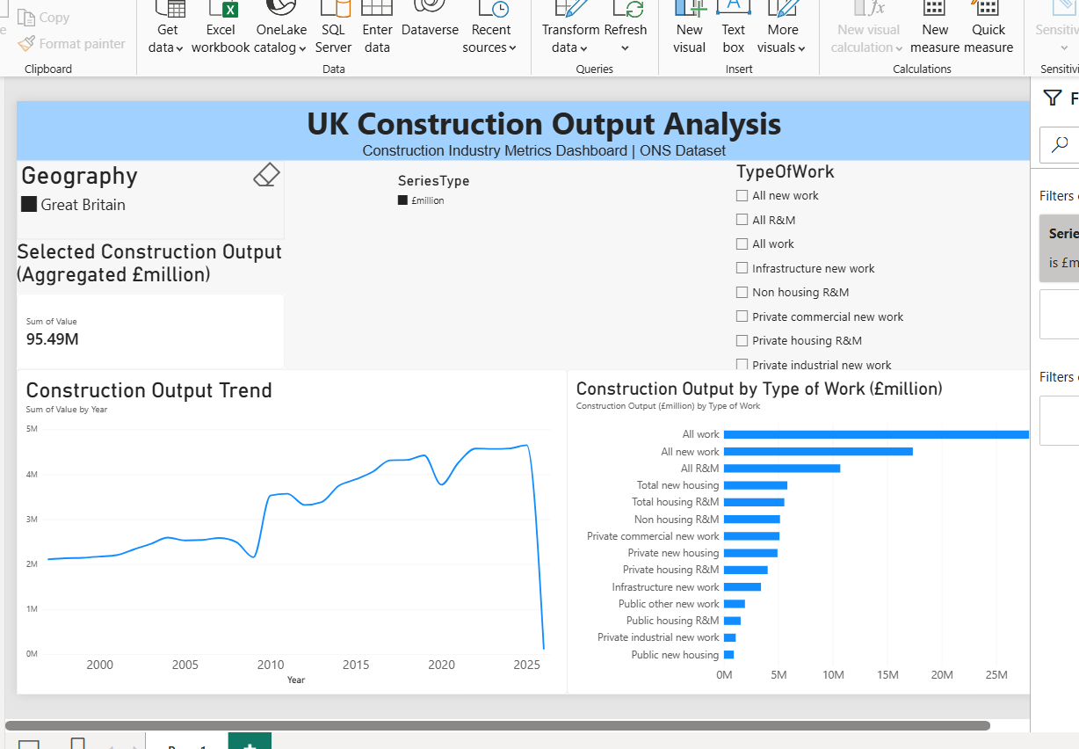

6. Appendix Summary
The screenshots included in this appendix demonstrate the practical implementation of the project, beginning with the import of the original ONS dataset and continuing through data quality assessment, data transformation, and dashboard development.
These screenshots support the methodology and results discussed in the report and provide evidence of the work completed during the internship project.

