INTERNSHIP TECHNICAL REPORT

Data Collection, Cleaning, and Preprocessing for Logistics Analysis

2. Executive Summary
This report presents the practical implementation of a data preprocessing workflow for logistics-oriented analysis. The project focuses on collecting, inspecting, cleaning, and transforming raw transactional data into a structured dataset that can be used for further analytical activities and business decision-making.
The project uses the Online Retail dataset obtained from the UCI Machine Learning Repository. The original dataset contains 541,909 transaction records and eight columns, including invoice numbers, product codes, product descriptions, quantities, invoice dates, unit prices, customer IDs, and country information.
Python was selected as the primary programming language, with Pandas and NumPy used for data manipulation and analysis. Scikit-learn was used to perform Min-Max normalization, while Visual Studio Code served as the development environment.
The preprocessing activities included dataset inspection, missing value identification, duplicate removal, identification of cancelled invoices, separation of potential product returns, investigation of invalid prices, and outlier detection using the Interquartile Range (IQR) method. Min-Max scaling was applied to the Quantity and UnitPrice columns to create normalized features while preserving the original values.
After preprocessing, the final dataset contained 524,878 records and 13 columns. Validation confirmed that duplicate records and missing product descriptions had been eliminated. However, missing CustomerID values were retained because these transactions can still be useful for sales-level analysis.
The report also examines how properly prepared data can support future logistics applications such as demand forecasting, regression analysis, clustering, inventory planning, and resource optimization. Overall, the project demonstrates the importance of systematic data preprocessing in improving data quality and preparing information for reliable analytical use.

3. Project Overview
Data preprocessing is an important stage in data analytics because raw datasets often contain missing values, duplicate records, inconsistent information, invalid entries, and unusual observations. If these issues are not handled properly, they can affect the accuracy of analysis and lead to unreliable business decisions.
This project, titled "Data Collection, Cleaning, and Preprocessing for Logistics Analysis," demonstrates a practical approach to preparing transactional data for logistics-oriented analytical applications.
The project uses the Online Retail dataset from the UCI Machine Learning Repository. Although the dataset represents online retail transactions rather than direct transportation or shipment records, its information about products, quantities, invoices, dates, and countries provides a useful foundation for demonstrating logistics-related data preparation.
The work was implemented using Python. The dataset was imported into a Pandas DataFrame and examined to understand its structure and quality. Different preprocessing techniques were then applied to identify and handle data quality issues.
The main activities performed in this project include:
- Collecting and importing the public dataset.
- Examining dataset dimensions, columns, and data types.
- Identifying missing values and duplicate records.
- Investigating cancelled invoices and potential product returns.
- Separating records with invalid or non-positive unit prices.
- Detecting unusual quantity and unit price values using the IQR method.
- Applying Min-Max normalization to selected numerical columns.
- Exporting the processed data into CSV files.
- Performing final validation to check the quality of the cleaned dataset.
The final output is a structured dataset that can be used as a starting point for further analysis. The project also demonstrates how data preprocessing can support future logistics activities such as demand estimation, inventory management, product analysis, and operational planning.

4. Project Objectives
The primary objective of this project is to develop and demonstrate a structured data preprocessing workflow using Python for logistics-oriented data analysis.
The specific objectives are:
- Data Collection: Obtain a publicly available transactional dataset from the UCI Machine Learning Repository for practical analysis.
- Data Inspection: Examine the dataset's structure, dimensions, column names, data types, and overall quality before performing any modifications.
- Missing Value Identification: Identify missing values in important columns and decide how to handle them according to their analytical importance.
- Duplicate Removal: Detect and remove duplicate transaction records to improve data consistency and prevent repeated information from affecting analysis.
- Invalid Data Investigation: Identify cancelled invoices, potential product returns, and records containing zero or negative unit prices.
- Outlier Detection: Apply the Interquartile Range (IQR) technique to identify unusual values in numerical columns such as Quantity and UnitPrice.
- Data Normalization: Apply Min-Max scaling to selected numerical features so that their values are transformed into a common range between 0 and 1.
- Data Export: Save the cleaned dataset and separated exception records into CSV files for future use.
- Data Validation: Verify the final dataset by checking missing values, duplicate records, numerical ranges, and normalized values.
- Logistics Analytics Preparation: Understand how cleaned and normalized data can support future analytical applications such as demand forecasting, inventory planning, clustering, and resource optimization.
The overall goal is to improve the reliability and usability of raw transactional data through systematic preprocessing techniques.

5. Tools and Technologies Used
The project was implemented using Python and supporting data analytics libraries. Each tool was selected according to its role in the data collection, cleaning, transformation, and validation process.

5.1 Python
Python was used as the primary programming language for the project. It provides a simple and flexible environment for data analysis and automation. Python was used to load the dataset, perform preprocessing operations, calculate statistical values, identify unusual records, and export the processed data.

5.2 Pandas
Pandas was the main library used for data manipulation and analysis. It provides DataFrame structures that make working with tabular datasets easier.
In this project, Pandas was used for:
- Importing the Excel dataset.
- Inspecting rows, columns, and data types.
- Identifying missing values.
- Detecting and removing duplicate records.
- Filtering cancelled invoices and potential returns.
- Separating invalid price records.
- Creating additional columns.
- Exporting the results into CSV files.

5.3 NumPy
NumPy was used as a supporting numerical computing library. It provides efficient operations for handling numerical data and performing calculations. It was included in the project environment and used alongside Pandas for numerical data processing.

5.4 Scikit-learn
Scikit-learn was used to implement Min-Max normalization through its MinMaxScaler class. This technique transformed the Quantity and UnitPrice columns into values between 0 and 1. The original columns were preserved so that the normalized values could be compared with the actual transaction values.

5.5 OpenPyXL
OpenPyXL was used as a supporting library for reading the original Excel dataset through Pandas. It enables Python applications to work with Excel .xlsx files.

5.6 Visual Studio Code
Visual Studio Code was selected as the development environment. It was used to write, edit, organize, and execute the Python preprocessing script. Its integrated terminal was also used to view program output and validate the results.

5.7 Microsoft Excel / CSV Format
The original dataset was provided in Excel format (.xlsx). After preprocessing, the resulting datasets were exported in CSV format. CSV files provide a simple and widely supported format for storing and exchanging structured tabular data.

5.8 Technology Selection Summary
Tool / Technology | Purpose in the Project
Python | Main programming language
Pandas | Data loading, cleaning, filtering, and exporting
NumPy | Numerical data operations
Scikit-learn | Min-Max normalization
OpenPyXL | Reading Excel files
Visual Studio Code | Code development and execution
Excel (.xlsx) | Original dataset format
CSV | Storage of processed datasets
The selected technologies are suitable for this project because they are widely used in data analytics, support efficient processing of structured data, and provide the necessary functionality to build a reproducible preprocessing workflow.

6. Dataset Source and Description

6.1 Dataset Source
For this project, the Online Retail dataset was obtained from the UCI Machine Learning Repository, which provides publicly available datasets for research, education, and data analysis.
Dataset Name: Online Retail
Source: UCI Machine Learning Repository
Official Dataset URL: https://archive.ics.uci.edu/dataset/352/online+retail
Original File Name: Online Retail.xlsx
The dataset contains historical transactional information from a UK-based online retail business. It provides details about products purchased, quantities, invoice dates, prices, customers, and countries.

6.2 Dataset Description
The original dataset contains 541,909 transaction records and 8 columns. Each record represents information related to a retail transaction.
The dataset includes the following fields:
Column Name | Description
InvoiceNo | Unique invoice number for each transaction.
StockCode | Product identification code.
Description | Name or description of the product.
Quantity | Number of product units purchased or recorded in a transaction.
InvoiceDate | Date and time when the transaction occurred.
UnitPrice | Price of one product unit.
CustomerID | Identification number of the customer.
Country | Country associated with the customer transaction.

6.3 Relevance to Logistics Analysis
Although the selected dataset is based on retail transactions rather than direct transportation or shipment records, it contains information that can be useful for demonstrating logistics-oriented data preparation.
For example, quantity and product information can support future demand analysis, invoice dates can help identify purchasing patterns, and country information can provide a geographical dimension for sales analysis.
The dataset can therefore be used as a practical example of preparing transactional information for future applications such as inventory planning, demand forecasting, and product movement analysis.

6.4 Dataset Characteristics
The initial dataset characteristics were:
- Total records: 541,909
- Total columns: 8
- File format: Excel (.xlsx)
- Data type: Structured transactional data
- Source: UCI Machine Learning Repository
- Time period: 1 December 2010 to 9 December 2011
This dataset provided a suitable foundation for implementing and testing different data preprocessing techniques.

7. Data Collection and Import Process
The first stage of the project involved obtaining the dataset from the UCI Machine Learning Repository and preparing it for processing in Python.

7.1 Dataset Collection
The Online Retail dataset was downloaded from its official UCI repository page. The original file was available in Excel format with the filename Online Retail.xlsx.
After downloading, the dataset was stored in the project's local data folder to maintain an organized project structure.

7.2 Development Environment Setup
Visual Studio Code was used as the development environment. Python was installed, and the required libraries were prepared before executing the preprocessing script.
The following libraries were used:
- Pandas
- NumPy
- OpenPyXL
- Scikit-learn

7.3 Importing the Dataset
The Pandas library was used to read the Excel file and load its contents into a DataFrame. A DataFrame is a tabular data structure that allows rows and columns to be inspected and manipulated.
The following Python code was used:
import pandas as pd
import numpy as np
import os

BASE_DIR = os.path.dirname(
os.path.dirname(os.path.abspath(__file__))
)

file_path = os.path.join(
BASE_DIR, "data", "Online Retail.xlsx"
)

df = pd.read_excel(file_path)
The code uses the project directory to locate the Excel file. This helps avoid problems caused by different working directories.

7.4 Data Storage and Organization
The project was organized into separate folders for better management:
- data/ – Stores the original Excel dataset.
- output/ – Stores the Python script and generated CSV files.
- screenshots/ – Stores screenshots of the implementation and results.

7.5 Successful Dataset Import
After importing the Excel file, the dataset was successfully loaded into a Pandas DataFrame.
The initial dimensions were:
- Rows: 541,909
- Columns: 8
This confirmed that the dataset was available for further inspection and preprocessing.

8. Initial Data Inspection
Initial data inspection was performed to understand the structure, size, format, and quality of the dataset before applying cleaning techniques.
This step was important because preprocessing decisions should be based on the actual condition of the data.

8.1 Checking the First Few Records
The head() function was used to display the first five records of the dataset.
df.head()
This helped examine the available columns and understand how transaction information was stored.

8.2 Checking Dataset Dimensions
The shape attribute was used to identify the number of rows and columns.
df.shape
Result: (541909, 8)
This indicated that the original dataset contained 541,909 records and 8 columns.

8.3 Checking Column Names
The column names were inspected to understand the available information.
df.columns
The dataset contained InvoiceNo, StockCode, Description, Quantity, InvoiceDate, UnitPrice, CustomerID, and Country.

8.4 Checking Data Types and Structure
The info() function was used to examine the data types and non-null values of each column.
df.info()
This inspection helped identify numerical, text-based, and date-related fields and provided an overview of missing information.

8.5 Identifying Missing Values
The following command was used to calculate missing values in each column:
df.isnull().sum()
The initial results showed:
Column | Missing Values
InvoiceNo | 0
StockCode | 0
Description | 1,454
Quantity | 0
InvoiceDate | 0
UnitPrice | 0
CustomerID | 135,080
Country | 0
The CustomerID column contained a considerable number of missing values, while the Description column also had missing entries.

8.6 Identifying Duplicate Records
Duplicate records were identified using:
df.duplicated().sum()
Result: 5,268 duplicate records.
These records required attention because repeated transactions could affect the accuracy of further analysis.

8.7 Checking the Transaction Date Range
The minimum and maximum invoice dates were examined to understand the time period covered by the dataset.
Starting Date: 1 December 2010
Ending Date: 9 December 2011
The initial inspection provided a clear understanding of the dataset and helped determine the preprocessing activities required in the next stages.

9. Data Quality Issues Identified
After performing the initial inspection, several data quality issues were identified. These issues needed to be investigated before preparing the dataset for further analysis.

9.1 Missing Values
The dataset contained missing values in two important columns:
- Description: 1,454 missing values.
- CustomerID: 135,080 missing values.
Missing product descriptions can make transaction records difficult to interpret. Missing customer IDs can affect customer-specific analysis, although the corresponding transaction information may still be useful for overall sales analysis.

9.2 Duplicate Records
A total of 5,268 duplicate records were identified.
Duplicate records can result in repeated information and may cause transaction quantities or sales values to be counted more than once. Therefore, duplicate records were removed during preprocessing.

9.3 Negative Quantity Records
The investigation identified 10,624 records with negative quantities.
Negative quantities may represent product returns or other adjustment transactions. These records should not automatically be treated as normal sales transactions.

9.4 Cancelled Invoices
A total of 9,288 records were initially identified as cancelled invoices by checking invoice numbers beginning with the letter C.
These records were investigated separately because cancelled transactions should be distinguished from normal completed sales.

9.5 Zero and Negative Unit Prices
The initial dataset contained:
- Zero unit price records: 2,515.
- Negative unit price records: 2.
Such records require investigation because non-positive prices may not be suitable for ordinary sales value calculations.

9.6 Outliers in Numerical Columns
The Interquartile Range (IQR) method was initially applied to Quantity and UnitPrice to identify unusually high or low values.
The initial outlier investigation produced the following results:
Column | Lower Limit | Upper Limit | Outlier Records
Quantity | -12.5 | 23.5 | 58,619
UnitPrice | -3.07 | 8.45 | 39,627
These values indicated that the dataset contained observations outside the normal statistical range.
Outliers were not automatically removed because some unusual quantities or prices may represent genuine business transactions.

9.7 Summary of Identified Data Quality Issues
The inspection revealed missing information, repeated records, cancelled transactions, negative quantities, invalid prices, and unusual numerical values.
These findings demonstrated the need for a structured preprocessing workflow before using the dataset for further analytical activities.

10. Data Cleaning and Preprocessing Methodology
Data cleaning and preprocessing were performed to improve the quality, consistency, and usability of the original dataset.
A step-by-step methodology was followed so that different types of data quality issues could be handled separately.

10.1 Creating a Working Copy
A copy of the original DataFrame was created before making changes.
clean_df = df.copy()
This ensured that the original imported dataset remained unchanged and could be used for comparison if required.

10.2 Removing Duplicate Records
Duplicate records were removed using the Pandas drop_duplicates() function.
clean_df = clean_df.drop_duplicates()
A total of 5,268 duplicate records were removed from the original dataset.

10.3 Separating Cancelled Invoices
Cancelled invoices were identified using invoice numbers beginning with the letter C.
cancelled_df = clean_df[
clean_df["InvoiceNo"].astype(str).str.startswith("C")
].copy()
These records were stored separately in cancelled_df and excluded from the main cleaned dataset.
After duplicate removal, 9,251 cancelled invoice records were separated.

10.4 Separating Potential Returns
Records with negative quantities were identified as potential product returns.
returns_df = clean_df[
clean_df["Quantity"] < 0
].copy()
These records were separated from normal positive-quantity transactions. A total of 1,336 potential return records were identified in this stage.
They were preserved separately rather than permanently deleted because return information may be useful for future business analysis.

10.5 Handling Missing Product Descriptions
Records with missing product descriptions were removed from the main cleaned dataset.
clean_df = clean_df.dropna(
subset=["Description"]
)
After the previous filtering steps, 592 records with missing descriptions were removed from the main dataset.

10.6 Separating Invalid Price Records
Records with zero or negative unit prices were identified and stored separately.
price_exceptions = clean_df[
clean_df["UnitPrice"] <= 0
].copy()

clean_df = clean_df[
clean_df["UnitPrice"] > 0
].copy()
A total of 584 price exception records were separated at this stage.

10.7 Calculating Sales Value
A new column named SalesValue was created by multiplying the transaction quantity by the unit price.
clean_df["SalesValue"] = (
clean_df["Quantity"] * clean_df["UnitPrice"]
)
This additional column provides a calculated transaction value that can support future sales and demand analysis.

10.8 Outlier Identification
After cleaning, the IQR method was applied to Quantity and UnitPrice. Outlier records were identified using statistical limits and marked with additional Boolean columns.
The outliers were flagged rather than deleted to preserve potentially meaningful business information.

10.9 Normalization
Min-Max normalization was applied to the Quantity and UnitPrice columns using Scikit-learn. The original values were retained, and new normalized columns were created.

10.10 Exporting Processed Data
The cleaned dataset and separated records were exported into individual CSV files.
The generated files included:
- cleaned_logistics_data.csv
- potential_returns.csv
- cancelled_invoices.csv
- price_exceptions.csv

10.11 Overall Methodology
The preprocessing workflow followed this sequence:
- Import the original dataset.
- Inspect the data structure and quality.
- Create a working copy.
- Remove duplicate records.
- Separate cancelled invoices.
- Separate potential returns.
- Remove records with missing descriptions.
- Separate non-positive price records.
- Calculate transaction sales values.
- Identify and flag numerical outliers.
- Normalize selected numerical columns.
- Export and validate the processed data.
This methodology helped create a more consistent dataset while preserving important exception records for possible future investigation.

11. Missing Value and Duplicate Handling
Missing values and duplicate records are common data quality problems in real-world datasets. If these issues are not handled properly, they can affect the accuracy of calculations, statistical analysis, and future predictive models.
In this project, missing values and duplicate records were examined using Pandas before applying the cleaning operations.

11.1 Missing Value Identification
The isnull().sum() function was used to calculate the number of missing values in each column.
The initial inspection identified the following missing values:
Column | Initial Missing Values
Description | 1,454
CustomerID | 135,080
All other columns had no missing values.

11.2 Handling Missing Product Descriptions
The Description column contains information about the products involved in transactions. Records without product descriptions may be difficult to interpret during product-level analysis.
Therefore, records with missing descriptions were removed from the main cleaned dataset using the following command:
clean_df = clean_df.dropna(
subset=["Description"]
)
After duplicate removal and the earlier transaction filtering steps, 592 records with missing descriptions were removed at this stage.

11.3 Handling Missing Customer IDs
The CustomerID column initially contained 135,080 missing values. After preprocessing, 132,186 missing CustomerID values remained in the final dataset.
These values were intentionally retained rather than deleting the entire transaction records.
The reason is that a transaction without a customer ID may still contain useful information about the product, quantity, invoice date, price, and country. Such records can contribute to overall sales-level analysis.
However, these records cannot directly support reliable customer-specific analysis without additional treatment.

11.4 Duplicate Record Removal
Duplicate records were identified using:
df.duplicated().sum()
The original dataset contained 5,268 duplicate records.
The duplicates were removed using:
clean_df = clean_df.drop_duplicates()
This operation ensured that repeated rows were not included in the main cleaned dataset.

11.5 Final Validation
After preprocessing, the final validation confirmed:
- Remaining duplicate records: 0
- Missing Description values: 0
- Missing CustomerID values: 132,186
The missing CustomerID values were retained intentionally, while duplicate records and missing product descriptions were successfully eliminated.
This approach helped improve data quality without unnecessarily discarding useful transaction information.

12. Outlier Detection and Treatment
Outliers are observations that differ significantly from the general distribution of a dataset. They may occur because of data entry errors, unusual business activities, bulk purchases, or exceptional transactions.
In logistics and retail analysis, identifying outliers is important because unusually high quantities or prices can influence demand estimates, sales calculations, inventory planning, and predictive models.

12.1 Selected Method: Interquartile Range (IQR)
The Interquartile Range method was selected to identify unusual values in the numerical columns Quantity and UnitPrice.
IQR is calculated as the difference between the third quartile and the first quartile.
Formula:
[
IQR = Q3 - Q1
]
Where:
- Q1 represents the 25th percentile.
- Q3 represents the 75th percentile.
- IQR represents the middle 50% range of the observations.
The lower and upper limits are calculated as:
[
Lower\ Limit = Q1 - 1.5 \times IQR
]
[
Upper\ Limit = Q3 + 1.5 \times IQR
]
Values outside these limits are identified as potential outliers.

12.2 Initial Outlier Investigation
Before cleaning, the IQR method was applied to the original dataset.
The initial results were:
Column | Lower Limit | Upper Limit | Outlier Count
Quantity | -12.5 | 23.5 | 58,619
UnitPrice | -3.07 | 8.45 | 39,627
These results showed that the original dataset contained a considerable number of observations outside the calculated statistical limits.

12.3 Outlier Detection After Cleaning
After separating cancelled invoices and potential returns and removing non-positive price records, the IQR method was applied again to the cleaned dataset.
The implementation used the following logic:
for column in ["Quantity", "UnitPrice"]:

Q1 = clean_df[column].quantile(0.25)
Q3 = clean_df[column].quantile(0.75)

IQR = Q3 - Q1

lower_limit = Q1 - 1.5 * IQR
upper_limit = Q3 + 1.5 * IQR

flag_column = column + "_Outlier"

clean_df[flag_column] = (
(clean_df[column] < lower_limit) |
(clean_df[column] > upper_limit)
)
The final outlier flagging results were:
Column | Outlier Records
Quantity | 27,111
UnitPrice | 37,827

12.4 Outlier Treatment Strategy
Instead of automatically deleting outliers, the project used Boolean flags to identify them.
Two additional columns were created:
- Quantity_Outlier
- UnitPrice_Outlier
These columns indicate whether a particular observation falls outside the calculated IQR limits.
This approach was selected because unusual transaction values may represent genuine business activities, such as bulk orders or high-value products.
Removing all outliers could result in the loss of important business information.

12.5 Importance for Logistics Analytics
Outlier identification can help analysts investigate unusual purchasing patterns, abnormal quantities, and exceptional prices.
For example, unusually high quantities may indicate bulk demand that could affect inventory requirements. Identifying such transactions can help analysts decide whether additional investigation or special treatment is necessary before demand forecasting and planning.

13. Data Normalization
Data normalization is a preprocessing technique used to transform numerical values into a common scale. It is useful when different numerical features have significantly different ranges.
In this project, Min-Max normalization was applied to the Quantity and UnitPrice columns using the Scikit-learn library.

13.1 Why Normalization Was Required
The Quantity and UnitPrice columns contain values with different numerical ranges. Quantity represents the number of product units, while UnitPrice represents the price of an individual product.
When numerical features have different scales, some machine learning algorithms may be more influenced by features with larger numerical ranges.
Normalization helps place selected features on a comparable scale, making them more suitable for certain downstream analytical techniques.

13.2 Min-Max Scaling Technique
The Min-Max scaling technique transforms numerical values into a specified range, generally between 0 and 1.
The formula is:
[
X_{normalized} =
\frac{X-X_{min}}{X_{max}-X_{min}}
]
Where:
- X represents the original value.
- Xmin represents the minimum value.
- Xmax represents the maximum value.
- Xnormalized represents the transformed value.

13.3 Python Implementation
The Scikit-learn MinMaxScaler class was used to perform normalization.
from sklearn.preprocessing import MinMaxScaler

scaler = MinMaxScaler()

columns_to_scale = ["Quantity", "UnitPrice"]

scaled_values = scaler.fit_transform(
clean_df[columns_to_scale]
)

clean_df["Quantity_Normalized"] = scaled_values[:, 0]

clean_df["UnitPrice_Normalized"] = scaled_values[:, 1]
This code transformed both numerical columns into values between 0 and 1.
The original Quantity and UnitPrice columns were preserved, and two additional normalized columns were created.

13.4 Normalization Results
The final normalized columns had the following ranges:
Normalized Column | Minimum | Maximum
Quantity_Normalized | 0.0 | 1.0
UnitPrice_Normalized | 0.0 | 1.0
The statistical summary also showed that most normalized observations were close to zero.
This occurred because the original data contained highly skewed numerical distributions and some very large values. Min-Max scaling changes the numerical range but does not remove skewness or the influence of extreme observations.

13.5 Importance of Normalization
Normalization can support future analytical techniques such as clustering and distance-based machine learning methods by reducing differences in numerical feature scales.
For example, normalized quantity and price features may be used in future product segmentation or transaction pattern analysis.
For future predictive modelling, the scaler should be fitted using training data only and then applied to validation and test data. This helps prevent data leakage.
Overall, Min-Max normalization successfully created additional scaled features while preserving the original transaction values for comparison and interpretation.

14. Python Implementation and Workflow
The complete preprocessing workflow was implemented using Python in Visual Studio Code. The program was organized into different stages so that the dataset could be inspected, cleaned, transformed, exported, and validated systematically.

14.1 Development Environment
The implementation was performed using the following environment:
- Operating System: Windows 11
- Programming Language: Python
- Code Editor: Visual Studio Code
- Data Processing Library: Pandas
- Numerical Library: NumPy
- Normalization Library: Scikit-learn
- Excel Reading Support: OpenPyXL

14.2 Main Implementation Stages
The Python script was developed to perform the following activities:
Stage 1: Importing Libraries
Pandas and NumPy were imported for data processing, while the required normalization functionality was imported from Scikit-learn.
Stage 2: Loading the Dataset
The Excel dataset was loaded into a Pandas DataFrame using read_excel().
Stage 3: Initial Data Inspection
Functions such as head(), shape, info(), isnull().sum(), and duplicated().sum() were used to understand the dataset structure and identify data quality problems.
Stage 4: Data Cleaning
A working copy was created. Duplicate records were removed, cancelled invoices and potential returns were separated, missing descriptions were removed, and non-positive price records were stored separately.
Stage 5: Feature Creation
A new SalesValue column was calculated by multiplying Quantity by UnitPrice.
Stage 6: Outlier Detection
The IQR method was applied to Quantity and UnitPrice. Additional Boolean columns were created to identify unusual observations.
Stage 7: Normalization
Min-Max scaling was applied to the selected numerical columns, producing Quantity_Normalized and UnitPrice_Normalized.
Stage 8: Data Export
The cleaned dataset and exception records were exported into CSV files.
Stage 9: Final Validation
The final dataset was checked for remaining duplicates, missing values, numerical ranges, normalized values, and overall dimensions.

14.3 Generated Output Files
The Python program generated the following files:
File Name | Purpose
cleaned_logistics_data.csv | Main cleaned and transformed dataset
potential_returns.csv | Separated negative-quantity transaction records
cancelled_invoices.csv | Separated cancelled invoice records
price_exceptions.csv | Separated non-positive price records

14.4 Reproducibility
The preprocessing script and dependency information were organized so that the workflow could be reproduced.
The requirements.txt file lists the Python libraries required to execute the project. The original dataset can be obtained from its official UCI source.
This organization makes it easier for another user to set up the environment, download the source dataset, and execute the preprocessing workflow.

15. Results and Key Findings
After completing the data collection, cleaning, outlier identification, and normalization activities, the final dataset was successfully generated and validated.
The results demonstrate that the preprocessing workflow improved the structure and consistency of the original transactional dataset.

15.1 Original and Final Dataset Comparison
The original dataset contained 541,909 records and 8 columns. After preprocessing and feature creation, the final dataset contained 524,878 records and 13 columns.
Parameter | Original Dataset | Final Dataset
Total Records | 541,909 | 524,878
Total Columns | 8 | 13
Duplicate Records | 5,268 | 0
Missing Descriptions | 1,454 | 0
Missing CustomerIDs | 135,080 | 132,186
Quantity | Original values | Positive values only
UnitPrice | Original values | Positive values only
The final dataset retained approximately 96.86% of the original records.

15.2 Data Cleaning Results
The main cleaning operations produced the following results:
Cleaning Activity | Result
Duplicate records removed | 5,268
Cancelled records separated | 9,251
Potential returns separated | 1,336
Missing descriptions removed at cleaning stage | 592
Non-positive price records separated at cleaning stage | 584
These counts represent the results of sequential cleaning operations. They should not be added together to calculate the total number of removed records because some data quality categories overlap.

15.3 Outlier Detection Results
The IQR method was used to identify unusual numerical values in the cleaned dataset.
Column | Flagged Outliers
Quantity | 27,111
UnitPrice | 37,827
The identified observations were flagged rather than deleted. This preserved potentially important transaction information for further investigation.

15.4 Normalization Results
Min-Max normalization was successfully applied to the Quantity and UnitPrice columns.
Column | Minimum Normalized Value | Maximum Normalized Value
Quantity_Normalized | 0.0 | 1.0
UnitPrice_Normalized | 0.0 | 1.0
The original numerical columns were preserved, allowing comparison between actual and normalized values.

15.5 Final Validation Results
The final validation process confirmed the following:
- Final dataset records: 524,878
- Final dataset columns: 13
- Remaining duplicate records: 0
- Missing Description values: 0
- Missing CustomerID values: 132,186
- Quantity minimum: 1
- Quantity maximum: 80,995
- UnitPrice minimum: 0.001
- UnitPrice maximum: 13,541.33
- Quantity_Normalized range: 0.0 to 1.0
- UnitPrice_Normalized range: 0.0 to 1.0
The remaining missing CustomerID values were retained intentionally because they do not prevent the transactions from being used for certain sales-level analyses.

15.6 Key Findings
The project produced several important findings:
- The original dataset contained multiple data quality issues that required separate investigation and treatment.
- Duplicate removal improved the consistency of the transaction records.
- Separating cancelled invoices and potential returns helped distinguish these transactions from ordinary positive-quantity sales.
- The IQR method identified unusual numerical values without automatically deleting potentially meaningful observations.
- Min-Max scaling successfully transformed the selected numerical columns into a common range.
- The final dataset retained a large proportion of the original records while gaining additional analytical features.
Overall, the project successfully demonstrated a structured preprocessing workflow using Python. The resulting dataset provides a more consistent foundation for future logistics-oriented analysis, demand forecasting, inventory planning, and other data-driven applications.

16. Applications in Logistics Analytics
Data preprocessing plays an important role in logistics analytics because business decisions depend on accurate, consistent, and reliable information. The cleaned dataset developed in this project can serve as a foundation for several future analytical applications.
Although the current project focuses on data collection and preprocessing, the resulting dataset can support further analysis in areas such as demand forecasting, inventory planning, product segmentation, and operational optimization.

16.1 Demand Forecasting Using Regression
Demand forecasting involves estimating future product requirements based on historical information.
The cleaned dataset contains transaction quantities and invoice dates, which can be aggregated to study purchasing patterns over time.
Regression techniques could be applied in a future phase to estimate product demand using relevant features such as historical quantities, transaction dates, and product information.
For example, a business could use historical purchasing patterns to estimate the quantity of products likely to be required in an upcoming period. These estimates could help improve stock availability and reduce unnecessary inventory.

16.2 Product and Customer Segmentation Using Clustering
Clustering is an unsupervised machine learning technique used to group similar observations based on selected characteristics.
The dataset contains product codes, quantities, prices, customer IDs, and country information. These fields could be used to develop future segmentation models.
For example:
- Products could be grouped according to purchasing volume and transaction value.
- Customers with available customer IDs could be grouped according to purchasing behaviour.
- Countries could be compared according to transaction volume and sales patterns.
Algorithms such as K-Means clustering could be explored for these applications after suitable feature selection and treatment of missing customer information.

16.3 Inventory Planning and Optimization
Inventory planning involves maintaining appropriate stock levels to meet customer demand while controlling storage and purchasing costs.
The cleaned transaction data could support future inventory analysis by providing information about product quantities and historical purchasing activity.
Optimization techniques could be used in a future phase to determine suitable inventory levels under business constraints such as storage capacity, expected demand, purchasing costs, and stock availability.
For example, a business could develop an optimization model to balance the cost of holding excess inventory against the risk of running out of products.

16.4 Sales and Transaction Analysis
The calculated SalesValue column provides transaction-level value information.
This can be used to examine product performance, compare transaction values, and identify important sales patterns.
Such analysis may help businesses understand which products contribute more to overall transaction value and which product categories require additional attention.

16.5 Geographical Analysis
The Country column provides a geographical dimension for transaction analysis.
In a future analytical phase, transactions could be grouped by country to compare purchasing activity across different geographical markets.
This information could help support market analysis and preliminary distribution planning. However, actual transportation route optimization would require additional information such as delivery locations, shipment distances, transport costs, and delivery times.

16.6 Overall Importance
These applications demonstrate how a properly prepared dataset can support more advanced analytical activities.
The current project provides the preprocessing foundation, while regression, clustering, forecasting, and optimization can be implemented as separate future stages using appropriate additional features and business information.

17. Data Quality Impact on Business Decisions
Data quality has a direct influence on the reliability of business analysis and decision-making. In logistics and retail operations, incorrect or incomplete information can affect demand estimates, inventory planning, sales analysis, and resource allocation.
The preprocessing activities performed in this project demonstrate how different data quality problems can influence analytical outcomes.

17.1 Impact of Missing Values
Missing product descriptions can make it difficult to identify and analyze products correctly.
Missing customer IDs can limit customer-specific analysis and segmentation. However, transaction records without customer IDs may still provide useful information for overall sales analysis.
Proper handling of missing values helps preserve useful records while reducing problems during future analysis.

17.2 Impact of Duplicate Records
Duplicate transactions can result in repeated counting of quantities and sales values.
For example, if the same transaction is included more than once, the calculated product demand may appear higher than the actual demand.
Removing duplicate records helps improve the consistency of transaction-level calculations.

17.3 Impact of Cancelled Transactions and Returns
Cancelled invoices and potential returns should be distinguished from normal sales transactions.
If these records are treated as ordinary positive sales, they may produce misleading demand calculations.
Separating them allows analysts to examine sales, cancellations, and returns independently.

17.4 Impact of Invalid Prices
Zero or negative unit prices may affect transaction value calculations and statistical summaries.
Separating these records helps prevent unsuitable price values from being included in ordinary positive-price sales analysis.

17.5 Impact of Outliers
Unusually high quantities or prices can influence averages, statistical models, and forecasting results.
Identifying and flagging outliers helps analysts investigate exceptional transactions before deciding whether they should be retained, transformed, or excluded for a particular analytical purpose.

17.6 Impact of Normalization
Numerical features with different scales can influence certain machine learning algorithms differently.
Normalization transforms selected numerical columns into a common range, which can improve the suitability of the data for future distance-based and scale-sensitive analytical methods.

17.7 Business Value of Data Preprocessing
The preprocessing workflow can support better business decisions by:
- Improving the consistency of transaction records.
- Reducing the risk of duplicate counting.
- Separating exceptional transactions for investigation.
- Making numerical features more suitable for selected analytical methods.
- Preparing structured data for future demand and inventory analysis.
Overall, reliable data preprocessing provides a stronger foundation for business intelligence and data-driven decision-making.

18. Limitations and Challenges
Although the preprocessing workflow was successfully implemented, some limitations and challenges were identified during the project.

18.1 Dataset Limitations
The Online Retail dataset mainly contains retail transaction information. It does not directly provide important logistics details such as delivery routes, shipment distances, warehouse locations, transportation costs, vehicle information, or delivery times.
Therefore, the dataset is suitable for demonstrating logistics-oriented transactional data preprocessing but is not sufficient by itself for complete transportation or supply chain optimization.

18.2 Missing Customer Information
A significant number of records contain missing CustomerID values.
These records were retained because their transaction details remain useful for sales-level analysis. However, missing customer identifiers limit the reliability of customer-level segmentation and purchasing behaviour analysis.

18.3 Outlier Handling
The IQR method identifies unusual observations based on statistical limits. However, it cannot automatically determine whether an observation is an error or a genuine business transaction.
For example, a very large quantity may represent a valid bulk purchase.
Therefore, the project flags outliers rather than deleting them. Additional business investigation would be necessary before making final treatment decisions.

18.4 Skewed Numerical Data
The original Quantity and UnitPrice distributions contain highly unusual and widely varying values.
Although Min-Max scaling transforms the values into a range between 0 and 1, it does not remove skewness. As a result, many normalized values are concentrated near zero.
Other scaling or transformation techniques may be more suitable for certain future analytical models.

18.5 Limited Analytical Modelling
The project focuses on data collection, cleaning, outlier identification, normalization, and validation.
Regression models, clustering algorithms, demand forecasting models, and optimization techniques were not implemented as part of the current preprocessing workflow.
These methods would require separate modelling stages, suitable feature selection, and additional validation.

18.6 Lack of Real-Time Data
The project uses a historical dataset covering December 2010 to December 2011.
It does not include real-time inventory updates, current customer orders, or live shipment information.
Therefore, the results demonstrate a historical preprocessing workflow rather than a live logistics monitoring system.

18.7 Data Processing Considerations
The cleaned dataset contains more than half a million records. Exporting and managing large CSV files can require considerable storage space and may create upload difficulties on platforms such as GitHub.
For larger projects, more efficient storage formats and database systems could be considered.
Despite these limitations, the project successfully demonstrates the essential preprocessing techniques required to improve the quality and usability of structured transactional data.

19. Recommendations and Future Improvements
Based on the results and limitations of the current project, several improvements can be considered to make the preprocessing workflow more advanced, efficient, and suitable for practical business applications.

19.1 Use of More Complete Logistics Datasets
Future work could include additional logistics-related information such as shipment records, delivery dates, warehouse locations, transportation costs, and stock levels.
Combining transaction information with actual logistics data would provide a stronger foundation for supply chain and distribution analysis.

19.2 Improved Missing Value Treatment
Missing CustomerID values could be investigated further using additional transaction information.
For example, customer-level analysis could be restricted to records with valid customer IDs, while sales-level analysis could continue using the full suitable transaction dataset.
Any imputation method should be selected carefully and should not create artificial customer identities.

19.3 Advanced Outlier Treatment
Future improvements could compare the IQR method with other statistical and machine learning techniques.
Possible methods include:
- Z-score analysis.
- Modified Z-score using the median absolute deviation.
- Isolation Forest for identifying unusual observations.
These techniques could help investigate complex outlier patterns. Business context should still be considered before removing or changing any unusual transaction.

19.4 Improved Normalization Techniques
Since the numerical features contain skewed distributions, future work could evaluate alternative scaling and transformation methods.
Possible techniques include:
- RobustScaler, which uses median and interquartile range.
- StandardScaler, which standardizes values using mean and standard deviation.
- Logarithmic transformation for suitable positively skewed numerical features.
The most appropriate method should be selected according to the requirements of the future analytical model.

19.5 Regression-Based Demand Forecasting
A future phase could use regression techniques to estimate product demand based on historical transaction quantities and time-related features.
Possible improvements include creating daily or weekly product demand summaries and comparing different forecasting approaches using suitable evaluation metrics such as MAE and RMSE.

19.6 Clustering-Based Product Segmentation
Clustering algorithms such as K-Means could be applied to group products based on purchasing volume, transaction frequency, and sales value.
This could help identify high-demand products, low-demand products, and products with similar purchasing patterns.
Customer segmentation could also be explored using records with valid customer IDs.

19.7 Inventory and Resource Optimization
Optimization models could be developed to support inventory planning and resource allocation.
Future models could consider demand estimates, storage limits, purchasing costs, and stock availability to identify suitable inventory decisions.
Actual transportation optimization would additionally require route, distance, vehicle capacity, and delivery cost information.

19.8 Automated Data Validation
The preprocessing script could be extended with automated validation checks to detect unexpected data changes.
For example, checks could be added for missing required columns, invalid dates, negative quantities, non-positive prices, and duplicate records.
This would make the pipeline more reliable when processing new datasets.

19.9 Database Integration
For larger datasets, the preprocessing workflow could be integrated with a relational database such as MySQL.
This would support structured storage, querying, and management of larger transaction datasets.

19.10 Interactive Reporting and Visualization
A future version could include a Power BI dashboard to display transaction trends, product performance, country-wise sales, and data quality indicators.
Interactive reports could help business users understand the results without directly examining Python output.
These improvements would extend the current preprocessing workflow into a more comprehensive analytics solution for logistics and business planning.

20. Conclusion
The project titled "Data Collection, Cleaning, and Preprocessing for Logistics Analysis" successfully demonstrated a structured approach to preparing raw transactional data for further analytical use.
The Online Retail dataset from the UCI Machine Learning Repository was used to perform practical data preprocessing activities using Python. Pandas, NumPy, and Scikit-learn supported the different stages of data inspection, cleaning, transformation, and validation.
During the project, the original dataset of 541,909 records and 8 columns was examined for missing values, duplicate records, cancelled invoices, potential returns, invalid prices, and unusual numerical observations.
Several preprocessing techniques were successfully implemented. Duplicate records were removed, cancelled invoices and potential returns were separated, missing product descriptions were handled, and non-positive price records were stored separately. The IQR method was used to identify unusual values in Quantity and UnitPrice, while Min-Max normalization was applied to create additional scaled numerical features.
The final processed dataset contained 524,878 records and 13 columns. Validation confirmed that no duplicate records or missing product descriptions remained. Missing CustomerID values were retained intentionally because the associated transactions could still be useful for sales-level analysis.
The project also highlighted the importance of data quality in business decision-making. Proper preprocessing can reduce the risk of inaccurate calculations, improve data consistency, and prepare information for future analytical activities.
Although regression, clustering, forecasting, and optimization were not implemented in the current assignment, the prepared dataset provides a starting point for exploring these techniques in future work.
Overall, this internship assignment provided practical experience in Python-based data preprocessing and demonstrated how structured data preparation can support reliable analysis and logistics-oriented business applications.

21. References
The following sources and technical documentation were referred to during the completion of this project.

21.1 Dataset Reference
- UCI Machine Learning Repository. (2015). Online Retail Dataset. University of California, Irvine.
https://archive.ics.uci.edu/dataset/352/online+retail

21.2 Python and Library Documentation
- Python Software Foundation. Python Documentation.
https://docs.python.org/3/
- Pandas Development Team. Pandas Documentation.
https://pandas.pydata.org/docs/
- NumPy Developers. NumPy Documentation.
https://numpy.org/doc/
- Scikit-learn Developers. MinMaxScaler Documentation.
https://scikit-learn.org/stable/modules/generated/sklearn.preprocessing.MinMaxScaler.html
- OpenPyXL Documentation. Reading and Writing Excel Files.
https://openpyxl.readthedocs.io/

21.3 Development Tool Reference
- Microsoft. Visual Studio Code Documentation.
https://code.visualstudio.com/docs/
These references were used to understand the dataset, Python programming concepts, data manipulation functions, numerical operations, normalization techniques, and the development environment used in this project.

22. Appendix A: Implementation Screenshots
This appendix contains screenshots captured during the practical implementation of the data preprocessing workflow. These screenshots provide visual evidence of dataset collection, inspection, cleaning, normalization, validation, and generated output files.

Figure 1: Initial Dataset Inspection
This screenshot shows the initial dataset inspection in Python, including the dataset dimensions, first few records, column names, and general structure.
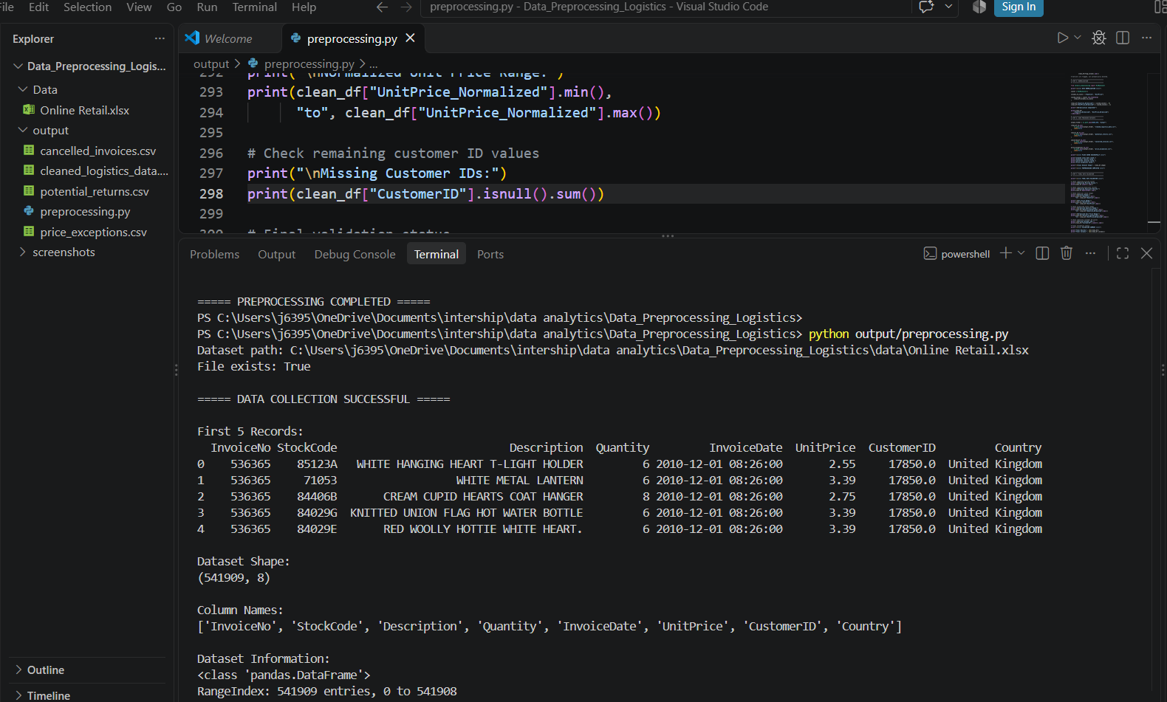

Figure 2: Missing Values and Duplicate Records
This screenshot displays the missing value counts and duplicate record count identified during the initial data quality assessment.
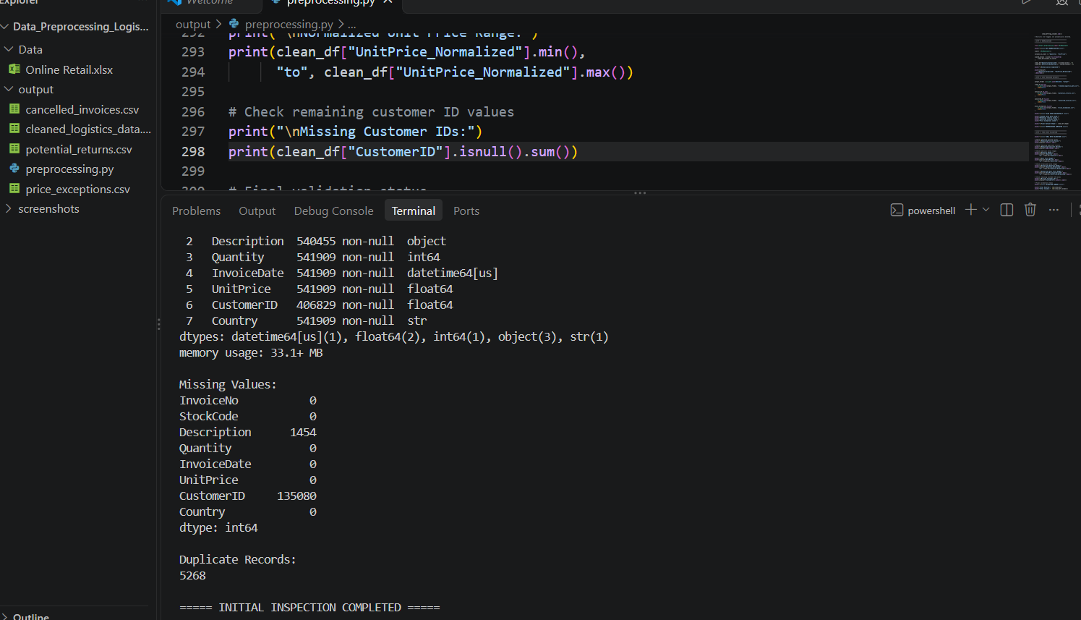

Figure 3: Data Investigation and Outlier Detection
This screenshot shows the investigation of negative quantities, cancelled invoices, invalid prices, and initial IQR outlier detection results.
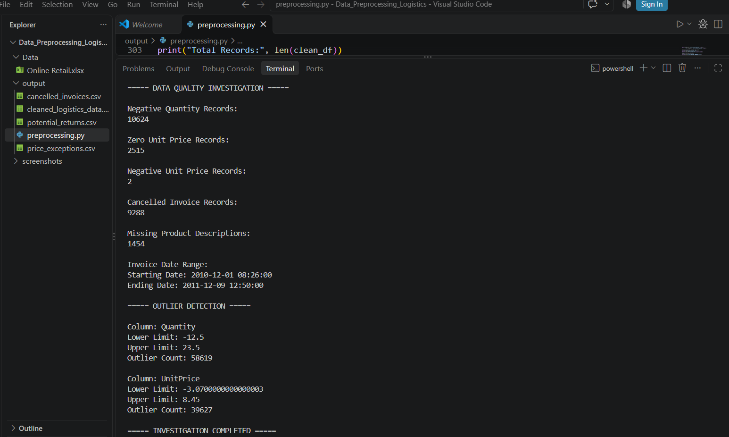

Figure 4: Data Cleaning Process
This screenshot demonstrates the Python cleaning operations, including duplicate removal and separation of cancelled invoices, potential returns, missing descriptions, and price exceptions.
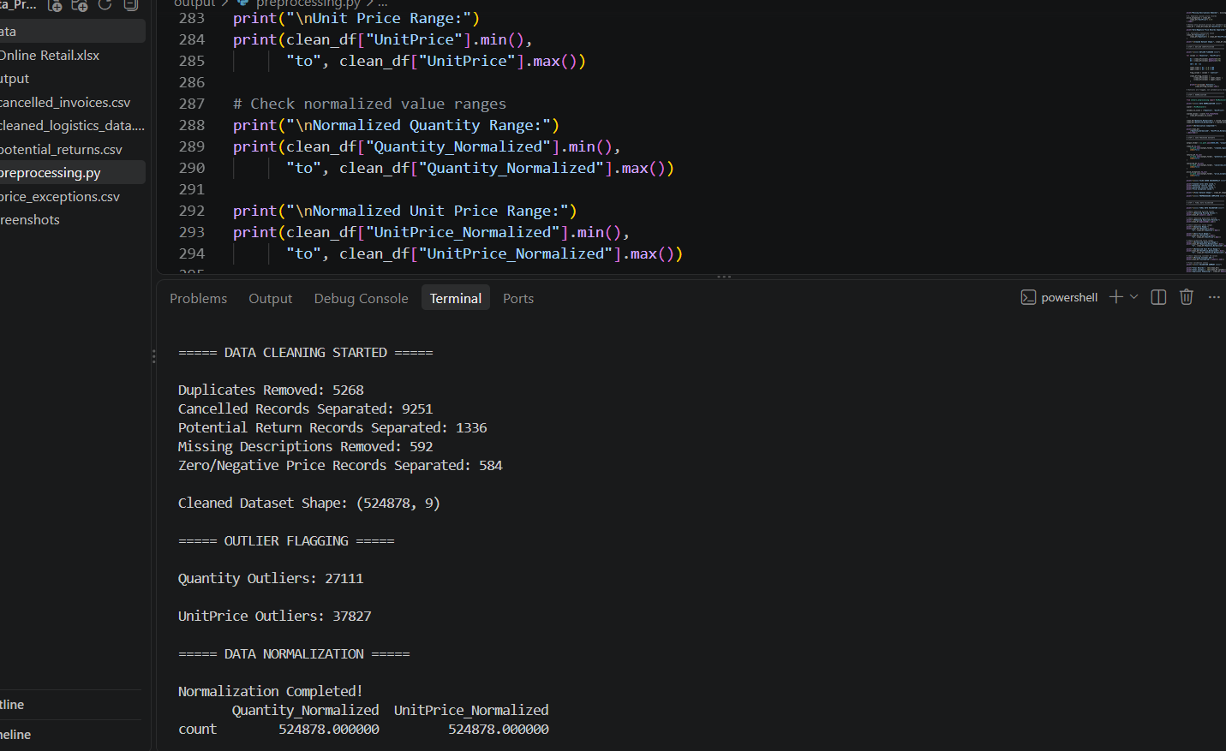

Figure 5: Data Normalization
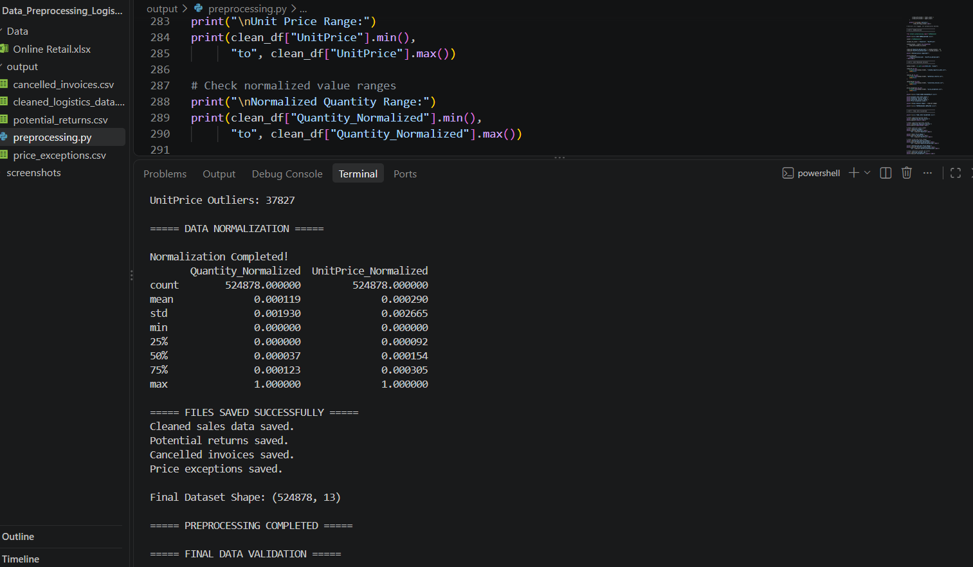
This screenshot displays the Min-Max normalization implementation and the resulting normalized numerical columns.

Figure 6: Final Data Validation
This screenshot presents the final validation results, including the final dataset dimensions, remaining duplicates, missing values, and normalized value ranges.
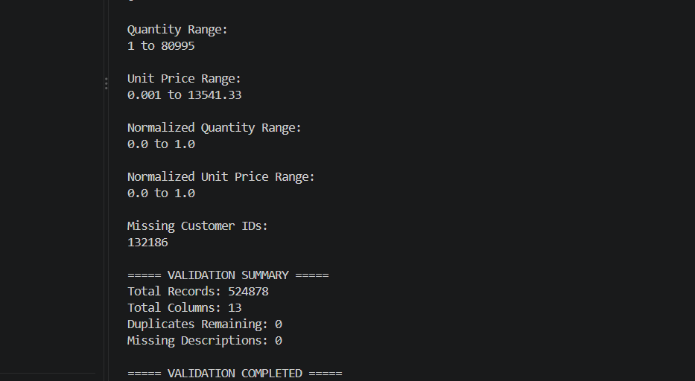

Figure 7: Generated Output Files
This screenshot shows the project output folder containing the Python preprocessing script and the generated CSV files.
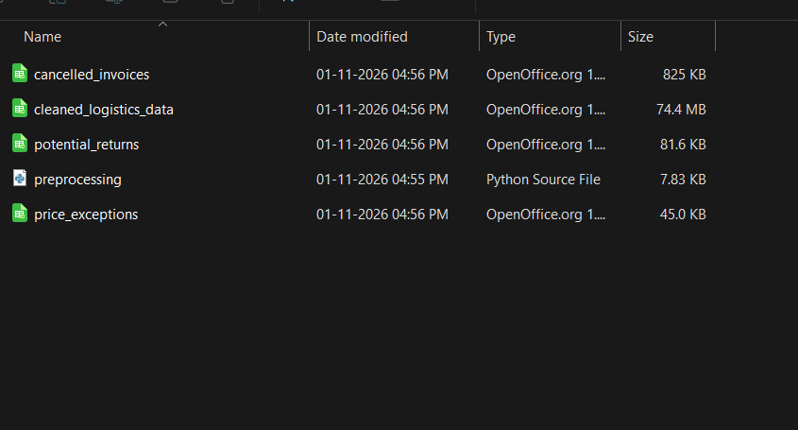
These screenshots demonstrate the practical execution of the preprocessing workflow and support the results discussed in the report.

23. Appendix B: Python Source Code
This appendix contains the Python source code developed for the data collection, cleaning, and preprocessing activities performed in this project.
The program uses Pandas, NumPy, and Scikit-learn to load the original Excel dataset, inspect data quality, remove duplicate records, separate exceptional transactions, calculate sales values, identify outliers, perform normalization, export processed files, and validate the final dataset.
The source code is maintained in the project repository under the filename:
preprocessing.py
The program generates the following output files:
- cleaned_logistics_data.csv
- potential_returns.csv
- cancelled_invoices.csv
- price_exceptions.csv

23.1 Complete Python Program
The complete executable source code is included below as the main implementation of the project.
[Insert the complete contents of preprocessing.py here.]

23.2 Required Python Libraries
The project uses the following libraries:
- pandas
- numpy
- openpyxl
- scikit-learn
These dependencies are listed in the project's requirements.txt file.

23.3 Execution Instructions
To execute the preprocessing program:
- Install Python and the required libraries.
- Download the Online Retail dataset from the official UCI Machine Learning Repository.
- Place Online Retail.xlsx inside the data folder.
- Open the project folder in Visual Studio Code.
- Open the integrated terminal.
- Execute the following command:
python output/preprocessing.py
After successful execution, the processed CSV files will be generated in the output folder.

