Strategic Planning and Data Exploration in Logistics
A practical study using online retail transaction data
Academic project report
Tools: Python, pandas, NumPy, Matplotlib and VS Code
Dataset: UCI Online Retail

Abstract
This project investigates how historical retail transactions can inform demand-oriented logistics planning. The UCI Online Retail dataset was examined and cleaned by removing exact duplicate rows and excluding cancellation invoices, non-positive quantities, and non-positive prices from the demand-focused analysis. The resulting dataset contained 524,878 transaction lines, 5,572,420 units, 19,960 unique invoices, and £10,642,110.80 in line-level sales value. The analysis calculated KPIs, explored daily and weekday patterns, ranked countries and products, identified high-demand days, and tested a seven-day moving-average forecast. The UK accounted for 84.59% of country sales value. On a chronological test period, the baseline forecast achieved MAE 29.54 orders and RMSE 37.70 orders. These findings can support demand and inventory planning, but the dataset lacks delivery times, routes, vehicle capacities, and warehouse staffing data, so delivery performance and route optimization cannot be directly measured.

1. Introduction
Logistics decisions require matching stock, labour, and fulfilment capacity to customer demand. Data exploration helps reveal patterns, while forecasting estimates future activity. This project demonstrates an end-to-end Python workflow using real historical transactions.

1.1 Objectives
- Inspect a public dataset and assess data quality.
- Clean transaction records for demand analysis.
- Calculate at least three relevant KPIs.
- Explore demand by date, weekday, country, and product.
- Build and evaluate a baseline daily-order forecast.
- Explain regression, clustering, and optimization and identify data needed for future extensions.

2. Dataset and Business Scenario
The UCI Online Retail dataset contains invoice number, stock code, description, quantity, invoice date, unit price, customer ID, and country. The original file contained 541,909 rows and eight columns. The analyzed dates span 1 December 2010 to 9 December 2011. The scenario is a retail operations team using transaction history to plan demand, inventory, and fulfilment resources. Since this is a sales transaction dataset rather than a delivery-log dataset, the project evaluates demand signals rather than actual delivery service levels.
Field | Meaning | Possible planning use
InvoiceNo | Invoice identifier; C-prefixed values indicate cancellations | Count invoices and flag cancellations
StockCode / Description | Product identifier and name | Product mix and inventory planning
Quantity | Units on transaction line | Unit demand
InvoiceDate | Transaction timestamp | Daily and weekday trends
UnitPrice | Price per unit | Line-level sales value
CustomerID | Customer identifier; some values missing | Possible later customer analysis
Country | Country associated with transaction | Market-level demand analysis

3. Methodology

3.1 Tools and workflow
Python was run in VS Code. pandas handled tabular processing, NumPy supported numerical calculations, and Matplotlib created charts. The workflow was: load data, inspect columns and missing values, remove duplicates, flag cancellations, filter demand records, calculate line-level sales, summarize demand, visualize results, forecast order counts, evaluate errors, and develop recommendations.

3.2 Data quality and cleaning
Check | Observed result | Treatment / interpretation
Original rows | 541,909 | Loaded source dataset
Exact duplicates | 5,268 | Removed
Rows after deduplication | 536,641 | Base for filtering
Cancellation invoice rows | 9,288 | Flagged and excluded from demand data
Zero/negative quantities | 10,624 | Excluded from demand dataset
Zero/negative prices | 2,517 | Excluded from demand dataset
Missing Description | 1,454 | Not used as an exclusion rule
Missing CustomerID | 135,080 | Retained for overall demand analysis
Final demand rows | 524,878 | Positive quantities and prices, excluding cancellations, after deduplication

Line-level sales value was calculated as Quantity × UnitPrice. These rules produce a practical dataset for gross demand exploration, but do not constitute a full accounting reconciliation. Returns, postage entries, and unusual records may require further business rules before operational use.

4. Key Performance Indicators
KPI | Result | Interpretation
Unique invoices | 19,960 | Distinct invoice identifiers in the demand dataset
Units sold | 5,572,420 | Sum of retained positive quantities
Sales value | £10,642,110.80 | Sum of Quantity × UnitPrice
Average daily orders | 65.44 | Mean across the daily calendar series used
Average daily sales | £34,892.17 | Mean daily line-level sales value
Peak daily orders | 142 | Maximum observed daily invoice count
90th percentile threshold | 102.60 orders | Boundary used to flag high-demand days
High-demand days | 31 | Days at or above that threshold
UK share of country sales | 84.59% | UK sales divided by sales across countries

These are demand and sales KPIs, not delivery reliability, delivery cost, vehicle utilization, or warehouse productivity KPIs. Those require operational data.

5. Exploratory Data Analysis

5.1 Daily and weekday demand
The busiest day by order count was 2 December 2010: 142 orders, 31,264 units, and £47,629.42 sales value. The day with the highest quantity was 9 December 2011: 93,949 units, 44 orders, and £200,900.98 sales value. Thus, the day with most orders was not the day with the most units.
Weekday | Unique orders | Units
Monday | 3,126 | 871,148
Tuesday | 3,554 | 1,113,087
Wednesday | 3,690 | 1,025,093
Thursday | 4,246 | 1,207,384
Friday | 3,140 | 890,199
Saturday | No rows in original weekday grouping | No rows in original weekday grouping
Sunday | 2,204 | 465,509

Thursday had the highest recorded order count (4,246), followed by Wednesday (3,690) and Tuesday (3,554). Saturday appears as NaN in the weekday table because the original transaction grouping had no Saturday rows; the NaN should not itself be interpreted as a measured zero.

5.2 High-demand days
The 90th percentile threshold was 102.60 orders, and 31 days met or exceeded it. The busiest day had 142 orders. These peaks can be used as a signal to review staffing, picking, packing, and dispatch plans. They do not prove that capacity shortages or delays occurred.
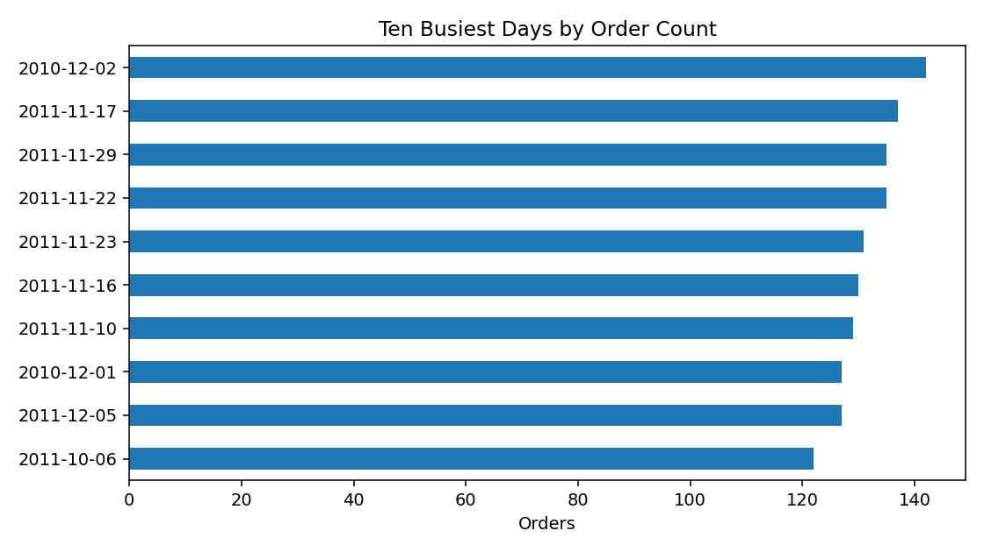

5.3 Country-level sales
The UK recorded £9,001,744.09 in sales value, 18,019 invoices, and 4,646,906 units. It represented 84.59% of total country sales value. The next markets by sales value were the Netherlands (£285,446.34), EIRE (£283,140.52), Germany (£228,678.40), and France (£209,625.37). The concentration supports close monitoring of UK demand while maintaining appropriate planning for international markets.
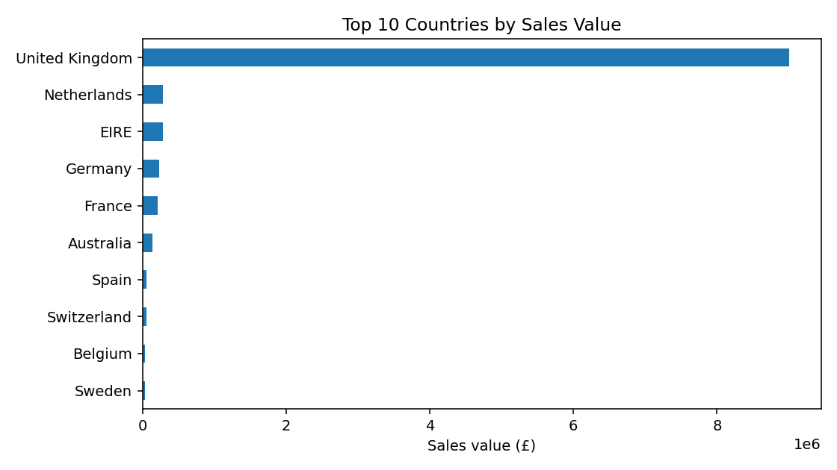

5.4 Product-level sales
DOTCOM POSTAGE was the largest entry by sales value (£206,248.77), followed by REGENCY CAKESTAND 3 TIER (£174,156.54) and PAPER CRAFT, LITTLE BIRDIE (£168,469.60). Postage and 'Manual' entries may not represent physical stock, so they should be separated from physical products before making purchasing or storage decisions.
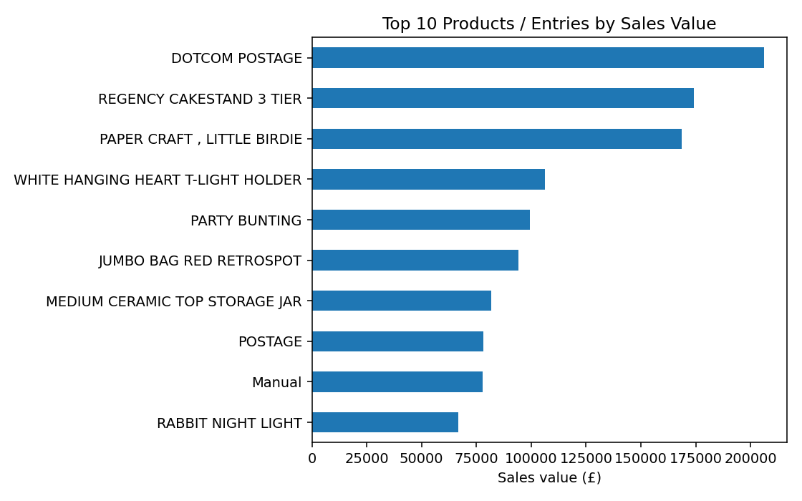

6. Demand Forecasting

6.1 Baseline model
A seven-day moving-average baseline estimated daily orders using the average of the preceding seven calendar days. It is simple and explainable, but can lag during sudden demand changes and does not explicitly model holidays or seasonal patterns. This is a moving-average method, not a regression model.

6.2 Evaluation results
Evaluation | MAE | RMSE | Interpretation
Initial rolling evaluation | 22.68 orders | 29.27 orders | Historical rolling forecast evaluation
Chronological test: 299 training days, 75 test days | 29.54 orders | 37.70 orders | Latest 20% of dates; forecast updated daily using prior actuals

The test MAE of 29.54 means absolute errors averaged about 30 orders per day. The test RMSE of 37.70 is higher because it penalizes large errors more heavily. The chronological test is the more appropriate headline result. The baseline needs improvement before it is used for important capacity decisions. Calendar dates without transaction rows were filled with zero in the forecasting series; the business trading calendar should be checked to confirm that these are genuinely non-trading days.

7. Regression, Clustering, and Optimization

7.1 Regression
Regression predicts a numeric outcome such as daily orders using explanatory variables. A future model could use weekday, month, and lagged order counts, then train on earlier dates and test on later dates. Regression is discussed as a suitable extension; it was not the model implemented here.

7.2 Clustering
Clustering groups similar records without pre-assigned labels. Countries could be grouped by sales, invoice count, and units, or products by sales value and quantity. These groups may help distinguish high-volume markets from smaller ones. No clustering algorithm was implemented in this analysis.

7.3 Optimization
Optimization chooses a plan that minimizes or maximizes an objective subject to constraints. For logistics, an example is minimizing transport cost while meeting demand, vehicle capacity, delivery windows, and driver-hour limits. This dataset lacks delivery locations, distances, vehicle capacities, and delivery windows, so route optimization is a proposed future application, not a completed experiment.

8. Recommendations
- Plan for peak demand. Use approximately 103 orders as an initial alert threshold for reviewing staffing and fulfilment capacity; validate against real capacity.
- Prioritize the main market. The UK accounts for 84.59% of country sales value, so demand planning should reflect this concentration while continuing to monitor other markets.
- Separate service entries from physical stock. Review postage and Manual entries before using product sales rankings for inventory purchasing.
- Improve forecasting. Compare the moving-average baseline with regression and seasonal-naive methods using chronological testing and consistent MAE/RMSE metrics.
- Validate the business calendar. Confirm how non-trading days and missing dates should be handled before using the forecast operationally.
- Collect logistics execution data. For delivery KPIs and route optimization, collect dispatch/delivery timestamps, destination/postcode, distance, vehicle capacity, costs, delivery windows, and staffing measures.
- Monitor KPIs routinely. Refresh order volume, units, sales, high-demand alerts, and forecast errors and keep KPI definitions consistent.

9. Limitations
- Transactions date from 2010–2011 and may not represent current demand.
- The dataset describes sales transactions rather than delivery tracking or warehouse execution.
- The moving-average baseline has material forecast error and should not be used alone for high-stakes decisions.
- Zero-filled dates and the trading calendar need business validation.
- Country/product sales may include postage or other non-physical entries.
- Regression, clustering, and route optimization were explained as future methods; they were not implemented in this practical analysis.

10. Conclusion
This project demonstrates a practical Python workflow for exploring retail transactions and translating findings into demand-oriented logistics planning. After deduplication and demand-focused filtering, 524,878 transaction lines remained, representing 5,572,420 units, 19,960 invoices, and £10.64 million in line-level sales value. The UK accounted for 84.59% of country sales value. The peak day had 142 orders, and 31 days met or exceeded the 90th-percentile threshold. The moving-average baseline produced test MAE 29.54 and RMSE 37.70 orders, indicating scope for forecasting improvement. Historical sales data can support demand and inventory decisions, while reliable delivery and route optimization require additional operational records.

References
- Chen, D. (2015). Online Retail [Dataset]. UCI Machine Learning Repository. https://doi.org/10.24432/C5BW33
- UCI Machine Learning Repository. Online Retail dataset. https://archive.ics.uci.edu/dataset/352/online+retail
- pandas development team. pandas documentation. https://pandas.pydata.org/docs/
- Matplotlib Development Team. Matplotlib documentation. https://matplotlib.org/stable/
- scikit-learn developers. scikit-learn user guide. https://scikit-learn.org/stable/user_guide.html

Appendix A. Core Python workflow
import pandas as pd
import matplotlib.pyplot as plt
df = pd.read_excel("data/Online Retail.xlsx")
clean_df = df.drop_duplicates().copy()
clean_df["IsCancellation"] = clean_df["InvoiceNo"].astype(str).str.startswith("C")
demand_df = clean_df[(~clean_df["IsCancellation"]) & (clean_df["Quantity"] > 0) & (clean_df["UnitPrice"] > 0)].copy()
demand_df["TotalValue"] = demand_df["Quantity"] * demand_df["UnitPrice"]
demand_df["Date"] = pd.to_datetime(demand_df["InvoiceDate"]).dt.date
daily_demand = demand_df.groupby("Date").agg(
Total_Orders=("InvoiceNo", "nunique"),
Total_Units=("Quantity", "sum"),
Total_Sales=("TotalValue", "sum")
).reset_index()
# A seven-day moving-average baseline is then calculated on a daily calendar series.

Appendix B. Key terms
Term | Plain-language explanation
KPI | A measurable indicator used to monitor activity or performance.
MAE | Average absolute difference between forecast and actual order counts.
RMSE | Forecast error metric that penalizes larger mistakes more heavily.
90th percentile | A threshold marking roughly the highest 10% of values, with possible ties.
Regression | Predicting a numerical outcome from explanatory variables.
Clustering | Grouping similar records without pre-assigned labels.
Optimization | Selecting a plan based on an objective and constraints.

