PROJECT REPORT

PREDICTIVE MODELING AND OPTIMIZATION IN LOGISTICS SYSTEMS

Project Title:
Predictive Modeling and Optimization in Logistics Systems
Tools and Technologies Used:
Python, Pandas, NumPy, Scikit-learn, Matplotlib, Seaborn and VS Code

2. EXECUTIVE SUMMARY
This project, titled "Predictive Modeling and Optimization in Logistics Systems," was completed as part of my Data Analytics Internship. The main purpose of the project was to explore logistics data, identify patterns in shipping performance, and develop a machine learning model to predict actual shipping duration.
The project used the DataCo SMART Supply Chain Dataset, which contains approximately 180,519 records related to orders, products, customers, markets, and shipping activities. Python was used for data loading, preprocessing, exploratory data analysis, model development, validation, and interpretation. The major libraries used included Pandas, NumPy, Scikit-learn, Matplotlib, and Seaborn.
During data preparation, relevant features were selected and unnecessary or unsuitable columns were excluded. Additional date-related features were created to support the analysis. Exploratory analysis was then performed to understand shipping patterns across different shipping modes, markets, and regions.
A Linear Regression model was developed to predict the actual number of shipping days using selected order-related features. The model was evaluated using a test dataset containing 36,104 records. It achieved a Mean Absolute Error (MAE) of 0.9921 days, a Root Mean Squared Error (RMSE) of 1.2657 days, and an R-squared value of 0.3923.
The optimization analysis showed that approximately 57.35% of the test orders exceeded their scheduled shipping duration. The analysis also identified differences in shipping performance across shipping modes and geographical markets. These findings were used to develop recommendations for reviewing shipping schedules, monitoring performance variations, and improving logistics planning.
Overall, this internship project provided practical experience in data analytics and machine learning. It also demonstrated how historical logistics data can support performance analysis and planning. However, the model should be treated as a decision-support tool rather than a guaranteed delivery-time predictor, as further data and testing would be required to improve its predictive performance.

3. PROJECT OVERVIEW

3.1 Introduction
Logistics management plays an important role in supply chain operations. It involves the planning and movement of goods from one location to another while managing delivery schedules, transportation, and order fulfilment. Efficient logistics operations help organizations manage resources, reduce delays, and improve customer satisfaction.
With the increasing availability of business data, data analytics and machine learning techniques can be used to study historical logistics performance and identify useful patterns. Predictive analysis can also help organizations understand shipping behaviour and support better operational planning.
This project focuses on applying Python-based data analytics and machine learning techniques to a logistics dataset. It examines actual shipping duration, scheduled shipping duration, shipping modes, and geographical patterns to understand the factors associated with shipping performance.

3.2 Project Background
The project uses the DataCo SMART Supply Chain Dataset, which contains historical information about orders, products, customers, markets, and shipping activities. The dataset provides an opportunity to study shipping performance using real-world-style supply chain records.
The work began with understanding the dataset and selecting relevant columns for analysis. Data preprocessing was performed to prepare the information for exploratory analysis and predictive modelling. Different visualizations were then created to examine shipping patterns and compare performance across categories.
A Linear Regression model was developed to estimate actual shipping duration. Its performance was evaluated using standard regression metrics. Further analysis was conducted to understand prediction errors and identify areas where logistics performance could be reviewed.

3.3 Scope of the Project
The project covers the following activities:
- Loading and inspecting the logistics dataset.
- Selecting relevant variables for analysis and prediction.
- Preparing data and creating date-related features.
- Performing exploratory data analysis using charts and statistical summaries.
- Developing a Linear Regression model to predict actual shipping days.
- Evaluating the model using MAE, RMSE, and R-squared.
- Comparing actual and scheduled shipping durations.
- Examining shipping performance across shipping modes, markets, and regions.
- Interpreting model coefficients and preparing business recommendations.

3.4 Expected Outcome
The expected outcome of this project was to develop a basic predictive analytics workflow that could study historical shipping behaviour and support logistics planning.
The project aimed to identify shipping performance patterns, evaluate the usefulness of a regression model, and highlight areas that may require further investigation. The final results provide analytical insights based on the available dataset rather than guaranteeing improvements in actual logistics operations.

4. PROJECT OBJECTIVES

4.1 Main Objective
The main objective of this project was to apply data analytics and machine learning techniques to historical logistics data in order to study shipping performance, predict actual shipping duration, and identify opportunities for better logistics planning.

4.2 Specific Objectives
The specific objectives of the project were:
- Understand the Dataset: Study the DataCo SMART Supply Chain Dataset and understand its structure, columns, and available logistics information.
- Prepare the Data: Select relevant variables, inspect data quality, and prepare the dataset for exploratory analysis and predictive modelling.
- Perform Exploratory Data Analysis: Examine shipping patterns and identify variations across shipping modes, markets, and geographical regions.
- Develop a Predictive Model: Apply Linear Regression to estimate actual shipping duration using selected order-related features.
- Evaluate Model Performance: Measure prediction accuracy using Mean Absolute Error (MAE), Root Mean Squared Error (RMSE), and R-squared.
- Analyze Logistics Performance: Compare actual shipping duration with scheduled shipping duration to identify orders that exceeded their expected schedules.
- Interpret Model Results: Examine the model coefficients and prediction errors to understand how the selected features relate to the predictions.
- Provide Business Recommendations: Suggest practical areas for further investigation and improvement in logistics planning based on the analytical findings.

4.3 Learning Objectives
This project also aimed to develop practical skills in the following areas:
- Working with large datasets using Python.
- Data cleaning, transformation, and feature selection.
- Creating charts and visual reports.
- Applying regression techniques using Scikit-learn.
- Evaluating and interpreting machine learning models.
- Understanding how data analytics can support business decision-making.
- Organizing project files and documenting analytical work.

5. TOOLS AND TECHNOLOGIES USED

5.1 Python
Python was used as the primary programming language for this project. It provided the environment for loading data, performing preprocessing, conducting exploratory analysis, developing the predictive model, and evaluating results.

5.2 Visual Studio Code
Visual Studio Code (VS Code) was used as the development environment. Python scripts were created, edited, and executed through its integrated terminal. It also helped organize the project into separate folders for code, datasets, figures, models, and reports.

5.3 Pandas
Pandas was used for data loading, inspection, selection, and transformation. It helped manage the large dataset in tabular form and prepare the required columns for analysis and modelling.

5.4 NumPy
NumPy was used for numerical operations and mathematical calculations. It also supported the calculation of prediction errors and evaluation-related values.

5.5 Scikit-learn
Scikit-learn was used for machine learning tasks. It provided tools for data preprocessing, feature transformation, train-test splitting, Linear Regression, Ridge Regression, hyperparameter tuning, and model evaluation.

5.6 Matplotlib
Matplotlib was used to create visualizations such as shipping performance comparisons, actual-versus-predicted plots, and feature coefficient charts.

5.7 Seaborn
Seaborn was used to create statistical visualizations, including the distribution of prediction errors. It helped present patterns in the data in an understandable graphical format.

5.8 Joblib
Joblib was used to save and load the trained machine learning pipeline. This made it possible to reuse the final model in later analysis scripts without training it again.

5.9 Technologies Summary
Tool / Technology | Purpose
Python | Main programming language
Visual Studio Code | Code development and execution
Pandas | Data loading and manipulation
NumPy | Numerical calculations
Scikit-learn | Machine learning and evaluation
Matplotlib | Data visualization
Seaborn | Statistical visualization
Joblib

6. DATASET DESCRIPTION

6.1 Dataset Overview
The dataset used in this project is the DataCo SMART Supply Chain Dataset, which is publicly available through Mendeley Data. It contains historical supply chain information related to customer orders, products, shipping activities, markets, and geographical locations.
The dataset was selected because it provides information that can be used to examine shipping performance and develop a predictive model for actual shipping duration.
The original dataset contains approximately 180,519 records and 53 columns. It was provided in CSV format and loaded into Python for inspection and analysis.

6.2 Dataset Source
The dataset was obtained from the following public source:
Dataset Name: DataCo SMART Supply Chain Dataset
Source Platform: Mendeley Data
Dataset Link: https://data.mendeley.com/datasets/8gx2fvg2k6/5
File Format: CSV
Original Dataset Size: 180,519 rows and 53 columns

6.3 Important Dataset Attributes
The original dataset contains several attributes related to orders, products, customers, and shipping operations. Some of the important fields considered during the project included:
Attribute | Description
Days for shipping (real) | Actual shipping duration recorded in the dataset
Days for shipment (scheduled) | Scheduled shipping duration
Shipping Mode | Shipping service category
Order Country | Country associated with the order
Order Region | Geographical region associated with the order
Market | Market classification
Order Item Quantity | Quantity of items in an order
Order Item Product Price | Product price information
Order Item Discount Rate | Discount rate applied to an order item
Category Name | Product category
Department Name | Department associated with the product
Customer Segment | Customer segment classification
Order Date | Date when the order was placed
These attributes provided information for examining shipping patterns and selecting suitable input variables for the predictive model.

6.4 Dataset Suitability
The dataset was suitable for this project because it included both actual and scheduled shipping duration, along with several order-related and geographical attributes.
This allowed the project to compare shipping performance, examine differences between shipping categories, and develop a regression model using selected features.
The dataset also provided enough records for dividing the data into training and testing sets. This supported model development and performance evaluation using a separate test dataset.

6.5 Dataset Limitations
Although the dataset was useful for analytical purposes, it had some limitations. It represents historical records and may not reflect current logistics conditions. Some fields in the original dataset were missing or unsuitable for the modelling objective.
The dataset also did not provide all operational details that could influence shipping performance, such as detailed warehouse processing times, real-time carrier conditions, and transportation distance. Therefore, the analysis was limited to the information available in the dataset.

7. DATA PREPARATION AND FEATURE SELECTION

7.1 Data Loading and Initial Inspection
The DataCo SMART Supply Chain Dataset was loaded into Python using the Pandas library. The original dataset contained approximately 180,519 records and 53 columns.
An initial inspection was performed to understand the dataset structure, identify relevant attributes, and check the availability of values. This step helped determine which columns were suitable for further analysis and predictive modelling.

7.2 Feature Selection
The original dataset contained several columns that were not required for predicting shipping duration. Therefore, relevant features were selected based on their potential usefulness and availability when an order is placed.
The selected features included scheduled shipping days, order quantity, product price, discount rate, shipping mode, market, order country, order region, product category, department, customer segment, and order-related date information.
The target variable selected for prediction was Days for shipping (real), which represents the actual shipping duration recorded in the dataset.

7.3 Date Feature Extraction
The order date was used to create additional numerical features. Three attributes were extracted:
- Order Month: Represents the month in which the order was placed.
- Order Day of Week: Represents the day of the week associated with the order.
- Order Hour: Represents the hour at which the order was placed.
These features were included to examine whether order timing was associated with shipping duration.

7.4 Removal of Unnecessary and Unsuitable Columns
Several original columns were excluded because they were not needed for the selected modelling objective.
Identifiers and personal customer information were not included as predictive features. Columns containing information recorded after shipment, such as actual delivery dates and delivery status, were also excluded.
The field Late_delivery_risk was excluded because it could introduce information that overlaps with the shipping outcome being studied. This helped reduce the risk of data leakage and kept the model focused on information intended to be available when an order is placed.

7.5 Handling Missing Values
The original dataset contained missing values in some columns. For example, the Product Description field was entirely missing, while Order Zipcode contained a large number of empty values.
These columns were not required for the selected modelling approach and were excluded during feature selection. The resulting modelling dataset contained no missing values in the selected features and target variable.

7.6 Final Prepared Dataset
After feature selection and date-based feature extraction, the prepared dataset contained 180,519 records and 16 columns, including 15 input features and one target variable.
The prepared dataset was saved in CSV format for use in exploratory data analysis, model training, validation, and optimization analysis.
This preparation process reduced unnecessary information and created a consistent dataset for the next stages of the project.

8. EXPLORATORY DATA ANALYSIS (EDA)

8.1 Introduction
Exploratory Data Analysis (EDA) was performed to understand the patterns and relationships within the prepared logistics dataset. The analysis focused on shipping duration, shipping modes, scheduled delivery time, and selected numerical variables.
Python libraries such as Pandas, Matplotlib, and Seaborn were used to calculate summary statistics and create visualizations.

8.2 Overall Shipping Duration
The analysis showed that the average actual shipping duration in the dataset was approximately 3.5 days.
The target variable, Days for shipping (real), contained values ranging from 0 to 6 days. This indicated that orders had different recorded shipping durations depending on their shipping arrangements and other characteristics.

8.3 Shipping Duration by Shipping Mode
Shipping performance was examined across four shipping modes. The average actual shipping duration was:
Shipping Mode | Average Actual Shipping Days
Same Day | 0.48
First Class | 2.00
Second Class | 3.99
Standard Class | 4.00
The results showed clear differences between shipping modes. Same Day had the lowest average actual shipping duration, while Standard Class and Second Class had the highest averages.
These results describe the recorded shipping durations and should not be interpreted as proof that the shipping mode alone caused the differences.
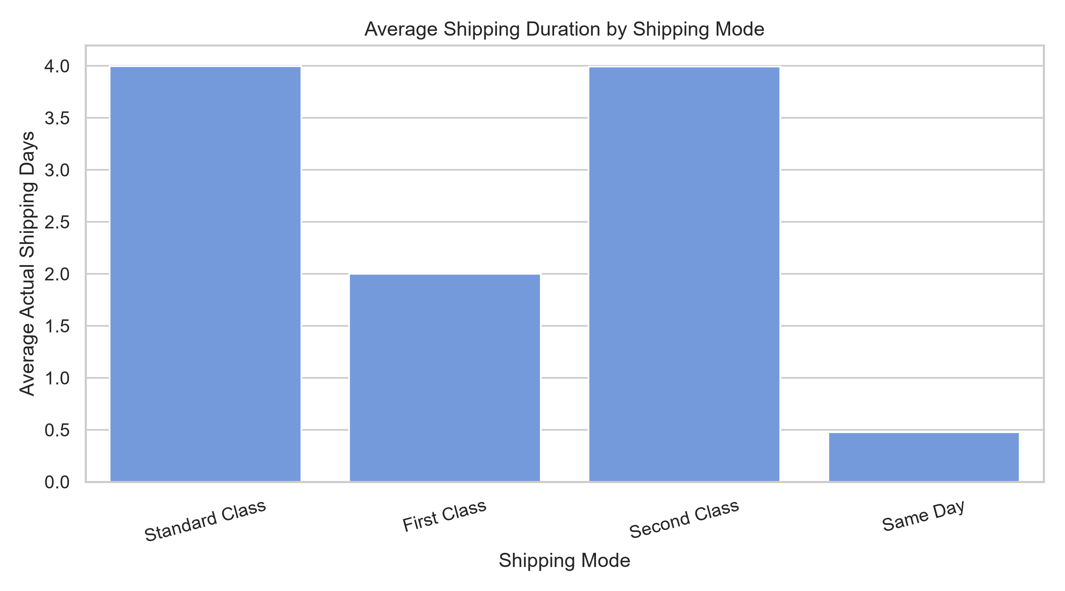

8.4 Scheduled Shipping Duration Analysis
The relationship between scheduled shipping duration and actual shipping duration was also examined.
Scheduled Shipping Days | Average Actual Shipping Days
0 | 0.48
1 | 2.00
2 | 3.99
4 | 4.00
The results indicated that actual shipping duration generally increased with the scheduled shipping duration. This suggested that the scheduled duration could be a useful predictor for the regression model.
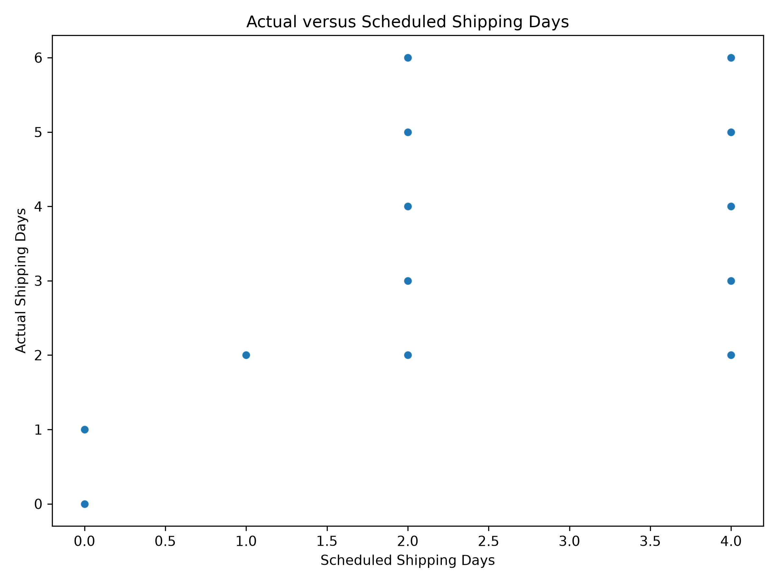

8.5 Correlation Analysis
Correlation analysis was performed to examine the linear relationships between numerical variables and the target variable.
The scheduled shipping duration showed the strongest positive correlation with actual shipping duration, with a correlation value of approximately 0.516.
Other numerical variables showed much weaker linear correlations:
Numerical Feature | Correlation with Actual Shipping Days
Scheduled Shipping Days | 0.516
Order Hour | 0.017
Product Price | 0.002
Discount Rate | 0.001
Quantity | -0.001
Order Day of Week | -0.003
Order Month | -0.008
This analysis suggested that scheduled shipping duration had a stronger linear relationship with the target than the other listed numerical variables. However, correlation does not establish causation and does not measure every possible relationship.
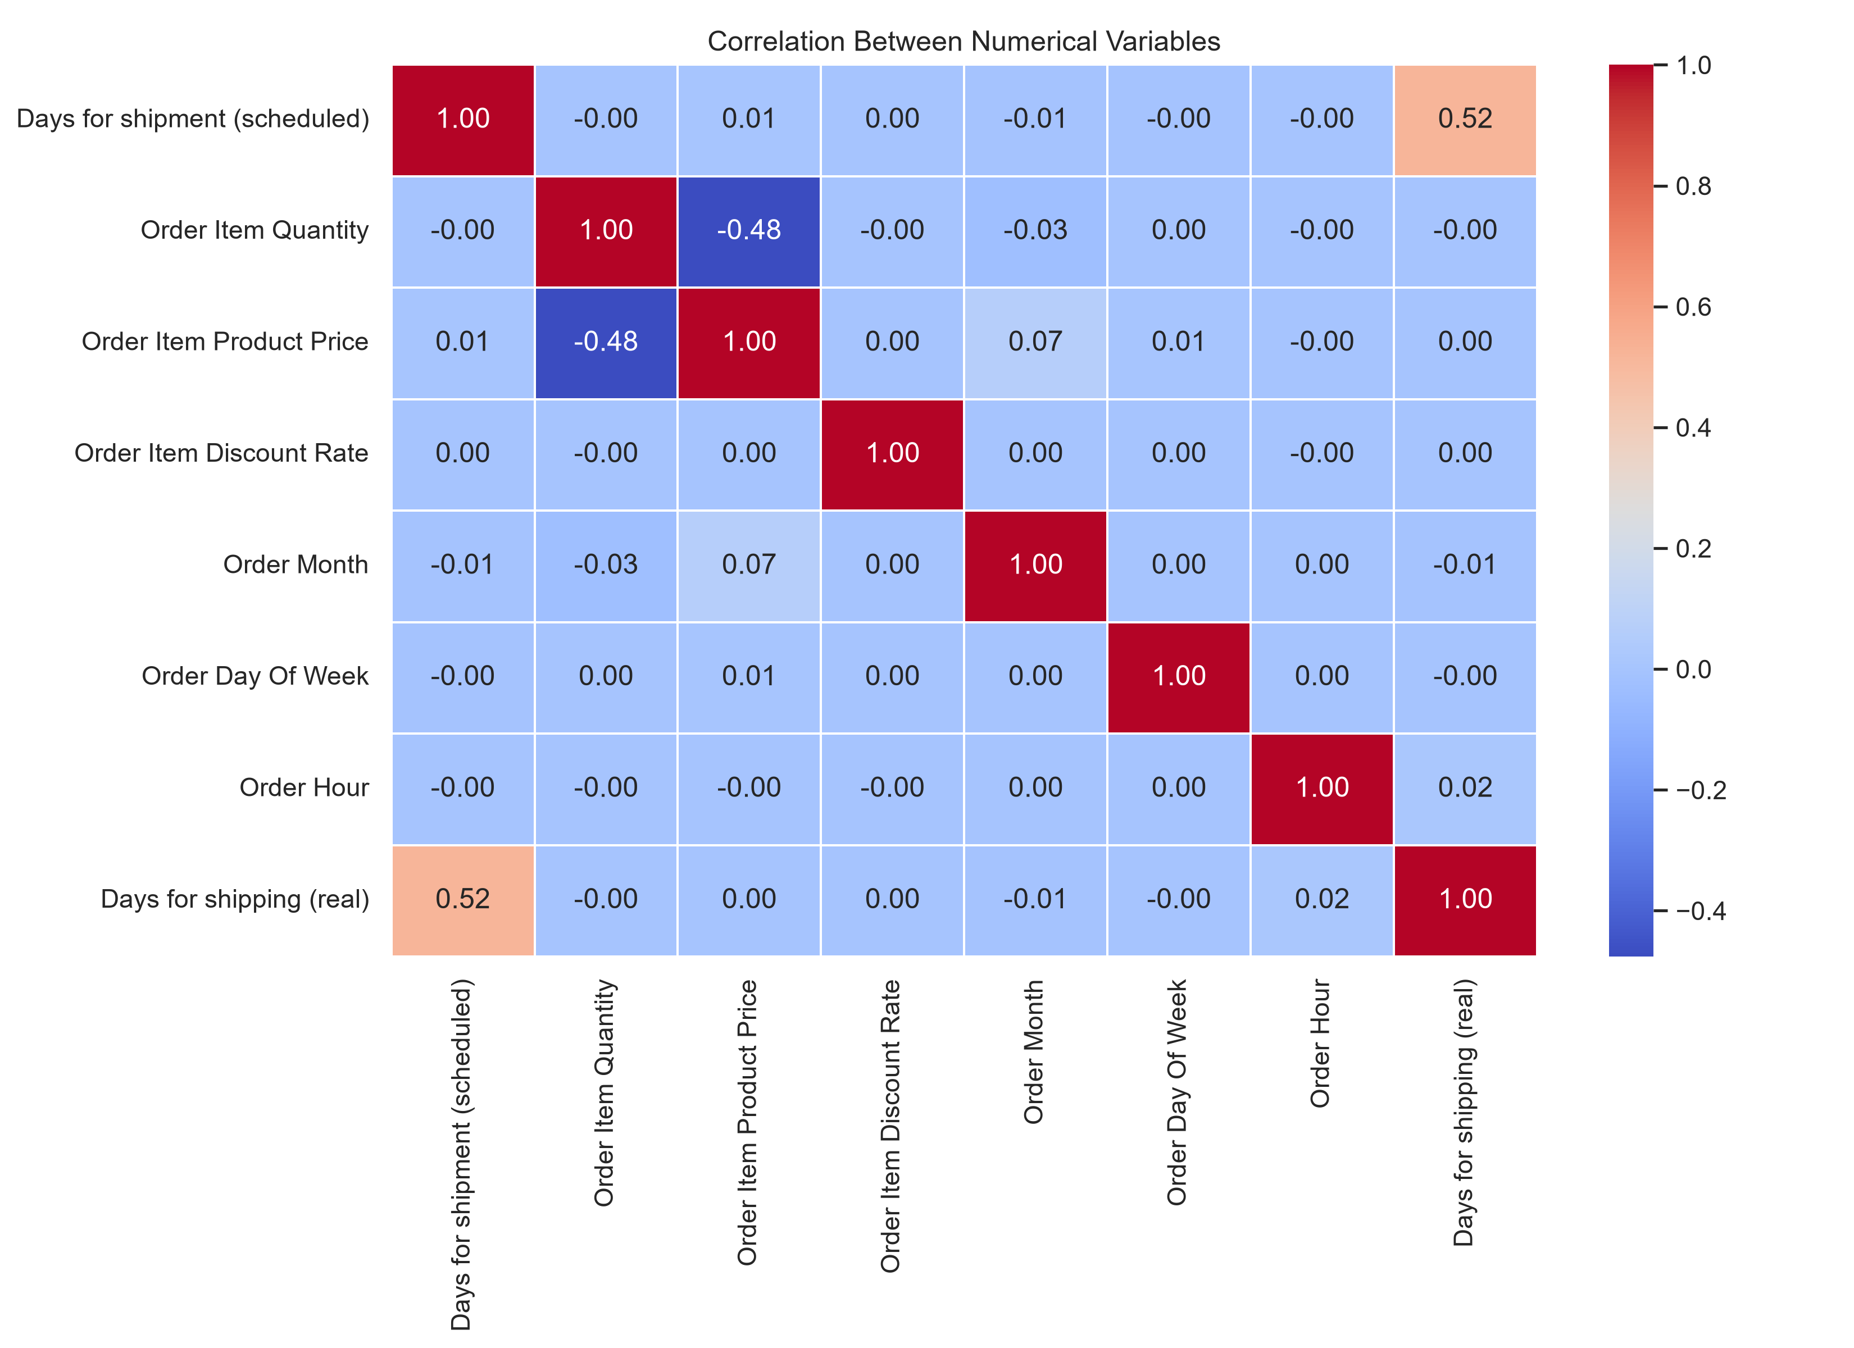

8.6 Key Findings from EDA
The main findings from the exploratory analysis were:
- The average actual shipping duration was approximately 3.5 days.
- Same Day shipping had the lowest average actual shipping duration.
- Standard Class and Second Class had average durations of approximately four days.
- Scheduled shipping duration had the strongest numerical correlation with the target variable.
- Other numerical features showed relatively weak individual linear correlations.

8.7 Conclusion of EDA
The exploratory analysis provided an initial understanding of shipping patterns and helped identify useful variables for predictive modelling.
The findings supported the use of scheduled shipping duration, shipping mode, geographical information, and other order-related features in the next stage of the project.

9. MODEL DEVELOPMENT AND TRAINING

9.1 Introduction
After completing data preparation and exploratory analysis, the next stage was to develop a predictive machine learning model. The main objective was to predict actual shipping duration using selected order-related, product-related, and geographical features.
A regression approach was selected because the target variable, Days for shipping (real), represents a numerical shipping duration.

9.2 Training and Testing Data
The prepared dataset contained 180,519 records. It was divided into two separate subsets for model development and evaluation.
Dataset | Number of Records | Percentage
Training Data | 144,415 | 80%
Testing Data | 36,104 | 20%
Total | 180,519 | 100%
The training dataset was used to fit the models, while the testing dataset was kept separate to evaluate their performance on unseen records.
A fixed random state was used during the split to make the experiment reproducible.

9.3 Models Selected
Three regression models were evaluated during the project:
1. Dummy Regressor
The Dummy Regressor was used as a baseline model. It provided a simple reference point to determine whether the other models could improve prediction performance.
2. Ridge Regression
Ridge Regression was included as a regularized linear model. It applies a penalty to large coefficients to help control model complexity.
3. Linear Regression
Linear Regression was selected to examine the relationship between the input features and actual shipping duration. It provided a straightforward approach for predicting a numerical target and interpreting model coefficients.

9.4 Model Training Results
The three models were trained and evaluated using the same training and testing split.
Model | MAE | RMSE | R² Score
Dummy Regressor | 1.4241 | 1.6236 | Approximately 0
Ridge Regression | 0.9922 | 1.2658 | 0.3922
Linear Regression | 0.9921 | 1.2657 | 0.3923
The results showed that both Linear Regression and Ridge Regression performed considerably better than the baseline Dummy Regressor.
Linear Regression achieved a slightly lower MAE and RMSE, along with a marginally higher R² score than Ridge Regression.

9.5 Model Selection
Based on the initial evaluation results, Linear Regression was selected as the preferred model for the next stages of the project.
Its Mean Absolute Error was approximately 0.99 days, indicating that the predictions differed from the actual values by about one day on average.
The R² score of approximately 0.3923 indicated that the model explained around 39.23% of the variation in the target variable on the test dataset.
Although the model showed improvement over the baseline, its predictive performance was moderate. Therefore, further validation and interpretation were necessary before drawing conclusions about its practical usefulness.

9.6 Conclusion of Model Development
The model development stage established a baseline and compared two linear regression approaches. Linear Regression was selected based on its slightly better test performance.
The selected model was saved for reuse in subsequent validation, logistics optimization, and model interpretation activities.

10. MODEL VALIDATION AND EVALUATION

10.1 Introduction
After training the predictive models, validation and evaluation were performed to examine how well they could predict actual shipping duration.
The evaluation process used a separate test dataset and standard regression metrics. Hyperparameter tuning was also performed to examine whether the Ridge Regression model could achieve better results.

10.2 Evaluation Metrics
Three evaluation metrics were used in this project:
Mean Absolute Error (MAE): Measures the average absolute difference between actual and predicted shipping duration. A lower MAE indicates more accurate predictions.
Root Mean Squared Error (RMSE): Measures prediction errors while giving greater weight to larger errors. A lower RMSE indicates better performance.
R-squared (R²): Measures how much variation in the target variable is explained by the model. A value closer to 1 generally indicates a better fit.

10.3 Initial Model Performance
The three models were evaluated using the same test dataset containing 36,104 records.
Model | MAE | RMSE | R²
Dummy Regressor | 1.4241 | 1.6236 | Approximately 0.0000
Ridge Regression | 0.9922 | 1.2658 | 0.3922
Linear Regression | 0.9921 | 1.2657 | 0.3923
The results showed that both Linear Regression and Ridge Regression performed considerably better than the Dummy Regressor baseline.
Linear Regression achieved a slightly lower MAE and RMSE, along with a marginally higher R² score. Therefore, it was selected as the final model.

10.4 Ridge Regression Hyperparameter Tuning
GridSearchCV was used to tune the Ridge Regression model. Three-fold cross-validation was performed with the following alpha values:
- 0.1
- 1.0
- 10.0
- 100.0
The best alpha value identified during tuning was 100.0, with a cross-validation RMSE of approximately 1.266.
This process helped examine the effect of regularization on model performance.

10.5 Final Model Comparison
After tuning, the Ridge Regression model was evaluated again and compared with the Linear Regression model.
Model | MAE | RMSE | R²
Linear Regression | 0.992071 | 1.265682 | 0.392278
Tuned Ridge Regression | 0.991244 | 1.265782 | 0.392182
The tuned Ridge model achieved a slightly lower MAE, while Linear Regression achieved a slightly lower RMSE and a marginally higher R² score.
The differences between the two models were very small. Linear Regression was retained as the final model because it provided the better RMSE and R² results in this evaluation.

10.6 Interpretation of Evaluation Results
The final Linear Regression model achieved an MAE of approximately 0.99 days, meaning that its predictions differed from actual shipping duration by about one day on average in absolute terms.
Its RMSE was approximately 1.27 days, while its R² score was approximately 0.3923. This indicates that the model explained around 39.2% of the variation in the target variable on the test dataset.
The results demonstrate that the model identified useful patterns in the data, although its predictive performance was moderate and there is room for improvement.

10.7 Conclusion of Model Evaluation
The validation process helped identify Linear Regression as the final model among the evaluated alternatives. The model performed better than the baseline and provided a measurable level of predictive capability.
However, the results also indicate that additional operational information and further model improvements may be required to achieve more accurate shipping predictions.

11. LOGISTICS PERFORMANCE AND OPTIMIZATION ANALYSIS

11.1 Introduction
After completing model development and validation, a logistics performance analysis was conducted using the test dataset. The purpose was to compare actual shipping duration with scheduled shipping duration and identify areas that may require further operational investigation.
The analysis covered shipping modes, markets, geographical regions, and prediction errors. A total of 36,104 test records were included.

11.2 Actual Versus Scheduled Shipping Performance
The comparison between actual and scheduled shipping duration showed that:
- 20,705 orders (57.35%) exceeded their scheduled shipping duration.
- 15,399 orders were completed within or on the scheduled duration.
- The average difference between actual and scheduled shipping duration was approximately 0.564 days.
These findings indicate that more than half of the test records had an actual shipping duration greater than the scheduled duration.

11.3 Performance Analysis by Shipping Mode
Shipping performance was compared across the four shipping modes.
Shipping Mode | Number of Orders | Average Actual Days | Average Scheduled Days | Average Difference
Second Class | 7,026 | 3.973 | 2.000 | 1.973
First Class | 5,531 | 2.000 | 1.000 | 1.000
Same Day | 1,961 | 0.482 | 0.000 | 0.482
Standard Class | 21,586 | 4.001 | 4.000 | 0.001
The results showed that Second Class had the largest average difference between actual and scheduled shipping duration, at approximately 1.973 days.
First Class and Same Day also showed positive average differences, while Standard Class had an average difference close to zero.
These results suggest that Second Class scheduling and performance deserve further investigation. However, the observed differences alone do not establish the cause of the delays.

11.4 Performance Analysis by Market
The average difference between actual and scheduled shipping duration was also examined across markets.
Market | Average Difference (Days)
Pacific Asia | 0.581
Europe | 0.572
LATAM | 0.561
USCA | 0.550
Africa | 0.514
Pacific Asia recorded the highest average difference among the listed markets, at approximately 0.581 days. The differences between markets were relatively small, so these results should be treated as areas for further investigation rather than proof of major operational differences.

11.5 Regional Performance Analysis
Regional performance was examined to identify geographical areas with relatively higher average differences between actual and scheduled shipping duration.
Only regions with at least 100 test orders were included in the regional comparison to avoid highlighting results based on very small samples.
Some of the highest recorded average differences were:
Region | Number of Orders | Average Difference (Days)
Eastern Europe | 800 | 0.644
South Asia | 1,556 | 0.636
Eastern Asia | 1,413 | 0.613
South of USA | 815 | 0.610
Southern Africa | 213 | 0.606
Western Europe | 5,493 | 0.603
Eastern Europe recorded the highest average difference among the regions listed above. South Asia and Eastern Asia also showed relatively higher values.
These findings can help identify geographical areas for more detailed investigation.

11.6 Prediction Error by Shipping Mode
The model's prediction errors were also compared across shipping modes.
Shipping Mode | Mean Absolute Error (Days)
First Class | 0.048
Same Day | 0.479
Second Class | 1.208
Standard Class | 1.210
The model showed lower average prediction error for First Class, while Standard Class and Second Class had higher prediction errors.
This indicates that prediction accuracy varied across shipping modes. Therefore, the model's performance should be reviewed separately for different operational categories rather than relying only on the overall evaluation metrics.

11.7 Optimization Opportunities
Based on the analysis, several areas were identified for further investigation:
- Review Second Class performance: Examine why its average actual shipping duration exceeded its scheduled duration by approximately 1.973 days.
- Investigate regional patterns: Review shipping operations in Eastern Europe, South Asia, and Eastern Asia to understand the differences observed in the dataset.
- Examine market-level performance: Study the relatively higher average difference recorded in Pacific Asia.
- Improve operational data collection: Include information about warehouse processing time, carrier performance, transportation distance, and inventory availability in future analysis.
- Use predictive modelling as decision support: Apply model predictions as planning guidance while continuing to monitor actual shipping performance.

11.8 Conclusion of Optimization Analysis
The logistics performance analysis identified differences between scheduled and actual shipping duration across shipping modes, markets, and geographical regions.
Second Class showed the largest average difference between actual and scheduled shipping duration. Pacific Asia and Eastern Europe also recorded relatively higher average differences in their respective comparisons.
These findings provide useful areas for further operational investigation. However, the analysis is based on historical data and does not establish the causes of the observed differences or prove that any specific operational change will reduce delays.

12. MODEL INTERPRETATION

12.1 Introduction
Model interpretation was performed to understand the behaviour of the final Linear Regression model and examine how the selected input features were associated with predicted shipping duration.
The analysis focused on model coefficients, actual-versus-predicted values, and the distribution of prediction errors. These results helped explain the model's predictions and identify areas where its performance could be improved.

12.2 Linear Regression Coefficient Analysis
The final Linear Regression model used numerical and categorical features to generate shipping duration predictions.
Categorical variables were transformed using one-hot encoding so that they could be processed by the regression model. The coefficients were then examined to understand how individual encoded features contributed to the model's predictions.
Some of the larger positive and negative coefficients were associated with geographical categories, including countries and regions.
For example, the analysis identified relatively large negative coefficients for categories such as Bangladesh, Botswana, South Africa, Pakistan, and India. Positive coefficients were also observed for categories such as Turkmenistan, Southern Africa, and South Asia.
These coefficients represent differences relative to the reference categories used during encoding, while accounting for the other features in the model. They should not be interpreted as proof that a particular country or region causes faster or slower shipping.
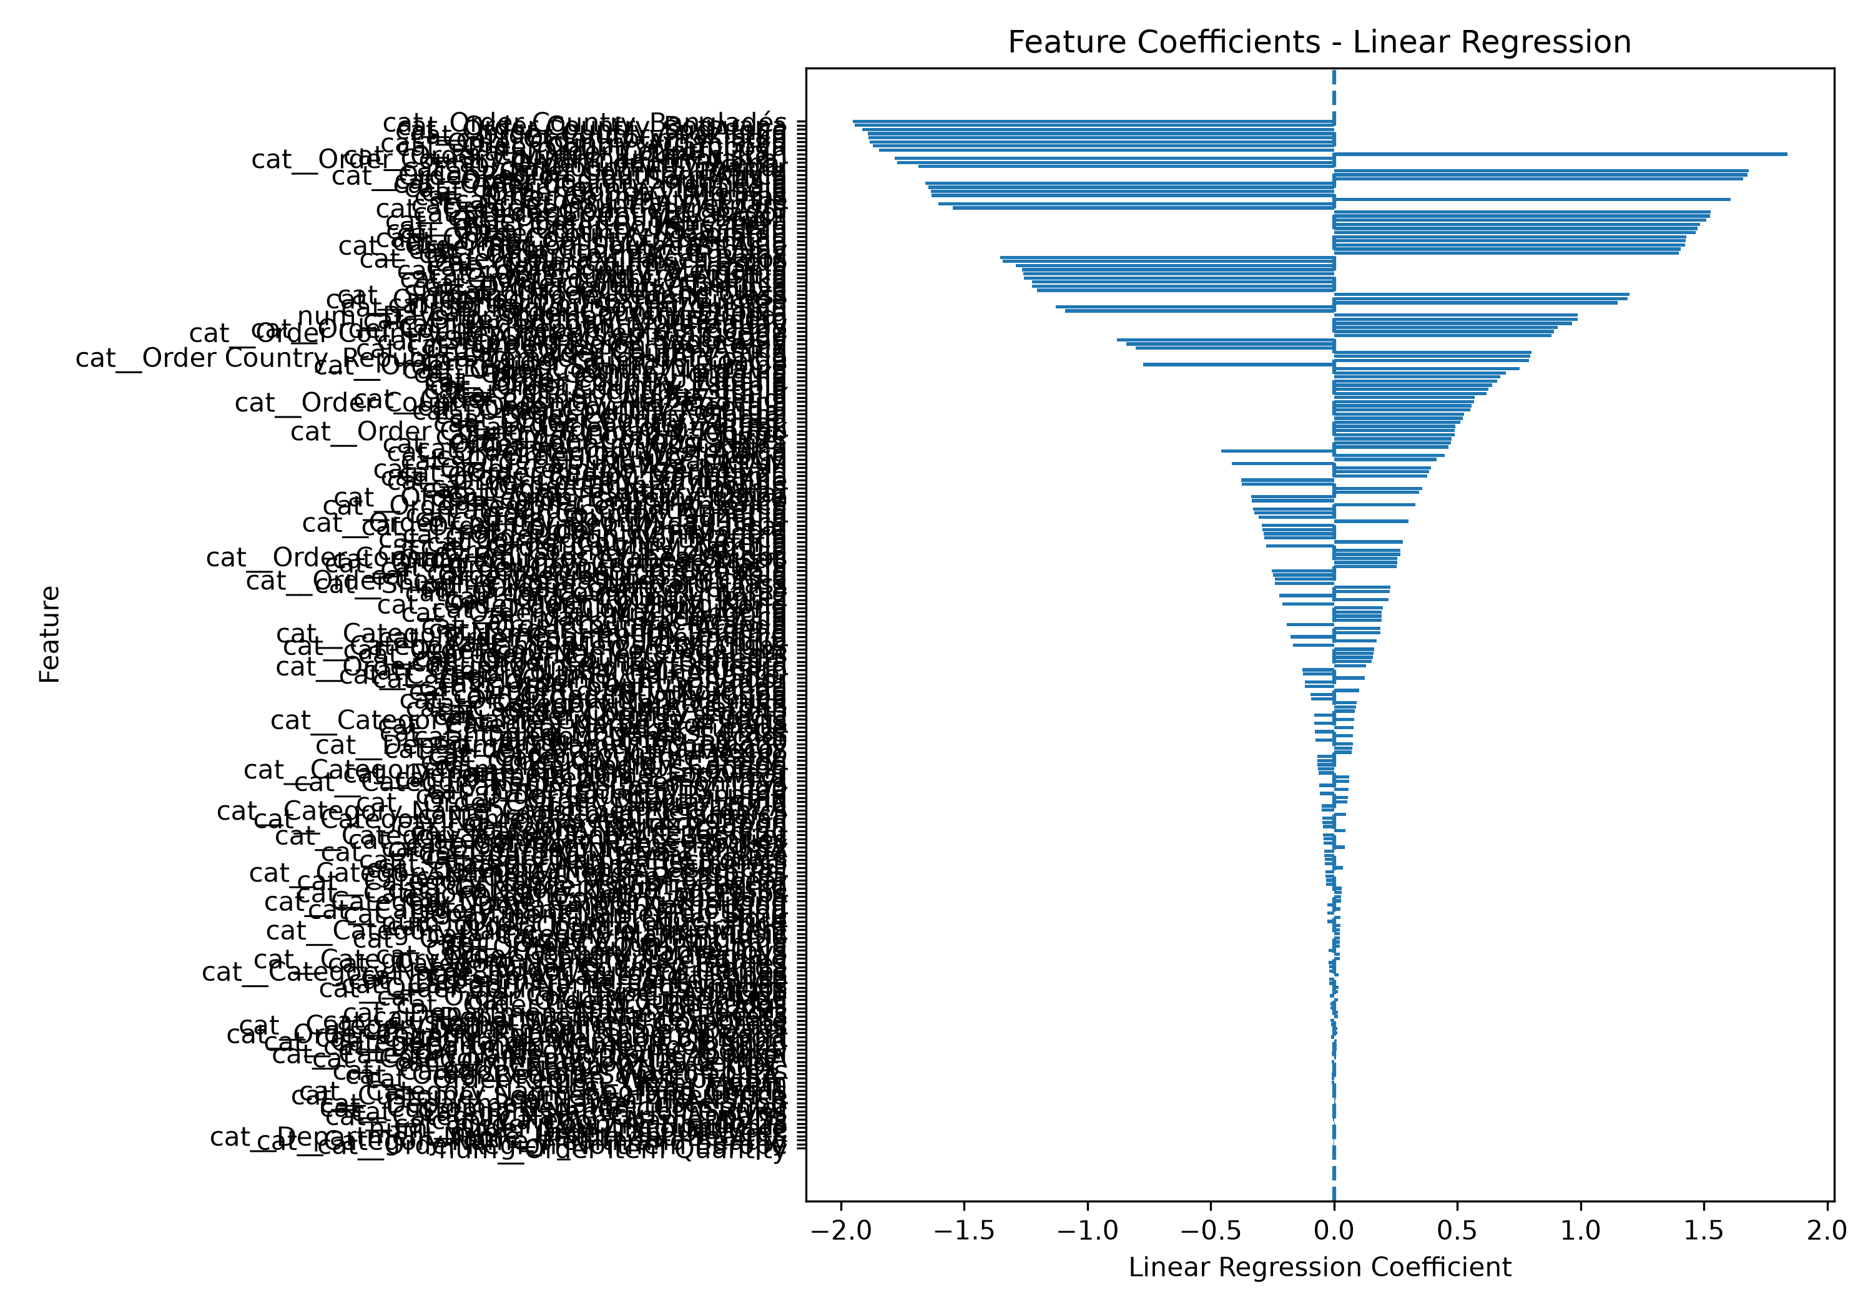

12.3 Actual Versus Predicted Shipping Duration
The actual-versus-predicted chart was created to compare the model's predictions with the actual shipping duration recorded in the test dataset.
The comparison helps show how closely the predicted values follow the actual values. Predictions closer to the corresponding actual values indicate better model performance, while larger differences indicate prediction errors.
The chart provides a visual way to assess the predictive behaviour of the final model.
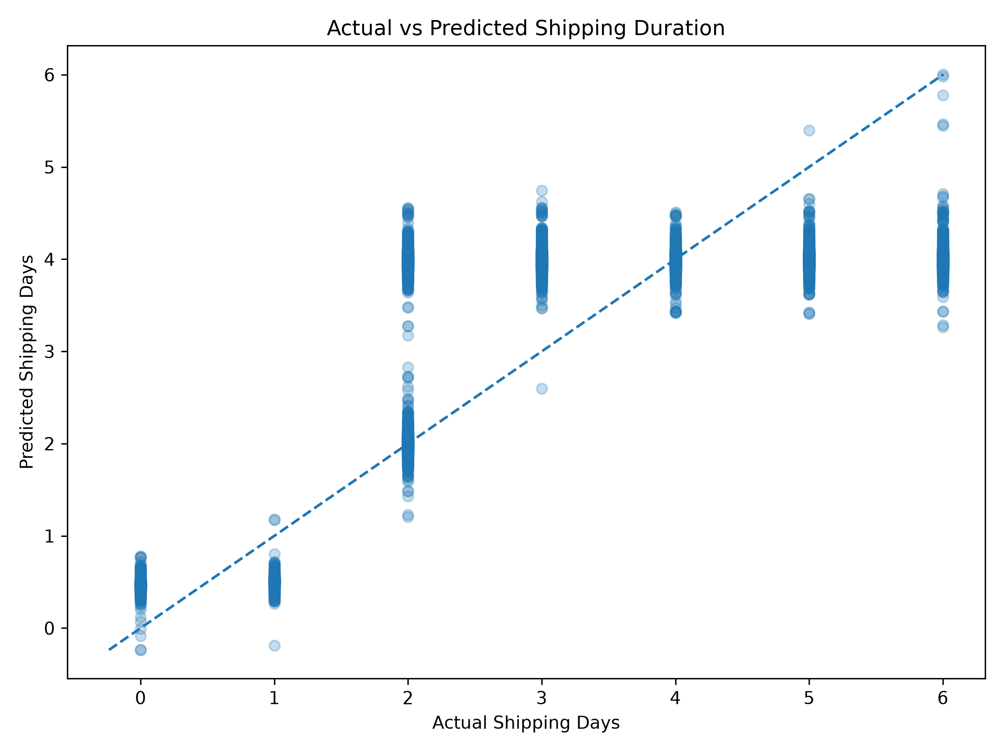

12.4 Prediction Error Distribution
A prediction error distribution chart was created to examine how the model's errors were spread across the test records.
Prediction error was calculated as:
Prediction Error = Actual Shipping Duration − Predicted Shipping Duration
Positive errors indicate that the actual duration was higher than the predicted duration, while negative errors indicate that the prediction was higher than the actual duration.
The distribution helps identify whether errors are concentrated around zero or spread across a wider range. This is useful for understanding the consistency of the model's predictions.
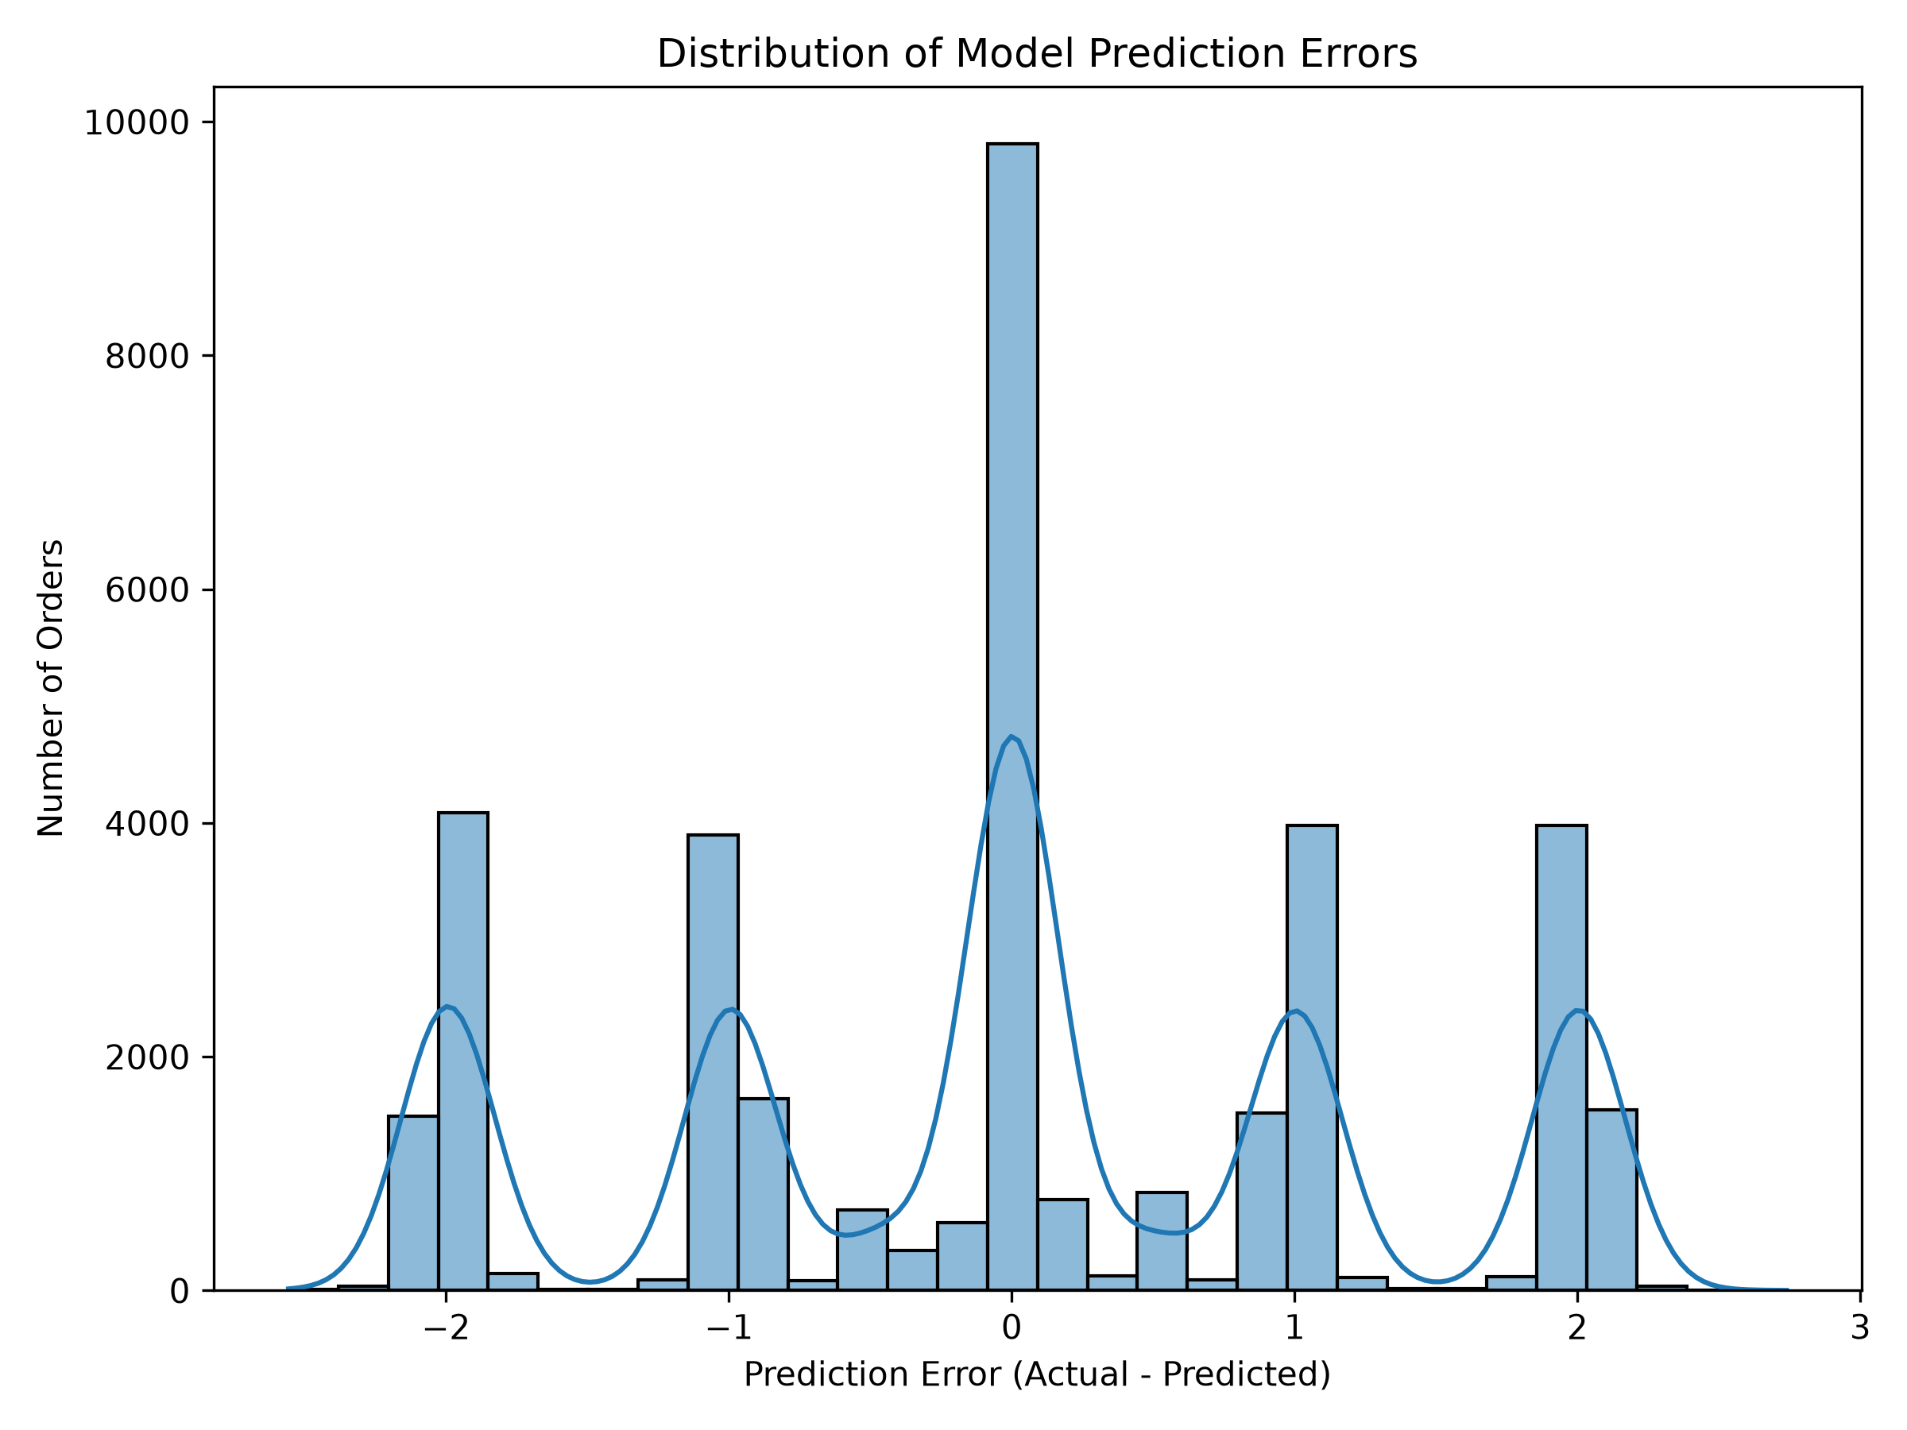

12.5 Overall Model Interpretation
The final model achieved the following evaluation results:
Evaluation Metric | Result
MAE | 0.9921 days
RMSE | 1.2657 days
R² | 0.3923
The results indicate that the model identified useful relationships in the selected dataset, but its predictive ability was moderate.
The coefficient analysis also showed that geographical categories contributed to the model's predictions. However, the coefficients describe statistical relationships within the fitted model and do not establish causal relationships.

12.6 Conclusion of Model Interpretation
Model interpretation provided additional understanding of how the final Linear Regression model generated its predictions.
The coefficient analysis and prediction visualizations helped examine the model's behaviour beyond its overall evaluation scores. These results also highlighted the importance of additional operational information and further validation for improving future logistics prediction models.

13. BUSINESS RECOMMENDATIONS

13.1 Introduction
Based on the exploratory data analysis, predictive modelling, and logistics performance analysis, several recommendations were identified. These recommendations focus on improving shipping schedule reviews, monitoring operational performance, and making better use of predictive analytics.

13.2 Review Second Class Shipping Performance
The analysis showed that Second Class had the highest average difference between actual and scheduled shipping duration, at approximately 1.973 days.
Logistics teams could review the scheduling process and operational activities associated with this shipping mode. Further investigation may help identify whether scheduling assumptions, warehouse processing, or transportation arrangements contribute to the observed difference.

13.3 Monitor Regional Shipping Performance
Eastern Europe recorded an average actual-minus-scheduled shipping duration difference of approximately 0.644 days. South Asia and Eastern Asia also showed relatively high average differences.
These regions could be prioritized for more detailed performance reviews. Comparing order volumes, shipping arrangements, and operational records may help identify patterns that require attention.

13.4 Improve Market-Level Monitoring
Pacific Asia recorded the highest average difference among the markets analysed, at approximately 0.581 days.
Regular monitoring of market-level shipping performance could help logistics teams identify changes in shipping patterns and investigate unusual differences between scheduled and actual durations.

13.5 Use Predictive Models for Planning Support
The final Linear Regression model achieved an MAE of approximately 0.99 days and an R² score of 0.3923.
The model could be used as an initial decision-support tool for estimating shipping duration and identifying orders that may require closer monitoring. However, predictions should not be treated as guaranteed delivery estimates because the model still has prediction errors.

13.6 Collect Additional Operational Data
Future analysis could be improved by collecting additional information, including:
- Warehouse processing and dispatch timestamps.
- Carrier and transportation performance records.
- Transportation distance and route information.
- Inventory availability at the time of order placement.
- Weather and traffic conditions, where available and appropriate.
These additional variables could help provide a more complete understanding of factors associated with shipping performance.

13.7 Regular Model Evaluation
The predictive model should be evaluated periodically using new and representative data. Its prediction errors should also be monitored across different shipping modes and geographical regions.
If additional data becomes available, alternative regression techniques and more advanced modelling approaches could be tested and compared with the current Linear Regression model.

13.8 Conclusion
The recommendations focus on using historical analysis and predictive modelling to support logistics planning and performance monitoring.
Reviewing Second Class shipping performance, monitoring geographical patterns, improving operational data collection, and regularly evaluating the predictive model may help support better-informed logistics decisions. These are proposed opportunities for further investigation rather than proven improvements achieved by the project.

14. CHALLENGES AND LIMITATIONS

14.1 Introduction
During the development of this project, several technical and analytical challenges were encountered. The project also had certain limitations related to the available dataset, selected features, and predictive model performance.
Understanding these challenges is important for evaluating the project results and identifying opportunities for future improvement.

14.2 Dataset Quality and Missing Values
The original dataset contained missing values in some columns. For example, Product Description was entirely missing, while Order Zipcode contained a large number of empty values.
These columns were not required for the selected modelling approach and were excluded during feature selection. Careful selection of relevant attributes was necessary to prepare a consistent dataset for analysis.

14.3 Large Dataset Processing
The dataset contained approximately 180,519 records and 53 original columns. Loading, inspecting, transforming, and analysing this data required careful handling of columns and data types.
Python libraries such as Pandas and NumPy helped manage the data and perform the required operations.

14.4 Technical Environment Limitations
During model development, a Windows Application Control restriction prevented certain Scikit-learn components related to tree-based models from loading successfully.
As a result, Decision Tree and Random Forest models could not be used in the final comparison. The project instead evaluated Dummy Regression, Ridge Regression, and Linear Regression.
This limitation affected the range of algorithms that could be tested within the available development environment.

14.5 Moderate Predictive Performance
The final Linear Regression model achieved an MAE of approximately 0.99 days, an RMSE of approximately 1.27 days, and an R² score of 0.3923.
Although the model performed better than the baseline, its R² score indicates that a considerable amount of variation in actual shipping duration remained unexplained.
Therefore, the model should be considered a decision-support experiment rather than a highly accurate or production-ready shipping prediction system.

14.6 Limited Operational Information
The available dataset did not provide all the operational details that may influence shipping performance.
Information such as warehouse processing time, carrier-specific performance, transportation distance, inventory availability, traffic, and weather conditions could not be fully examined.
The absence of these variables limited the ability to investigate the reasons behind differences in actual and scheduled shipping duration.

14.7 Historical Data Limitations
The project was based on historical records rather than live logistics data. Shipping patterns and operational conditions may change over time.
Therefore, the findings may not represent current logistics performance, and the model would require further testing on recent data before being considered for practical deployment.

14.8 Model Interpretation Limitations
The project used Linear Regression coefficients to interpret the final model. Categorical variables were transformed using one-hot encoding, meaning that their coefficients represented differences relative to reference categories.
These coefficients should not be interpreted as proof of cause and effect. Similarly, the observed differences between shipping modes and geographical regions do not establish the exact operational reasons for delays.

14.9 Future Improvements
The following improvements could be considered in future work:
- Test additional machine learning algorithms when the technical environment permits.
- Include more detailed warehouse, carrier, and transportation information.
- Evaluate the model using newer datasets and different validation strategies.
- Investigate prediction errors across shipping modes and geographical regions.
- Explore additional feature engineering and model optimization techniques.
- Consider deployment only after further testing, monitoring, and validation.

14.10 Conclusion
Despite the technical and data-related challenges, the project successfully completed the main stages of a predictive logistics analytics workflow.
The limitations identified during development provide a clear direction for future improvements and help establish realistic expectations about the model's capabilities.

15. CONCLUSION

15.1 Project Summary
The project titled "Predictive Modeling and Optimization in Logistics Systems" focused on analysing historical supply chain data, examining shipping performance, and developing a machine learning model to predict actual shipping duration.
The DataCo SMART Supply Chain Dataset, containing approximately 180,519 records, was used for the analysis. Python and its data analytics libraries were used to perform data preparation, exploratory data analysis, predictive modelling, validation, and model interpretation.

15.2 Key Outcomes
The project successfully completed the main stages of the predictive analytics workflow.
The exploratory data analysis identified differences in actual shipping duration across shipping modes and geographical areas. The average actual shipping duration was approximately 3.5 days.
Three regression approaches were evaluated: Dummy Regression, Ridge Regression, and Linear Regression. Linear Regression was selected as the final model because it achieved the lowest RMSE and a marginally higher R² score than the tuned Ridge model.
The final model achieved the following results:
- MAE: 0.9921 days
- RMSE: 1.2657 days
- R²: 0.3923
The logistics performance analysis also found that 57.35% of the test orders exceeded their scheduled shipping duration. Second Class showed the largest average difference between actual and scheduled shipping duration, at approximately 1.973 days.

15.3 Learning and Practical Experience
This project provided practical experience in working with a large real-world-style supply chain dataset and applying Python-based data analytics techniques.
It improved understanding of data preparation, feature selection, exploratory analysis, regression modelling, model evaluation, and result interpretation.
The project also provided experience in organizing Python scripts, saving model outputs, creating visualizations, and presenting analytical findings in a structured report.

15.4 Future Scope
The project can be extended by incorporating additional operational information, such as warehouse processing time, transportation distance, carrier performance, and inventory availability.
Future work could also evaluate additional machine learning algorithms, test the model on newer data, and explore methods to improve predictive accuracy.

15.5 Final Conclusion
Overall, the project demonstrated how historical logistics data and predictive analytics can be used to examine shipping performance and support planning-related decisions.
Although the final model achieved moderate predictive performance and has certain limitations, the project successfully demonstrated a complete data analytics and machine learning workflow.
The findings and recommendations provide a foundation for further investigation into shipping performance and the development of more advanced logistics prediction systems.

16. REFERENCES
The following sources and documentation were referred to during the development of this project:

16.1 Dataset Source
- Mendeley Data. DataCo SMART Supply Chain Dataset. Available at: https://data.mendeley.com/datasets/8gx2fvg2k6/5

16.2 Programming Language and Libraries
- Python Software Foundation. Python Documentation. Available at: https://docs.python.org/3/
- The pandas Development Team. Pandas Documentation. Available at: https://pandas.pydata.org/docs/
- NumPy Developers. NumPy Documentation. Available at: https://numpy.org/doc/
- Scikit-learn Developers. Scikit-learn Documentation. Available at: https://scikit-learn.org/stable/
- Matplotlib Development Team. Matplotlib Documentation. Available at: https://matplotlib.org/stable/
- Seaborn Development Team. Seaborn Documentation. Available at: https://seaborn.pydata.org/
- Joblib Developers. Joblib Documentation. Available at: https://joblib.readthedocs.io/

16.3 Development Environment
- Microsoft. Visual Studio Code Documentation. Available at: https://code.visualstudio.com/docs/

