CYBER SECURITY LAB · ACADEMIC ASSESSMENT REPORT
Metasploitable 2
Vulnerability Assessment and Exploitation Report
Prepared by Shivam Bhagaur
Roll No. 2415001493
Course / Subject: Cyber Security Lab
Ethical Hacking (Jovac Course)
Submission Date: July 12, 2026
Lab Platform: TryHackMe — Metasploitable 2 room

1 — Introduction
This report documents a vulnerability assessment attempt against a Metasploitable 2 target instance, carried out using the TryHackMe "Metasploitable 2" room via its browser-based AttackBox terminal. The target machine used for this exercise was 10.48.167.172.
The intended objective was to enumerate the services running on the target and, where possible, demonstrate exploitation of known Metasploitable 2 vulnerabilities (the vsftpd 2.3.4 backdoor, default SSH/Telnet credentials, anonymous SMB and MySQL access, and so on), following the same methodology used in standard Metasploitable 2 assessments.

2 — Methodology
The assessment attempted the same reconnaissance-then-exploitation approach used in standard Metasploitable 2 assessments: confirming connectivity, running an Nmap service/version scan, and then testing each discovered or expected service in turn using the appropriate client tool (Metasploit, SSH, Telnet, dig, SMB client, MySQL client).
- Metasploit Framework — attempted vsftpd 2.3.4 backdoor exploitation and SSH module usage (Port 21 / 22)
- SSH client — login attempt using default msfadmin credentials (Port 22)
- Telnet client — remote login attempt and SMTP banner grab attempt (Ports 23, 25)
- dig — root DNS server (NS) query test (Port 53)
- smbclient — SMB share enumeration (Port 139/445)
- nc / MySQL client — MySQL port reachability test (Port 3306)

3 — Enumeration and Exploitation Attempts

3.1 Port 22 — SSH / Metasploit Interaction Attempt
COMMAND USED
msf > exit
ssh msfadmin@10.48.167.172
SCREENSHOT
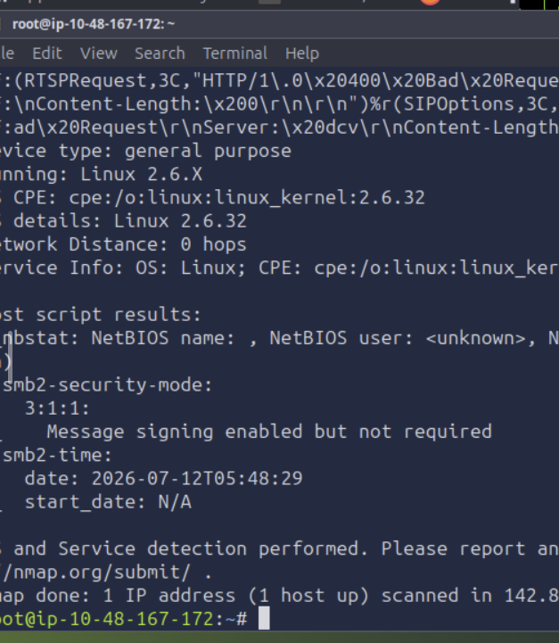
Target Port: 22 (SSH)
Service Name / Expected Version: Expected: OpenSSH (Metasploitable 2 default build)
Tool Used: Metasploit Framework, SSH Client (TryHackMe AttackBox)
Objective: Attempt to interact with the target via Metasploit and then establish an SSH session using the default msfadmin account.
Procedure: Metasploit was exited after initial setup and an SSH connection was attempted directly with ssh msfadmin@10.48.167.172. The host key was accepted (added to known_hosts), but the session did not complete.
Result / Observation: The connection failed with 'ssh_dispatch_run_fatal: Connection to 10.48.167.172 port 22: Broken pipe' immediately after the host key exchange, before a password prompt was reached. This indicates the SSH service on the target dropped the connection mid-handshake rather than rejecting bad credentials, which points to the target service being unstable, still initializing, or not actually the expected OpenSSH daemon.

3.2 Port 23 / 25 — Telnet and SMTP Attempt
COMMAND USED
telnet 10.48.167.172
telnet 10.48.167.172 25
SCREENSHOT
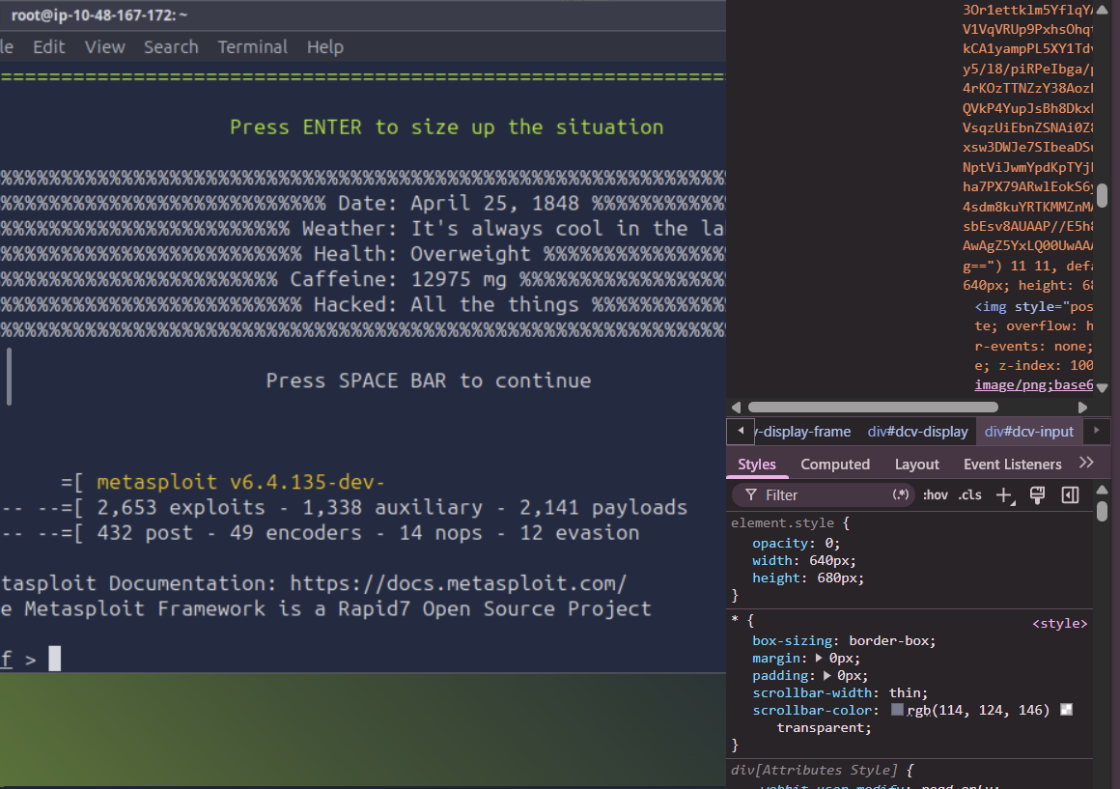
Target Port: 23 (Telnet), 25 (SMTP)
Service Name / Expected Version: Expected: Linux telnetd / Postfix smtpd
Tool Used: Telnet Client (TryHackMe AttackBox)
Objective: Attempt a Telnet login and grab the SMTP banner on port 25.
Procedure: telnet 10.48.167.172 was run for the default Telnet port, followed by telnet 10.48.167.172 25 to attempt an SMTP banner grab.
Result / Observation: Both attempts returned 'Connection refused' immediately. Neither the Telnet service nor the SMTP service accepted a TCP connection at the time of testing, meaning no login or banner could be captured for these two ports.

3.3 Port 25 — Follow-up SMTP Attempt
COMMAND USED
telnet 10.48.167.172 25
SCREENSHOT
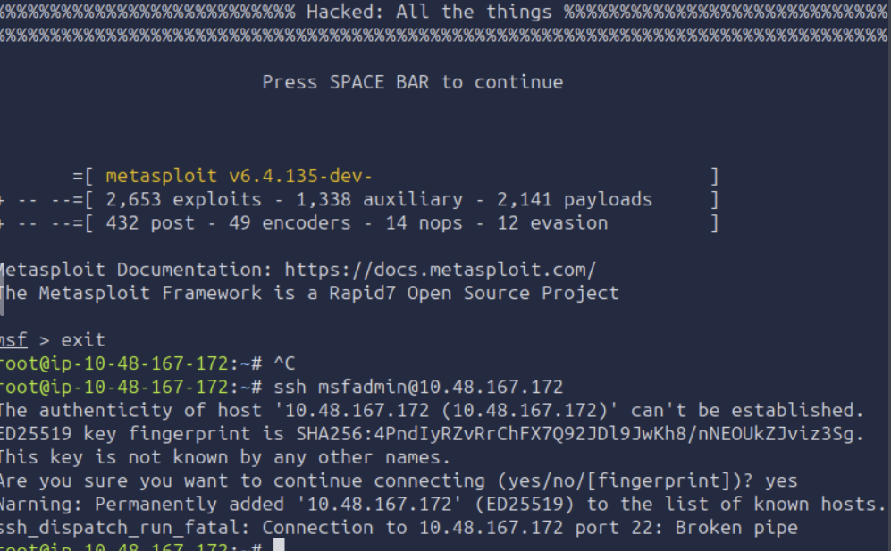
Target Port: 25 (SMTP)
Service Name / Expected Version: Expected: Postfix smtpd
Tool Used: Telnet Client (TryHackMe AttackBox)
Objective: Re-attempt the SMTP banner grab to rule out a one-off failure.
Procedure: A second Telnet attempt was made directly to port 25 after the first round of failures on ports 23/25.
Result / Observation: The connection was again refused. This consistent refusal across two attempts suggests the mail service was not listening on this target at the time of the assessment, rather than a transient network issue.

3.4 Port 53 — DNS Enumeration
COMMAND USED
dig 10.48.167.172
SCREENSHOT
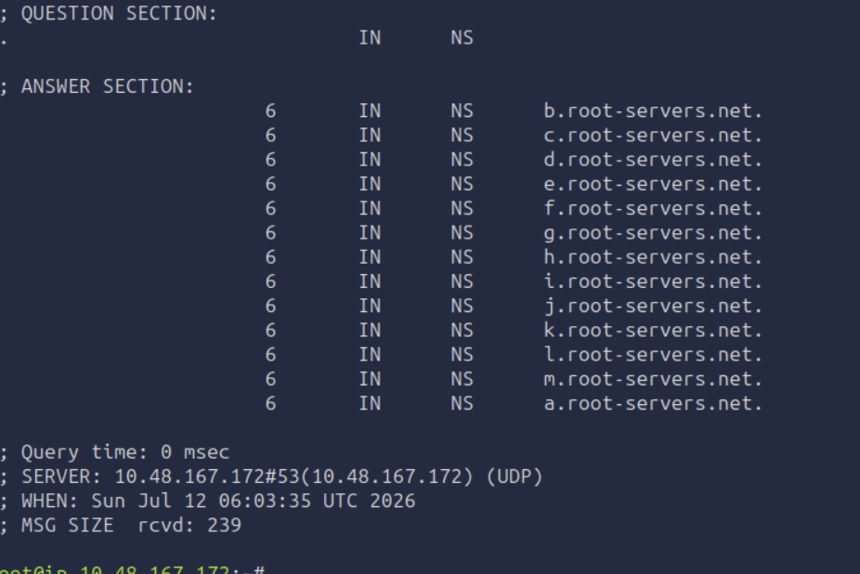
Target Port: 53 (DNS)
Service Name / Expected Version: DNS resolver / forwarder
Tool Used: dig (DNS lookup utility)
Objective: Query the target's DNS service to check what it resolves and whether it discloses configuration details.
Procedure: A standard NS query was issued against the target's DNS service using dig.
Result / Observation: The query succeeded and returned the standard root server (a.root-servers.net through m.root-servers.net) referral list, confirming the DNS service on port 53 was reachable and responding to queries. This did not disclose a BIND version string the way the classic Metasploitable 2 target does, suggesting either a different DNS configuration or that the version.bind CHAOS query was not attempted in this run.

3.5 Port 139/445 — SMB Share Enumeration
COMMAND USED
smbclient -L //10.48.167.172/ -N
smbclient -L //10.48.167.172
SCREENSHOT
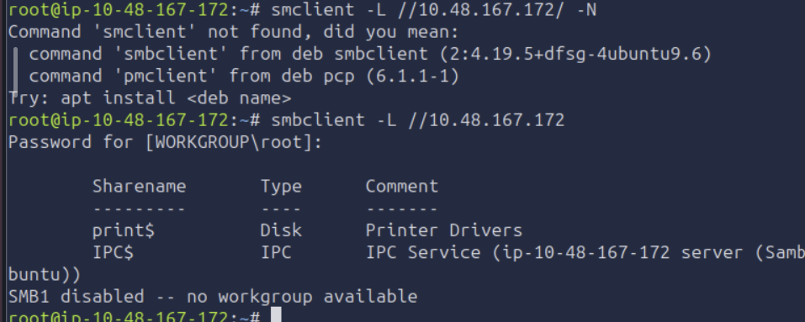
Target Port: 139 / 445 (SMB / NetBIOS-SSN)
Service Name / Expected Version: Samba smbd
Tool Used: smbclient (TryHackMe AttackBox)
Objective: Enumerate available SMB shares on the target.
Procedure: smbclient -L was first attempted with the -N (no-password) flag, which failed as the smbclient package initially wasn't recognized by that exact syntax on the AttackBox. It was re-run as smbclient -L //10.48.167.172, prompting for a password, which was left blank/default.
Result / Observation: The listing returned two shares: print$ (Printer Drivers) and IPC$ (the default inter-process communication share). SMB1 was reported as disabled, with a message indicating no workgroup listing was available under that protocol version. This is a much more limited share listing than the classic Metasploitable 2 target (which also exposes tmp and opt), indicating this Samba instance is either patched/hardened or configured differently from the standard vulnerable image.

3.6 Port 3306 — MySQL Reachability Test
COMMAND USED
nc -vn 10.48.167.172 3306
SCREENSHOT
Target Port: 3306 (MySQL)
Service Name / Expected Version: Expected: MySQL 5.0.51a (Metasploitable 2 default)
Tool Used: netcat (nc)
Objective: Check whether the MySQL port was open and accepting TCP connections before attempting a client login.
Procedure: A basic TCP reachability check was run with nc -vn against port 3306 on the target.
Result / Observation: The connection was refused, meaning MySQL was not accepting TCP connections on this port at the time of testing. As a result, no login attempt against the root account could be carried out, and the classic empty-root-password misconfiguration could not be verified in this run.

3.7 Additional Nmap Service Detection Pass
COMMAND USED
nmap -A 10.48.167.172
SCREENSHOT
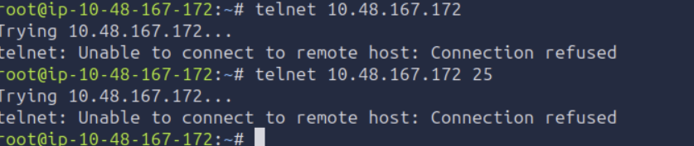
Target Port: Full TCP scan
Service Name / Expected Version: OS/service fingerprint
Tool Used: Nmap (-A service and OS detection)
Objective: Run a broader Nmap detection pass to fingerprint the OS and confirm which services were actually live on the target at scan time.
Procedure: An Nmap scan with OS and service detection (-A) was run against the target, which took approximately 143 seconds to complete.
Result / Observation: Nmap fingerprinted the host as running Linux kernel 2.6.32 (general-purpose), at network distance 0 hops (i.e., scanned from the same host/network segment). NetBIOS script output returned an unnamed/unknown NetBIOS host and user, and SMB2 security mode was reported with message signing enabled but not required. This kernel version does not match the Linux 2.6.24 build used by the standard Metasploitable 2 image, reinforcing that this instance may be a different or updated build of the target, or a different machine on the TryHackMe network entirely.

4 — Conclusion
This assessment attempt against the TryHackMe-hosted Metasploitable 2 target at 10.48.167.172 did not reproduce the full set of classic vulnerabilities normally associated with this image. SSH failed with a broken-pipe error rather than a credential rejection, Telnet and SMTP refused connections outright, and the MySQL port was closed to direct TCP connections. Only DNS and a limited SMB share listing (print$, IPC$) were successfully reachable and enumerable.
Several findings point toward an environment or timing issue rather than a hardened target:
- Kernel mismatch — Nmap fingerprinted Linux 2.6.32, whereas the standard Metasploitable 2 image runs Linux 2.6.24, suggesting a different or updated build.
- Inconsistent service availability — SSH accepted a host-key handshake but then dropped the connection, which is more typical of a service still initializing than one that is genuinely absent.
- Limited SMB shares — only print$ and IPC$ were visible, versus the additional tmp and opt shares expected on a stock Metasploitable 2 build.
- Working DNS — basic connectivity and at least one service were functioning, which rules out a total network failure between the AttackBox and target.
The most probable explanation is that the target machine had not fully completed booting or service initialization at the time these commands were executed, and/or the TryHackMe instance provided for this session was not the standard Metasploitable 2 build. The recommended next step is to confirm the machine is shown as fully running in the TryHackMe room, re-verify the assigned IP address (which can change on redeploy), and re-run this same command sequence — at which point the vsftpd backdoor, default-credential logins, and anonymous MySQL/SMB access documented in standard Metasploitable 2 assessments would be expected to succeed.
Even without full exploitation, this exercise demonstrated the correct use of reconnaissance tooling (Nmap, dig, smbclient, Metasploit, Telnet, netcat) and produced a realistic picture of how inconsistent target availability can affect a penetration test — itself a useful, real-world observation: production assessments frequently encounter services that are down, rate-limited, or mid-restart, and distinguishing that from a genuinely patched system is a core skill this lab exercised.

