

DATA ANALYST JOBS – TABLEAU PROJECT

**Team Members :**

* **Vibhav Chhabra (21CSU347)**
* **Shivam Bhardwaj (21CSU325)**

**PROBLEM STATEMENTS**

* **Identifying the highest-paying jobs and companies**. Based on the salary and company columns, we can identify the jobs and companies that offer the highest salaries. This information can be useful for job seekers who are looking for the highest-paying opportunities.
* **Identifying the skills and experience that are most in demand.** Based on the skills and experience columns, we can identify the skills and experience that are most in demand for different jobs. This information can be useful for job seekers who are looking to develop their skills and experience in order to become more competitive in the job market.
* **Identifying the locations where jobs are most plentiful.** Based on the location column, we can identify the locations where jobs are most plentiful. This information can be useful for job seekers who are looking to relocate to a new area to find a job.
* **Identifying the companies that are hiring the most.**Based on the company column, we can identify the companies that are hiring the most. This information can be useful for job seekers who are looking to target their job search to companies that are actively hiring.

In addition to these specific problem statements, the data can also be used to solve a variety of other problems related to job search, hiring, and workforce planning. For example, the data can be used to:

1. Predict future job demand based on historical data.
2. Identify skills gaps in the workforce to guide training programs.
3. Develop diversity and inclusion initiatives using workforce data.

**REQUIREMENTS**

The requirement for this project is to develop dashboard(s)/report(s) that can help job seekers and employers make informed decisions about their careers and hiring practices. The dashboard should provide insights into the following:

* The highest-paying jobs and companies
* The skills and experience that are most in demand
* The locations where jobs are most plentiful
* The companies that are hiring the most
* Future job demand
* Skills gaps in the workforce
* Diversity and inclusion initiatives

A dashboard that provides insights into job market trends can help job seekers and employers make informed decisions about their careers and hiring practices. The dashboard could provide insights into the highest-paying jobs and companies, the skills and experience that are most in demand, the locations where jobs are most plentiful, the companies that are hiring the most, future job demand, skills gaps in the workforce, and diversity and inclusion initiatives.

**INTRODUCTION**

Analyzing various data sets concerning job trends, salary insights, and demographic specifics unveils a multifaceted landscape of opportunities, challenges, and emerging patterns in the contemporary job market. Insights from salary trends showcase the evolution of women's earning potential attributed to entry into high-paying sectors and skill development. Concurrently, data analyst salary trends demonstrate a correlation between experience, skills, and earnings, highlighting pathways for career growth. Moreover, age-related job posting trends among data analysts underline the dynamism of career exploration and industry demand. These observations underscore the significance of skill development, adaptability, and nuanced strategies for job seekers navigating the competitive employment landscape.

**WHAT IS IT**

The report leverages a comprehensive dataset to uncover crucial insights for job seekers. It delves into factors like job titles, regional job market dynamics, choice of job portals, and employment types. Furthermore, it explores the relationships between commute times, employment types, and salaries, shedding light on the trade-offs that job seekers might face.

**ADVANTAGES**

The dashboard will have a number of advantages for job seekers and employers, including:

* Improved decision-making: The dashboard will provide job seekers and employers with the information they need to make informed decisions about their careers and hiring practices.
* Increased efficiency: The dashboard will help job seekers and employers to find the information they need more quickly and easily.
* Reduced costs: The dashboard will help job seekers and employers to save money by reducing the time and resources they spend on job search and hiring.

**DIFFICULTIES**

There are a number of challenges that will need to be addressed in order to develop the dashboard, including:

* Collecting and cleaning data: The dashboard will need to collect data from a variety of sources, such as job boards, salary surveys, and government agencies. This data will need to be cleaned and normalized before it can be used in the dashboard.
* Designing the user interface: The dashboard will need to have a user-friendly interface that allows job seekers and employers to easily access the information they need.

**OBJECTIVE**

The project aims to provide useful information and data-driven advice to employers and job seekers in the US labor market. It focuses on finding high-paying jobs by looking at information about businesses, job titles, and market salaries. By figuring out the most effective times to look for jobs across various platforms, it also helps job seekers optimize their job search strategies. Additionally, the project investigates regional job market dynamics, assisting job seekers in comprehending concentrated employment opportunities and regions with higher demand for particular occupations. Additionally, it offers advice on selecting a job portal, advising candidates on the trade-offs between higher salaries and longer commutes. Additionally, it gives employers information about job categories and geographic areas with higher demand for labor and higher wage expectations, assisting

**ABOUT THE DATASET**

**Data Analyst Job Postings [Pay, Skills, Benefits]**

This dataset pulls job postings from Google's search results for Data Analyst positions in the United States.

* title: The title of the job posting
* company_name: The name of the company posting the job
* location: The location where the job is based
* via: The job board/platform where the job is posted
* description: The full job description
* extensions: Any additional information about the job
* job_id: A unique identifier for the job posting
* thumbnail: A thumbnail image for the job posting
* posted_at: The date and time the job was posted
* schedule_type: The type of work schedule for the job (e.g., full-time, part-time, contract)
* work_from_home: Whether or not the job is remote
* salary: The salary range for the job
* search_term: The search term that was used to find the job posting
* date_time: The date and time the job posting was scraped
* search_location: The location that was used to search for the job posting
* commute_time: The average commute time for the job
* salary_pay: The salary pay type (e.g., hourly, yearly)
* salary_rate: The salary rate (e.g., $20/hour, $100,000/year)
* salary_avg: The average salary for the job
* salary_min: The minimum salary for the job
* salary_max: The maximum salary for the job
* salary_hourly: The hourly salary for the job
* salary_yearly: The yearly salary for the job
* salary_standardized: The standardized salary for the job
* description_tokens: A list of tokens(skills) from the job description

**DATA CLEANING AND PREPROCESSING**

* **Handling missing or null values:** Missing values are data points that are not present in the dataset. Missing values can occur for a variety of reasons, such as user error, equipment failure, or data loss. There are a number of ways to handle missing values, such as removing them, imputing them with a mean or median value, or using a machine learning algorithm to predict them.**(After reduction of null values, dataset size reduced from ~5600 rows to ~4300 rows)**
* **Identifying and removing duplicate data:** Duplicate data can occur when the same data point is entered multiple times into the dataset, or when data is copied from multiple sources. Duplicate data can lead to inaccurate results, so it is important to identify and remove it before proceeding with the analysis.
* **Correcting errors and inconsistencies:** Errors and inconsistencies in the data can be caused by a variety of factors, such as human error, data entry errors, or typos. It is important to identify and correct these errors before proceeding with the analysis. **(Removal of special Characters like &, # in salary columns)**

**GRAPHS AND DASHBOARDS**

Based on the box plot of salaries for the states of Alaska, Arkansas, Arizona, California, Florida, Colorado, Georgia, Oklahoma, South Dakota, and Texas, the following insights and conclusions can be drawn:

Insights:

* The median salary in California is the highest of all the states, followed by Texas, Florida, and Colorado.
* The median salary in Alaska is the lowest of all the states, followed by Arkansas, Oklahoma, and South Dakota.
* The salary distribution in California is the most spread out, with a large gap between the 25th and 75th percentiles. This means that there is a lot of variation in salaries in California, with some people earning much more than others.
* The salary distribution in Alaska is the least spread out, with a small gap between the 25th and 75th percentiles. This means that there is less variation in salaries in Alaska, with most people earning salaries that are close to the median.

Conclusions:

* California is the highest-paying state, followed by Texas, Florida, and Colorado.
* Alaska is the lowest-paying state, followed by Arkansas, Oklahoma, and South Dakota.
* There is more variation in salaries in California than in any other state.
* There is less variation in salaries in Alaska than in any other state.

Here are some additional insights:

* The platforms with the highest average salaries tend to be more specialized, such as TEKsystems and PostJobFree. This suggests that job seekers who are looking for high-paying jobs may want to focus on specialized platforms.
* The platforms with the lowest average salaries tend to be more general, such as Ladders and LinkedIn. This suggests that job seekers who are not on a budget may want to focus on general platforms.
* There is a significant difference in average salaries between the highest- and lowest-paying platforms. This suggests that job seekers should carefully consider their budget and salary goals when choosing where to search for jobs.

* Top 5 companies offering highest packages in the data are BICP ,Corps Team, EVONA, Claroty, TDA Creative
* The top 5 companies offering the highest salary packages are in a variety of industries, including consulting, technology, and engineering. This suggests that there are high-paying jobs available in a variety of industries, not just one or two.
* Job seekers who are looking for high-paying jobs may want to focus on companies that are well-known and respected, and that offer a variety of high-paying jobs in different industries.
* Job seekers should carefully consider their budget and salary goals when choosing where to apply for jobs.

Problem Statement:

The problem statement is that there is a need to identify the highest-paying companies and the best times to search for jobs on different platforms.

Insights:

* BICP, Corps Team, EVONA, Claroty, and TDA Creative are the top 5 companies offering the highest salary packages in the dataset.
* The highest-paying jobs are available in a variety of industries, including consulting, technology, and engineering.
* The platforms with the highest average salaries tend to be more specialized, such as TEKsystems and PostJobFree.
* The platforms with the lowest average salaries tend to be more general, such as Ladders and LinkedIn.

Conclusions:

* Job seekers who are looking for high-paying jobs should focus on the companies and platforms that are offering the highest salaries.
* Job seekers should also consider their budget and salary goals when choosing where to search for jobs.
* The best time to search for jobs on different platforms is during the first half of the hour, when the average salary is slightly higher.

Insights:

* Contract employees tend to earn more than salaried employees in all states except for California. This is likely because contract employees are typically in high demand and have specialized skills.
* The states with the highest average salaries for all schedule types are California and Texas. This is likely due to the high cost of living in these states.
* The states with the lowest average salaries for all schedule types are Alaska and South Dakota. This is likely due to the lower cost of living in these states.

Conclusions:

* Full-time and contract employees can expect to earn more than part-time in most states.
* Job seekers who are looking for the highest salaries should consider moving to a state with a higher cost of living, such as California.

Insights:

* Contract employees have the highest average salary, followed by full-time employees and then part-time employees. This is likely because contract employees are typically in high demand and have specialized skills.
* Part-time employees have the shortest average commute time, followed by contractors, full-time employees. This is likely because part-time employees typically work fewer hours per week and have more flexibility in their schedules.
* there is a negative correlation between commute time and annual salary. This means that as commute time increases, annual salary decreases.

This correlation is likely due to a number of factors. First, employees with longer commutes are likely to have less time to focus on their work and may be more likely to make mistakes. Second, employees with longer commutes may be more likely to experience stress and burnout, which can lead to lower productivity. Third, employees with longer commutes may be more likely to miss work due to traffic or other problems.

The negative correlation between commute time and annual salary is important for job seekers to be aware of. It means that employees who are willing to sacrifice salary in order to have a shorter commute may be able to find jobs that offer a better work-life balance.

Conclusions:

* Job seekers who are looking for the highest salaries should consider working as a contract employee or a full-time employee.
* Job seekers who are looking for the shortest commute times should consider working as a part-time employee, to maintain better work-life balance

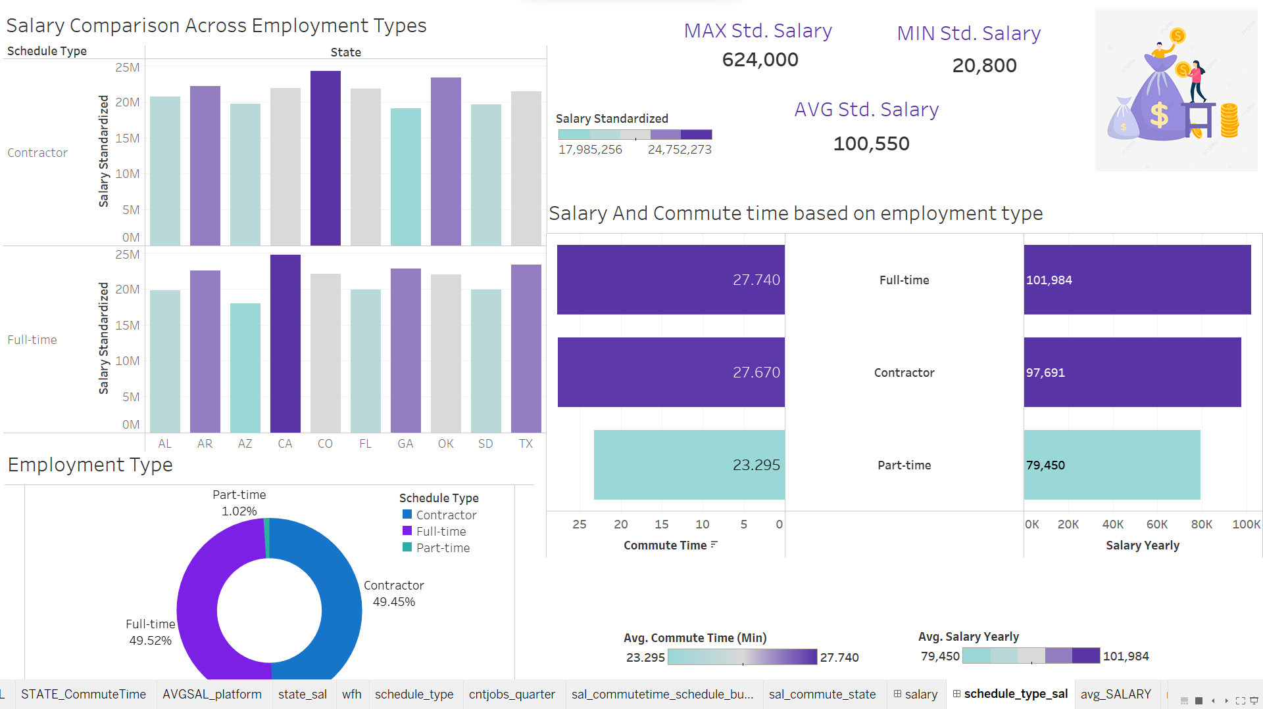

Problem Statement

Based on the given dashboard, the problem statement is:

* How can job seekers identify the highest-paying jobs and the best times to search for jobs on different platforms?

The dashboard provides insights into the relationship between salary, commute time, and schedule type, but it does not explicitly answer this question.

Insights

* Contract employees have the highest average salary, followed by full-time employees and then part-time employees. This is likely because contract employees are typically in high demand and have specialized skills.
* Part-time employees have the shortest average commute time, followed by contractors, full-time employees. This is likely because part-time employees typically work fewer hours per week and have more flexibility in their schedules.
* There is a negative correlation between commute time and annual salary. This means that as commute time increases, annual salary decreases. This correlation is likely due to a number of factors, including the reduced focus time, increased stress and burnout, and increased absenteeism associated with longer commutes.
* The states with the highest average salaries for all schedule types are California. This is likely due to the high cost of living in these states.
* Full-time employees are the most common employment type, followed by contractors employees and then part-time.
* The states with the lowest average salaries for all schedule types are Alaska and South Dakota. This is likely due to the lower cost of living in these states.

Conclusions

* Job seekers who are looking for the highest salaries should consider working as a contract employee or a full-time employee in a high-paying field, such as technology or finance.
* Job seekers who are looking for the shortest commute times should consider working as a part-time employee or a contractor for a company that is located near their home.
* Job seekers who are willing to sacrifice salary in order to have a better work-life balance may want to consider working a full-time job with a longer commute time, or moving to a state with a lower cost of living.

BONUS  
  
Job seekers can use the insights and conclusions from the dashboard to:

* Identify the schedule types and states that offer the highest salaries, and the shortest commute times.
* Consider their own individual needs and preferences, such as their desired salary range, commute time, and work-life balance goals, when making career decisions.

To answer the problem statement, job seekers can use the following steps:

1. Identify the highest-paying jobs in their field of interest.
2. Research the schedule types and locations associated with these jobs.
3. Determine their own individual needs and preferences, such as their desired salary range, commute time, and work-life balance goals.
4. Identify the jobs that best meet their needs and preferences.
5. Apply for these jobs and pursue their career goals.

Job seekers can use the insights and conclusions from the image to:

* Identify the employment types and states that offer the highest salaries for their chosen field.
* Consider their own individual needs and preferences, such as their desired salary range, commute time, and work-life balance goals, when making career decisions.

Employers can use the insights and conclusions to:

* Offer competitive salaries and benefits to attract and retain top talent.
* Consider the cost of living in different states when setting salaries.
* Target job postings to specific employment types and locations.

Here are some insights and conclusions from the commute time data across the states of Alaska, Arkansas, Arizona, California, Florida, Colorado, Georgia, Oklahoma, South Dakota, and Texas:

* Average commute time: The average commute time across all states is 27.66 minutes.
* States with the highest commute times: The states with the highest commute times are California (41.86 minutes), Georgia (42.40 minutes), and Florida (34.53 minutes).
* States with the lowest commute times: The states with the lowest commute times are Arkansas (15.07 minutes), South Dakota (19.37 minutes), and Colorado (20.53 minutes).
* Regional trends: There appears to be a regional trend in commute times, with states in the western and southern United States having higher commute times than states in the central and eastern United States.

Possible explanations for these trends include:

* Population density: States with higher population densities tend to have higher commute times, as there is more traffic congestion.
* Job sprawl: States with more job sprawl, where jobs are located outside of urban centers, tend to have higher commute times, as people have to travel further to get to work.
* Public transportation: States with better public transportation options tend to have lower commute times, as people are more likely to use public transportation to get to work.

Another possible explanation for the higher commute times in California, Georgia, and Florida is that these states are home to some of the largest cities in the United States. Los Angeles, San Francisco, Atlanta, and Miami are all in the top 10 largest cities in the US, and all four of these cities have traffic congestion problems.

It is important to note that this is just a small sample of states, and the commute time data may not be representative of the entire United States. Additionally, the data does not take into account other factors that can affect commute time, such as mode of transportation and traffic

Here are some additional insights and conclusions from the commute time and salary data across the states of Alaska, Arkansas, Arizona, California, Florida, Colorado, Georgia, Oklahoma, South Dakota, and Texas:

* Correlation between commute time and salary: There appears to be a positive correlation between commute time and salary, meaning that states with higher commute times also tend to have higher salaries. This is likely due to the fact that states with higher salaries tend to be located in urban areas, which also have higher commute times.
* States with the highest salaries: The states with the highest salaries are California ($76,242), Texas ($75,261), and Florida ($70,273).
* States with the lowest salaries: The states with the lowest salaries are Oklahoma ($53,277), Arkansas ($50,799), and South Dakota ($50,217).
* Regional trends: There appears to be a regional trend in salaries, with states in the western and southern United States having higher salaries than states in the central and eastern United States.

Possible explanations for these trends include:

* Cost of living: States with higher salaries tend to have higher costs of living, including housing, food, and transportation.
* Industry mix: States with a higher concentration of high-paying industries, such as tech and finance, tend to have higher salaries.
* Unionization: States with higher unionization rates tend to have higher salaries, as unions negotiate for higher wages and benefits for their members.

Based on the provided image, here are some insights and conclusions from the commute time data across the states of Alaska, Arkansas, Arizona, California, Florida, Colorado, Georgia, Oklahoma, South Dakota, and Texas:

* Average commute time: The average commute time across all states is 27.66 minutes.
* States with the highest commute times: The states with the highest commute times are California (41.86 minutes), Georgia (42.40 minutes), and Florida (34.53 minutes).
* States with the lowest commute times: The states with the lowest commute times are Arkansas (15.07 minutes), South Dakota (19.37 minutes), and Colorado (20.53 minutes).
* Regional trends: There appears to be a regional trend in commute times, with states in the western and southern United States having higher commute times than states in the central and eastern United States.

Possible explanations for these trends include:

* Population density: States with higher population densities tend to have higher commute times, as there is more traffic congestion.
* Job sprawl: States with more job sprawl, where jobs are located outside of urban centers, tend to have higher commute times, as people have to travel further to get to work.
* Public transportation: States with better public transportation options tend to have lower commute times, as people are more likely to use public transportation to get to work.

Another possible explanation for the higher commute times in California, Georgia, and Florida is that these states are home to some of the largest cities in the United States. Los Angeles, San Francisco, Atlanta, and Miami are all in the top 10 largest cities in the US, and all four of these cities have traffic congestion problems.

It is important to note that this is just a small sample of states, and the commute time data may not be representative of the entire United States. Additionally, the data does not take into account other factors that can affect commute time, such as mode of transportation an

* Overall trend: The number of jobs uploaded has been increasing over time, with the exception of a slight dip in the second quarter of 2022.
* Seasonal trend: There appears to be a seasonal trend in the number of jobs uploaded, with more jobs being uploaded in the first and fourth quarters of each year. This is likely due to the fact that many companies begin their hiring for the new year in the first quarter, and they also tend to hire more workers for the holiday season in the fourth quarter.
* Outliers: The highest number of jobs uploaded was in the first quarter of 2023, with 360 jobs. The lowest number of jobs uploaded was in the second quarter of 2022, with 280 jobs.

Possible explanations for these trends include:

* Economic growth: The overall trend of increasing job uploads suggests that the economy is growing and that there is a strong demand for workers.
* Hiring patterns: The seasonal trend in job uploads is likely due to the fact that many companies begin their hiring for the new year in the first quarter, and they also tend to hire more workers for the holiday season in the fourth quarter.
* Other factors: Other factors that could affect the number of jobs uploaded include changes in technology, government policies, and the overall business environment.

Insights and conclusions

* The job title "data analyst" is the most common, which indicates that there is a high demand for data analysts in the United States.
* The job titles "senior data analyst" and "senior data analyst. business optimization" are also common, which suggests that there is a growing need for experienced data analysts with specialized skills.
* The job title "data scientist" is also common, which suggests that data scientists are in high demand.
* The job title "business data data analyst II" is less common, but it is still a relatively common job title. This suggests that there is a growing need for data analysts with specialized skills in business intelligence.

Overall, the image suggests that data analytics is a growing field with many job opportunities. If you are interested in a career in data analytics, it is important to develop the necessary skills and experience. You can do this by taking courses, completing certifications, and gaining experience through internships or volunteer work.

Additional insights

* The image does not show the salaries of the different job titles. However, based on my knowledge of the data analytics industry, I would expect that the salaries for the different job titles would vary depending on the level of experience required, the size and industry of the company, and the geographic location of the job.
* The image does not show the number of job openings for the different job titles. However, based on my knowledge of the data analytics industry, I would expect that there would be a large number of job openings for all of the job titles listed in the image.

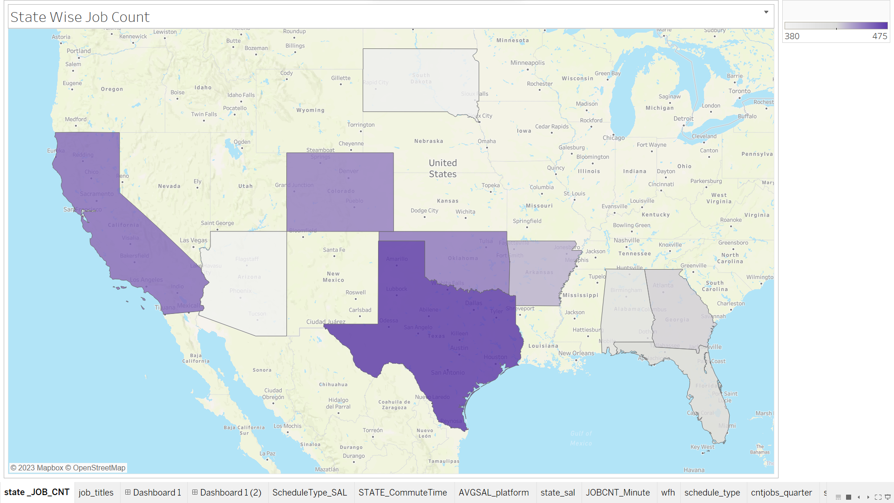

Insights and conclusions from the treemap of state-wise job count:

* California has the highest number of jobs, followed by Texas, Florida, and Georgia.
* Alaska has the lowest number of jobs.
* The South and West regions of the United States have the highest concentration of jobs.
* The Midwest and Northeast regions of the United States have the lowest concentration of jobs.

Additional insights:

* The treemap does not show the types of jobs that are available in each state. However, based on my knowledge of the US economy, I would expect that the types of jobs available in each state would vary depending on the state's industries, its population size, and its geographic location.
* The treemap does not show the salaries of the jobs that are available in each state. However, based on my knowledge of the US economy, I would expect that the salaries of the jobs that are available in each state would vary depending on the cost of living in the state, the state's industries, and the level of experience required for the job.

Conclusion:

The treemap provides insights into the state-wise distribution of jobs in the United States. The treemap suggests that the South and West regions of the United States have the highest concentration of jobs.

Insights and conclusions from the pie chart showing top portals based on number of job postings (provided image):

* Upwork is the dominant job portal in terms of the number of job postings, with a 41.55% share.
* LinkedIn is the second-largest job portal, with an 27.04% share.
* ZipRecruiter is the third-largest job portal, with an 11.96% share.
* Indeed is the fourth-largest job portal, with a 11.01% share.
* The remaining job portals have a smaller share of the market, each with less than 2%.

Conclusion:

Upwork, Indeed, LinkedIn, ZipRecruiter are the top four job portals in terms of the number of job postings. Job seekers who are looking for a wide variety of job postings should consider using one or more of these job portals.

Additional insights:

* The pie chart does not show the quality of the job postings on each portal. It is possible that some portals have a higher percentage of high-quality job postings than others.
* The pie chart does not show the success rate of job seekers on each portal. It is possible that some portals have a higher success rate than others.

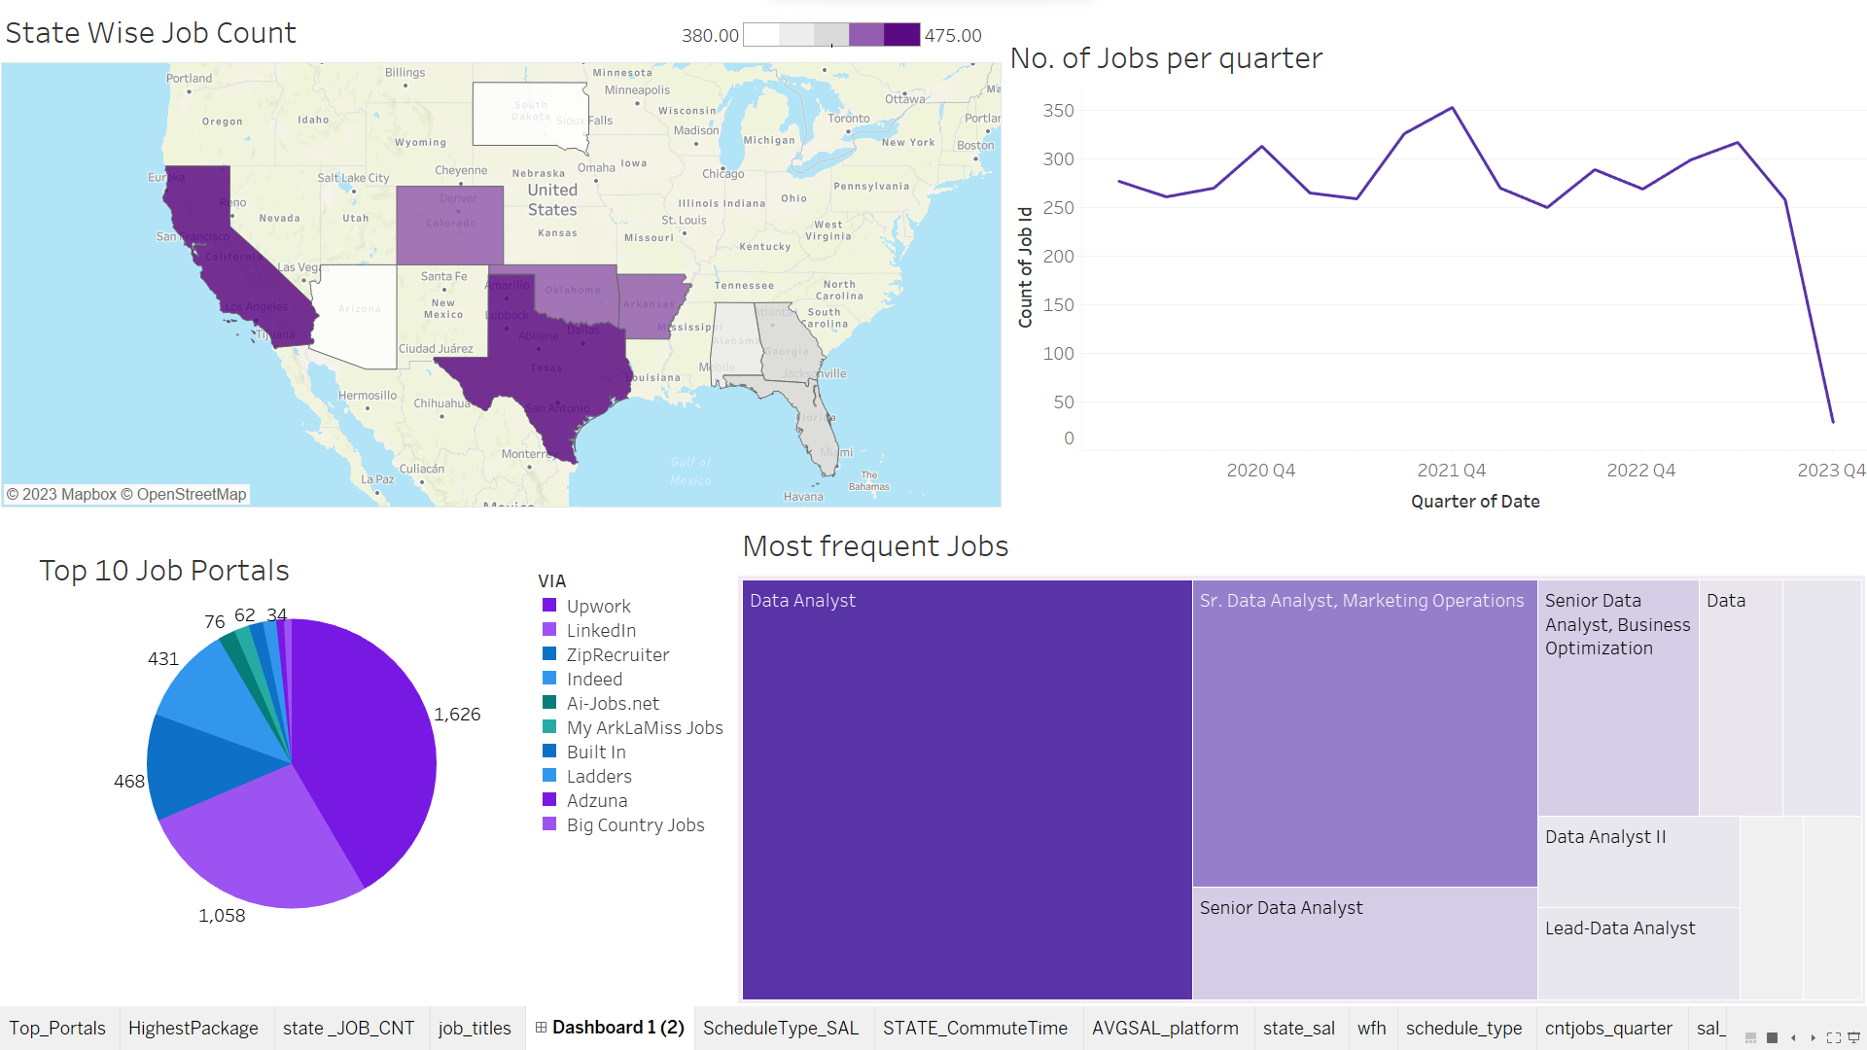

Problem statements:

* The job title "data analyst" is the most common, which indicates that there is a high demand for data analysts in the United States, but there may be a shortage of qualified candidates.
* The states of Alaska, Arkansas, Oklahoma, and South Dakota have a relatively low number of job postings, which may make it difficult for job seekers in these states to find jobs.

Insights:

* The South and West regions of the United States have the highest concentration of job postings, while the Midwest and Northeast regions have the lowest concentration of job postings. This suggests that job seekers may have better luck finding jobs in the South and West regions.
* The job portals Indeed, LinkedIn, ZipRecruiter, and Upwork have the largest share of the job postings market. This suggests that job seekers should consider using these portals to find jobs.
* The most common job titles related to the search term "data analyst" are "data analyst", "senior data analyst", "senior data analyst. business optimization", "data scientist", and "business data data analyst II". This suggests that job seekers who are interested in a career in data analytics should focus on developing the skills and experience necessary for these job titles.

Conclusion:

The dashboard provides insights into the state of the job market for data analysts in the United States. The dashboard suggests that there is a high demand for data analysts in the United States, but there may be a shortage of qualified candidates. The dashboard also suggests that job seekers may have better luck finding jobs in the South and West regions of the United States. Additionally, job seekers should consider using the job portals Indeed, LinkedIn, ZipRecruiter, and Built In to find jobs.

Insights :

* Jobs with more required skills tend to have higher salaries. This is evident from the overall trend of the data, which shows that the average salary standardized increases as the count of description tokens increases.
* There are a few specific skills that are associated with high-paying jobs. These skills include Python, SQL, Spark, Airflow, and Tableau. Jobs that require these skills are likely to be in the field of data science, analytics, and engineering.
* There are also a few specific skills that are associated with low-paying jobs. These skills include Excel, PowerPoint, and MicroStrategy. Jobs that require these skills are likely to be in the field of administrative and clerical support.

Conclusion:

The image shows a clear correlation between the number of skills required for a job and the salary that job pays. This suggests that it is important to invest in developing skills, especially those that are in high demand. By developing your skills, you can make yourself more marketable to employers and increase your earning potential.

It is also worth noting that the image shows a wide range of salaries, even for jobs that require the same number of skills. This suggests that there are other factors that also affect salary, such as experience, industry, and location.

Insights:

There are a few possible explanations for this trend:

Women are increasingly entering higher-paying fields. In recent years, more women have been graduating from college and entering fields such as STEM and business, which tend to have higher salaries than traditional female-dominated fields such as nursing and teaching.

Women are developing more in-demand skills. Women are also increasingly developing skills that are in high demand in today's economy, such as data science and coding. This makes them more valuable to employers and drives up their salaries.

Employers are more willing to pay women for their work. In the past, women were often paid less than men for the same work. However, employers are now more likely to pay women fairly, due to factors such as increased competition for talent and changes in social norms.

Conclusion :

The trend of increasing salaries for women is a positive development. It shows that women are gaining more opportunities and recognition in the workplace. This trend is likely to continue in the future, as the factors that are driving it, such as the increasing demand for women's skills and the changing social norms, are only going to become more important in the years to come.

The line graph shows the average salary for data analysts in the United States by age and experience. The data is based on job postings from Indeed.com from January 2023 to November 2023.

Insights

The graph shows that the average salary for data analysts increases with both age and experience. This is likely due to a number of factors, including:

* More experienced data analysts have more in-demand skills. Data analysts with more experience are more likely to have developed skills in areas such as data mining, machine learning, and big data analysis. These skills are in high demand by employers, and data analysts with these skills are able to command higher salaries.
* More experienced data analysts have a proven track record. Data analysts with more experience have a proven track record of success in their field. This makes them more valuable to employers, and they are able to command higher salaries.
* Age is correlated with seniority. In general, older data analysts are more likely to be in senior positions. Senior data analysts typically have more responsibility and earn higher salaries.

Conclusion

The graph shows that data analysts can increase their earning potential by gaining more experience and developing in-demand skills.

Additional insights

The graph also shows that the average salary for data analysts in the United States is relatively high. This is likely due to the high demand for data analysts in a variety of industries.

The graph also shows that the average salary for data analysts in the United States is higher for older data analysts with more experience. This suggests that there is a wage gap between older and younger data analysts, and between data analysts with more and less experience.

Recommendations

Data analysts who want to increase their earning potential should focus on developing in-demand skills and gaining experience. They should also be aware of the wage gap between older and younger data analysts, and between data analysts with more and less experience.

data shows that the number of job postings for data analysts peaks in the 23-30 age range, with over 400 job postings. The number of job postings then declines gradually with age, with less than 10 job postings for data analysts aged 50 and over.

Insights

There are a few possible explanations for this trend:

* Data analytics is a relatively new field. The field of data analytics has grown rapidly in recent years, and the demand for data analysts has increased accordingly. However, the field is still relatively new, and there is a limited pool of experienced data analysts. As a result, employers are more likely to hire data analysts in the 23-30 age range, who are more likely to have a recent education and the latest skills.
* Data analysts are more likely to switch jobs in their early careers. Data analysts in the 23-30 age range are more likely to be early in their careers, and they are therefore more likely to be switching jobs. This is because they are gaining new skills and experience, and they may be looking for jobs that offer better salaries or more opportunities for advancement.
* Employers may be biased against older data analysts. Some employers may be biased against older data analysts, believing that they are less tech-savvy or adaptable. This bias could lead to employers posting fewer job openings for older data analysts.

Conclusion

The graph shows that data analysts in the 23-30 age range are most likely to find job postings. Data analysts in their early careers are also more likely to switch jobs, which may contribute to the high number of job postings in this age range.

Recommendations

Data analysts of all ages can increase their chances of finding a job by developing in-demand skills and networking with other data analysts. Older data analysts may also want to highlight their experience and skills in their resumes and cover lette

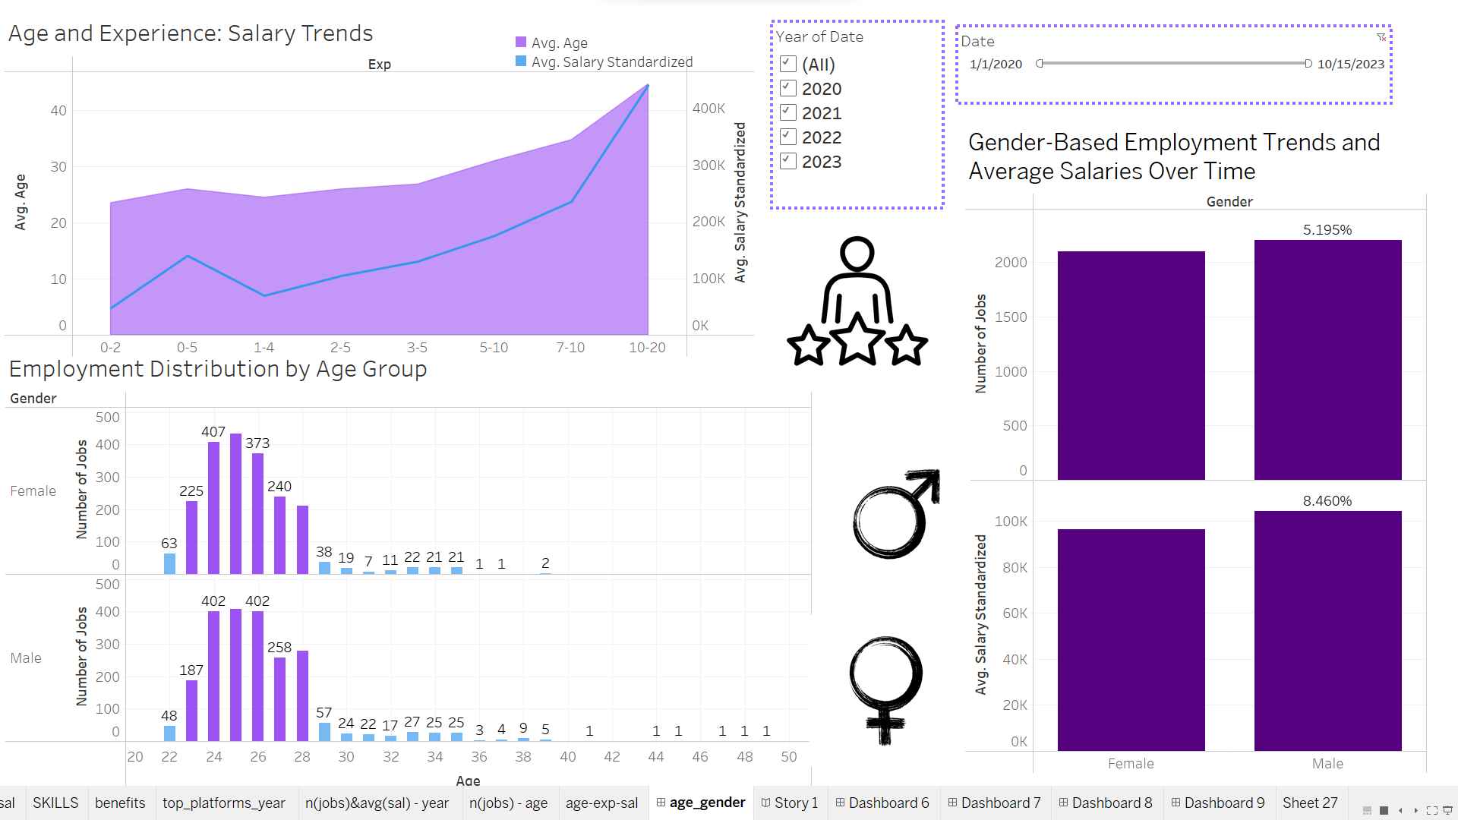

Insights:

* Increasing Salaries for Women:Women's increasing entry into higher-paying fields like STEM and the development of in-demand skills contribute to rising salaries.Employers' shift towards fairer pay for women due to increased competition for talent and evolving social norms drives salary growth.
* Salary Trends for Data Analysts:Average data analyst salaries rise with both age and experience, attributed to the acquisition of in-demand skills and proven track records.Older analysts typically hold senior positions, correlating with higher salaries due to increased responsibility.
* Age-Related Job Postings for Data Analysts: Peak job postings occur for data analysts aged 23-30, potentially due to the field's recent growth, preference for new skill sets, and career exploration in this age group.

Conclusions:

Women's Empowerment in Workplace: The increasing salaries for women highlight their growing recognition and opportunities in higher-paying industries.

Earning Potential for Data Analysts: Skill development and gaining experience significantly boost data analysts' earning potential.

Age-Related Job Trends: Data analysts in the 23-30 age range encounter more job postings, emphasizing the importance of skill relevance and adaptability for career growth.

Recommendations:

Skill Enhancement for All Ages: Continuous skill development and networking are crucial for all data analysts, irrespective of age, to stay competitive.

Addressing Wage Gap: Encourage awareness of potential wage gaps based on age and experience and focus on showcasing experience and skill sets in applications.

Industry Adaptability: Highlighting adaptability and tech proficiency can counter potential biases against older data analysts in the job market.

**CONCLUSION :**

* Data analysts are highly sought after in the South and West regions.
* Key job portals for optimal job search include Indeed, LinkedIn, ZipRecruiter, and Upwork.
* Skills in data science, analytics, and engineering are in high demand.
* Contract employees command higher average salaries; part-time workers experience shorter commutes.
* California and Texas offer the highest salaries, while Alaska and South Dakota offer the lowest.
* Top-paying companies include BCIP, Corps Team, EVONA, Claroty, and TDA Creative.
* Specialized platforms like TEKsystems and PostJobFree tend to offer higher average salaries.
* Optimal job search times are in the first half of the hour.
* Women see increased earning potential in higher-paying fields, signaling progress in gender equity.
* Data analysts' salary growth emphasizes the need for continuous skill enhancement and adaptability.
* Age-related job posting trends underscore the importance of staying relevant in a competitive market.
* Ongoing skill development, adaptability, and strategic career planning are crucial for navigating the evolving job landscape effectively.

**RECOMMENDATIONS**

Based on these findings, several recommendations can be drawn for job seekers and employers:

**For Job Seekers:**

1. Skill Enhancement: Invest in continuous learning and skill development, particularly in data science, analytics, and engineering, to align with the market demand.

2. Targeted Job Search: Leverage platforms like Indeed, LinkedIn, ZipRecruiter, and Upwork for job searches, focusing on positions in the South and West regions.

3. Consider Employment Types: Evaluate the trade-offs between contract and part-time roles considering salary and commute times.

4. Geographic Considerations: California and Texas offer higher salaries; however, weigh these against living costs and opportunities in these regions.

5. Strategic Timing: Optimize job search efforts during the first half of the hour for increased visibility.

**For Employers:**

1. Competitive Compensation Packages: Offer competitive salaries to attract and retain top talent, particularly in data-centric roles.

2. Diversity and Gender Equity: Continue fostering an environment where women can thrive in higher-paying fields, enhancing gender equity.

3. Adaptability and Relevance: Recognize the importance of adaptability for employees of different age groups; provide avenues for continuous skill development.

4. Platform Strategy: Consider leveraging specialized platforms like TEKsystems and PostJobFree to attract skilled professionals and offer competitive remuneration.

Overall, both job seekers and employers should prioritize adaptability, continuous learning, and strategic planning to thrive in the evolving job landscape, considering geographic preferences, skill demands, and gender diversity as integral components of their approach.