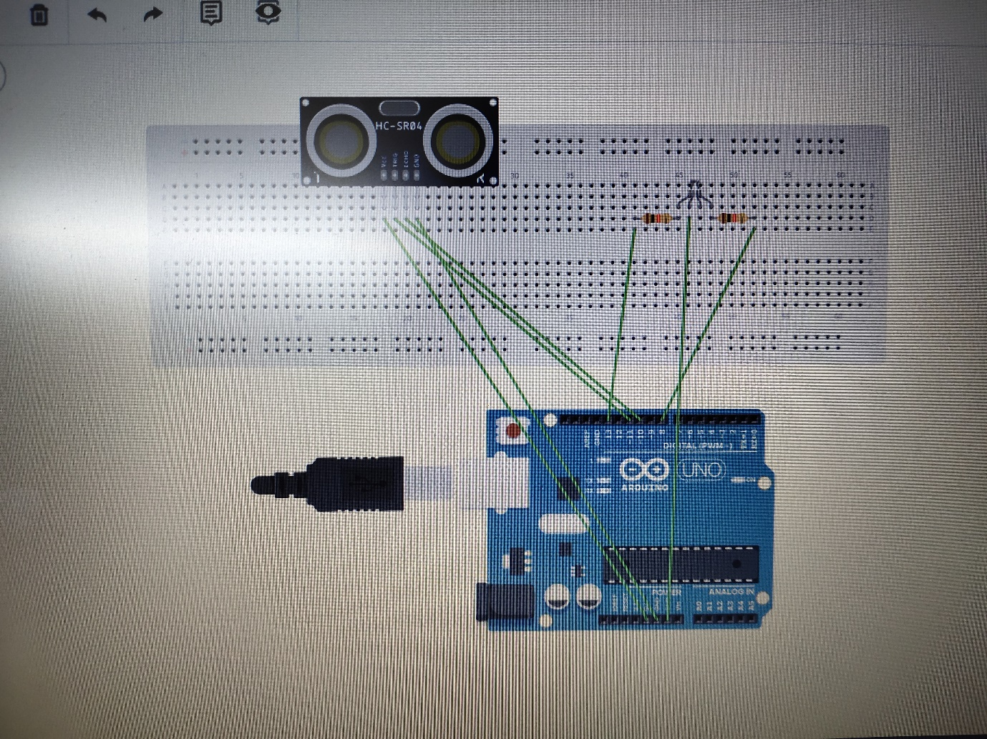

const int trigPin=11;

const int echoPin=10;

int duration;

int distance;

void setup()

{pinMode(trigPin,OUTPUT);

pinMode(echoPin,INPUT);

Serial.begin(9600);

pinMode(13,OUTPUT);

pinMode(8,OUTPUT);

}

void loop()

{

digitalWrite(trigPin, LOW);

delayMicroseconds(2);

digitalWrite(trigPin,HIGH);

delayMicroseconds(10);

digitalWrite(trigPin, LOW);

duration = pulseIn(echoPin, HIGH);

distance = duration\*0.034/2;

if(distance<20)

{digitalWrite(13,HIGH); }

else

{digitalWrite(8,HIGH); }

}