STREAMLINING BANKING SUPPORT OPERATIONS
Through Agile Methodology and the Business Model Canvas
Post-Trade Operations Support Transformation | Simulated Global Investment Bank Engagement
Prepared By | Shivam Chaudhary — Business Analyst
Document Version | 1.0
Date | July 2026
Engagement Context | 3-year finance transformation program; results expected within first few quarters
Scope | 120+ post-trade applications; offshore-only to mixed-shore support model

1. Executive Summary & Business Context
This investment bank is undergoing a three-year finance transformation program and needs visible operational improvement within the first few quarters. Post-trade application support today is offshore-only, with more than 120 applications in scope. Current pain points include dispersed and undocumented support procedures, limited stakeholder visibility into progress, redundant or unclear ownership across the support chain, and minimal use of design thinking in how support workflows are structured.
This project applies two complementary frameworks to address these pain points: the Business Model Canvas (BMC), used to map the support function as a business ecosystem across its nine building blocks, and Agile delivery, used to structure a phased, incremental transition to a mixed-shore (onshore + offshore) support model. The result is a release strategy, a prioritized backlog of Epics and User Stories, a root-cause analysis of current pain points, and a redesigned support experience grounded in real user personas.

2. Business Model Canvas — Support Operations Ecosystem
The Business Model Canvas was applied to the banking support function to map it the way a business would map any value-delivering operation — even though this is an internal cost center rather than a revenue-generating unit. Revenue Streams was reframed as "Value Realized / Cost Avoidance" to reflect that internal support creates value through efficiency and risk reduction rather than direct revenue.
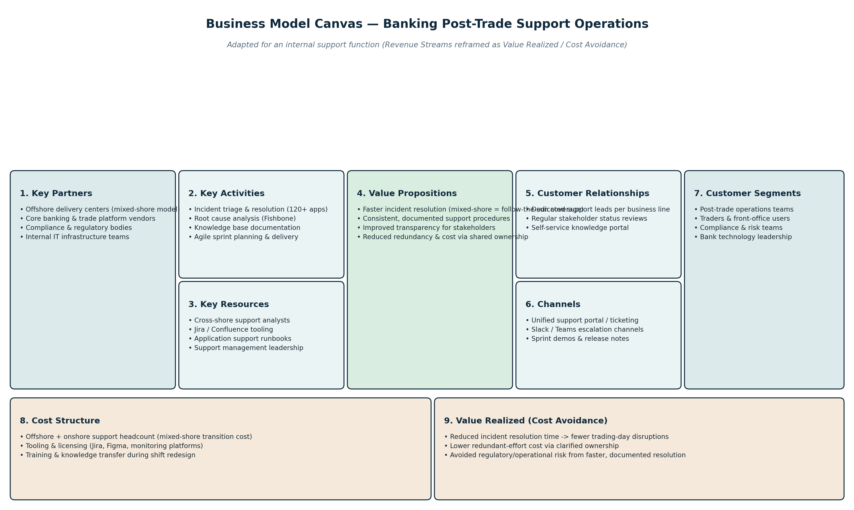
Figure 1: Business Model Canvas mapped to the post-trade support ecosystem

3. Root Cause Analysis — Fishbone Diagram
Before redesigning the support workflow, a Fishbone (Ishikawa) diagram was used to trace the current pain points back to their root causes across six categories: People, Process, Technology, Documentation & Knowledge, Governance & Visibility, and Design Thinking. This ensures the Agile backlog addresses underlying causes rather than surface symptoms.
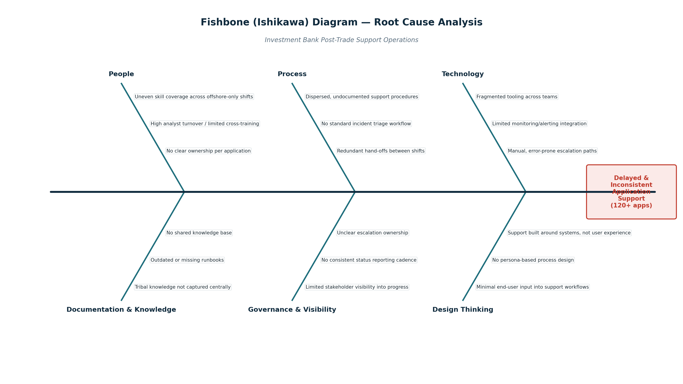
Figure 2: Fishbone diagram — root causes of delayed and inconsistent application support

Key root causes identified:
- People: uneven skill coverage from an offshore-only model, with no clear per-application ownership.
- Process: undocumented procedures and inconsistent incident triage across shifts.
- Technology: fragmented tooling with manual, error-prone escalation.
- Documentation & Knowledge: tribal knowledge that is never centrally captured.
- Governance & Visibility: stakeholders have no consistent view into support progress.
- Design Thinking: workflows are built around systems, not around the people who use them.

4. Customer Personas
To ensure the redesigned support workflow is grounded in real user needs rather than system constraints, three personas were developed representing the key groups affected by the support process.
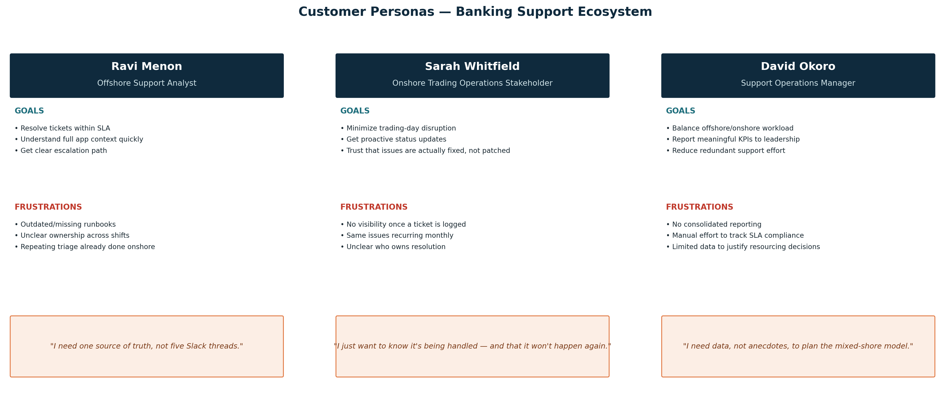
Figure 3: Customer personas — offshore analyst, onshore stakeholder, and support manager

5. To-Be Experience Map
The To-Be Experience Map traces the support journey across five stages — from issue identification through post-resolution review — contrasting today's pain points with the redesigned future-state experience and the emotional shift this is intended to create for users.
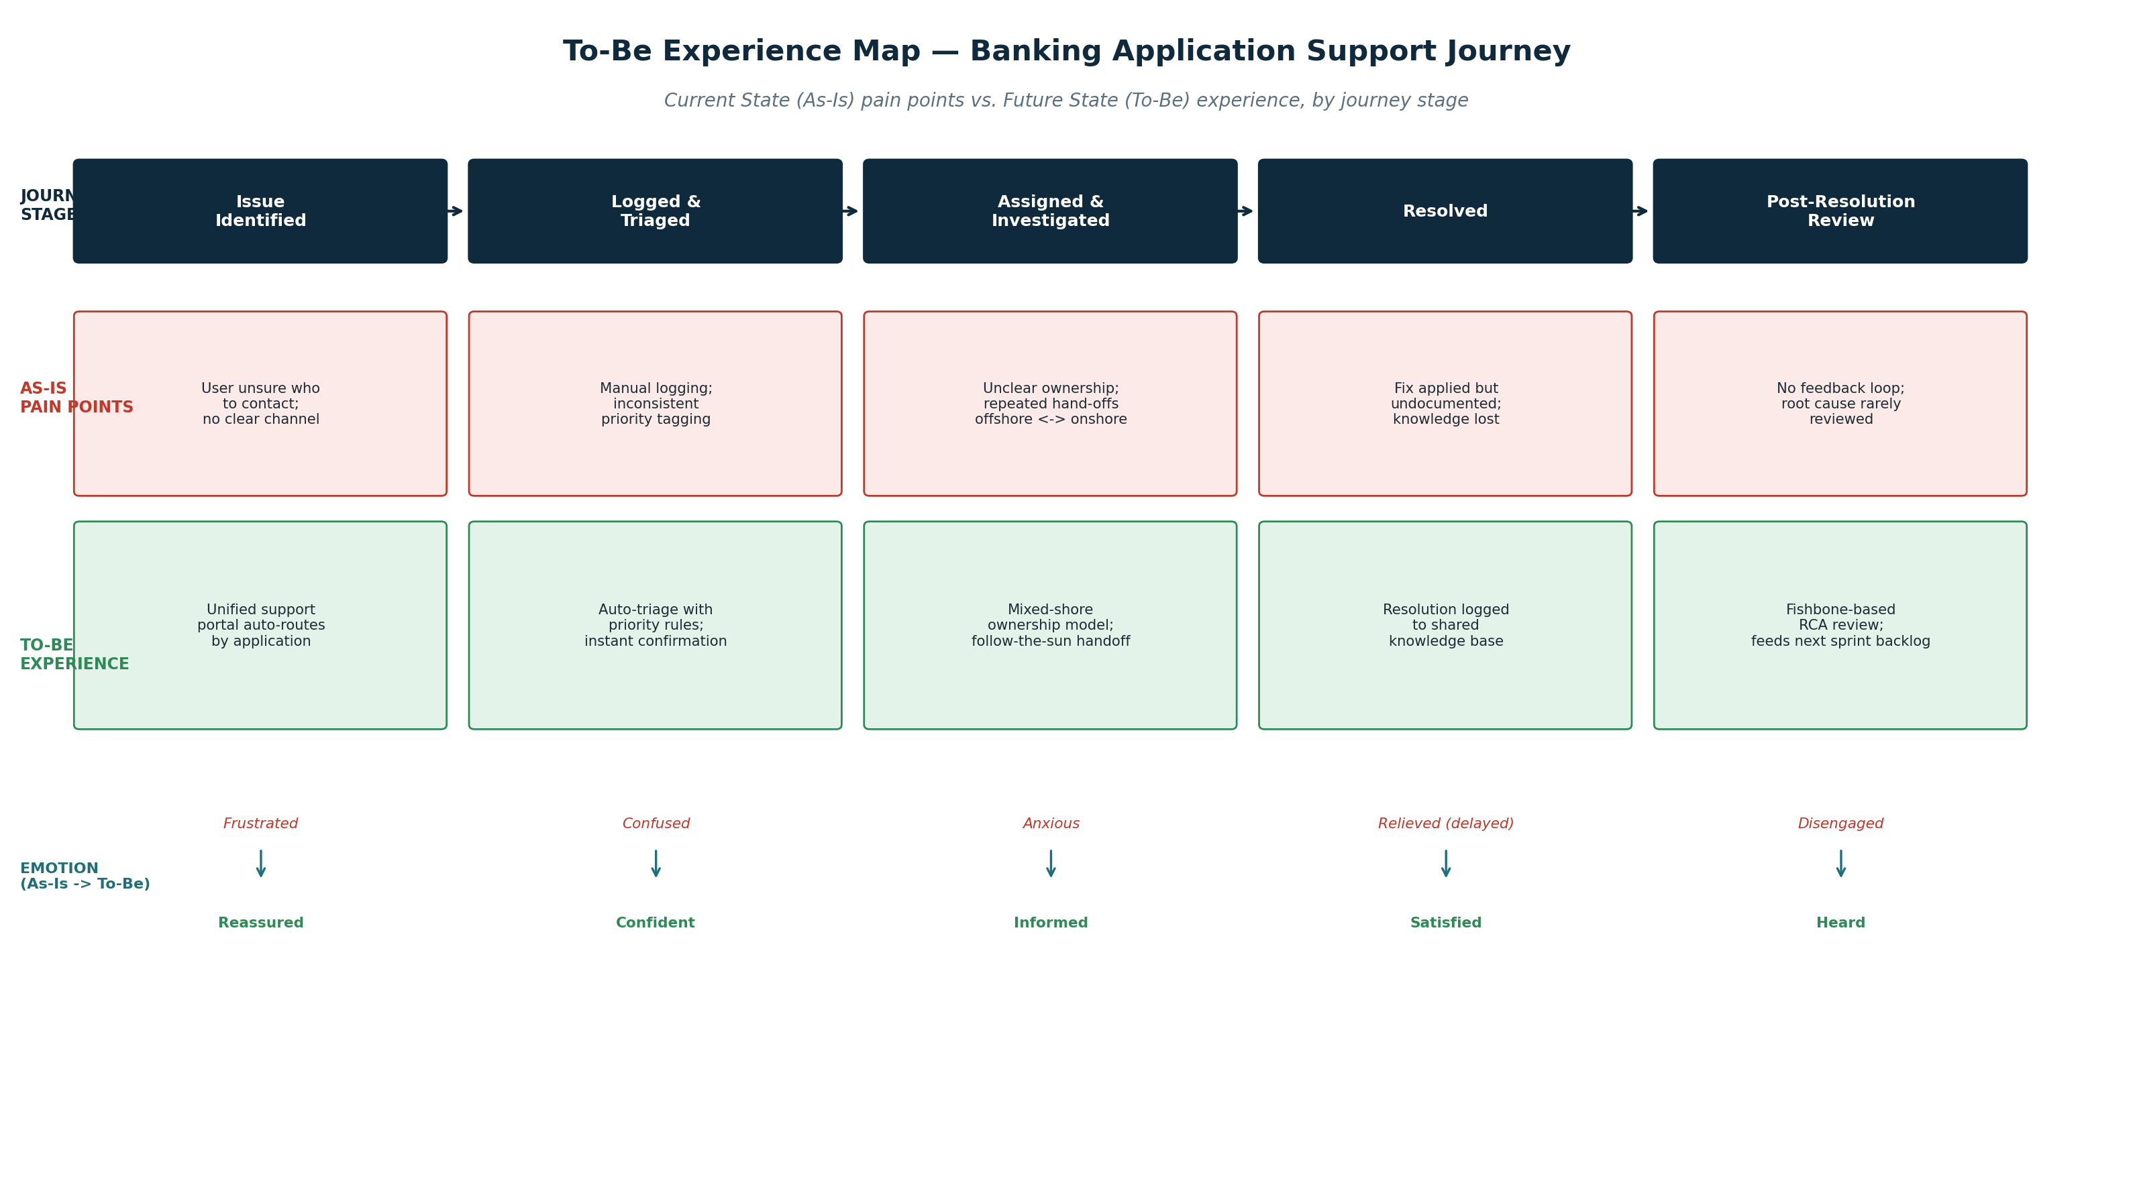
Figure 4: To-Be Experience Map — current pain points vs. future-state support journey

6. Agile Release Strategy
Given the requirement to show visible results within the first few quarters, the transformation is structured into three incremental releases rather than a single big-bang cutover. Each release delivers standalone value and builds toward the full mixed-shore model.
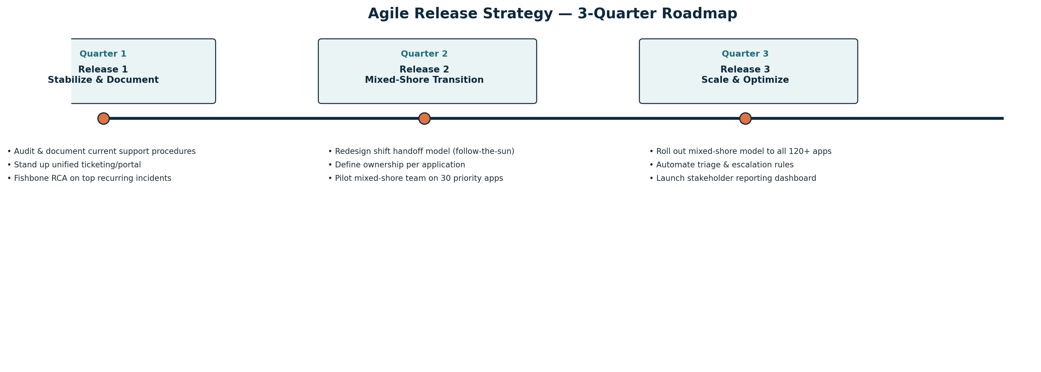
Figure 5: Three-quarter Agile release roadmap

7. Epics & Backlog Summary
The full backlog — 6 Epics and 12 User Stories with acceptance criteria written in Given/When/Then format and validated against the INVEST principle — is maintained in the companion file Support_Ops_Agile_Backlog.xlsx (structured as a Jira-style export). A summary of the Epics is below.
Epic ID | Epic Name | Release | Business Value
EPIC-01 | Unify & Document Support Procedures | Release 1 | Consistent incident handling; faster onboarding
EPIC-02 | Mixed-Shore Support Model Transition | Release 2 | 24/5 coverage; balanced workload across shores
EPIC-03 | Unified Support Portal & Escalation Tooling | Release 1 | Single source of truth; fewer manual errors
EPIC-04 | Root Cause Analysis & Continuous Improvement | Release 1 | Fewer repeat incidents; data-driven backlog
EPIC-05 | Stakeholder Visibility & Reporting | Release 3 | Improved trust; faster leadership decisions
EPIC-06 | Design-Thinking-Led Workflow Redesign | Release 2 | Workflows built around real user needs

8. Success Metrics
- Reduction in average incident resolution time following mixed-shore rollout (measured per release).
- Decrease in recurring incidents on the same application within a 30-day window.
- Stakeholder-reported improvement in visibility into support status (survey-based, post-Release 3).
- Reduction in redundant hand-offs per incident (shift-to-shift and offshore-to-onshore).
- Adoption rate of the unified support portal across all 120+ applications by end of Release 3.

9. Next Steps
This document, the Business Model Canvas, Fishbone analysis, personas, and To-Be Experience Map form the discovery foundation for Release 1. The companion backlog file translates this into sprint-ready Epics and User Stories, validated against INVEST, ready for sprint planning.

