Customer Churn out
It is the rate at which customers stop doing business with an entity. It is most commonly expressed as the percentage of service subscribers who discontinue their subscriptions within a given time period.
Understanding Churn Rate
A high churn rate could adversely affect profits and impede growth. Churn rate is an important factor in the telecommunications industry. In most areas, many of these companies compete, making it easy for people to transfer from one provider to another.
The churn rate not only includes when customers switch carriers but also includes when customers terminate service without switching. This measurement is most valuable in subscriber-based businesses in which subscription fees comprise most of the revenues.
Advantage:
- Provides clarity on how the business is doing to retain its customers.
- Provides whether the customers are satisfied with the product or not.
- Allows to compete with peers.
Examples of Churn Rate
- Telecommunications Industry Churn Rate
The churn rate is a particularly useful measurement in the telecommunications industry. This includes cable or satellite television providers, Internet providers, and telephone service providers (landline and wireless service providers).
As most customers have multiple options from which to choose, the churn rate helps a company determine how it is measuring up to its competitors. If one out of every 20 subscribers to a high-speed Internet service terminated their subscriptions within a year, the annual churn rate for that Internet provider would be 5%.

- Employment Churn Rate
Employee turnover within a business can also be measured with the churn rate, as it provides a method for analysing the company's hiring and retention patterns. This can be especially helpful if overall employee longevity within a company is low.

When statistics are examined on a department-by-department basis, it can highlight which particular departments are experiencing more frequent turnover within the company, or at a higher rate than the business average. This can help determine if the pay is satisfactory, the quality of the managers in that division, as well as the workload that each employee bears.
Why does customer churn out?
There are no specific factors on why does a customer stop using the services of the company. It may be due to the competition between companies offering better deals or the service that they are getting are not good enough to retain the customer.

A data analyts job is to find out the pattern of the in the given data and point out the factors, for which a customer is leaving the company.

Data Visualization
Attributes:
Column | Meaning
customerID | Customer Unique No
gender | Gender of the customer
Partner | Customer has partner?
Dependents | Customer has dependent?
tenure | how long as a customer (Months)
MusicTime | has the customer subscribe to streaming service (Music Time)
ayoba | has the customer subscribe to messaging service (ayoba)
InternetService | the type of internet service
OnlineSecurity | has the customer subscribe to Online Security
GlobalConnect | has the customer subscribe to Global Connect service
DeviceProtection | has the customer subscribe to Device Protection
Mobile Money (MoMo) users | is the customer a Mobile Money (MoMo) user
StreamingTV | has the customer subscribe to Streaming TV
StreamingMovies | has the customer subscribe to Streaming Movies
Contract | Contract type
aYo insurance | has the customer subscribe to aYo insurance
PaperlessBilling | has the customer subscribe to Paperless Billing
PaymentMethod | Payment mode used by customers
MonthlyCharges | Monthly charges
TotalCharges | Total charges
numAdminTickets | number of tickets opened in the administrative category
numTechTickets | number of tickets opened in the technical category
Churn | Customers who left within the last month

Observations
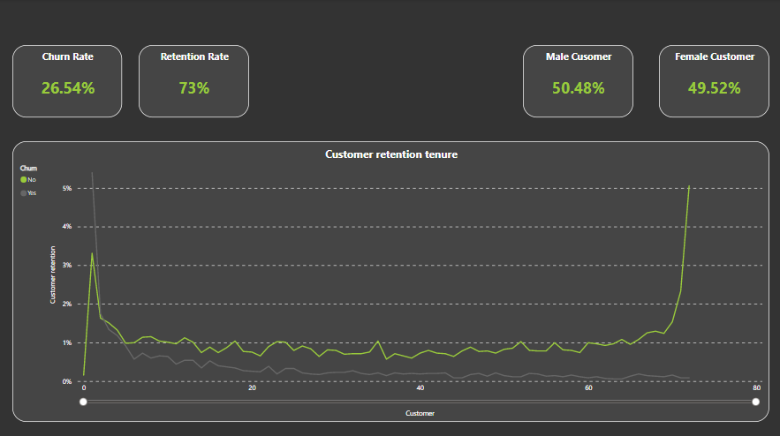

- The churn rate is high during the initial months if the subscription, and this signifies as the retention rate also decreases from 3.31% to 1.63% in a span to 2 months.
- The churn rate decreases after passing of months and after 72 months the churn rate is almost 0%, and this signifies by the retention rate of the customer as it increases exponentially after 69 months.

Services
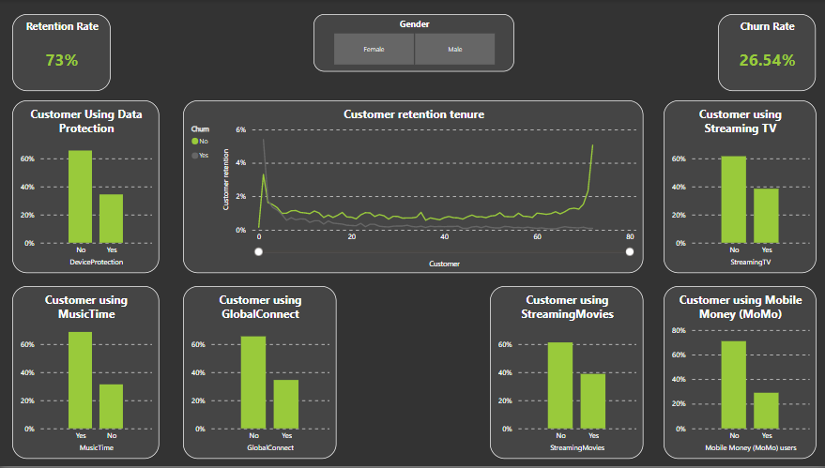
Data Protection Service- Customer not using data protection tend to churn out in the initial years. The company can advertise to the customers regarding the data protection service and the benefits of the service.
Music Time - The churn out rate is 26.5% and the churn rate for customer using Music Time is 22.5%. This shows that the company should not stop Music Time service.
Global Connect - The churn out rate for customer not using global connect is 19.1%. The company should focus on advertising this service.
Streaming Movies - The churn graph is high in the initial months of the service. Therefore, company should focus more on this service.
Mobile Money - According to the customer retention graph companies should advertise more regarding this service so that customers gain trust and use this service.
Streaming TV - Same goes with this service also, the company should advertise this service but customers using this service also tend to churn out, we have to dig deep to find out the reason for leaving the company. If we will dig deep, we will find out that male tend to leave the company after using this service.

Conclusion

