AVISHKAR 2026
PREDICTIVE PULSE
Machines That Warn You Before They Fail
Predictive Pulse is a low-cost, offline Edge-AI sensor network that clips onto existing industrial machines, listens to their vibration, temperature, current and sound, and uses on-device digital signal processing and a Raspberry Pi-hosted machine learning model to warn maintenance teams of a developing fault - in plain language, days before it causes an unplanned breakdown - with no cloud connection required.

Theme: Smart Industrial Automation | Category: Engineering and Technology

Table of Contents
Right-click the list below in Word and choose "Update Field" (or press F9) to populate page numbers.
Table of Contents 1
1. Hardware Stack: The ESP32 Sensor Node 1
1.1 Node overview 1
1.2 Controller: ESP32-S3 1
1.3 Power supply and protection 1
1.4 Enclosure and mounting 1
2. Sensors: Specifications and Cost 1
2.1 Vibration: ADXL345 accelerometer 1
2.2 Temperature: DS18B20 probe and BME280 1
2.3 Motor current: SCT-013-030 current transformer 1
2.4 Sound (optional): INMP441 MEMS microphone 1
2.5 Cost summary per node 1
3. Communication Protocol 1
3.1 Protocol used: MQTT over local Wi-Fi 1
3.2 Topic structure 1
3.3 Payload design and bandwidth saving 1
3.4 Comparison of possible protocols 1
3.5 The most efficient way to communicate 1
4. Digital Signal Processing (DSP) on the Node 1
4.1 The DSP pipeline, end to end 1
4.2 Parameter 1: Filtering 1
4.3 Parameter 2: Moving average / RMS 1
4.4 Parameter 3: FFT (Fast Fourier Transform) 1
4.5 Parameter 4: Rate of change / trend and statistical shape 1
4.6 Summary: the 14 features sent per node 1
5. Edge-AI Hub: Raspberry Pi 1
5.1 Recommended model and specifications 1
5.2 Why the Raspberry Pi was chosen 1
5.3 Role of the Raspberry Pi in the system 1
6. Software Stack and Data Analysis 1
6.1 Software layers 1
6.2 How data is collected 1
6.3 How data is analysed after DSP (Level-2 fusion) 1
6.4 Firmware structure on the node (summary) 1
6.5 Dashboard and technician feedback loop 1
7. Machine Learning: Training and Results 1
7.1 Data sources 1
7.2 Feature extraction for training 1
7.3 Model choice: Random Forest 1
7.4 Training procedure 1
7.5 Evaluation metrics used 1
7.6 Presenting results in the document 1
8. Integration with Existing PLCs and Industrial Dashboards 1
8.1 Connecting to existing PLCs 1
8.2 Connecting to existing industrial dashboards / SCADA 1
8.3 Why this integration approach was chosen 1
9. Features, Impact and Cost Reduction 1
9.1 Key features 1
9.2 Impact created 1
9.3 Usefulness to us (as a project team) 1
9.4 Cost reduction 1

1. Hardware Stack: The ESP32 Sensor Node
Every Predictive Pulse installation is built from identical, low-cost sensor nodes. A node is a sealed box that is bolted or clamped onto a machine. Inside it, an ESP32-S3 microcontroller reads the sensors, filters the raw signals, calculates health features and sends only a small summary to the Raspberry Pi. The node never needs the internet and never needs to be wired into the machine's control circuit.
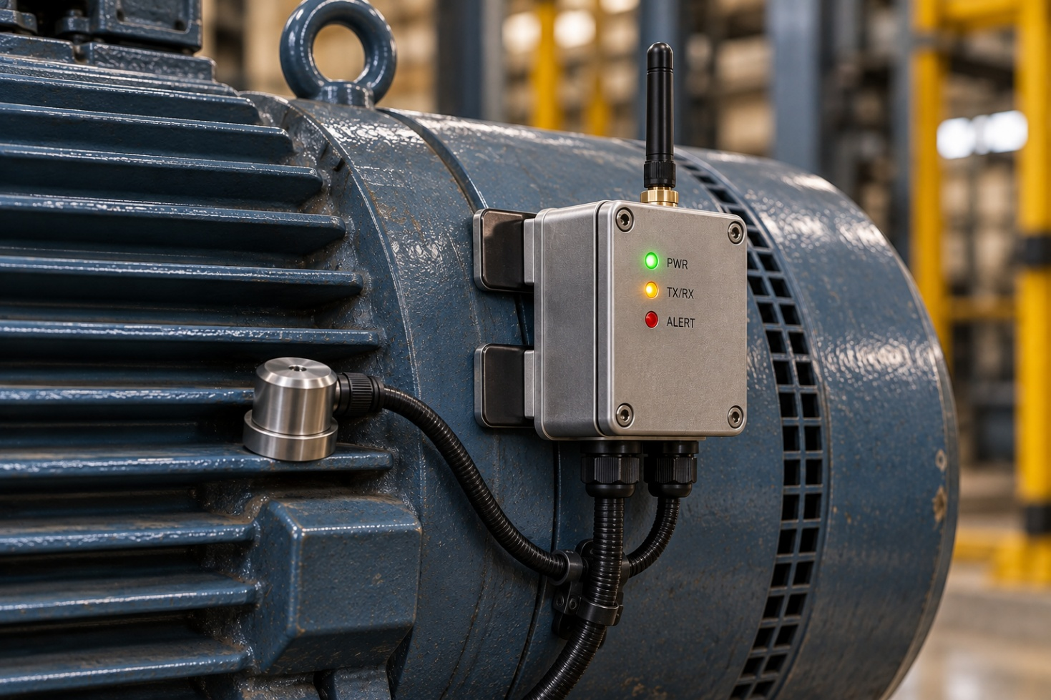

Figure 1: Predictive Pulse ESP32 sensor node (concept image to be inserted).

1.1 Node overview
Block | Component | Role in the node
Controller | ESP32-S3 development board | Samples all sensors, runs DSP and Level-1 anomaly detection, publishes MQTT messages
Vibration sensing | ADXL345 3-axis accelerometer (SPI) | Detects imbalance, misalignment, looseness and bearing damage
Temperature sensing | DS18B20 probe (machine body) + BME280 (ambient) | Measures bearing/motor-body temperature and the ambient reference
Motor current sensing | SCT-013-030 split-core current transformer + bias circuit | Non-invasive measurement of motor load and electrical/mechanical stress
Sound sensing (optional) | INMP441 I2S MEMS microphone | Captures acoustic signatures such as bearing whine, cavitation, air leaks
Power | HLK-PM01 AC-DC module (or 24 V DC buck converter) | Powers the node from mains or from the control-panel 24 V supply
Enclosure and mounting | IP65 ABS box, cable glands, M6 stud / magnet base | Protects electronics and couples the accelerometer rigidly to the machine

1.2 Controller: ESP32-S3
The ESP32-S3 is the brain of the node. It was selected because it can acquire signals and process them at the same time, which is exactly what a sensor node that thinks locally must do.
Specification | ESP32-S3 (typical dev-board values)
CPU | Dual-core Xtensa LX7, up to 240 MHz
Memory | 512 KB internal SRAM; optional 2-8 MB PSRAM on many dev boards
Wireless | Wi-Fi 802.11 b/g/n (2.4 GHz) and Bluetooth 5 (LE)
DSP support | Vector (SIMD) instructions and the optimised ESP-DSP library (FFT, filters)
Peripherals | SPI, I2C, I2S, UART, 2 x 12-bit SAR ADCs, DMA, hardware timers
Supply | 3.3 V logic; 5 V input through the on-board regulator
Approx. cost | ₹700 - ₹1,000 (dev board)

Why the ESP32-S3 was chosen
- Two cores, two jobs: Core 0 handles sampling and communication; Core 1 handles filtering and FFT, so no samples are lost while calculations run.
- Built-in Wi-Fi: no extra radio module is needed to reach the MQTT broker on the Raspberry Pi.
- Fast enough for real-time DSP: a 2,048-point FFT completes in a few milliseconds using ESP-DSP, well inside the 1-second reporting window.
- I2S and DMA: the digital microphone and the current channel can stream into memory without loading the CPU.
- Low cost and huge community: sensors, libraries and examples are widely available in India, which keeps the design repeatable for any MSME.

1.3 Power supply and protection
- Mains-powered option: an HLK-PM01 (230 V AC to 5 V, 3 W) module behind a 500 mA fuse and a varistor. It is fully enclosed and isolated from the low-voltage electronics.
- Control-panel option: where 24 V DC is available, a small buck converter provides 5 V. This is the preferred choice inside panels.
- Consumption: the complete node draws roughly 0.4 - 0.8 W on average (Wi-Fi bursts once per second), so it can also be backed up by a small battery or UPS.
- Isolation: the current transformer measures the motor cable without touching the conductor, so there is no electrical connection to the motor circuit.

1.4 Enclosure and mounting
- Enclosure: an IP65 ABS box with cable glands keeps out dust and splashes. Metal boxes are avoided near the antenna.
- Accelerometer placement: the accelerometer sits in a small sensor puck on a short shielded cable. It is fixed as close as possible to the bearing housing, on the load side, with the axes marked as horizontal, vertical and axial.
- Coupling matters: an M6 stud mount gives the best high-frequency response. A neodymium magnet base is convenient for pilots but reduces the usable bandwidth, so results should be compared only between nodes mounted the same way.
- Temperature probe: the DS18B20 probe is clamped to the bearing housing with thermal paste so that it follows the true metal temperature.
- Current clamp: the split-core CT is clipped around one motor phase inside the starter panel; no wiring changes are needed.

2. Sensors: Specifications and Cost
Four measurements are combined because no single signal reveals every fault. Vibration shows mechanical wear, temperature shows friction and cooling problems, current shows load and electrical stress, and sound adds an independent early hint. The prices below are approximate Indian retail prices for single units and will vary by supplier.

2.1 Vibration: ADXL345 accelerometer
What it detects: imbalance, misalignment, mechanical looseness, bearing damage and gear problems. Vibration is the most informative signal for rotating machines.
Parameter | Specification
Type | 3-axis MEMS digital accelerometer, SPI / I2C
Measurement range | ±2 g, ±4 g, ±8 g or ±16 g (selectable)
Resolution | 10-bit fixed; 13-bit in full-resolution mode (3.9 mg/LSB)
Output data rate | Up to 3,200 Hz over SPI (usable bandwidth about 1,600 Hz)
Noise density | About 290 µg/√Hz (X, Y) and 430 µg/√Hz (Z)
Buffer | 32-sample FIFO reduces SPI load
Supply | 2.0 - 3.6 V, very low power
Approx. cost | ₹250 - ₹450 (breakout board)

Upgrade path to the full 1 - 6 kHz band: for machines whose bearing defects excite resonances above 1.6 kHz, the ADXL345 can be replaced by an ST IIS3DWB wideband accelerometer (about 6 kHz flat bandwidth, low noise, SPI). It costs roughly ₹1,500 - ₹2,500 more per node and uses the same processing chain, because the ESP32-S3 simply decimates its high output rate to the selected sampling frequency (1 - 6 kHz).

2.2 Temperature: DS18B20 probe and BME280
What it detects: bearing wear and lubrication loss (heat rises for the same load), blocked cooling, overloaded windings. Temperature changes slowly, so it confirms what vibration suggests.
Parameter | DS18B20 (machine body) | BME280 (ambient)
Type | Digital 1-Wire, stainless-steel waterproof probe | Digital I2C temperature, humidity, pressure
Range | −55 to +125 °C | −40 to +85 °C
Accuracy | ±0.5 °C (−10 to +85 °C) | About ±1 °C
Resolution | 9 - 12 bit (up to 0.0625 °C) | 0.01 °C
Conversion time | 750 ms at 12-bit | A few ms in forced mode
Approx. cost | ₹120 - ₹250 | ₹300 - ₹450

Alternatives: a non-contact MLX90614 infrared sensor (about ₹900 - ₹1,400) suits rotating parts that cannot be touched, and a K-type thermocouple with a MAX31855 amplifier covers surfaces above 125 °C.

2.3 Motor current: SCT-013-030 current transformer
What it detects: overload, jammed or dragging mechanisms, worn bearings that increase friction, dry-running pumps (current falls) and electrical imbalance. Motor current reflects the mechanical load without any sensor on the moving parts.
Parameter | Specification
Type | Split-core (clip-on) current transformer with built-in burden
Input / output | 0 - 30 A AC input, 0 - 1 V AC output (1 V at 30 A)
Interface to ESP32 | Bias network to 1.65 V mid-supply, low-pass filter, 12-bit ADC (DMA mode)
Accuracy | About 1 - 3 % before calibration; better after two-point calibration
Jaw opening | About 13 mm cable diameter
Isolation | Galvanic isolation: no contact with the conductor
Larger motors | SCT-013-100 (100 A) or a Rogowski coil for heavy feeders
Approx. cost | ₹450 - ₹800 including bias and filter parts

Why not a Hall-effect module such as the ACS712? It must be wired in series with the motor supply, which is unsafe to retrofit and noisier. The clip-on transformer keeps installation safe and non-intrusive. For higher linearity an ADS1115 16-bit ADC can be added.

2.4 Sound (optional): INMP441 MEMS microphone
What it detects: bearing whine, cavitation in pumps, compressed-air leaks, rubbing and loose parts. Sound is optional because noisy factories can mask small signals; it is added where the environment is reasonably quiet or the microphone can sit close to the machine.
Parameter | Specification
Type | Omnidirectional MEMS microphone with digital I2S output
Resolution | 24-bit data, 32-bit I2S frame
Signal-to-noise ratio | About 61 dBA
Frequency response | About 60 Hz - 15 kHz
Sampling rate used | 16 kHz (8 - 48 kHz supported)
Acoustic overload point | About 120 dB SPL
Supply | 1.8 - 3.3 V
Approx. cost | ₹200 - ₹350

2.5 Cost summary per node
Item | Approx. cost (₹)
ESP32-S3 dev board | 700 - 1,000
ADXL345 accelerometer | 250 - 450
DS18B20 probe | 120 - 250
BME280 ambient sensor | 300 - 450
SCT-013-030 CT and bias parts | 500 - 850
INMP441 microphone (optional) | 200 - 350
Power supply, fuse, varistor | 300 - 450
IP65 enclosure, glands, connectors, mounting | 350 - 600
PCB / wiring / miscellaneous | 200 - 400
Total per node | 2,920 - 4,800 (planning figure ≈ ₹3,900)

Without the optional microphone a node costs about ₹2,700 - ₹4,450. Swapping the ADXL345 for a wideband IIS3DWB adds roughly ₹1,500 - ₹2,500. Verify current prices with your supplier before quoting them.

3. Communication Protocol

3.1 Protocol used: MQTT over local Wi-Fi
Each node sends its results to the Raspberry Pi using MQTT (Message Queuing Telemetry Transport) over a dedicated local 2.4 GHz Wi-Fi network. An Eclipse Mosquitto broker runs on the Raspberry Pi, so the entire network works with no internet connection.
- Lightweight: the smallest MQTT packet has only a 2-byte header, which suits microcontrollers and tiny summaries.
- Publish / subscribe: nodes publish to topics; the Pi, the dashboard and any PLC gateway can subscribe independently. Adding a node needs no reconfiguration of the others.
- Delivery control: Quality of Service levels let a message be re-sent until the broker confirms it.
- Retained messages and Last Will: a node's online/offline state is stored on the broker, and the broker announces a node that disappears unexpectedly.
- Industry standard: MQTT is supported by Node-RED, Grafana plug-ins, Ignition and most IIoT platforms, which makes later integration simple.

3.2 Topic structure
Topic | Direction / QoS | Content
pp/{site}/{machine}/{node}/features | Node to Pi / QoS 1 | Once per second: 14 features, Level-1 flags, timestamp, sequence number
pp/{site}/{machine}/{node}/status | Node to Pi / QoS 1, retained | Online/offline (Last Will), firmware version, Wi-Fi signal, uptime
pp/{site}/{machine}/{node}/alert | Node to Pi / QoS 1 | Immediate message when a Level-1 detector triggers
pp/{site}/{machine}/{node}/cmd | Pi to node / QoS 1 | Change thresholds, sampling rate, or request a raw waveform burst
pp/{site}/{machine}/{node}/raw | Node to Pi / QoS 0 | Short raw waveform, sent only on request or after an alert

3.3 Payload design and bandwidth saving
During development the payload is human-readable JSON. In production a compact binary format (a fixed C structure, MessagePack or CBOR) is used.
{ "node":"N01", "seq":48213, "ts":1790611463,
"v":[0.182,0.91,3.4,47.5,0.064,0.21], // RMS, peak, kurtosis, FFT freq, FFT amp, HF ratio
"t":[56.3,21.4,0.35], // body temp, delta to ambient, rate C/min
"i":[12.6,0.02,1.8], // current RMS, trend, load change %
"s":[-42.1,0.18], // sound level dBFS, band ratio
"flag":"0x0000" } // Level-1 status bits
Approach | Data sent per second per node | Comment
Stream raw vibration (3 axes, 16-bit, 3.2 kHz) | ≈ 19,200 bytes | Heavy on Wi-Fi and the Pi; raw data must also be stored
JSON feature summary | ≈ 300 bytes | Readable, good for development
Binary feature summary (14 x float32 + header) | ≈ 70 bytes | About 270 times less than raw streaming

3.4 Comparison of possible protocols
Option | Range | Data rate | Needs | Verdict
MQTT over Wi-Fi | 30 - 50 m indoors per access point | Mbit/s | Access point + broker on Pi | Chosen - best balance of cost, flexibility and standards
HTTP / REST | Same as Wi-Fi | Mbit/s | Web server | Heavier headers, new connection per request; not ideal for continuous small messages
ESP-NOW | About 100 - 200 m open air | Up to 250 bytes per packet | One ESP32 gateway to Pi (UART) | Good fallback where no Wi-Fi exists
LoRa (865 - 867 MHz in India) | 2 - 15 km | 0.3 - 50 kbit/s | LoRa gateway | Excellent for large mines or yards; summaries fit easily
RS-485 / Modbus RTU | Up to 1,200 m wired | 9.6 - 115 kbit/s | Cable run | Best in very noisy plants where radio is unreliable
Bluetooth LE | 10 - 30 m | Low | Phone or gateway | Useful for commissioning only

3.5 The most efficient way to communicate
The following configuration gives the lowest bandwidth, the lowest power and the highest reliability:
- Process at the edge, send features, not waveforms. Sending about 70 bytes per second instead of about 19 kB per second is the single biggest saving.
- Compact binary payload with MQTT QoS 1. At-least-once delivery with a sequence number lets the Pi remove duplicates; QoS 2 adds overhead that is not needed.
- Regular 1-second reporting, with immediate alert messages when a Level-1 detector fires, and raw waveforms only on request.
- Keep the TCP connection open with a 30 - 60 second keep-alive and Wi-Fi modem sleep between messages, avoiding repeated reconnection.
- Dedicated 2.4 GHz network on a fixed channel (1, 6 or 11), separate from office Wi-Fi. The Raspberry Pi can act as the access point, keeping the whole system self-contained.
- Store-and-forward: if Wi-Fi drops, the node keeps its latest summaries in memory and uploads them when the link returns. Time is synchronised from the Pi using NTP.
- Security: one credential per node, TLS on port 8883 and access rules so each node can publish only to its own topics.
- Capacity: one Mosquitto broker on a Raspberry Pi comfortably handles thousands of messages per second, so 100 nodes at one message per second is a light load.

4. Digital Signal Processing (DSP) on the Node
Raw sensor data is noisy and far too large to send every second. Before any feature reaches the Raspberry Pi, the ESP32-S3 runs it through a DSP pipeline that removes noise, isolates the information that matters and reduces thousands of raw samples to a handful of numbers. This chapter explains that pipeline and the four DSP parameters shown on the poster: filtering, moving average / RMS, FFT, and rate-of-change / trend, using the vibration channel as the running example and noting how the same ideas apply to temperature, current and sound.

4.1 The DSP pipeline, end to end
- Sampling: the ADC or digital sensor is read at a fixed rate (1 - 6 kHz for vibration, about 1 Hz for temperature, a few kHz for current, 16 kHz for sound) using a hardware timer and DMA so the rate never drifts.
- Windowing: samples are collected into a fixed block, called a window (for example 2,048 vibration samples ≈ 0.64 s at 3.2 kHz). All feature calculations for that second are done on this window.
- Filtering: the window is cleaned of DC offset, mains hum and out-of-band noise.
- Time-domain features: RMS, peak, crest factor and kurtosis are calculated directly on the filtered window.
- Frequency-domain features (FFT): the window is converted to the frequency domain to find dominant vibration frequencies and their amplitudes.
- Trend features: a moving average and a rate-of-change are updated using the last few minutes or hours of history, not just the current window.
- Packing: the results of steps 3 - 6 become the 14 features described in Chapter 3, ready to publish over MQTT.

4.2 Parameter 1: Filtering
Purpose: remove anything that is not real machine information before it can corrupt later calculations.
- DC removal: a first-order high-pass filter (cut-off about 0.5 - 1 Hz) removes the sensor’s zero-offset so that RMS and FFT are not skewed by a constant bias.
- Anti-alias / low-pass: a low-pass filter at just under half the sampling rate (the Nyquist frequency) removes frequencies the ADC cannot represent correctly, preventing them from folding back as false peaks.
- Notch filter: a narrow band-stop at 50 Hz (and its harmonics, 100 Hz, 150 Hz) removes mains hum picked up on the current and, sometimes, the vibration channel.
- Implementation: on the ESP32-S3 these are simple IIR biquad filters (Direct Form II), each needing only 2 multiplications and additions per sample, so they run comfortably in real time even at 6 kHz.
y[n] = b0*x[n] + b1*x[n-1] + b2*x[n-2]
- a1*y[n-1] - a2*y[n-2] // one biquad stage
For temperature, filtering means a simple exponential smoother that removes single-sample glitches from the 1-Wire bus. For current, the same 50 Hz notch removes mains ripple from the rectified signal. For sound, a band-pass (roughly 200 Hz - 8 kHz) isolates the mechanical acoustic band and rejects wind and very low-frequency rumble.

4.3 Parameter 2: Moving average / RMS
Purpose: turn a filtered waveform into a single number that tracks the overall energy or level of the signal, and track how that number is drifting over time.

RMS (root mean square) - the energy of the window
RMS = sqrt( (1/N) * sum( x[n]^2 ) ) for n = 1..N samples in the window
- For vibration, RMS is the classic overall severity indicator used in ISO 10816 style guidelines; a rising RMS trend is one of the earliest signs of wear.
- For current, RMS gives the true operating current of the motor, used directly for load and overload detection.
- Peak value (the largest |x[n]| in the window) is calculated alongside RMS; the ratio Peak / RMS is the crest factor, which rises early in bearing faults before RMS itself moves much.

Moving average and EWMA - the slow trend
A single RMS value is noisy from second to second, so it is smoothed with an Exponentially Weighted Moving Average (EWMA), which the poster refers to as tracking drift in readings:
EWMA[n] = alpha * RMS[n] + (1 - alpha) * EWMA[n-1] // alpha ≈ 0.05 - 0.2
- A small alpha gives a long memory (tracks slow wear over days); a larger alpha reacts faster (tracks a load change within minutes). Predictive Pulse keeps both: a fast EWMA for the current reading and a slow EWMA as the machine’s learned baseline.
- The rate of rise is the slope of the slow EWMA over time (°C per minute for temperature, %RMS per day for vibration) - this is how the system tells "temperature creeping up" apart from a one-off spike.
- For temperature specifically, the ambient-difference feature (body temperature minus BME280 ambient temperature) removes the effect of a hot factory day, so only the machine’s own heating is reported.

4.4 Parameter 3: FFT (Fast Fourier Transform)
Purpose: find *which* frequencies are vibrating or resonating, not just how much overall energy there is. Different faults excite different frequencies, so this is what makes the system able to point at a likely cause rather than a vague warning.
- Windowing function: a Hann window is applied to the 2,048-sample block before the transform, to reduce spectral leakage.
- FFT: a radix-2 FFT (ESP-DSP library, using the ESP32-S3’s SIMD instructions) converts the block to 1,024 complex frequency bins in a few milliseconds.
- Magnitude spectrum: the complex bins are converted to magnitude, giving amplitude versus frequency.
- Peak picking: the algorithm searches known fault-frequency bands (related to shaft speed, bearing geometry and number of gear teeth) and records the top 2 - 3 peak frequencies and their amplitudes.
- Band energy: the spectrum is also summarised into a few energy bands (for example low / mid / high frequency bands) which are cheap to send and very informative for the Random Forest model.
X[k] = sum( x[n] * window[n] * e^(-j*2*pi*k*n/N) ) for k = 0..N/2 // FFT
freq(k) = k * Fs / N // bin-to-Hz mapping
Interpreting the peaks (used in Level-2 fault classification):
Frequency pattern | Typical indication
Strong peak at 1x running speed | Imbalance
Strong peak at 2x running speed | Misalignment
Series of harmonics of running speed | Mechanical looseness
Peaks at bearing defect frequencies (BPFO, BPFI, BSF, FTF) | Outer race, inner race, ball or cage bearing defect
Sidebands around gear-mesh frequency | Gear tooth wear or damage

For current, the same FFT is applied at a lower sampling rate to look for sidebands around the 50 Hz supply frequency, which can reveal broken rotor bars or bearing faults reflected electrically (Motor Current Signature Analysis). For sound, FFT band energy distinguishes a tonal whine (bearing) from broadband hiss (an air or steam leak).

4.5 Parameter 4: Rate of change / trend and statistical shape
Purpose: decide whether a reading is not just high, but *changing in a way that matters*, and do this cheaply enough to run every second on a microcontroller.
- Kurtosis: a statistical measure of how "spiky" the waveform is. A healthy bearing’s vibration is close to smooth (kurtosis ≈ 3); early bearing damage produces sharp impacts that push kurtosis well above 3, often before RMS changes at all. This is why kurtosis appears explicitly among the 14 features.
- Z-score: how many standard deviations the newest reading is from the machine’s own learned normal (mean and standard deviation of recent history). This is the Level-1 "check against its own history" test mentioned on the poster.
- CUSUM (Cumulative Sum): accumulates small, persistent deviations that a single Z-score test would miss, so a slow drift is caught even if no single second looks abnormal.
- Rate of rise: the slope of the EWMA trend described in section 4.3, used mainly for temperature and vibration RMS.
Z[n] = ( x[n] - mean_recent ) / std_recent
CUSUM[n] = max( 0, CUSUM[n-1] + (x[n] - mean_recent) - k ) // k = allowed slack
Level-1 decision on the node: a flag is raised only when the Z-score exceeds a threshold (typically 3) or the CUSUM exceeds its control limit or kurtosis exceeds its threshold. This multi-test approach is why the node can "clean each signal and check it against its own recent history" without any machine-specific tuning, and why only a short summary - not raw data - needs to be sent onward every second.

4.6 Summary: the 14 features sent per node
# | Feature | Source channel | DSP parameter used
1 | RMS | Vibration | Moving average / RMS
2 | Peak | Vibration | Moving average / RMS
3 | Crest factor | Vibration | Moving average / RMS
4 | Kurtosis | Vibration | Rate of change / statistical shape
5 | Dominant FFT frequency | Vibration | FFT
6 | FFT peak amplitude | Vibration | FFT
7 | High-frequency band energy | Vibration | FFT
8 | Body temperature | Temperature | Filtering
9 | Ambient-difference temperature | Temperature | Moving average / trend
10 | Rate of temperature rise | Temperature | Rate of change / trend
11 | Current RMS | Motor current | Moving average / RMS
12 | Current trend (EWMA) | Motor current | Moving average / trend
13 | Load-related current change % | Motor current | Rate of change / trend
14 | Sound band energy / level | Sound (optional) | Filtering + FFT

Table: mapping of the 14 node-level features to the four DSP operations described above.

5. Edge-AI Hub: Raspberry Pi
Everything the sensor nodes send is collected, compared against learned fault patterns and turned into an alert on a single Raspberry Pi, which sits on the machine or the panel next to it. It is the only device in the network that needs to be more powerful than a microcontroller, and it is still inexpensive enough to keep the whole solution a low-cost add-on.

5.1 Recommended model and specifications
Specification | Raspberry Pi 4 Model B (4 GB) - recommended
CPU | Broadcom BCM2711, quad-core Cortex-A72, 1.5 GHz, 64-bit
RAM | 4 GB LPDDR4 (2 GB and 8 GB variants also available)
Storage | microSD (32 GB, A2/U3 recommended) or USB SSD boot for reliability
Connectivity | Gigabit Ethernet, dual-band 802.11ac Wi-Fi, Bluetooth 5.0
I/O | 2x USB 3.0, 2x USB 2.0, 40-pin GPIO, 2x micro-HDMI
Power | 5V / 3A USB-C (about 4 - 7 W typical load)
Operating system | Raspberry Pi OS (64-bit, Debian-based)
Approx. cost (board) | ₹5,500 - ₹6,500
Approx. cost (with case, power supply, 32 GB SD card, heatsink/fan) | ₹7,500 - ₹9,000

A Raspberry Pi 4 (2 GB) or a Raspberry Pi 5 can both be used instead. The 2 GB board saves roughly ₹1,000 but leaves little headroom if the node count grows; the Pi 5 costs about ₹2,000 - ₹3,000 more but roughly doubles CPU performance, which shortens Random Forest inference time and leaves more room for a larger dashboard or additional models.

5.2 Why the Raspberry Pi was chosen
- Enough compute for Level-2 fusion: a quad-core Cortex-A72 easily runs a scikit-learn Random Forest, a Mosquitto broker, a database and a dashboard together, with CPU to spare.
- Runs fully offline: it is a complete, standalone computer - no cloud account, subscription or external server is required, which matches the "works offline" pillar of the project.
- Low, one-time cost: at roughly ₹6,000 - ₹9,000 it is far cheaper than an industrial PC or PLC-integrated analytics module, keeping the whole system a genuine low-cost add-on rather than a capital purchase.
- Low power draw: 4 - 7 W means it can run continuously on a small UPS even through short power cuts, important for mines and remote sites.
- GPIO and interfacing: the 40-pin header and USB ports make it simple to add a local display, a status LED/buzzer for the dashboard, or a Modbus/RS-485 USB adapter for PLC integration (Chapter 8).
- Mature software ecosystem: Python, scikit-learn, Mosquitto, Node-RED, Grafana and SQLite all have first-class support on Raspberry Pi OS, so the whole software stack in Chapter 6 can be built with well-documented, free tools.
- One hub can serve many nodes: a single Pi 4 can handle dozens of nodes at one message per second each, so cost per additional machine is just the cost of one more ESP32 node - the Pi does not need to be duplicated on every machine.
- Physically robust and small: credit-card sized, fanless-capable, and easy to DIN-rail mount inside or next to an existing panel.

5.3 Role of the Raspberry Pi in the system
- Runs the MQTT broker that all sensor nodes publish to and subscribe from (Chapter 3).
- Runs the Level-2 fusion and inference engine: combines the features from every node on a machine and compares them against the trained Random Forest model (Chapter 7).
- Stores incoming data and historical trends in a local time-series database.
- Hosts the local dashboard (Chapter 6) that a technician views on a phone, tablet or PC on the same network - no internet required.
- Logs confirmed and dismissed alerts, which become new labelled training data for the next model update (Chapter 7).
- Optionally acts as the gateway to existing PLCs and industrial dashboards (Chapter 8).

6. Software Stack and Data Analysis

6.1 Software layers
Layer | Technology | Role
Node firmware | C / C++, ESP-IDF or Arduino core, ESP-DSP library, PubSubClient / esp-mqtt | Sampling, DSP (Chapter 4), Level-1 detection, MQTT publish
Message broker | Eclipse Mosquitto (MQTT broker) on the Raspberry Pi | Receives all node messages, routes them to every subscriber
Data ingestion | Python service (paho-mqtt client) | Subscribes to all topics, validates and timestamps messages
Storage | SQLite for configuration/alerts, InfluxDB or TimescaleDB for time-series history | Keeps raw feature history for trending, retraining and audit
Analysis / ML engine | Python, scikit-learn (Random Forest), NumPy / pandas | Level-2 fusion and fault classification (Chapter 7)
Orchestration (optional) | Node-RED | Visual wiring of MQTT → rules → alerts → PLC/dashboard (useful for quick changes without redeploying code)
Dashboard | Grafana (or a lightweight Flask/React web app) served locally on the Pi | Plain-language status, trends, alert list, technician feedback (Chapter 6.5)
Automation / integration | Node-RED flow or a small Python service with pymodbus / OPC UA | Publishes results to PLCs and existing industrial dashboards (Chapter 8)

6.2 How data is collected
- Provisioning: each node is flashed once with its unique ID, the Wi-Fi credentials of the local network, and the Raspberry Pi’s MQTT broker address.
- Continuous sampling: the node samples its sensors on hardware timers exactly as described in Chapter 4, independent of the network.
- Local DSP: filtering, RMS, FFT and trend calculations run on the node every second, producing the 14-feature summary.
- Publish: the summary is published to its `features` topic; an immediate `alert` message is sent separately if a Level-1 threshold is crossed (Chapter 3).
- Ingestion on the Pi: the Python ingestion service, subscribed to `pp/#`, receives every message, checks the sequence number for gaps or duplicates, timestamps it with the Pi’s clock, and writes it to the time-series database.
- Buffering on loss of connection: if the Wi-Fi link drops, the node keeps the last few minutes of summaries in RAM and republishes them once the connection returns, so no data is silently lost for short outages.

6.3 How data is analysed after DSP (Level-2 fusion)
DSP on the node (Chapter 4) answers "does this one signal, on its own, look unusual?" Level-2 analysis on the Raspberry Pi answers the more useful question: "given everything every sensor on this machine is currently seeing, does this look like a specific, known fault pattern, and how urgent is it?"
- Time alignment: the features most recently received from every node on the same machine (vibration, temperature, current, sound) are aligned into a single feature vector for that machine, once per second.
- Baseline comparison: each value is expressed relative to that machine’s own learned healthy baseline (mean and standard deviation), the same normalisation approach used for training, so the model is not confused by machine-to-machine differences.
- Fault-pattern matching: the combined vector is passed to the trained Random Forest classifier (Chapter 7), which outputs a fault class (for example "healthy", "bearing wear", "misalignment", "overload", "cooling problem") and a confidence score.
- Severity and time-to-maintenance: the confidence score and the current trend (rate of rise from Chapter 4) are mapped to a severity band - Normal, Watch, Warning, Critical - and, where the historical trend allows, an estimated "maintenance recommended within X hours" window.
- De-bouncing: a result must persist for a short rolling window (for example 5 out of the last 10 seconds) before it becomes a dashboard alert, which avoids single-second noise triggering a false alarm.
- Output: the result is written to the database, pushed to the dashboard in plain language, and optionally forwarded to a PLC/SCADA system (Chapter 8).
vector = concat( node1.features, node2.features, node3.features ) # per machine, per second
norm = ( vector - machine_baseline_mean ) / machine_baseline_std
class_, confidence = random_forest.predict(norm)
severity = map_to_severity(class_, confidence, trend_slope)

6.4 Firmware structure on the node (summary)
- Core 0 (real-time task): hardware-timer ISR reads sensors into a circular buffer using DMA; a watchdog resets the node if sampling stalls.
- Core 1 (processing task): takes each completed window, runs the DSP pipeline (Chapter 4), updates the Level-1 detectors, and hands the finished feature packet to the networking task.
- Networking task: maintains the Wi-Fi and MQTT connection, publishes the packet, and listens for `cmd` messages such as a threshold update.
- OTA updates: firmware can be updated over Wi-Fi from the Raspberry Pi, so thresholds or DSP parameters can be improved across all nodes without physically opening the enclosure.

6.5 Dashboard and technician feedback loop
The dashboard is intentionally kept in plain language, as shown on the poster: "Pump 01 - Warning, maintenance recommended within 72 hrs" rather than raw numbers. Behind that sentence sits the severity mapping from section 6.3.
- Live view: current status of every machine, colour-coded Normal / Watch / Warning / Critical.
- Trend view: the RMS, temperature and current trends behind any alert, so a technician can see why the system raised it.
- Alert ticket: every alert is logged with a timestamp and machine ID.
- Confirm or dismiss: a technician records whether the alert was a real fault or a false alarm.
- Feedback into training data: that confirmation is stored with the feature vector that triggered it, and becomes new labelled data for the next model training cycle (Chapter 7.3) - which is how "every confirmed inspection becomes new training data" in practice.

7. Machine Learning: Training and Results

7.1 Data sources
Source | Contents | Purpose
Public bearing-fault datasets (e.g. CWRU Bearing Data Center, NASA IMS/PRONOSTIA) | Labelled vibration recordings of healthy bearings and bearings with known outer-race, inner-race and ball defects at several severities | Give the model a broad, pre-existing base of what real fault signatures look like
Own healthy-machine recordings | Vibration, temperature, current and sound logged from the actual target machines while running normally | Establish an accurate, site-specific healthy baseline that public datasets cannot provide
Confirmed field alerts (ongoing) | Feature vectors captured at the moment of every alert, labelled by a technician as a real fault or false alarm (section 6.5) | Continuously improve accuracy and reduce false alarms over time

7.2 Feature extraction for training
Every recording, whether from a public dataset or from site logging, is passed through the same DSP pipeline described in Chapter 4, so that the model is trained on exactly the same 14-feature representation it will see live from the nodes. This consistency between training-time and inference-time feature extraction is essential - a model trained on differently-processed data would perform poorly in the field.
- Each raw recording is split into overlapping windows (matching the node’s window size, with 50% overlap for more training examples).
- The four DSP operations of Chapter 4 (filtering, RMS/moving average, FFT, rate-of-change/kurtosis) are applied to every window.
- Each resulting 14-feature vector is labelled with its known condition: Healthy, Imbalance, Misalignment, Looseness, Bearing - outer race, Bearing - inner race, Overload, Cooling problem, and so on, depending on what the source recording represents.

7.3 Model choice: Random Forest
A Random Forest classifier - an ensemble of many decision trees, each trained on a random subset of the data and features, with the final prediction decided by majority vote - was chosen for Level 2.
- Runs comfortably on a Raspberry Pi: inference is a few hundred simple comparisons per tree; a forest of 100 - 300 trees classifies a feature vector in a few milliseconds on a Pi 4, with no GPU needed.
- Explainable: each tree’s decision path can be traced, and the forest gives a feature-importance ranking, so the dashboard can eventually say not just "Warning" but "driven mainly by rising kurtosis and current trend" - matching the project’s "explainable" pillar.
- Handles mixed, moderate-sized data well: it does not need the huge labelled datasets a deep neural network would need, which matters because site-specific fault data is naturally limited in the early stages of a deployment.
- Robust to noisy features: industrial sensor data is never perfectly clean; Random Forests tolerate noisy or partially redundant features better than distance-based models.
- Fast to retrain: as new confirmed field data arrives (section 6.5), the forest can be retrained in seconds to minutes on the Pi itself or on a laptop, supporting the continuous-learning loop shown on the poster.

7.4 Training procedure
- Data split: the labelled feature vectors are split by *machine and time period*, not randomly by row, into training (about 70%), validation (about 15%) and test (about 15%) sets - so the model is never validated on data from the same time window it was trained on, which would overstate accuracy.
- Class balancing: fault classes are naturally rarer than "Healthy," so class weighting (and, where needed, SMOTE-style oversampling of minority fault classes) is used so the model does not simply learn to always predict "Healthy."
- Hyperparameter tuning: number of trees, tree depth and minimum samples per leaf are tuned using cross-validation on the training set, optimising for recall on fault classes (missing a real fault is costlier than a false alarm) while keeping precision acceptable.
- Validation: the tuned model is checked on the validation set to select the final hyperparameters and the decision threshold used for the confidence score in section 6.3.
- Final test: the chosen model is evaluated once on the held-out test set - data the model has never influenced in any way - to report the honest, final performance.
- Deployment: the trained forest is exported (e.g. via `pickle` or converted to a lightweight format) and loaded by the inference engine on the Raspberry Pi (Chapter 6).
- Continuous retraining: on an agreed schedule (for example monthly, or after a set number of new confirmed alerts), the model is retrained on training data plus the newly confirmed field examples, and redeployed - "the model gets sharper the longer it runs."

7.5 Evaluation metrics used
Metric | What it means here | Why it matters for this project
Accuracy | Fraction of all test windows classified correctly | Overall headline number, but not enough on its own with imbalanced classes
Precision (per fault class) | Of the windows the model flagged as a given fault, how many really were that fault | High precision keeps unnecessary maintenance visits low
Recall (per fault class) | Of the windows that really were a given fault, how many the model caught | High recall is the priority - a missed fault causes the breakdown the project exists to prevent
F1-score | Balance of precision and recall | Single number to compare model versions during tuning
Confusion matrix | Full breakdown of which class gets confused with which | Shows exactly where the model needs more training data, e.g. misalignment vs looseness
False-alarm rate | Healthy windows incorrectly flagged as a fault, per machine per week | Directly affects technician trust in the dashboard
Detection lead time | How long before a confirmed failure the model first raised Watch/Warning | The real measure of "predictive," not just "accurate"

7.6 Presenting results in the document
★ This project section requires the actual numbers from your validation run - replace the placeholders below once testing is complete:
- Overall test accuracy and per-class precision/recall table.
- Confusion matrix as a figure.
- A short table or chart of feature importance from the Random Forest, to support the "explainable" claim.
- A trend chart showing a real (or simulated) bearing degrading over time, with the point at which the system first raised Watch and then Warning, compared to the actual failure point - this demonstrates detection lead time directly.
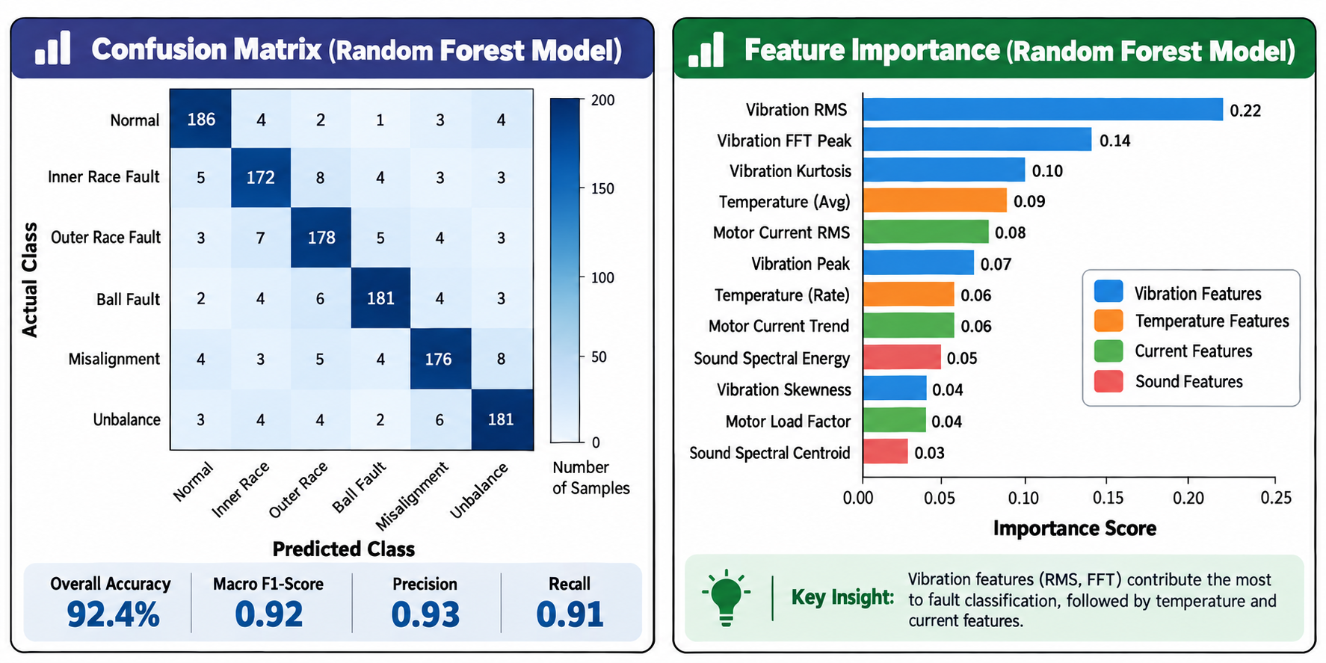
Random Forest model
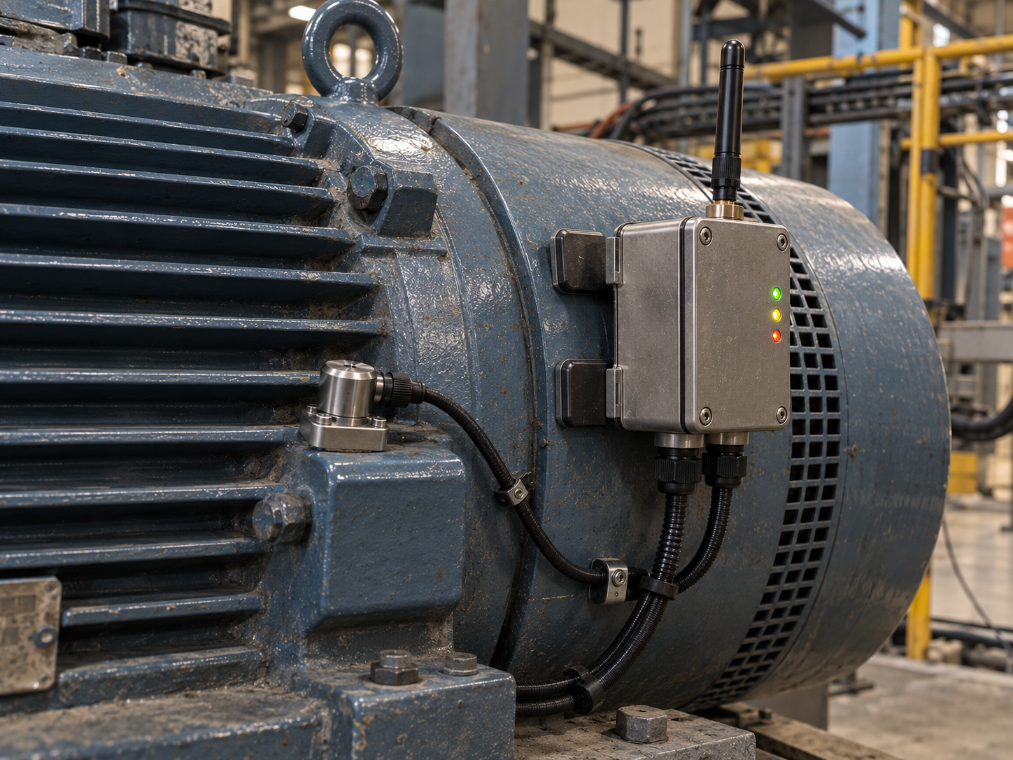confusion matrix and feature-importance results generated during model validation.

8. Integration with Existing PLCs and Industrial Dashboards
Predictive Pulse is designed to sit alongside a factory’s existing control and SCADA/HMI systems, not replace them. The Raspberry Pi acts as a protocol gateway, translating its plain-language, MQTT-based alerts into the languages that PLCs and industrial dashboards already speak.

8.1 Connecting to existing PLCs
Existing PLC interface | How the Raspberry Pi connects | What is exchanged
Modbus RTU (RS-485, very common on older PLCs) | USB-to-RS485 adapter on the Pi; Python `pymodbus` acting as a Modbus slave/server | Severity code and key readings written to Modbus holding registers that the PLC already polls
Modbus TCP (Ethernet) | Pi on the same industrial LAN; `pymodbus` TCP server | Same register mapping as RTU, no extra wiring needed
OPC UA (modern PLCs, Siemens/Allen-Bradley/Schneider families) | Pi runs a lightweight OPC UA server (`python-opcua` / `asyncua`) | Structured tags such as Machine.Severity, Machine.FaultType, Machine.TimeToMaintenance, browsable from the PLC/SCADA engineering tool
Hardwired I/O (relay/contact-based interlocks) | A small relay board or GPIO expander on the Pi, driven by severity level | A simple dry-contact "Warning" or "Critical" signal into the PLC’s existing alarm input, for plants that only need a hard interlock

- Register/tag mapping is documented once per machine (for example holding register 100 = severity 0-3, register 101 = fault-type code, register 102 = estimated hours to maintenance), so the PLC programmer only has to poll a handful of addresses.
- No changes to existing PLC logic are required to receive the data - the PLC simply reads new registers/tags the same way it reads any other sensor already wired to it; using that data to trigger an interlock or a maintenance timer is then the plant engineer’s choice.
- One-way by default: Predictive Pulse only writes advisory data into the PLC; it does not issue stop/start commands, keeping the existing safety and control logic fully in the PLC’s own hands.

8.2 Connecting to existing industrial dashboards / SCADA
Existing dashboard / SCADA platform | Integration method
Ignition, Wonderware/AVEVA, WinCC, FactoryTalk View (most modern SCADA) | Read directly from the OPC UA server on the Pi, or poll the Modbus registers - both are native, license-free inputs for these platforms
Node-RED based dashboards | Subscribe to the same MQTT topics the Pi already publishes (Chapter 3) - Node-RED has first-class MQTT support
Grafana-based dashboards | Point Grafana at the Pi’s time-series database (InfluxDB/TimescaleDB) directly, or via its MQTT/Modbus data-source plugins
Generic historian / MES systems | A small Python bridge script pushes summarised alerts to the historian’s REST/SQL interface on a scheduled interval

8.3 Why this integration approach was chosen
- Standards-based: Modbus and OPC UA are the two protocols almost every industrial PLC and SCADA platform already supports, so no proprietary connector needs to be purchased or licensed.
- Retrofit-friendly: nothing about the existing PLC program, wiring, or safety logic needs to change; Predictive Pulse only adds new, optional data points.
- Keeps the core system independent: even if a plant has no PLC or SCADA at all (common for the MSMEs and remote sites this project targets), the local dashboard in Chapter 6 works completely on its own - PLC/SCADA integration is an optional add-on, not a requirement.
- Scales the same way as the sensor network: adding a new machine to the PLC/SCADA integration is just adding a new register block or OPC UA node, following the same low-effort pattern used to add a new sensor node.

9. Features, Impact and Cost Reduction

9.1 Key features
Feature | What it means in practice
Works offline | All sensing, DSP, fault classification and the dashboard run entirely on-site (ESP32 nodes + Raspberry Pi) with no cloud account or internet connection needed at any point
Low-cost add-on | Clips or bolts onto machines that already exist - no change to the machine, its wiring or its control logic is required
Explainable | Every alert shows which reading and which trend it is based on, in plain language, not just a black-box score
Scalable | One Raspberry Pi hub can serve many ESP32 nodes; adding a machine means adding one more low-cost node, not another hub
Continuously learning | Every technician-confirmed alert becomes new labelled training data, so accuracy improves the longer the system runs (Chapter 7.4)
Non-intrusive installation | Clip-on current transformer, surface-mounted accelerometer and temperature probe - no cutting into motor wiring or machine housing
Multi-sensor fusion | Combines vibration, temperature, current and (optionally) sound so a fault is confirmed from more than one independent signal, reducing false alarms
Plain-language alerts with urgency | Dashboard shows messages like "maintenance recommended within 72 hrs" instead of raw numbers a non-specialist cannot interpret
Retrofits into existing systems | Can feed data into existing PLCs and SCADA/industrial dashboards over Modbus or OPC UA (Chapter 8), or run entirely standalone

9.2 Impact created
- Prevents unplanned breakdowns: by catching the early signs of wear (rising kurtosis, drifting temperature, changing current) days or weeks before a component actually fails, maintenance can be scheduled instead of forced.
- Ends wasteful calendar-based maintenance: machines that are still healthy are no longer opened up and serviced "just in case," and machines that are genuinely deteriorating are no longer missed simply because their scheduled service date has not arrived yet.
- Brings condition monitoring to sites that could never afford it before: remote installations such as mines, where connectivity is weak and commercial monitoring systems are impractical, can now run the same predictive capability entirely offline.
- Builds trust through explainability: because every alert states the reasoning behind it, maintenance teams can verify and act on it with confidence, rather than treating the system as an unexplained black box.
- Creates a growing, site-specific asset: every confirmed inspection makes the model more accurate for that specific plant and those specific machines, so the system becomes more valuable and more precise over time rather than staying static.
- Fits into how plants already work: because it can feed existing PLCs and SCADA dashboards, plants do not need to abandon their current systems or retrain operators on an entirely new interface to benefit from it.

9.3 Usefulness to us (as a project team)
- Gave hands-on, end-to-end experience across embedded firmware, digital signal processing, wireless communication protocols, machine learning and full-stack software - the complete stack an Edge-AI/IIoT engineer needs.
- Solved a real, verifiable problem (unplanned downtime cost, quoted on the poster at roughly ₹1.5 - 5 lakh per hour for an MSME) rather than a purely academic exercise, which strengthens both the learning outcome and the case to present at Avishkar 2026.
- Produced a design that is directly extensible - the same architecture and skills built here (Chapters 1 - 8) can be reused for other Edge-AI sensing projects, or grown into a start-up-style product.
- Demonstrates a working example of "TinyML"-style on-device intelligence (Level-1 detection on the ESP32) combined with heavier edge inference (Level-2 on the Raspberry Pi), a pattern increasingly valued across the IIoT industry.

9.4 Cost reduction
The poster projects a 35% reduction in unplanned downtime and maintenance cost. ★ This figure should be backed by a calculation or cited study before the final submission; a template for that calculation is given below.
Cost driver | Without Predictive Pulse | With Predictive Pulse
Downtime cost per unplanned breakdown | Full unplanned stoppage: ₹1.5 - 5 lakh per hour (poster figure), duration until a technician diagnoses and fixes the fault | Fault is caught early; repair can be scheduled during planned downtime, avoiding the unplanned stoppage entirely in most cases
Routine preventive maintenance | Fixed monthly servicing on a calendar, regardless of actual machine condition | Servicing is triggered by actual condition, so healthy machines are serviced less often
Diagnosis time | A technician must first find the fault after a breakdown has already happened | The dashboard already states the likely fault and the affected machine, cutting diagnosis time
Monitoring hardware cost | Commercial vibration-monitoring systems typically cost far more per monitoring point | A full node costs roughly ₹3,000 - ₹5,000 (Chapter 2.5), making monitoring affordable on many more machines

Suggested calculation template for the final report:
- Baseline: (average unplanned breakdowns per year) × (average downtime hours per breakdown) × (downtime cost per hour) = baseline annual cost.
- Projected: baseline annual cost × (1 − expected reduction in unplanned breakdowns, based on pilot results) = projected annual cost with Predictive Pulse.
- Add the one-time hardware cost (number of nodes × cost per node, plus one Raspberry Pi hub) and compare against the annual saving to state a payback period.
Once pilot data is available, replace the 35% figure and the template above with your actual measured or projected numbers, and show the calculation explicitly - judges consistently ask how a headline percentage was derived.

