**"Electrochemical Discharge Machining on Zirconium Metal”**

Himanshu Bhardwaj1, Kartik Parashar2, Gurpreet Singh3, B. K. Bhuyan1 and Pankaj Shakkarwal4

Department of Mechanical Engineering, FET, MRIIRS, Faridabad, Haryana, India

Corresponding Author: Himanshubhardwajfbd@gmail.com

Iamkartik3009@gmail.com

***Abstract*:** *One popular method for examining Material Removal Rate (MRR) is Electrochemical Discharge Machining (ECDM), which is distinguished by its capacity to produce zero residual stress. The hybrid ECDM machining method is perfect for precise machining of non-conductive and delicate materials, such as ceramics and fragile materials. This cutting-edge technique produces remarkable results by combining Electrochemical Machining (ECM) and Electric Discharge Machining (EDM).The study report provides a thorough experimental investigation of micro-machining procedures and related procedures, such as accurate electrolyte concentration control. The quality and accuracy of micro drilled holes are highly dependent on the voltages that are applied, with particular attention paid to the electrochemical processes that take place and the optimal placements for the holes. ECDM has proven to be an effective technique for machining a variety of materials, with a focus on workpieces.* *Owing to the innate brittleness of these materials, conventional machining techniques frequently prove inadequate, rendering ECDM an essential remedy. This paper explains the basic physical principles that underpin the ECDM process, making it a useful and insightful resource. The aerospace and optical industries are the main drivers of the growing need for precision machining of non-conductive materials, which highlights ECDM's superiority in these fields.*

***Keywords:* ECDM, EDM, ECM, MRR, Radial Overcut**

**1. INTRODUCTION**

The Electrochemical Discharge Machining (ECDM) procedure is a compelling method for creating cavities in a variety of materials. However, there are numerous scientific restrictions that can hinder the use of some non-metallic substances. Consequently, there are different types of applications in modern industries [1]. The performance limit of metal has been reached due to engineering advancements. The advantages of using metals include good creep resistance, which leaves no alternative but to seek increased corrosion resistance, increased thermal shock resistance, increased temperature resistance, and increased hardness characteristics. The principle of ECDM is to achieve an eroding effect using controlled ECDM on the electrodes [2]. The Metal Removal Rate (MRR), which is considered in the process, is achieved through pulsing the electrical current at a high frequency from the electrode to the workpiece. There are minimal Metal cuttings are minimal due to the controlled workpiece. Eventually, the needs of contemporary industries have surpassed the limitations of metal's performance, necessitating new strategies [3]. One prominent application is the production of superior holes, such as those found in turbine blades, which are often constructed from materials like silicon nitride. Numerous investigations have examined the impact of variables, such as applied voltage, on the rate of material removal, which has significant consequences for the efficiency of machining. Scholars have also studied how different types of electrodes and insulators affect the ECDM process.

The development of ECDM has led to innovative approaches for material removal, including the utilization of thermal energy for machining, regardless of the material's hardness [4]. This advancement has enhanced the machining of materials like aluminium and enabled the production of Molds, dies, and components for the automotive and aerospace industries [5]. The exceptional precision machining capabilities of Electro Chemical Discharge Machining (ECDM), a cutting-edge and inventive machining method, have attracted significant attention in recent years, especially when applied to challenging materials such as zirconium [6]. Zirconium is a refractory metal widely used in various industries, including aerospace, nuclear, and medicine, due to its remarkable resistance to corrosion and high temperatures. However, because zirconium is both robust and resistant to conventional machining techniques, it presents significant challenges for machining.

This in-depth investigation delves into the intriguing realm of ECDM, a state-of-the-art technique that offers a solution to the complex machining requirements of zirconium and other challenging materials. This introduction provides an overview of the importance, guiding principles, and potential applications of ECDM [7]. Zirconium metal is extremely challenging to machine. Zirconium is a highly sought-after refractory metal used in nuclear reactors, chemical processing, and medical implants due to its exceptional resistance to heat, chemicals, and corrosion. However, the very qualities that make zirconium so appealing also make it difficult to process with conventional techniques. Its exceptional hardness, high melting point, and propensity to produce a built-up edge (BUE) during machining make it challenging to machine, even with the most advanced tools.

For precise machining of zirconium and related materials, ECDM shows promise. By combining elements of electrochemical machining (ECM) and electro discharge machining (EDM), this innovative method minimizes its drawbacks while maximizing its advantages. ECDM presents an opportunity to overcome the issues associated with traditional ECDM functions based on a set of fundamental principles that distinguish it from conventional machining techniques. Essentially, electrical current discharge melting (ECDM) involves the controlled removal of material through chemical processes and electrical discharges. To facilitate the machining of the workpiece, this process utilizes an electrolyte and an electrode that conducts electricity [8]. Electro discharge machining (EDM): ECDM employs the same principles as EDM, specifically generating sparks between the electrode and the workpiece through high-frequency electrical discharges. Localized melting and vaporization resulting from these electrical discharges lead to material removal. EDM's capability to handle hard, high-melting-point materials is invaluable in zirconium machining [9]. Electrochemical Machining (ECM): By incorporating an electrochemical reaction into the process, ECM enhances EDM. In the case of zirconium, ECDM has a wide range of applications. Zirconium's exceptional resistance to radiation and corrosion makes it a popular material for use in nuclear fuel rods and reactor components. Nevertheless, sophisticated machining methods are necessary to provide the precise measurements and complex geometries required for nuclear applications [10].

For zirconium components intended for nuclear reactors, ECDM provides the best machining option available, ensuring maximum precision and structural integrity [11]. Using this technique, the complex shapes, holes, and channels required for safe and effective nuclear reactor operation can be created

Zirconium is used in aircraft as well as in nuclear applications, where its capacity to withstand high temperatures and corrosive environments is crucial. The production of high-tolerance and complex-designed aerospace components can be facilitated with the assistance of ECDM.

**2. WORKING PRINCIPLE**

The precision machining method known as Electro Chemical Discharge Machining (ECDM) has become increasingly important because it can handle challenging materials such as zirconium. In this comprehensive examination of its fundamental concepts, we will elucidate how ECDM operates on zirconium, providing engineers and researchers with a deeper understanding of the process [12]. ECDM is a hybrid machining method that combines the principles of electrochemical machining (ECM) with electro discharge machining (EDM). When these two processes are amalgamated, a potent tool is created, which can be used to machine materials that are often difficult to work with using traditional techniques [13]. Zirconium is one such material that greatly benefits from this, well-known for its exceptional resistance to corrosion and high temperatures. Spark Generation: EDM and ECDM have a significant influence on each other, especially in this aspect. The fundamental idea here is the utilization of high-frequency electrical discharges between the electrode and the workpiece. Localized areas on the workpiece experience sparks or spark-like phenomena due to these electrical discharges. EDM's ability to handle materials with high melting points and hardness is crucial when dealing with zirconium [14]. The temperatures of the sparks produced can melt or evaporate the material, enabling controlled material removal

An essential component of EDM is a dielectric fluid. It serves several purposes. Firstly, it enables controlled discharge by isolating the electrode from the workpiece. Additionally, it helps in removing debris and cooling the machining area to prevent overheating. Regarding ECDM for zirconium, Materials for the Electrode: In EDM, the choice of electrode is critical [15]. Factors such as the material's hardness, the desired surface finish, and the process parameters should all be taken into account when selecting the electrode material for ECDM on zirconium. It's vital to ensure that the electrode material does not contaminate or react with zirconium during the machining process

Material removal is the result of localized heating and vaporization of the workpiece caused by spark generation [16]. The sparks efficiently erode the zirconium surface, and the debris is removed by the dielectric fluid, ensuring a precise and controlled machining operation. Component of Electrochemical Machining (ECM): An electrolyte solution is introduced into the machining process as part of the ECM component of ECDM. The principles of EDM and ECM are seamlessly integrated through the complex and dynamic process of ECDM. It offers a precision machining solution for challenging materials like zirconium that cannot be achieved with conventional techniques [17]. Due to the unique way in which ECDM's working principles combine electrical discharges with electrochemical processes, it is a powerful technology for efficiently machining zirconium and other materials that present similar challenges [18].

.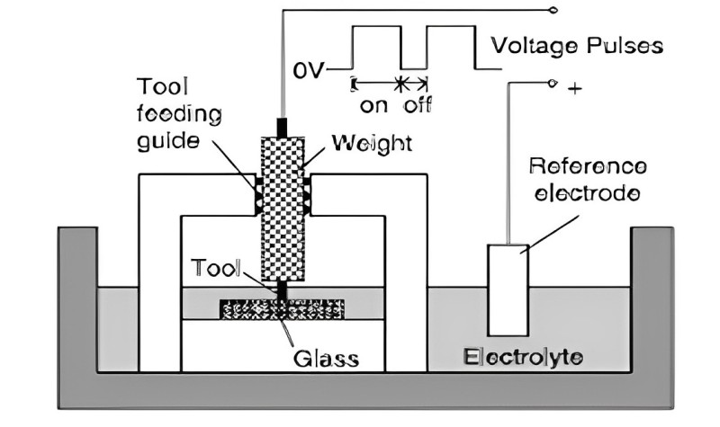

**Figure.1 Line diagram of Drilling ECDM Process**

**3. EXPERIMENTAL PROCEDURE**

The Zirconium Metal Electro Chemical Discharge Machining (ECDM) experimental process is a meticulously planned sequence of actions and considerations aimed at ensuring precision, effectiveness, and safety [19]. In this comprehensive explanation, we will highlight the key elements of the experimental protocol, providing valuable guidance to engineers and researchers engaged in productive ECDM investigations involving zirconium. Every ECDM experiment begins with the initial setup of the machining system [20]. Illustrated in Figure 1, a line diagram visually depicts the essential components and their interactions within the drilling ECDM process. This diagram assists operators in comprehending the process workflow and the critical functions of each component, serving as a valuable reference tool.

Regarding the workspace setup, it is imperative to maintain a clean, well-ventilated area equipped with the necessary safety gear, including gloves and safety glasses for personal protection. Ensuring that all parameters and settings are accurately configured on the ECDM machine is essential. This calibration process encompasses selecting the appropriate electrode material, voltage, and current [21]. The zirconium workpiece must be securely fastened within the machine, and the correct electrode material should be chosen. The selected dielectric fluid, suitable for zirconium machining, should be placed in the machine's dielectric fluid reservoir. To prevent electrical hazards, it is crucial to have safety measures such as emergency stop buttons and proper grounding in place.

Before commencing the ECDM experiment, optimizing machining parameters is a critical step, as these parameters have a significant impact on the final outcome of the process [22]. Important parameters to consider involve selecting the appropriate voltage and current values based on the specific experiment requirements. These parameters play a crucial role in determining the intensity of the electrical discharges, which, in turn, affects the material removal rate and surface finish [23].

It's essential to choose the most suitable electrolyte solution for zirconium machining. The choice of solution can influence electrochemical reactions and material removal efficiency [24]. Carefully select the electrode material, considering its compatibility with zirconium and the desired finish. Common electrode materials include copper, graphite, and brass. Determine the shape and size of the electrode, as these factors impact the geometry of machined features and process precision [25].

Conducting a tool wear analysis before commencing the primary experiment is advisable. This involves observing wear patterns on the electrode by running the ECDM procedure for a brief period. Tool wear analysis ensures that the chosen electrode is suitable for the experiment and assists in estimating the expected tool life [26].

With the workpiece, setup, and settings in readiness, the actual ECDM experiment can commence. Starting with an initial run is recommended to observe how the process behaves, helping identify any setup issues or necessary parameter adjustments [27]. Initiate the ECDM process, which generates sparks between the electrode and the zirconium workpiece using high-frequency electrical discharges. Some sparks cause localized heating. Conclude the experiment by summarizing the findings, including the material removal rate, surface quality, and tool wear patterns [28]. Document the experiment's outcomes, both successful elements and challenges encountered [29]. The results and insights gained from the experiment can be invaluable for future research and process refinement.

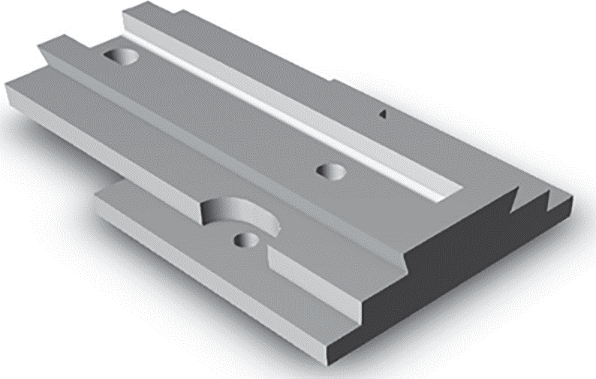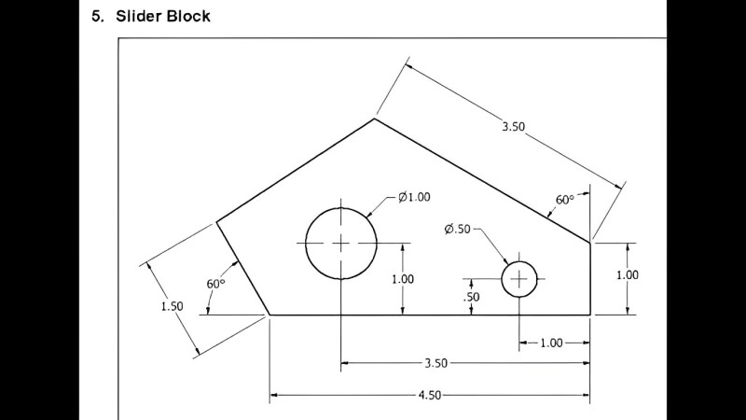

**Figure 2. 3D and 2D model of Single axis Sliding Block (z axis)**

The 3D model of a single-axis (Z-axis) sliding block is an integral part of the ECDM system for zirconium electrochemical machining. A detailed view of this meticulously designed block is presented in Figure 2, illustrated below. It plays a critical role in regulating the vertical movement of the electrode in relation to the zirconium workpiece. This vertical motion control is essential for precisely controlling the machining process at the desired depth [30]. The 3D model of the sliding block incorporates features such as vertical motion control, fine-tuning adjustments, and secure fixturing for the workpiece. These features ensure that the ECDM process effectively removes material from the zirconium workpiece while maintaining the necessary dimensional accuracy and surface finish [31].

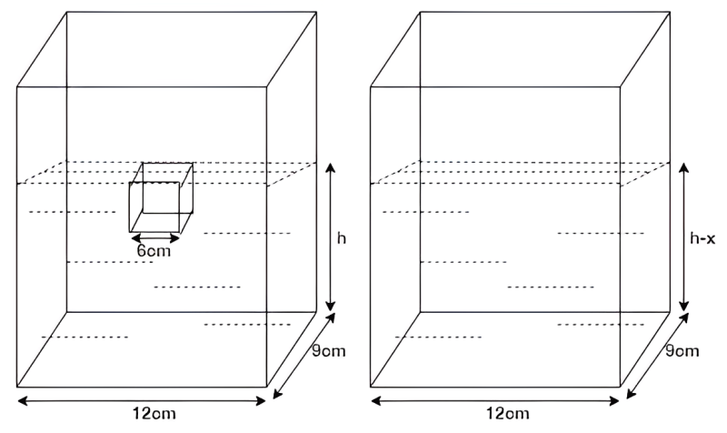

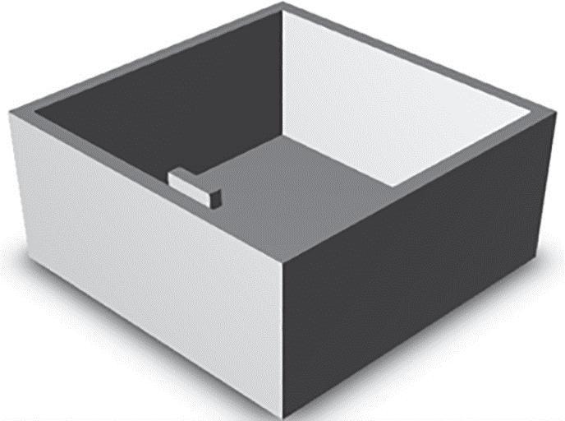

**Figure 3. 3D and 2D model of Electrolyte container**

An essential component of the ECDM system is the 3D model of the electrolyte container for electrochemical machining [32]. Figure 3 (shown above) is an example of this carefully crafted container that forms the core of the ECDM process. It contains the crucial electrolyte solution required for the machining process. The container's well-optimized design ensures the uniform and efficient distribution of the electrolyte in the machining area, facilitating the necessary electrochemical reactions for accurate material removal. To ensure a safe and controlled procedure, the container is equipped with features like precise flow control and safety precautions to prevent spills or leaks [33]. As a vital component of the ECDM system, this 3D model ensures that the electrolyte solution reaches the workpiece in a controlled and efficient manner, enabling precise machining on materials like zirconium.

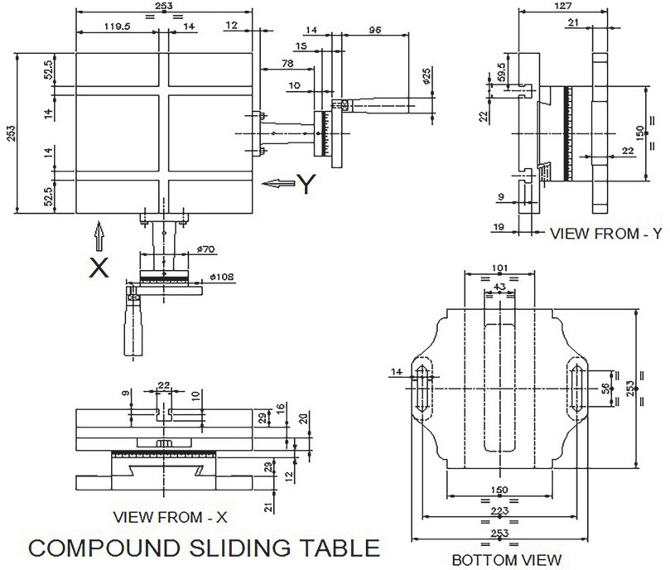

**Figure4. 2D Drawing of Compound sliding table**

This crucial part of the ECDM system is shown in depth technically in the 2D schematic of a compound sliding table for electrochemical machining [34]. The table's dimensions, structure, and sliding mechanisms—which allow for exact horizontal and vertical movement—are depicted in Figure. 4 (see Above). This part provides regulated motion throughout the machining process by acting as the base for securing the workpiece and electrode [35]. In order to fabricate the sliding table to exact specifications and ensure that ECDM operations on materials like zirconium are carried out precisely, producers and engineers 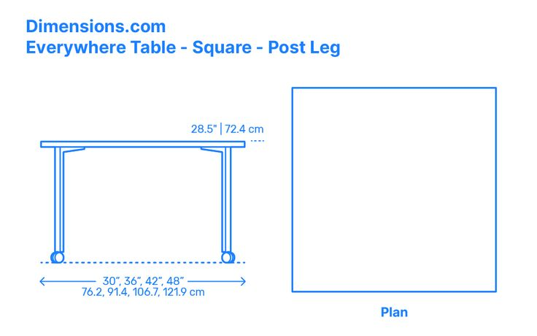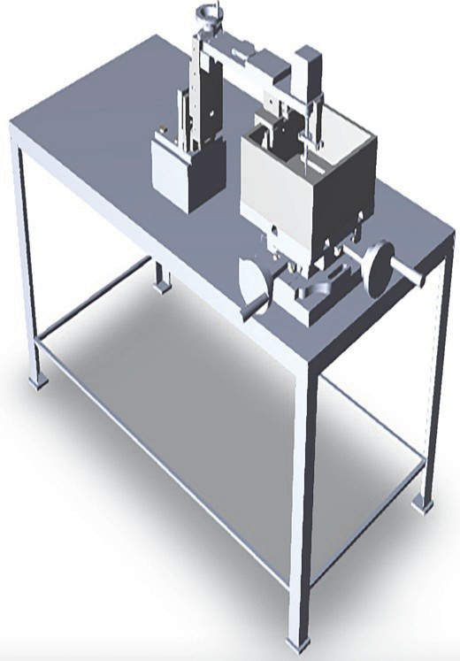rely on the 2D drawing for crucial information.

**Fig.5 3D and 2D Model of ECDM Machine assembly**

Understanding the overall assembly of the ECDM machine is crucial for comprehending the ECDM process. The 3D model of the ECDM machine, as depicted in Figure 5 (shown above), offers a detailed representation of the entire system. This model serves as a valuable tool for grasping the intricate construction of the ECDM machine and its essential components.

**Table 1. Summary of the Drilling ECDM Process**

|  |  |  |  |  |  |
| --- | --- | --- | --- | --- | --- |
| **Workpiece** | **Electrolyte** | **Input Parameters with range** | **Output Parameters** | **Major Findings** | **Ref** |
| Glasses | NaNO3 | Diameter of the electrode tool (0.5–0.9 mm); voltage between electrodes (35–45 V); and discharge circuit capacitance (33–840 F). Density of work liquid: 1.05–1.20 g/cm^ | Ankle-tool electrode wear | A spring may be used to apply the necessary force to rupture the insulating layer that has formed on the product when utilizing a semi-dielectric type working fluid. It has been determined that a plant may be electrochemically treated as a component of a small mechanical workshop or research project. | **12** |
| Quartz | NaOH | The values for the spindle speed are 100-200 rpm, electrode voltage (30-38 V), frequency (20-320 Hz), amplitude (10-30 µm), and duty ratio (0.2-0.8) µ. | MRM | The methods of material removal for conventional and micro-drilling with ECDM were examined. Supply discontinuities were identified through traditional ECDM and removed through ECDM-activated micro-drilling. | **15** |
| Pyrex Glasses | SiO2 | Tool electrode diameter (ጲ 300 µm) and pulse voltage (80 V) | Device Charge-Coupled | Different material removal mechanisms are used in the front and side slots of ECDD. The front gap is primarily where discharge takes place, while the side gap is where the generated relite layer is electrochemically eliminated | **20** |

A summary of the Electrochemical Discharge Machining (ECDM) process is shown in Table 1. ECM is a specialized machining technology that combines elements of electrical discharge machining (EDM) and electrochemical machining (ECM) to ensure accurate material removal. Applications requiring complicated forms, limited heat-affected zones, and great precision frequently employ ECDM. The main attributes and features of the ECDM process are outlined in this table.

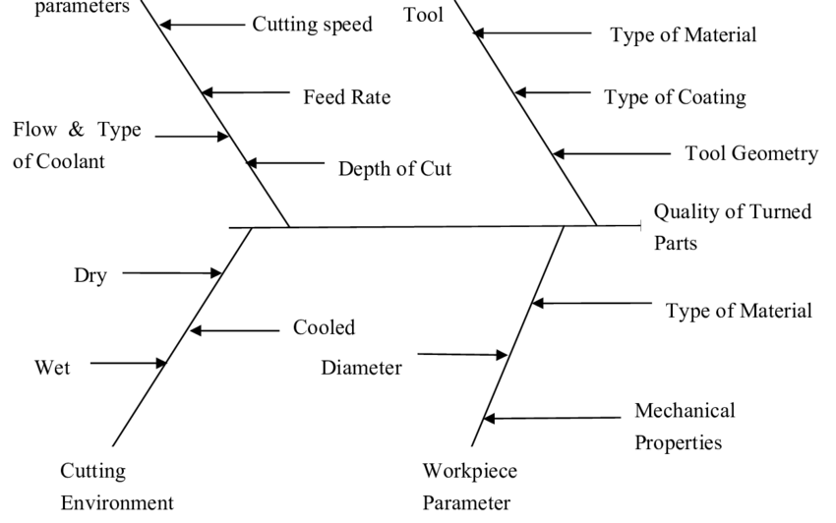

**Figure 6. Fish bone (Ishikawa) diagram for the performance of ECDM**

To maximize the effectiveness and quality of an Electrochemical Discharge Machining (ECDM) process, performance analysis is essential. The Fishbone (Ishikawa) diagram, a visual tool that helps identify and categorize potential causes of problems or performance variations, is one useful instrument for conducting this type of analysis. A Fishbone diagram specifically designed for assessing and improving the performance of the ECDM process is presented in Figure 6.

**4. RESULTS AND DISCUSSION**

The primary objectives of this pilot experiment were to determine the optimal micro-drill process with minimal overlap and taper while achieving the highest material removal rate. In this project, we successfully worked on developing a prototype of ECDM and used Zirconium as the workpiece. Although ECDM is typically intended for nonmetals or nonconductive materials, we employed Zirconium, a ductile material. Consequently, we were able to perform drilling in Zirconium metal using NaCl and KOH solutions as the electrolyte, achieving minimal overcut and a fine surface finish without compromising the Material Removal Rate (MRR).

**Figure 7. Pie-Chart of Percentages of different Processes of Responses of ECDM on Zirconium Metal**

The computation of Surface Roughness and Radial Overcut Material Removal Rate (MRR) requires the examination of machining parameters in the lack of precise experimental data. The determination of Radial Overcut MRR usually involves evaluating the amount of material removed in a given amount of time, taking into account variables such as feed rate and cut depth. Ra and other metrics are used to measure deviations from the ideal surface in order to evaluate surface roughness. Accurate calculations depend on certain values and variables, such as workpiece characteristics, tool geometry, and cutting speed. Unfortunately, a thorough explanation of the particular calculating process is not possible without extensive experimental data.

*NO. Of Papers*

*No. Of Electrolyte Use*

**Figure 5. Number of publications Year-wise**

One of the most important components of academic analysis is the yearly quantification of research paper production. Precise tracking and classification of articles according to their individual publication years are required for this computation. Through the methodical examination of databases, scholarly journals, and conference proceedings, scholars can determine the yearly output of scholarly publications within a particular discipline. This procedure not only makes it easier to comprehend how the field of research has changed over time, but it also offers insightful information about the main themes, developments, and trends in a certain academic field. Precise year-by-year estimates play a major role in assessing research productivity and identifying new themes in the academic community.

**5. RESEARCH POTENTIAL AND SCOPE FOR FUTURE WORK**

Past research efforts have often been constrained by time limitations, which have prevented the thorough exploration of various aspects within the field of Electrochemical Discharge Machining (ECDM). This project aims to delve into the intrinsic properties of ECDM while also identifying potential directions for future research. A comprehensive analysis, grounded in a thorough evaluation of relevant literature, underscores several significant research gaps [36]. For instance, ECDM, as a hybrid machining technique, holds great potential for the machining of micro-sized components, meeting the increasing demand for intricate, small-scale workpieces. Moreover, ECDM can be applied to machine advanced materials, including composites and superalloys, contributing to materials development. Future research projects could prioritize the development of environmentally friendly electrolytes and tool materials to mitigate the environmental impact typically associated with traditional machining processes.

The versatility of ECDM is demonstrated by its capability to be employed in the machining of various materials, including glass, marble, floor tiles, and within the ceramics industry. Examples of glass products benefiting from this versatility include pharmaceutical bottles and solar-protected glasses [37]. Advancements in ECDM machine design offer the potential for achieving higher surface finishes, potentially eliminating the need for post-processing and reducing overall machining lead times. Additionally, ECDM proves to be a valuable technique for machining electrically non-conductive materials, such as ceramics, composites, cermet’s, and various types of glass. Industries such as automotive, defense, and aerospace find utility in this technique [38].

Through the enhancement of ECDM methods, precision at the micron and even nanoscale levels can be achieved, enabling the creation of minuscule, intricately detailed parts with a wide range of industrial applications. Notably, the medical field holds substantial potential for ECDM, particularly in the fabrication of complex, customized implants. The integration of cutting-edge sensors and real-time monitoring methods can strengthen control over the ECDM process, facilitating adjustments for peak performance [39]. The significant improvement in surface finish quality at lower Material Removal Rates (MRR) underscores the importance of optimizing the efficiency of the ECDM system [40]. Research on process optimization remains a promising field that warrants further exploration.

**CONCLUSION**

The investigation into ECDM involves the utilization of chemical and electrical discharge methods for removing material from non-conductive, brittle materials commonly used in precision machining, often referred to as micro-drilling [41]. The material removal rate (MRR) is typically enhanced by increasing the voltage and current. Commonly used electrolytes include NaCl and KOH. ECDM is a valuable technique applied to metals, composites, and non-conductive materials. While it may result in lower MRR, this is advantageous during the machining process [42]. It's important to note that the ECDM process is primarily intended for conductive materials. In our case, we used zirconium as the workpiece, which is a metal known for being one-fourth the weight of steel and having ductile properties. We were able to drill holes in the zirconium workpiece using a copper tool, with minimal burr formation, and aimed to achieve a superior surface finish.

**REFERENCES**

[1] C.S. Jawalkar, Apurbba Kumar Sharma and Pradeep Kuma, “Micromachining with ECDM: Research Potentials and Experimental Investigations”, International Journal of Mechanical and Mechatronics Engineering, vol. 6, (2012), pp. 340 –348.

[2] Abhishek Charak & C.S Jawalkar, “Experimental Investigation and Analysis on Borosilicate Glass Using Electrochemical Discharge Machining Process”, silicon,14, (2022), pp. 1823-1829 .

[3] Julfekar Arab and Pradeep Dixit, “Influence of tool electrode feed rate in the electrochemical Discharge drilling of a glass substrate”, Materials and manufacturing processes vol. 35 ,(2020), pp. 1749-1760.

[4] Rajendra Kumar Arya and Akshay Dvivedi, “Investigations on quantification and replenishment of Vaporized electrolyte during deep micro-holes drilling using pressurized flow-ECDM process”, Journal of Materials Processing Technology vol. 266,(2019), pp. 217-229.

[5] S. F. Huang , Y. Liu , J. Li , H. X. Hu & L. Y. “Sun Electrochemical Discharge Machining MicroHole in Stainless Steel with Tool Electrode”, High-Speed Rotating Materials and Manufacturing Processes,vol. 29, (2014), pp. 634-636.

[6] K.P. Rajurkara, M. M. Sundaramb and A. P. Malshec “Review of Electrochemical and Electrodischarge Machining” , Procedia CIRP vol. 6,( 2013), pp.13 –26.

[7] Gaurav Saini, Alakesh Manna and Amanpreet Singh Seth “An experimental investigation During Electro Chemical Discharge Machining of e-glass fibre reinforced polymer composite “,International Journal of Applied Engineering Research vol. 13 (2018), pp. 8899-8906.

[8] Maneetkumar R. Dhanvijay , Vinay A. Kulkarni and Akshay Doke “Experimental Investigation and analysis of Electrochemical Discharge on Fibreglass Reinforced Plastic”, Journal of the Institution of Engineers vol. 100, (2019), pp.763-769.

[9] Zheng Yang Xu , Yan Zhang1 , Fei Ding1 and Feng Wang, An electrochemical discharge drilling Method of small deep holes The International Journal of Advanced Manufacturing Technology Vol. 95 (2018), pp. 3037-3044.

[10] Parvesh Antil , Sarbjit Singh and Alakesh Manna,”Electrochemical Discharge Drilling of SiC Reinforced Polymer Matrix Composite Using Taguchi’s Grey Relational Analysis” , Arabian Journal for Science and Technology vol. 43,(2018), pp. 1257—1266.

[11] Sanjay K. Chak & P. Venkateswara Rao,” The drilling of Al2O3 using a pulsed DC supply with a Rotary abrasive electrode by the electrochemical discharge process” Int J Adv Manuf Technol Vol. 39 (2008), pp. 633–641.

[12] Y.S. Laioa, L.C. Wua and W.Y. Pengb “A study to improve drilling quality of electrochemical Discharge machining (ECDM) process”,Procedia CIRP vol. 6 (2013), pp. 609 – 614.

[13] Tarlochan Singh, Rajendra Kumar Arya & Akshay Dvivedi Experimental investigations into rotary Mode electrochemical discharge drilling (RM-ECDD) of metal matrix composites ,MachiningScience and Technology vol. 24, (2020), pp. 195-226.

[14] Pravin Pawar1, Raj Ballav, “Amaresh Kumar,Measurement Analysis in Electrochemical Discharge Machining (ECDM) Process”: A Literature Review ,J. Chem. Chem. Eng. 9 (2015), pp. 140- 144.

[15] S. Elhami, M.R. Razfar, “Application of nano electrolyte in the electrochemical discharge machining Process Precision Engineering” vol. 64 (2020), pp. 34–44.

[16] Mr. Mohammed Moizoddin Shaikh Muniruddin1 Mr. Mohammad Ibrahim Masood Ahmed “Review Paper on Electrochemical Discharge Machining: Mechanism and Future Scope”, International Journal of Engineering Research & Technology (IJERT) (2021), pp. 104-105.

[17] Baoyang Jiang, Shuhuai Lan, and Jun , “ Experimental investigation of drilling incorporated Electrochemical discharge Machining”, International Manufacturing Science and Engineering (2014), pp. 1-7.

[18] Pankaj Kumar Gupta, Akshay Dvivedi & Pradeep Kumar “Effect of Pulse Duration on Quality Characteristics of Blind Hole Drilled in Glass by ECDM Materials and Manufacturing Processes”, (2015), pp. 1-32.

[19] Lijo Paul and Somashekhar S Hiremath , “Experimental and Theoretical Investigations in ECDM Process” , An Overview Procedia Technology (2016), pp. 1242 – 1249.

[20] Tarlochan Singh & Akshay Dvivedi, “A pressurized feeding approach for effective control on Working gap in ECDM of borosilicate glass”, Materials and Manufacturing Processes vol. 33, (2017), pp. 462-473.

[20] Julfekar Arab and Pradeep Dixit, “Influence of tool electrode feed rate in the electrochemical Discharge drilling of a glass substrate”, Materials and manufacturing processes vol. 35 ,(2020), pp. 1749-1760.

[21] B. Bhattacharyya, B.N. Doloi and S.K. Sorkhe , “Experimental investigations into electrochemical Discharge machining (ECDM) of non-conductive ceramic material” Journal of Materials Processing Technology, vol. 95, (1999), pp.145-154.

[22] Er. Khushwahkant Sharma, Er.Jai Om and Mr. Vikram Singh Rawat, “A review paper on Electrochemical machining”, IJERT vol. 9 (2020), pp. 582-588.

[23] Anjali V. Kulkarn , “Electrochemical Discharge Machining Process”, Defence Science Journal ,Vol. 57. (2007), pp. 765-770.

[24] Viveksheel Rajput, Mudimallana Goud and Narendra Mohan Suri, “Study on Effective process Parameters toward the better comprehension of Ecdm process”,International Journal of Modern Manufacturing Technologies ,vol. 11,( 2019), pp. 104-113.

[25] Margareta Coteaţă, Hans-Peter Schulze & Laurenţiu Slătineanu , “Drilling of Difficult-to-Cut Steel By Electrochemical Discharge Machining”, Materials and Manufacturing Processes, vol. 26, (2011), pp. 1466–1472.

[26] Rajendra Kumar Arya, Akshay Dvivedi, “Investigations on quantification and replenishment of Vaporized electrolyte during deep micro-holes drilling using pressurized flow-ECDM process”, Journal of Materials Processing Technology, vol. 266, (2018), pp. 217-229.

[27] Navin Kumar Jha, Tarlochan Singh, Akshay Dvivedi & Shivanna Rajesha “Experimental Investigations into triplex hybrid process of GA-RDECDM during subtractive processing Of MMC’s Materials and Manufacturing Processes”, vol. 34, (2019), pp. 243-255.

[28] Zheng Yang Xu, Yan Zhang ,Fei Ding and Feng Wang, “An electrochemical discharge drilling Method of small deep holes”, The International Journal of Advanced Manufacturing Technology ,Vol. 95, (2018), pp. 3037-3044.

[29] K.P. Rajurkara, M. M. Sundaramb and A. P. Malshec , “Review of Electrochemical and Electrodischarge Machining” ,Procedia CIRP 6 ,(2013), pp. 13 – 26.

[30] Mukesh Verma and Alakesh Manna , “Experimental Investigations on Developed Electrochemical Spark Machining Set up during Machining of Alumina Ceramic Component”,International Journal Of Creative Research Thoughts, vol. 5, (2017), pp. 1004-1012.

[31] Lijo Paul ,and Somashekhar S Hiremath , “Experimental and Theoretical Investigations in ECDM Process – An Overview Procedia Technology”, vol. 25,( 2016), pp. 1242 – 1249.

[32] Pankaj Kumar Gupta, Akshay Dvivedi, and Pradeep Kumar , “Developments on electrochemical Discharge machining: A review of experimental investigations on tool electrode process parameters”, Journal of Engineering Manufacture, vol. 229,( 2014), pp. 910-920.

[33] Anjali V. Kulkarni, “Electrochemical Discharge Machining Process”, Defence Science Journal ,vol. 57,( 2007), pp. 765-770.

[34] Dae-Jin Kima, Yoomin Ahnb, Seoung-Hwan Leeb and Yong-Kweon Kimc, “Voltage pulse Frequency, and duty ratio effects in an electrochemical discharge micro-drilling process of Pyrex Glass”, International Journal of Machine Tools & Manufacture 46, (2006), pp. 1064–1067.

[35] Xianchun Shi, Shaofu Huang and Long Wang, “Investigation of the Material Removal Mechanism In Electrochemical Discharge Drilling Using a High-Speed Rotating Helical Tool-Electrode”, Int. J. Electrochem. Sci., 14, (2019), pp. 9239 – 9254 .

[36] Gaurav Saini, Alakesh Manna, and Amanpreet Singh Sethi, “An experimental investigation during Electro Chemical Discharge Machining of e-glass fiber reinforced polymer composite”, International Journal of Applied Engineering Research, vol. 13,( 2018), pp. 8899-8906.

[37] C.S. Jawalkar, Apurbba Kumar Sharma, Pradeep Kumar, “Micromachining with ECDM: Research Potentials and Experimental Investigations”, International Journal of Mechanical and Mechatronics Engineering, voi. 6, (2012), pp. 340-345).

[38] Mukesh Verma and Alakesh Manna, “Experimental Investigations on Developed Electrochemical Spark Machining Set up during Machining of Alumina Ceramic Component” IJCRT, vol. 5, (2017), pp. 004-1011.

[39] Basanta Kumar Bhuyan & Vinod Yadava, “Experimental Study of Traveling Wire Electrochemical Spark Machining of Borosilicate Glass”, Materials and Manufacturing Processes, vol. 29,(2014), pp. 298-303.

[40] Mr. Mohammed Moizoddin Shaikh Muniruddin, Mr. Mohammad Ib B. Mallick, Rahim Masood Ahmed “Review Paper on Electrochemical Discharge Machining: Mechanism and Future Scope” International Journal of Engineering Research & Technology (IJERT),vol. ,(2021), pp. 104-106

[41] B.R. Sarkar, B. Doloi and B. Bhattacharyya, “Experimental investigation into electrochemical Discharge micro-drilling on advanced ceramics Int. J. Manufacturing Technology and Management”, Vol. 13, ( 2008), pp. 214-225 .

[42] Ashish Kumar and Dr. P. S. Rao, “A Review on Research trends in electrochemical discharge Machining,International”,Journal of Technical Innovation in Modern Engineering & Science, vol, 4, (2018), pp. 466-470.