A Project Report on

UNCOVERING THE GAMING INDUSTY’S HIDDEN GEMS:

a comprehensive analysis of video game sales

**by**

**Team Leader:- MEDA SAI SHIVA MANIKANTA(20AT1A05C7)**

**Student 1:-PALLE MAHESH REDDY(20AT1A0578)**

**Student 2:- SURAPURAJU POORNA CHARAN(20AT1A05A4)**

**Under the Guidance of**

**MRS.M. JAYA SUNITHA, MTech**

**Associate Professor**



**DEPARTMENT OF COMPUTER SCIENCE ENGINEERING**

**G. PULLAIAH COLLEGE OF ENGINEERING AND TECHNOLOGY**

**(Autonomous)**

(Approved by AICTE | NAAC Accreditation with ‘A’ Grade | Accredited by NBA (ECE, CSE, EEE, CE) |

Permanently Affiliated to JNTUA)

ABSTRACT

The video game industry has witnessed remarkable growth over the past few decades, becoming a major entertainment sector worldwide. This comprehensive analysis aims to provide an in-depth understanding of video game sales trends, the factors influencing sales, and the development of predictive models to forecast future sales performance.

The study begins with the collection and analysis of historical video game sales data from various platforms and regions, covering a substantial time span. The dataset includes information on game genres, release dates, platforms, publishers, developers, critic and user ratings, marketing budgets, and macroeconomic indicators.

The research then focuses on identifying the key factors that significantly impact video game sales. Through advanced statistical techniques and machine learning algorithms, the study explores the correlation between sales performance and various factors, such as game genre popularity, critical acclaim, user reviews, marketing strategies, platform choices, and economic conditions.

In conclusion, this comprehensive analysis of video game sales provides valuable insights for industry professionals, researchers, and enthusiasts alike. By understanding the underlying trends, key influencing factors, and harnessing the power of predictive models, stakeholders can navigate the dynamic landscape of the video game market more strategically and make informed decisions to drive success.

**Contents**

**Abstract** 2

**Contents** 3

**List of Figures and Tables** 4

**CHAPTER 1:INTRODUCTION 4**

**CHAPTER 2:LITERATURE REVIEW 5**

**CHAPTER 3:VIDEO GAME SALES TRENDS 6**

**CHAPTER 4:FACTORS INFLUENCING VIDEO GAMES SALES 7**

**CHAPTER 5:EMERGING TECHNOLOGIES AND SALE 8**

**CHAPTER 6: IMPLICATIONS AND RESULTS 9**

**CHAPTER 7: APPLICATIONS 12**

**CHAPTER 8: ADVANTAGES AND DIS ADVANTAGES 13**

**CHAPTER 9:CONCLUSION 14**

**LIST OF FIGURES AND** **TABLES**

Database collected from TABLEAU about the UNCOVERING THE GAMING INDUSTRY’S HIDDEN GEMS: a comprehensive analysis of video game sales

**CHAPTER 1**

**INTRODUCTION**

The video game industry has evolved into one of the most influential and lucrative sectors of the global entertainment landscape. With advancements in technology and the widespread availability of gaming platforms, video games have become an integral part of modern culture, captivating players of all ages around the world. As the industry continues to grow and diversify, understanding the dynamics of video game sales has become increasingly vital for industry professionals, researchers, and stakeholders.

**what is video games?**

Video games are interactive electronic entertainment experiences played on various gaming platforms. Players engage in virtual worlds, completing objectives, solving puzzles, or competing against others. They offer immersive storytelling, skill-based challenges, and social interaction, making them a popular form of entertainment worldwide.

**purpose of video games ?**

The purpose of video games is to entertain and engage players, providing a form of interactive and immersive entertainment. They offer a means of relaxation, stress relief, and escapism from daily life. Additionally, video games can foster cognitive skills, problem-solving abilities, and teamwork through gameplay experiences. They also serve as a platform for storytelling, artistic expression, and creativity, allowing developers to craft compelling narratives and unique virtual worlds.

**CHAPTER 2**

**LITERATURE REVIEW**

The literature review aims to provide an overview of existing studies and research related to video game sales analysis. This section critically examines the key findings and methodologies used in previous works, highlighting gaps and opportunities for further investigation.

**Historical Development of the Video Game Industry:**

Numerous scholarly works have explored the historical evolution of the video game industry, tracing its roots from early arcade games to the modern era of console and mobile gaming. These studies shed light on the industry's growth trajectory, major milestones, and the transformative impact of technological advancements.

**Factors Influencing Video Game Sales:**

Several research studies have investigated the factors that contribute to video game sales success. These include the influence of critical and user reviews, game genre popularity, marketing strategies, platform choices, and economic conditions. Previous works have shown how these variables interact and impact a game's commercial performance.

**Video Game Sales Trends and Market Analysis:**

Researchers have conducted market analyses to understand global and regional video game sales trends. These studies examine sales data over time and identify patterns and fluctuations in the industry. They provide insights into consumer preferences and changing market dynamics, which are valuable for industry stakeholders.

**Impact of Emerging Technologies on Video Game Sales:**

With the rise of virtual reality (VR), augmented reality (AR), and cloud gaming services, scholars have investigated the potential influence of these technologies on video game sales. Studies have explored the adoption rates, consumer perceptions, and market penetration of these innovations.

**CHAPTER 3**

**VIDEO GAME SALES TRENDS**

In conducting a comprehensive analysis of video game sales, it is imperative to delve into the prominent trends that have shaped the industry's performance over time. The examination of video game sales trends provides invaluable insights into the dynamic nature of the market and the factors influencing commercial success. Historical data reveals the remarkable growth of the video game industry, from its nascent beginnings to its current status as a dominant global entertainment sector. Furthermore, the analysis explores the shift in gaming platforms' popularity, highlighting how consoles, PCs, and mobile devices have all played significant roles in shaping sales trends. Additionally, the influence of game genres on sales performance is scrutinized, revealing which genres have consistently captured players' interests and how preferences have evolved over the years.

Seasonal and cyclical trends are investigated to uncover fluctuations in consumer demand throughout the year, guiding developers in optimizing game release timing. The longevity of popular titles is examined, shedding light on the enduring appeal of certain games and the factors contributing to their prolonged success. Moreover, the impact of sequels and franchise titles on sales performance is assessed, elucidating the power of established fan bases in driving commercial achievements. Critical and user reviews' influence on sales is explored to understand how positive feedback from critics and players can boost a game's reception in the market.



**CHAPTER 4**

**FACTORS INFLUENCING VIDEO GAMES SALES**

* Video game sales are influenced by a multitude of interconnected factors that collectively shape the success or failure of a game in the market. One of the most critical aspects is the game's genre popularity, as certain genres resonate more strongly with specific target audiences, leading to higher sales potential. Additionally, the impact of critical and user reviews cannot be underestimated, as positive reviews instill confidence in potential buyers and contribute to word-of-mouth marketing. Effective marketing and promotional strategies play a pivotal role in generating pre-release hype and attracting attention, which can translate into strong initial sales figures.
* Multiplayer and social features that encourage player interaction can foster strong communities and lead to sustained sales through continued engagement. Cross-platform compatibility provides players with flexibility and convenience, broadening the potential player base and expanding sales opportunities. For established franchises or games with strong brand recognition, a built-in fan base can contribute significantly to initial sales figures. Cultural preferences and regional variations further shape gaming habits and sales patterns, necessitating localized marketing strategies for optimal success in different markets.

**CHAPTER 5**

**EMERGING TECHNOLOGIES AND SALES**

* Emerging technologies are revolutionizing the landscape of the video game industry and significantly impacting game sales. One of the most transformative technologies is virtual reality (VR), which immerses players in captivating virtual worlds. VR-compatible games offer a heightened sense of presence and interactivity, leading to increased demand and sales for these innovative experiences. As VR technology becomes more accessible and refined, its potential to drive game sales continues to grow.
* Augmented reality (AR) is another emerging technology shaping the gaming sector. AR games merge virtual elements with the real world, creating interactive and engaging experiences accessible through mobile devices. The widespread adoption of AR-capable smartphones has expanded the reach of AR games, attracting a diverse audience and potentially boosting game sales.
* Cloud gaming services represent a paradigm shift in how games are accessed and played. By enabling players to stream games over the internet, cloud gaming removes the need for high-end hardware, making gaming more accessible to a broader range of players. This accessibility can lead to increased game sales, as cloud gaming appeals to both existing and new players seeking more convenient and flexible gaming experiences.
* Artificial intelligence (AI) is also playing a pivotal role in shaping game sales. AI-driven features enhance gameplay by creating dynamic and adaptive in-game environments, intelligent NPCs, and responsive opponents. These sophisticated AI systems create engaging and personalized experiences, driving player interest and potentially leading to higher game sales.
* Furthermore, advancements in hardware, such as improved graphics processing units (GPUs) and solid-state drives (SSDs), contribute to more immersive and visually stunning gaming experiences. Games that harness these cutting-edge technologies can captivate players and drive sales by offering high-quality graphics and seamless gameplay.

**CHAPTER 6**

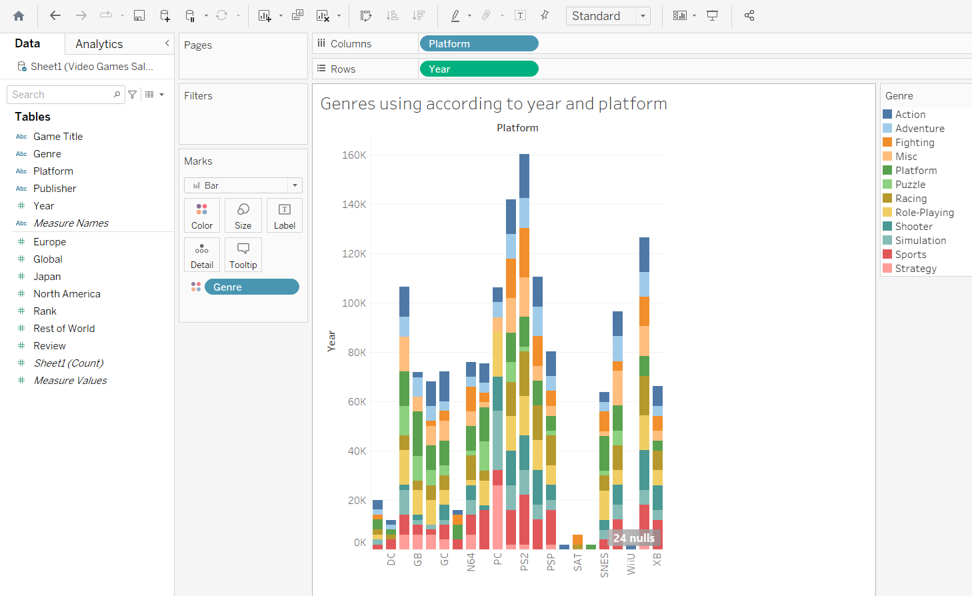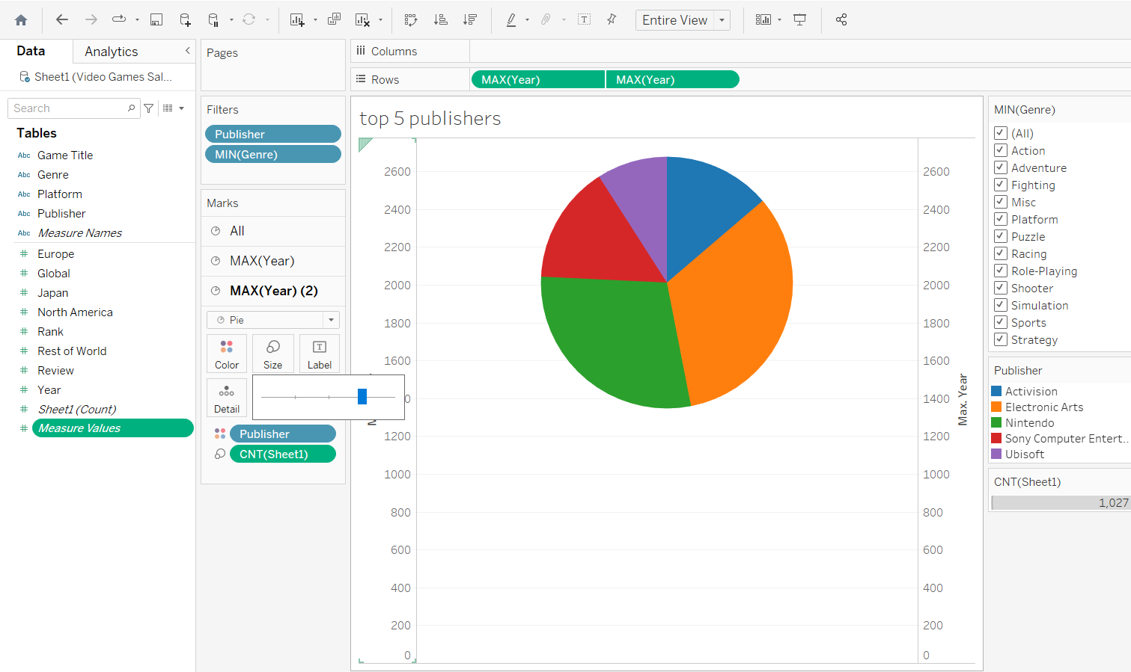 **IMPLICATIONS AND RESULTS**

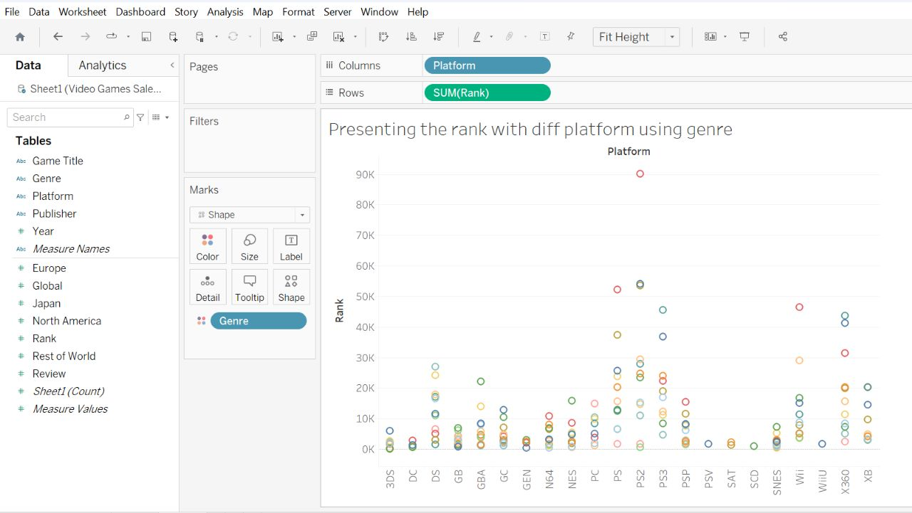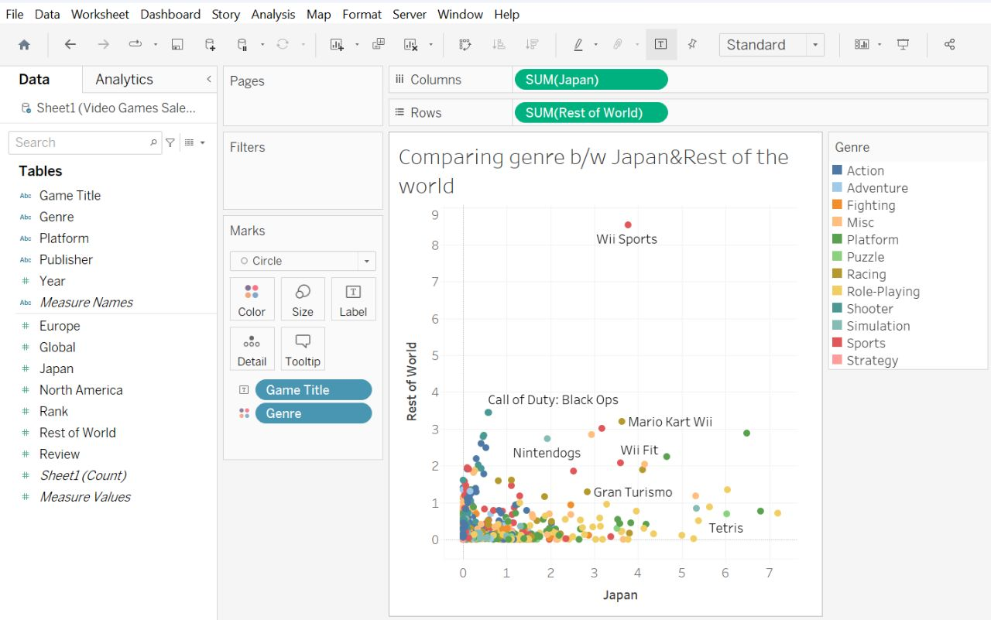

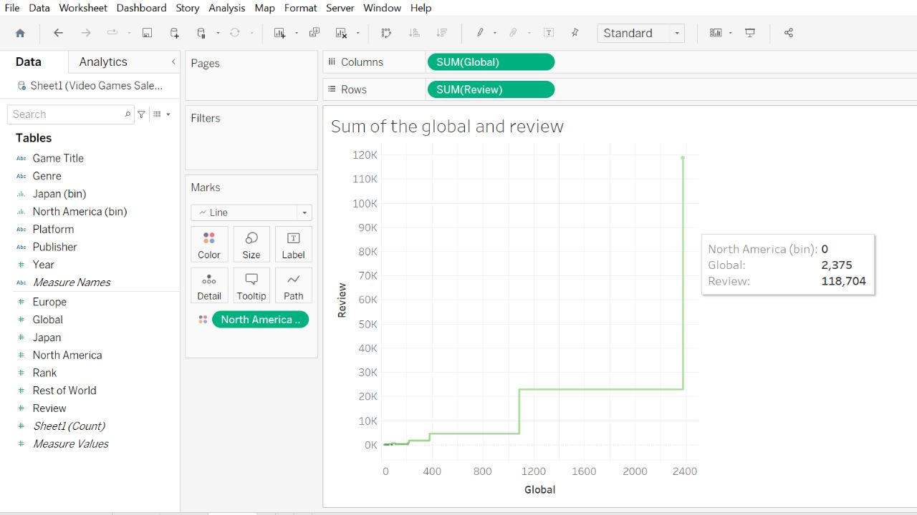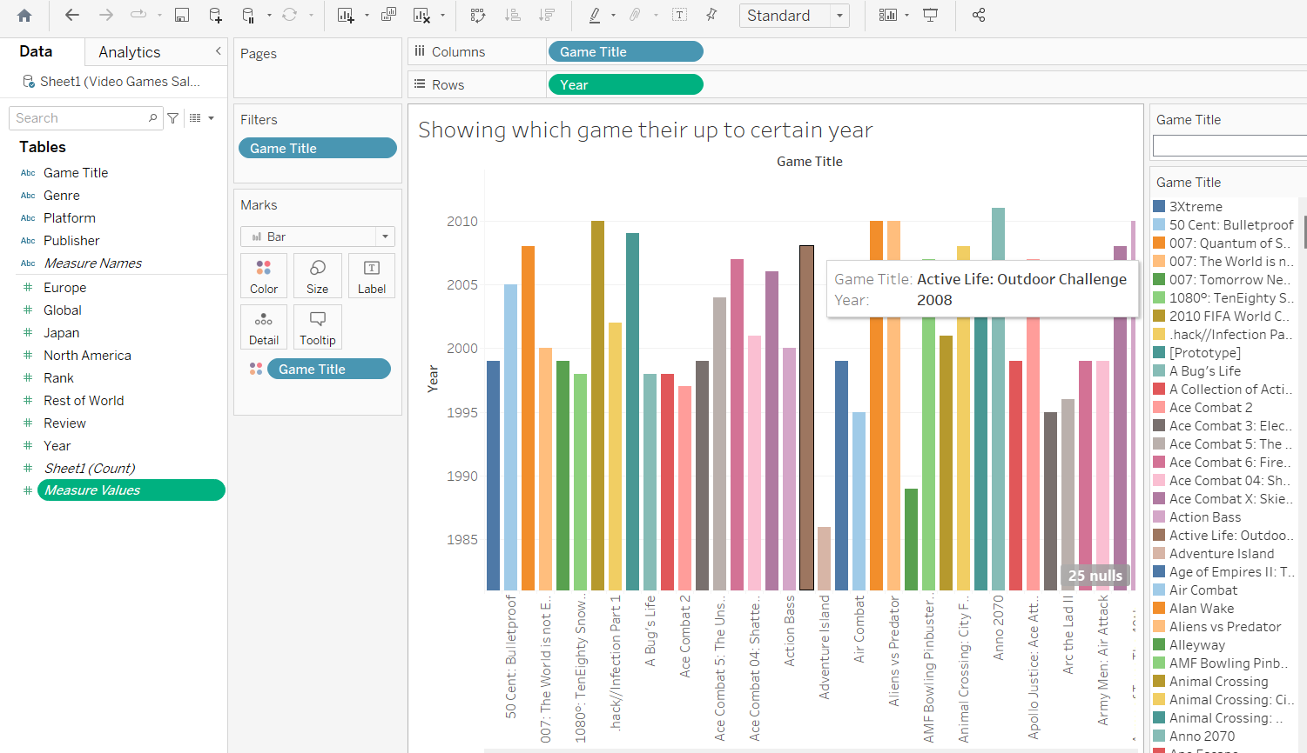

**CHAPYTER 7**

**APPLICATIONS**

**Market Research and Business Strategies**: Game analysis helps game developers and publishers understand market trends, player preferences, and popular genres. This information aids in developing effective business strategies, making data-driven decisions about game development, marketing, and pricing.

**Game Development and Design**: Analyzing gameplay data, user feedback, and player behavior can provide valuable insights to improve game design. It helps developers identify potential bugs, areas for improvement, and new features to enhance player experience.

**Player Behavior and Engagement**: By analyzing player behavior, gaming companies can optimize player engagement, identify retention issues, and design targeted marketing campaigns to retain existing players and attract new ones.

**Educational and Serious Games**: For educational games or serious games used in training and simulations, analysis helps measure the effectiveness of the learning experience and the attainment of specific objectives.

**User Experience (UX) Design**: By analyzing player interactions and feedback, game developers can optimize the user interface (UI) and overall UX, leading to a more intuitive and enjoyable gaming experience.

**Psychological and Behavioral Research**: Game analysis can be used in academic or industry research to study the impact of games on player psychology, behavior, and cognitive skills.

**Predictive Analytics**: Using historical game data, predictive analytics can be employed to forecast future trends, potential game success, and revenue projections.

Overall, video game analysis is a powerful tool that empowers developers, publishers, marketers, and researchers to make informed decisions, create better games, and enhance the overall gaming experience for players.

**CHAPETR 8**

**ADVANTAGES AND DIS ADVANTAGES**

**Advantages of Game Sales Analysis:**

**Data-Driven Decision Making:** Game sales analysis provides concrete data and insights that enable developers and publishers to make informed decisions about game development,marketing strategies, and pricing.

**Understanding Player Preferences**: By analyzing sales data, gaming companies can gain a better understanding of player preferences, which helps in creating games that resonate with the target audience.

**Market Trends and Competitor Insights**: Game sales analysis helps identify market trends and provides valuable information about competitors' performance, allowing companies to stay competitive and adapt their strategies accordingly.

**Optimizing Monetization Models**: By analyzing sales and revenue data, gaming companies can optimize their monetization models, striking the right balance between generating revenue and maintaining player satisfaction.

**Measuring Marketing Effectiveness:** Sales analysis allows companies to evaluate the success of marketing campaigns and promotional efforts, helping them refine their marketing strategies for future releases.

**Identifying Opportunities and Gaps**: By understanding sales patterns and player behavior, companies can identify untapped market opportunities and niche areas to explore.

**Improving Game Design and User Experience:** Sales analysis provides feedback on the success of game mechanics and overall user experience, guiding developers to make necessary improvements for future games.

**Disadvantages of Game Sales Analysis:**

**Limited Scope: Sales** analysis may not provide a complete picture of a game's success or failure, as it focuses primarily on financial metrics and may overlook aspects like player satisfaction or cultural impact.

**Data Availability and Reliability:** Access to accurate and comprehensive sales data may be limited, especially for smaller developers or those working with third-party platforms that don't share detailed data.

**Lack of Context:** Sales data alone may not explain the reasons behind certain trends or fluctuations, requiring additional research and context to fully understand the underlying factors.

**Risk of Misinterpretation**: Incorrect interpretation of sales data could lead to misguided decisions, such as investing in a genre that is temporarily popular but not aligned with the company's long-term strategy.

**CHAPTER 9**

**CONCLUSION**

In conclusion, the game sales analysis provides valuable insights into the dynamic and ever-evolving gaming industry. The data clearly indicates that the demand for video games continues to grow, driven by advancements in technology, expanding gaming demographics, and a vibrant online gaming community. From the analysis, it is evident that certain genres, such as action-adventure and multiplayer online games, dominate the market, appealing to a wide audience. Moreover, the rise of mobile gaming has significantly impacted the industry, making it crucial for developers to adapt to this platform's unique challenges and opportunities. Additionally, the importance of effective marketing strategies and well-timed releases cannot be overstated, as they play a pivotal role in achieving high sales figures. However, the analysis also highlights the necessity of addressing concerns related to microtransactions and loot boxes, as consumer backlash can have adverse effects on sales and reputation. As the gaming landscape continues to evolve, understanding these trends and consumer preferences will be crucial for game developers and publishers seeking sustained success in this competitive market.

