**Database Design assignment**

ER for inventory module

ER for cart module

ER for notification module

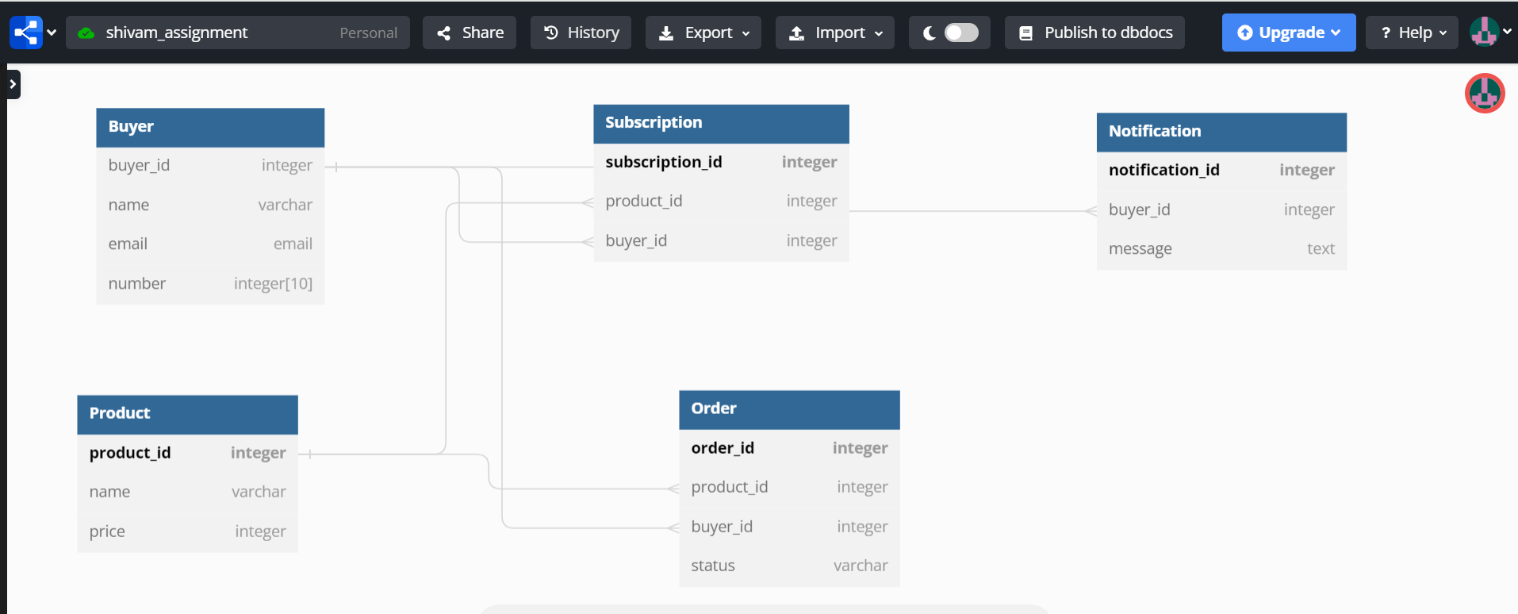

Er for authentication and authorization

