**SENSOR FUSION ALGORITHM**

Sensor Fusion is the process of merging data from multiple sensors such that to reduce the amount of uncertainty that may be involved in a robot navigation motion or task performing. Sensors are used to collect data from disparate sources. The data is then computed to achieve the resulting information having has uncertainty than would be possible when these sources were used individually. The algorithm allows the passage of collected data to be passed through a series of computational steps to return a value which is representative of the correct raw data from the sensors. It also helps depict the sensors whose values are out of range or when they start working asynchronously.

The following structure diagram explains the working of the algorithm in a step wise manner:

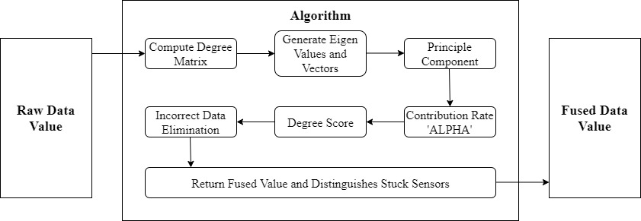

Fig. 1. Structure Diagram.