**Assessment 1**

Project Management Setup:

The development team will establish Azure Boards to manage the Agile/Scrum project's progress, including creating a Project Board, Backlogs Board, Sprints/Iterations and Tasks Board.

**Epic Created:**

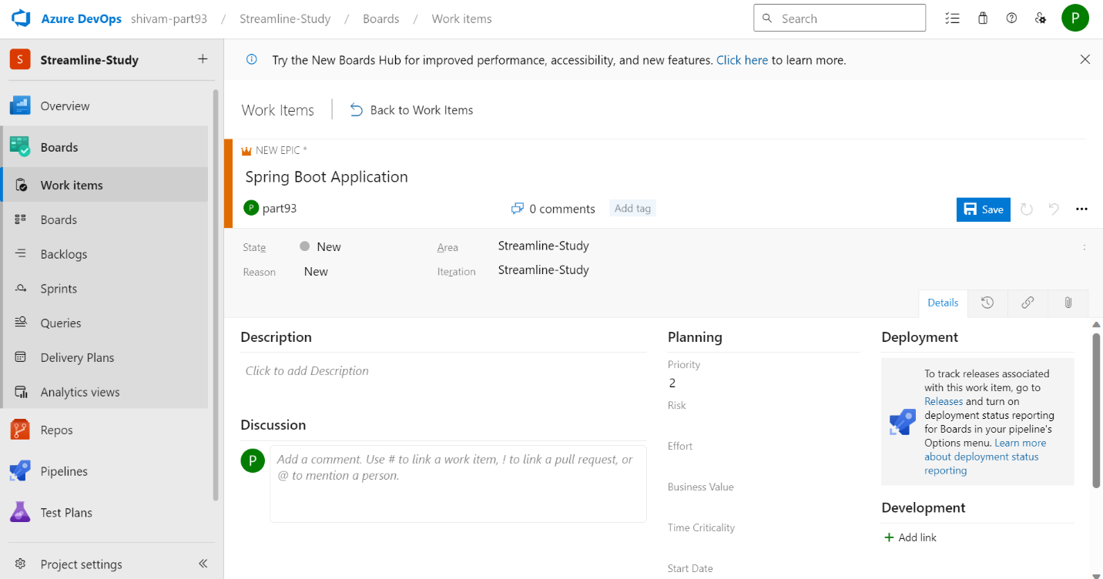

**Screenshot of Work Items:**

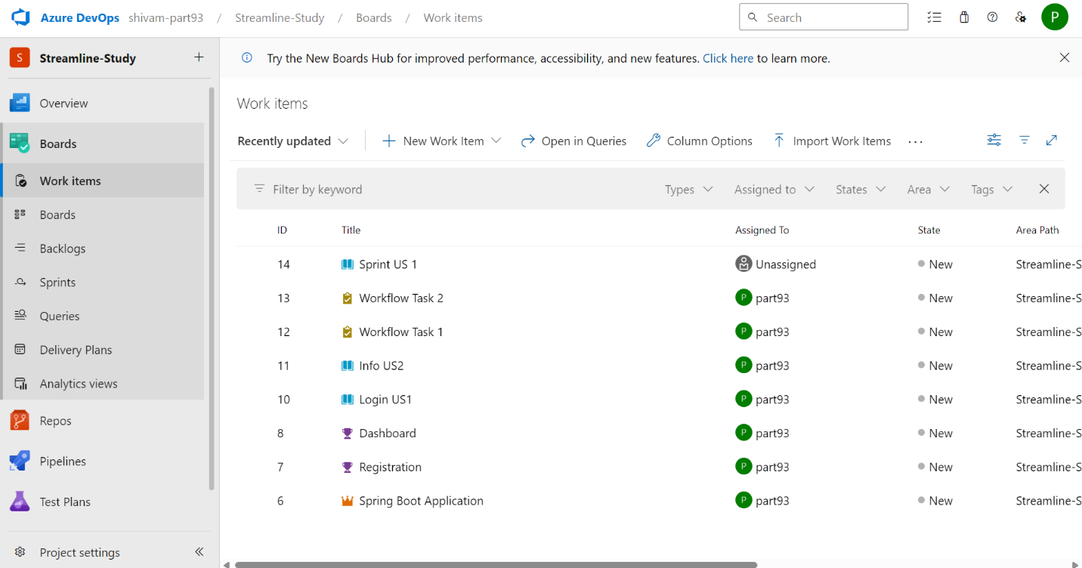

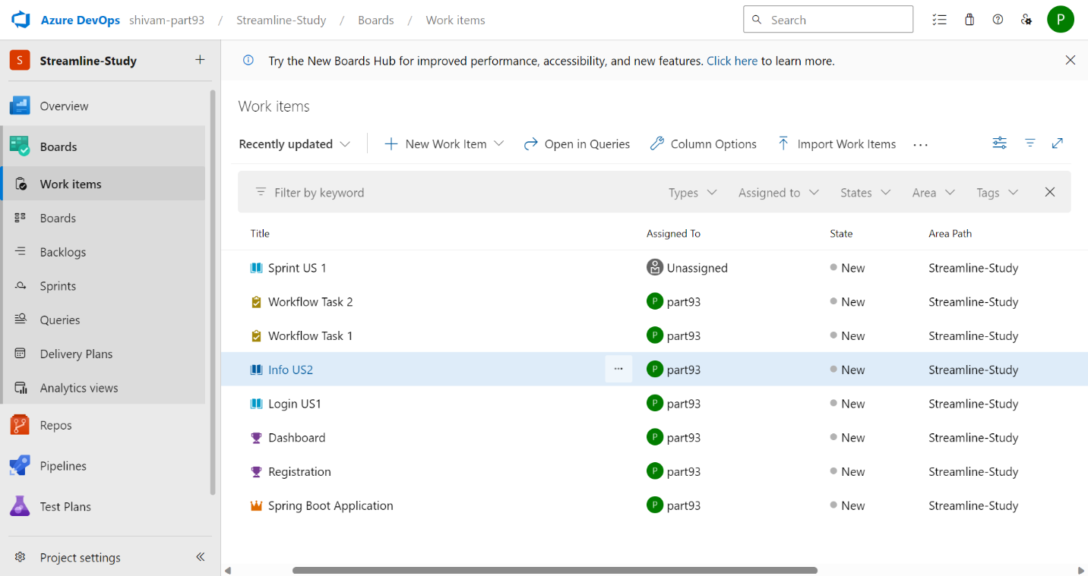

**Boards:**

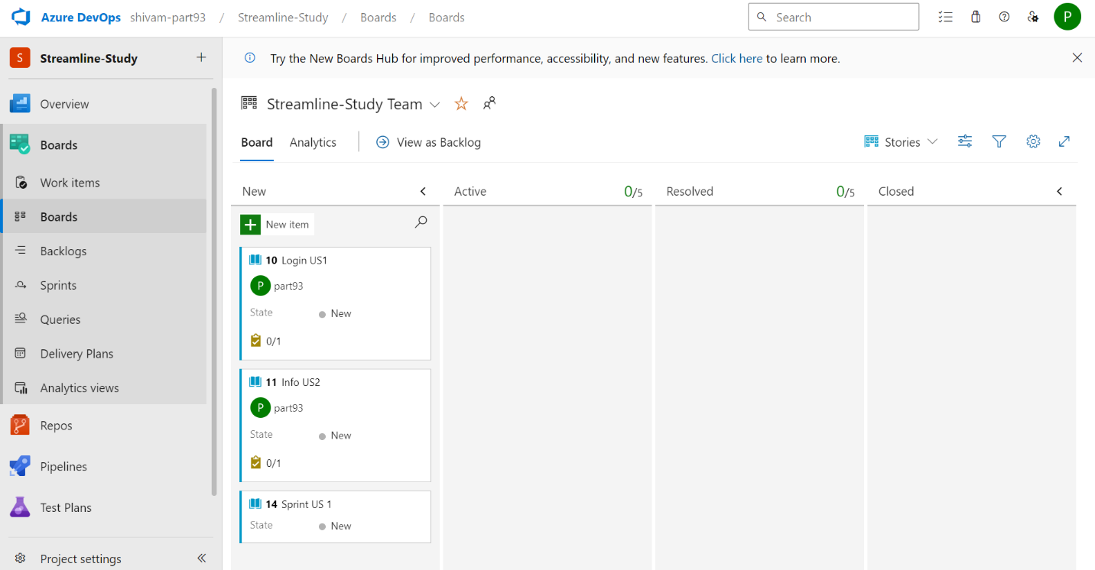

**Backlogs:**

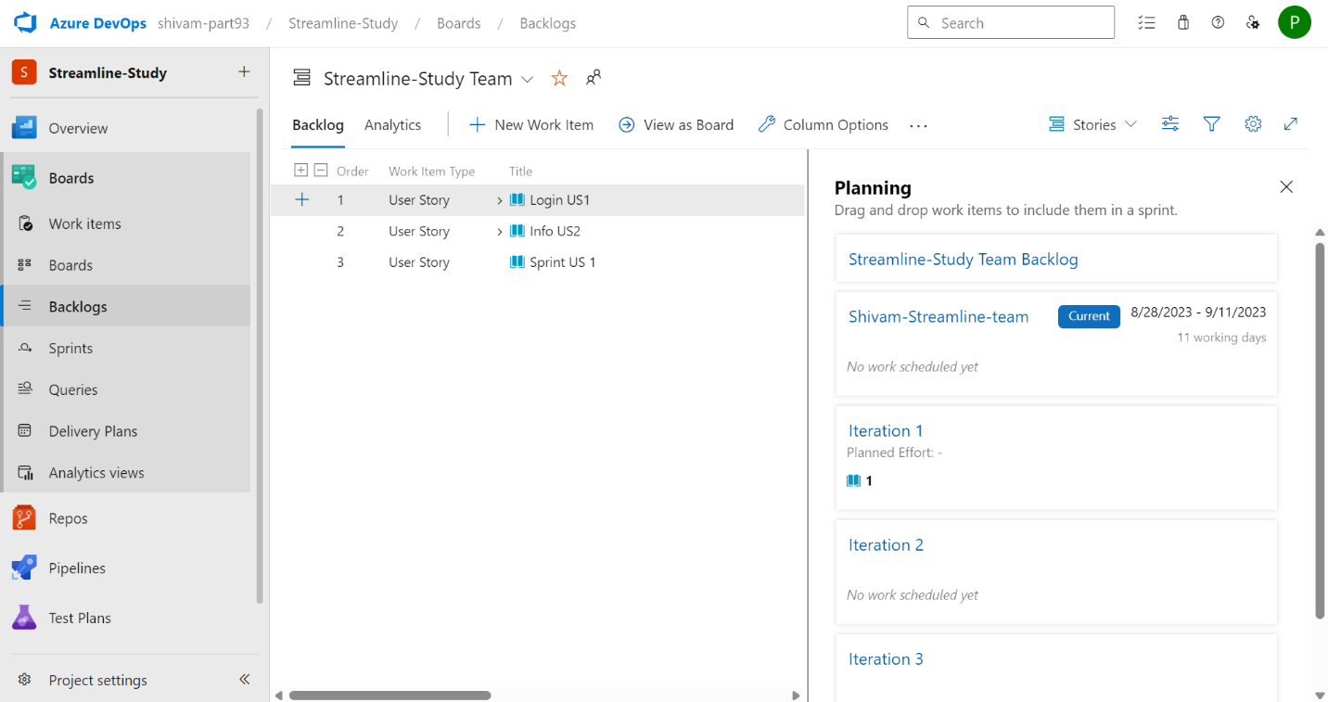

**Sprint Created:**

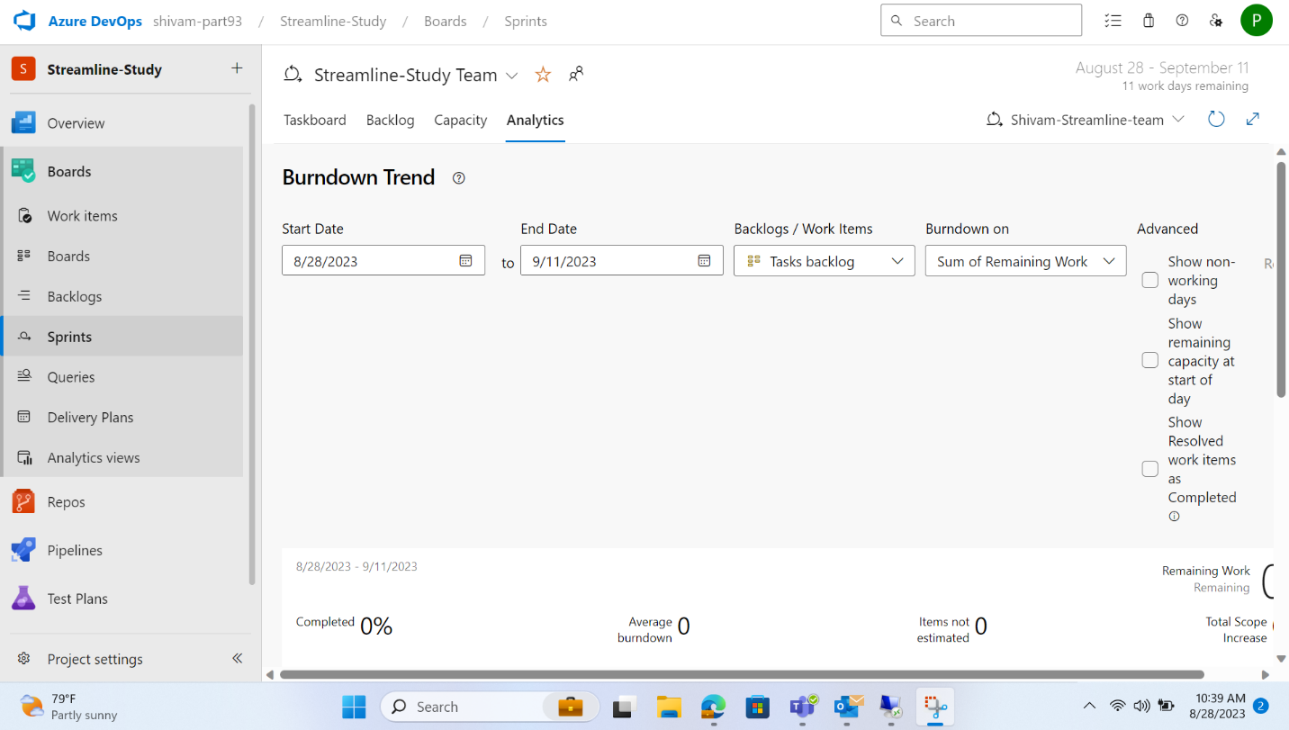

GitHub Repository and Feature Branching:

Developers will fork the main GitHub repository (https://github.com/hrb1989/shell_7_foundation_Java_Spring) into their local environments. They will create feature branches to work on specific enhancements or tasks related to the Java Spring Boot application.

**Forked Github Repository and Created New Branch and Pushed the code in that branch.**

**Branch name: branch1**

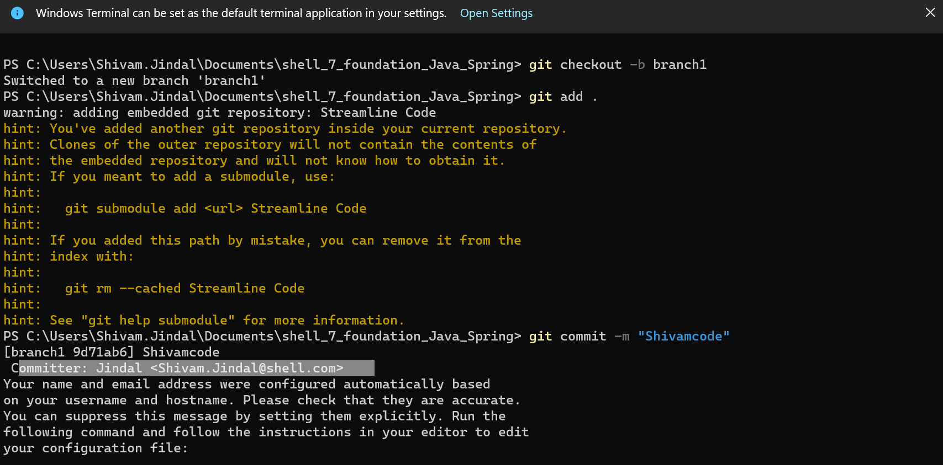

**Pushed Code Successfully**

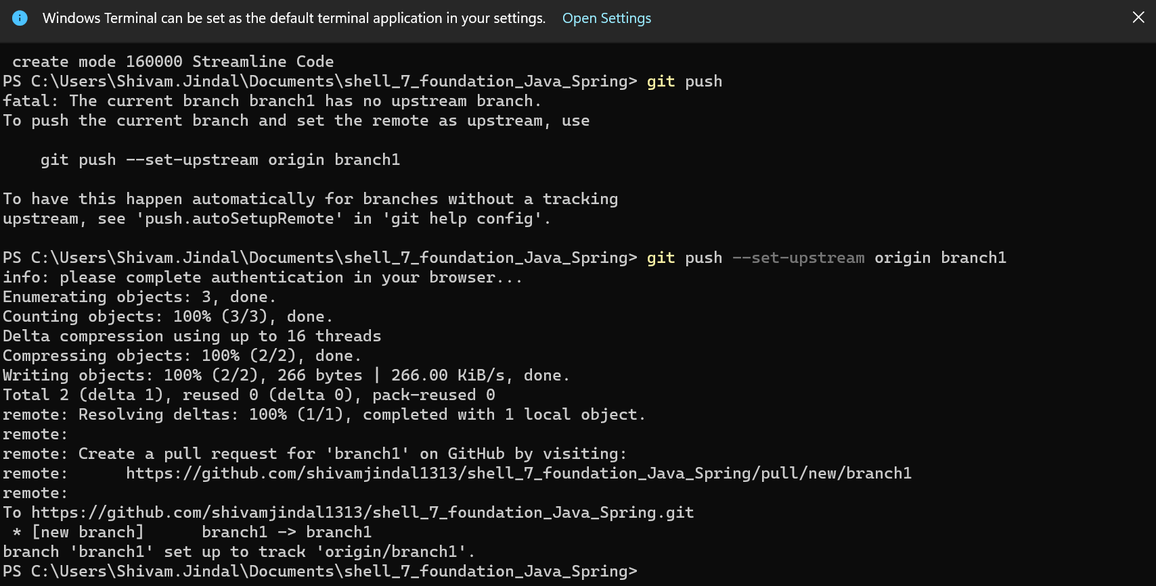

Azure VM Configuration:

The IT team will configure a virtual machine (VM) on Azure with specific performance and resource specifications to accommodate the development needs. Respective Location, Resource Group, B2s, Ubuntu, Username, Password, Standard HDD, Basic Dynamic Public IP.

**VM Creation**

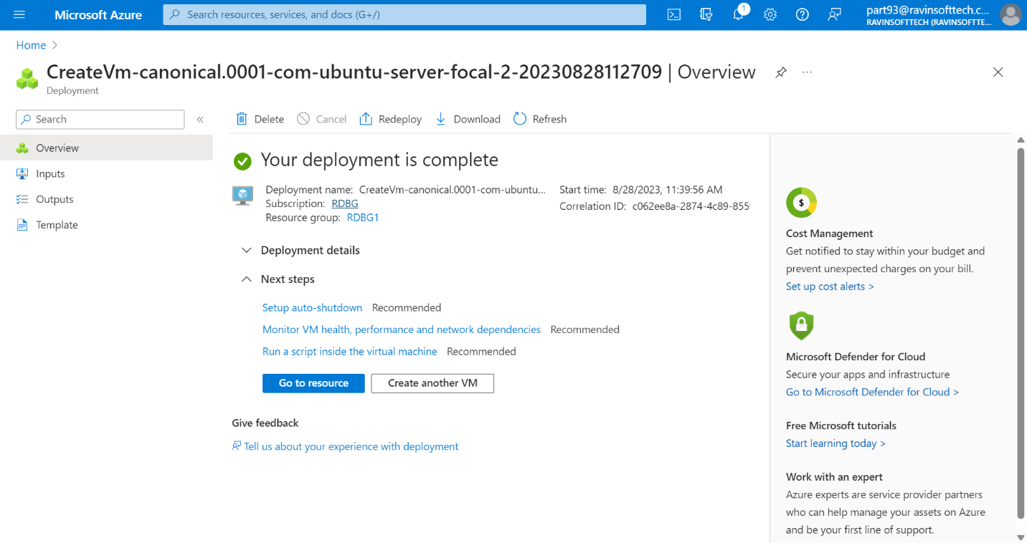

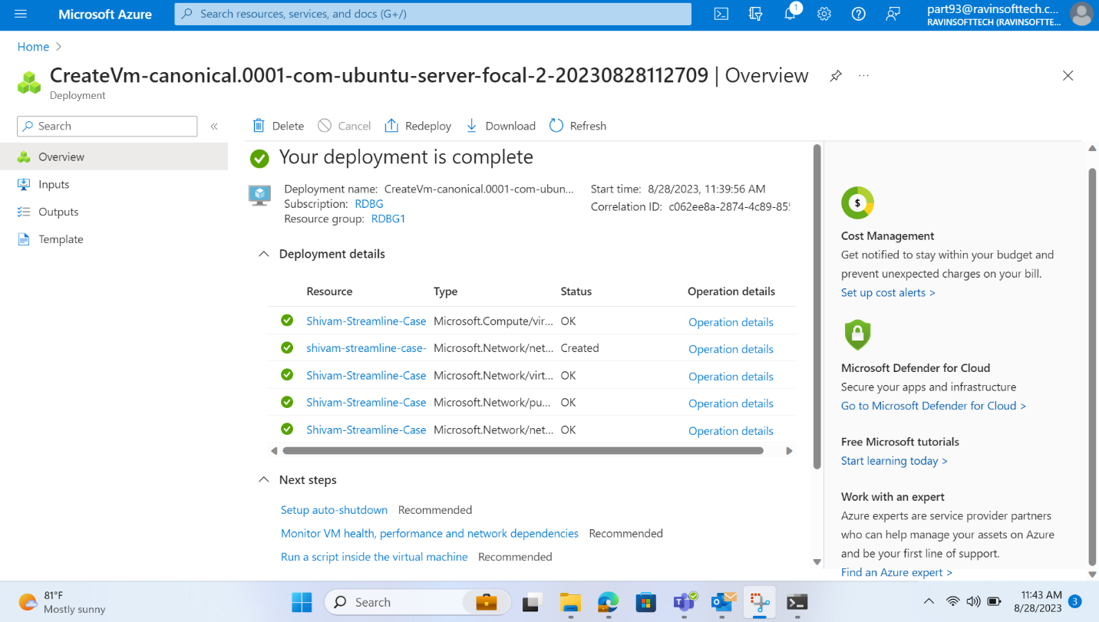

Maven-Based Build Process:

The development team will install Maven on the Azure VM and define a Maven-based build process. This process will generate a Java Application Archive (JAR) file from the Java Spring Boot application's codebase.

**Installed Maven Successfully**

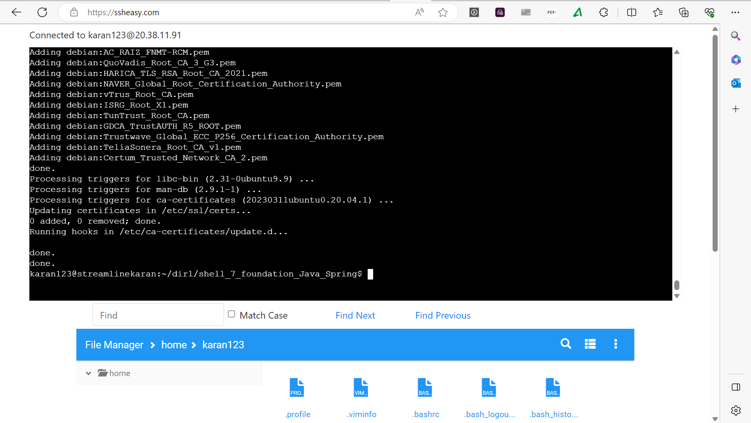

**Build Success**

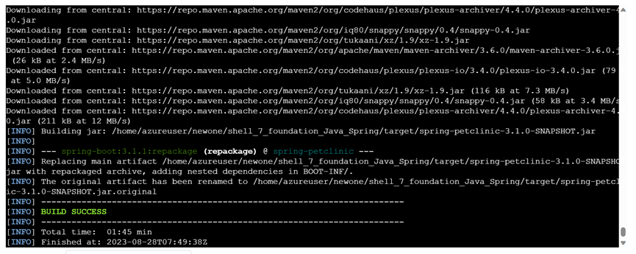

**Jar file created.**

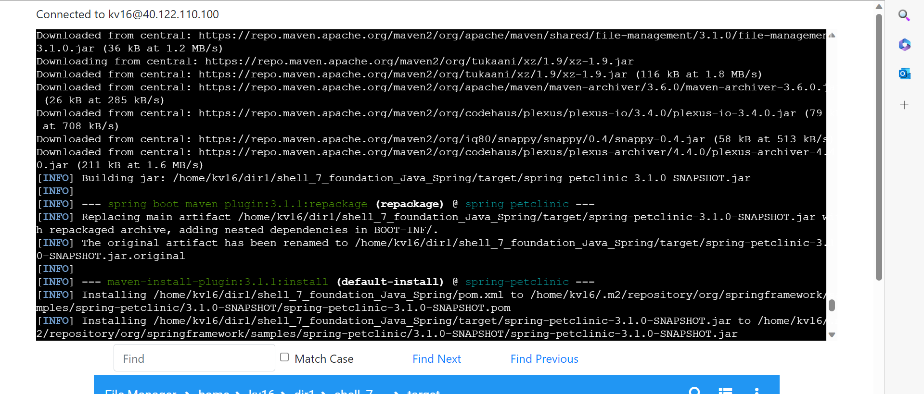

Prometheus Monitoring Integration:

The IT operations team will install Prometheus on the Azure VM. They will configure Prometheus to monitor the local environment and explore the possibility of monitoring the Java Spring Boot application.

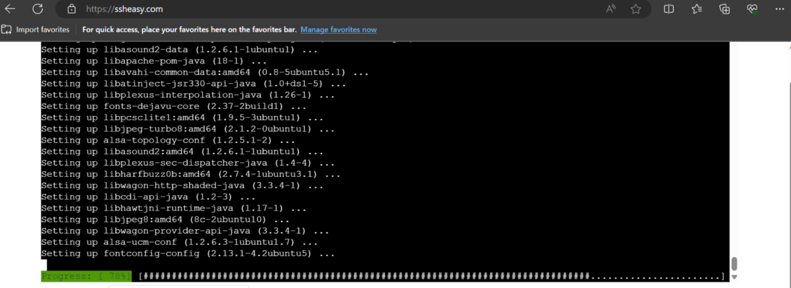

**Prometheus Running**

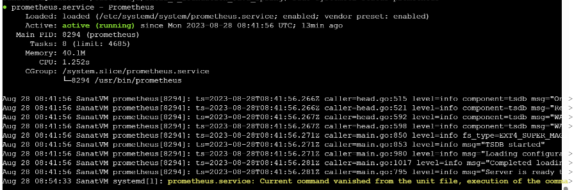

Docker Containerization:

On the Azure VM, the development team will craft a Dockerfile tailored for the Java Spring Boot application. This Dockerfile will define the steps necessary to package the application into a Docker container.

**Docker Image created.**

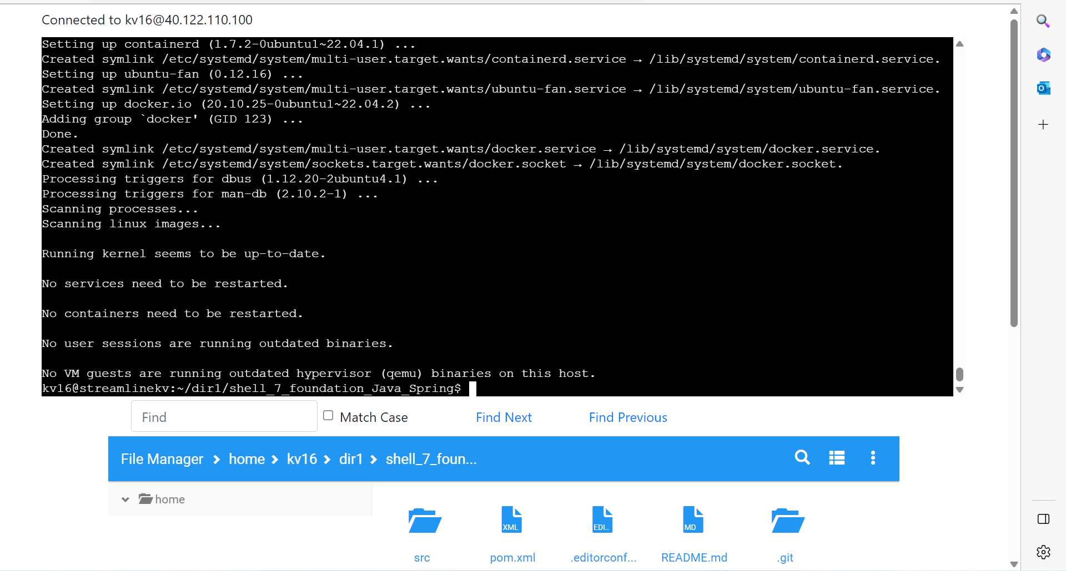

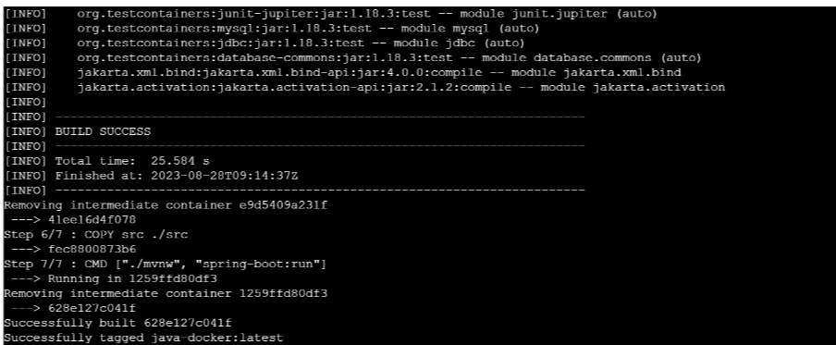

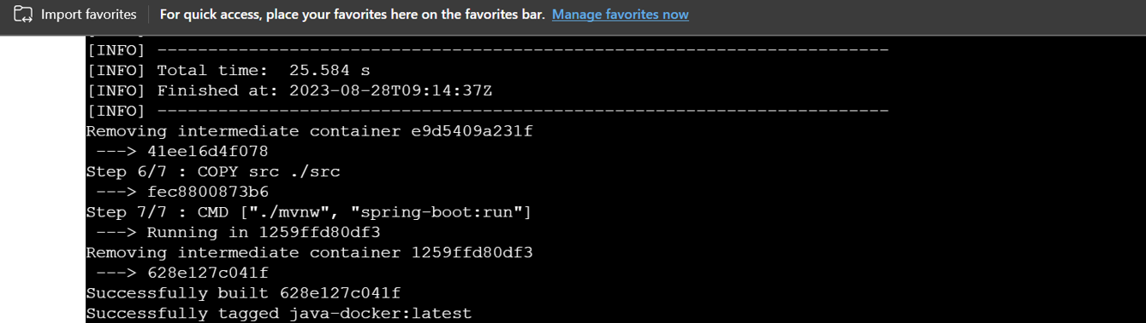

Azure Web App Configuration:

The IT team will configure a Azure Web App on Azure with specific performance and resource specifications to accommodate the development needs. Respective Location, Resource Group, Docker Container and NOT with CODE, ASP – F1

**Web App Deployed**

