Project Report on
‘CreditGuard: A Scalable Big Data Framework for
Credit Card Fraud Detection using Apache Spark’
Submitted in Big Data Analytics and Business Intelligence Course, CSET 371
Bachelor of Technology
Of
Bennett University, Greater Noida
By
Shivam Jurel S24CSEU0508
BENNETT UNIVERSITY (THE TIMES GROUP), GREATER NOIDA
Under the guidance of
Monia
[Designation – ask your faculty or check the SCSET faculty page]
School of Computer Science Engineering and Technology (SCSET)
DECLARATION
I hereby declare that the project report entitled “CreditGuard: A Scalable Big Data Framework for Credit Card Fraud Detection using Apache Spark”, has not been copied or plagiarized from any other source, and all information, data, and materials used in this report have been properly acknowledged and cited in the text. The work has not been submitted previously for any other course project.
PLAGIARISM REPORT CERTIFICATE
Further, the plagiarism similarity index of the report from Turnitin is _____ %, AI plag is _______% which is within the permissible limit of Turnitin and AI must be 0%. All sources of information used in the report have been properly acknowledged and cited.
Student Name: Shivam Jurel Enrollment No.: S24CSEU0508
Signature of Candidate: ____________________
Teamwork and Collaboration
Team member name | Enrollment No | Individual Contribution in Project
Shivam Jurel | S24CSEU0508 | Individual project – [list what you did: dataset selection, Spark pipeline, model training and evaluation, streaming, web application, Power BI dashboard, report]

TABLE OF CONTENTS
Chapter 1: Problem Domain Identification and Analysis 5
1.1 Background of the Study 5
1.2 Introduction to the Problem Domain 5
1.3 Literature Review 5
1.4 Research Gap and Literature Gaps 6
1.5 Review of Existing Solutions 6
1.6 Limitations of Existing Systems 6
1.7 Problem Statement 7
1.8 Proposed Solution Overview 7
1.9 Objectives of the Project 7
1.10 Scope of the Project 7
1.11 Industrial Applications and Use Cases 7
Chapter 2: Project Design and Methodology 9
2.1 System Overview 9
2.2 Proposed System Architecture 9
2.3 Architecture Components and Their Functions 10
2.4 Proposed Methodology 10
2.5 Methodology Workflow Use-case/DFD Flow Diagram 11
2.6 Algorithms and Techniques Used 11
2.7 Dataset Description 12
2.8 Data Collection and Data Preprocessing 13
2.9 Tools and Technologies Used 14
2.10 Experimental Setup and Configuration 14
2.11 Evaluation Metrics 15
References 16

(Right-click the table → Update Field → Update entire table after you finish writing.)

Chapter 1: Problem Domain Identification and Analysis

1.1 Background of the Study
Writing kit (notes – delete before submitting) · Target length: 1–1.5 pages
▸ Start broad: how fast digital payments are growing (cards, UPI, online shopping). Find the latest figure in the RBI Annual Report or NPCI statistics and cite it.
▸ More digital payments → more fraud. Quote the latest RBI Annual Report figure on bank frauds (number of cases / amount) and cite it. Do not guess numbers.
▸ Banks process millions of transactions per day → impossible to check each one by hand.
▸ Older rule-based systems ("block if amount > X") → miss new fraud patterns, raise many false alarms.
▸ Machine learning learns fraud patterns from past labelled data [Bolton & Hand 2002].
▸ Data is huge + continuous (volume, velocity) → need Big Data tools such as Apache Spark [Zaharia 2016].
▸ Link to your project in the last paragraph: 2.1 million transactions, fraud is only 0.17% (ULB) and 0.52% (Sparkov).
[ Write this section here in your own words. ]

1.2 Introduction to the Problem Domain
Writing kit (notes – delete before submitting) · Target length: about 1 page
▸ Define credit card fraud + types: card-not-present (online), lost/stolen card, counterfeit/skimming, account takeover.
▸ Fraud detection = binary classification (Legitimate 0 / Fraud 1) using supervised learning (labelled history).
▸ Imbalanced data: ULB 1 fraud per 598 transactions, Sparkov 1 per 190.
▸ Why accuracy misleads: predicting "always legitimate" gives 99.83% accuracy on ULB but catches 0 frauds.
▸ The 3 Vs for fraud data: volume (millions/day), velocity (real-time decisions), variety (amount, time, location, merchant, customer).
▸ Batch (training on history) vs real-time (scoring each new transaction) – both are needed.
[ Write this section here in your own words. ]

1.3 Literature Review
Writing kit (notes – delete before submitting) · Target length: 2–3 pages
▸ Read at least the abstract, method and results of each paper below (links via Google Scholar). Write 1 paragraph per paper: what they did, data, result, one limitation.
▸ Bolton & Hand (2002) – review of statistical fraud-detection methods [ref 5].
▸ Chawla et al. (2002) SMOTE – oversampling for imbalanced data [ref 6].
▸ Whitrow et al. (2009) – transaction aggregation (card history features) → same idea as your window-function features [ref 7].
▸ Bhattacharyya et al. (2011) – compared logistic regression, SVM and random forest on real card data [ref 8].
▸ Dal Pozzolo et al. (2015, 2018) – the ULB dataset authors; undersampling calibration, realistic modelling, concept drift [refs 9, 10].
▸ Jurgovsky et al. (2018) – LSTM on transaction sequences [ref 11].
▸ Carcillo et al. (2018) SCARFF – scalable streaming fraud detection with Spark + Kafka; very close to your project [ref 12].
▸ Saito & Rehmsmeier (2015) – why PR curves are better than ROC for imbalanced data [ref 13].
▸ Group papers under small headings (statistical, ML, imbalance handling, Big Data/streaming). End with Table 1.1.
[ Write this section here in your own words. ]
Table 1.1 Summary of reviewed literature
Ref. | Authors (Year) | Method | Dataset | Key result | Limitation
[ ] | [ ] | [ ] | [ ] | [ ] | [ ]
[ ] | [ ] | [ ] | [ ] | [ ] | [ ]
[ ] | [ ] | [ ] | [ ] | [ ] | [ ]
[ ] | [ ] | [ ] | [ ] | [ ] | [ ]
[ ] | [ ] | [ ] | [ ] | [ ] | [ ]
[ ] | [ ] | [ ] | [ ] | [ ] | [ ]

1.4 Research Gap and Literature Gaps
Writing kit (notes – delete before submitting) · Target length: about 1 page
▸ Only claim a gap if the papers YOU read really show it. Refer to them by number.
▸ Possible gaps: many studies run on one machine / small samples → not scalable.
▸ Many report accuracy or ROC-AUC only → misleading for rare fraud [ref 13].
▸ Random train/test splits → the model "sees the future"; real systems must predict later transactions (your Sparkov split is time-based).
▸ Few end-to-end systems that combine batch training + real-time scoring + a BI dashboard (SCARFF [12] is an exception – say how yours differs: 5-model comparison, 2 datasets, Power BI, web app).
▸ For each gap, write one line: "This project addresses this by …".
[ Write this section here in your own words. ]

1.5 Review of Existing Solutions
Writing kit (notes – delete before submitting) · Target length: about 1 page
▸ Describe real systems from their OFFICIAL product pages (cite the page): FICO Falcon Fraud Manager, Visa Advanced Authorization, Mastercard Decision Intelligence.
▸ Bank rule engines (thresholds, blacklists, velocity rules) + manual review teams.
▸ Open research code / Kaggle notebooks: good accuracy on one CSV file but not a deployable system.
▸ Stay qualitative – do not invent statistics about these products.
▸ Fill Table 1.2 to compare them with CreditGuard.
[ Write this section here in your own words. ]
Table 1.2 Comparison of existing solutions
Solution | Approach | Real-time? | Open / affordable? | Limitation
[ ] | [ ] | [ ] | [ ] | [ ]
[ ] | [ ] | [ ] | [ ] | [ ]
[ ] | [ ] | [ ] | [ ] | [ ]
CreditGuard (proposed) | [ ] | [ ] | [ ] | [ ]

1.6 Limitations of Existing Systems
Writing kit (notes – delete before submitting) · Target length: 0.5–1 page
▸ Commercial systems: proprietary "black box", expensive, not available to students or small banks.
▸ Rule-based systems: many false alarms (annoy customers) and miss new fraud patterns.
▸ Research code: single machine, not scalable, no streaming, no dashboard.
▸ Evaluation often uses accuracy only.
▸ Write each as a short bullet with 2–3 sentences of explanation.
[ Write this section here in your own words. ]

1.7 Problem Statement
Writing kit (notes – delete before submitting) · Target length: one strong paragraph
▸ Include: WHO needs it (banks / payment processors), WHAT the problem is (rare fraud hidden in millions of transactions, decision needed in real time), DATA (2 public datasets, 2.1M transactions), WHAT you will build (Spark pipeline + 5 models + streaming + dashboard), CONSTRAINT (heavy class imbalance; balance catching fraud vs false alarms).
▸ Examiners read this first – make it clear and specific. Consider putting it in a bordered box.
[ Write this section here in your own words. ]

1.8 Proposed Solution Overview
Writing kit (notes – delete before submitting) · Target length: 0.5–1 page
▸ Name: CreditGuard. Give the main parts (details come in Chapter 2, Figure 2.1):
▸ Spark ingestion + cleaning → Parquet; EDA + statistical tests.
▸ Feature engineering with Spark window functions (card's last-24-hour activity, usual amount, time since previous transaction).
▸ 5 Spark MLlib models with class weights; decision threshold tuned on validation data; best model chosen by F1.
▸ Serving: FastAPI + React web app, Spark Structured Streaming with live fraud alerts, Power BI dashboard.
[ Write this section here in your own words. ]

1.9 Objectives of the Project
Writing kit (notes – delete before submitting) · Target length: 5–6 numbered objectives
▸ Each starts with "To …" and must be measurable (you will tick them off in Chapter 5).
▸ Topics to cover: scalable Spark pipeline for 2.1M transactions; EDA + statistical tests; ≥5 PySpark models compared with Precision, Recall, F1, ROC-AUC, PR-AUC; real-time scoring with Structured Streaming; Power BI + web dashboard for decisions; SDG alignment.
[ Write your objectives here as a numbered list. ]

1.10 Scope of the Project
Writing kit (notes – delete before submitting) · Target length: about 0.5 page
▸ In scope: 2 public datasets; Spark in local mode; 5 MLlib models; file-based stream that simulates Kafka; web app; Power BI dashboard.
▸ Out of scope: real bank integration; real card numbers / personal data; deep learning models; cloud cluster deployment; production Kafka. (Mention these as future work.)
[ Write this section here in your own words. ]

1.11 Industrial Applications and Use Cases
Writing kit (notes – delete before submitting) · Target length: about 1 page
▸ Users: banks and card issuers, payment gateways, e-commerce platforms, fintech / UPI apps, insurance claim checks.
▸ Use cases: real-time transaction screening, alert queue for fraud analysts, management dashboard of fraud trends.
▸ SDGs (cite the UN 2030 Agenda [ref 20]): SDG 8 (target 8.10 – stronger financial institutions), SDG 9 (innovation & infrastructure), SDG 16 (target 16.4 – reduce illicit financial flows).
[ Write this section here in your own words. ]

Chapter 2: Project Design and Methodology

2.1 System Overview
Writing kit (notes – delete before submitting) · Target length: about 0.5 page
▸ Inputs: transaction details (Dataset 2: amount, merchant category, time, customer age, card history; Dataset 1: Time, Amount, V1–V28).
▸ Processing: Spark cleaning + features → trained model.
▸ Outputs: fraud score, Fraud/Legitimate label, Low/Medium/High risk level, live alerts, dashboards.
▸ Mention: same saved Spark PipelineModel is used by the web app and the stream → identical preprocessing everywhere.
[ Write this section here in your own words. ]

2.2 Proposed System Architecture
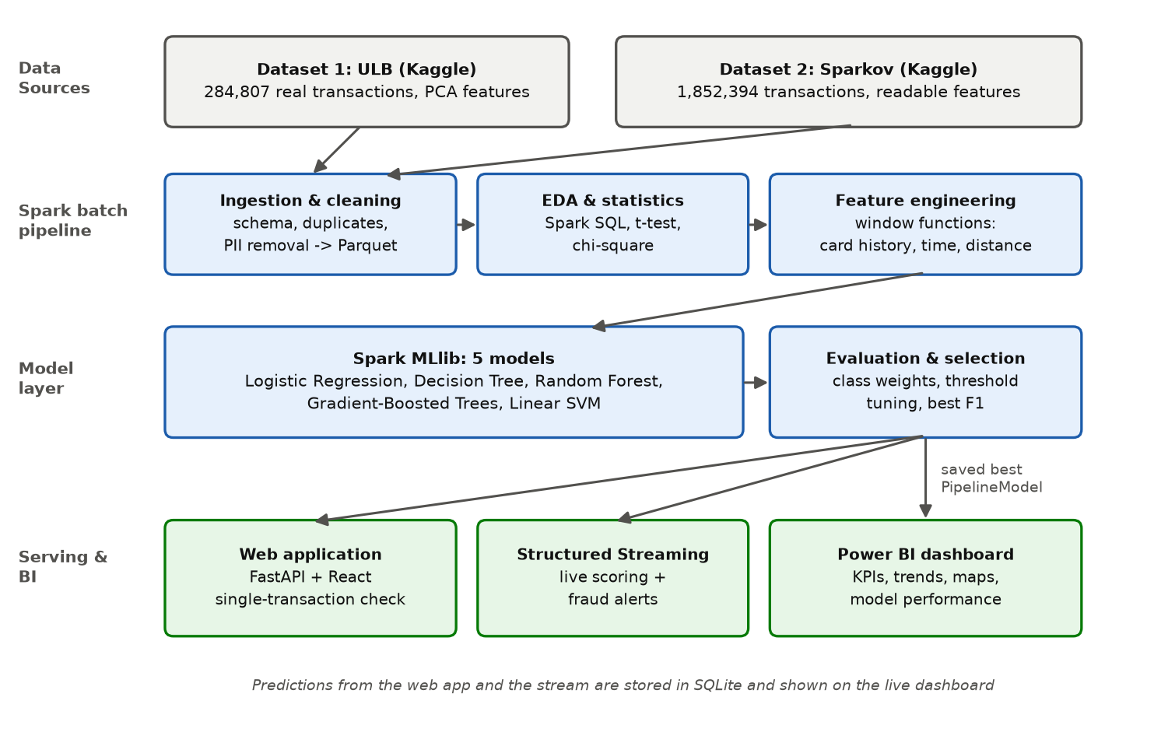
Figure 2.1 Proposed system architecture of CreditGuard
Writing kit (notes – delete before submitting) · Target length: 1–2 paragraphs
▸ Explain the figure layer by layer (data sources → Spark batch pipeline → model layer → serving & BI). Refer to it as "Figure 2.1".
[ Write this section here in your own words. ]

2.3 Architecture Components and Their Functions
Table 2.1 Architecture components and their functions
Component | Function | Technology (project file)
Ingestion & cleaning | Read CSVs with explicit schema; remove duplicates/invalid rows; drop personal columns; save Parquet | PySpark (s01_ingest_clean.py)
EDA & statistics | Class balance, fraud by hour/category/age, Welch t-test, chi-square test, charts | Spark SQL, MLlib ChiSquareTest, Matplotlib (s02_eda.py)
Feature engineering | Card-history features with window functions; time, age, distance, log features | Spark window functions (s03_features.py)
Model training | Train 5 classifiers with class weights; tune threshold; select best | Spark MLlib Pipeline (s04_train_models.py)
Evaluation | Comparison charts, confusion matrices, ROC and PR curves | Matplotlib, scikit-learn metrics (s05_evaluate.py)
Real-time scoring | Score micro-batches of new transactions; alerts; store results | Spark Structured Streaming (s06_streaming.py)
Web application | Score one transaction; history; live dashboard | FastAPI + SQLite (backend/), React (frontend/)
BI dashboard | KPIs, trends, maps, model performance | Power BI Desktop (powerbi/)

Writing kit (notes – delete before submitting) · Target length: a few lines
▸ Add 2–3 sentences introducing the table; the table itself is factual and can stay.
[ Write this section here in your own words. ]

2.4 Proposed Methodology
Writing kit (notes – delete before submitting) · Target length: 1–2 pages
▸ Explain each step AND why it is needed:
▸ 1) Ingestion with explicit schema → 2) cleaning (ULB: 1,081 duplicate rows removed; Sparkov: 0) → 3) EDA + tests.
▸ 4) Feature engineering – only PAST transactions of each card are used (no data leakage).
▸ 5) Splitting: ULB stratified 70% train / 10% validation / 20% test; Sparkov uses its own time-based split (train Jan 2019–Jun 2020, test Jun–Dec 2020) + 10% of train as validation.
▸ 6) Imbalance: balanced class weights (fraud weight ≈ 308 for ULB, ≈ 87 for Sparkov).
▸ 7) Train 5 models → 8) tune each model's decision threshold for best F1 on validation → 9) select best by validation F1 → 10) evaluate once on the test set → 11) deploy (web app, streaming, Power BI).
[ Write this section here in your own words. ]

2.5 Methodology Workflow Use-case/DFD Flow Diagram
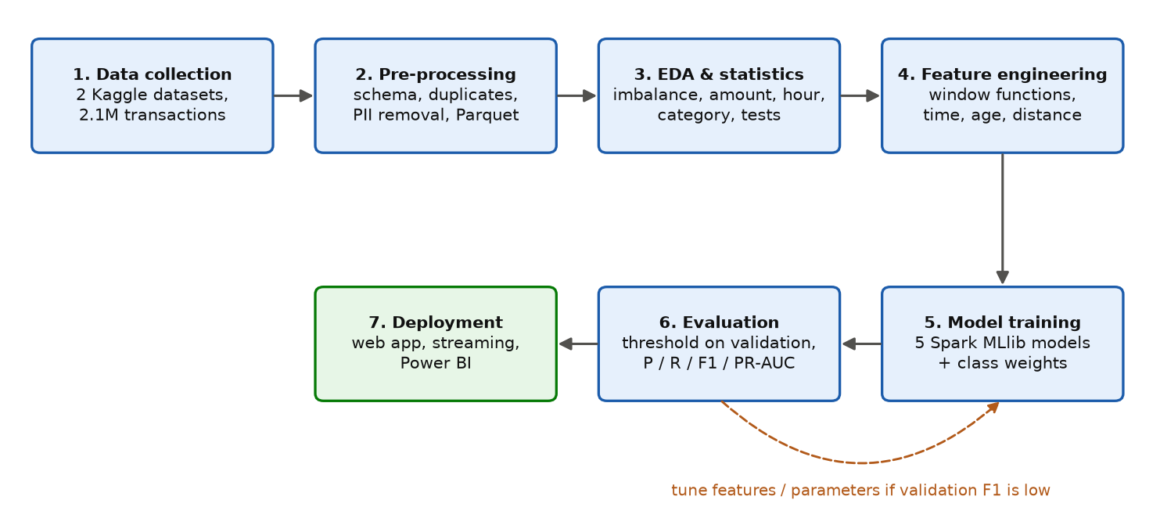
Figure 2.2 Methodology workflow
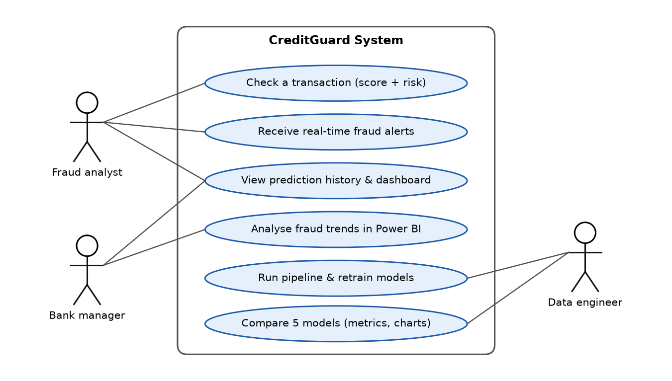
Figure 2.3 Use-case diagram of CreditGuard
Writing kit (notes – delete before submitting) · Target length: 0.5 page
▸ Explain Figure 2.2 (the 7 stages and the feedback loop) and Figure 2.3 (3 actors: fraud analyst, bank manager, data engineer – and what each can do).
[ Write this section here in your own words. ]

2.6 Algorithms and Techniques Used
Writing kit (notes – delete before submitting) · Target length: 1.5–2 pages
▸ One paragraph per model: simple idea + why chosen. Cite the original paper.
▸ Logistic Regression – weighted sum → sigmoid → probability; baseline [ref 14].
▸ Decision Tree – if/else splits; explainable; can overfit [ref 15].
▸ Random Forest – many trees on random rows/features, averaged vote [ref 16].
▸ Gradient-Boosted Trees – trees built one after another, each fixing previous errors [ref 17].
▸ Linear SVM – widest-margin separating line; no probabilities [ref 18].
▸ Techniques: class weighting, threshold tuning, StandardScaler, one-hot encoding, window functions.
[ Write this section here in your own words. ]
Table 2.2 Algorithms used
Algorithm | Type | Spark MLlib class | Reason for selection
Logistic Regression | Linear classifier | LogisticRegression | [ ]
Decision Tree | Tree | DecisionTreeClassifier | [ ]
Random Forest | Bagging ensemble | RandomForestClassifier | [ ]
Gradient-Boosted Trees | Boosting ensemble | GBTClassifier | [ ]
Linear SVM | Max-margin linear classifier | LinearSVC | [ ]

2.7 Dataset Description
Writing kit (notes – delete before submitting) · Target length: 1–1.5 pages
▸ Describe both datasets, why two are used (real-but-anonymised vs large-and-readable), and the class imbalance. Refer to Table 2.3 and Figures 2.4–2.5.
▸ State that the datasets were approved by your faculty (after you get approval!).
[ Write this section here in your own words. ]
Table 2.3 Dataset description
Attribute | Dataset 1: ULB Credit Card Fraud | Dataset 2: Sparkov Card Transactions
Source | Kaggle: mlg-ulb/creditcardfraud (ULB Machine Learning Group) [9] | Kaggle: kartik2112/fraud-detection (generated with Sparkov) [21]
Real / simulated | Real transactions (anonymised) | Simulated
Period | 2 days, September 2013 | 1 Jan 2019 – 31 Dec 2020
Rows | 284,807 | 1,852,394 (train file 1,296,675 + test file 555,719)
Frauds | 492 (0.172%) | 9,651 (0.521%)
Features | Time, V1–V28 (PCA), Amount | Date-time, category, merchant, amount, gender, city/state, lat/long, city population, job, date of birth, merchant location
Target column | Class (1 = fraud) | is_fraud (1 = fraud)
Size | ≈ 144 MB CSV | ≈ 478 MB CSV (2 files)

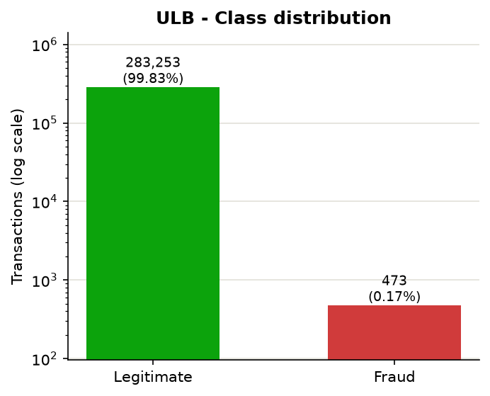
Figure 2.4 Class distribution – Dataset 1 (ULB)
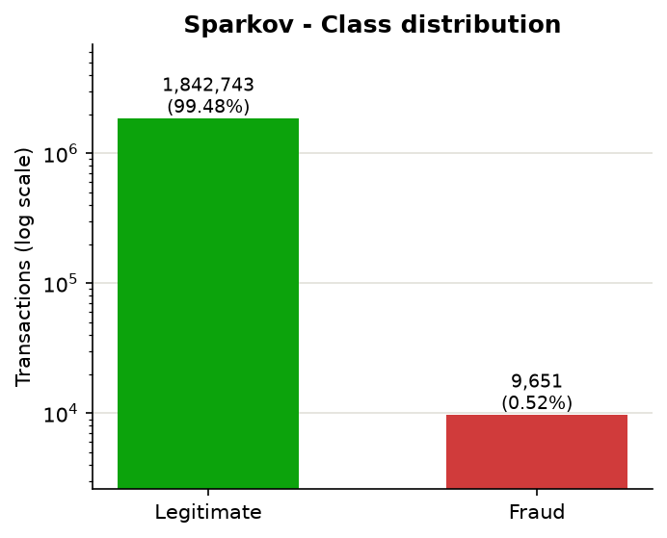
Figure 2.5 Class distribution – Dataset 2 (Sparkov)

2.8 Data Collection and Data Preprocessing
Writing kit (notes – delete before submitting) · Target length: 1–1.5 pages
▸ Collection: downloaded from Kaggle (ULB via its public mirror; Sparkov via Kaggle's dataset download).
▸ Explicit Spark schema for every column (catches bad rows, faster than guessing types).
▸ Missing values: none found in either dataset (report this – it is a result of your check).
▸ Duplicates: 1,081 exact duplicate rows removed from ULB (283,726 remain); 0 duplicate transaction ids in Sparkov.
▸ Invalid values: negative / zero amounts filtered.
▸ Privacy: names, street, zip, transaction id dropped; card number replaced by an anonymous SHA-256 hash.
▸ Types: text dates → timestamps; categories lower-cased; label renamed to 'label'.
▸ Storage: Parquet (columnar, compressed). Scaling (StandardScaler) + one-hot encoding happen inside the MLlib pipeline.
[ Write this section here in your own words. ]

2.9 Tools and Technologies Used
Table 2.4 Tools and technologies
Category | Tool / Version | Purpose
Big Data engine | Apache Spark 3.5.9 (PySpark) | Distributed processing, Spark SQL
Machine learning | Spark MLlib | 5 classifiers, pipelines, statistics
Streaming | Spark Structured Streaming | Real-time scoring of micro-batches
Storage | Apache Parquet; SQLite | Processed data; prediction history
Business Intelligence | Microsoft Power BI Desktop | Interactive dashboard
Backend | Python 3.12, FastAPI 0.115, Pydantic 2.10 | REST API serving the Spark model
Frontend | React 19, Vite 8, Recharts 3 | Web interface and live dashboard
Reporting | Pandas 2.2, Matplotlib 3.11 | Charts for the report
Runtime | Java 17, Hadoop winutils 3.3.6 (Windows) | Required to run Spark on Windows
Development | VS Code, Git | Coding and version control

Writing kit (notes – delete before submitting) · Target length: a few lines
▸ Introduce the table in 2–3 sentences; say why Spark (scalability) and Power BI (BI requirement).
[ Write this section here in your own words. ]

2.10 Experimental Setup and Configuration
Table 2.5 Experimental configuration
Item | Configuration
Hardware | Laptop: 24 logical CPU cores, 16 GB RAM
Operating system | Windows 11
Spark mode | local[*] – all cores on one machine (same code can run on a cluster)
Spark driver memory | 8 GB for training; shuffle partitions = 48
Data split – ULB | Stratified 70% train / 10% validation / 20% test
Data split – Sparkov | Time-based: train Jan 2019–Jun 2020 (90% train, 10% validation), test Jun–Dec 2020
Imbalance handling | Balanced class weights (weightCol)
Threshold | Tuned per model for best F1 on the validation set
Model selection | Highest validation F1
Random seed | 42

Writing kit (notes – delete before submitting) · Target length: a few lines
▸ Introduce the table; mention that for Milestone 1 this is the planned setup and final values are reported in Chapter 4.
[ Write this section here in your own words. ]

2.11 Evaluation Metrics
Table 2.6 Evaluation metrics
Metric | Formula | Meaning
Accuracy | (TP + TN) / (TP + TN + FP + FN) | Share of correct predictions (misleading when fraud is rare)
Precision | TP / (TP + FP) | Of flagged transactions, how many were fraud
Recall | TP / (TP + FN) | Of real frauds, how many were caught
F1-score | 2 × Precision × Recall / (Precision + Recall) | Balance of precision and recall (selection metric)
ROC-AUC | Area under TPR vs FPR curve | Ranking quality over all thresholds
PR-AUC | Area under Precision vs Recall curve | Ranking quality focused on the rare fraud class
Confusion matrix | TP, FP, TN, FN counts | Where the model is right and wrong

Writing kit (notes – delete before submitting) · Target length: about 1 page
▸ Define TP, FP, TN, FN in the context of fraud (FN = missed fraud → money lost; FP = false alarm → annoyed customer).
▸ Explain why accuracy is not used for selection (99.83% for a useless model).
▸ Why F1 for selection and PR-AUC as a key metric for rare classes [ref 13].
[ Write this section here in your own words. ]

References
Writing kit (notes – delete before submitting) · Target length: as needed
▸ Only keep references you actually read and cite in the text; add the RBI / NPCI reports and product pages you use in 1.1 and 1.5.
▸ Check every entry on Google Scholar (authors, year, pages) before submitting – you are responsible for your citations.
▸ Keep one style (IEEE). Number them in the order they first appear in your text, and renumber the kit hints accordingly.
[1] M. Zaharia et al., “Apache Spark: A unified engine for big data processing,” Communications of the ACM, vol. 59, no. 11, pp. 56–65, 2016.
[2] X. Meng et al., “MLlib: Machine learning in Apache Spark,” Journal of Machine Learning Research, vol. 17, no. 34, pp. 1–7, 2016.
[3] M. Armbrust et al., “Spark SQL: Relational data processing in Spark,” in Proc. ACM SIGMOD, 2015, pp. 1383–1394.
[4] M. Armbrust et al., “Structured Streaming: A declarative API for real-time applications in Apache Spark,” in Proc. ACM SIGMOD, 2018, pp. 601–613.
[5] R. J. Bolton and D. J. Hand, “Statistical fraud detection: A review,” Statistical Science, vol. 17, no. 3, pp. 235–255, 2002.
[6] N. V. Chawla, K. W. Bowyer, L. O. Hall, and W. P. Kegelmeyer, “SMOTE: Synthetic minority over-sampling technique,” Journal of Artificial Intelligence Research, vol. 16, pp. 321–357, 2002.
[7] C. Whitrow, D. J. Hand, P. Juszczak, D. Weston, and N. M. Adams, “Transaction aggregation as a strategy for credit card fraud detection,” Data Mining and Knowledge Discovery, vol. 18, no. 1, pp. 30–55, 2009.
[8] S. Bhattacharyya, S. Jha, K. Tharakunnel, and J. C. Westland, “Data mining for credit card fraud: A comparative study,” Decision Support Systems, vol. 50, no. 3, pp. 602–613, 2011.
[9] A. Dal Pozzolo, O. Caelen, R. A. Johnson, and G. Bontempi, “Calibrating probability with undersampling for unbalanced classification,” in Proc. IEEE Symposium Series on Computational Intelligence (SSCI), 2015.
[10] A. Dal Pozzolo, G. Boracchi, O. Caelen, C. Alippi, and G. Bontempi, “Credit card fraud detection: A realistic modeling and a novel learning strategy,” IEEE Transactions on Neural Networks and Learning Systems, vol. 29, no. 8, pp. 3784–3797, 2018.
[11] J. Jurgovsky et al., “Sequence classification for credit-card fraud detection,” Expert Systems with Applications, vol. 100, pp. 234–245, 2018.
[12] F. Carcillo, A. Dal Pozzolo, Y.-A. Le Borgne, O. Caelen, Y. Mazzer, and G. Bontempi, “SCARFF: A scalable framework for streaming credit card fraud detection with Spark,” Information Fusion, vol. 41, pp. 182–194, 2018.
[13] T. Saito and M. Rehmsmeier, “The precision-recall plot is more informative than the ROC plot when evaluating binary classifiers on imbalanced datasets,” PLoS ONE, vol. 10, no. 3, e0118432, 2015.
[14] D. R. Cox, “The regression analysis of binary sequences,” Journal of the Royal Statistical Society: Series B, vol. 20, no. 2, pp. 215–242, 1958.
[15] L. Breiman, J. H. Friedman, R. A. Olshen, and C. J. Stone, Classification and Regression Trees. Wadsworth, 1984.
[16] L. Breiman, “Random forests,” Machine Learning, vol. 45, no. 1, pp. 5–32, 2001.
[17] J. H. Friedman, “Greedy function approximation: A gradient boosting machine,” Annals of Statistics, vol. 29, no. 5, pp. 1189–1232, 2001.
[18] C. Cortes and V. Vapnik, “Support-vector networks,” Machine Learning, vol. 20, no. 3, pp. 273–297, 1995.
[19] J. Kreps, N. Narkhede, and J. Rao, “Kafka: A distributed messaging system for log processing,” in Proc. NetDB Workshop, 2011.
[20] United Nations, “Transforming our world: The 2030 Agenda for Sustainable Development,” A/RES/70/1, 2015.
[21] K. Shenoy, “Credit Card Transactions Fraud Detection Dataset,” Kaggle, 2020. [Online]. Available: https://www.kaggle.com/datasets/kartik2112/fraud-detection
[22] Machine Learning Group – ULB, “Credit Card Fraud Detection,” Kaggle. [Online]. Available: https://www.kaggle.com/datasets/mlg-ulb/creditcardfraud

