**PRACTICAL FILE**

**OF**

**“Object Oriented System Engineering Lab”**

**SUBMITTED IN PARTIAL REQUIREMENT FOR THE DEGREE OF BACHELOR OF TECHNOLOGY**

**IN**

**COMPUTER SCIENCE & ENGINEERING**



**SUBMITTED TO: SUBMITTED BY:   
Er. Simran Name  
(Asst. Prof.) Roll No.**

**CSE (7th semester)**

**Department of Computer Science & Engineering,**

**Seth Jai Parkash Mukand Lal Institute of Engineering & Technology,**

**Radaur – 135133 (Yamuna Nagar)**

|  |  |  |
| --- | --- | --- |
| **SR. No.** | AIM | **TEACHER’SSIGNATURE** |
|  | Choose anyone project and Write the complete problem statement. |  |
|  | Write the software requirement specification document. |  |
|  | To draw a sample Entity Relationship diagram for real projector system. |  |
|  | To draw the dataflow diagrams at level 0 and level 1. |  |
|  | Draw Use Case Diagram. |  |
|  | Draw Activity Diagram of all use cases |  |
|  | Draw state chart diagram of all use cases. |  |
|  | Draw sequence diagram of all use cases. |  |
|  | Draw Collaboration Diagram of all use cases. |  |
|  | Assign objects in sequence diagram to classes and make class diagram. |  |

**INDEX**

**PRACTICAL NO.–1**

### **AIM:** Choose anyone project and Write the complete problem statement.

**Project Name:** Library Management System

##### ProblemStatement:

The problem occurred before having computerized system includes:

* Filelost
  + When computerized system is not implemented file is always lost because of human environment. Sometimes due to some human error there may be a loss of records.
* Filedamaged
  + When acomputerized system is nottherefileis always lost due to some accidentlike spillingofwaterbysomemember on fileaccidentally. Besides somenaturaldisasterlikefloodsorfiresmayalsodamagethe files.
* Difficultto searchrecord
  + When thereis nocomputerized system thereis always a difficultyin searchingofrecordsiftherecords arelargeinnumber.
* Spaceconsuming
  + Afterthe number ofrecords become largethe spaceforphysical storageoffileand recordsalsoincreasesifnocomputerized systemisimplemented.
* Costconsuming
  + As thereis nocomputerized system to add each record paperwillbeneeded whichwillincreasethecostforthemanagementoflibrary.

Thus, an Library Management System is the need of the hour. Library Management System is a computerized system which helps user(librarian)to managethe librarydailyactivityinelectronicformat.It reduces the risk of paper work such as file lost, filedamaged and timeconsuming. It can help user to managethe transaction orrecord moreeffectivelyand time-saving.

ModulesforLibraryManagement System:

1. UserModule
   * **New User Register:** To sign up a new user to this system.
   * **Student Login:** So as to confirm that only an authenticated user is using the project.
   * **SearchBook:**Theusercan searchbook basedon book id,bookname,or byauthorname.
   * **IssueBook:** Tohelptheusergettherequiredbooksissued.
   * **Return Book:** To return the book before the last date without fine, or after thespecifiedtimedurationwithalate fine.
2. AdminModule
   * It is to be operated by the admin with a unique id and password. The admin is theperson who decides authentication and authorization for all the different users ofthe application.
   * Registeruser
   * IssueBook
   * Maintainbooksinastack, whichmeansrecordtheavailabilityataregular timeinterval.

# PRACTICALNO.– 2

**AIM:** Write the software requirement specification document.

**SoftwareRequirements:**

* **Operating system:** Windows 10 or 7 is used as the operating system as it is stable andsupportsmorefeaturesandismore userfriendly.
* **Database MYSQL:** MYSQL is used as database as it easy to maintain and retrieverecords by simple queries which are in English language which are easy tounderstandandeasytowrite.
* **DevelopmenttoolsandProgramminglanguage:** HTML is used towrite the wholecode and develop webpages with CSS, JavaScript for styling work andPHP for severside scripting.

## HardwareRequirements:

* Intel core i5 starting from 2nd generation is used as a processor because it is fast thanother processors an provide reliable and stable and we can run our pc for longtime. Byusing thisprocessor,wecankeepondeveloping ourprojectwithoutanyworries.
* Ram 1 GB is used as it will provide fast reading and writing capabilities and will in turnsupportinprocessing

## SoftwareTools:

* **HTML:**HyperTextMarkupLanguage(HTML)isthemainmarkuplanguageforcreating web pages and other information that can be displayed in a web browser.HTMLis written in the form of HTML elements consisting of tags enclosed in angle brackets(like<html>),within the web page content.HTML tagsmostcommonly comein pairslikeandalthoughsometagsrepresentemptyelementsandsoareunpaired,forexample

<img>. The first tag in a pair is the start tag, and the second tag is the end tag (they arealso called opening tags and closing tags). In between these tags web designers can addtext, further tags, comments and other types of text-based content. The purpose of a webbrowseristoread HTMLdocumentsandcompose them intovisibleoraudiblewebpages. The browser does not display the HTML tags, but uses the tags to interpret thecontent of the page.HTML elements form the building blocks of all websites. HTMLallows images and objects to be embedded and can be used to create interactive forms. Itprovides a means to create structured documents by denoting structural semantics for textsuch as headings, paragraphs, lists, links, quotes and other items. It can embed scriptswritteninlanguagessuchasJavaScriptwhichaffect thebehaviourofHTMLwebpages.

* **CSS:** Cascading Style Sheets(CSS) is a style sheet language used fordescribing the lookandformattingofadocumentwritteninamarkuplanguage.Whilemostoftenusedto

style web pages and interfaces written in HTML and XHTML, the language can beapplied to any kind of XML document, including plain XML, SVG and XUL. CSS is acornerstone specification of the web and almost all web pages use CSS style sheets todescribetheirpresentation.CSSisdesignedprimarilytoenabletheseparationofdocument content from document presentation, including elements such as the layout,colors,andfonts.Thisseparationcanimprovecontentaccessibility,providemoreflexibility and control in the specification of presentation characteristics, enable multiplepages to share formatting, and reduce complexity and repetition in the structural content(such as by allowing for table less web design).CSS can also allow the same markup pageto be presented in different styles for different rendering methods, such as on-screen, inprint, by voice (when read out by a speech-based browser or screen reader) and onBraille-based,tactile devices.Itcan alsobe usedtoallowthe web page todisplaydifferently depending on the screen size or device on which it is being viewed. While theauthor of a document typically links that document to a CSS file, readers can use adifferent style sheet, perhaps one on their own computer, to override the one the authorhas specified. However, if the author or the reader did not link the document to a specificstylesheetthe defaultstyle of thebrowserwillbe applied.CSSspecifies a priorityscheme to determine which style rules apply if more than one rule matches against aparticular element. In this so-called cascade, priorities or weights are calculated andassignedtorules,sothattheresultsarepredictable.

* **JAVASCRIPT**: JavaScript(JS) is a dynamic computer programming language. It is mostcommonly used as part of web browsers, whose implementations allow client-side scriptsto interact with the user, control the browser, communicate asynchronously, and alter thedocument content that is displayed. It is also being used in server-side programming,game development and the creation of desktop and mobile applications. JavaScript is aprototype-based scripting language with dynamic typing and has first-class functions. Itssyntax wasinfluencedby C.JavaScriptcopiesmany names andnamingconventionsfromJava,butthetwolanguagesareotherwiseunrelatedandhaveverydifferentsemantics.The key design principles withinJavaScriptare takenfrom the Self andScheme programming languages. It is a multi-paradigm language, supporting object-oriented, imperative, and functional programming styles. The application of JavaScript touse outside of web pages, for example, in PDF documents, site-specific browsers, anddesktop widgetsis also significant. Newer and faster JavaScript VMs and platforms builtupon them (notably Node.js) have also increased the popularity of JavaScript for server-side web applications. On the client side, JavaScript was traditionally implemented as aninterpreted language but just-in-time compilation is now performed by recent (post-2012)browsers.
* **PHP:**PHPis a server-side scriptinglanguage designedfor web developmentbutalsoused as a general-purpose programming language. PHP is now installed on more than 244million websites and 2.1 million web servers. Originally created by 15 RasmusLerdorf in1995, the reference implementation of PHP is now produced by The PHP Group. WhilePHPoriginallystoodforPersonalHomePage,itnowstandsforPHP:HypertextPreprocessor, a recursive backronym.PHP code is interpreted by a web server with a PHPprocessormodule,whichgeneratestheresultingwebpage:PHPcommandscanbe

embedded directly into an HTML source document rather than calling an external file toprocess data. It has also evolved to include a command-line interface capability and canbe used in standalone graphical applications. PHP is free software released under the PHPLicense. PHP can be deployed on most web servers and also as a standalone shell onalmosteveryoperatingsystemandplatform,freeofcharge.

* **MYSQL:** MySQL("My S-Q-L", officially, but also called "My Sequel") is (as ofJuly2013) the world's second most widely used open-source relational database managementsystem (RDBMS). It is named after co-founder Michael Widenius daughter, My. TheSQL phrase stands for Structured Query Language. The MySQL development project hasmade its source code available under the terms of the GNU General Public License, aswellasunderavarietyofproprietaryagreements.MySQLwasownedandsponsoredbyasinglefor-profitfirm,theSwedishcompanyMySQLAB,nowownedby OracleCorporation. MySQL is a popular choice of database for use in web applications, and is acentral component of the widely used LAMP open-source web application software stack(andother'AMP'stacks).LAMPisanacronymfor"Linux,Apache,MySQL,Perl/PHP/Python."Free-software-open-sourceprojectsthatrequireafull-featureddatabasemanagementsystemoftenuseMySQL.Forcommercialuse,severalpaideditions are available, and offer additional functionality. Applications which use MySQLdatabasesinclude: TYPO3,MODx,Joomla,WordPress,phpBB,MyBB,Drupal andother software. MySQL is also used in many high-profile, large-scale websites, includingWikipedia, Google(thoughnotfor searches),Facebook,Twitter,Flickr,andYouTube.

# PRACTICALNO.– 3

**AIM**:-To draw a sample ENTITY RELATIONSHIP DIAGRAM for real project or system.

##### HardwareRequirements:

Pentium 4 processor(2.4GHz),128 Mb RAM, Standard keyboard n mouse, colored monitor.

##### SoftwareRequirements:

RationalRose,WindowsXP,

##### THEORY

Entity Relationship Diagrams are a majordatamodellingtoolandwillhelporganizethedata in your project into entities and define the relationships between the entities. Thisprocess has proved to enable the analyst to produce a good database structure so that thedata canbe storedandretrievedinamostefficientmanner.

##### Entity

A data entity is anything real or abstract about which we want to store data. Entity typesfallintofiveclasses:roles,events,locations,tangiblethingsorconcepts.E.g.employee,payment, campus, book. Specific examples of an entity are called instances. E.g. theemployee JohnJones,MarySmith's payment,etc.

##### Relationship

Adatarelationshipisanaturalassociationthatexistsbetweenoneormoreentities.E.g.Employees process payments. Cardinality defines the number of occurrences of oneentity for a single occurrence of the related entity. E.g. an employee may process manypaymentsbutmightnotprocessanypaymentsdepending onthe natureofherjob.

##### Attribute

A data attribute is a characteristic common to all or most instances of a particular entity.Synonyms include property, data element, field. E.g. Name, address, Employee Number,payrateareallattributesoftheentityemployee.Anattributeorcombinationofattributesthat uniquely identifies one and only one instance of an entity is called a primary key oridentifier.E.g.Employee NumberisaprimarykeyforEmployee.

##### EntityRelationship(ER)Diagram

AnEntityRelationship(ER) Diagramisatypeofflowchartthatillustrateshow“entities”suchaspeople, objects or concepts relate to each other within a system. ER Diagrams are most oftenused to design or debug relational databases in the fields of software engineering, businessinformationsystems,educationandresearch.

**ENTITYRELATIONSHIPDiagramForLibrarymanagementSystem:**

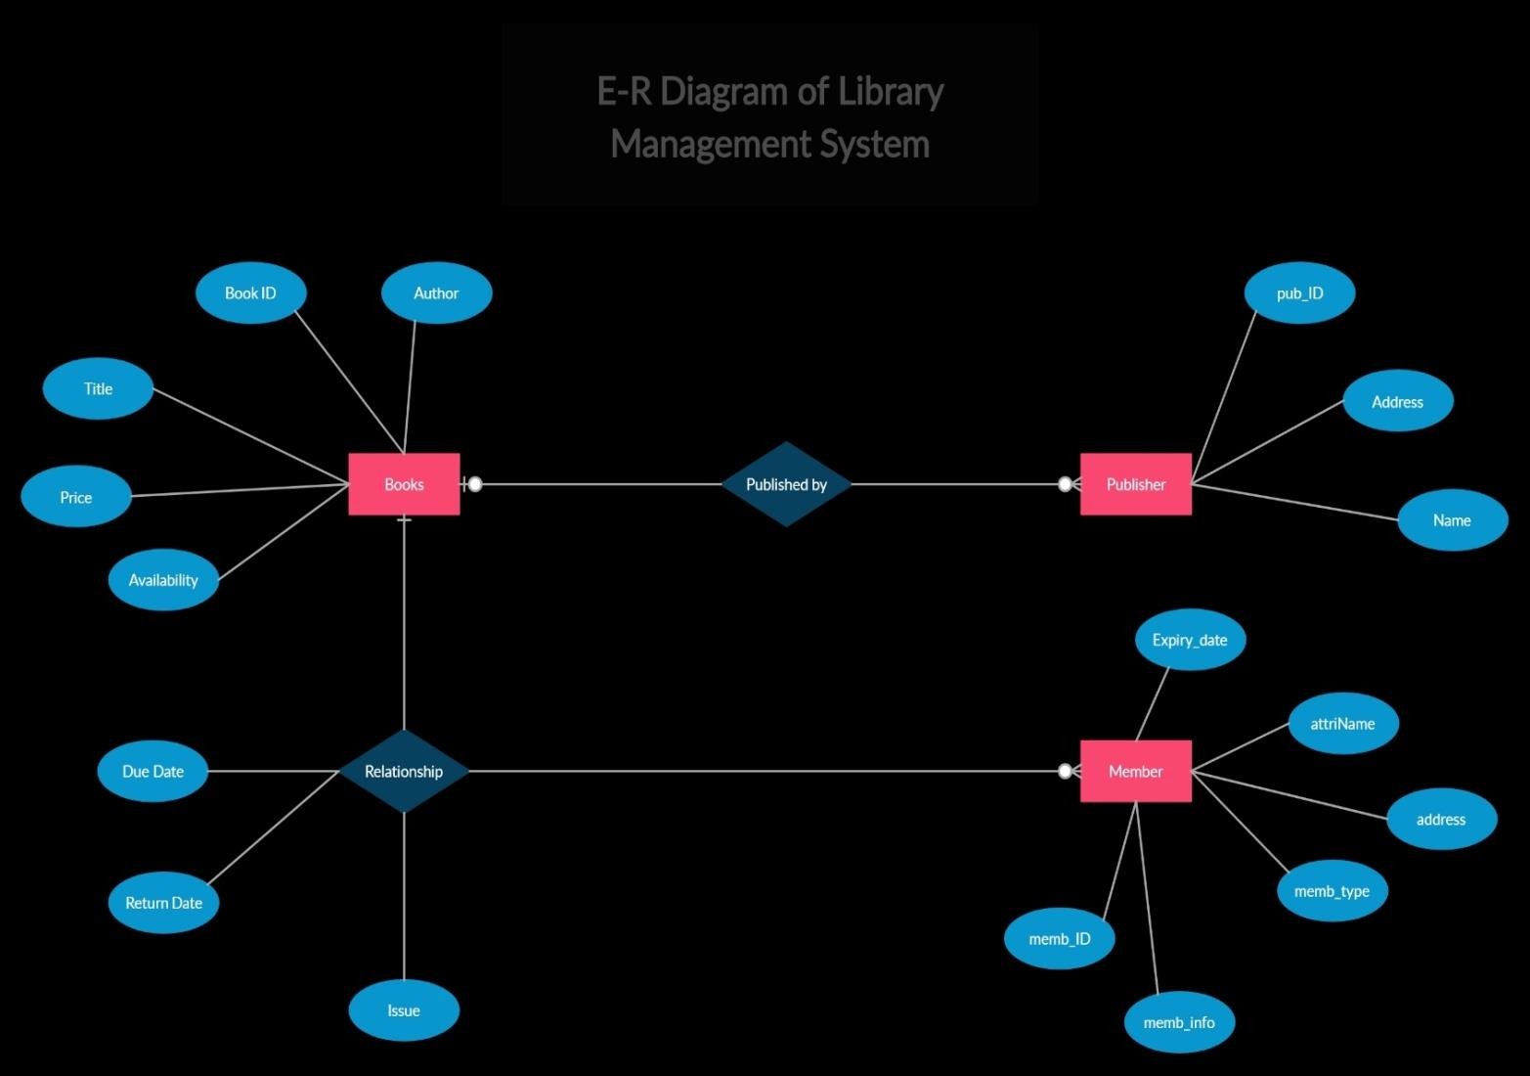

# PRACTICALNO.– 4

**AIM**:-To draw the data flow diagrams at level0 and level1.

##### Data FlowDiagramDefinition:

A data flow diagram shows the way information flows through a process or system. It includesdata inputs and outputs, data stores, and the various sub-processes the data moves through. DFDsarebuiltusingstandardizedsymbolsandnotationtodescribevariousentitiesandtheirrelationships.

Data flow diagrams visually represent systems and processes that would be hard to describe in achunk of text. You can use these diagrams to map out an existing system and make it better or toplan out a new system for implementation. Visualizing each element makes it easy to identifyinefficienciesandproducethebestpossible system.

DataFlowDiagram(DFD)depictstheflowofinformationandthetransformationappliedwhena data moves in and out from a system. The overall system is represented and described usinginput,processingandoutputintheDFD.Theinputscanbe:

* **Bookrequest**whenastudent requestsfor abook.
* **Librarycard** whenthestudenthastoshowor submithis/heridentityasaproof.

The overall processing unit will contain the following output that a system will produce orgenerate:

* Bookwillbetheoutputasthebook demandedbythestudentwillbegiventothem.
* Information of demandedbook should be displayed by thelibrary information systemthat can be used by the student while selecting the book which makes it easier for thestudent.

##### Level0 DFD–

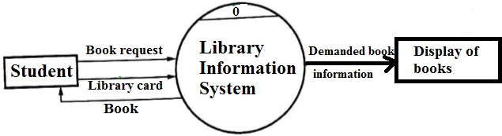

1. **Level1 DFD–**

Atthislevel,thesystemhastoshoworexposedwithmoredetailsofprocessing.The processesthatareimportanttobe carriedoutare:

* + Book delivery
  + Searchbytopic

List of authors, List of Titles, List of Topics, the bookshelves from which books can be locatedare some information that is required for these processes.**Data store** is used to represent thistype ofinformation.

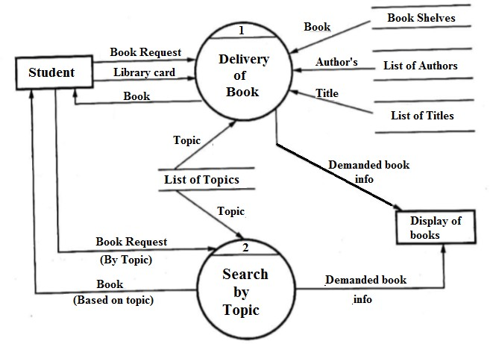

# PRACTICALNO.– 5

### **AIM:** Draw use case diagram.

Usecasediagrams(Behaviormodelordiagram),describesanddisplaystherelationorinteraction between the users and providers of application service or the system. It describesdifferentactions thata system performsin collaboration to achieve somethingwith one ormoreusers ofthesystem.

### UseCaseDiagramfor LibraryManagementSystem:

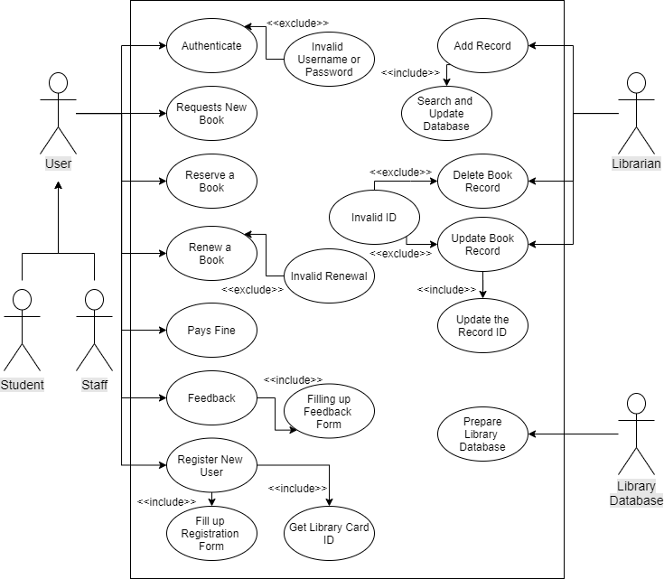

Here,wewillunderstandthedesigningofusecasediagramforthelibrarymanagementsystem.Somescenarios of thesystemareasfollows:

1. Userwho registers himself as a new userinitially is regarded as staff orstudentforthelibrarysystem.
   * Fortheusertogetregisteredasanewuser,registrationformsareavailablethatisneededtobefulfilledbytheuser.
   * After registration, a library card is issued to the user by the librarian. Onthelibrarycard,anIDisassignedtocardholderoruser.
2. After getting the library card, a new book is requested by the useras per thererequirement.
3. After, requesting, the desired book or the requested book is reserved by the user thatmeansnootherusercanrequestforthatbook.
4. Now, the user can renew a book that means the user can get a new due date for thedesiredbookif theuserhas renewedthem.
5. If theusersomehowforgets toreturn thebook before thedue date, then the userpaysfine.Orif the userforgets to renew the book till the due date, then the bookwillbeoverdueandtheuserpaysfine.
6. Usercanfill thefeedbackformavailableiftheywantto.
7. Librarian has a key role in this system. Librarian adds the records in the librarydatabase about each student or user every timeissuing thebook or returning thebook,orpayingfine.
8. Librarian also deletes the record of a particularstudentif the studentleaves thecollege or passed outfrom the college. If the book nolonger exists in the library,thentherecordoftheparticularbookisalsodeleted.
9. UpdatingdatabaseistheimportantroleofLibrarian.

# PRACTICALNO.– 6

### **AIM:** Draw Activity Diagram of all use cases.

##### Activitydiagram:

An**activitydiagram**isverysimilartoaflowchart.

We use Activity Diagrams to illustrate the flow of control in a system and refer to the stepsinvolved in the execution of a use case. We model sequential and concurrent activities usingactivity diagrams. So, we basically depict workflows visually using an activity diagram. Anactivity diagramfocuseson condition offlowandthesequenceinwhichithappens.Wedescribeordepictwhatcausesaparticulareventusinganactivitydiagram.

UMLmodelsbasicallythreetypesofdiagrams,namely,structurediagrams,interactiondiagrams,and behaviour diagrams.An activity diagram isa behavioural diagram i.e.it depictsthebehaviourofasystem.

An activity diagram portrays the control flow from a start point to a finish point showing thevariousdecisionpathsthatexistwhiletheactivityisbeingexecuted.

**ActivityDiagramNotations:-**

* + **InitialStateorStartPoint**

A small filled circle followed by an arrow represents the initial action state or the startpointforanyactivitydiagram.For activitydiagramusingswimlanes,makesurethestartpointisplacedinthe topleftcornerofthe firstcolumn.

Start point symbol - Activity diagram

##### ActivityorActionState

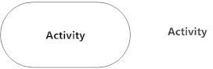Anactionstaterepresentsthenon-interruptible actionofobjects.Youcandrawanactionstate inSmartDraw usinga rectanglewithroundedcorners.

##### ActionFlow

Actionflows, alsocallededgesandpaths,illustratethetransitionsfromoneactionstatetoanother.Theyare usuallydrawnwithanarrowedline.

Action flow - Activity diagram

##### ObjectFlow

Objectflow refers to the creation andmodification of objects by activities. An objectflow arrow from an action to an object means that the action creates or influences theobject. An object flow arrow from an object to an action indicates that the action stateusestheobject.

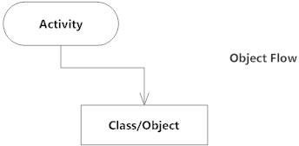

##### DecisionsandBranching

Adiamondrepresentsadecisionwithalternatepaths.Whenanactivityrequiresadecisionpriortomovingontothenextactivity,addadiamondbetweenthetwoactivities. The outgoing alternates should be labeled with a condition or guard expression.Youcanalsolabeloneofthepaths"else."



##### Guards

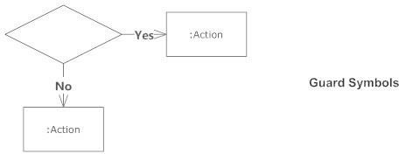In UML, guards are a statement written next to a decision diamond that must be truebefore moving next to the next activity. These are not essential, but are useful when aspecificanswer,suchas"Yes,threelabelsareprinted,"isneededbeforemovingforward.

**Activity Diagram for Library Management System:-**

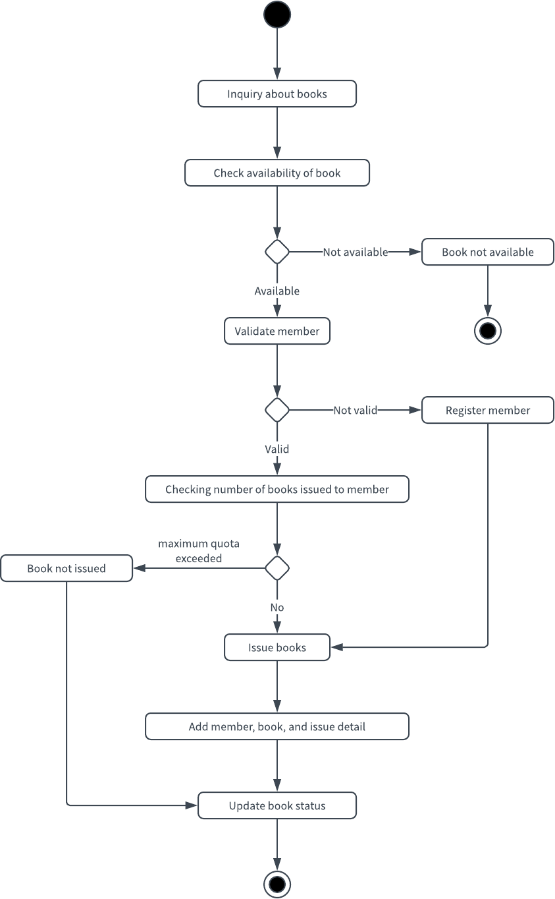

# PRACTICALNO.-7

### **AIM:** Draw state chart diagram of all use cases.

**UML –State chart Diagrams:** The name of the diagram itself clarifies the purpose of thediagram and other details. It describes different states of a component in a system. The states arespecific toa component/objectofa system.

A State chart diagram describes a state machine.State machine can be defined as a machinewhich defines different states of an object and these states are controlled by external or internalevents.

Activity diagram explained in the next chapter, is a special kind of a State chart diagram. As State chart diagram defines the states, it is used to model the lifetime of an object.

#### Purpose of State chart Diagrams:

State chart diagram is one of the five UML diagrams used to model the dynamic nature of asystem. They define different states of an object during its lifetime and these states are changedby events. State chart diagrams are useful to model the reactive systems. Reactive systems can bedefinedas a systemthatrespondstoexternalorinternalevents.

State chart diagram describes the flow of control from one state toanother state. States aredefined as a condition in which an object exists and it changes when some event is triggered. Themost important purpose of State chart diagram is to model lifetime of an object from creation to termination.

State chart diagrams are also used for forward and reverse engineering of a system. However, themainpurposeis tomodelthereactivesystem.

Following are the main purposes of using State chart diagrams–

* + To model the dynamic aspect of a system.
  + To model the lifetime of a reactive system.
  + To describe different states of an object during its lifetime.
  + Define a state machine to model the states of an object.

**StateDiagramforLibraryManagement:**

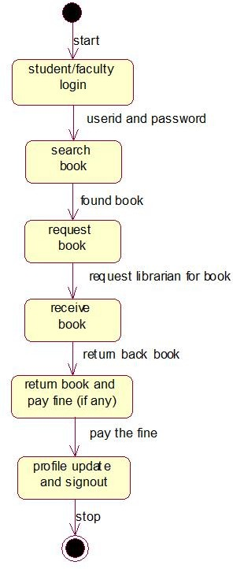

# PRACTICALNO.– 8

### **AIM:**Draw SequenceDiagramofalluse cases.

A **sequence diagram** simply depicts interaction between objects in a sequential order i.e. theorder in which these interactions take place. We can also use the terms event diagrams or eventscenarios torefertoasequencediagram.

Sequence diagrams describe how and in what order the objects in a system function. These diagrams are widely used by businessmen and software developers to document and understand requirements for new and existing systems.

#### Purpose of a Sequence Diagram

1. To model high-level interaction among active objects within a system.
2. To model interaction among objects inside a collaboration realizing a use case.
3. It either models generic interactions or some certain instances of interaction.

#### Notations of a Sequence Diagram

##### Lifeline

An individual participant in the sequence diagram is represented by a lifeline. It is positioned atthetopofthediagram.

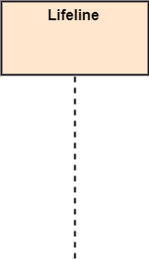

##### Actor

A role played by an entity that interacts with the subjectis called as an actor. It is out of the scope of the system. It represents the role, which involves human users and external hardware or

subjects. An actor may or may not represent a physical entity, but it purely depicts the role of an entity. Several distinct roles can be played by an actor or vice versa.



##### Activation

It is represented by a thin rectangle on the lifeline. It describes that time period in which anoperation is performed by an element, such that the top and the bottom of the rectangle isassociatedwiththeinitiationandthe completiontime,eachrespectively.

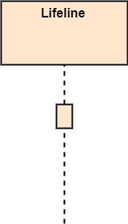

##### Messages

The messages depict the interaction between the objects and are represented by arrows. They arein the sequential order on the lifeline. The core of the sequence diagram is formed by messagesandlifelines.

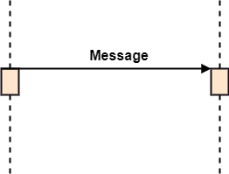

##### Note

A note is the capability of attaching several remarks to the element. It basically carries usefulinformationforthemodelers.

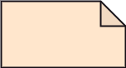

#### BenefitsofaSequenceDiagram

* 1. Itexploresthereal-timeapplication.
  2. Itdepictsthemessageflowbetweenthedifferentobjects.
  3. Ithaseasymaintenance.
  4. It iseasytogenerate.
  5. Implementbothforwardandreverseengineering.
  6. It caneasilyupdateasperthe newchangeinthe system.

**SequenceDiagramforLibraryManagementSystem:-**

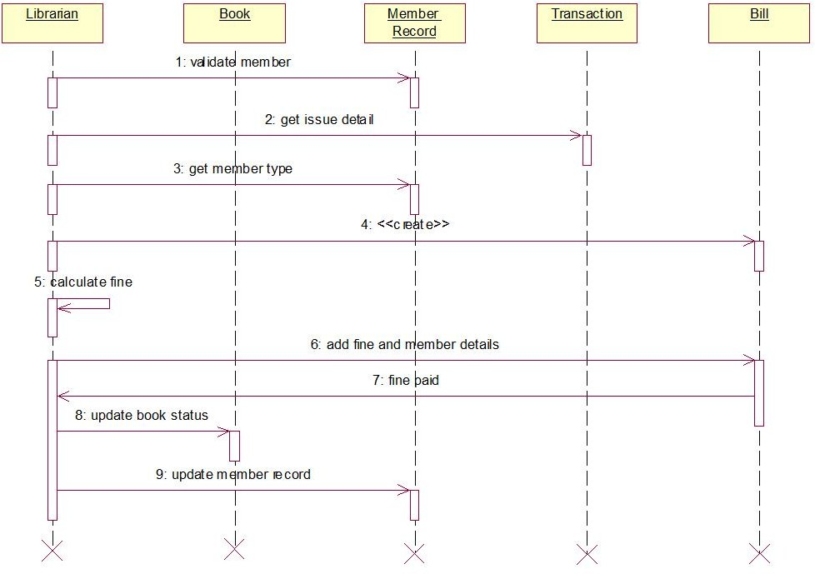

# PRACTICALNO.– 9

### **AIM:**Draw Collaboration Diagram of all use cases.

#### DefinitionofCollaborationDiagram:

The collaboration diagram is used to show the relationship between the objects in a system. Boththe sequence and the collaboration diagrams represent the sameinformation but differently.Instead of showing the flow of messages, it depicts the architecture of the object residing in thesystem as it is based on object-oriented programming. An object consists of several features.Multiple objects present in the system are connected to each other. The collaboration diagram,which is also known as a communication diagram, is used to portray the object's architecture inthe system.

#### NotationsofaCollaborationDiagram:

Followingarethecomponentsofacomponentdiagramthatareenlistedbelow:

1. Objects:Therepresentationofanobjectisdonebyanobjectsymbolwithits nameandclassunderlined,separatedbya colon.

Inthecollaborationdiagram, objectsareutilizedinthefollowingways:

* + Theobjectisrepresented byspecifyingtheirname andclass.
  + Itisnotmandatoryforeveryclasstoappear.
  + Aclassmayconstitutemorethanoneobject.
  + Inthecollaborationdiagram,firstly,theobjectiscreated,andthenitsclassisspecified.
  + Todifferentiateoneobjectfromanotherobject,itisnecessarytonamethem.

1. Actors: In the collaboration diagram, the actor plays the main role as itinvokes theinteraction. Each actor has its respective role and name. In this, one actor initiates the usecase.
2. Links: The link is an instance of association, which associates the objects and actors. Itportrays a relationship between the objects through which the messages are sent. It isrepresented by a solidline.The linkhelps an object toconnectwith or navigate toanotherobject,suchthatthemessageflowsare attachedtolinks.
3. Messages: It is a communication between objects which carries information and includesa sequence number, so that the activity may take place. It is represented by a labeledarrow, which is placed near a link. The messages are sent from the sender to the receiver,andthedirectionmustbenavigableinthatparticulardirection.Thereceivermustunderstandthemessage.

#### StepsforcreatingaCollaborationDiagram

1. Determinethebehaviorforwhichtherealizationandimplementationarespecified.
2. Discoverthestructuralelementsthatareclassroles,objects,andsubsystemsforperformingthefunctionalityofcollaboration.
   * Choosethecontextofaninteraction:system, subsystem,usecase, andoperation.
3. Thinkthroughalternativesituationsthatmaybe involved.
   * Implementationofacollaborationdiagramataninstancelevel,ifneeded.
   * Aspecificationleveldiagrammaybemadeintheinstancelevelsequencediagramforsummarizingalternativesituations.

**CollaborationDiagramforLibraryManagementSystem:-**

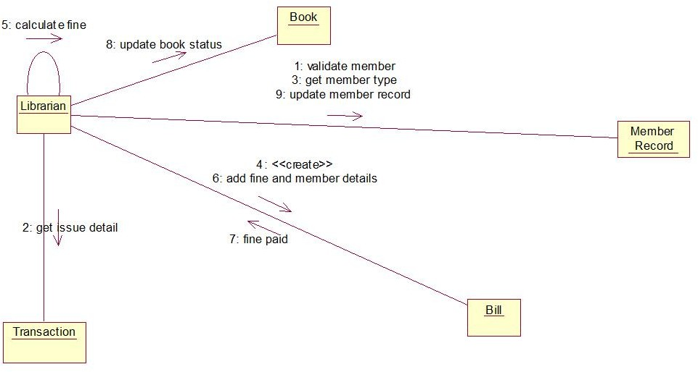

# PRACTICAL NO.–10

### **AIM:** Assign objects in sequence diagram to classes and make class diagram.

The class diagram depicts a static view of an application. It represents the types of objectsresidingin the system and the relationships between them.A class consists of its objects, andalso it may inherit from other classes. A class diagram is used to visualize, describe, documentvariousdifferentaspectsofthe system,andalsoconstructexecutable software code.

It shows the attributes, classes, functions, and relationships to give an overview of the softwaresystem. It constitutes class names, attributes, and functions in a separate compartment that helpsinsoftwaredevelopment.Sinceitisacollectionofclasses,interfaces,associations,collaborations,andconstraints,itistermedasa structuraldiagram.

Purpose:

* Itanalysesanddesignsastaticviewofanapplication.
* Itdescribesthemajorresponsibilitiesofasystem.
* Itisabaseforcomponent anddeployment diagrams.
* Itincorporatesforwardandreverseengineering.

Benefits:

* Itcanrepresenttheobjectmodelforcomplexsystems.
* Itreducesthemaintenancetimebyprovidinganoverviewofhowanapplicationisstructuredbeforecoding.
* Itprovidesageneralschematicofanapplication forbetterunderstanding.

Components:

* UpperSection:The uppersection encompasses the name of the class.A classis arepresentation of similar objects that shares the same relationships, attributes, operations,and semantics. Some of the following rules that should be taken into account whilerepresentingaclass aregivenbelow:
  + Capitalizetheinitialletteroftheclassname.
  + Place the class name in the centre of the upper section.
  + A class name must be written in bold format.
  + The nameoftheabstractclassshouldbewritteninitalicsformat.
* Middle Section: The middle section constitutes the attributes, which describe the qualityofthe class.Theattributeshave thefollowingcharacteristics:
  + The attributes are written along with its visibility factors, which are public (+), private(-),protected(#),andpackage (~).
  + Theaccessibilityofanattribute classisillustratedbythevisibilityfactors.
  + A meaningful name should be assigned to the attribute, which will explain its usageinside theclass.
* LowerSection:Thelowersectioncontainsmethodsoroperations.Themethodsarerepresentedin theform of alist,whereeachmethodis writtenin asingleline.Itdemonstrateshowaclassinteractswithdata.

Relationships:

* Dependency: A dependency isasemanticrelationshipbetween twoormoreclasseswhereachangeinoneclasscausechangesinanotherclass.Itformsaweakerrelationship.Inthefollowingexample,Student_Nameisdependent ontheStudent_Id.

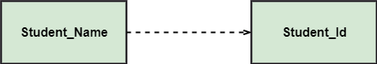

* Generalization: A generalization is a relationship between a parent class (superclass) andachildclass(subclass).Inthis,thechildclassisinheritedfromtheparentclass.Forexample,TheCurrentAccount,SavingAccount,andCreditAccountarethegeneralizedformofBankAccount.

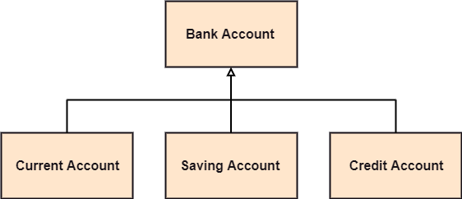

* Association: It describes a static or physical connection between two or more objects. Itdepicts how many objects are there in the relationship. For example, a department isassociatedwiththecollege.

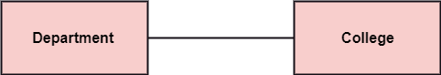

* Multiplicity: It defines a specific range of allowable instances of attributes. In case if arange is not specified, one is considered as a default multiplicity. For example, multiplepatientsareadmittedtoone hospital.

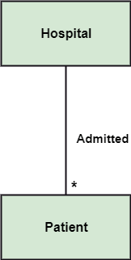

* Aggregation: Anaggregationisasubsetofassociation,whichrepresentshasarelationship.Itismorespecificthanassociation.Itdefinesapart-wholeorpart-ofrelationship. In this kind of relationship, the child class can exist independently of itsparentclass.Thecompanyencompassesanumberofemployees,andevenifoneemployee resigns,thecompanystillexists.

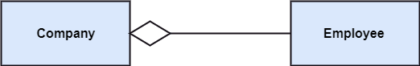

* Composition: The composition is a subset of aggregation. It portrays the dependencybetween the parent and its child, which means if one part is deleted, then the other partalso gets discarded. It represents a whole-part relationship.A contact book consists ofmultiplecontacts,and ifyou deletethecontactbook,allthecontactswillbelost.

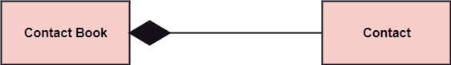

##### AbstractClasses:

In the abstract class, no objects can be a direct entity of the abstract class. The abstract class canneitherbedeclarednorbeinstantiated.Itisusedtofindthefunctionalitiesacrosstheclasses.Thenotation of the abstract class is similar to that of class; the only difference is that the name of theclass is written in italics. Since it does not involve any implementation for a given function, it isbesttousetheabstractclass withmultiple objects.

Let us assume that we have an abstract class named displacement with a method declared insideit,andthatmethodwillbecalledasa drive().Now,thisabstractclassmethodcanbeimplementedbyanyobject,forexample,car,bike,scooter,cycle,etc.

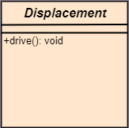

##### Howtodrawclassdiagram?

The class diagram is used most widely to construct software applications. It not only represents astatic view of the system but also all the major aspects of an application. A collection of classdiagramsas awhole represents asystem.

Somekeypointsthat areneeded tokeepin mindwhiledrawingaclassdiagramaregiven below:

1. Todescribeacompleteaspectofthesystem,itis suggestedtogiveameaningfulnametothe class diagram.
2. Theobjectsandtheirrelationshipsshouldbeacknowledgedinadvance.
3. Theattributesandmethods(responsibilities)ofeachclass mustbeknown.
4. Aminimumnumberofdesiredpropertiesshouldbespecifiedasmorenumberoftheunwantedpropertywillleadtoacomplexdiagram.
5. Notescanbeusedasandwhenrequiredbythedevelopertodescribetheaspectsofadiagram.
6. The diagrams shouldbe redrawn and reworked as many times to makeitcorrectbeforeproducingitsfinalversion.

##### ClassdiagramforLibraryManagement System:

