A STUDY ON DAMPING COEFFICIENTS OF A VIBRATORY MODEL OF HUMAN BODY
S.C. Zanwar Mayank Mishra Dr. S. P. Nigam
Research Scholar M.E (CAD / CAM and Robotics) Visiting Professor
Mechanical Engineering Department., Thapar University , Patiala
Abstract : Paper introduces concept and causes of Human Body Vibration and its broad two categories Hand-arm Vibration (HAV) and Whole-Body Vibration (WBV). Moreover different methods of measurement along with International and Indian standards of vibration assessments has been discussed in brief. Literature reviews shows many models are developed to study the complex nature of Human body vibration to suit variety of applications. In this paper, a 15 degrees of freedom lumped parameter spring-mass vibratory model of human body for vertical mode vibrations based on 50th percentile US Male anthropometric data has been modeled as linear spring-mass-damper system. The human body has been divided into 15 ellipsoidal segments. The human body has been modeled as a Mass and stiffness of each segment are determined from the elastic modulii of bones and tissues. Viscous damping has been considered. An effort had been made to calculate appropriate clearance values of piston and cylinder (dash-pot damper model) by assuming the viscosity of blood and other fluids. The damping coefficient and damping ratio values of individual segments are obtained The optimal values of damping ratios of body segments are calculated. . In addition this paper presents frequency response of different parts of body due to constant force excitation at foot and hands.
----------------------------------------------------------------------------------------------------------------

1.0 INTRODUCTION [1,2]
The human body is an exquisite combination of interacting systems which can be analyzed using multidisciplinary engineering principles. Biomechanical and biomedical engineering combine the discipline of mechanical engineering with human anatomy and physiology. Lot of work/ investigations are being carried out in these areas with reference to variety of applications. One such area is Human Body Vibrations. Human vibration is separated in two well–defined categories whole-body vibration (WBV) and hand–arm vibration (HAV). Whole-body vibration occurs when the human body is supported on a vibrating surface such as seat, floor or bed that is vibrating. Hand-arm vibration, by contrast, is a form of local vibration where hand of a person is in contact with a vibrating piece of equipment and the vibration enters the body at the hand.

1.1 Hand-Arm Vibration (HAV)
HAV can be experienced when holding vibrating equipment, or when holding material which is in contact with vibrating or rotating equipment. HAV problems can be caused while working with following types of equipments such as Concrete breakers , Grinders and polishers ,Hammer drills Hand-held grinders and sanders, Power hammers and chisels, Powered lawnmowers, Rotary burring tools Vibration levellers and compactors.

Regular exposure to HAV can give rise to permanent injuries. The common health effects of hand-arm vibration are Damage to the blood circulation in the fingers (vibration white finger-Raynaud’s disease) ,Pain in the wrists (carpal tunnel syndrome) ,Pain or loss of sensation in the hands or fingers ,Loss of grip strength ,Tingling sensations (pins and needles) ,Loss of manual dexterity ,Loss of sense of temperature in the fingers.

1.2 Whole-Body Vibration (WBV)
Person experiences WBV through buttocks (seating posture) or feet (standing posture) while travelling in a vehicle or working on a machine. Work activities of greatest risk which may cause WBV include use of Agricultural and forestry vehicles and machinery - tractors, Compaction, hammering or punching machinery - hammer mills, mobile crushers, Construction and quarrying vehicles and machinery - diggers, dumper trucks, Passenger vehicles -, rail, buses, helicopters, Industrial trucks - forklifts, straddle carriers.

The most common complaint from WBV is persistent back pain, but it may also cause Digestive disorders , Cardiovascular stress , Dizziness or motion sickness, due to balance organ or sensory system disorder, Loss of tissue, Annoyance and impaired concentration.

Fortunately WBV can prevent problems of muscle or bone loss experienced by astronauts in space. Accordingly, NASA scientists suggest that astronauts prevent bone loss by standing on a lightly vibrating plate for 10 to 30 minutes each day. The same therapy is used to treat millions of people who suffer from bone loss, called osteoporosis here on earth.

1.3 Vibration measurement
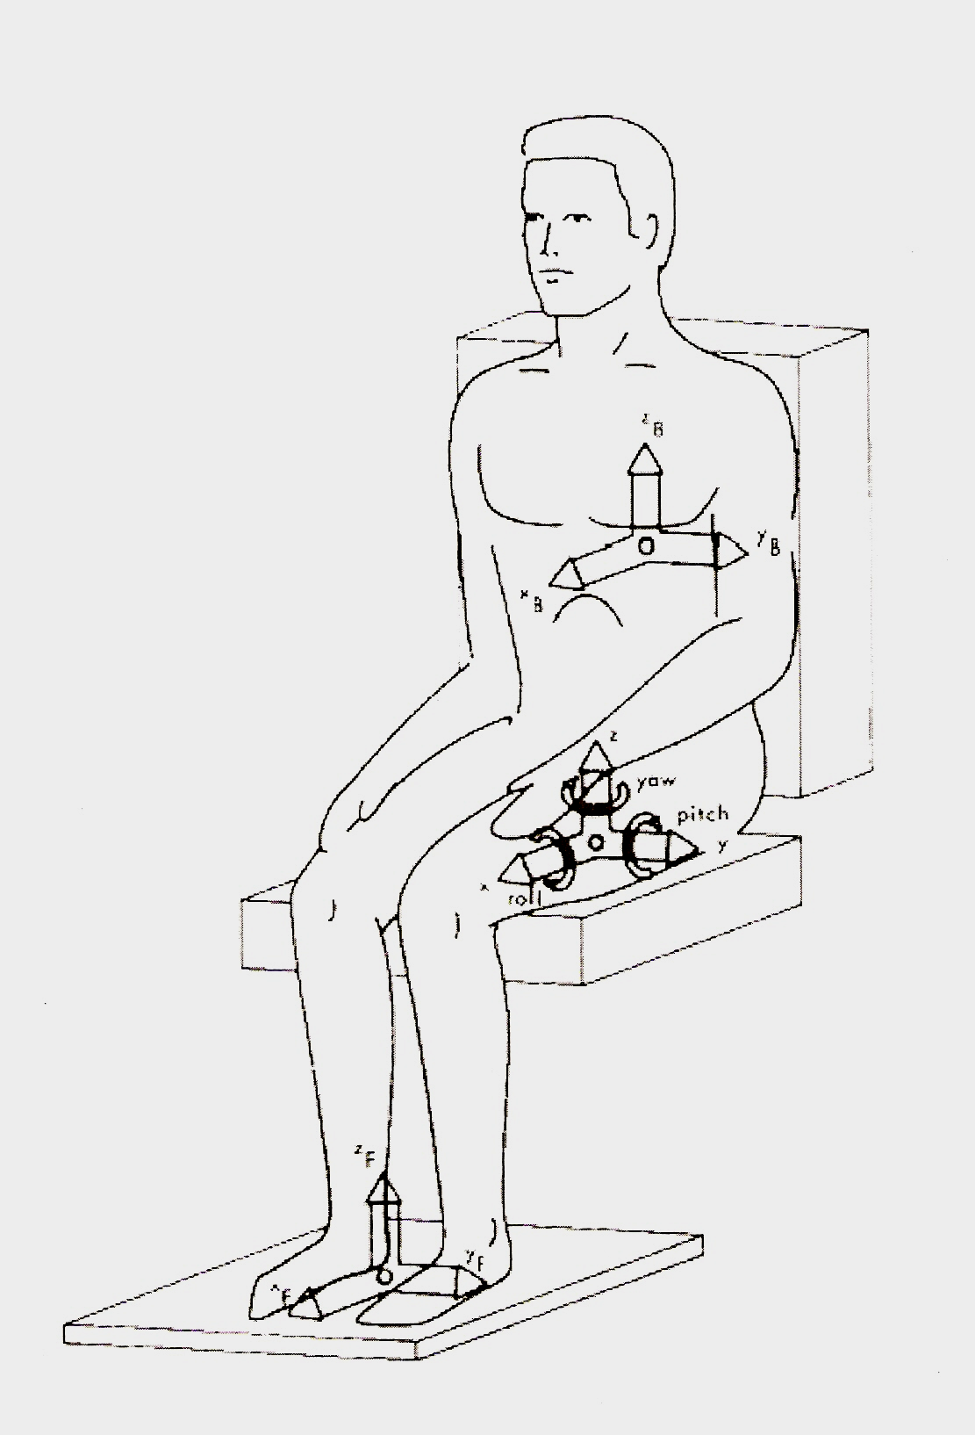
Vibration is the rapid acceleration and deceleration of a body or body part, produced by rotating or oscillating machinery. When this movement is transmitted to the human body usually through the hands, arms, feet or buttocks it has the potential to cause injury. Vibration is measured in 3 axes the x axis is back to front, the y axis is left to right, and the z axis is up and down in the vertical plane as shown in figure 1. The acceleration in each of the planes is measured, and gives a reading in m/s². An accelerometer (equipment for measuring the rate of acceleration) is used to measure the vibration on each of the three axes, and calculate the acceleration value. This data has to be adjusted to give the equivalent value of exposure to vibration over a normalized 8 hour day. This is expressed as units of m/s² (8hr). It is based on root-mean-square (rms) averaging method. The other parameter is vibration dose value (VDV). It is based on the 4th root-mean quad of the acceleration signal with units of m/s^{1.75}.

Figure 1: Show Axes along which vibration may enter the human body.

1.4 International Standards for the assessment of the effects of vibration
The ISO Standards controlling the assessment procedures are ISO 2631 for whole body vibration , ISO 5349 for hand-arm vibration and ISO 8041 for Human response to vibration-Measuring instrumentation. The way in which vibration affects the different categories of assessment is dependent on the frequency content of the applied vibration and its duration. The preferred parameter of vibration measurement and assessment is therefore the frequency-weighted r.m.s. acceleration, & its relationship with exposure duration, when an allowable dose for a work period is to be calculated. If a person is exposed to more than one source of vibration (perhaps because they use two or more different machines or activities during the day) then a partial VDV is calculated from the magnitude and duration of each axis and for each exposure. The partial VDV are combined to give the overall VDV for the person , for each axis. The daily VDV is then the highest of the three single axis values. In India, BS 2631 and BS 5349 are same as per ISO standards.
2.0 MODELLING OF HUMAN BODY
Extensive research had been undertaken in developed countries to study Human response to vibrations in the last five decades. The estimation of damping is of great importance to establish an accurate mechanical model of the human body to predict the dynamic response and energy absorbed in different parts of the human body in different postures. Muskian and Nash[3] have established the possibility of a frequency dependant muscle forces. Garg and Ross[4] developed a 16 degrees of freedom vibratory model based on their experimental results. The damping values for various joints in the human body were obtained individually in this study. Fairley and Griffin[5] provided comprehensive experimental data on the driving point frequency response of a seated human body and by fitting the response of a lumped parameter model at a natural frequency of 5Hz, obtained the damping ratio of the upper part of the body as 0.475.Pankide and Woelfel [6] obtained the stiffness and damping ratio of the pelvis and the tissues between the pelvis and ground by fitting natural frequency predominant resonance of human body response and the magnitudes of impedance/transfer functions from the seat to the head. Matsumoto and Griffin[7] identified damping ratios and other model parameters by minimizing the error between the measured apparent mass and the calculated apparent mass.
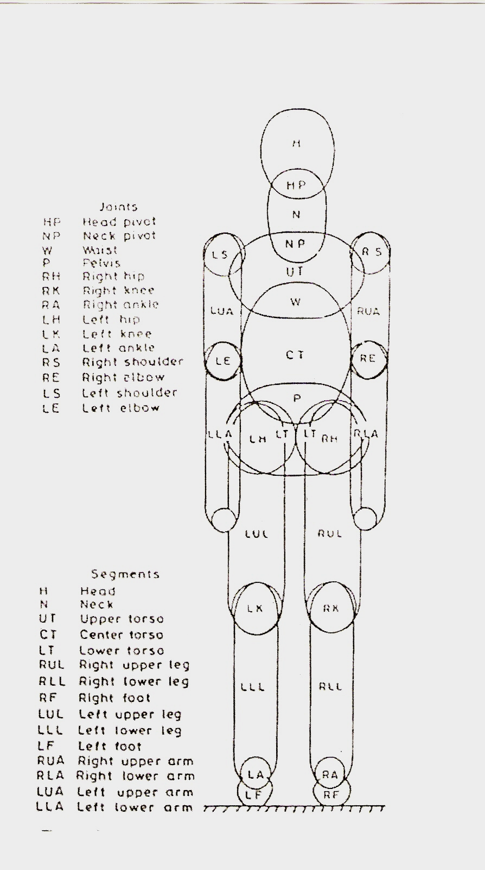
Bartz and Gionotti [8] discussed the dimensional and inertial properties of human body by formulating a 15-segments model with measurement on the human body. A computer program was developed to calculate properties of the human body. The input data was sex, standing height, seated height and weight. The program calculates 15-segmental link lengths of the ellipsoid elements, contact surface dimensions, masses and moment of inertia. Human model is represented as shown in figure 2. The model was prepared to generate computer simulation of the motor vehicle crash victim. The model was prepared based on the anthropometric 50th percentile male/female data obtained from representative samples of the U.S. population. The 15 segments are Head, Neck, Upper Torso, Center Torso, Lower Torso, Right Upper Leg, Right lower leg, Right foot, Left upper leg, Left lower leg, Left foot, Right upper arm, Right lower arm, Left upper arm, Left lower arm.

Figure 2: Anthropomorphic model of the human body.
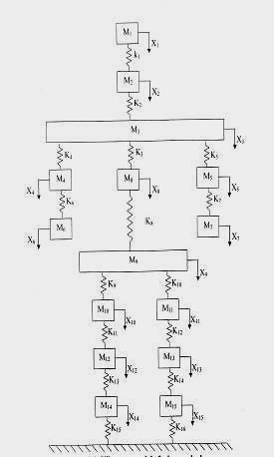
Nigam S.P., et al. [9] proposed the use of anthropomorphic data and geometric models in order to develop a generalized analytical approach for standing-human body-vibratory model. The model was conceived to linear-spring-mass system with undamped lumped parameter consisting of 15-degree of freedom. The modeling procedure presented is based on several assumptions. The foremost being the approximation of the body segment to ellipsoids, truncation of the ellipsoids for calculating segment stiffness, and the approximation of segment elastic modulus as a geometric mean of bones and tissues elastic moduli.

Gupta[10] estimated the damping ratio for the individual segments of the human body by extension of 15 degree spring-mass, undamped human body vibratory model developed by Nigam and Malik[9].
Figure 3 Vibratory model of Human body.

This paper explains the details analysis of calculating the damping ratios and natural frequencies for 15 degree spring-mass-damper model as shown in figure 3. Moreover forces were applied at foot and at hand and its effect was analysed on whole-body-vibrations and hand-arm vibrations. It has been represented in the form of graphs in the frequency range of 0 to 40 Hz.
3. EVALAUATION OF MASS AND STIFFNESS OF THE 15 DEGREE SPRING-MASS-DAMPER LUMPED MODEL
Bartz and Gianotti[8] presented a 15 body ellipsoidal segments model based on this anthropometric measurements of 50th percentile US male are based on 31 parameters as tabulated in Table 1.
Table 1 Anthropometric Measurements of the 50th Percentile US Male
Dimensional Data | Measurement  (cm) | Dimensional Data | Measurement (cm)
L1 Standing height | 168.67 | L19 Biceps circumference | 32.52
L2 Shoulder height | 146.53 | L20 Elbow circumference | 31.42
L3 Armpit height | 136.02 | L21 Forearm circumference | 29.28
L4 Waist height | 108.38 | L22 Wrist circumference | 17.86
L5 Seated height | 92.96 | L23 knee height, seated | 53.14
L6 Head length | 19.86 | L24 Thigh circumference | 50.52
L7 Head breadth | 15.57 | L25 Upper leg circumference | 37.24
L8 Head to chin height | 23.24 | L26 Knee circumference | 36.20
L9 Neck circumference | 37.95 | L27 Calf circumference | 33.32
L10 Shoulder breadth | 46.20 | L28 Ankle circumference | 21.06
L11 Chest depth | 23.32 | L29 Ankle height, outside | 6.91
L12 Chest breadth | 32.89 | L30 Foot breadth | 9.35
L13 Waist depth | 21.51 | L31 Foot length | 25.40
L14 Waist breadth | 28.22
L15 Buttock depth | 23.19
L16 Hip breadth, standing | 35.43
L17 Shoulder to Elbow length | 37.54
L18 Forearm-hand length | 48.69

The densities of each segment is taken equal to the average density of the whole body since densities of different body segments are almost equal. The mass of the segment was evaluated by equation (1).
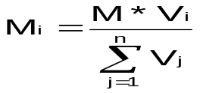 (1)
Where Vi = Volume of i^{th} segment of the body, modeled as an ellipsoid of semi-axes a_{i},b_{i},c_{i} is (4/3)**a_{i}*b_{i}*c_{i} , M =Total body mass.

The various segments are assumed to be linearly elastic homogeneous bodies with linear viscous dissipation. The axial deformation of segment is assumed to be contributed by bones and tissues and the axial elastic modulus E of the segment is approximated as geometric mean of their elastic modulii E_{b} and E_{t}. Spring Stiffness S_{i} for each segment under axial loading with truncated factor t_{r} =0.05. were calculated using equation(2). The values are tabulated in Table 2.
S_{i} = π E a_{i} b_{i} /(c_{i}I_{i}), (2)
where I_{i}= log(2- t^{i}_{r})/t^{i}_{r} and t^{i}_{r} = 1-d_{i} / c_{i,} d_{i} is the half length of the truncated ellipsoid.

Table 2 Mass and Stiffness Values of the Ellipsoidal Segments (50th Percentile U.S. Male)
Truncation Factor t_{r} = 0.05, Segment Elastic modulus, E = SQRT(E_{b} * E_{t})= 1.30MN/m²
 | Body Segment and  (Designation) | Semi-axes of Ellipsoids |  |  | Mass of the segment M(kg) | Stiffness of the segment
 | Body Segment and  (Designation) | a_{i} (cm) | b_{i} (cm) | c_{i} (cm) | Mass of the segment M(kg) | Designation | S_{i} (KN/m)
1 | HEAD  (H) | L₇ / 2  = 7.785 | L₇ / 2 =7.785 | L₆ / 2  =9.931 | 3.229 | S₁ | 681.3
2 | NECK  (N) | L₉/(2  =6.040 | L₉/(2  =6.040 | (L₁- L₂ - L₆) / 2  =1.140 | 0.223 | S₂ | 3,572.3
3 | U.TORSO  (UT) | L₁₂ / 2  =16.195 | L₁₁ / 2  =11.660 | L₁₇ / 4  =9.385 | 9.510 | S₃ | 2246.1
4,5 | U.ARM  (RUA,  LUA) | L₁₉ / (2)  =5.239 | L₁₉ / (2)  =5.239 | L₁₇ / 2  =18.770 | 2.765 | S_{4,} S₅ | 163.3
6,7 | L.ARM  (RLA,  LLA) | L₂₁ / (2)  =4.628 | L₂₁ / (2)  =4.628 | L₁₈ / 2  =24.345 | 2.798 | S_{6,} S₇ | 98.2
8 | C.TORSO  (CT) | L₁₄ / 2  =14.110 | L₁₃ / 2  =10.755 | (L₁₇ +L₁₈ ) / 4  =21.558 | 17.555 | S₈ | 785.8
9 | LTORSO  (LT) | L₁₆ / 2  =17.715 | L₁₅ / 2  =11.595 | L₁₈ / 4  =12.173 | 13.417 | S₉ | 1883.7
10,11 | U.LEG  (RUL,  LUL) | L₂₅ / (2)  =5.927 | L₂₅ / (2)  =5.927 | (L₂ - L₁₇ – L₂₃) /2  =27.925 | 5.264 | S_{10,} S₁₁ | 140.4
12,13 | L.LEG  (RLL  LLL) | L₂₇ / (2)  =5.304 | L₂₇ / (2)  =5.304 | (L₂₃- L₂₉) / 2  =23.110 | 3.488 | S_{12,} S₁₃ | 135.8
14,15 | FEET  (RF,LF) | L₃₀/ 2  =4.674 | L₃₁/ 2  =12.700 | L₂₉  =6.909 | 1.139 | S_{14,} S₁₅ | 959.2

4. EVALUATION OF DAMPING COEFFICIENTS OF THE SEGMENT
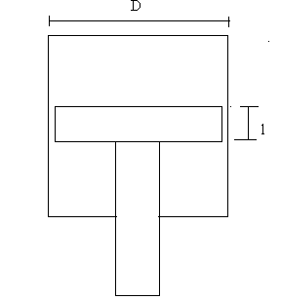
The 15 degree spring-mass model for further analyzed for damping consideration for each segment. It is represented by a dash pot or damper as shown in Fig 4. Here the piston reciprocates in a cylinder which is filled with a fluid and there will be a clearance between the piston and the cylinder. The major sources of damping depend on both the system and the environment. The most common sources are:
- Drag between a moving body and its fluid environment
- Damping produced by the pressure flow of the fluid through the clearance space as a result of piston displacement.
Fig 4. Fluid Dash pot System

- Damping resistance due to the pressure difference on the two sides of the piston.
Seg no. | Body Segment | Diameter of the  Segment D_{i} (Cm) | Length of the Segment  L_{i} (Cm)
1 | HEAD  (H) | L₇  = 15.57 | L₆  =19.86
2 | NECK  (N) | L₉/(  =12.08 | L₁- L₂ - L₆  =4.56
3 | U.TORSO  (UT) | L₁₁  =23.32 | L₁₇ / 4  =9.385
4,5 | U.ARM  (RUA,  LUA) | ( L₂₀ / + L₁₉/ ) / (2)  =10.24 | L₁₇  =37.54
6,7 | L.ARM  (RLA,  LLA) | ( L₂₀ / + L₂₂/ ) / (2)  =7.84 | L₁₈  =48.69
8 | C.TORSO  (CT) | L₁₃  =21.51 | (L₁₇ +L₁₈ ) / 4  =21.558
9 | LTORSO  (LT) | L₁₅  =23.19 | L₁₈ / 4  =12.173
10,11 | U.LEG  (RUL,  LUL) | ( L₂₅ / + L₂₆/ ) / (2)  =11.68 | L₂ - L₁₇ – L₂₃  =55.85
12,13 | L.LEG  (RLL  LLL) | ( L₂₆ / + L₂₈/ ) / (2)  =8.65 | L₂₃- L₂₉  =46.22
14,15 | FEET  (RF,LF) | L₃₀  =9.35 | L₃₁  =25.40
Table 3 Formulae for geometrical dimensions of the Body Segment

Table 4 Range of damping ratios for
different body segment available in literature .
BODY SEGMENT | ξ_{i}
Foot and legs | 1 –1.5
Lower torso | 0.5 –1.0
Central torso | 0.01 –0.2
Upper torso | 0.002- 0.015
Hands | 0.001 – 0.01
Neck | 0.015
Head | 0.004

The pressure difference is caused by the restriction to fluid flow due to piston motion.
If the clearance between the piston and the cylinder is small, the first two components of the damping are negligible and the total damping is due to third component only.

The viscous damping coefficient _{i} of the individual i^{th} segments are established on assumptions based on mean diameter ( D_{m} ), length of segments (l) and coefficient of viscosity of the blood and synovial fluid (  ) as per equation (3) and geometrical dimensional data of each segment as per formule and values in Table (3).
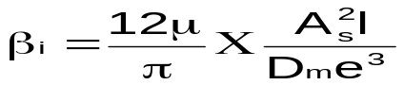 (3)
A_{s} , = Area of the segment

Using equation (4), the damping ratio    of i^{th} segment were obtained by changing the clearance and length of various body segments in terms of stiffness (S) and mass (M) of each segment . The result of some of these computations are shown in Table 6 which were compared with the damping coefficients within the range of experimental values available in literature and given in Table 4. The damping constants of the body segments were calculated from damping ratios as per formulae and values given in Table 5.
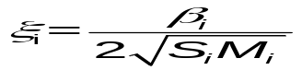 (4)
Table 5 Damping Coefficients and Damping Constants
of the Body Segment
Damping coefficients |  | Damping constants
Symbol | Values | Symbol | Values
β₁ | 4.10 | C₁= 2 β₁ β₂ / ( β₁ ₊ β₂) | 4.80
β₂ | 5.80 | C₂= 2 β₂ β₃ / ( β₂ ₊ β₃) | 7.6
β₃ | 11.00 | C₃= 2 β₃ β₈ / ( β₃ ₊ β₈) | 15.9
β₄ | 3.00 | C₄= 2 β₃ β₄ / ( β₃ ₊ β₄) | 4.71
β₅ | 3.00 | C₅= 2 β₃ β₅ / ( β₃ ₊ β₅) | 4.71
β₆ | 10.60 | C₆= 2 β₄ β₆ / ( β₄ ₊ β₆) | 4.68
β₇ | 10.60 | C₇= 2 β₅ β₇ / ( β₅ ₊ β₇) | 4.68
β₈ | 28.73 | C₈= 2 β₈ β₉ / ( β₈ ₊ β₉) | 55.55
β₉ | 835.25 | C₉= 2 β₉ β₁₀ / ( β₉ ₊ β₁₀) | 1204.02
β₁₀ | 2155.85 | C₁₀= 2 β₉ β₁₁ / ( β₉ ₊ β₁₁) | 1204.02
β₁₁ | 2155.85 | C₁₁= 2 β₁₀ β₁₂ / ( β₁₀ ₊ β₁₂) | 1034.40
β₁₂ | 680.44 | C₁₂= 2 β₁₁ β₁₃ / ( β₁₁ ₊ β₁₃) | 1034.40
β₁₃ | 680.44 | C₁₃= 2 β₁₂ β₁₄ / ( β₁₂ ₊ β₁₄) | 759.07
β₁₄ | 858.26 | C₁₄= 2 β₁₃ β₁₅ / ( β₁₃ ₊ β₁₅) | 759.07
β₁₅ | 858.26 | C₁₅= 2 β₁₄ | 1716.52
 |  | C₁₆= 2 β₁₅ | 1716.52

Clearance  (e=X%D) | Length of the  piston  (l=Y%L) | Damping Ratio values of different body segment
X | Y | H | N | UT | UA | LA | CT | LT(HIP) | UL | LL | F
 | 1 | 0.0159 | 0.0034 | 0.01082 | 0.0833 | 0.2453 | 0.02003 | 0.00271 | 0.4423 | 0.1928 | 0.1755
1 | 3 | 0.0567 | 0.0104 | 0.02164 | 0.2499 | 0.7361 | 0.02164 | 0.00813 | 1.327 | 0.5775 | 0.5265
1 | 5 | 0.0945 | 0.0149 | 0.03246 | 0.4166 | 1.2261 | 0.10001 | 0.01356 | 2.2117 | 0.9625 | 0.8976
 | 7 | 0.1323 | 0.0243 | 0.04328 | 0.5832 | 1.7176 | 0.1402 | 0.0189 | 3.0964 | 1.3475 | 1.2287
 | 9 | 0.1701 | 0.0313 | 0.0541 | 0.7499 | 2.2083 | 0.1803 | 0.0244 | 3.9811 | 1.7325 | 1.5397
 | 1 | 0.0007 | 0.0001 | 0.0004 | 0.0031 | 0.00927 | 0.00075 | 0.0001 | 0.0167 | 0.0072 | 0.0066
3 | 3 | 0.0021 | 0.0004 | 0.0008 | 0.0094 | 0.02767 | 0.00227 | 0.0003 | 0.0501 | 0.0218 | 0.0199
3 | 5 | 0.0035 | 0.0006 | 0.000122 | 0.0157 | 0.04637 | 0.00378 | 0.00051 | 0.0836 | 0.0363 | 0.0331
 | 7 | 0.005 | 0.0009 | 0.00163 | 0.022 | 0.06492 | 0.0052 | 0.00071 | 0.117 | 0.0509 | 0.0464
 | 9 | 0.0064 | 0.0011 | 0.00204 | 0.0283 | 0.08347 | 0.0068 | 0.00092 | 0.1504 | 0.0654 | 0.0597
 | 1 | 0.0002 | 0.00009 | 0.00009 | 0.00069 | 0.00204 | 0.00016 | 0.000023 | 0.00368 | 0.0016 | 0.00146
5 | 3 | 0.0005 | 0.00016 | 0.00016 | 0.00208 | 0.00613 | 0.0005 | 0.000065 | 0.011063 | 0.0048 | 0.00439
5 | 5 | 0.0007 | 0.00027 | 0.00027 | 0.00347 | 0.0102 | 0.00083 | 0.000113 | 0.01843 | 0.008 | 0.00731
 | 7 | 0.0011 | 0.00036 | 0.00036 | 0.00486 | 0.0143 | 0.00116 | 0.000158 | 0.0258 | 0.0112 | 0.0102
 | 9 | 0.0014 | 0.00045 | 0.00045 | 0.00625 | 0.0184 | 0.0015 | 0.000203 | 0.03319 | 0.0144 | 0.01317
 | 1 | 0.0001 | 0.000011 | 0.000011 | 0.000259 | 0.00076 | 0.000062 | 0.000008 | 0.0007 | 0.000597 | 0.00059
7 | 3 | 0.0003 | 0.000032 | 0.000032 | 0.000776 | 0.00228 | 0.000187 | 0.000025 | 0.0022 | 0.0017 | 0.0019
7 | 5 | 0.0004 | 0.000054 | 0.000054 | 0.00129 | 0.0038 | 0.000311 | 0.000042 | 0.0038 | 0.00298 | 0.00298
 | 7 | 0.0006 | 0.000076 | 0.000076 | 0.00181 | 0.00533 | 0.000435 | 0.000059 | 0.0053 | 0.00418 | 0.00418
 | 9 | 0.0008 | 0.000097 | 0.000097 | 0.00232 | 0.00685 | 0.00056 | 0.00232 | 0.0068 | 0.00537 | 0.00537

5. FREQUENCY RESPONSE OF DIFFERENT BODY SEGMENTS
The human model of 15 degree of freedom. It will require 15 equations of motions to define it completely. These 15 equations were arranged in the matrix form as shown in equation (5).
.. .
[M][X] + [C][X] + [K][X] =[F] sin t (5)
Where [M].[C],[K] are mass, damping and stiffness, 15 X 15 matrices. Mass matrix is a diagonal matrix and [F] is 15 x 1 force matrix.
All the elements of force matrix are zero except 14th and 15th elements. The 14th and 15th elements are forces on left foot and right foot respectively. Matrix inverse method was used to obtain the response of the system to forced vibration for damped multi degree of freedom system using equations (6 to 8).
Assuming harmonic solution of the form
 (6)
Substituting equation (6) in (5) and equating the like terms equations becomes:.

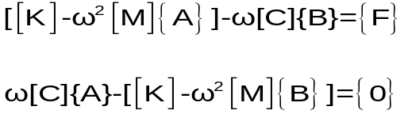 (7)
Equation 7 can be written in the form as shown in equation
[A]{X} = {F} (8)
Where [A] =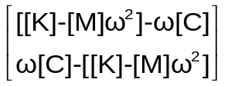 and
{X} =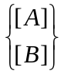 and {F} =
This equation 8 is a matrix equation of order 2n, where n is degree of freedom of the system [A] and[B]. The amplitude is given as
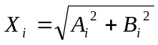 (9)

6. FREQUENCY RESPONSE OF DIFFERENT BODY SEGMENTS DUE TO CONSTANT FORCE (100N) AT M14 / M15 and M6/M7
The relative amplitudes for the different segments of the system masses for a constant force of 100N acting on mass M14/M15 and M6/M7 have been evaluated from equation(8-9). The excitation frequency is varied from 0 Hz to 40Hz. Frequency response curves are plotted for different body segments with amplitudes against excitation frequencies. The Response curves were given in Fig.5 respectively. The results were compared with Garg and Ross [4] response plots obtained by conducting experiments on young males of 20-25 ages.

Fig 5. Frequency response of different body segments for 100N force on foot(M14/M15)
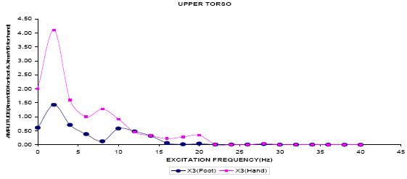
and hand (M6/M7)
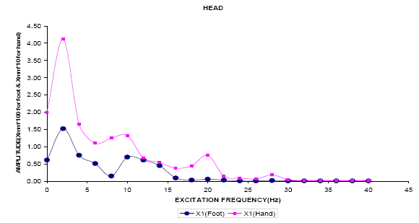

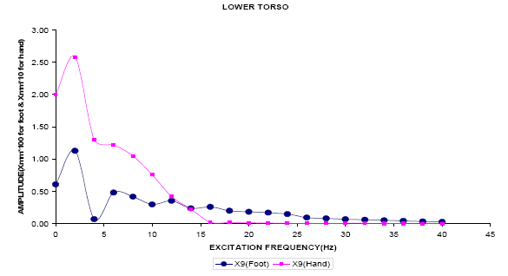
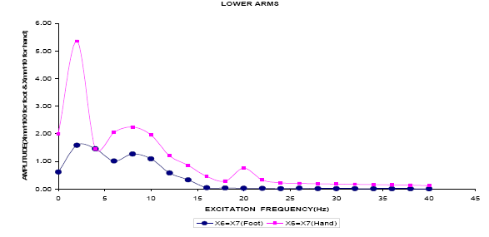

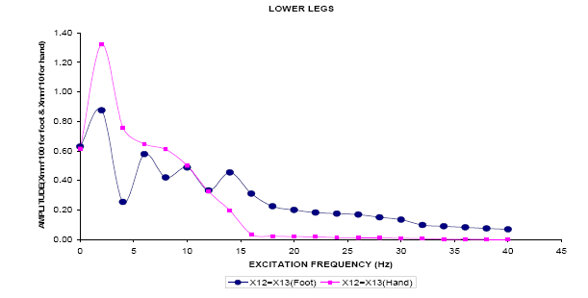

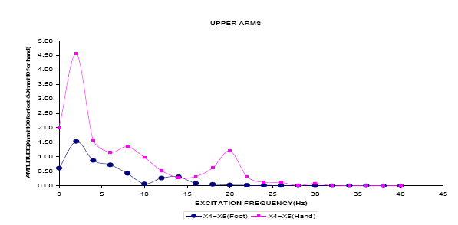
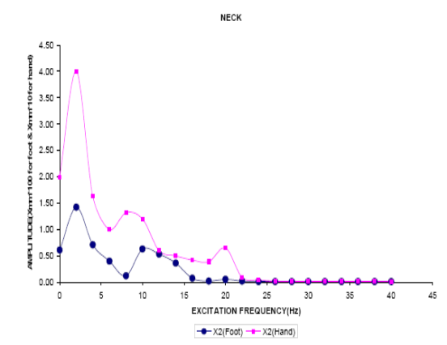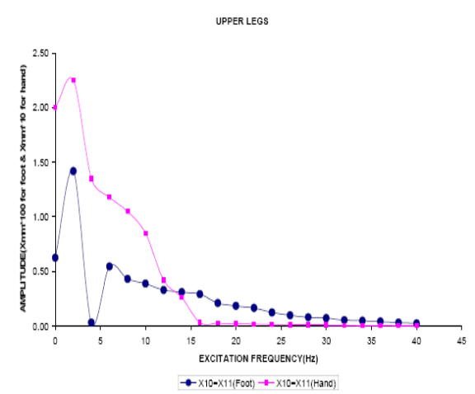

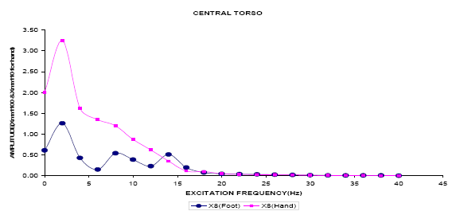
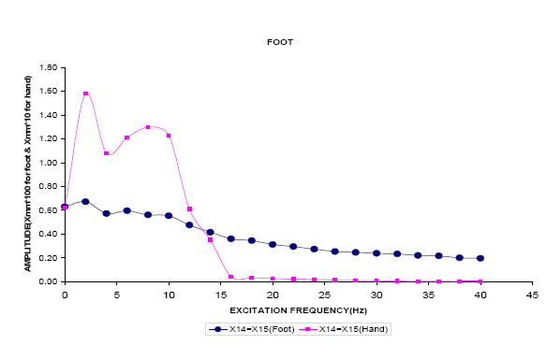
7. DISCUSSION
For analyzing the vibration characteristics of a machine and structures, one of the important steps is to model the system by schematic arrangement of masses, elastic elements and damping elements. Similar to the vibratory modeling of any machine or structure the vibratory model of human body has to be initially framed as a basic spring-mass system. Further development in the vibratory model of human body was made by incorporating necessary damping values of viscous fluids of human body.

In the present analysis an initial effort is made to evaluate the damping coefficients of the individual segments by considering the viscosity of blood and synovial fluid (plasma) and damping values have been obtained to analyze the model frequency response.

8. CONCLUSION
The objective of the present paper was to develop a generalized approach towards human body vibratory modeling including damping considerations. The problem was then to introduce damping in the basic spring mass model. This has been done first by calculating the damping coefficients of the various segments of the anthropomorphic model and using the anthropomorphic data, clearance values and viscosity of blood. The damping ratios of the segments are obtained through their mass, stiffness and damping coefficient. The human body segments are more prone to low frequency excitations only slow peaks in frequency response. At high frequency the response gradually decreases and beyond certain frequency, it is practically negligible.
REFERENCES
- The measurement of Vibration Characteristics of mining equipments and impact percussive machines and tools, Final Project Report. Project No. GEN 503, Research Agency : Laboratory for Advanced Engineering, University of Pretoria., Jan.1999.
- Literature Review by CIRCIS ( Collaboration in Research and Development of New Curriculum in Sound And Vibartion) Eu Asia-Link ASIE/2005/111000.
- Muksian R., Nash C.D., On Frequency –Dependenat Dam[ping Coefficients in Lumped-Parameter Models of Human Beings”, Journal of Biomechnics, Vol.9,pp.339-342.,1976.
- Garg, P.D., Gianotti, Ross, A.M.,. “Vertical Mode Human Body Vibration Transmissibility”., Journal of IEEE transaction on systems Man and Cybernetics., Vol. SMC-6, No.2, pp.102-112.,1976.
- Fairley, T.E., Griffin, M.J., “The Apparent Mass of the Seated Human Body, Vertical vibration”., Journal of Biomechanics ., Vol.22(2),pp.81-94.,1989.
- Pankoke,B.B., Woelfel,H.P., “Dynamic FE Model of Sitting Man Adjustable to Body Height, Body Mass and Posture Used for calculating Internal Forces in the Lumbar Vertical Disks”., Journal of Sound Vibartion.,215(4),pp.827-839,1998.
- Matsumoto,Y., Griffin,M.J., “Mathematical Models for the Apparent Masses of Standing Subjects Exposed to Vertical Whole-Body Vibration., Journal of Sound Vibration.,260,pp.431-451.,
- Bartz, J.A., Gianotti.,C.R., “Computer Program To Generate Dimensional And Inertial Properties Of Human Body”., ASME Journal of Engineering For Industry., Vol.97.,pp.49-47, 1974.
- Nigam, S.P., Malik, M., “A Study On A Vibratory Model Of A Human Body’., Journal Of Biomechanical Engineering, ASME Transactions., Vol. 109., (2)., pp.148-153, 1987.
- Gupta,T.C., “Identification and Experimental Validation of damping ratios of Different Human body Segments Through Anthropometric Vibratory Model in Standing Posture”., Journal of Biomechanical Engineering.,Vol.129.,pp566-574.,2007.

