**ANSWER – 1**

using System;

using System.Collections.Generic;

using System.Linq;

using System.Text;

using System.Threading.Tasks;

namespace ConsoleApp1

{

internal class Program

{

static void Main(string[] args)

{

for (int i = 1; i <= 6; ++i)

{

for (int j = 1; j <= i; ++j)

{

Console.Write("*");

}

Console.WriteLine();

}

}

}

}

**OUTPUT:**

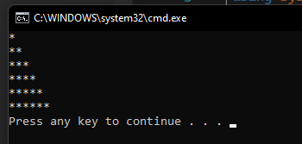

**ANSWER – 2**

using System;

using System.Collections.Generic;

using System.Linq;

using System.Text;

using System.Threading.Tasks;

namespace ConsoleApp1

{

internal class Program

{

static void Main(string[] args)

{

int i, j, n;

n = 5;

for (i = 0; i <= n; i++)

{

for (j = 1; j <= n - i; j++)

Console.Write(" ");

for (j = 1; j <= i; j++)

Console.Write("{0}", j);

for (j = i - 1; j >= 1; j--)

Console.Write("{0}", j);

Console.Write("\n");

}

}

}

}

**Output:**

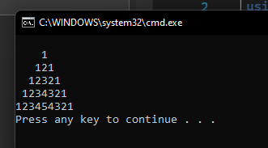

**ANSWER – 3**

using System;

using System.Collections.Generic;

using System.Linq;

using System.Text;

using System.Threading.Tasks;

namespace ConsoleApp1

{

internal class Program

{

static void Main(string[] args)

{

int i, j, r;

r =5;

for (i = 1; i <= r; i++)

{

for (j = 1; j <= i; j++)

Console.Write("{0}", i);

Console.Write("\n");

}

}

}

}

**OUTPUT:**

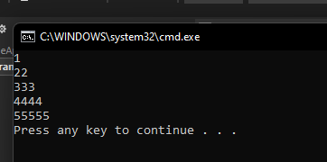

**ANSWER – 4**

using System;

using System.Collections.Generic;

using System.Linq;

using System.Text;

using System.Threading.Tasks;

namespace ConsoleApp1

{

internal class Program

{

static void Main(string[] args)

{

int n = 5;

Console.WriteLine();

for (int i = 1; i < n; i++)

{

for (int j = 1; j <= i; j++)

Console.Write(j.ToString());

Console.WriteLine();

}

for (int i = n; i >= 0; i--)

{

for (int j = 1; j <= i; j++)

Console.Write(j.ToString());

Console.WriteLine();

}

Console.WriteLine();

}

}

}

**OUTPUT:**

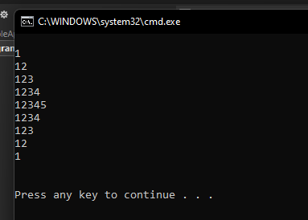

**ANSWER – 5**

using System;

using System.Collections.Generic;

using System.Linq;

using System.Text;

using System.Threading.Tasks;

namespace ConsoleApp1

{

internal class Program

{

static void Main(string[] args)

{

int n = 5;

Console.WriteLine();

for (int i = n; i >= 0; i--)

{

for (int j = 1; j <= i; j++)

Console.Write(j.ToString());

Console.WriteLine();

}

for (int i = 1; i <= n; i++)

{

for (int j = 1; j <= i; j++)

Console.Write(j.ToString());

Console.WriteLine();

}

Console.WriteLine();

}

}

}

OUTPUT:

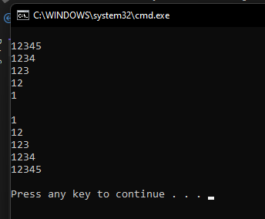

**ANSWER – 6**

using System;

using System.Collections.Generic;

using System.Linq;

using System.Text;

using System.Threading.Tasks;

namespace ConsoleApp1

{

internal class Program

{

static void Main(string[] args)

{

int i, j, n, p, q;

n = 5;

for (i = 1; i <= n; i++)

{

if (i % 2 == 0)

{ p = 1; q = 0; }

else

{ p = 0; q = 1; }

for (j = 1; j <= i; j++)

if (j % 2 == 0)

Console.Write("{0}", p);

else

Console.Write("{0}", q);

Console.Write("\n");

}

}

}

}

**OUTPUT:**

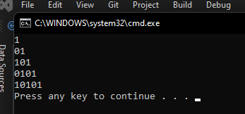

**ANSWER – 7**

using System;

using System.Collections.Generic;

using System.Linq;

using System.Text;

using System.Threading.Tasks;

namespace ConsoleApp1

{

internal class Program

{

static void Main(string[] args)

{

int i, j, rows, k = 1;

rows =4;

for (i = 1; i <= rows; i++)

{

for (j = 1; j <= i; j++)

Console.Write("{0} ", k++);

Console.Write("\n");

}

}

}

}

**OUTPUT:**

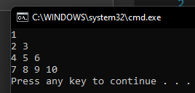

**ANSWER-8**

using System;

using System.Collections.Generic;

using System.Linq;

using System.Text;

using System.Threading.Tasks;

namespace ConsoleApp1

{

internal class Program

{

static void Main(string[] args)

{

{

int i = 5;

while (i >= 1)

{

int j = 5;

while (j >= i)

{

Console.Write(j);

j--;

}

i--;

Console.WriteLine();

}

Console.Read();

}

}

}

}

**OUTPUT:**

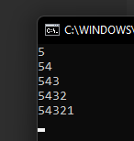

**ANSWER – 9**

using System;

using System.Collections.Generic;

using System.Linq;

using System.Text;

using System.Threading.Tasks;

namespace ConsoleApp1

{

internal class Program

{

static void Main(string[] args)

{

int i, j, k;

for (i = 1; i <= 7; i++)

{

for (j = 1; j <= i; ++j)

Console.Write(j);

for (k = 7 - i; k >= 1; k--)

Console.Write("*");

Console.Write("\n");

}

Console.ReadLine();

}

}

}

**ANSWER – 10**

using System;

using System.Collections.Generic;

using System.Linq;

using System.Text;

using System.Threading.Tasks;

namespace ConsoleApp1

{

internal class Program

{

static void Main(string[] args)

{

int no_row, c = 1, blk, i, j;

no_row = 6;

for (i = 0; i < no_row; i++)

{

for (blk = 1; blk <= no_row - i; blk++)

Console.Write(" ");

for (j = 0; j <= i; j++)

{

if (j == 0 || i == 0)

c = 1;

else

c = c * (i - j + 1) / j;

Console.Write("{0} ", c);

}

Console.Write("\n");

}

}

}

}

**Output:**

