AUDIONIX ENGINEERS LLP
Website Development Proposal

Executive Summary
This document outlines the website development project for Audionix Engineers LLP - an independent consultancy designing professional AV, acoustics, and lighting systems for government, institutional, and corporate spaces across India.

Website Structure
The website consists of the following pages:
• Home: Landing page with hero section, company overview, services preview, portfolio highlights, and contact information.
• About & Founder: Detailed company introduction, founder profile (Vineet Tripathi), and the Audionix Advantage section.
• Services: Comprehensive list of services including AV System Design, Room Acoustics, Lighting Design, Technical Review, and ICT.
• Portfolio: Flagship project highlights and sector-specific experience (Convention Centres, Public Infrastructure, Judiciary, etc.)
• Contact: Contact form, email, phone, location details, and embedded Google Maps.

Color Theme & Design System
The website uses a sophisticated cream and navy blue color palette:
Color Name | Hex Code | Usage
Cream Background | #E8E0D0 | Primary background color
Cream Light | #F5F0E6 | Secondary background, light sections
Navy Dark | #0A1628 | Footer, dark sections
Navy Primary | #1A2B5A | Headers, buttons, primary text
Navy Light | #2A3B6A | Hover states, secondary elements
Gold Accent | #C9A962 | Call-to-action buttons, highlights, decorative elements
Gold Light | #D4B87A | Secondary accents

Typography
• Playfair Display: Headings and titles - elegant serif font
• Montserrat: Body text and navigation - clean sans-serif
• Great Vibes: Decorative script text for taglines

Key Website Features
• Responsive design - works on desktop, tablet, and mobile devices
• Smooth scrolling and fade-in animations for enhanced user experience
• Fixed navigation bar with scroll-aware styling
• Interactive image hover effects with grayscale transitions
• Animated statistics counter on the home page
• Contact form with validation and email notifications
• Embedded Google Maps for location
• SEO-optimized with proper meta tags and semantic HTML
• Fast loading with optimized images

Images Used in the Website
The following images are used throughout the website:
Image File | Used In
audionix_Main_logo-removebg-preview.png | Company Logo (Navigation & Footer)
auditorium_view.jpg | Auditorium View - About Page
Auditorium_view_eagel_eye.jpg | Auditorium Eagle Eye View - About Page
founder_owner_image_vineet.jpg | Founder Photo - Vineet Tripathi
speakers_with_screen.jpg | AV System Design - Services Page
Auditorium.jpg | Room Acoustics - Services Page
a_image_stage_spotlight.jpg | Stage Lighting - Services Page
a_tree_in_hand_with_some_coins_in_side.jpg | Value Engineering - Services Page
rbi_office.jpg | RBI Office - Portfolio (BFSI Sector)
Indira_paryavaran_bhawan.jpg | Indira Paryavaran Bhawan - Portfolio
Bharat_mandapam.jpg | Bharat Mandapam - Convention Centres
aiims_rae_bareli.jpg | AIIMS - Education Sector
Kushabhau_thakre_hall.jpg | Kushabhau Thakre Hall - Places of Worship
Banjara_virsat_museum.jpg | Banjara Museum - Experience Centres
man_doing_work_in_auditorium.jpg | Hero Section Background
speakers_image.jpg | Speakers - Home Page Services
Science_city_convention_centre.jpg | Science City - Experience Centres
Atal_sarovar.jpg | Atal Sarovar - Experience Centres
sbi_office.jpg | SBI Office - BFSI Sector

Sample Images
Company Logo:


Auditorium View:
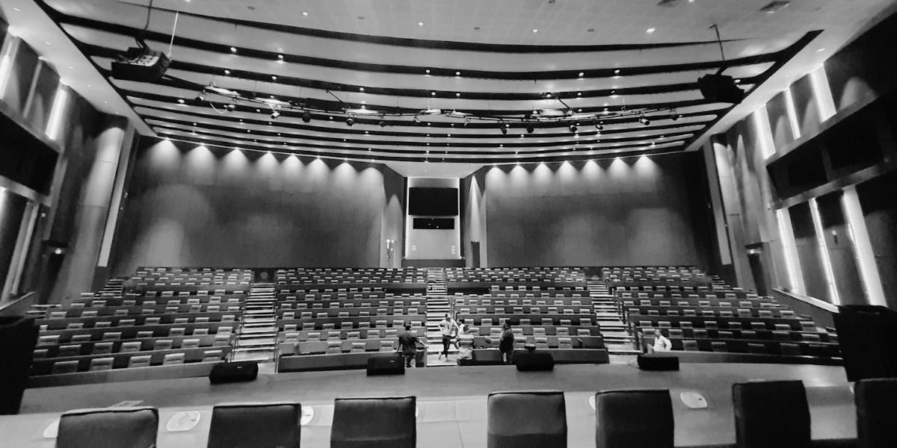

RBI Office Project:
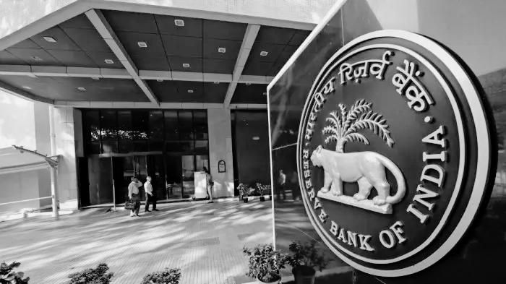

Bharat Mandapam:
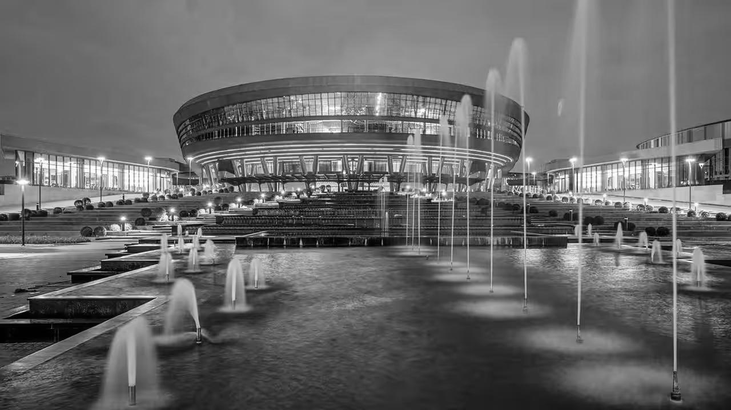

Founder - Vineet Tripathi:


Technology Stack
• Backend: Python Flask
• Frontend: HTML5, CSS3, JavaScript
• Styling: Custom CSS with CSS Variables
• Fonts: Google Fonts (Playfair Display, Montserrat, Great Vibes)
• Icons: Unicode Emoji Icons
• Maps: Google Maps Embed

Contact Information (Displayed on Website)
• Email: INFO@AUDIONIXENGINEERS.COM
• Phone: +91 99997 62624
• Location: New Delhi, India
• Tagline: "Experiences, Amplified."

──────────────────────────────────────────────────
Document prepared for Audionix Engineers LLP
February 2026

