

AUDIONIX ENGINEERS LLP
Experiences, Amplified.

Website Content & Design Overview

February 2026

Color Theme & Design
The website uses an elegant Cream & Navy Blue color palette:
Color | Hex Code | Usage
Primary Background | #E8E0D0 | Warm cream - main background
Navy Primary | #1A2B5A | Deep navy - headers, buttons
Navy Dark | #0A1628 | Darker navy - footer
Gold Accent | #C9A962 | Gold - highlights, decorations
Cream Light | #F5F0E6 | Light cream - cards

Typography
• Playfair Display - Headings and titles
• Montserrat - Body text and navigation
• Great Vibes - Decorative script taglines

HOME PAGE

Hero Section
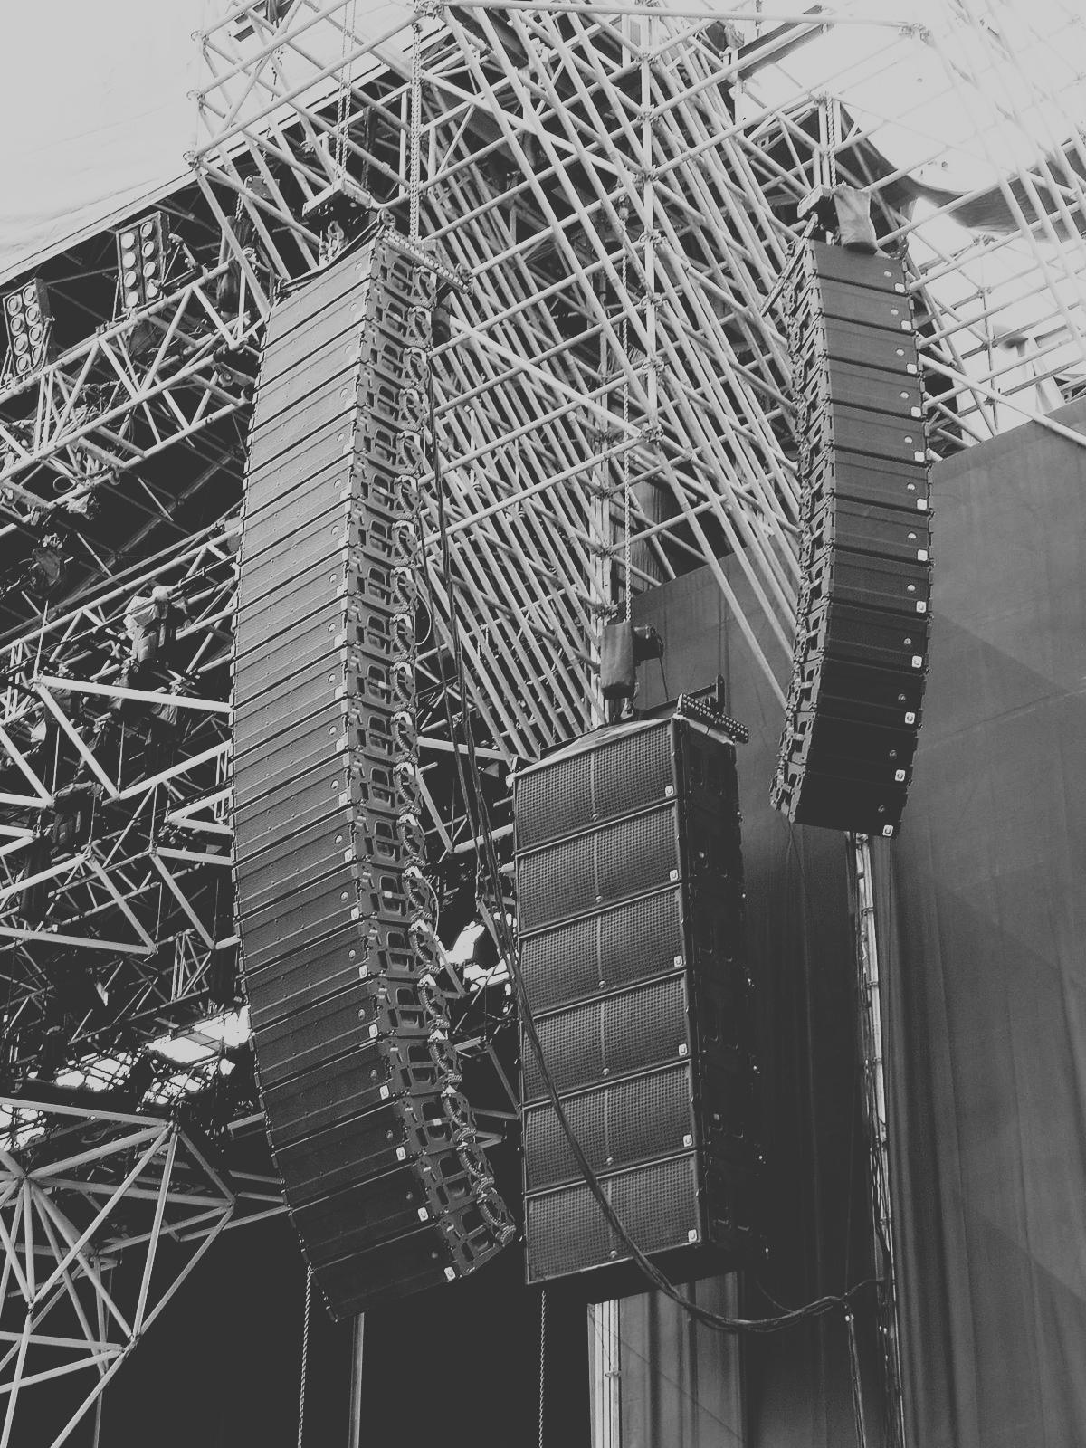

Welcome Message: "Welcome to Audionix Engineering LLP"
Tagline: "Experiences, Amplified."

Key Statistics:
• 10+ Years Experience
• 150+ Projects Completed
• 30+ Cities Served

Who We Are Section
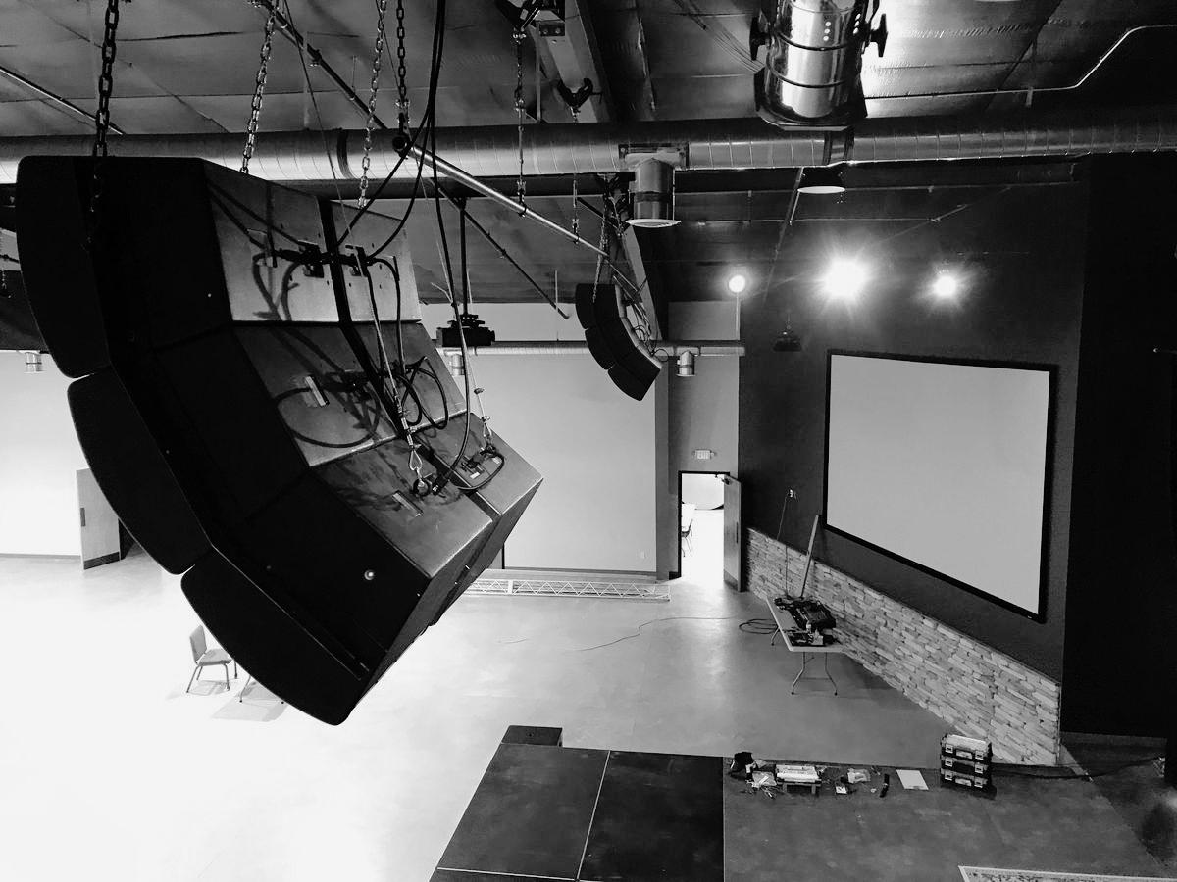

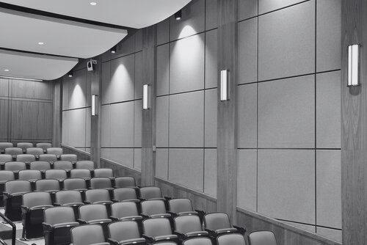

AUDIONIX ENGINEERS LLP is an independent consultancy that designs professional AV, acoustics and lighting systems for government, institutional and corporate spaces across India. With deep on-ground experience and a clear, vendor-neutral approach, we bridge the gap between client expectations, real-world site challenges and rapidly evolving technology.
The Result? Solutions that are reliable, scalable and effortless to operate.

About Founder Section


Vineet Tripathi - Founder
With over 10+ years of experience in India's professional AV industry, Vineet Tripathi brings deep technical expertise and hands-on experience from working with global leaders like Bose Professional and Harman International.
His career spans complex, large-format projects across government, institutional and corporate environments, giving him a clear understanding of real-site challenges, tendering processes and performance expectations.

SERVICES PAGE
Page Tagline: "Where sound, sight and sense come together."

1. AV System Design & Consulting
End-to-end design for auditoriums, lecture halls, boardrooms, convention centres and public spaces. From requirement mapping and schematics to BoQs, drawings and tender-ready documents.

2. Room Acoustics
End-to-end acoustic planning including analysis, material selection and layout optimisation to deliver crisp speech clarity, balanced sound and an environment tailored to its purpose.

3. Architectural & Stage Lighting Design

Thoughtfully crafted lighting solutions that elevate both function and ambience. Ideal for auditoriums, multipurpose halls and performance spaces, with a focus on comfort, visibility and energy efficiency.

4. Technical Review & Value Engineering
Independent audits of OEM or contractor proposals to ensure accuracy, fairness and performance. We identify gaps, remove unnecessary costs and strengthen the overall system design.

5. Information & Communication Technology
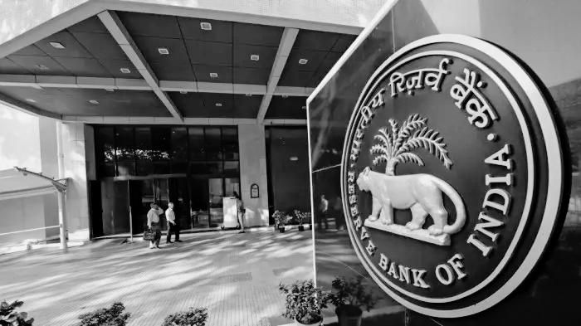
Planning and design of IT and networking infrastructure for new and existing buildings, ensuring seamless connectivity, efficient communication and future-ready systems.

PORTFOLIO PAGE
Title: The Leadership Portfolio
Subtitle: "Led With Precision"
From high-stakes courtrooms and national institutions to smart cities and sacred spaces, Vineet Tripathi's portfolio spans some of India's most demanding environments.

Flagship Projects

RBI (Reserve Bank of India)
Pan-India Boardroom Modernisation
Scale: 150+ Boardrooms across 30+ Cities
One of the biggest AMX deployments nationwide.

Prayagraj Smart City

[Image: Indira_paryavaran_bhawan.jpg]
Kumbh Mela 2025 Infrastructure
Scale: 700+ Speakers, 200+ Amplifiers, 200+ Intersections

Sector Experience
• Convention Centres: ITPO Delhi, Minto Hall Bhopal, ICAR Convention Centre
• Public Infrastructure: National War Memorial, National Police Memorial, Vigyan Bhawan
• Judiciary: Supreme Court Extension, District Court Goa
• Places of Worship: Ganga Ghats Varanasi, Kedarnath Temple, Kashi Vishwanath Corridor
• BFSI: RBI, SBI
• Experience Centres: Banjara Museum, Science City Ahmedabad, Atal Sarovar
• Education: IIT Bhilai, Jodhpur, Roorkee | AIIMS Jodhpur | IIM Jammu

ABOUT & FOUNDER PAGE
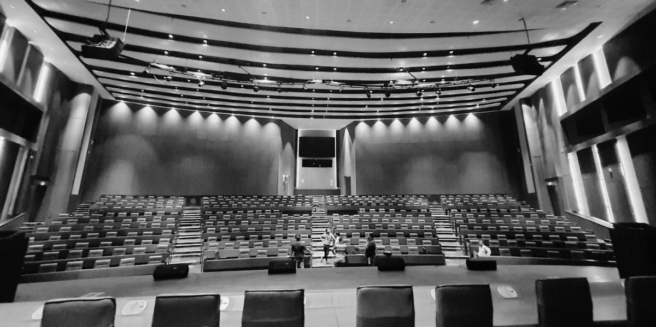

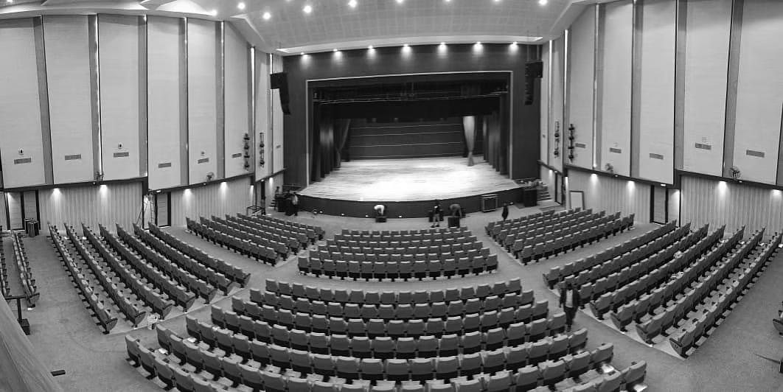

The Audionix Advantage
✓ Seamless Collaboration: We work smoothly with architects, PMCs, MEP, IT, and contractors.
✓ End-to-End Ownership: From requirement analysis to BoQs, drawings, tuning, and site reviews.
✓ Needs-First Thinking: We begin with your functional, architectural, and operational requirements.
✓ Product-Agnostic Expertise: Across major OEMs, we pick what fits best.

CONTACT PAGE
Tagline: "Let's engineer something exceptional together."

Contact Details
📧 Email: INFO@AUDIONIXENGINEERS.COM
📞 Phone: +91 99997 62624
📍 Location: New Delhi, India
🌐 Serving clients pan-India

Contact Form
Fields: Name, Email, Subject, Message
Includes embedded Google Maps for location.

Summary
Total Pages | 5 - Home, About, Services, Portfolio, Contact
Design Style | Professional cream & navy theme
Target Clients | Government, Institutional, Corporate
Key Features | Responsive, animations, contact form
Technology | Python Flask, HTML5, CSS3, JavaScript
Contact | info@audionixengineers.com | +91 99997 62624

AUDIONIX ENGINEERS LLP | Experiences, Amplified.

