The character classification is done for upper case and lower case alphabets using Hebbs’ Net and Perceptron

Input is the in file CharacterSet.xlsx. Some examples are show below.

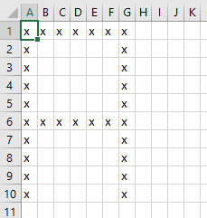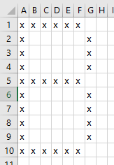

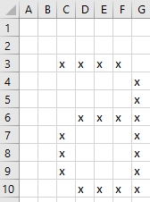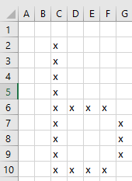

Convert the data to bipolar data and set the targets before training the model.

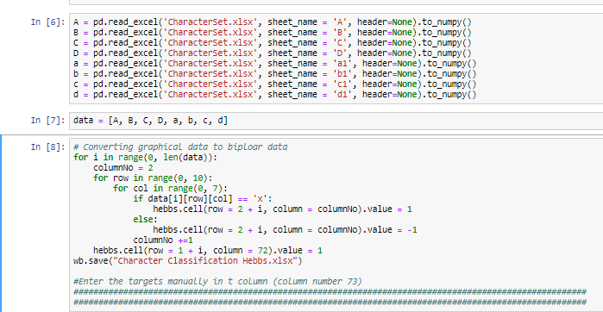

The input dataframe becomes

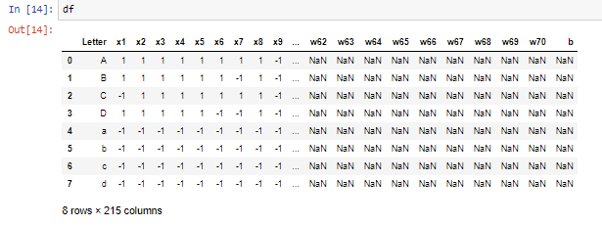

Then calculate the weights

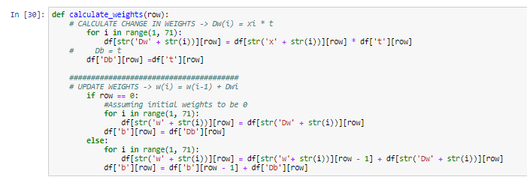

Testing the network

Test Cases

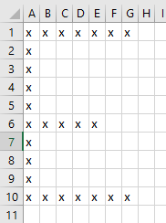 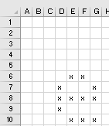

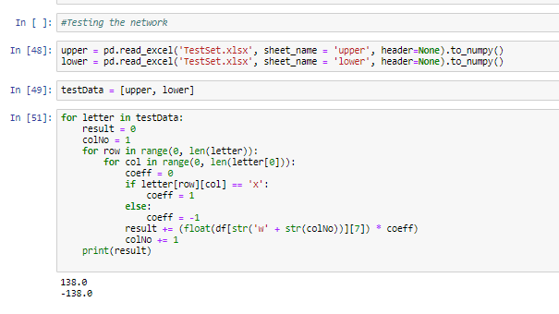

Output is 138 for E and -138 for e. Hence, classified.

Using Perceptron

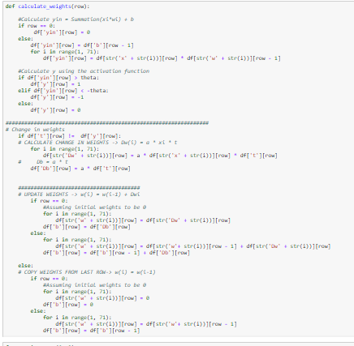

Testing the network for same test cases

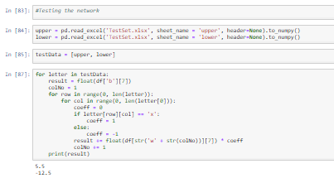

Output is 5.5. for E and -12.5 for e. Hence, classified.