PROJECT REPORT
BANKING LOAN APPROVAL PREDICTION SYSTEM
Machine Learning Based Loan Approval Analysis

Submitted by
Shivam Kumar
B.Tech – Electrical & Computer Engineering
Kurukshetra University
Academic Session 2026–27

ABSTRACT
This project develops a machine-learning based system for analysing banking loan applications and predicting whether a loan is approved. The supplied dataset contains 1000 applicant records and 20 variables covering income, credit score, existing loans, debt-to-income ratio, savings, collateral, loan amount, loan term and applicant characteristics. The notebook applies missing-value imputation, categorical encoding, feature scaling and supervised classification. Logistic Regression, K-Nearest Neighbors (KNN) and Gaussian Naive Bayes are trained and evaluated using accuracy, precision, recall and F1 score. The report also presents relationships between important variables and loan approval, supported by graphs and a correlation heatmap.

TABLE OF CONTENTS
1. Introduction
2. Problem Statement
3. Objectives
4. Dataset Description
5. System Methodology
6. Data Preprocessing
7. Exploratory Data Analysis
8. Variable Relationships and Correlation
9. Model Development
10. Model Evaluation
11. Results and Discussion
12. Limitations
13. Future Scope
14. Conclusion
15. References

1. INTRODUCTION
Loan approval is a classification problem in which an applicant is evaluated using financial and demographic information. In this project, machine learning is used to learn patterns from historical application records and predict the Loan_Approved outcome. The objective is to demonstrate an end-to-end data science workflow rather than replace human or institutional credit decision processes.

2. PROBLEM STATEMENT
The project addresses the problem of predicting whether a loan application will be approved using applicant-level financial, credit, employment and loan information. The target variable is Loan_Approved with two outcomes: Yes and No.

3. OBJECTIVES
- Load and inspect the banking loan dataset.
- Handle missing numerical and categorical values.
- Explore the distribution of loan approval and important applicant variables.
- Encode categorical variables into machine-learning compatible features.
- Scale numerical features before classification.
- Train Logistic Regression, KNN and Gaussian Naive Bayes models.
- Compare model performance using accuracy, precision, recall and F1 score.
- Study relationships between credit, income, DTI and the loan approval outcome.

4. DATASET DESCRIPTION
The dataset contains 1000 rows and 20 columns. The following variables are used in the project:
Variable | Description
Applicant_ID | Unique applicant identifier
Applicant_Income | Applicant income
Coapplicant_Income | Co-applicant income
Employment_Status | Employment category
Age | Applicant age
Marital_Status | Marital status
Dependents | Number of dependents
Credit_Score | Credit score
Existing_Loans | Number of existing loans
DTI_Ratio | Debt-to-income ratio
Savings | Savings amount
Collateral_Value | Collateral value
Loan_Amount | Requested loan amount
Loan_Term | Loan duration
Loan_Purpose | Purpose of the loan
Property_Area | Property area
Education_Level | Education category
Gender | Applicant gender
Employer_Category | Employer category
Loan_Approved | Target: Yes/No

5. SYSTEM METHODOLOGY
- Data loading and inspection
- Missing-value treatment
- Exploratory Data Analysis (EDA)
- Categorical encoding
- Correlation analysis
- Train-test split (80:20)
- Standard feature scaling
- Model training
- Model evaluation and comparison
The workflow is designed so that raw applicant information is transformed into numerical features suitable for classification algorithms. The target Loan_Approved is separated before model training.

6. DATA PREPROCESSING
The notebook handles missing values using mean imputation for numerical columns and most-frequent-value imputation for categorical columns. Applicant_ID is removed before modelling because it is an identifier rather than a predictive applicant characteristic. Education_Level and Loan_Approved are label encoded, while Employment_Status, Marital_Status, Loan_Purpose, Property_Area, Gender and Employer_Category are one-hot encoded. The resulting numerical features are standardized using StandardScaler.

7. EXPLORATORY DATA ANALYSIS
The exploratory analysis examines loan approval balance, education categories, income distributions and boxplots for Applicant_Income, Credit_Score, DTI_Ratio and Savings. These visualizations help identify distributions, possible outliers and differences between approved and non-approved groups.
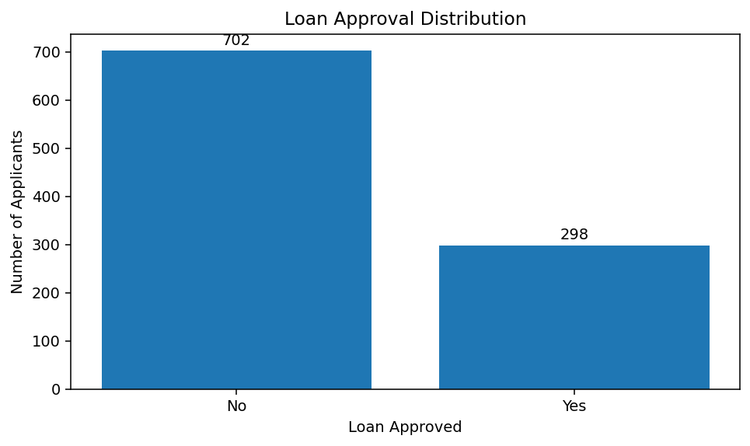
Figure 1. Distribution of loan approval outcomes.
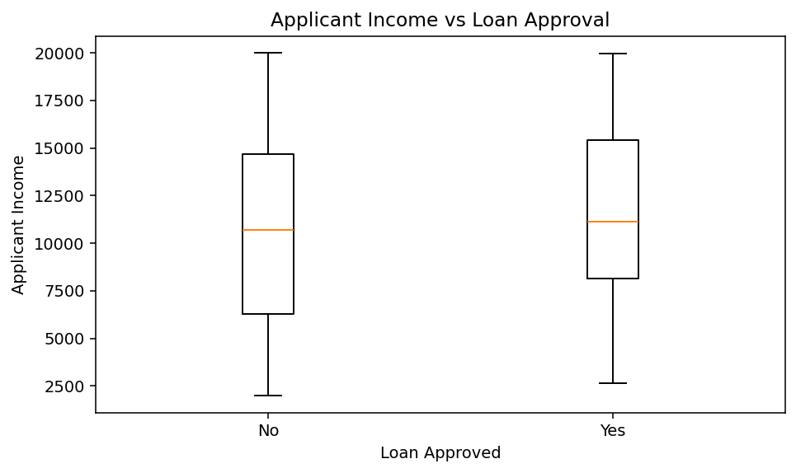
Figure 2. Applicant income distribution by loan approval outcome.
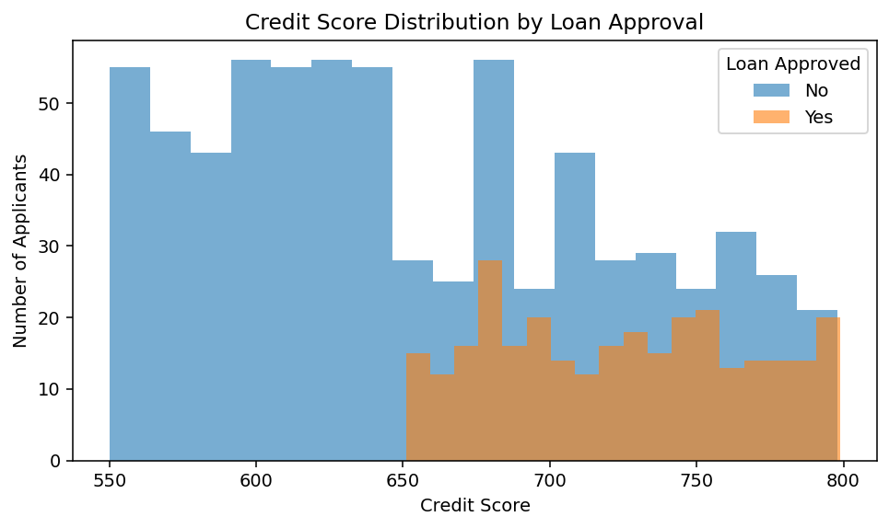
Figure 3. Credit score distribution for approved and non-approved applications.
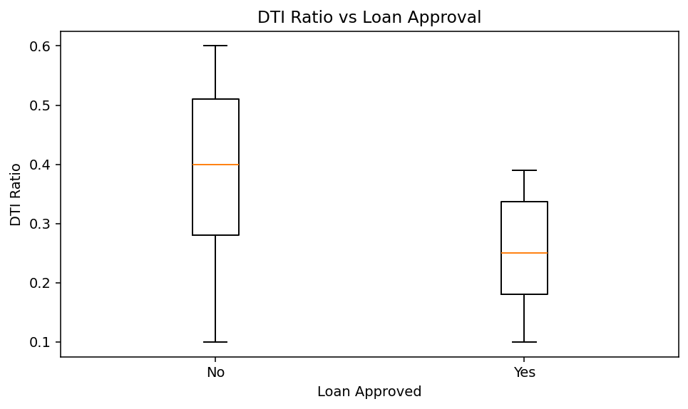
Figure 4. DTI ratio distribution by loan approval outcome.

8. VARIABLE RELATIONSHIPS AND CORRELATION
The relationship analysis focuses on how numerical applicant characteristics are associated with the loan approval target. The correlation analysis in the supplied dataset shows the strongest positive numerical association with Loan_Approved for Credit_Score (approximately 0.45), followed by Applicant_Income (approximately 0.12). Correlation indicates association and should not be interpreted as proof of causation.
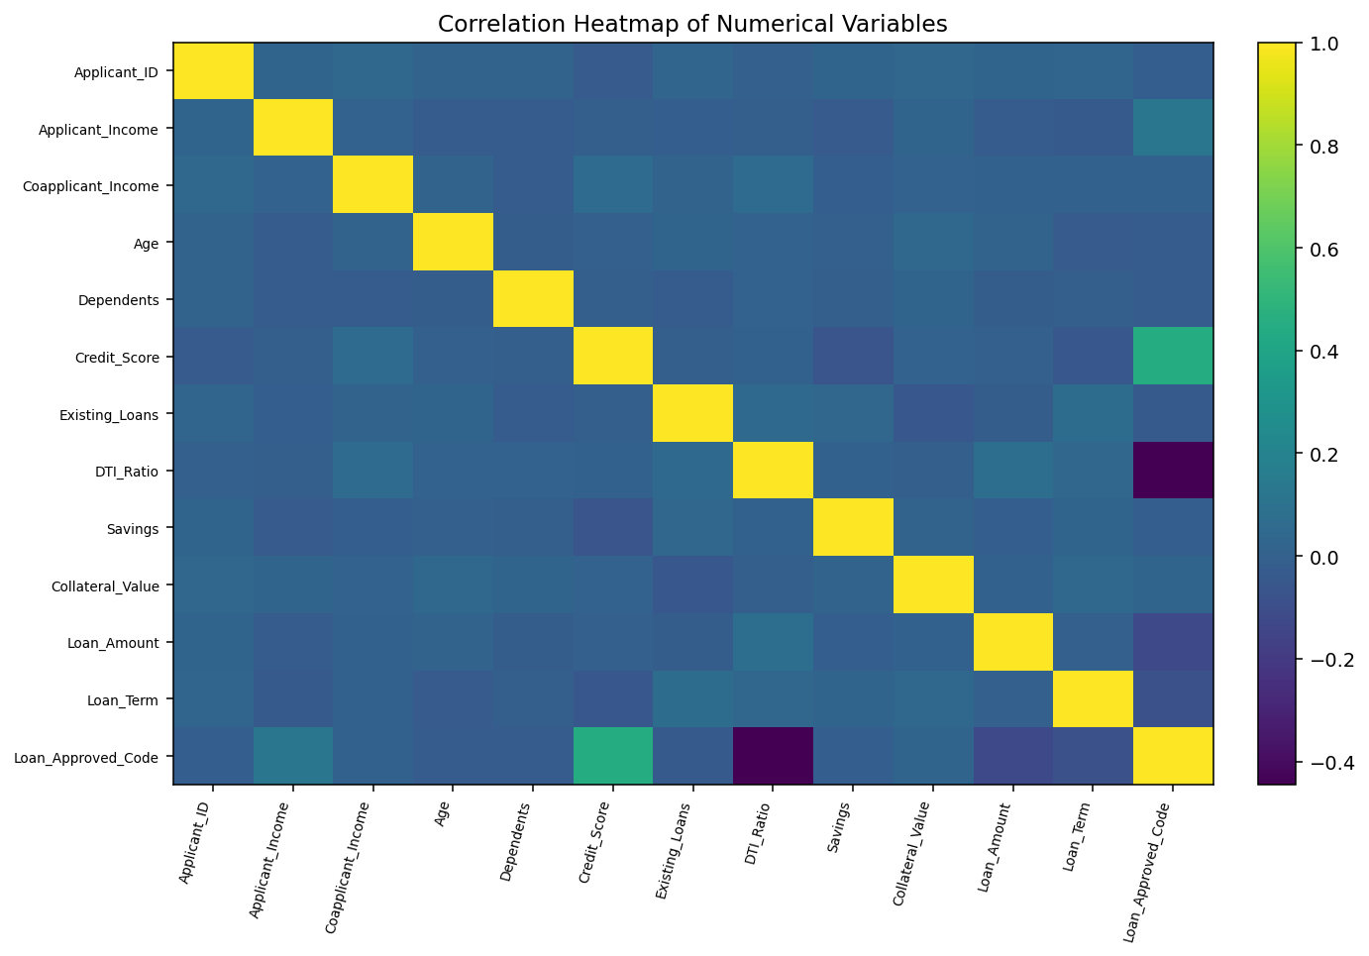
Figure 5. Correlation heatmap of numerical variables.
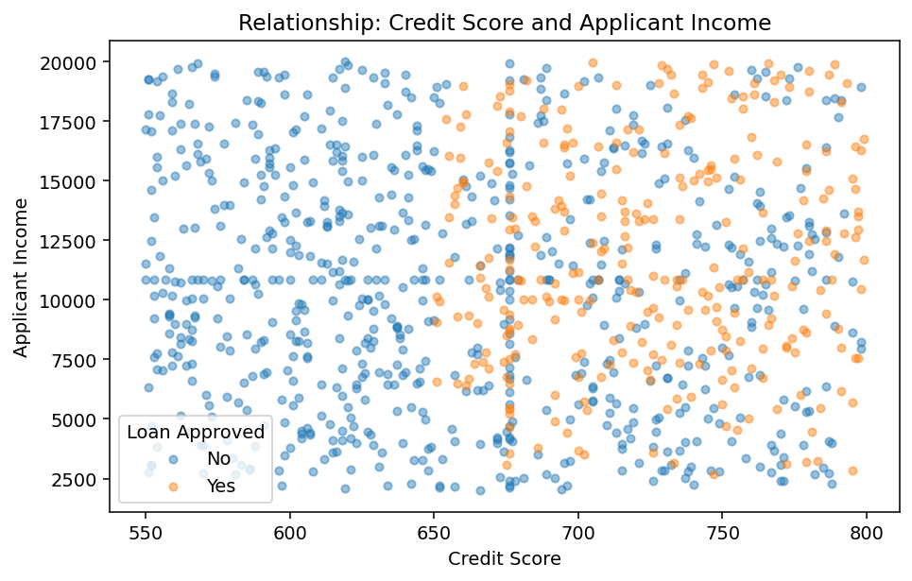
Figure 6. Relationship between credit score, applicant income and approval outcome.

9. MODEL DEVELOPMENT
Three supervised classification models are implemented in the notebook:
Model | Role in Project
Logistic Regression | A linear classification model used as a baseline for binary loan approval prediction.
K-Nearest Neighbors (KNN) | Classifies an application using the labels of nearby observations after feature scaling.
Gaussian Naive Bayes | A probabilistic classifier based on conditional feature distributions.

10. MODEL EVALUATION
The dataset is split into 80% training data and 20% test data using random_state=42. The models are evaluated on the test set using accuracy, precision, recall and F1 score.
Model | Accuracy | Precision | Recall | F1 Score
Logistic Regression | 0.865 | 0.783 | 0.770 | 0.777
KNN | 0.760 | 0.627 | 0.525 | 0.571
Naive Bayes | 0.865 | 0.804 | 0.738 | 0.769

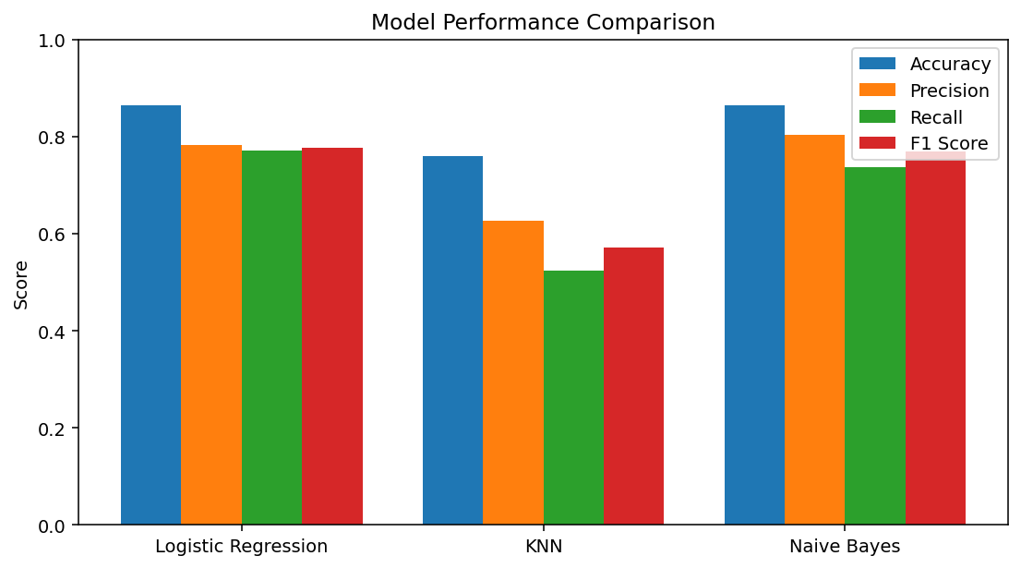
Figure 7. Comparison of classification model performance.

11. RESULTS AND DISCUSSION
On the 20% test split, Logistic Regression achieved an accuracy of 0.865, precision of 0.783, recall of 0.770 and F1 score of 0.777. KNN achieved an accuracy of 0.760, while Gaussian Naive Bayes achieved an accuracy of 0.865. The values are specific to this dataset, preprocessing pipeline and fixed train-test split.
The confusion matrices provide additional information about correct and incorrect classifications. For example, the Logistic Regression model produced the following test-set confusion matrix:
Predicted No | Predicted Yes
126 | 13
14 | 47

Rows correspond to the actual classes: No and Yes, respectively.

12. LIMITATIONS
- The results depend on the supplied dataset and may not generalize to real banking portfolios.
- Missing values are imputed, which may introduce approximation into some records.
- A single 80:20 train-test split is used, so results can vary with a different split.
- The project demonstrates prediction and does not include a production banking decision engine, live credit bureau data or deployment monitoring.
- Correlation values describe association and do not establish causal relationships.

13. FUTURE SCOPE
- Use cross-validation and hyperparameter tuning for more robust evaluation.
- Experiment with tree-based and ensemble models.
- Add explainability methods such as feature importance or SHAP for model interpretation.
- Develop a web interface for entering applicant details and displaying a model prediction.
- Monitor model drift and fairness across applicant groups before any real-world deployment.
- Use larger, validated and institutionally approved datasets for production-level development.

14. CONCLUSION
The Banking Loan Approval Prediction System demonstrates a complete machine-learning workflow from raw loan application data to classification results. The project includes data cleaning, exploratory analysis, categorical encoding, feature scaling, relationship analysis and comparison of three classification models. The added graphs make the relationships between applicant characteristics and loan approval easier to understand, while the performance table provides a concise summary of model behaviour on the test data.

15. REFERENCES
- Project Jupyter Notebook supplied for the Banking Loan Approval project.
- Loan approval dataset supplied with the project.
- scikit-learn documentation for Logistic Regression, KNN, Gaussian Naive Bayes and evaluation metrics.
- pandas documentation for data manipulation and analysis.
- Matplotlib and Seaborn documentation for data visualization.

