* **Title**: Asset tracking using LoRa Technology
* **Problem statement:** Keeping a track of one’s tangible assets and to monitor its real time status..
* **Literature survey:**

***LoRa fills a technology gap***

LoRa Technology has revolutionized IoT by enabling data communication over a long range while using very little power. When connected to a non-cellular LoRaWAN network, LoRa devices accommodate a vast range of IoT applications by transmitting packets with important information. LoRaWAN fills the technology gap of Cellular and Wi-Fi/BLE based networks that require either high bandwidth or high power, or have a limited range or inability to penetrate deep indoor environments. In effect, LoRa Technology is flexible for rural or indoor use cases in smart cities, smart homes and buildings, smart agriculture, smart metering, and smart supply chain and logistics.

***Filling the 5G gap***

While 5G was designed to bring faster speeds and connectivity, LoRa devices and the LoRaWAN protocol serve distinct use cases where devices need to be battery-operated and last in the field extended periods of time. The LoRaWAN protocol has a communication range reaching more than six miles, which is further than 5G’s mmWave variant. While 5G may be optimal for video calls or ultra-low latency applications, LoRaWAN is ideal for water and gas metering, asset tracking and many more applications where low power consumption and long range are required. In addition to LoRa devices’ long range capabilities, it has the power to penetrate physical structures where 5G signals cannot.

***LoRa complements Wi-Fi, Bluetooth and Cellular***

Like Wi-Fi, LoRaWAN operates in the unlicensed band and supports indoor applications; like Cellular, LoRa Technology is highly secure from end devices to the application server, and is suitable for outdoor applications. LoRa devices and the LoRaWAN protocol combine these features of Wi-Fi and Cellular networks to offer an efficient, flexible and economical connectivity solution ideal for IoT applications whether indoor or outdoor and installed in public, private or hybrid networks. Simple sensor data can fuel analytics platforms, such as those for artificial intelligence and machine learning. These require data diversity which is made possible by low-cost LoRa-enabled sensors.

* **Objective:** To develop a low power device using LoRaWAN standard which is open and freely available to communicate for a long range of 2Km to 10Km for Asset tracking.
* **Methodology:** LoRaWAN architecture is based on a star topology. End-devices communicate with gateways. Gateways relay the frames to the network server. Long-radio links are achieved with a proprietary modulation technique called LoraTM, developed by Semtech company and based on the Chirp Spread Spectrum technology. LoRa uses ISM bands and proposes also an adaptive data rate mechanism in order to adapt the transmission characteristics, such as data rate, spreading factor, and bandwidth, to the propagation conditions.

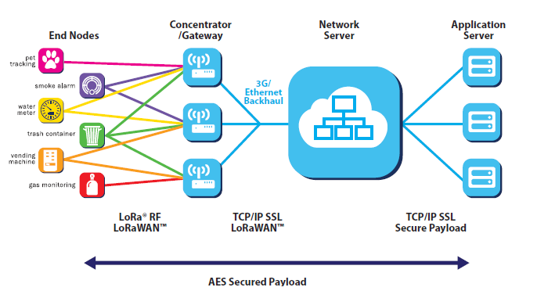

* **Hardware used:**

1. Raspberry pi 4B
2. STM32L552ZE
3. Arduino nano 33 IOT
4. RFM95
5. Antenna
6. Sensors
   * 1. Temperature sensor
     2. GPS module
     3. Humidity sensor

* **Software used:**

1. Raspberry pi imager
2. Arduino IDE
3. STM32 cube IDE