**TOWER OF HANOI**

**INTRODUCTION:**

The user can play Tower of Hanoi game. The program will display the score, number of moves, minimum moves and leader board(Top 3)

**PROBLEM DECOMPOSITION:**

The problem can be solved using following functions

1. transfer()

Transferring the elements from source stack to destination stack using transfer() function

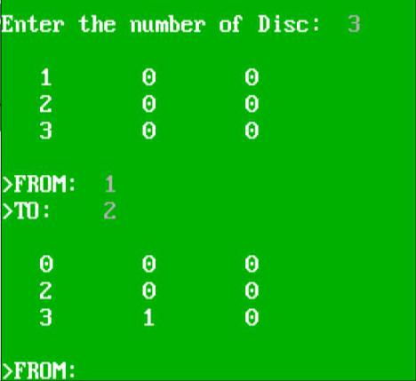

1. convert()

It is very easy to display the three towers using 2D array.

Convert() is used to copy the elements of stack in 2D array tower[lim][3].

1. zerotower()

Since all the operations are performed only on the stack and 2D array only contains the copy of stack it will not delete the previous values of 2D array.

Hence zerotower() is called before convert() to initialize all the elements of tower[i][j] to zero

So that the previous copied values are erased.

If we don’t use zerotower() the output will be as follows

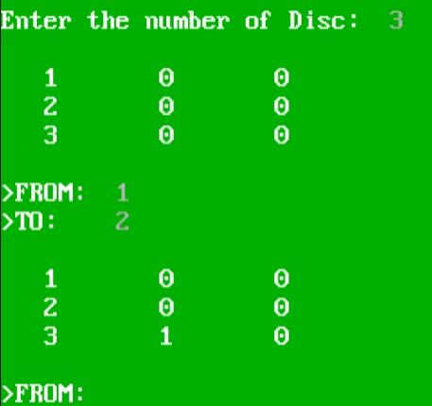

1. initializetower()

This will initialize tower[lim][3] .

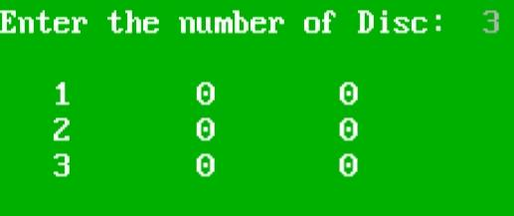

1. initializestack()

This will initialize source stack(stack x) from 1 to lim

1. Display()

This is used to display the 2D array

**IDENTIFYING DATA STRUCTURE:**

The best suited data structure for the game is Stack.

We can use three stacks for three towers and pop the element from one tower and push itto

the other tower.

Since in Tower of Hanoi game only the top disc can move from one tower to another Last in First Out approach is required.

**IMPLEMENTATION: -**

Code Attached

**OUTPUT:**

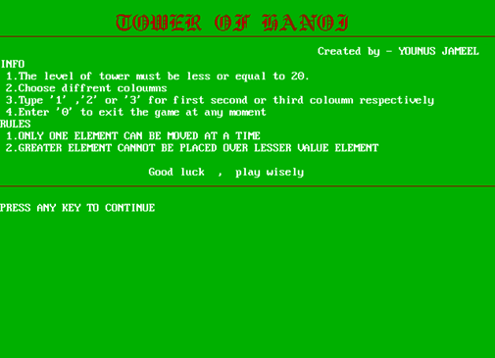

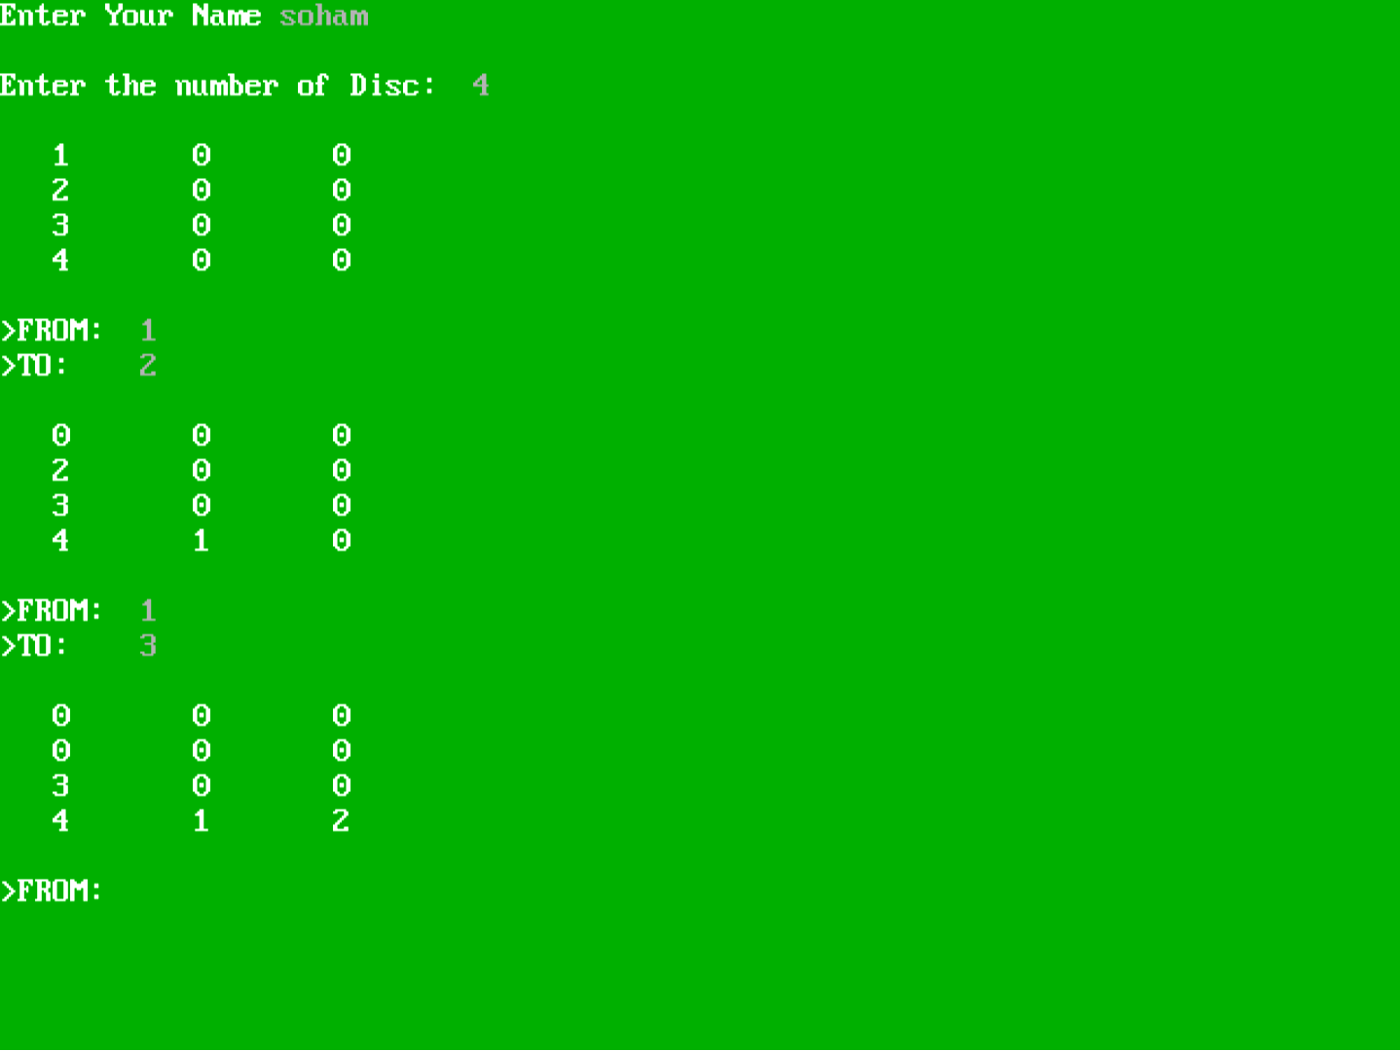

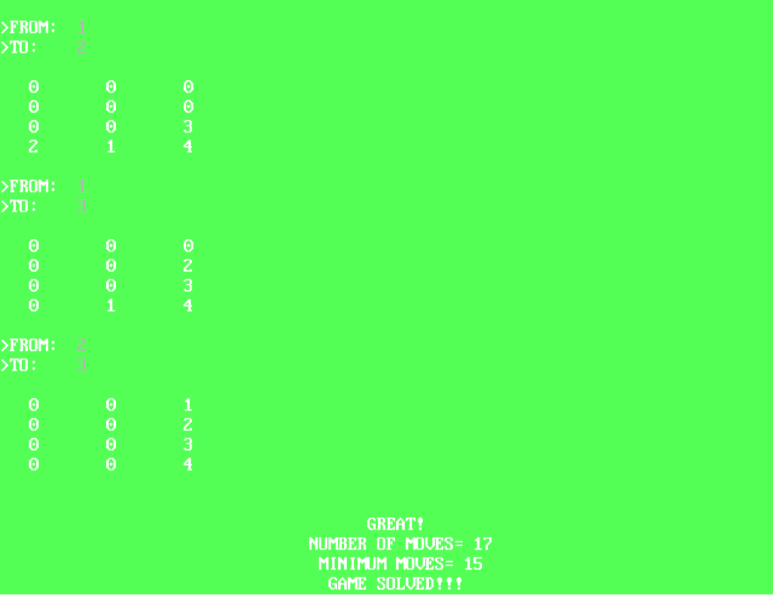

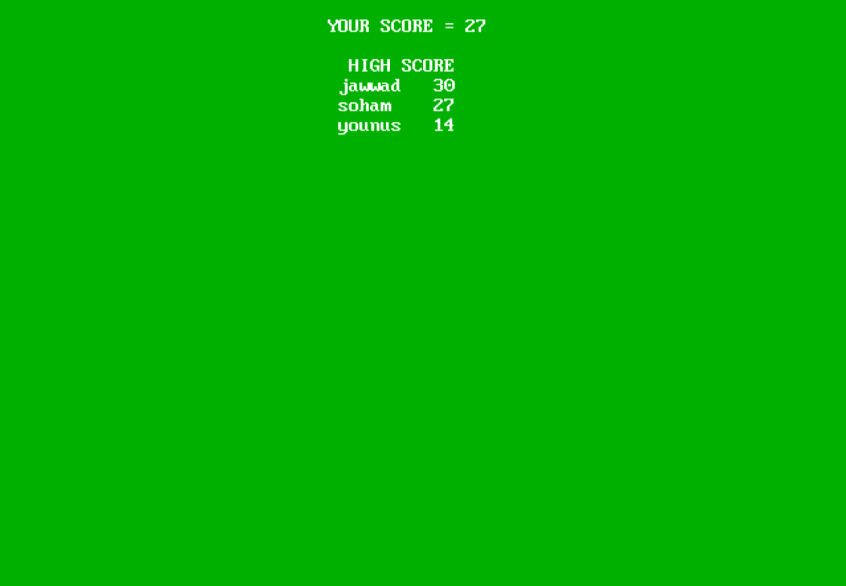

If the user doesn't want to continue the game further he can simply press 0

