Login with Email, password and role selection(Admin, Lead Manager, BA Specialist)

Register with Name, Email, password and Role selection(Admin, Lead Manager, BA Specialist)

This app contains three roles as Admin, Lead Manager and BA Specialist

each role having different functionalities, dashboards and according to that screens also

Role wise implementation and functionality

I will provide you the screenshot of each section

1. Admin
   1. Main admin dashboard for analytic and reports (Overview)

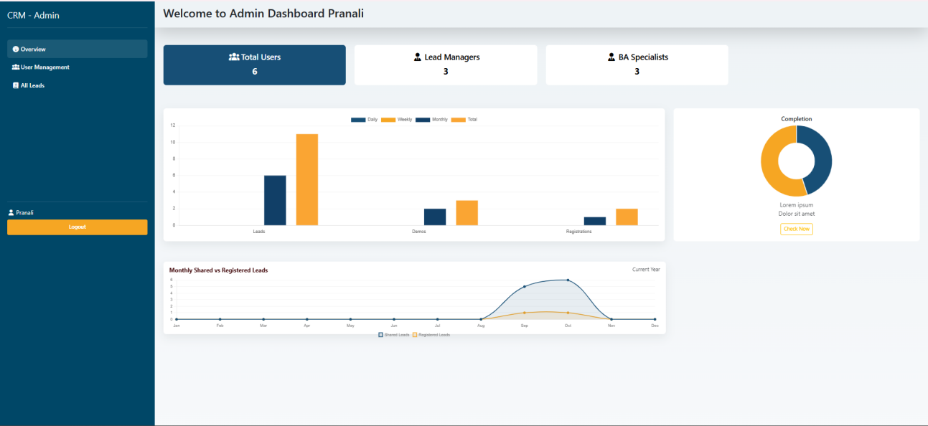

* 1. User management section/screen-- contains the list of All users in table format with action buttons like edit, delete and add button that will opens form to add new user

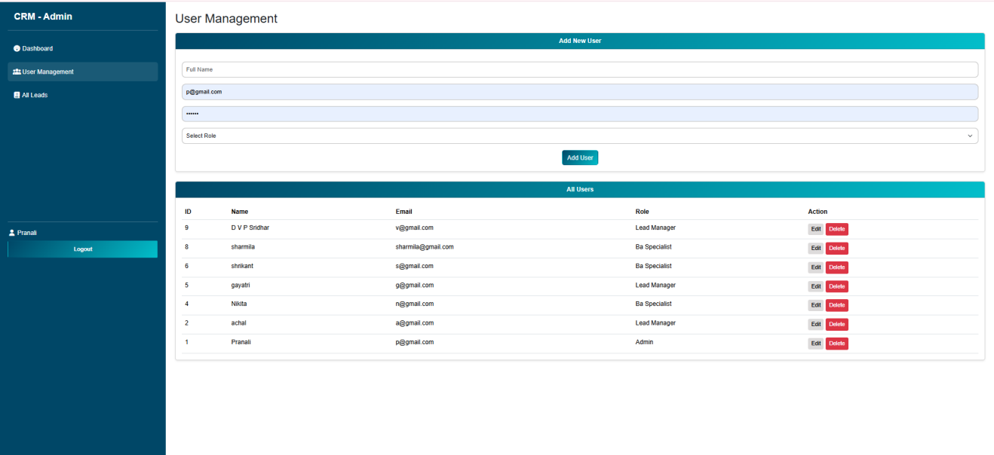

* 1. All Leads screen - list of all leads in table format, advanced options like Search by name or phone or email, filter by status, search by date I.e data selection from calender, filter by feedback  
     Export button that will export the list of leads in csv format  
     file choose that will enable to select the csv file only from mobile storage with Import csv button

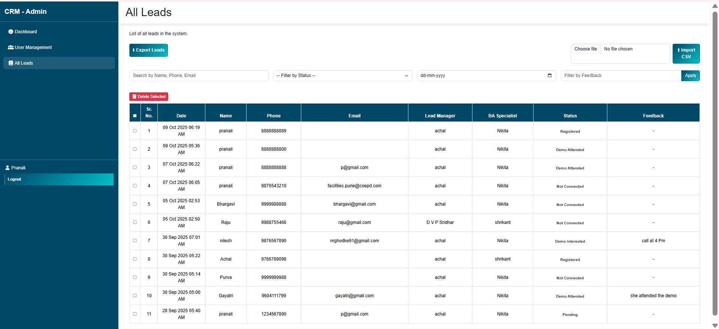

1. Lead Manager
   1. Main lead manager dashboard -- cotains the stats as in below image

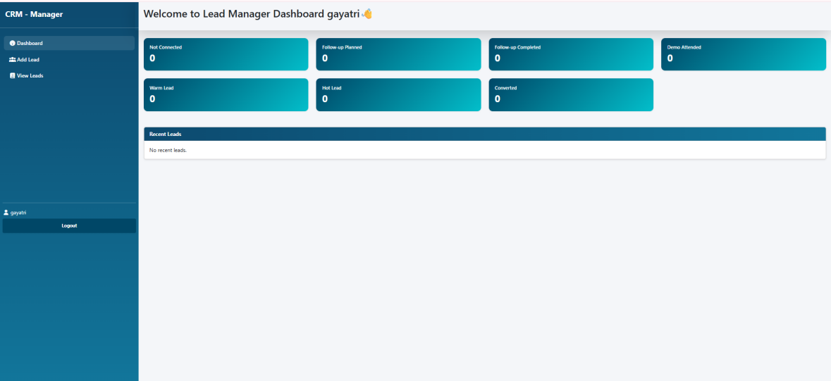

* 1. Add lead section -- opens a form that will ablr to fill the add lead form as below mentioned image that is for fields

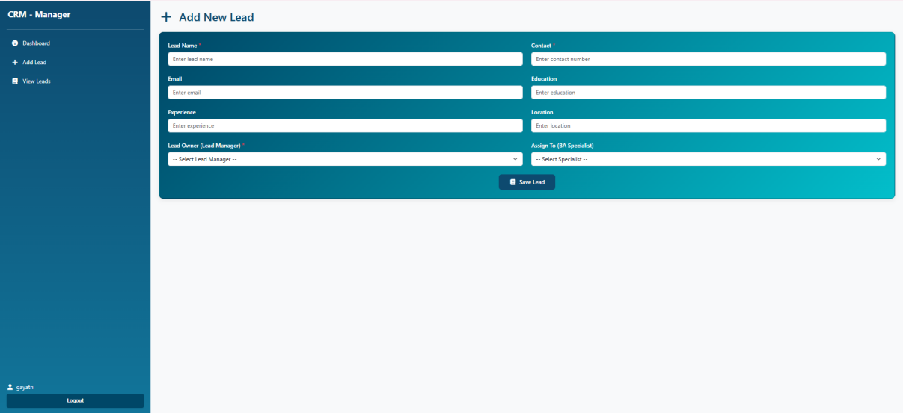

* 1. View leads section/screen -- contains the list of all leads in table format with Filter by Status as below

Each row or data having Action button like View with table header as History and Delete ison with Delete header

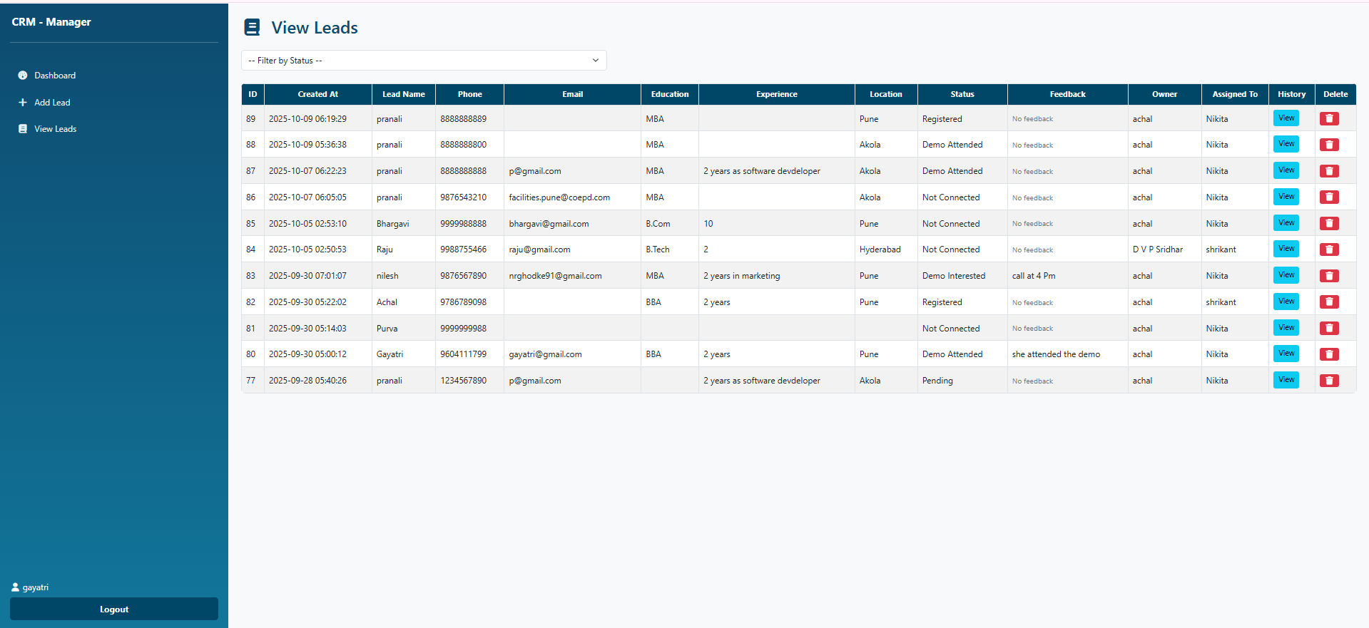

1. BA Specialist
   1. Main dashboard -- contains filter leads section and My leads section
      1. Filter leads having multiple filter options as mentionde in image
      2. My leads section contains the list of leads in table format as like mentioned in image

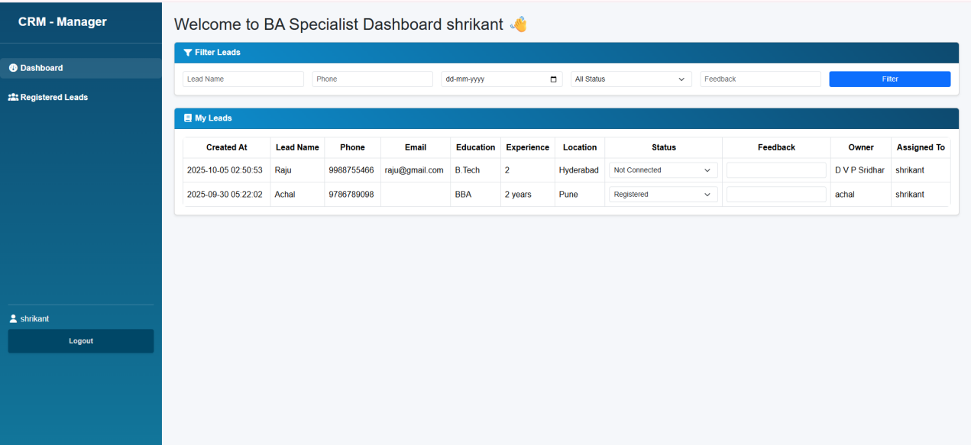

* 1. Registered Leads section -- contains the list of Registered List as like in image

