Report
Of
Java Programming Virtual Internship

Submitted
To
School of Computer Science and Engineering
IILM University, Greater Noida, U.P.
In partial fulfilment of the requirement of degree of
B.Tech CSE



By
Roll Number of Student : 25SCS1003005556
Name of Student: SHIVAM KUMAR
Batch: 2CSE5

2026-27

CANDIDATE'S DECLARATION

I, SHIVAM KUMAR do hereby declare that the internship report titled "Java Programming Virtual Internship" has been completed by me to fulfil the requirement for the award of the degree of Bachelor of Technology in CSE. All the references have been quoted and I have not taken as such any material from any other source. I affirm to you that this report is my own and has not been submitted to any other institute for any degree/diploma requirement and further I shall be solely responsible for any kind of copyright violation in this regard.


SHIVAM KUMAR
25SCS1003005556

ACKNOWLEDGEMENT

I am using this opportunity to express my gratitude to everyone who supported me throughout the Internship Program. I am thankful for their aspiring guidance, invaluably constructive criticism and friendly advice during this work. I am sincerely grateful to them for sharing their truthful and illuminating views on a number of issues related to this work.
I express my gratitude to my parents for their blessings.

SHIVAM KUMAR
25SCS1003005556

INTERNSHIP COMPLETION CERTIFICATE

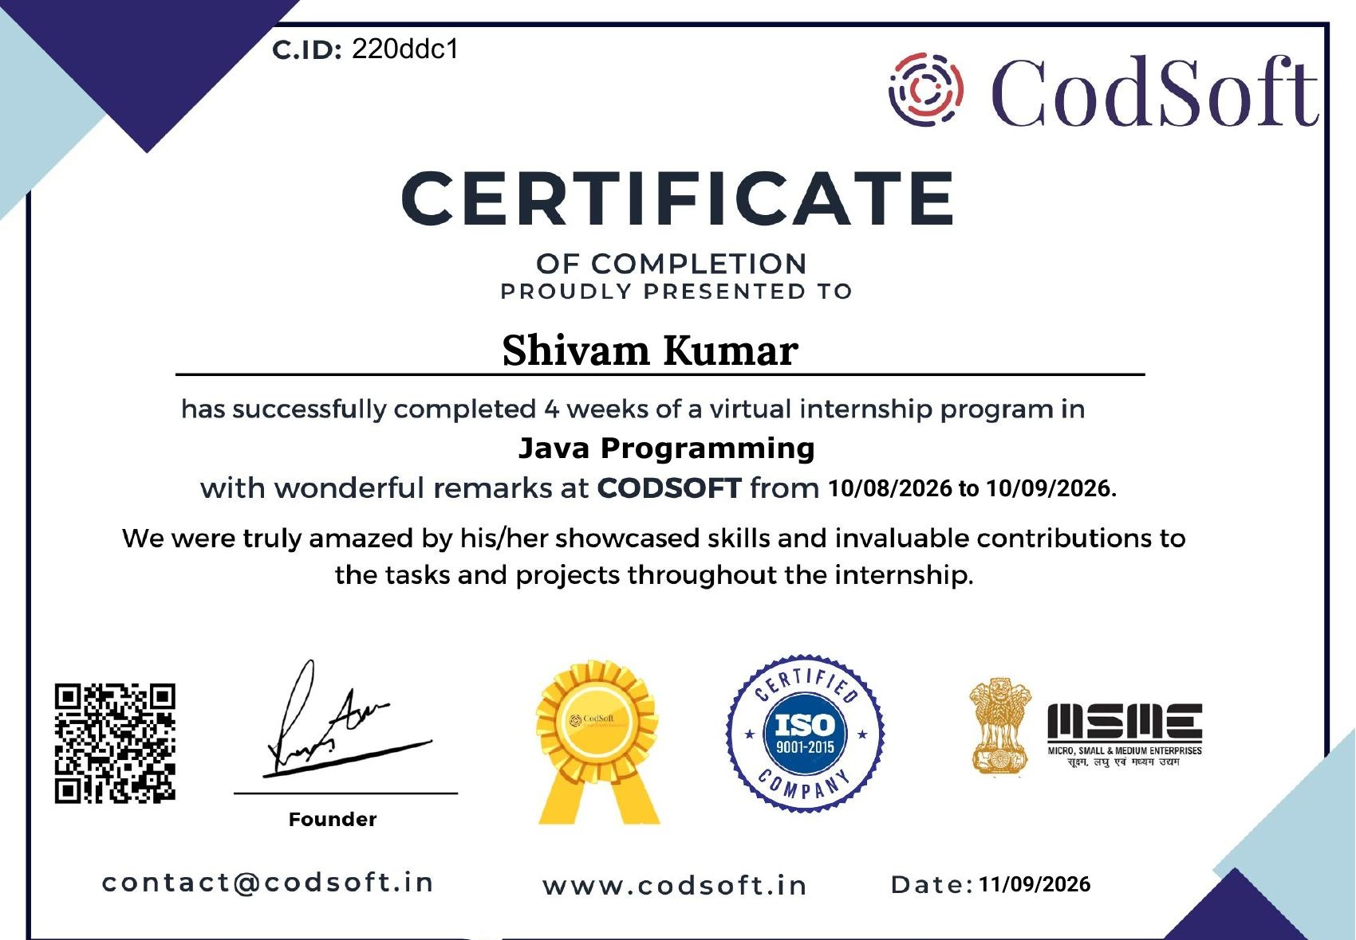

TABLE OF CONTENTS

Chapter No. | Chapter Name | Page Nos.
 | Cover Page | ----
1. | Candidate's Declaration | 2
2. | Acknowledgment | 3
3. | Internship Completion Certificate | 4
4. | Project Description | 6
 | 4.1 Introduction
 | 4.2 Organization Profile
 | 4.3 Problem Statement
 | 4.4 Project Objectives
 | 4.5 Scope of the Project
 | 4.6 Technologies and Tools Used
 | 4.7 System Architecture
 | 4.8 Methodology
 | 4.9 Projects & Tasks Implemented
 | 4.10 Expected Outcomes
5. | Bibliography/References | 10

4. PROJECT DESCRIPTION

4.1 Introduction
This report presents a detailed account of the Java Programming Virtual Internship completed with CodeSoft from 05 August 2026 to 05 September 2026. The internship provided practical exposure to Java programming through three tasks: Number Game, Student Grade Calculator, and ATM Interface, helping develop skills in Java fundamentals, programming logic, problem-solving, Object-Oriented Programming, debugging, and practical application development.

4.2 Organization Profile
CodeSoft is an organization that provides internship opportunities to students for developing practical and industry-oriented skills. It offers virtual internship programs in various technical domains, including Java Programming. The Java Programming internship focuses on hands-on learning through programming tasks and projects, enabling students to apply Java concepts, improve problem-solving abilities, and gain practical experience in software development.

4.3 Problem Statement
The main problem addressed during the internship was to apply Java programming concepts in practical situations rather than limiting learning to theoretical knowledge. The tasks required developing programs with proper logic, user input, conditional statements, loops, and data processing, while also testing and debugging the programs to produce the expected results.

4.4 Project Objectives
The main objective of the internship was to develop practical Java programming skills by understanding Java fundamentals, improving logical problem-solving abilities, applying Object-Oriented Programming concepts, developing functional programs, and gaining experience in coding, testing, and debugging through hands-on tasks.

4.5 Scope of the Project
The scope of the internship was to gain practical experience in Java programming and application development by implementing different programming tasks. It covered the use of Java fundamentals, programming logic, user input, conditional statements, loops, Object-Oriented Programming concepts, testing, and debugging through practical project development.

4.6 Technologies and Tools Used
The internship primarily used Java Programming for developing the assigned tasks. Java concepts such as variables, data types, conditional statements, loops, methods, classes and objects were applied along with user input, program execution, testing, and debugging to develop and verify the projects.

4.7 System Architecture
The Java programs developed during the internship followed a simple input-processing-output architecture, where the user provides input, the Java program processes it using predefined logic and conditions, and the final result is displayed as output. This basic architecture was applied across the Number Game, Student Grade Calculator, and ATM Interface, with each program using different logic according to its requirements.

4.8 Methodology
The internship followed a practical methodology involving understanding the task requirements, designing the program logic, writing Java code, executing and testing the program, identifying errors, debugging, and verifying the final output. This step-by-step approach was applied while developing the assigned Java programming tasks.

4.9 Projects & Tasks Implemented
During the internship, three Java programming tasks were implemented: Number Game, Student Grade Calculator, and ATM Interface. These projects provided practical experience in Java programming, logical problem-solving, user interaction, and implementation of different programming concepts.

4.10 Expected Outcomes
The internship helped in developing practical Java programming skills, improving logical problem-solving abilities, understanding Object-Oriented Programming concepts, and gaining experience in writing, testing, and debugging Java programs. It also provided practical exposure to developing functional applications through hands-on tasks.

5. BIBLIOGRAPHY / REFERENCES

1. CodeSoft, "Java Programming Virtual Internship", Internship Offer Letter, 2026.
2. CodeSoft, "Certificate of Virtual Internship - Java Programming", Certificate ID: 220ddc1, 2026.
3. Oracle, "Java Documentation", Java Platform Documentation.
4. Oracle, "The Java Tutorial", Java Programming Concepts and Language Basics.

