An Internship Report
Of
ELECTRIC VEHICLE MODELING
AND
SIMULATION DESIGN VIRTUAL INTERNSHIP
Submitted To
School of Computer Science and Engineering IILM University, Greater Noida, U.P.
In partial fulfilment of the requirement of degree of
B.Tech (Computer
Science and Engineering )

By
Roll Number of Student: 2410031537
Name of Student: SHIVAM KUMAR
Batch: 2024-2028

ANDIDATE'S DECLARATION
I, SHIVAM KUMAR, do hereby declare that the internship report titled “Electric
Vehicle Modeling And Simulation Design Virtual Internship” has been completed by me to fulfil the requirement for the award of the degree of Bachelor of Technology in Computer Science and Engineering. All the references have been quoted and I have not taken as such any material from any other source. I affirm that this report is my own and has not been submitted to any other institute for any degree/diploma requirement, and further I shall be solely responsible for any kind of copyright violation in this regard.
Signature:-
Student Name: SHIVAM KUMAR
Roll No.: 2410031537

ACKNOWLEDGEMENT
I am using this opportunity to express my gratitude to everyone who supported me throughout the Internship Program. I am thankful for their inspiring guidance, invaluable constructive criticism, and friendly advice during this work. I am sincerely grateful to them for sharing their truthful and illuminating views on various aspects related to this internship.
I would like to thank the AICTE – EduSkills Virtual Internship Program team, EduSkills Academy, and MathWorks for providing me with the opportunity and a structured platform to learn and gain hands-on exposure in the domain of Electric Vehicle Modeling and Simulation Design. I am also thankful to my institute, IILM University, Greater Noida, and the faculty of the School of Computer Science and Engineering for their continuous support, guidance, and encouragement throughout the internship.
I express my heartfelt gratitude to my parents for their blessings, constant support, and encouragement, which motivated me to successfully complete this internship.

Signature:-
Student Name: SHIVAM KUMAR
Roll No.: 2410031537

TABLE OF CONTENTS
1. Candidate's Declaration i
2. Acknowledgement ii

- Internship Completion Certificate .......................................................................... -
- Project Description ............................................................................................... 1
  - Introduction ................................................................................................... 1
  - Organization Profile ....................................................................................... 2
  - Problem Statement ......................................................................................... 3
  - Project Objectives .......................................................................................... 3
  - Scope of the Project ....................................................................................... 4
  - Technologies and Tools Used......................................................................... 4
  - System Architecture ....................................................................................... 5
  - Methodology .................................................................................................. 6
  - Expected Outcomes........................................................................................ 7
  - Certificates of Completion and Communication Proof .................................. 8
- Bibliography/References ....................................................................................... 9

3. INTERNSHIP COMPLETION CERTIFICATE
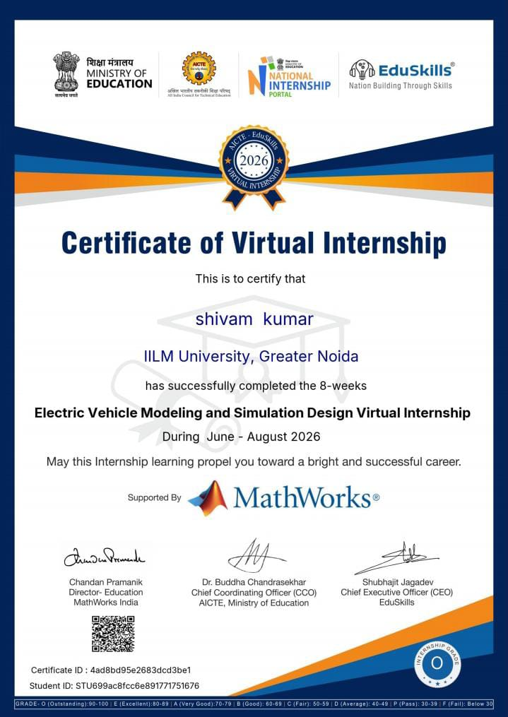

Internship Offer Letter
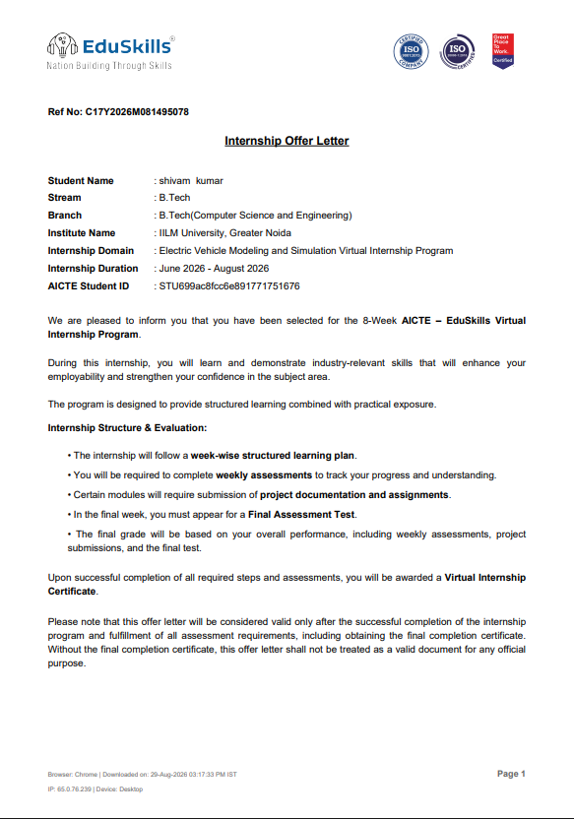

4. PROJECT DESCRIPTION

4.1 Introduction
This report presents a detailed account of the 8-week Virtual Internship undertaken under the AICTE – EduSkills Virtual Internship Program, in the domain of “Electric Vehicle Modeling and Simulation Design”, supported by MathWorks. The internship was carried out from June 2026 to August 2026 as part of the requirement of the Bachelor of Technology (Computer Science and Engineering) programme at IILM University, Greater Noida.
The primary aim of this internship was to develop a strong practical understanding of Electric Vehicle (EV) technology, modeling, and simulation using MATLAB and Simulink. The internship provided exposure to important concepts related to electric vehicle systems, including EV components, battery systems, electric motors, power electronics, vehicle dynamics, and system-level simulation.
The internship followed a structured learning approach that combined theoretical concepts with practical exercises, simulations, assignments, and assessments. Through these activities, I gained practical knowledge of how electric vehicle systems can be modeled and analyzed using simulation-based tools. The internship also helped me understand the importance of simulation in designing, testing, and improving electric vehicle performance before implementing systems in real-world applications.
On successful completion of the internship requirements, an AICTE–EduSkills Virtual Internship Certificate with an “Outstanding” Grade (Grade O) was awarded, supported by MathWorks and recognized under the AICTE and National Internship Portal.

4.2 Organization Profile
EduSkills Academy is an organization working with the vision of “Nation Building Through Skills” and focuses on providing industry-oriented learning and skill development opportunities to students. EduSkills collaborates with the All India Council for Technical Education (AICTE) to conduct the AICTE – EduSkills Virtual Internship Program under the AICTE National Internship Portal.
For the Electric Vehicle Modeling and Simulation Design internship track, EduSkills provided a structured learning platform supported by MathWorks. The program focused on developing practical knowledge of Electric Vehicle (EV) technologies, MATLAB, and Simulink, along with concepts related to EV modeling and simulation.
The internship curriculum was designed to combine theoretical learning with practical simulation-based activities, assignments, assessments, and hands-on exercises. Through this program, students gained industry-relevant knowledge and developed an understanding of how simulation tools can be used for the design, analysis, and performance evaluation of electric vehicle systems.

4.3 Problem Statement
Although a large number of engineering students learn the basic concepts of Electric Vehicles, batteries, electric motors, and power systems during their academic coursework, many students have limited opportunities to gain structured, hands-on experience in modeling and simulating complete electric vehicle systems using industry-standard tools such as MATLAB and Simulink. Concepts related to EV architecture, battery performance, motor control, vehicle dynamics, and power management are often understood mainly at a theoretical level, with limited practical exposure to simulation and system analysis.
The problem addressed by this internship was to practically understand and apply the modeling and simulation workflow for Electric Vehicles using MATLAB and Simulink. The internship focused on developing knowledge of EV components and their interactions, creating simulation models, analyzing system performance, and understanding how simulation can be used to design, test, and optimize electric vehicle systems before their real-world implementation.

4.4 Project Objectives
• To understand the fundamental concepts of Electric Vehicles (EVs) and their major components.
• To learn the basics of EV modeling and simulation using MATLAB and Simulink.
• To understand the working and characteristics of EV batteries, electric motors, power electronics, and energy management systems.
• To develop practical skills in creating electric vehicle system models and performing simulation-based analysis.
• To study vehicle dynamics and performance parameters such as speed, acceleration, torque, power, and energy consumption.
• To analyze the performance of different EV components and subsystems through simulation.
• To understand the role of MATLAB and Simulink in the design, testing, and optimization of electric vehicle systems.
• To gain hands-on experience in simulation-based problem solving and interpreting simulation results.
• To develop an understanding of how EV models can be used to evaluate and improve vehicle performance and efficiency.
• To successfully complete all the required internship assignments, assessments, and Internship Grade Point Assessment.

4.5 Scope of the Project
The scope of this internship covers the complete Electric Vehicle Modeling and Simulation workflow, starting from understanding the fundamentals of electric vehicles and their major components, and progressing towards the modeling, simulation, and analysis of EV systems using MATLAB and Simulink. The internship includes the study of battery systems, electric motors, power electronics, vehicle dynamics, energy consumption, and overall EV performance.
The project also focuses on developing and analyzing simulation models to understand the interaction between different EV components and evaluate important performance parameters such as speed, torque, power, energy consumption, and efficiency. It provides practical exposure to simulation-based design, testing, and performance analysis of electric vehicle systems.
The internship was limited to a virtual, simulation and lab-based learning environment provided through the AICTE–EduSkills Virtual Internship Program, with support from MathWorks, and did not involve the deployment of any electric vehicle model or system in a live commercial or industrial environment.

4.6 Technologies and Tools Used
• Modeling & Simulation Tools: MATLAB, Simulink
• Electric Vehicle Modeling: Electric Vehicle (EV) system models, battery models, electric motor models, and vehicle dynamics models
• Battery & Energy Systems: Battery modeling, State of Charge (SOC) analysis, power and energy consumption analysis
• Electric Motor & Power Electronics: Electric motor modeling, motor performance analysis, power electronic components and control systems
• Simulation & Analysis: MATLAB/Simulink simulation, system-level modeling, performance analysis, and simulation result evaluation
• Learning Platform: AICTE–EduSkills Virtual Internship Program learning modules, assignments, assessments, and practical simulation exercises
• Supporting Organization: MathWorks, for MATLAB and Simulink-based learning and simulation activities

4.7 System Architecture
The general architecture followed during the internship for the Electric Vehicle Modeling and Simulation Design track can be summarized in the following layers:
- Input Layer: Provides the required parameters and inputs such as battery specifications, vehicle speed, motor characteristics, load conditions, and other EV system parameters.
- Component Modeling Layer: Represents the major components of an electric vehicle, including the battery, electric motor, power electronics, controller, and vehicle dynamics.
- Control Layer: Handles the control and management of the EV system, including motor control, power management, and battery-related control parameters.
- Simulation Layer: The complete EV model is simulated using MATLAB and Simulink to study the behavior and interaction of different components under different operating conditions.
- Analysis Layer: Simulation results are analyzed using parameters such as speed, torque, power, battery State of Charge (SOC), energy consumption, and efficiency.
- Optimization Layer: The simulation results can be used to identify performance issues and improve the efficiency, stability, and overall performance of the electric vehicle system.
- Assessment Layer: Assignments, practical simulation exercises, quizzes, and the Internship Grade Point Assessment were used to evaluate learning progress and successful completion of the internship.

4.8 Methodology
The internship followed a structured, week-wise methodology combining conceptual learning, hands-on simulation exercises, practical activities, and assessment-based learning. The internship focused on Electric Vehicle Modeling and Simulation Design using MATLAB and Simulink. The learning process progressed from basic EV concepts to component modeling, system simulation, performance analysis, and final assessment, as summarized below.
Week | Module | Description
1 | Introduction to Electric Vehicles | Introduction to EVs, their working principles, types, major components, advantages, and basic EV architecture.
2 | EV Components and Systems | Study of important EV components including batteries, electric motors, power electronics, controllers, and charging systems.
3 | Battery Modeling and Analysis | Understanding battery characteristics, battery models, State of Charge (SOC), voltage, current, power, and energy-related parameters.
4 | Electric Motor Modeling | Study and modeling of electric motors used in EVs, along with analysis of motor speed, torque, power, and operating characteristics.
5 | EV Powertrain Modeling | Development and understanding of an EV powertrain model by integrating the battery, motor, controller, and other major subsystems.
6 | Vehicle Dynamics and Simulation | Modeling vehicle dynamics and analyzing parameters such as vehicle speed, acceleration, torque, power demand, and energy consumption.
7 | EV System Simulation and Performance Analysis | Performing simulations using MATLAB and Simulink and analyzing the overall performance, efficiency, and behavior of the EV system under different conditions.
8 | Advanced EV Modeling and Simulation | Applying the concepts learned to improve and analyze EV models through simulation-based activities and practical exercises.
Final | Final Assessment / Internship Grade Point Assessment | Completion of the final assessment and evaluation of the knowledge and practical skills gained throughout the internship.
Note: There was no stipend associated with this internship.
Each week consisted of learning modules, practical simulation activities, assignments, and assessments to evaluate conceptual understanding and practical knowledge. In the final phase, an Internship Grade Point Assessment was conducted, and the overall internship performance was evaluated based on the completion of the weekly learning activities and final assessment.

4.9 Expected Outcomes
- Ability to explain the basic concepts and working principles of Electric Vehicles (EVs) and their major components.
- Practical understanding of EV batteries, electric motors, power electronics, controllers, and vehicle powertrain systems.
- Hands-on experience in developing Electric Vehicle models using MATLAB and Simulink.
- Ability to understand and analyze important EV parameters such as speed, torque, power, State of Charge (SOC), energy consumption, and efficiency.
- Practical knowledge of performing simulation and performance analysis of electric vehicle systems under different operating conditions.
- Ability to interpret simulation results and identify opportunities for improving EV performance and energy efficiency.
- Development of simulation-based problem-solving skills and familiarity with industry-oriented EV modeling tools.
- Successful completion of the weekly learning modules, practical exercises, assignments, and Internship Grade Point Assessment, resulting in an “Outstanding” grade.

4.10 Certificates of Completion and Communication Proof
The Internship Offer Letter and the Internship Completion Certificate issued by EduSkills Academy, confirming successful completion of the 8-week AICTE – EduSkills Virtual Internship Program in Google AI-ML, are attached in Chapter 3 of this report. The official completion e-mail from EduSkills Foundation.

5. BIBLIOGRAPHY/REFERENCES
- EduSkills Academy, “AICTE – EduSkills Virtual Internship Program – Electric Vehicle Modeling and Simulation Design,” Internship Offer Letter, 2026.
- EduSkills Academy, “Certificate of Virtual Internship – Electric Vehicle Modeling and Simulation Design,” 2026.
- MathWorks, “MATLAB Documentation,”
https://www.mathworks.com/help/matlab/
- MathWorks, “Simulink Documentation,”
https://www.mathworks.com/help/simulink/
- MathWorks, “Simscape Documentation,”
https://www.mathworks.com/help/physmod/simscape/
- MathWorks, “Simscape Electrical Documentation,”
https://www.mathworks.com/help/physmod/sps/
- MathWorks, “Electric Vehicle Modeling and Simulation,”
https://www.mathworks.com/solutions/electrification.html
- AICTE – EduSkills, “Virtual Internship Program,” AICTE National Internship Portal, 2026.
- National Internship Portal, All India Council for Technical Education (AICTE),
https://internship.aicte-india.org/

