Project Design Phase-II

The IMovies Data Flow Diagram & User Stories

Date | 25 October 2026
Team ID | Not assigned
Project Name | The IMovies
Maximum Marks | 4 Marks

Data Flow Diagrams:
These diagrams show how moviegoer and administrator requests move through The IMovies frontend and Express API to MongoDB. The API validates requests and applies booking rules before data is read or changed. Real payment processing and collection of card details are outside the project scope.

Level 0 - Context Data Flow
The context view treats The IMovies API and data layer as one system. The browser is the user-facing client; MongoDB is the persistent data store behind the server.
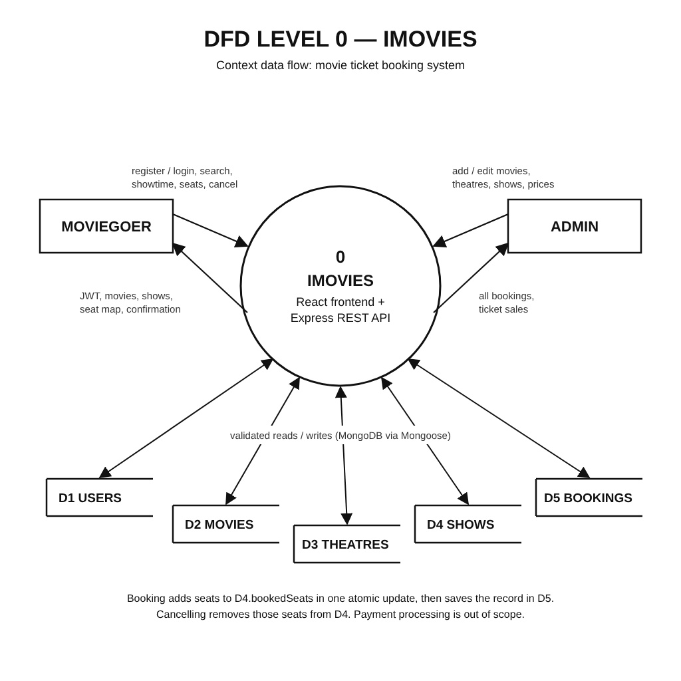
Source | Destination | Data flow
Moviegoer | React website | Search terms, filters, selected movie, cinema, showtime, and seat choices.
React website | Express REST API | JSON requests for catalog, showtimes, authentication, seat availability, and bookings; JWT on protected requests.
Administrator | Express REST API | Authorized movie, cinema, showtime, and operational data updates.
Express REST API | MongoDB | Validated reads and writes for users, movies, cinemas, showtimes, seat holds, and bookings.
MongoDB / Express API | React website | Catalog/showtime results, current seat availability, booking confirmation, or a clear validation/conflict error.
React website | Moviegoer / Administrator | Rendered movie information, seat map status, INR prices, account state, and booking results.

Level 1 - Movie Discovery and Reservation Data Flow
The detailed view separates authentication, movie discovery, showtime/seat availability, and booking confirmation. Seat availability is checked again on the server when confirming a reservation.
Process | Input | Data store / rule | Output
1. Authenticate | Email/password and registration details. | Users collection; validate input and compare password hash. | Account/session result and JWT on successful login.
2. Discover movies | Search term, genre/filter choices, selected date or location. | Movies, cinemas, and showtimes collections. | Matching movie details, cinema options, and showtimes.
3. Check seats / hold seats | Showtime ID and requested seat IDs. | Bookings/seat holds; reject unavailable seats and assign an expiring temporary hold. | Updated seat map and hold expiry, or a conflict response.
4. Confirm booking | Authenticated user and active hold/seat selection. | Recheck hold ownership and expiry; atomically verify seat availability and create booking. | Booking confirmation and saved reservation, or a conflict error.
5. Review bookings / administer catalog | User asks for own history; admin submits authorized catalog updates. | Bookings and user records; movies, cinemas, and showtimes. | Booking history or updated catalog data; unauthorized requests are rejected.
Data notes: Passwords are stored as secure hashes, not plain text. JWTs authorize protected requests. Temporary seat holds expire; final confirmation rechecks availability to prevent duplicate bookings.
User Stories

User Story Table - The IMovies
User Type | Functional Requirement (Epic) | User Story / Task | Acceptance Criteria | Priority | Release
Moviegoer | Authentication | As a moviegoer, I can register and sign in securely to access my bookings. | Valid registration creates an account; sign-in succeeds with valid credentials; protected requests require valid authorization. | High | Planned Sprint-1
Visitor | Movie Discovery | As a visitor, I can browse, search, and filter the movie catalog. | Results match the search/filter criteria; empty results show a helpful message. | High | Planned Sprint-2
Moviegoer | Movie Details & Pricing | As a moviegoer, I can view film details and ticket prices in INR. | Movie details load clearly and prices use a consistent INR format. | High | Planned Sprint-2
Moviegoer | Cinema & Showtimes | As a moviegoer, I can compare cinemas and select a date and showtime. | Available showtimes show cinema, date/time, format, and price before seat selection. | High | Planned Sprint-2
Moviegoer | Seat Selection | As a moviegoer, I can see available seats and temporarily hold selected seats. | Unavailable seats cannot be selected; holds expire and release seats; conflicts are explained. | High | Planned Sprint-3
Signed-in User | Booking Management | As a signed-in user, I can confirm a reservation and view my booking history. | The server rechecks availability before saving; confirmation and history show the saved booking. | High | Planned Sprint-3
Administrator | Catalog Management | As an authorized administrator, I can create and update movie, cinema, and showtime information. | Only authorized admins can make changes; invalid input is rejected with clear feedback. | Medium | Planned Sprint-4
Project Team | Reliability & Accessibility | As a project team, we can verify responsive pages, API validation, and booking conflict handling. | Key flows work on mobile/tablet/desktop; validation and conflict cases return understandable results. | High | Planned Sprint-4

