


File Compression Simulator (Using Core Java & OOP Concepts)
RU-100-01-00012
Object Oriented Programming with Java

SESSION: 2025-26

Submitted By Shivam kumar
Erp- 11368

Bachelor of Technology in Computer Science

Under the Guidance of Mr. Ashish shivhare

SCHOOL OF COMPUTER SCIENCE AND ENGINEERING RUNGTA INTERNATIONAL SKILLS UNIVERSITY
BHILAI, CG

(April 2026)

Title PAGE
Contact Management System using Object-Oriented Programming.

- Name- Shivam kumar.
- SECTION- 2M.
- ERP I’D- RU-25-11368.
- COURSE- B.tech.
- BRANCH- CSE(core).
- SEMESTER- 2nd.
- SUBMISSION DATE- 11.04.2026.

Acknowledgement

I am also thankful to my institution for providing the necessary resources and environment to carry out this work.
Abstract
- What is your project ?
- The Contact Management System using Object-Oriented Programming is a software application designed to efficiently store, manage, and organize personal and professional contact information. In today’s digital world, managing a large number of contacts manually becomes difficult and time-consuming. This project is needed to provide a simple, fast, and reliable way to handle contact details in an organized manner.

- Why is it needed ?
- This project is needed because managing a large number of contacts manually is difficult and time-consuming. It helps to store and organize contact information in a systematic and efficient way.

- What it does ?
- The application enables users to store contact information, search for specific contacts, update existing details, and delete unwanted contacts in a simple and efficient manner.

Introduction

- In today’s fast-paced digital world, managing contact information efficiently is very important. People often need to store details such as names, phone numbers, and email addresses for personal and professional use. Managing these contacts manually can be time-consuming, unorganized, and prone to errors.

- · To manage contact records efficiently
- · To store and organize contact details
- · To search contacts quickly
- · To update and delete contact information
- · To reduce manual work and errors

Scope
- This project is useful for managing contact details efficiently for personal or small-scale use. It can be further enhanced with database integration and advanced features in the future.

System Requirements

Hardware Requirements
- Computer or Laptop
- Minimum 4 GB RAM
- Processor: Intel i3 or above
- Software Requirements
- Operating System: Windows / Linux / macOS
- Java Development Kit (JDK)
- IDE: VS Code / Eclipse / Edit Plus
- Web Browser (optional)

Methodology
- The system works by allowing users to add, view, search, update, and delete contact details. It uses OOP concepts to manage data efficiently and provide a simple user interface.

Flowchart

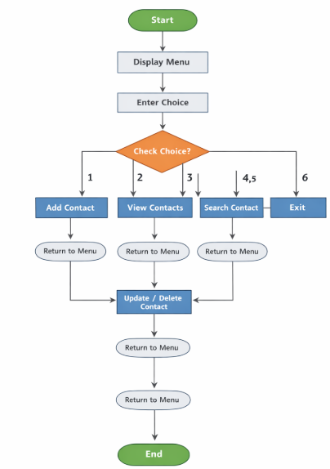

Class diagram

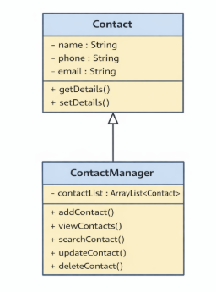

Implementation
- The project is developed using Object-Oriented Programming and includes two main classes: Contact and ContactManager.
- The Contact class stores contact details like name, phone, and email.
- The system works through a menu-driven interface where users select options to perform different actions. All data is stored in memory using objects, making the system simple and efficient.

Sample input/output(screenshot)

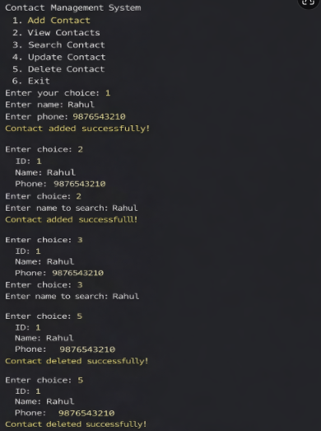

Gantt Chart

A Gantt chart is used to plan and schedule the different tasks involved in the project. It helps in organizing the work into phases such as planning, design, coding, testing, and documentation.

- Planning & Structure
- Planning & Structure → Project idea was decided
- System Design → Flowchart and class diagram were created
- Testing → Errors were identified and fixed
- Documentation → Project report was prepared
- Final Review → Project was reviewed and submitted

Time Management

Time Management helps in scheduling tasks by defining their start and end time, ensuring timely completion of the project.

Conclusion
- The project successfully demonstrates the use of Object-Oriented Programming concepts in Java and provides a functional Contact Management System.
- It allows users to efficiently store, manage, search, and update contact details. The system is simple, user-friendly, and helps reduce manual effort. Overall, this project shows how OOP concepts can be applied to solve real-world problems effectively.

References
- Balagurusamy, E. (2020). Programming with Java: A Primer (6th Edition).
McGraw Hill Education.

- Schildt, H. (2021). Java: The Complete Reference (12th Edition).
McGraw Hill Education.

- Oracle Corporation. (2026). Java Documentation. Retrieved from
https://docs.oracle.com/javase/

- Bloch, J. (2018). Effective Java (3rd Edition).
Addison-Wesley Professional.

- Sierra, K., & Bates, B. (2022). Head First Java (3rd Edition).
O'Reilly Media.

- Rungta International Skills University. (2025–26).
Object Oriented Programming with Java Course Material.

- GeeksforGeeks. (2026). Java Programming Tutorials and OOP Concepts.
Retrieved from https://www.geeksforgeeks.org/java/

- TutorialsPoint. (2026). Java Tutorial. Retrieved from
https://www.tutorialspoint.com/java/

- Contact Management System project developed using Core Java and
Object-Oriented Programming concepts for academic purposes

- Various online resources and study materials referred to for
understanding Java classes, objects, inheritance, encapsulation,
and data management techniques.

