Main Assignment – Analytics and SQL : Shivam Kumar

The DBT run and test results:

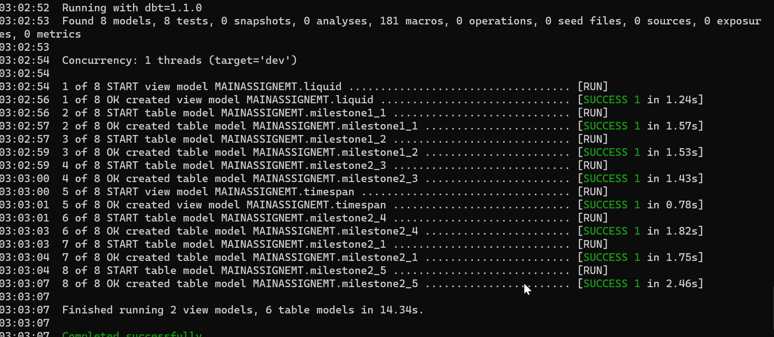

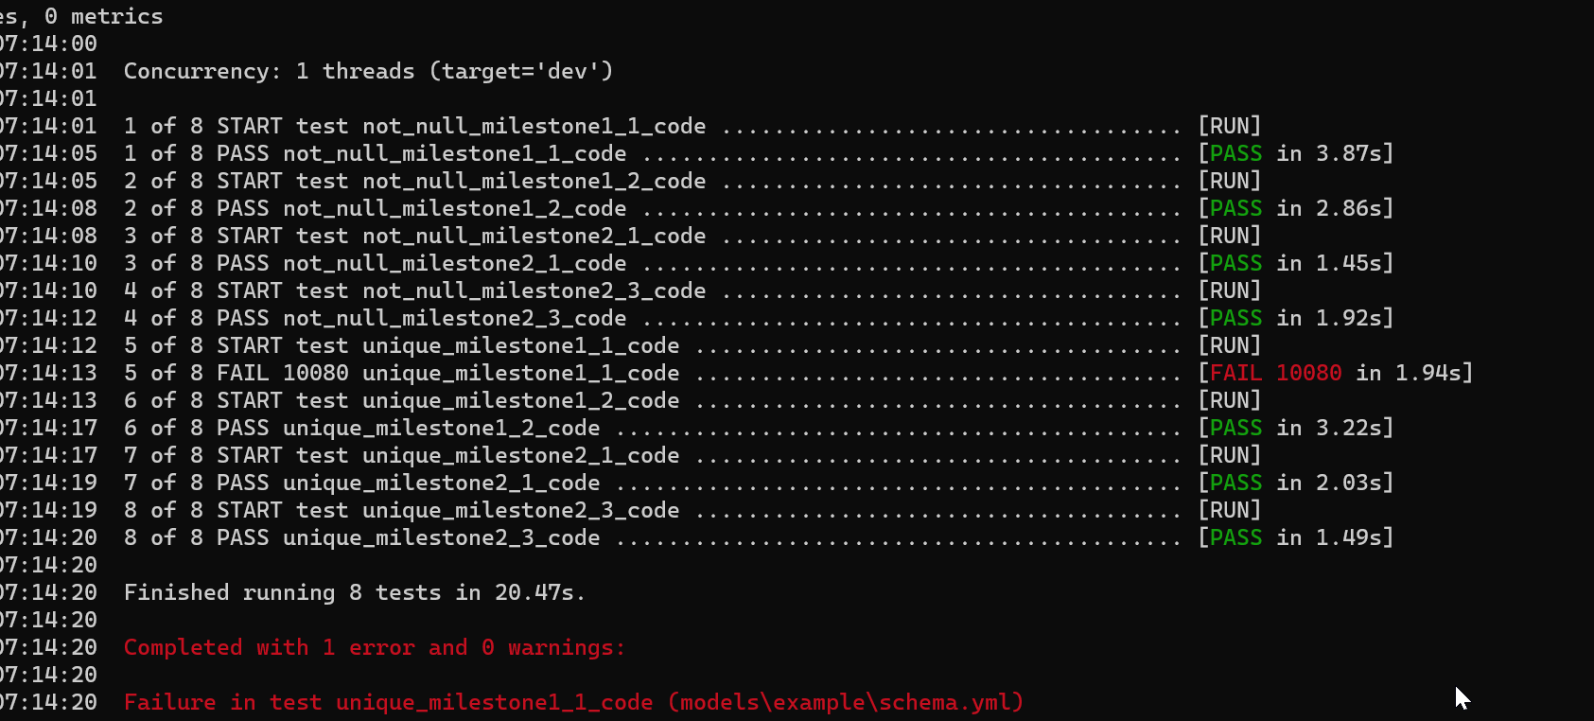

Milestone 1_1 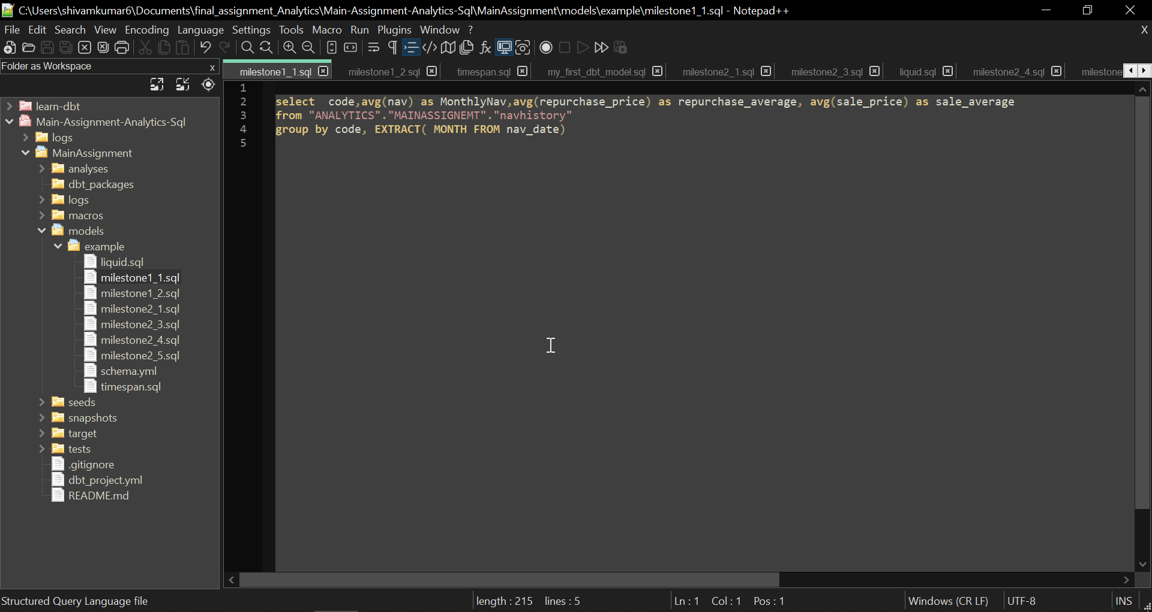

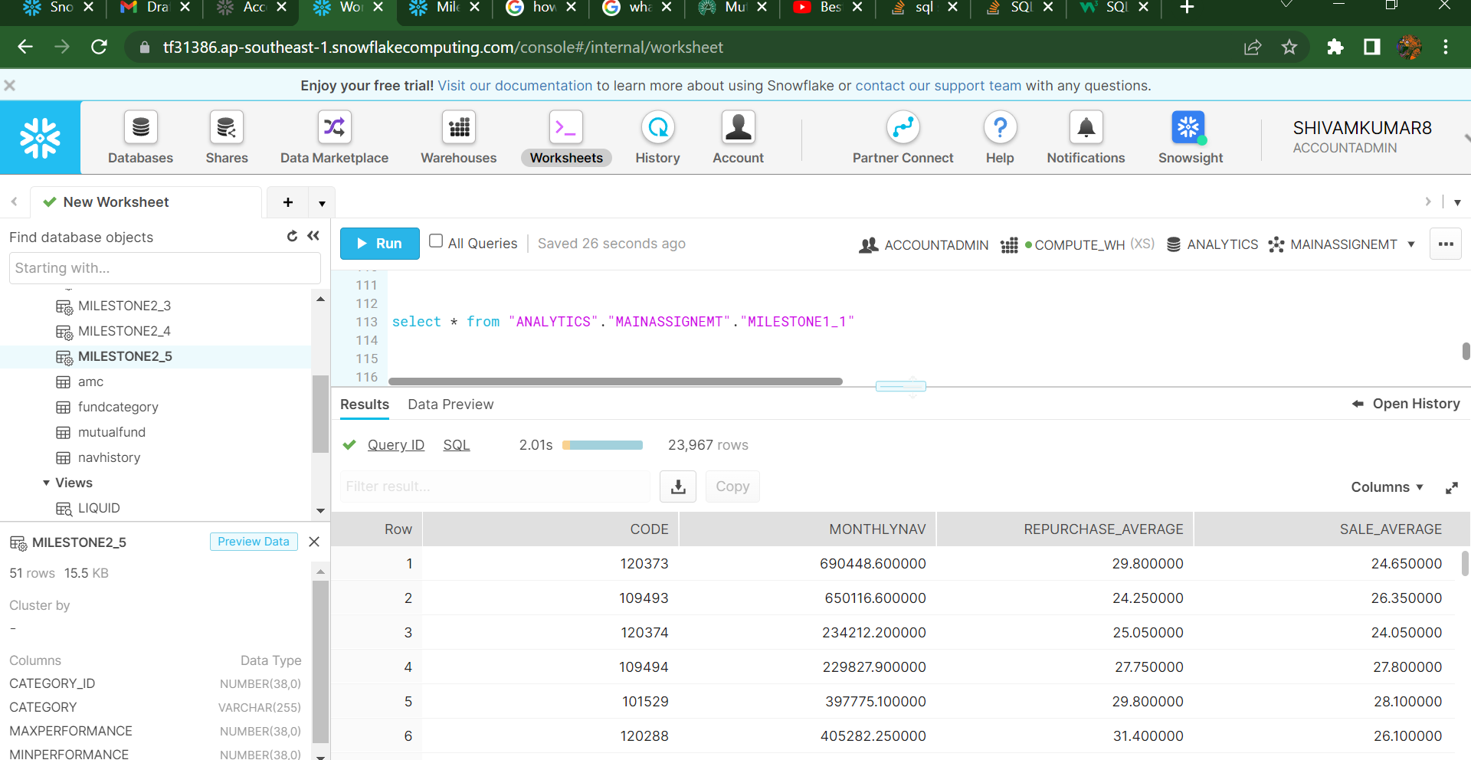

Milestone 1_2 : P.T.O

In this first part (which I have commented) in the inside query I have first found the max nav value for every scheme and then found the date at which it occurred , but here I sensed that the join was not performing as I thought it would do, because It resulted in a lot rows, because I think max nav can happen on many days , So in the end I just printed the Max Nav and Min Nav for a scheme.

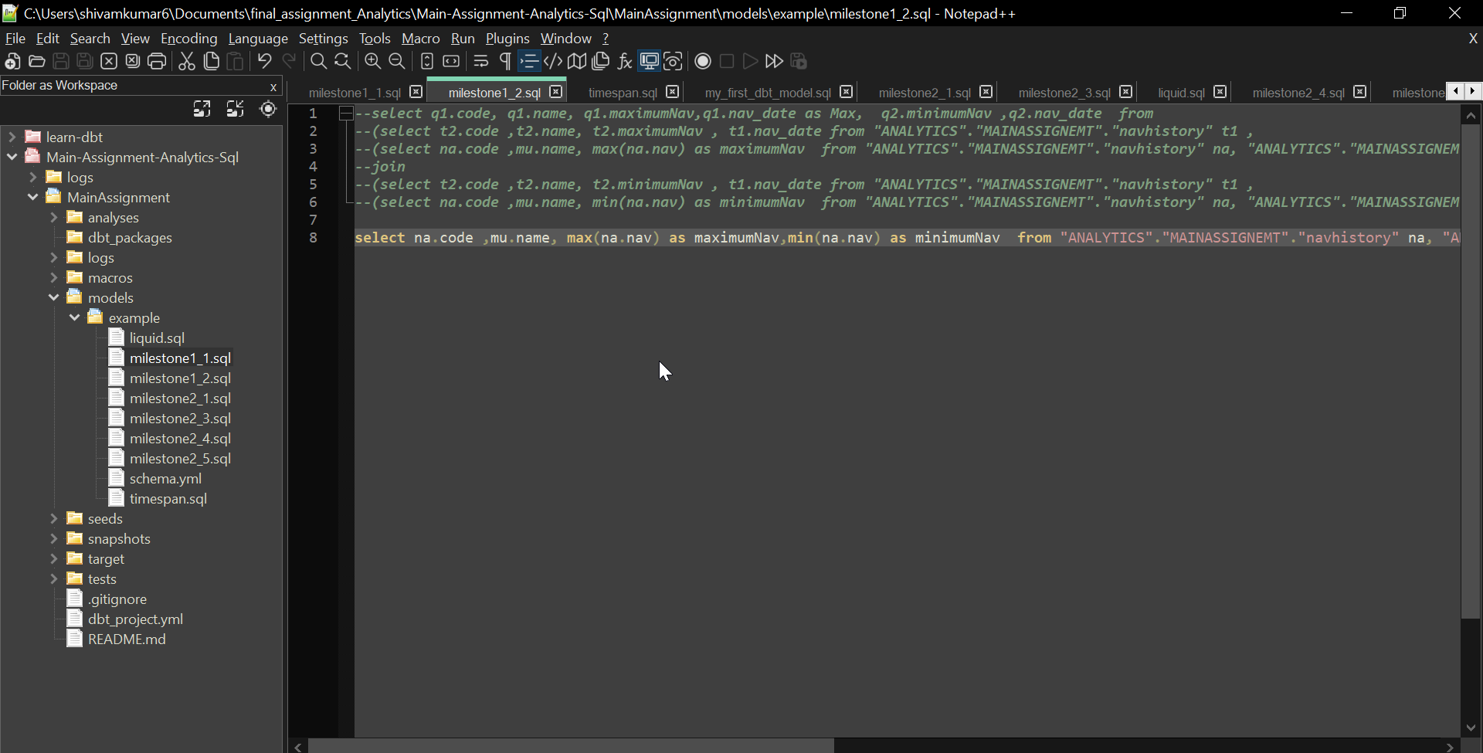 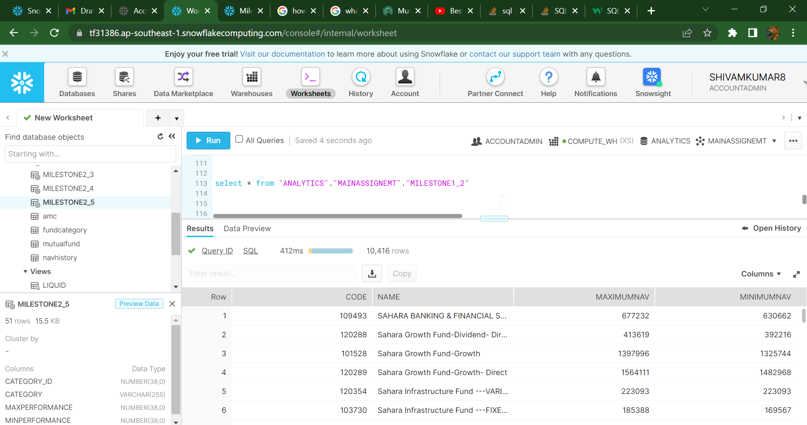

Milestone 2_1

YTD: as the data was of 2018 dec to 2019 feb , I tried to get the Performance for however many trading days were there in 2018, (I could also do that for 2019 as well) , Apart from that I Could not divide by nav of before the time period because the data in nav_history had 0 for few schemes which did not trade on the opening day of the time period so , It always showed divide by zero error. Thus I have simple subtracted Lastnav with Firstnav. 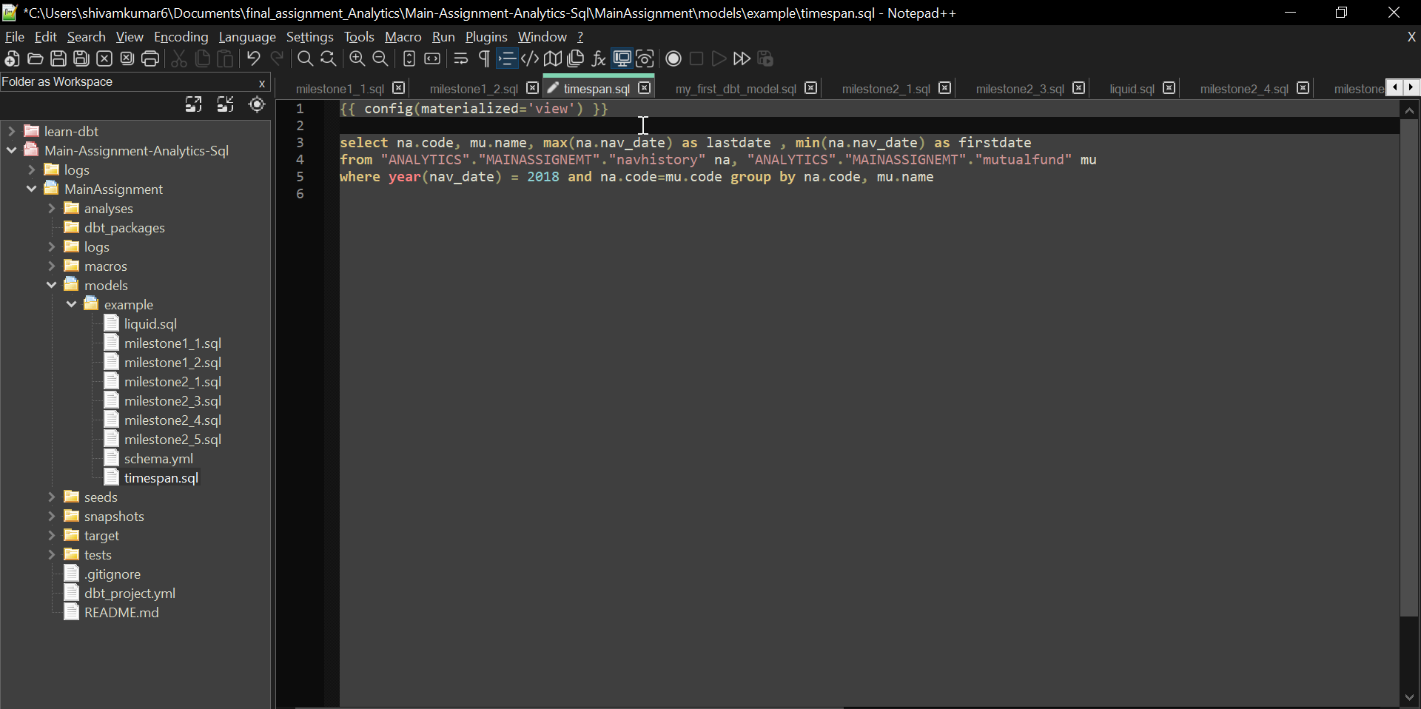

The view I created for referencing in the YTD query for the timespan , I can make this MTD by adding month clause in the condition.

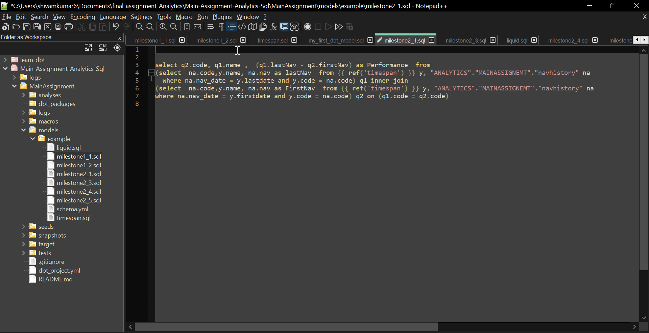

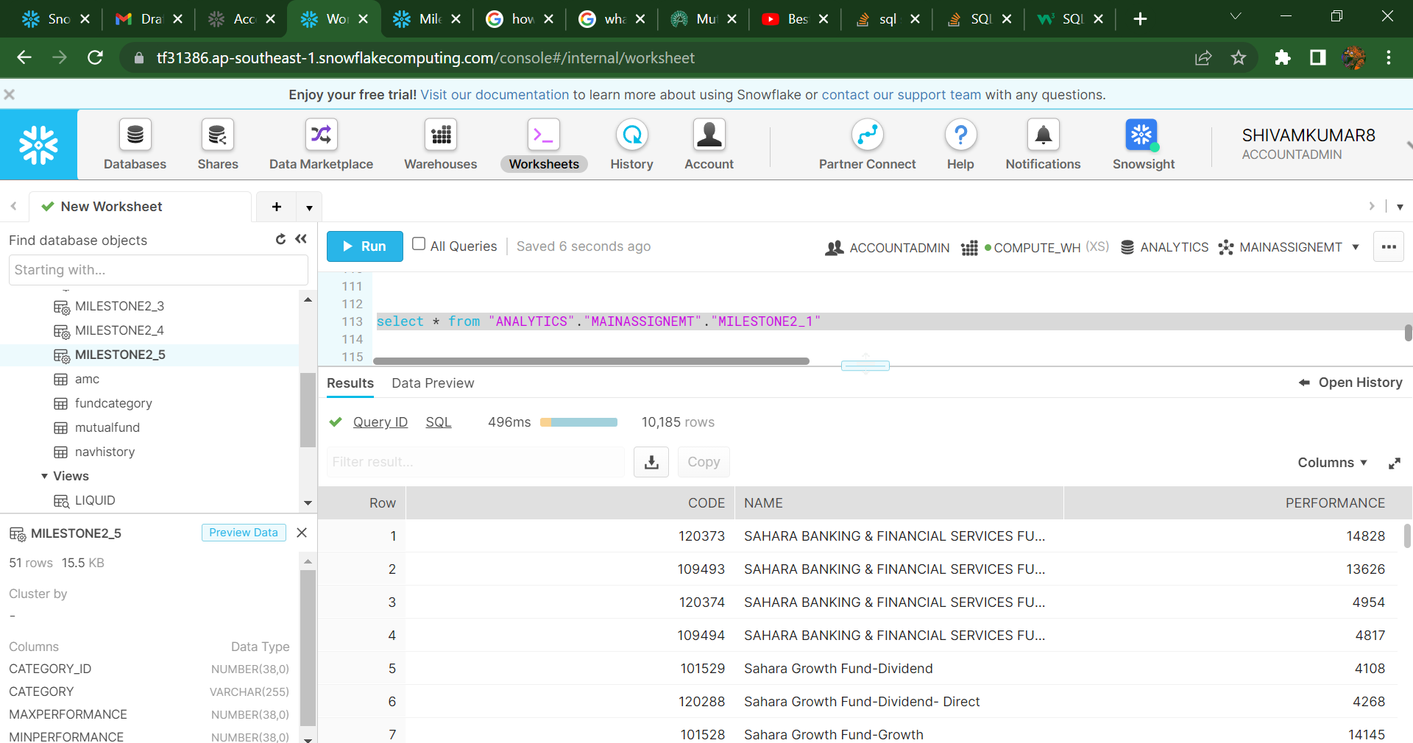

Milestone 2_3

For this query of finding the schemes that were discontinued, I assumed that the schemes that do not trade till the last day of the Year , are not being continued.

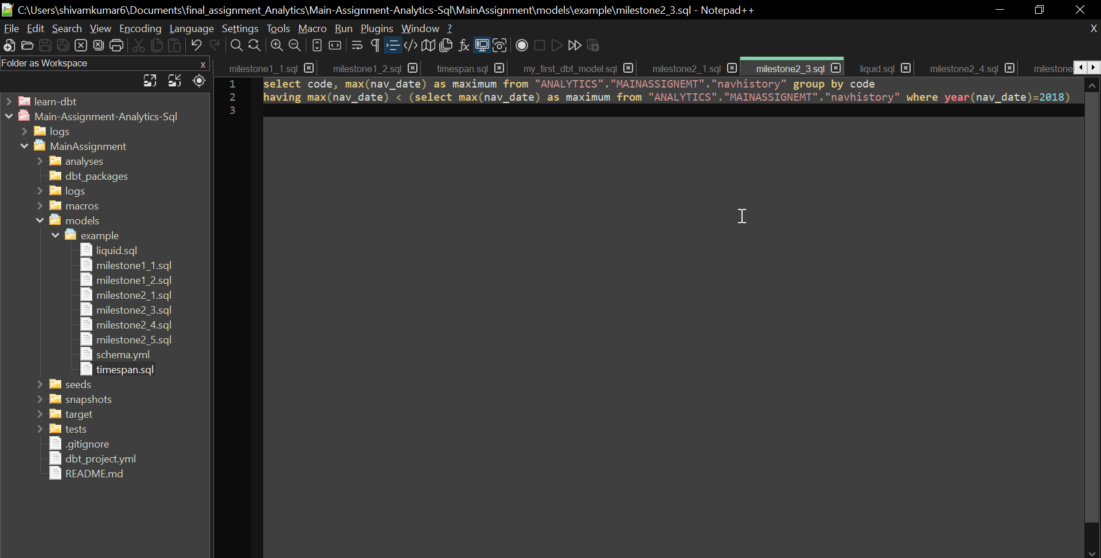

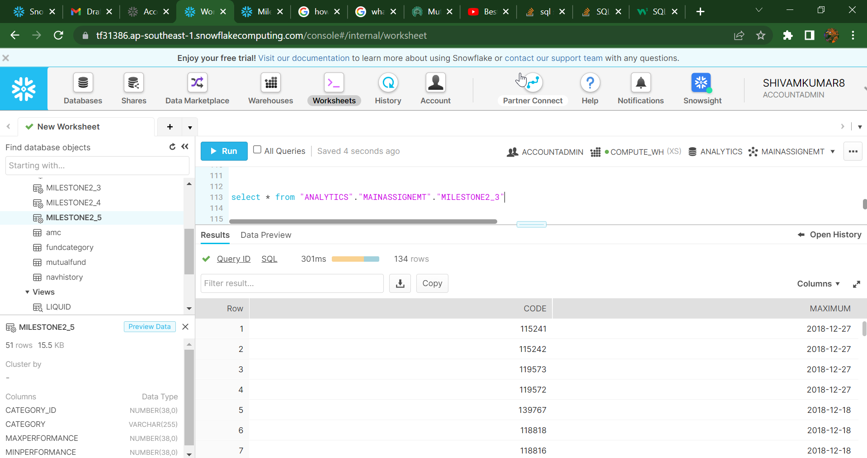

Milestone 2_4: Here I created another view for making the timespan of liquid funds and in 2018

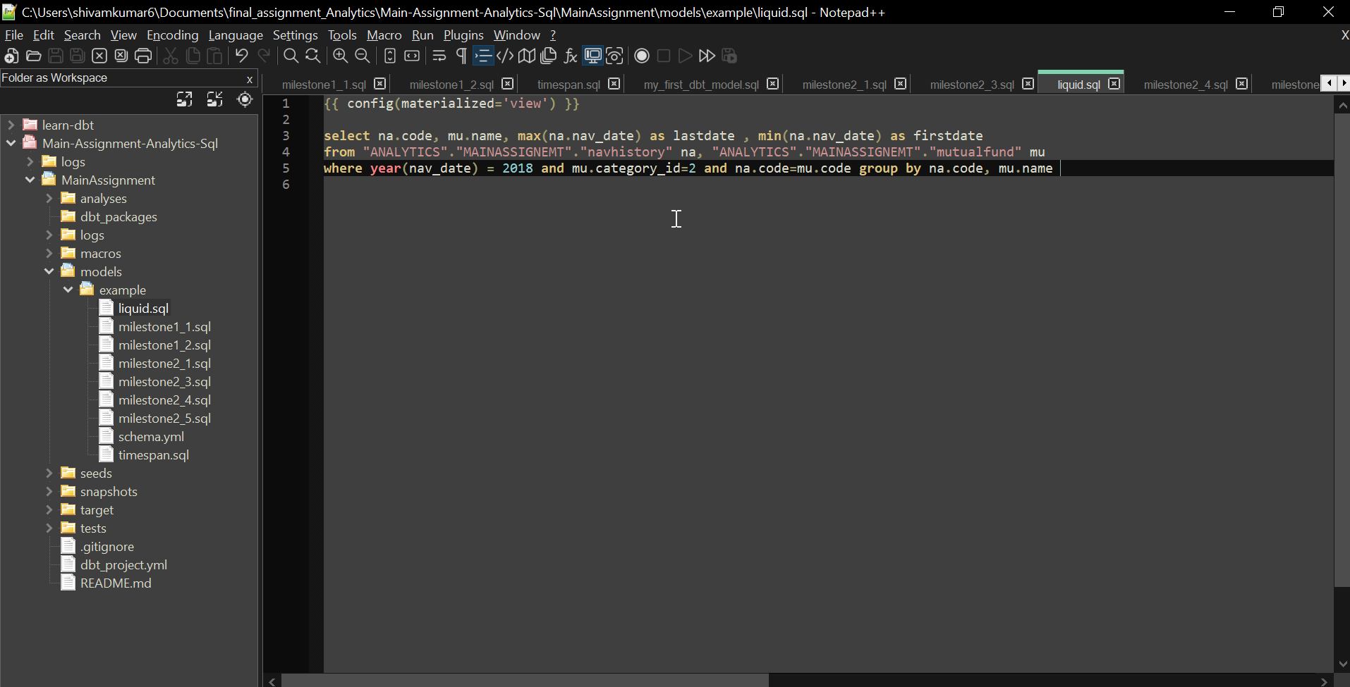

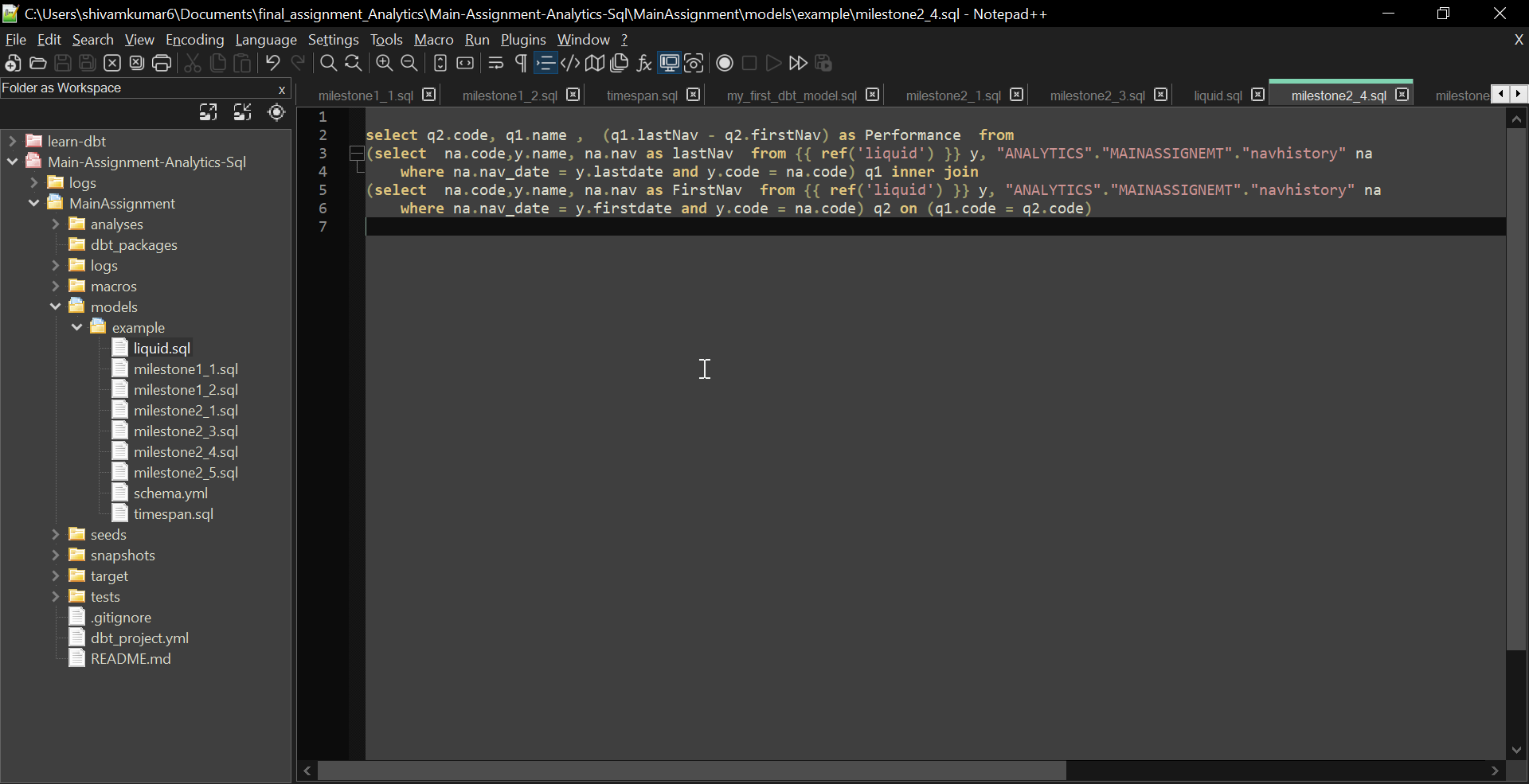

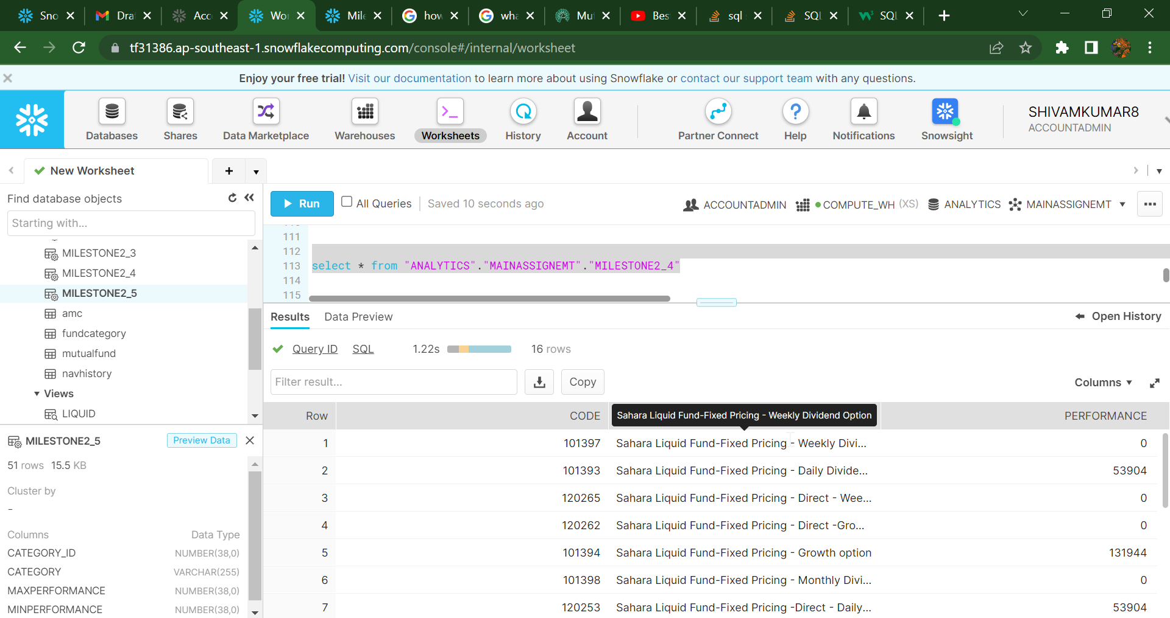

Milestone 2_5:

Here I built upon the logic of YTD performance and over that query I added the group by category ID and Category Name.

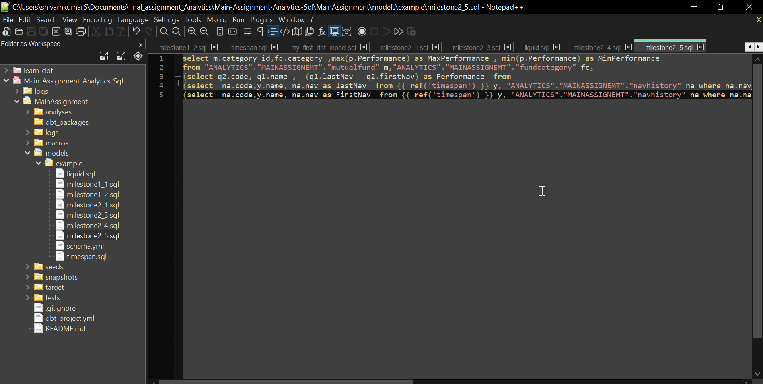

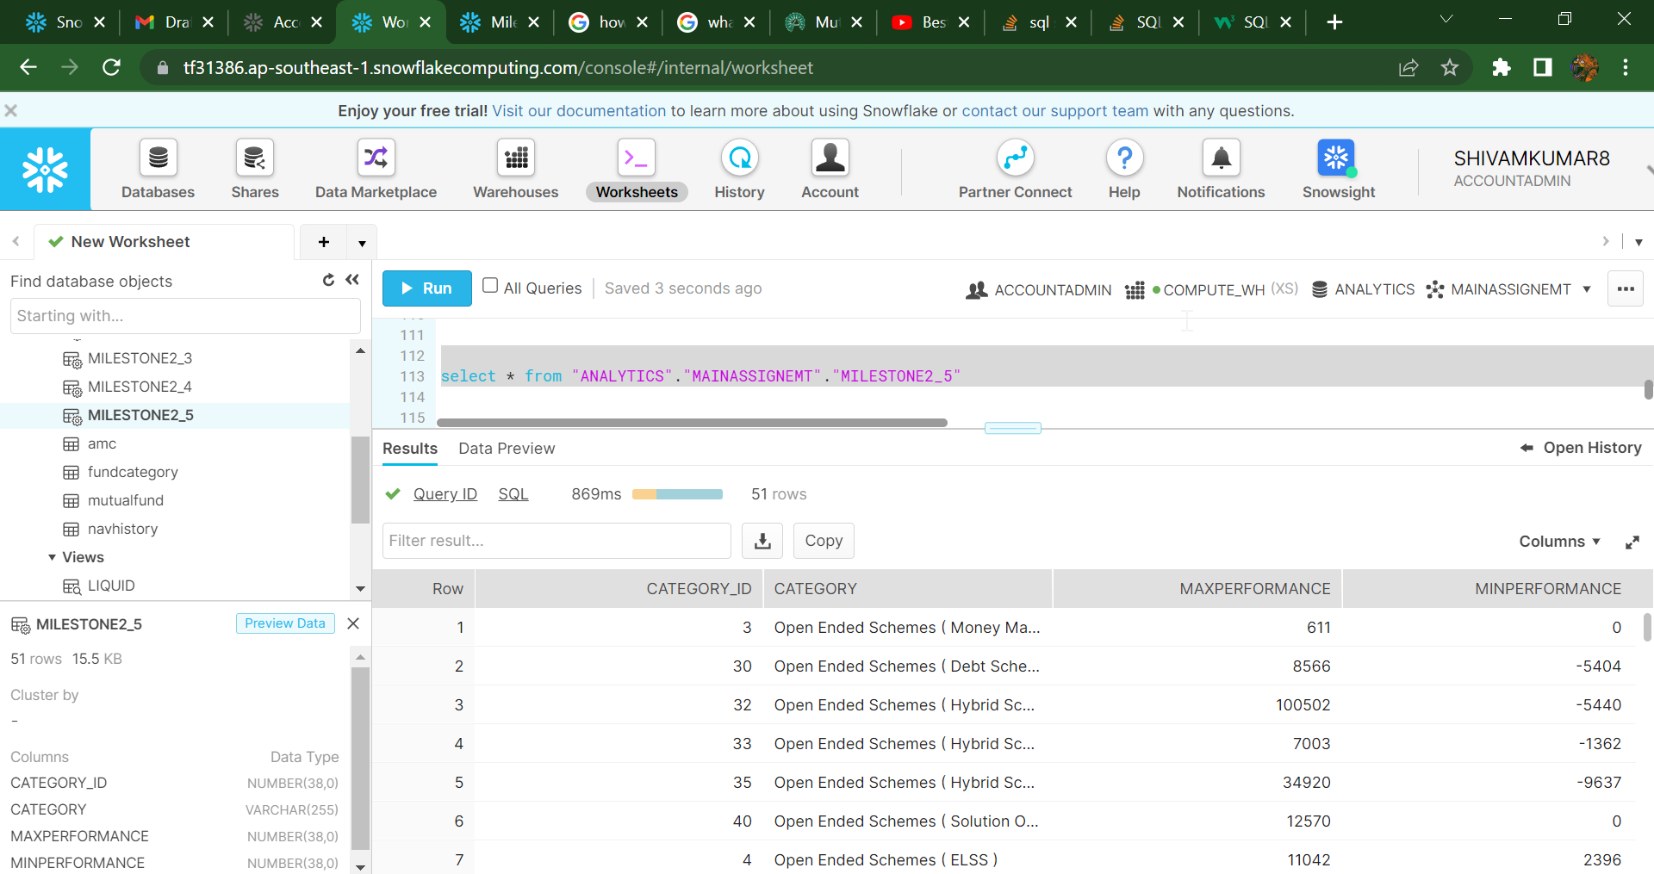

Data Studio: I have done 3_1,3_3, 3_4 , Published report link https://datastudio.google.com/reporting/8bcef141-7061-4a73-bdc4-5f10d1b3d669

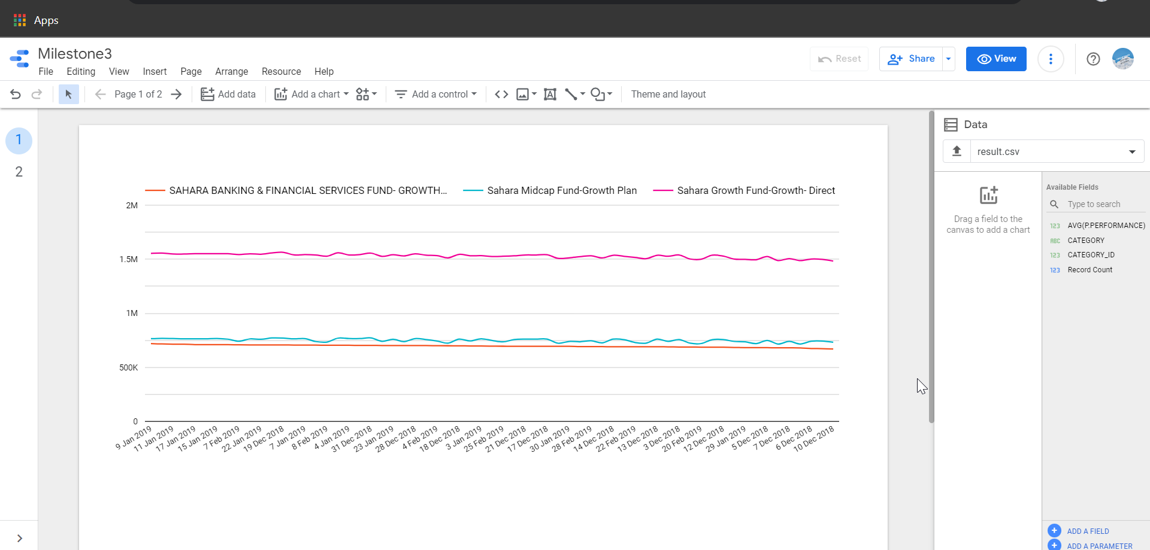

3_1 Plotting performance of upto 3 funds for the past 3 months.

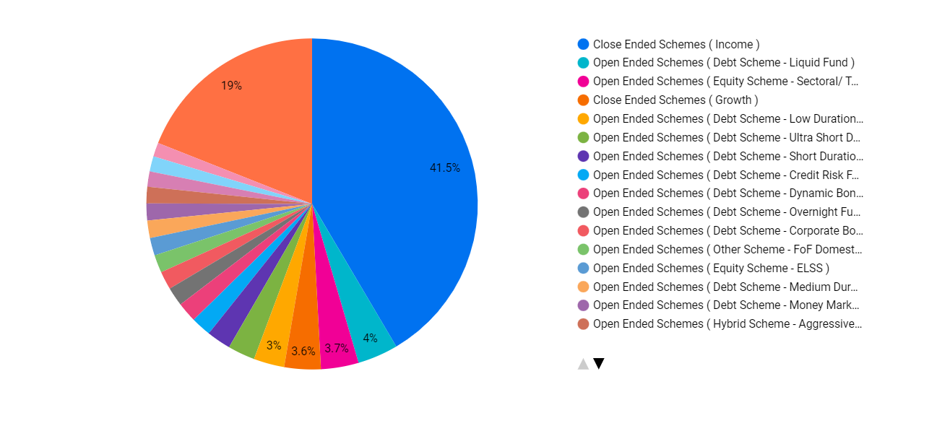

3_3 Distribution of latest mutual funds based on category

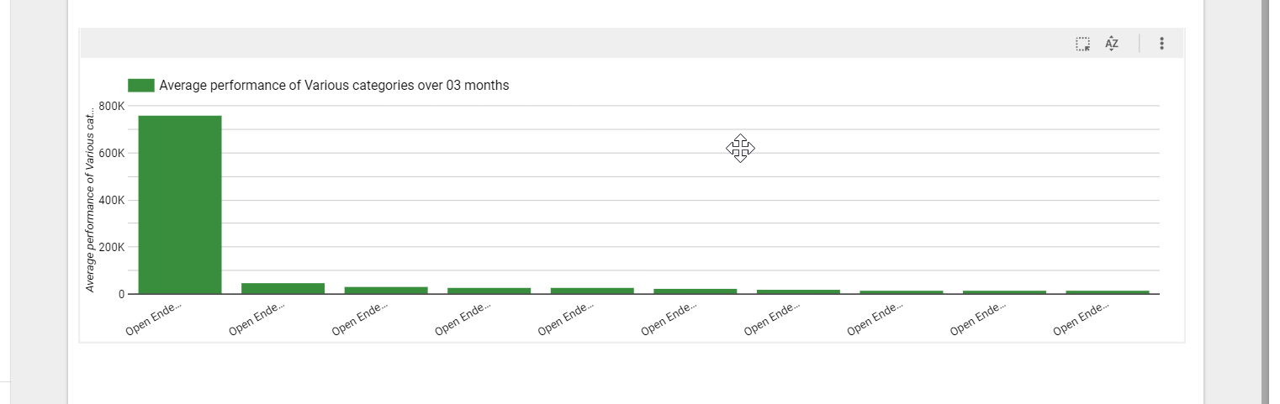

3_4 Average growth of mutual funds based on category for past 3months