What is a JOIN? – Need for combining multiple tables

Ans: join is used to combine Data, from two or more Tables, based on related columns between them.

2. Types of Joins:

* INNER JOIN
* LEFT JOIN
* RIGHT JOIN
* FULL OUTER JOIN

1. INNER JOIN

> Returns records that have matching values in both tables.

* **Syntax**

SELECT Col_name(s)

FROM **TableA**

INNER JOIN **TableB**

ON **TableA**.Col_name = **TableB**.col_name

* **Example**

Select *

From customer AS c

INNER JOIN payment AS p

ON c.customer_id = p.customer_id

2. LEFT JOIN

> Returns all records from the left table, and the matched

records from the right table

* **Syntax**

SELECT Col_name(s)

FROM **TableA**

LEFT JOIN **TableB**

ON **TableA**.Col_name = **TableB**.col_name

* **Example**

Select *

From customer AS c

LEFT JOIN payment AS p

ON c.customer_id = p.customer_id

* . RIGHT JOIN

Returns all records from the right table, and the matched

records from the left table

**Syntax**

SELECT Col_name(s)

FROM **TableA**

RIGHT JOIN **TableB**

ON **TableA**.Col_name = **TableB**.col_name

**Example**

Select *

From customer AS c

RIGHT JOIN payment AS ON c.customer_id = p.customer_id

* . FULL JOIN

. Returns all records when there is a match in either left or right table

* **Syntax**

SELECT Col_name(s)

FROM **TableA**

LEFT JOIN **TableB**

ON **TableA**.Col_name = **TableB**.col_name

* **Example**

Select *

From customer AS c

LEFT JOIN payment AS p

ON c.customer_id = p.customer_id

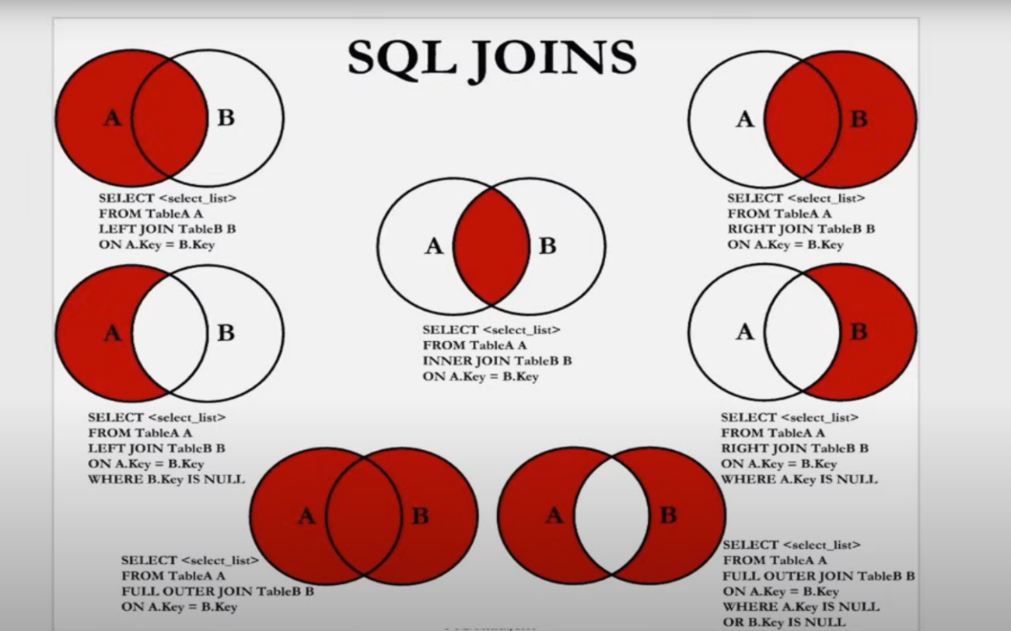

5. SELF JOIN

* A **self-join** is a regular join in which a table is joined to itself
* **SELF Joins** are powerful for comparing values in a column of rows with the same table
* Syntax

SELECT column_name(s)

FROM **Table AS T1**

JOIN **Table AS T2**

ON **T1**.col_name = **T2**.col_name