AI INTERNSHIP REPORT
ON
ARTIFICIAL INTELLIGENCE PROJECTS
(Chatbot with Rule-Based Responses, Tic-Tac-Toe AI, Recommendation System)
Submitted To
School of Computer Science and Engineering
IILM University, Greater Noida, U.P.
In partial fulfilment of the requirement of degree of
B.Tech CSE
By
Roll Number of Student: 25SCS1003001526
Name of Student: SHIVAM KUSHWAHA
Batch: 2CSE16
2026-27

CANDIDATE'S DECLARATION
I, Shivam Kushwaha, Roll No. 25SCS1003001526, do hereby declare that the internship report titled “AI Internship at CodSoft” has been completed by me to fulfil the requirement for the award of the degree of Bachelor of Technology in CSE. All the references have been quoted and I have not taken as such any material from any other source. I affirm to you that this report is my own and has not been submitted to any other institute for any degree/diploma requirement and further I shall be solely responsible for any kind of copyright violation in this regard.
Signature
Student Name: Shivam Kushwaha
Roll No.: 25SCS1003001526

ACKNOWLEDGEMENT
I am using this opportunity to express my gratitude to everyone who supported me throughout my Internship Program at CodSoft. I am thankful for their aspiring guidance, invaluably constructive criticism and friendly advice during this work. I am sincerely grateful to them for sharing their truthful and illuminating views on a number of issues related to Artificial Intelligence and its applications.
I would also like to thank the faculty of the School of Computer Science and Engineering, IILM University, for their continuous support and encouragement throughout this internship.
I express my gratitude to my parents for their blessings.
Signature
Student Name: Shivam Kushwaha
Roll No.: 25SCS1003001526

INTERNSHIP COMPLETION CERTIFICATE
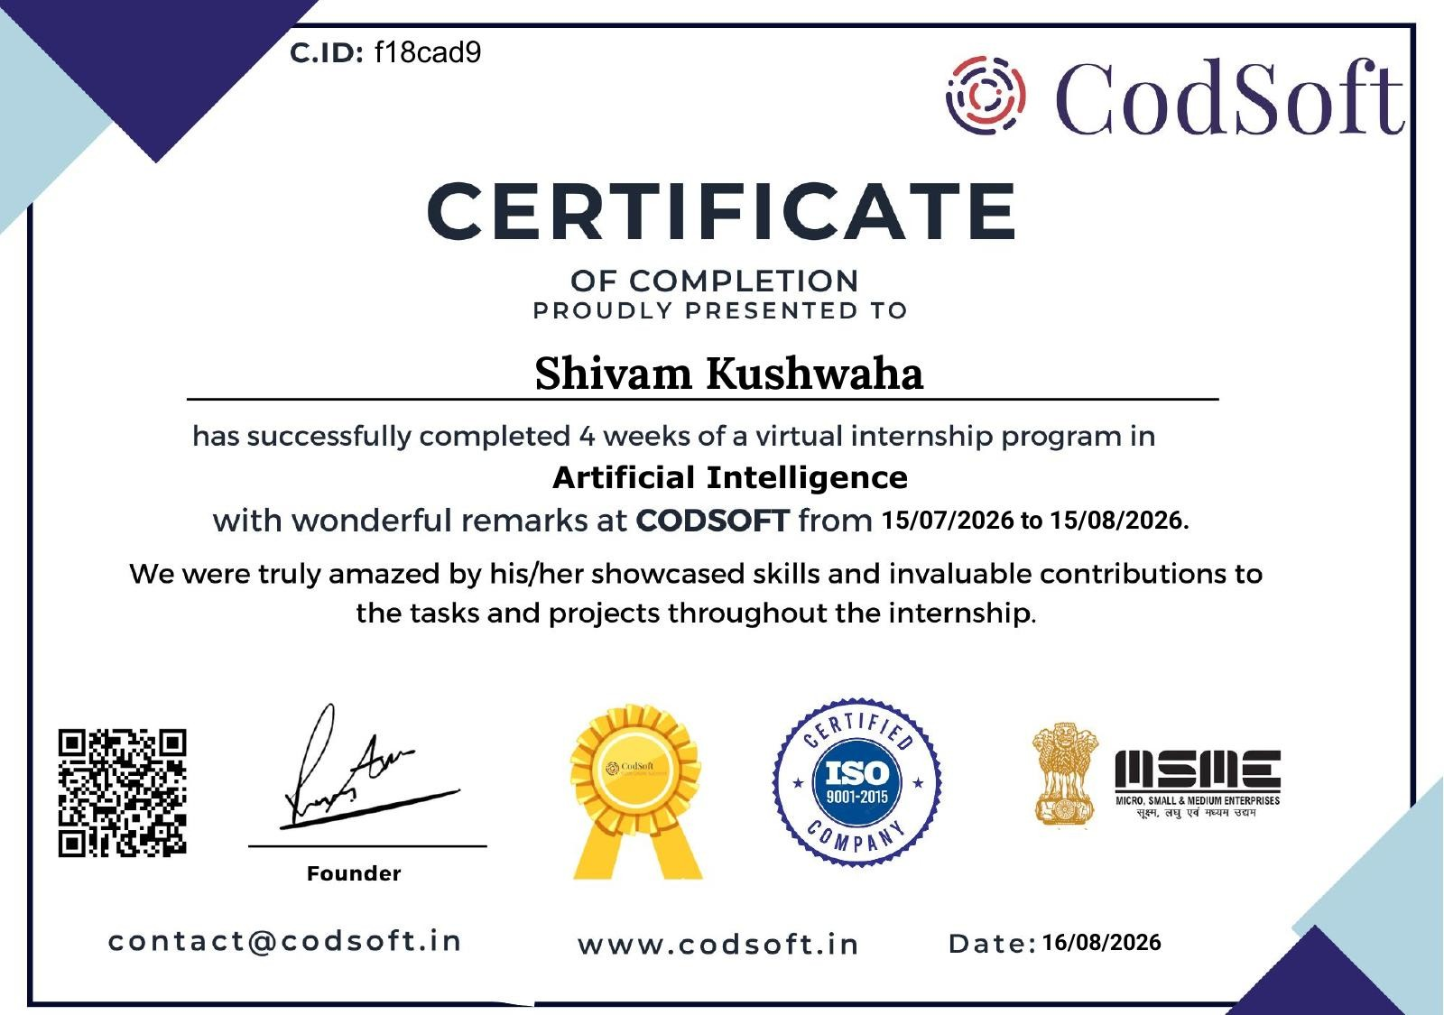

INDEX / TABLE OF CONTENTS
Chapter No. | Chapter Name | Page Nos.
 | Cover Page | ----
1. | Candidate's Declaration | i
2. | Acknowledgement | ii
3. | Internship Completion Certificate | iii
4. | Project Description  4.1 Introduction  4.2 Organization Profile  4.3 Problem Statement  4.4 Project Objectives  4.5 Scope of the Project  4.6 Technologies and Tools Used  4.7 System Architecture  4.8 Methodology  4.9 Expected Outcomes  4.10 Certificates of Completion | 1
5. | Bibliography/References | 15

CHAPTER 4: PROJECT DESCRIPTION
4.1 Introduction
Artificial Intelligence (AI) is one of the most rapidly growing fields of Computer Science, enabling machines to simulate human-like decision-making, learning, and reasoning. As part of my internship at CodSoft, I worked on a series of AI-based mini-projects designed to build a strong foundation in core AI concepts such as rule-based systems, search and game-playing algorithms, and recommendation techniques. This report presents the work carried out during the internship, including the problem statements, objectives, technologies used, methodology, and outcomes of each task.
4.1.1 Background
AI systems appear in everyday life in many forms: virtual assistants that answer questions, game engines that challenge human players, and streaming or shopping platforms that suggest what to watch or buy next. Although the production versions of these systems rely on large datasets and sophisticated machine learning, their underlying ideas can be understood and practised through small, well-defined programs. Rule-based reasoning, state-space search and similarity-based filtering are three such ideas, and each of them formed the basis of one internship task.
4.1.2 Internship Overview
The internship was a 4-week virtual program in Artificial Intelligence, conducted from 15 July 2026 to 15 August 2026. It was organised around three independent mini-projects, each targeting a core AI concept. Working from structured task sheets, I designed, wrote and tested each solution on my own in Python, with mentorship available from the organization.
4.1.3 Structure of the Report
The report begins with the organization profile and the problem statement, followed by the objectives, scope, and the technologies used. The system architecture and the methodology of each task are then described in detail, along with sample outputs and observations. The report closes with the outcomes of the internship, the proof of completion, and the references used.
4.2 Organization Profile
CodSoft is a technology-focused organization that provides internship and training programs to students in domains such as Artificial Intelligence, Web Development, Android Development, Python Programming, Java Programming and Data Science. It offers hands-on, project-based learning where interns are given real-world tasks to build practical skills. Through structured task sheets and mentorship, CodSoft helps students gain exposure to industry-relevant tools and problem-solving approaches, which was the primary mode of learning followed during this internship.
The learning model followed by CodSoft combines three elements: a structured task sheet that defines what has to be built, independent implementation by the intern, and mentorship for guidance. This arrangement gives interns the freedom to decide how to solve a problem while still keeping the work aligned with industry-relevant expectations. The organization places its focus on practical problem-solving skills rather than purely theoretical study.
Table 4.1: Internship Program Details
Particular | Details
Organization | CodSoft
Program | Virtual Internship in Artificial Intelligence
Duration | 4 weeks (15 July 2026 to 15 August 2026)
Mode | Virtual (online)
Number of Tasks | Three independent AI mini-projects
Learning Model | Task sheets, independent implementation and mentorship
Programming Language | Python 3

4.3 Problem Statement
Beginners in Artificial Intelligence often struggle to connect theoretical concepts, such as rule-based logic, search algorithms and recommendation techniques, with practical implementation. The internship addressed this gap by assigning three independent AI tasks, each targeting a specific concept: conversational logic (chatbot), adversarial search (game-playing AI), and personalization (recommendation systems). The problem, therefore, was to design and implement working solutions for each of these tasks using Python.
Each task carried its own challenge. For the chatbot, the challenge was to recognise what a user means from free-form text without any learning component. For the game-playing agent, it was to search a large space of possible future positions efficiently and choose a move that can never lead to a loss. For the recommendation system, it was to decide which items to suggest when only a small amount of preference data is available.
Table 4.2: Mapping of Tasks to AI Concepts
No. | Task | AI Concept | Core Technique
1 | Chatbot with Rule-Based Responses | Conversational AI / NLP basics | If-else logic and regular-expression pattern matching
2 | Tic-Tac-Toe AI | Game-playing AI / adversarial search | Minimax with Alpha-Beta Pruning
3 | Recommendation System | Personalization | Collaborative and content-based filtering

4.4 Project Objectives
The overall aim of the internship was to build a strong practical foundation in Artificial Intelligence. The specific objectives were:
- To build a rule-based chatbot capable of responding to user queries using pattern matching.
- To implement an unbeatable Tic-Tac-Toe AI agent using the Minimax algorithm with Alpha-Beta Pruning.
- To design a simple recommendation system that suggests movies/books/products based on user preferences.
- To gain practical understanding of Natural Language Processing, Game Theory and Search Algorithms, and Recommendation Techniques (Collaborative and Content-Based Filtering).
Beyond these task-level objectives, the internship also aimed at developing good programming habits: writing modular functions, testing programs with different inputs, and keeping the work under version control using Git and GitHub.
4.5 Scope of the Project
The scope of this internship was limited to building foundational, console-based AI applications in Python that demonstrate core concepts rather than production-grade, deployable systems. The chatbot handles a predefined set of rules/patterns; the Tic-Tac-Toe AI is scoped to the standard 3x3 board game; and the recommendation system works on a small sample dataset of user preferences. These projects can further be extended with larger datasets, machine learning models, and web-based interfaces in future work.
Table 4.3: Scope and Limitations of the Three Projects
Project | Within Scope | Outside Scope
Chatbot | Predefined rules; keyword and pattern recognition; console conversation | Learning from conversations; understanding context across many turns; speech or web interface
Tic-Tac-Toe AI | Standard 3x3 board; human versus AI play; optimal move selection | Larger boards; other games; graphical interface
Recommendation System | Small sample dataset; user-based and content-based filtering | Large-scale data; real-time updates; deployment as a service

4.6 Technologies and Tools Used
- Programming Language: Python 3
- Concepts: If-else / Pattern Matching, Minimax Algorithm, Alpha-Beta Pruning, Collaborative & Content-Based Filtering
- Libraries (as applicable): re (regular expressions), pandas/numpy for data handling in the recommendation system
- Tools: VS Code / Jupyter Notebook, Git & GitHub for version control
Python 3 was used for all three tasks because of its readable syntax and its rich set of libraries for text processing and data handling. The built-in re module made it possible to express chatbot rules as patterns, while pandas and NumPy provided convenient structures for the rating table and the similarity calculations. VS Code served as the main editor, and Jupyter Notebook was convenient for trying out the recommendation logic step by step. Git and GitHub were used to track changes and keep each project organised.
Table 4.4: Tools and Their Purpose
Tool / Technology | Purpose in the Internship
Python 3 | Core programming language for all three tasks
Pattern Matching / Regex (re) | Rule-based logic for recognising user queries in the chatbot
Minimax and Alpha-Beta Pruning | Game theory and adversarial search for the Tic-Tac-Toe agent
Pandas / NumPy | Data handling and similarity computation in the recommendation engine
VS Code / Jupyter Notebook | Development environment for writing and testing code
Git & GitHub | Version control and project tracking

The programs are lightweight and run on any ordinary computer, as summarised below.
Table 4.5: Software and Hardware Requirements
Requirement | Specification
Operating System | Windows, macOS or Linux
Python Version | Python 3.x
Python Libraries | re (built in), pandas, NumPy
Editor / IDE | VS Code or Jupyter Notebook
Hardware | Any standard laptop or desktop; no GPU required

4.7 System Architecture
Each of the three tasks follows a simple, modular architecture consisting of an input layer (user query/board state/user preference), a processing/logic layer (rule engine, Minimax search tree, or similarity/filtering engine), and an output layer that returns the chatbot's response, the AI's next move, or the list of recommended items respectively. Since these are independent console-based applications, there is no shared architecture between them beyond the common Python environment used for development.
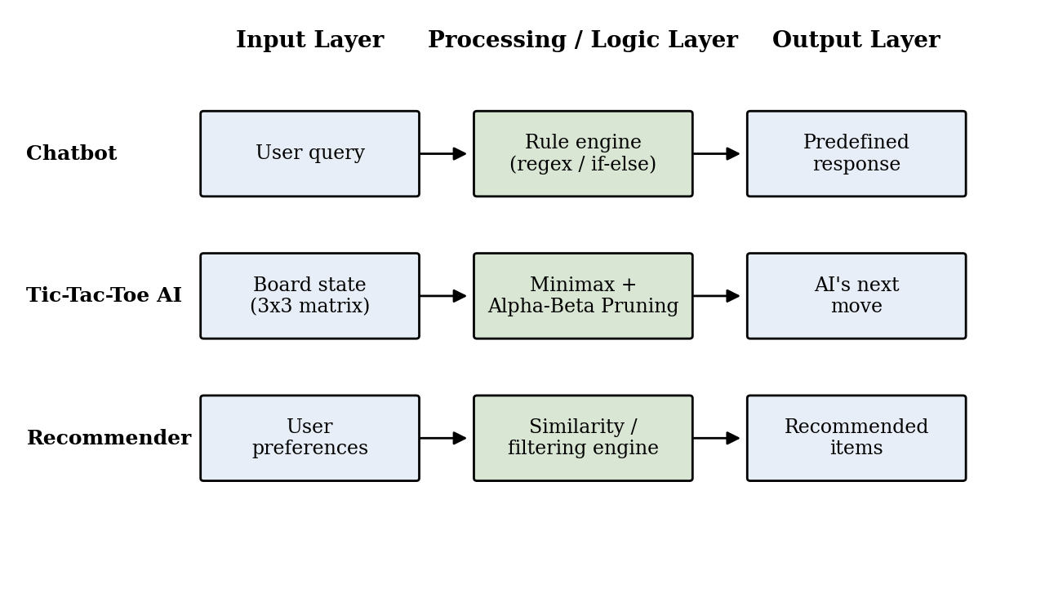
Figure 4.1: Three-layer architecture followed by each task
The separation into layers keeps each program easy to understand and test. The input layer is responsible only for collecting data from the user, the logic layer contains the intelligence of the system, and the output layer presents the result. Because the logic layer is isolated in functions, it can later be reused behind a different interface, such as a web page, without being rewritten.
Table 4.6: Layers of Each Task
Task | Input Layer | Processing / Logic Layer | Output Layer
Chatbot | User query | Rule engine (if-else, regex pattern matching) | Predefined response
Tic-Tac-Toe AI | Board state (3x3 matrix) | Minimax search tree with Alpha-Beta Pruning | AI's next move
Recommendation System | User preferences | Similarity / filtering engine | List of recommended items

4.8 Methodology
Task 1: Chatbot with Rule-Based Responses
A simple chatbot was built that responds to user inputs based on predefined rules. If-else statements and pattern matching techniques were used to identify user queries and map them to appropriate predefined responses. This task provided a basic understanding of Natural Language Processing concepts and conversation flow design.
The design follows four steps. First, the user's message is converted to lower case and stripped of extra spaces so that “Hello” and “ hello ” are treated alike. Second, the message is compared against an ordered list of patterns, each written as a regular expression. Third, the reply attached to the first matching pattern is returned. Finally, if no pattern matches, a polite fallback message asks the user to rephrase. A loop keeps the conversation going until the user says goodbye.
The following listing shows a representative implementation of this approach.
import re

RULES = [
(r"\b(hi|hello|hey)\b", "Hello! How can I help you today?"),
(r"\bhow are you\b", "I'm doing well, thank you for asking!"),
(r"\b(your name|who are you)\b", "I am a simple rule-based chatbot."),
(r"\b(help|support)\b", "I can answer basic questions."),
(r"\b(bye|goodbye|exit)\b", "Goodbye! Have a great day."),
]

def get_response(user_input):
text = user_input.lower().strip()
for pattern, reply in RULES:
if re.search(pattern, text):
return reply
return "Sorry, I did not understand that. Could you rephrase?"

def chat():
print("Bot: Hi! Type 'bye' to end the chat.")
while True:
user = input("You: ")
reply = get_response(user)
print("Bot:", reply)
if re.search(r"\b(bye|goodbye|exit)\b", user.lower()):
break

if __name__ == "__main__":
chat()
Listing 4.1: Rule-based chatbot using regular expressions
Word boundaries (\b) in the patterns prevent accidental matches inside longer words, for example “hi” inside “thinking”. The order of the rules matters because the first match wins, so more specific rules should be placed before general ones.
Table 4.7: Sample Conversation with the Chatbot
User Input | Chatbot Response
Hello | Hello! How can I help you today?
How are you? | I'm doing well, thank you for asking!
What is your name? | I am a simple rule-based chatbot.
Tell me about the weather | Sorry, I did not understand that. Could you rephrase?
Bye | Goodbye! Have a great day.

The sample conversation shows both the strength and the limitation of the rule-based approach. Questions that match a rule receive an accurate, instant reply, whereas anything outside the rule list falls to the fallback response. Extending the chatbot therefore means adding more rules, which is simple but does not scale to open-ended conversation. This limitation clarified why modern conversational systems use statistical and neural language models.
Task 2: Tic-Tac-Toe AI
An AI agent was implemented to play the classic game of Tic-Tac-Toe against a human player. The Minimax algorithm, along with Alpha-Beta Pruning for optimization, was used to make the AI player unbeatable. The board was represented as a matrix, and the algorithm recursively evaluated all possible future game states to choose the optimal move at every turn. This project strengthened understanding of game theory and basic adversarial search algorithms.
Tic-Tac-Toe is a two-player, zero-sum game of perfect information: whatever one player gains, the other loses, and both players can see the whole board. In Minimax, the AI assumes that it will always choose the move that maximises its outcome (MAX) while the human will choose the move that minimises it (MIN). Each finished game is scored as +1 for an AI win, −1 for a human win and 0 for a draw, and these scores are propagated back up the search tree so that the AI can pick the best first move.
The search tree for a full game is large, but many branches cannot influence the final decision. Alpha-Beta Pruning exploits this by keeping two values: alpha, the best score MAX can already guarantee, and beta, the best score MIN can already guarantee. Whenever beta becomes less than or equal to alpha, the remaining moves of that node are skipped, because a rational opponent would never allow that position to be reached. Pruning does not change the result of Minimax; it only reduces the work required to obtain it.
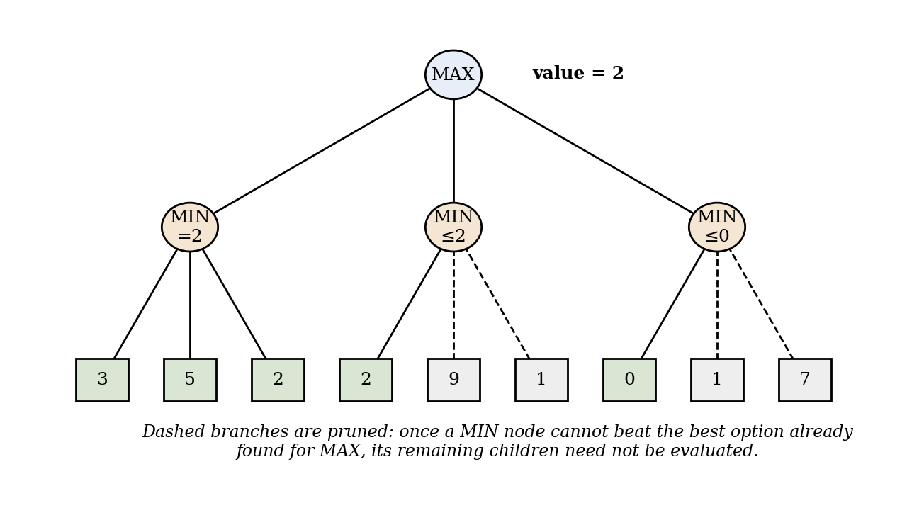
Figure 4.2: Minimax search with Alpha-Beta Pruning on a small game tree
The board is stored as a list of nine cells (a flattened 3x3 matrix) in which a space denotes an empty square. The eight winning lines (three rows, three columns and two diagonals) are checked after every move. The listing below shows a representative implementation.
import math

def winner(b):
lines = [(0,1,2),(3,4,5),(6,7,8),(0,3,6),(1,4,7),(2,5,8),(0,4,8),(2,4,6)]
for a, c, d in lines:
if b[a] != " " and b[a] == b[c] == b[d]:
return b[a]
return None

def minimax(b, is_ai, alpha, beta):
w = winner(b)
if w == "O": return 1 # AI wins
if w == "X": return -1 # human wins
if " " not in b: return 0 # draw
if is_ai:
best = -math.inf
for i in range(9):
if b[i] == " ":
b[i] = "O"
best = max(best, minimax(b, False, alpha, beta))
b[i] = " "
alpha = max(alpha, best)
if beta <= alpha: break
return best
best = math.inf
for i in range(9):
if b[i] == " ":
b[i] = "X"
best = min(best, minimax(b, True, alpha, beta))
b[i] = " "
beta = min(beta, best)
if beta <= alpha: break
return best

def best_move(b):
move, best = None, -math.inf
for i in range(9):
if b[i] == " ":
b[i] = "O"
score = minimax(b, False, -math.inf, math.inf)
b[i] = " "
if score > best:
best, move = score, i
return move
Listing 4.2: Minimax with Alpha-Beta Pruning for Tic-Tac-Toe
To measure the benefit of pruning, the number of game states evaluated by the AI was counted with and without Alpha-Beta Pruning for the AI’s reply to two different opening moves by the human player. In both cases pruning reduced the work by roughly nine-tenths while producing the same decision.
Table 4.8: Game States Evaluated by Minimax With and Without Pruning
Human’s Opening Move | Minimax Only | With Alpha-Beta | Reduction
Centre square | 55,504 | 6,138 | 89%
Corner square | 59,704 | 4,089 | 93%
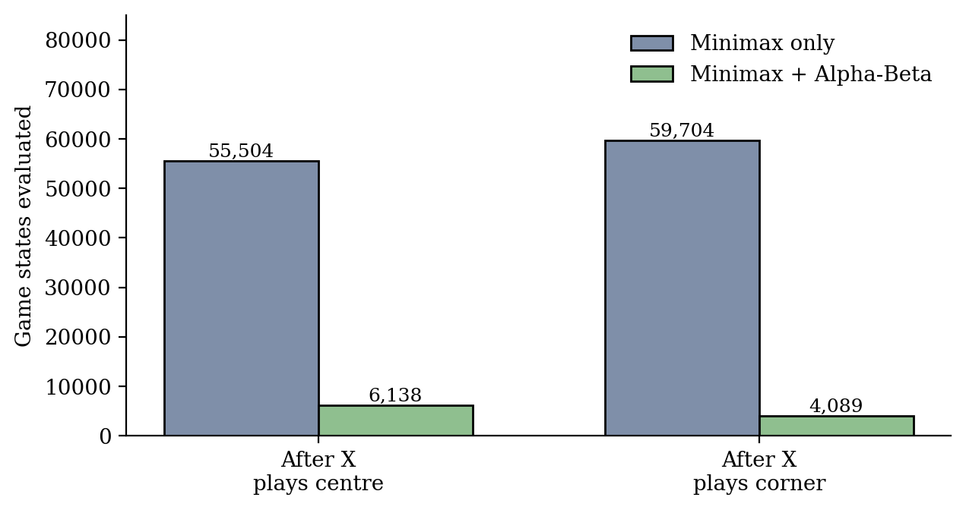
Figure 4.3: Effect of Alpha-Beta Pruning on the number of states evaluated
The agent was tested by playing against it in many ways, including deliberately weak moves and the strongest openings. It always won when the human made a mistake and otherwise forced a draw, never losing a game. It also took a winning move when one was available and blocked the human’s winning move when necessary, which follows directly from the scoring of the search.
Task 3: Recommendation System
A simple recommendation system was created that suggests items (movies, books, or products) to users based on their preferences. Both collaborative filtering (recommending items liked by similar users) and content-based filtering (recommending items similar in attributes to what the user already likes) approaches were explored, using a small sample dataset to demonstrate the working of these techniques.
In collaborative filtering, the ratings given by users are stored in a table with users as rows and items as columns. The similarity between two users is measured with cosine similarity, which compares the direction of their rating vectors, so that users with similar tastes score close to 1. For a target user, the most similar user is found, and the items that this neighbour rated highly but the target has not yet seen are recommended.
In content-based filtering, each item is described by its attributes, such as genre. An item is represented as a vector of these attributes, and the items whose vectors are most similar to an item the user already likes are recommended. This approach does not need data from other users, which makes it useful when little rating data is available, but it can only suggest items similar to what the user has already seen.
The listing below shows a representative implementation using pandas and NumPy on a small sample dataset of four users and five movies.
import pandas as pd
import numpy as np

ratings = pd.DataFrame(
{"Inception":[5,4,1,0], "Interstellar":[5,5,2,1],
"Titanic":[1,2,5,4], "The Notebook":[0,1,5,5],
"Avatar":[4,0,2,0]},
index=["Aman","Riya","Karan","Meera"])

def cosine(a, b):
return a @ b / (np.linalg.norm(a) * np.linalg.norm(b))

def collaborative(user, n=2):
target = ratings.loc[user].values
sims = {u: cosine(target, ratings.loc[u].values)
for u in ratings.index if u != user}
best = max(sims, key=sims.get)
unseen = ratings.columns[ratings.loc[user] == 0]
picks = ratings.loc[best, unseen].sort_values(ascending=False)
return best, round(float(sims[best]), 2), list(picks[picks > 0].index[:n])

genres = pd.DataFrame(
{"Sci-Fi":[1,1,0,0,1], "Romance":[0,0,1,1,0], "Drama":[0,1,1,1,0]},
index=ratings.columns)

def content_based(movie, n=2):
v = genres.loc[movie].values
sims = {m: cosine(v, genres.loc[m].values)
for m in genres.index if m != movie}
return sorted(sims, key=sims.get, reverse=True)[:n]
Listing 4.3: Collaborative and content-based filtering with pandas and NumPy
Table 4.9: Sample Output of the Recommendation System
Request | Technique | Recommendation
Recommend for Aman | Collaborative (most similar user: Riya, 0.85) | The Notebook
Recommend for Meera | Collaborative (most similar user: Karan, 0.94) | Avatar, Inception
Movies similar to Inception | Content-based (genre vectors) | Avatar, Interstellar
Movies similar to Titanic | Content-based (genre vectors) | The Notebook, Interstellar

The results behave as expected. Meera, who prefers romance films, is matched with Karan, who has a similar taste, and receives titles that Karan rated. Content-based filtering recommends the science-fiction films closest to Inception, and romance and drama films closest to Titanic. Comparing the two approaches, collaborative filtering can surface items that are different in attributes but popular with similar users, while content-based filtering is more predictable and works even for a new user with a single liked item.
Testing and Evaluation
Each program was tested separately with a variety of inputs, covering normal use, unusual input and boundary situations. The table below summarises the main test cases and the results observed.
Table 4.10: Summary of Test Cases
Project | Test Case | Observed Result
Chatbot | Greeting in capital letters or with extra spaces | Recognised after normalisation; correct reply
Chatbot | Unknown question | Fallback message shown
Chatbot | Farewell word | Goodbye message shown and the program ends
Tic-Tac-Toe AI | Human plays a weak move | AI finds a winning line and wins
Tic-Tac-Toe AI | Human plays the strongest moves | Game ends in a draw; AI never loses
Tic-Tac-Toe AI | Human threatens to win in one move | AI blocks the winning square
Recommender | User who has seen most items | Only unseen items are suggested
Recommender | Item with no similar genre | Lower-scoring items returned after closest matches

4.9 Expected Outcomes
- A working rule-based chatbot that can hold a basic conversation with the user.
- An unbeatable Tic-Tac-Toe AI agent that never loses against a human opponent.
- A functional recommendation system that suggests relevant items based on user preference data.
- Strengthened practical knowledge of core AI concepts: NLP basics, game theory/search algorithms, and recommendation techniques.
4.9.1 Outcomes Achieved
All three expected outcomes were achieved. The chatbot holds a basic conversation using predefined rules; the Tic-Tac-Toe agent plays optimally and does not lose; and the recommendation system produces suggestions using both collaborative and content-based filtering on a sample dataset. Together, the three projects gave hands-on experience in translating AI theory into working Python code.
Table 4.11: Skills and Knowledge Gained
Area | What Was Learned
Natural Language Processing basics | Pattern matching, input normalisation, fallback handling and conversation flow design
Game theory and search | Game state representation, recursive search, Minimax evaluation and Alpha-Beta Pruning
Recommendation techniques | Rating matrices, cosine similarity, collaborative and content-based filtering
Programming practice | Modular functions, testing with varied inputs, use of pandas/NumPy, Git and GitHub

4.9.2 Challenges and Solutions
Table 4.12: Challenges Faced and How They Were Handled
Challenge | Approach Taken
Rules matching the wrong words in the chatbot | Used word boundaries in regular expressions and ordered specific rules before general ones
Slow decision making in the Tic-Tac-Toe search | Applied Alpha-Beta Pruning, which cut the evaluated states by about 90%
Recommending items a user had already seen | Restricted candidates to items with no rating from the target user
Very little data for the recommender | Combined collaborative filtering with content-based filtering and tested on a small sample set

4.9.3 Future Enhancements
- Extend the chatbot with intent classification and a machine learning or large language model back end, and add a web or messaging interface.
- Add a graphical interface to the Tic-Tac-Toe game and generalise the search to larger boards or other games such as Connect Four.
- Train and evaluate the recommender on a larger public dataset, and combine both filtering methods into a hybrid system.
4.9.4 Conclusion
The internship at CodSoft provided a practical introduction to three important areas of Artificial Intelligence. By building a chatbot, a game-playing agent and a recommendation system, I could see how a theoretical idea becomes a working program and where its limits lie. The experience strengthened my programming skills and my interest in AI, and it forms a good base for learning more advanced topics such as machine learning and natural language processing.

4.10 Certificates of Completion
The CodSoft Artificial Intelligence virtual internship completion certificate is attached below as proof of completion. The certificate details are as follows:
Detail | Information
Certificate ID (C.ID) | f18cad9
Awarded To | Shivam Kushwaha
Program | Virtual Internship in Artificial Intelligence (4 weeks)
Duration | 15/07/2026 to 15/08/2026
Date of Issue | 16/08/2026
Issued By | CodSoft (contact@codsoft.in | www.codsoft.in)

Figure 4.4: CodSoft internship completion certificate

BIBLIOGRAPHY / REFERENCES
- CodSoft Internship Task Sheet – Artificial Intelligence Internship, 2026.
- Python Software Foundation. Python 3 Documentation. https://docs.python.org/3/
- Russell, S., & Norvig, P. Artificial Intelligence: A Modern Approach. Pearson Education.
- GeeksforGeeks. Minimax Algorithm in Game Theory. https://www.geeksforgeeks.org/
- Knuth, D. E., & Moore, R. W. (1975). An analysis of alpha-beta pruning. Artificial Intelligence, 6(4), 293–326.
- Jurafsky, D., & Martin, J. H. Speech and Language Processing. Pearson.
- Ricci, F., Rokach, L., & Shapira, B. (Eds.). Recommender Systems Handbook. Springer.
- The pandas development team. pandas Documentation. https://pandas.pydata.org/docs/
- NumPy Developers. NumPy Documentation. https://numpy.org/doc/

