
Git & GitHub
DEVOPS | Assignment
SUBMISSION GUIDELINES
• Complete all tasks and document your work in a doc (Google Doc or Microsoft Word) with screenshots/commands and explanations.
• Create one folder named Git_and_GitHub_YourName.
• Put your complete project source code and all files inside this folder.
• Add your documentation file (with screenshots and explanations) inside the same folder.
• Compress the folder into a .zip file (Git_and_GitHub_YourName.zip).
• Upload the .zip file on the submission portal.
Zip File Must Contain
• Your complete project source code and all files
• Document with screenshots/commands and explanation for every task
• GitHub repository link
⚠ Your full project code MUST be submitted inside this .zip file. Screenshots (terminal / commands / output) are mandatory. Also share your GitHub repository link.
Do NOT upload separate files.
Do NOT submit without compressing into a .zip file.

Objective: Practise the full Git workflow — SSH setup, branching, merging, conflict resolution, sequential commits, git reset, and rebasing — using a Flask project.

Task 1: Repository Setup & First Branch
- Create a new GitHub repository.
Ans : Link :- https://github.com/shivamlearning9078-debug/Git_and_GitHub_Shivam
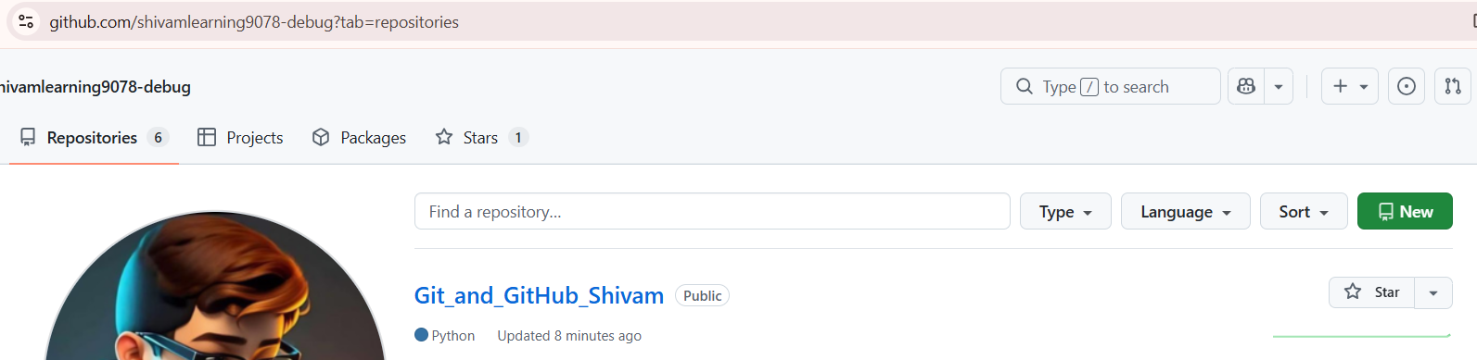

- Clone the repository to your local machine using SSH (generate an SSH key if needed, and add the public key to your GitHub account).
Ans: Added ssh key to my GitHub
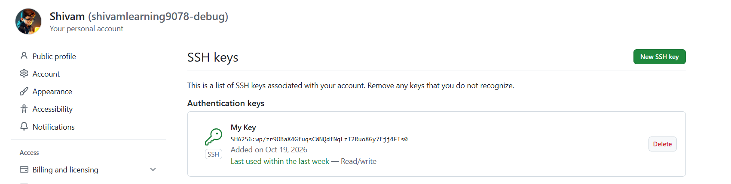
Connection Test done
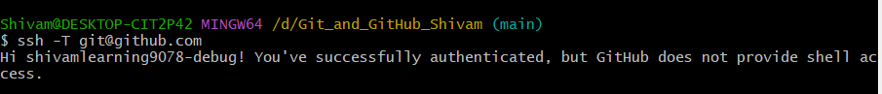
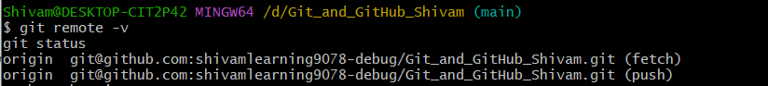
- Create a new branch named after your username (e.g., Tutedude).
Ans: git branch
git branch -M main
git switch -c Shivam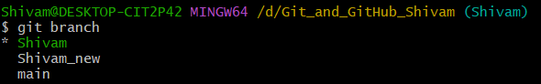
- Add your Flask project files to this branch.
Ans: 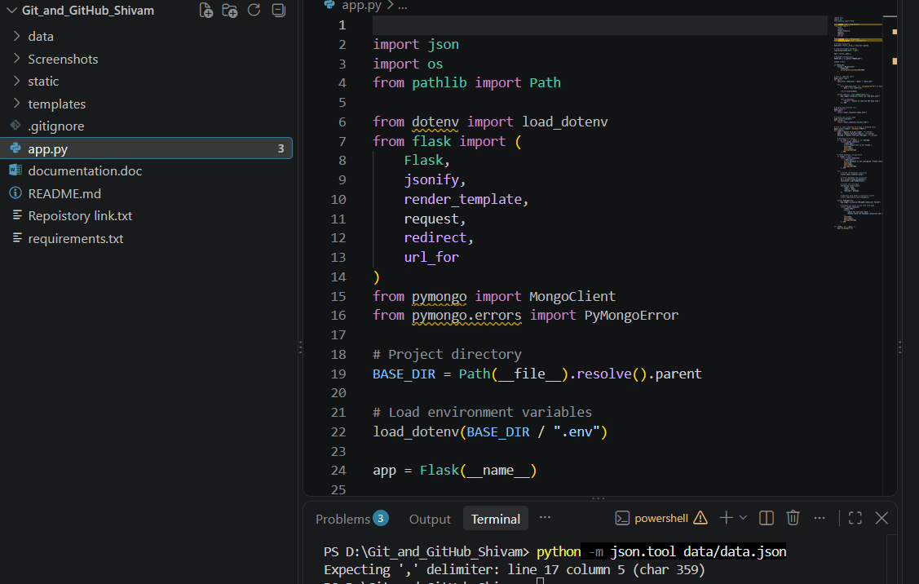
- Commit the changes and merge the branch into the main branch.
Ans: 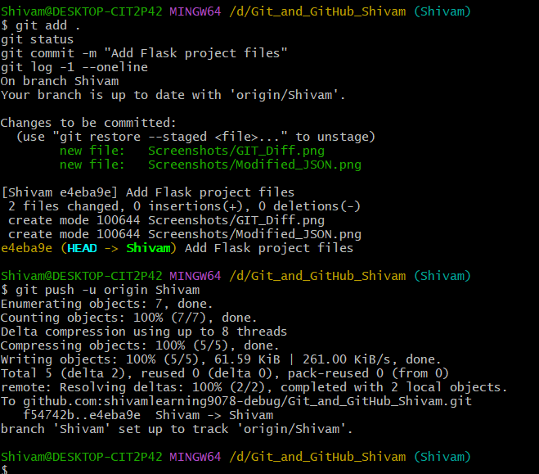
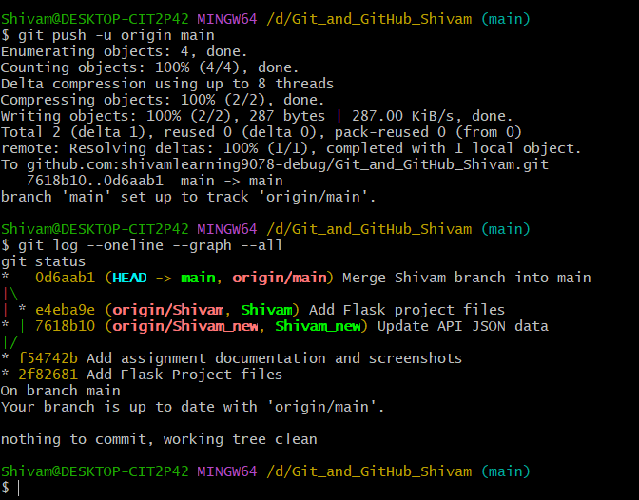
Task 2: Update JSON & Resolve Conflicts
- Create a new branch named _new (e.g., Tutedude_new).
Ans: Created a new branch named Shivam_new
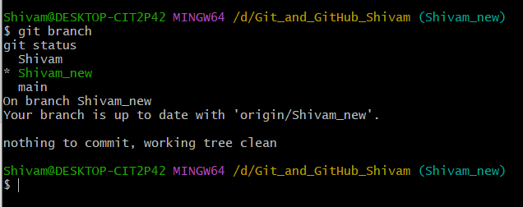
- Update the content of the JSON file used for the /api route in this branch.
Ans: JSON file
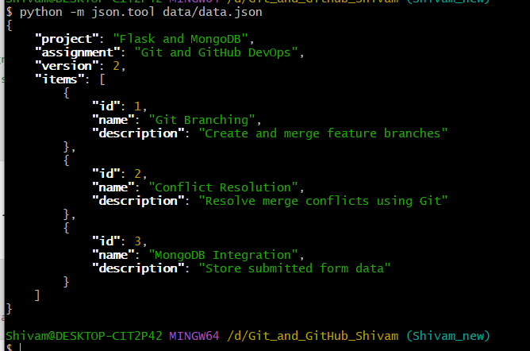
Commit the change:
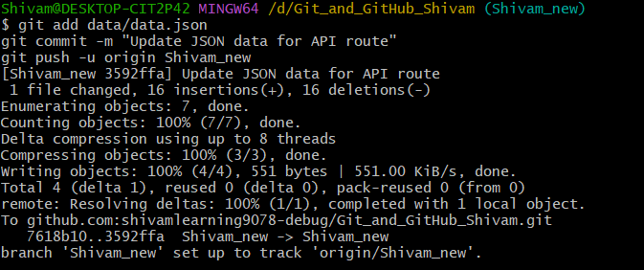

- Merge the _new branch into the main branch.
Ans: Merge Shiivam_new to main
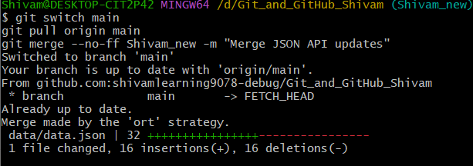
- If there are conflicts during the merge, resolve them by accepting the changes from the _new branch.
Ans: Resolved conflict and accepted necessary changes
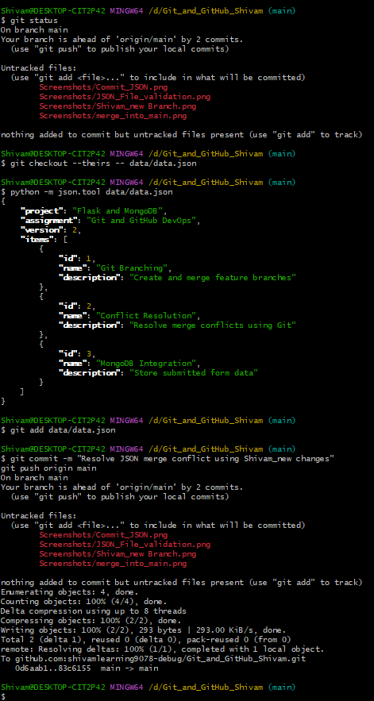
- Add the resolved changes to the staging area, commit them, and push the updates to the remote repository.
Ans: 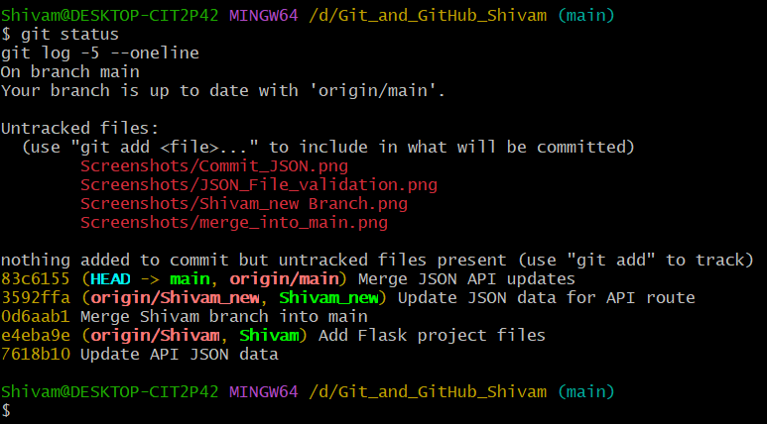
Task 3: Parallel Feature Development
- Branch Creation: Create two branches, master_1 and master_2, from the main branch.
Ans : Switched to main
git switch main
git pull origin main
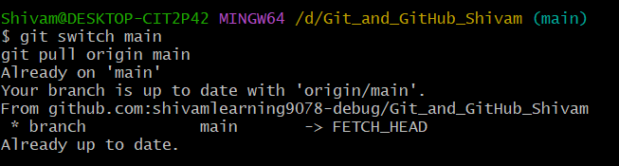
Create first branch
git switch -c master_1
git push -u origin master_1
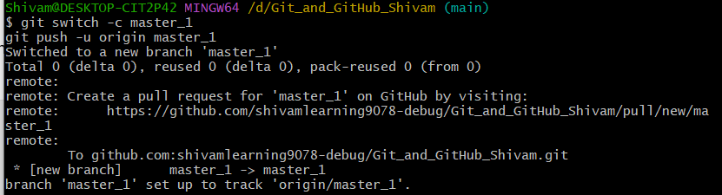
Return to main and create the second branch:
git switch main
git switch -c master_2
git push -u origin master_2
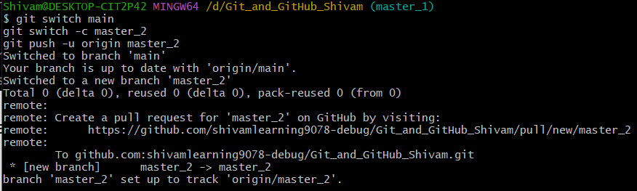
Verify the branches:
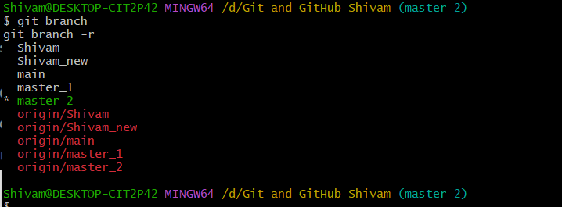
- Feature Development in master_1: Create a To-Do Page in the frontend with a form containing the fields Item Name and Item Description.
Ans: Switched to master_1
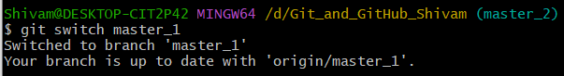
Created a To-Do Page in frontend i.e, index.html
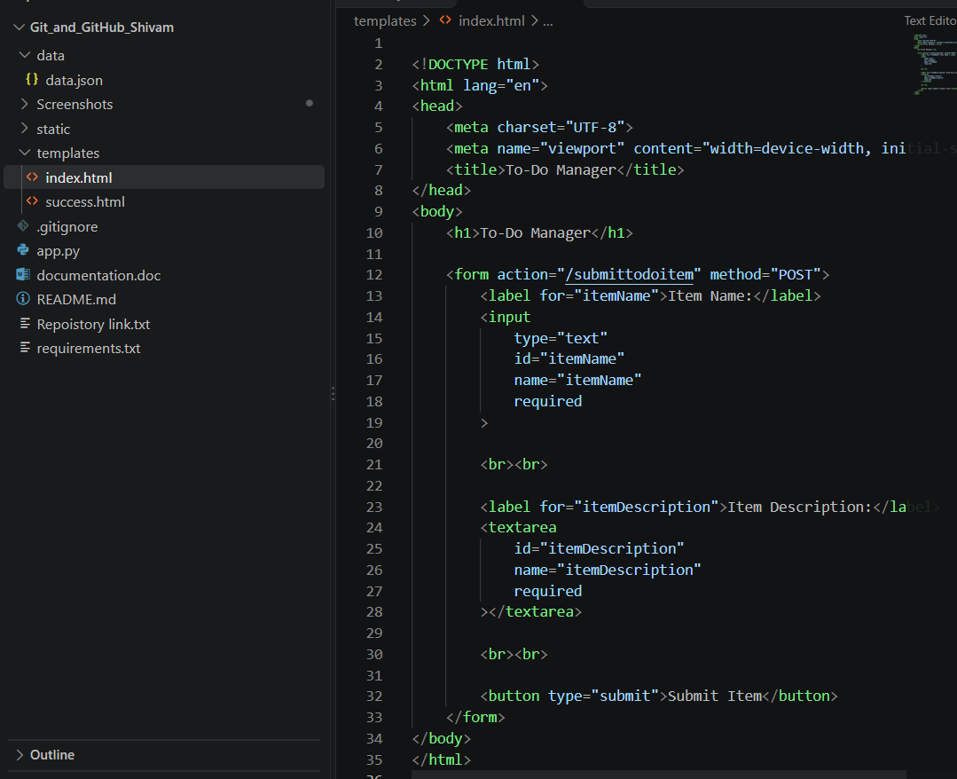
Commit and pushed frontend changes
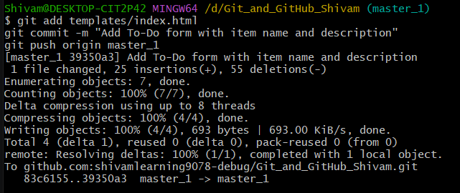
- Backend API in master_2: Create a backend route named /submittodoitem that accepts itemName and itemDescription via a POST request and stores these details in a MongoDB database.
Ans: /submittodoitem added
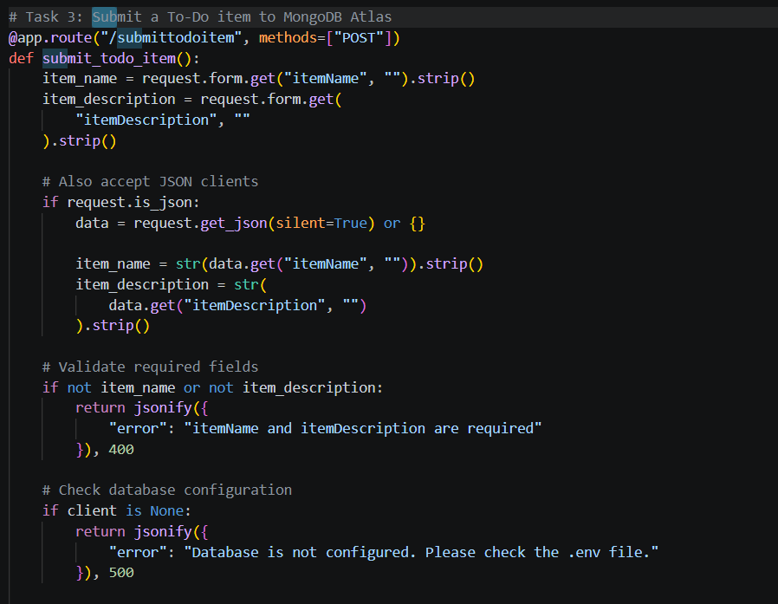
Committed and pushed in backend
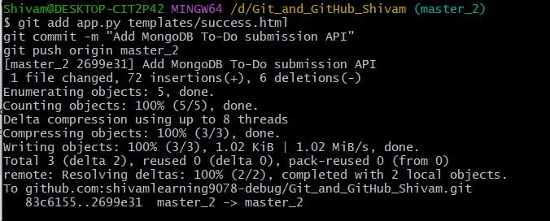
- Merging Changes: Merge the changes from both master_1 and master_2 into the main branch.
Ans: Merged frontend and backend
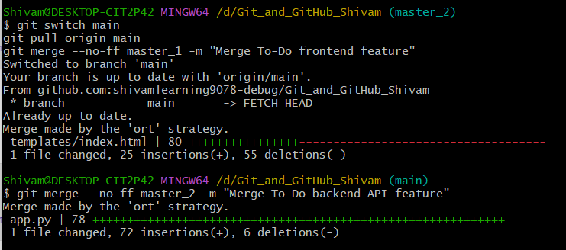
Push the merged result 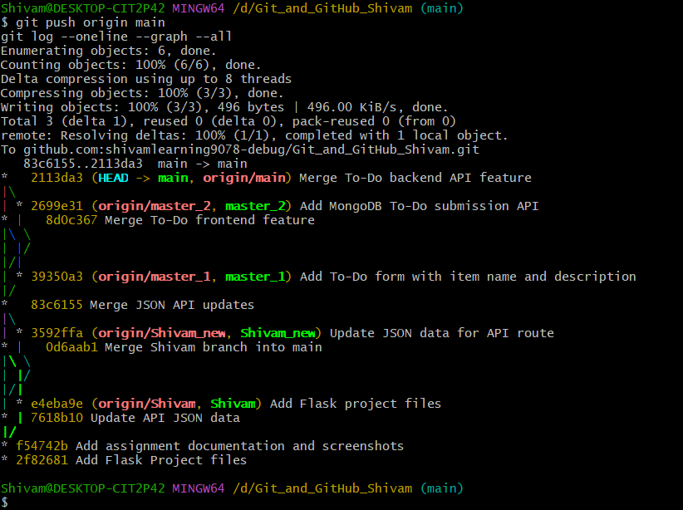
Open the local URL displayed by Flask, http://127.0.0.1:5000
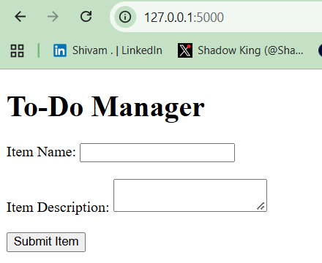
Submitted successfully
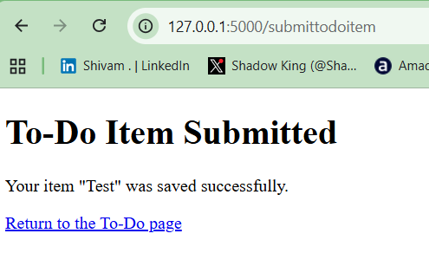
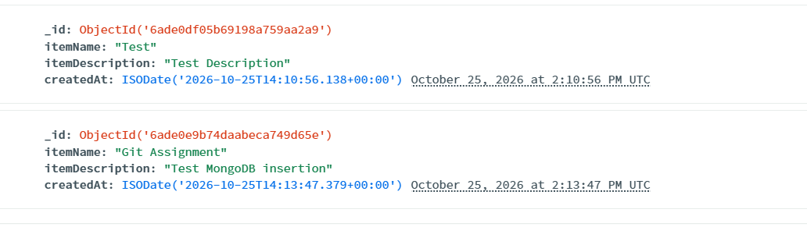
Task 4: Sequential Commits, Reset & Rebase
- Enhancing the To-Do Form in master_1: Add the following fields to the To-Do form: Item ID, Item UUID, Item Hash.
Ans: Added in index.html
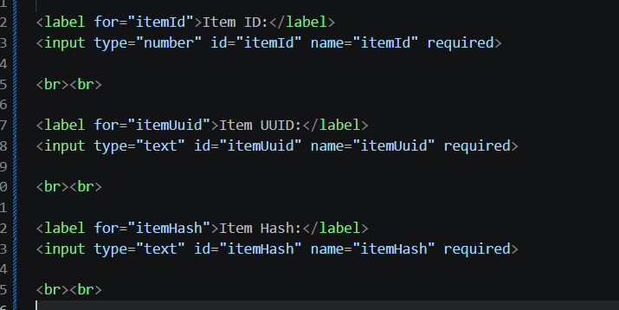
- Committing in Sequence: Add and commit each field separately — first commit: Item ID; second commit: Item UUID; third commit: Item Hash.
Ans: Commit Item ID
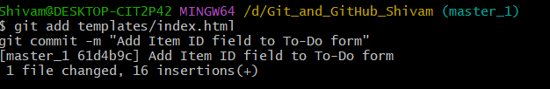
Commit Item UUID
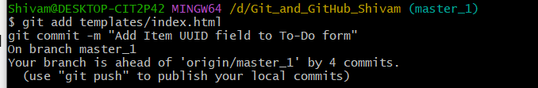
Commit Item Hash
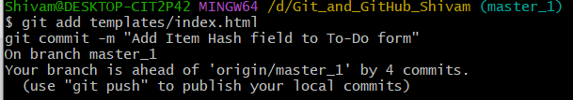
- Merging to main: Merge the master_1 branch into the main branch.
Ans: Merge master_1 into main branch
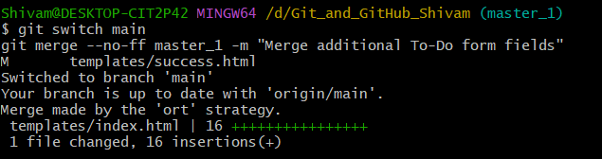
- Git Reset: In the main branch, roll back to the commit where only the Item ID field was added. Use git reset --soft to ensure changes remain staged, then re-commit this state and merge it to main.
Ans:
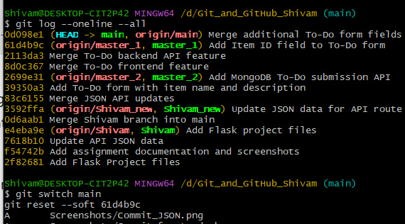
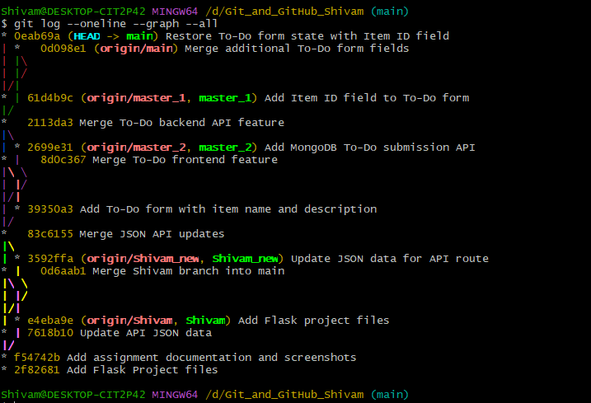
- Rebasing: Rebase the updated main branch changes onto master_1 using git rebase main master_1. Preserve individual commits (do NOT squash) to maintain commit history.
Ans: Required commands
git switch main
git pull origin main
git switch master_1
git rebase main master_1
