
Python & Bash
DEVOPS | Assignment
SUBMISSION GUIDELINES
• Complete all tasks and document your work in a doc (Google Doc or Microsoft Word) with screenshots/commands and explanations.
• Create one folder named Python_and_Bash_YourName.
• Put your complete project source code and all files inside this folder.
• Add your documentation file (with screenshots and explanations) inside the same folder.
• Compress the folder into a .zip file (Python_and_Bash_YourName.zip).
• Upload the .zip file on the submission portal.
Zip File Must Contain
• Your complete project source code and all files
• Document with screenshots/commands and explanation for every task
• GitHub repository link (or code files)
⚠ Your full project code MUST be submitted inside this .zip file. Screenshots (terminal / commands / output) are mandatory. Also share your GitHub repository link.
Do NOT upload separate files.
Do NOT submit without compressing into a .zip file.

Objective: Practise core Python programming — conditionals, dictionaries, and file handling (reading and writing files).

1. Grade Checker
Take a score as input and print the grade based on the following:
- 90+ : “A”
- 80–89 : “B”
- 70–79 : “C”
- 60–69 : “D”
- Below 60 : “F”
- Use a basic if / else statement to determine the grade.
Ans: Python program for Grade Checker
# Grade Checker Program
score = float(input("Enter the student's score (0-100): "))

if score < 0 or score > 100:
print("Invalid score! Enter a score between 0 and 100.")
elif score >= 90:
print("Grade: A")
elif score >= 80:
print("Grade: B")
elif score >= 70:
print("Grade: C")
elif score >= 60:
print("Grade: D")
else:
print("Grade: F")

Output :
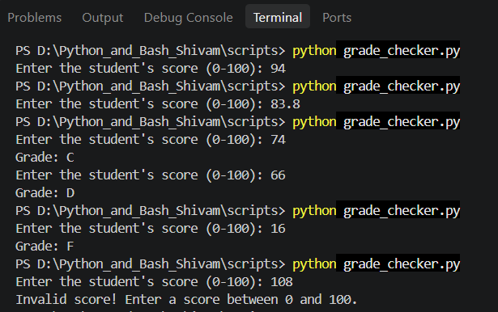
Explanation:
Step 1: Adding a comment
# Grade Checker Program
The # symbol is used to write a comment. Python ignores comments when running the program. This comment tells us what the program does.
Step 2: Take the student's score as input
score = float(input("Enter the student's score (0-100): "))
The input() function asks the user to enter a score. The float() function converts the entered value into a number, allowing decimal marks such as 89.5. The score is stored in the variable score.
Step 3: Check whether the score is valid
if score < 0 or score > 100:
This checks whether the score is below 0 or above 100. The or operator means that if either condition is true, the score is invalid.
print("Invalid score! Enter a score between 0 and 100.")
If the score is invalid, this message is displayed.
Step 4: Check for Grade A
elif score >= 90:
The elif keyword means "else if." If the previous condition is false, Python checks whether the score is 90 or higher. If true, it prints Grade: A.
Step 5: Check for Grade B
elif score >= 80:
If the score is less than 90 but at least 80, the program prints Grade: B.
Step 6: Check for Grade C
elif score >= 70:
If the score is less than 80 but at least 70, the program prints Grade: C.
Step 7: Check for Grade D
elif score >= 60:
If the score is less than 70 but at least 60, the program prints Grade: D.
Step 8: Assign Grade F
else:
print("Grade: F")
If none of the previous conditions is true, the score is below 60. The program prints Grade: F.

2. Student Grades
Create a dictionary where the keys are student names and the values are their grades. Allow the user to:
- Add a new student and grade.
- Update an existing student's grade.
- Print all student grades.
- Use a dictionary and basic operations with if / else.
Ans: Python program for Student Grades
# Student Grades Management Program

students = {
"Rahul": "A",
"Priya": "B",
"Aman": "C"
}

while True:
print("\n--- Student Grades Menu ---")
print("1. Add a new student")
print("2. Update a student's grade")
print("3. Display all student grades")
print("4. Exit")

choice = input("Enter your choice (1-4): ").strip()

if choice == "1":
name = input("Enter student name: ").strip()
grade = input("Enter student grade (A, B, C, D, F): ").strip().upper()

if not name:
print("Student name cannot be empty.")
elif grade not in ["A", "B", "C", "D", "F"]:
print("Invalid grade. Please enter A, B, C, D, or F.")
elif name in students:
print("Student already exists. Choose update instead.")
else:
students[name] = grade
print("Student added successfully.")

elif choice == "2":
name = input("Enter the student name to update: ").strip()

if name in students:
grade = input("Enter the new grade (A, B, C, D, F): ").strip().upper()

if grade in ["A", "B", "C", "D", "F"]:
students[name] = grade
print("Grade updated successfully.")
else:
print("Invalid grade.")
else:
print("Student not found.")

elif choice == "3":
if students:
print("\n--- All Student Grades ---")
for name, grade in students.items():
print(f"{name}: {grade}")
else:
print("No students found.")

elif choice == "4":
print("Exiting Student Grades Program.")
break

else:
print("Invalid choice. Please enter a number from 1 to 4.")

Output:
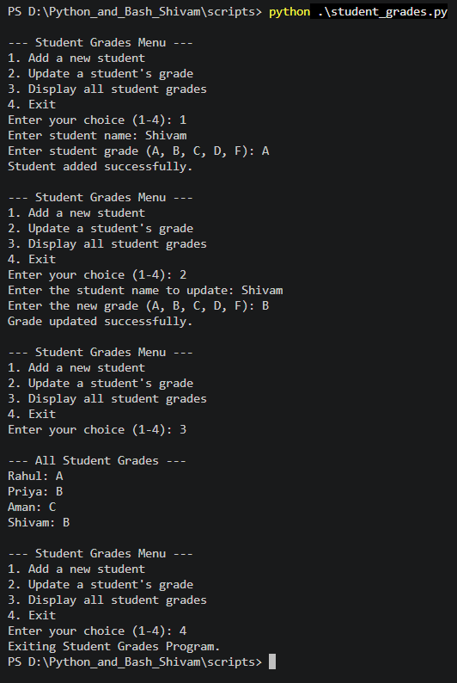
Explanation:
1. Create a Dictionary: Stores student names as keys and their grades as values.
2. Display the Menu: The while True loop repeatedly displays the menu until the user exits.
3. Take User Input: The input() function accepts the user's choice, and strip() removes extra spaces.
4. Add a Student: The if condition checks the name and grade. If valid and the student does not already exist, the student is added using students[name] = grade.
5. Update a Grade: The elif condition checks whether the student exists. If found, the program updates their grade; otherwise, it displays an error message.
6. Display All Grades: The students.items() method retrieves all student names and grades, and the for loop displays them.
7. Exit the Program: The break statement stops the loop when the user selects option 4.
8. Handle Invalid Choices: The else statement displays an error message if the user enters an invalid menu option.

3. Write to a File
- Write a program to create a text file and write some content to it, using file functions like open() and write().
Ans: Python program to create a text file and write some content
# Write Content to a File

file = open("student_data.txt", "w")

file.write("Python and Bash Assignment\n")
file.write("Name: Shivam\n")
file.write("Topic: File Handling in Python\n")
file.write("This file was created using Python.\n")

file.close()

print("Content written to student_data.txt successfully!")

Output :
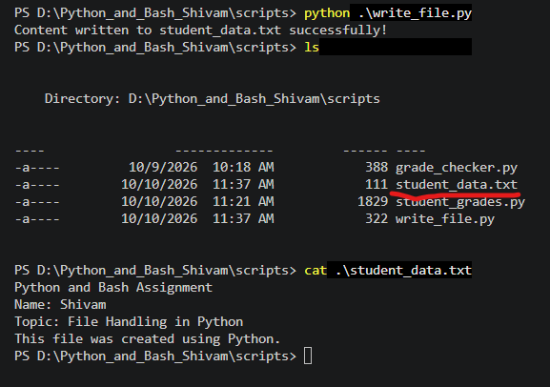
Explanation:
- open("student_data.txt", "w") opens the file in write mode and creates it if it does not exist.
- write() adds text to the file.
- \n moves the next text to a new line.
- close() closes the file after writing.
- Important: Write mode ("w") replaces existing contents when the file already exists.
4. Read from a File
- Open the file in read mode and use file.read() to read and display its content.
Ans: Python program to open file in read mode
# Read Content from a File

file = open("student_data.txt", "r")

content = file.read()

print("Contents of the file:")
print(content)

file.close()

Output:
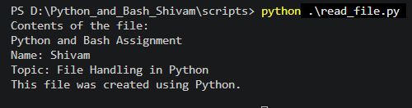

Explanation:
open("student_data.txt", "r") opens the existing file in read mode.
file.read() reads the entire contents of the file.
print(content) displays those contents in the terminal.
close() closes the file.

