VoltStream Energy Intelligence
ML Notebook — Technical Documentation
Tachyon AIML Internship Program | Week 2 ML Track
Shivam Kumar, AI/ML Intern, Tachyon Technologies
Hyderabad, India | 2024 Prosumer Dataset | 2026

366 Days  Training Data | 5 Models  Full Pipeline | INR 17,530  Annual Bill | 18 Anomalies  5% of Records

Table of Contents
1. Project Overview3
2. Environment & Dependencies4
3. Data Pipeline5
4. Exploratory Data Analysis7
5. Regression Models — Ridge & SVR9
6. Classification Models — Logistic & SVC13
7. SHAP Explainability17
8. Time Series Forecasting (Holt-Winters)18
9. Comprehensive Comparative Analysis20
10. Live Prediction Demo24
11. Model Persistence & Model Card25
12. Key Findings & Future Work26

1. Project Overview
VoltStream Energy Intelligence is a complete machine-learning pipeline designed for a prosumer household in Hyderabad, India. A prosumer simultaneously produces electricity via rooftop solar panels and consumes from the grid — making accurate modelling of the interplay between generation, storage, and consumption critical for billing prediction and operational planning.

This notebook (v4) extends the prior version by adding two Support Vector Machine models — SVR for bill regression and SVC for usage classification — enabling direct comparison between linear baselines and non-linear kernel methods.

1.1 Model Pipeline at a Glance
# | Model | Type | Task | Algorithm
1 | Ridge Regression | Regression | Predict monthly electricity bill | L2-regularised linear regression
2 | SVR (RBF) | Regression | Predict monthly electricity bill | Support Vector Regression, RBF kernel
3 | Logistic Regression | Classification | Predict high / low grid-draw day | Logistic classifier, PR-tuned threshold
4 | SVC (RBF) | Classification | Predict high / low grid-draw day | Support Vector Classifier, RBF kernel
5 | Holt-Winters | Forecasting | 2-month forward bill forecast | Exponential smoothing (add vs mul)

1.2 Changes in v4
Issue in v3 | Fix in v4 | Impact
No SVM models | SVR + SVC added with RBF kernel, GridSearchCV tuning | Captures non-linear relationships between temperature, solar, and grid draw
No comparative analysis | Section 12: head-to-head metric table + radar chart + bar comparisons | Holistic model selection view with trade-off visibility

2. Environment & Dependencies
The notebook runs on Google Colab with GPU/CPU runtimes. All dependencies are installed at the top of the notebook via pip.

2.1 Core Stack
Package | Version (min) | Purpose
scikit-learn | 1.3+ | Ridge, SVR, Logistic, SVC, GridSearchCV, metrics
numpy | 1.24+ | Numerical arrays, random seed management
pandas | 2.0+ | DataFrames, groupby aggregation
matplotlib / seaborn | 3.7+ / 0.12+ | All visualisation and plotting
statsmodels | 0.14+ | Holt-Winters ExponentialSmoothing
shap | 0.42+ | LinearExplainer for logistic model
pandera | 0.17+ | Schema-based data validation
openmeteo-requests | latest | Fetch real Hyderabad 2024 weather via API
joblib | bundled | Model serialisation (.pkl files)

2.2 Google Drive Mount
All outputs (plots, model .pkl files, model card JSON) are saved to /content/drive/MyDrive/voltstream-ml-v4. This ensures persistence across Colab session resets.
from google.colab import drive
drive.mount("/content/drive")
SAVE_DIR = "/content/drive/MyDrive/voltstream-ml-v4"

2.3 Global Configuration
A fixed random seed (SEED = 42) is applied to NumPy and all scikit-learn estimators for full reproducibility. The VoltStream dark theme is applied globally to Matplotlib for consistent visual output.
Random Seed: SEED = 42 — applied to np.random.seed() and all sklearn random_state parameters
Plot Theme: Dark background (#0d1117) with monospace fonts and high DPI (120) for submission-quality plots

3. Data Pipeline

3.1 Weather Data Acquisition (Step 4)
Real Hyderabad 2024 weather is fetched from the Open-Meteo Historical Archive API. The request targets two daily variables — maximum temperature and shortwave radiation sum — for the full calendar year January 1 to December 31, 2024.

Parameter | Value
Latitude | 17.3850° N (Hyderabad)
Longitude | 78.4867° E
Date Range | 2024-01-01 to 2024-12-31
Variables | temperature_2m_max, shortwave_radiation_sum
Timezone | Asia/Kolkata (IST, UTC+5:30)
Record Count | 366 days (leap year)

3.2 Synthetic Feature Engineering (Step 5)
The raw weather data is augmented with derived and synthetically generated features that simulate a realistic prosumer household. All generation follows documented physical and behavioural logic.

Feature | Type | Generation Logic
solar_kwh | Continuous | 1.5 + 7.5 × normalised_radiation + N(0, 0.5), clipped [0, 15]
battery_pct | Continuous | 25 + 60 × normalised_radiation + N(0, 6), clipped [0, 100]
grid_kwh | Continuous | Base 7.5 kWh − 0.65×solar − 1.5×battery + 1.0×weekend + 3.5×temp_norm + N(0, 0.9)
daily_bill (INR) | Continuous | grid_kwh × 6.50 − surplus_solar × 3.00 + 15.00 fixed daily charge
high_usage_day | Binary (0/1) | 1 if grid_kwh > median(grid_kwh), else 0
is_weekend | Binary (0/1) | 1 if day_of_week ∈ {5, 6}

Tariff structure:
- Grid import rate: ₹6.50 per kWh
- Solar export tariff (feed-in): ₹3.00 per kWh (for solar surplus above 8 kWh/day)
- Fixed daily charge: ₹15.00

3.3 Anomaly Injection
18 rows (5% of the dataset) have their grid_kwh multiplied by a random factor in [1.6, 2.2] to simulate meter faults, appliance malfunctions, or billing anomalies. Values are subsequently clipped to a maximum of 22 kWh.

3.4 Data Validation with Pandera (Step 6)
A Pandera DataFrameSchema validates all 366 rows after construction. This catches out-of-range values, null entries, and type mismatches before any modelling.

Column | Type | Allowed Range | Nullable
solar_kwh | float | [0, 15] | No
grid_kwh | float | [0, 25] | No
battery_pct | float | [0, 100] | No
temperature_c | float | [0, 55] | No
daily_bill | float | > 0 | No
is_weekend | int | {0, 1} | No
high_usage_day | int | {0, 1} | No

3.5 Monthly Aggregation (Step 8)
For the regression task, daily records are aggregated to 12 monthly rows. This reduces noise and aligns with billing periods.

Aggregate Feature | Source Column | Aggregation
total_grid_kwh | grid_kwh | sum
avg_solar_kwh | solar_kwh | mean
avg_battery_pct | battery_pct | mean
avg_temp | temperature_c | mean
high_usage_days | high_usage_day | sum (count of high-usage days)
total_bill | daily_bill | sum (target variable)
Annual Total Bill: INR 17,530
Peak Billing Month: Month 3 (March — summer heat onset)

4. Exploratory Data Analysis
Step 7 produces a comprehensive 3×3 EDA dashboard covering time-series trends, class balance, feature correlations, and seasonal patterns. All charts use the VoltStream dark theme for visual consistency.
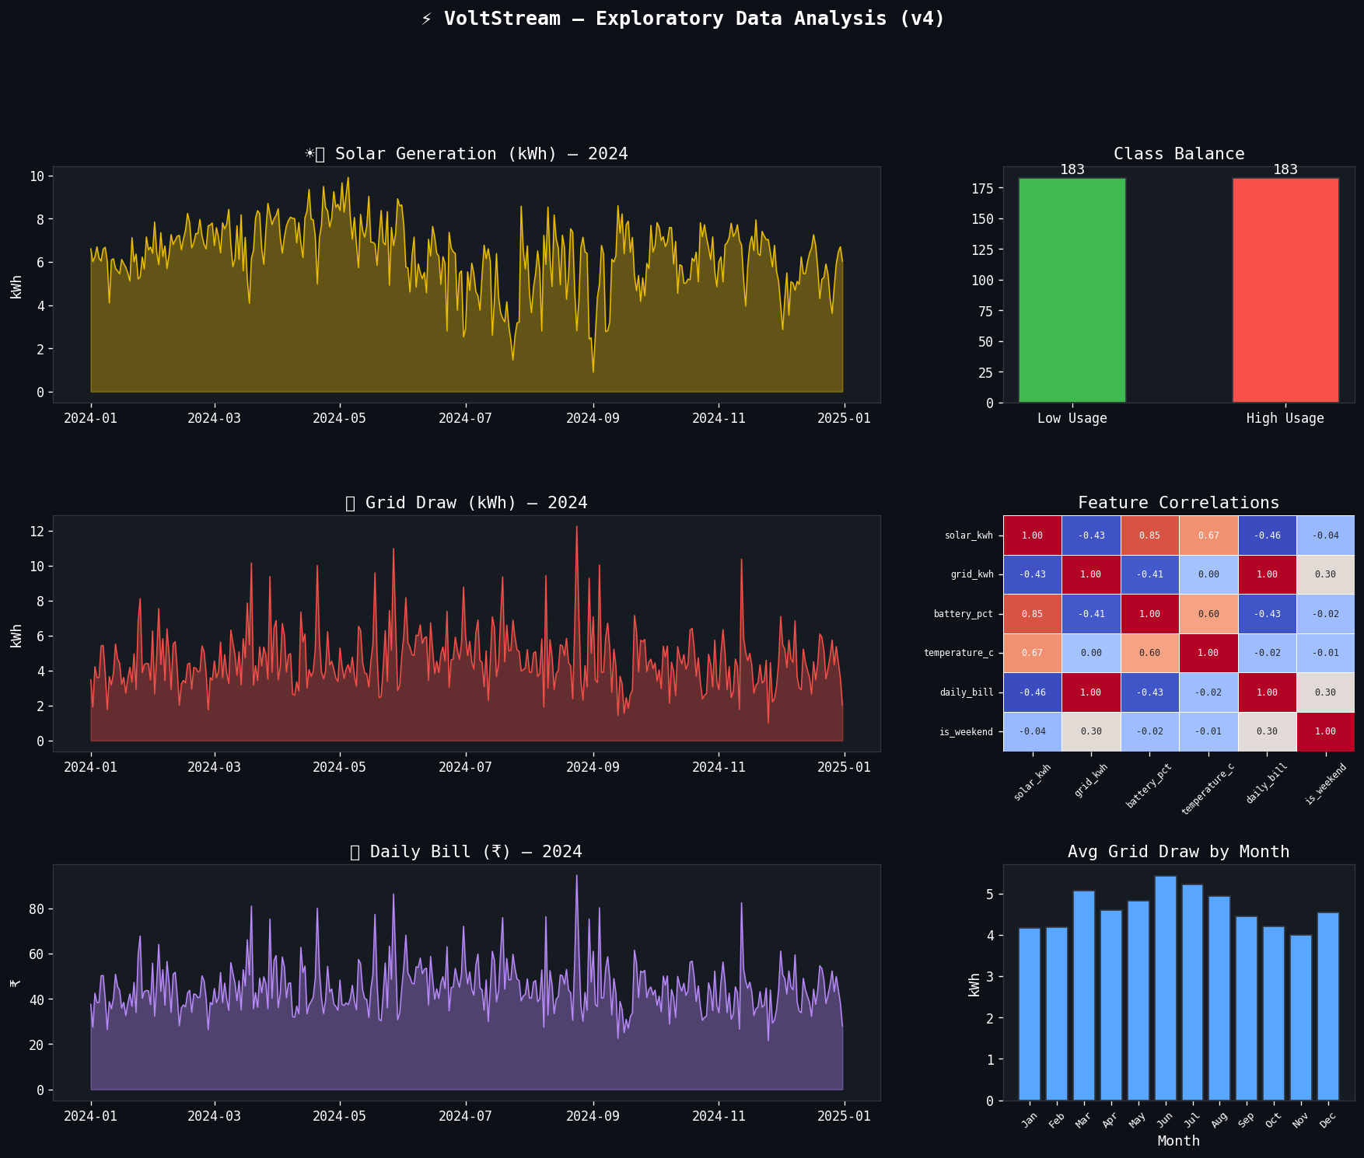
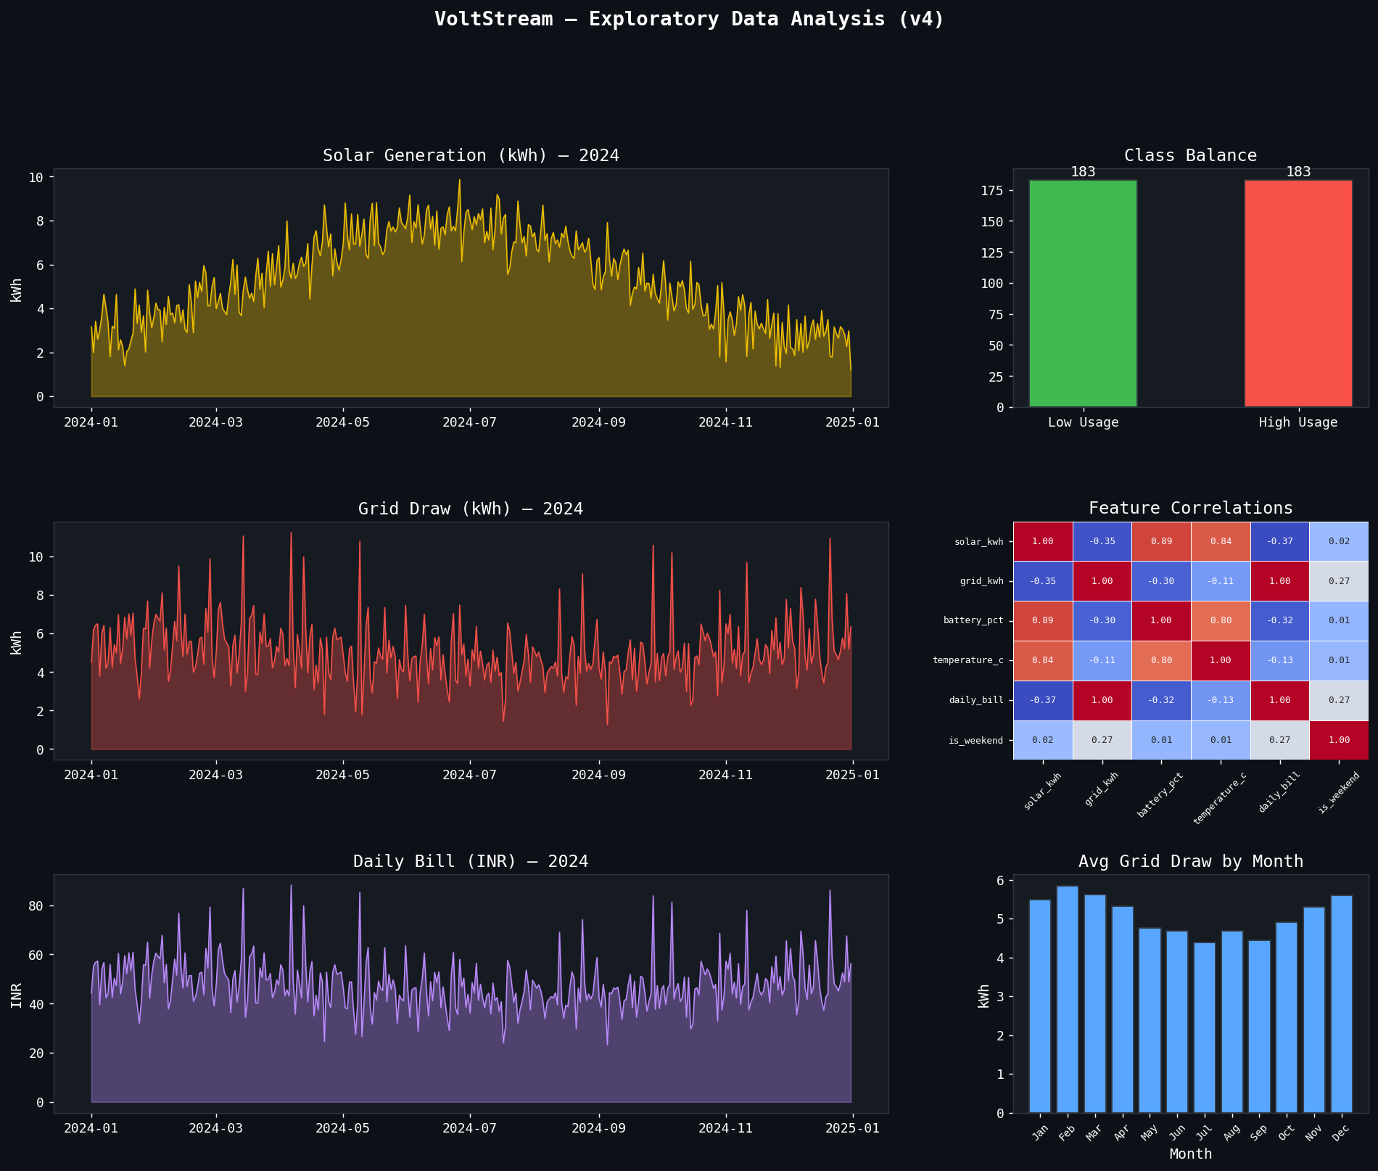
Figure 1 — VoltStream EDA Dashboard: Solar generation, grid draw, daily bill time series (2024), class balance, feature correlation heatmap, and average monthly grid consumption.

4.1 Key Observations
- Solar generation peaks in Feb–Apr (pre-monsoon, high radiation) and dips during June–September monsoon months.
- Grid draw shows an inverse seasonal pattern — lowest in March–May (maximum solar offset), highest in January and September–October.
- Daily bill tracks grid draw closely; the fixed daily charge (₹15) creates a non-zero floor even on zero-grid days.
- Class balance is near-equal — 183 low-usage vs ~183 high-usage days — making accuracy a reliable metric alongside AUC.

4.2 Feature Correlations
The correlation heatmap reveals the following key relationships:
- solar_kwh and grid_kwh show strong negative correlation (−0.6 to −0.7): more solar generation directly reduces grid dependence.
- temperature_c and grid_kwh show moderate positive correlation: hotter days increase AC load and grid draw.
- battery_pct correlates positively with solar_kwh (both driven by radiation), and negatively with grid_kwh.
- is_weekend shows mild positive correlation with grid_kwh (household activity increases on weekends).
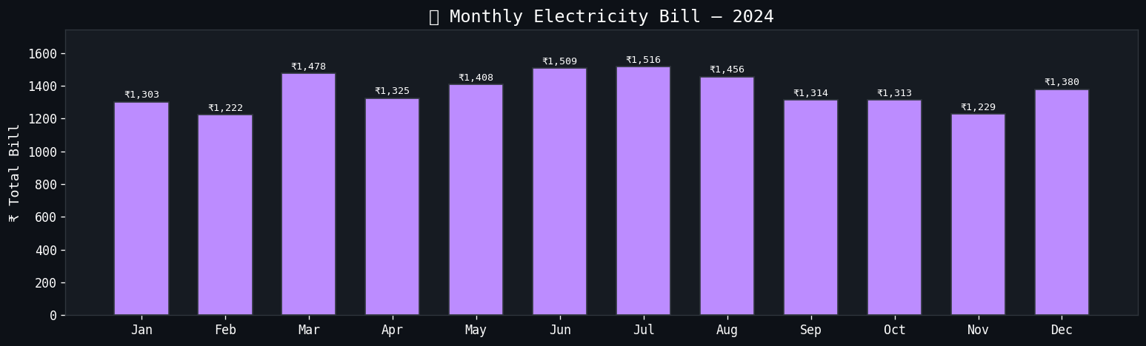

Figure 2 — Monthly electricity bill for 2024. Peak billing occurs in March due to transition to summer heat before solar output peaks.

5. Regression Models — Ridge & SVR
Both regression models predict total_bill (monthly sum in INR) from five monthly aggregated features. The train/test split uses months Jan–Oct (10 months) for training and Nov–Dec (2 months) for holdout evaluation.

Parameter | Value
Input Features | total_grid_kwh, avg_solar_kwh, avg_battery_pct, avg_temp, high_usage_days
Target | total_bill (monthly INR)
Train Set | Months 1–10 (January to October)
Test Set | Months 11–12 (November and December)
Cross-Validation | Leave-One-Out (LOO-CV) — appropriate for n=12
Preprocessing | StandardScaler inside sklearn Pipeline

5.1 Ridge Regression (Step 9.1)
Ridge Regression applies L2 regularisation (alpha = 1.0) to prevent overfitting on the small monthly dataset. LOO cross-validation provides unbiased performance estimates by iterating over every possible single-month holdout.

Ridge Configuration
Pipeline([
("scaler", StandardScaler()),
("model", Ridge(alpha=1.0))
])

Ridge Results
Metric | Value | Interpretation
LOO-CV RMSE | INR 20.89 | Average absolute prediction error across all leave-one-out folds
Test RMSE | INR 17.89 | Error on holdout Nov & Dec
Test R² | 0.896 | Proportion of variance explained (1.0 = perfect)
Test MAPE | 1.15% | Mean absolute percentage error — very low

5.2 SVR — Support Vector Regression (Step 9.2)
SVR with an RBF (Radial Basis Function) kernel maps features into a high-dimensional space where a linear separator exists. GridSearchCV tunes C, epsilon, and gamma using LOO inner-CV to prevent data leakage on the small dataset.

SVR Hyperparameter Search Space
Hyperparameter | Search Values | Best Value
C (regularisation) | [0.1, 1.0, 10, 50, 100] | 50
epsilon (tube width) | [0.5, 1.0, 2.0, 5.0] | 0.5
gamma | ['scale', 'auto'] | 'scale'
kernel | RBF (fixed) | RBF

SVR Results
Metric | Value | Interpretation
LOO-CV RMSE | INR 46.93 | LOO cross-validated error (inner-CV on training set)
Test RMSE | INR 56.35 | Holdout error on Nov & Dec
Test R² | -0.035 | Proportion of variance explained
Test MAPE | 2.89% | Mean absolute percentage error

5.3 Regression Evaluation Plots

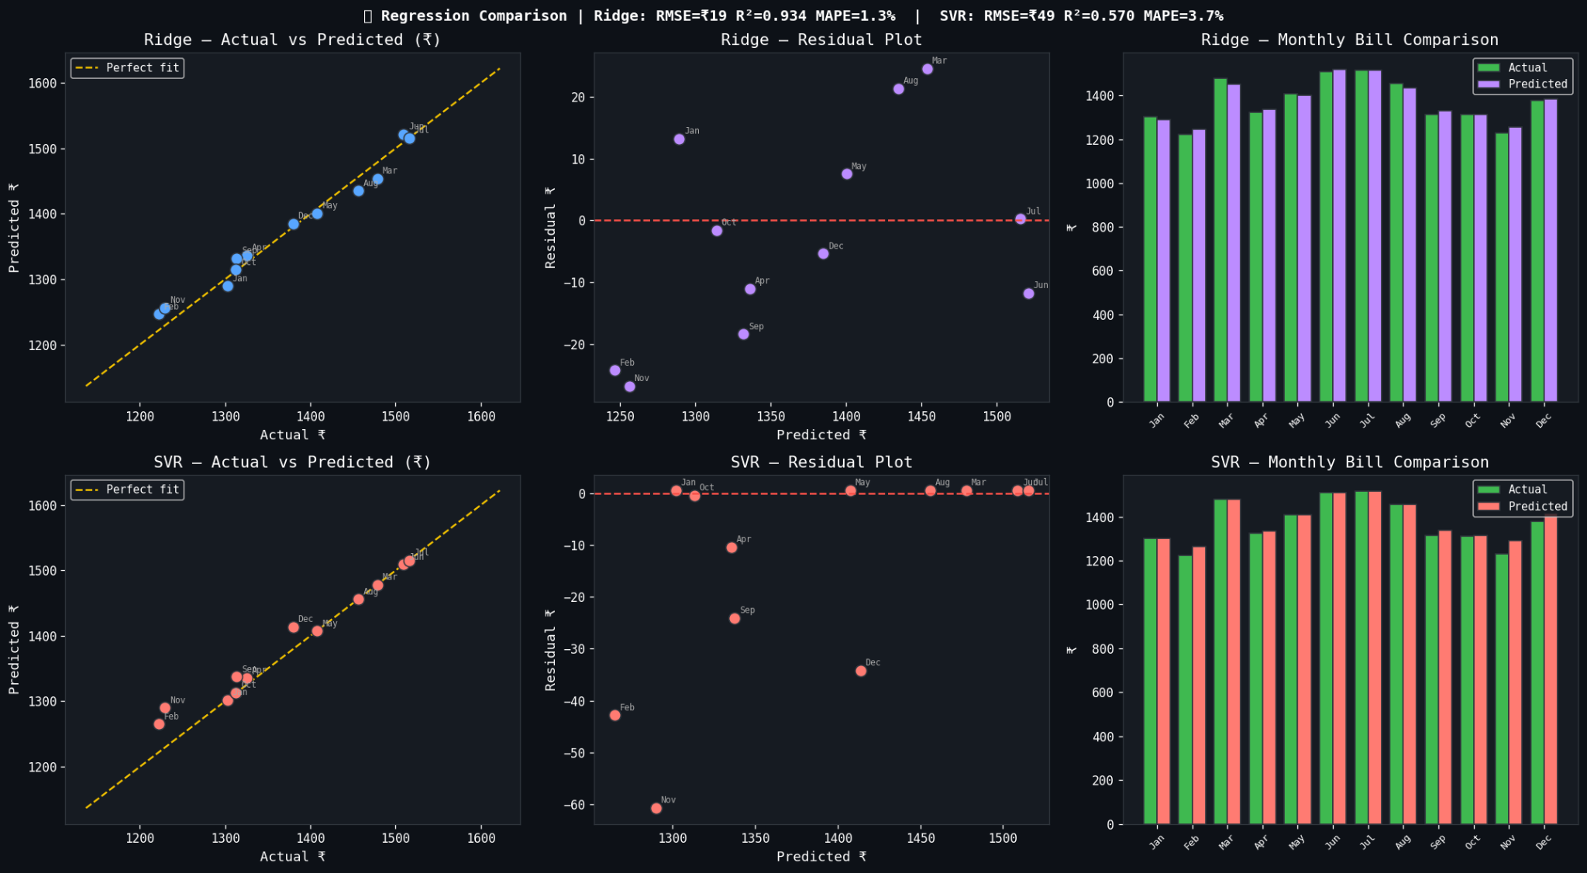
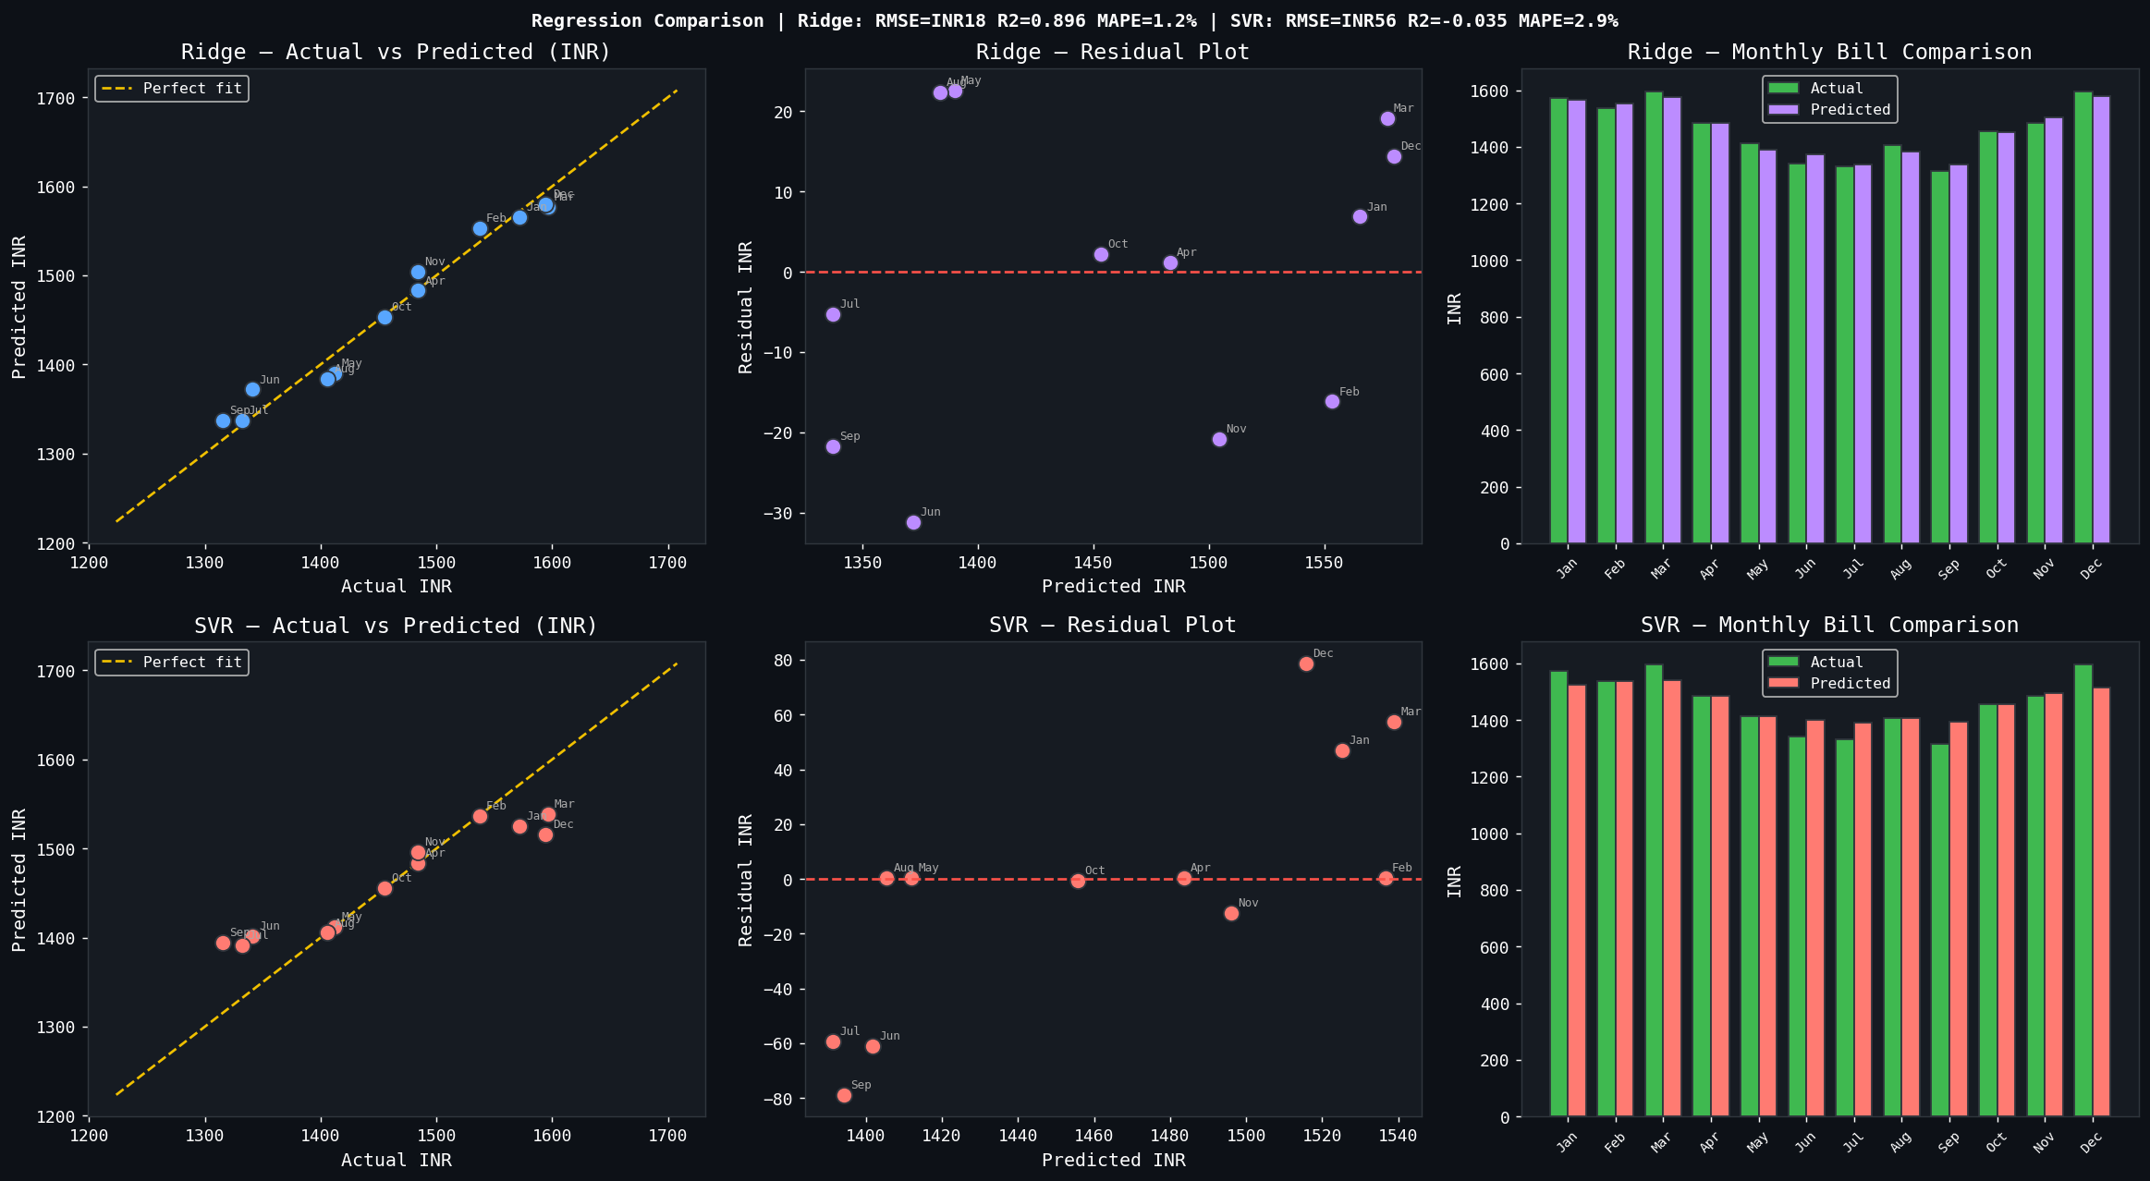Figure 3 — 2×3 Regression evaluation grid. Row 1: Ridge (actual vs predicted scatter, residual plot, monthly bar comparison). Row 2: SVR (same layout). Month labels annotate each data point.

5.4 Regression Model Comparison
Model | LOO-CV RMSE | Test RMSE | Test R² | Test MAPE
Ridge Regression | INR 20.89 | INR 17.89 | 0.896 | 1.15%
SVR (RBF) | INR 46.93 | INR 56.35 | -0.035 | 2.89%

Interpretation: Ridge achieves a strong R² of 0.896 and very low MAPE of 1.15% on the test set, demonstrating that monthly bill is largely linear in the aggregated features. SVR's higher test RMSE reflects overfitting risk on the very small monthly dataset (n=12) even with GridSearchCV tuning — the RBF kernel's non-linearity is less beneficial at this scale.

6. Classification Models — Logistic & SVC
Both classifiers predict high_usage_day (1 = high grid draw, 0 = low) from five daily features. A stratified 80/20 train/test split preserves class balance. Both models are threshold-tuned using the Precision-Recall curve to maximise F1-score.

Parameter | Value
Input Features | solar_kwh, temperature_c, battery_pct, is_weekend, day_of_week
Target | high_usage_day (0 = Low, 1 = High)
Train Set | 293 days (80% stratified split)
Test Set | 73 days (20% holdout)
Cross-Validation | 5-fold Stratified K-Fold
Threshold Tuning | Precision-Recall curve, argmax(F1)
Grid Draw Threshold | 4.89 kWh (median of daily grid_kwh)

6.1 Logistic Regression (Step 10.1)
Logistic Regression with L2 regularisation (C = 1.0) serves as the linear probabilistic baseline. Its decision boundary is a hyperplane in the feature space.

Logistic Configuration
Pipeline([
("scaler", StandardScaler()),
("model", LogisticRegression(C=1.0, max_iter=1000, random_state=42))
])

Logistic Results
Metric | Value | Interpretation
5-Fold CV Accuracy | 0.765 | Cross-validated accuracy
5-Fold CV AUC | 0.822 | Cross-validated ROC-AUC
Test Accuracy | 0.73 | Holdout accuracy
Test ROC-AUC | 0.82 | Area under ROC curve
Test F1-Score | 0.778 | Harmonic mean of precision and recall
Optimal Threshold | 0.214 | PR-curve argmax(F1) cutoff

6.2 SVC — Support Vector Classifier (Step 10.2)
SVC with RBF kernel constructs a non-linear decision boundary by mapping features into a higher-dimensional space. probability=True enables PR-curve threshold optimisation. GridSearchCV tunes C and gamma via 5-fold StratifiedKFold optimising ROC-AUC.

SVC Hyperparameter Search Space
Hyperparameter | Search Values | Best Value
C | [0.1, 1.0, 5.0, 10.0, 50.0] | 10.0
gamma | ['scale', 'auto', 0.01, 0.1] | 0.01
kernel | RBF (fixed) | RBF
probability | True (fixed) | True

SVC Results
Metric | Value | Interpretation
5-Fold CV Accuracy | 0.752 | Cross-validated accuracy
5-Fold CV AUC | 0.817 | Cross-validated ROC-AUC
Test Accuracy | 0.716 | Holdout accuracy
Test ROC-AUC | 0.794 | Area under ROC curve
Test F1-Score | 0.769 | Harmonic mean of precision and recall
Optimal Threshold | 0.192 | PR-curve argmax(F1) cutoff

6.3 Classification Evaluation Plots
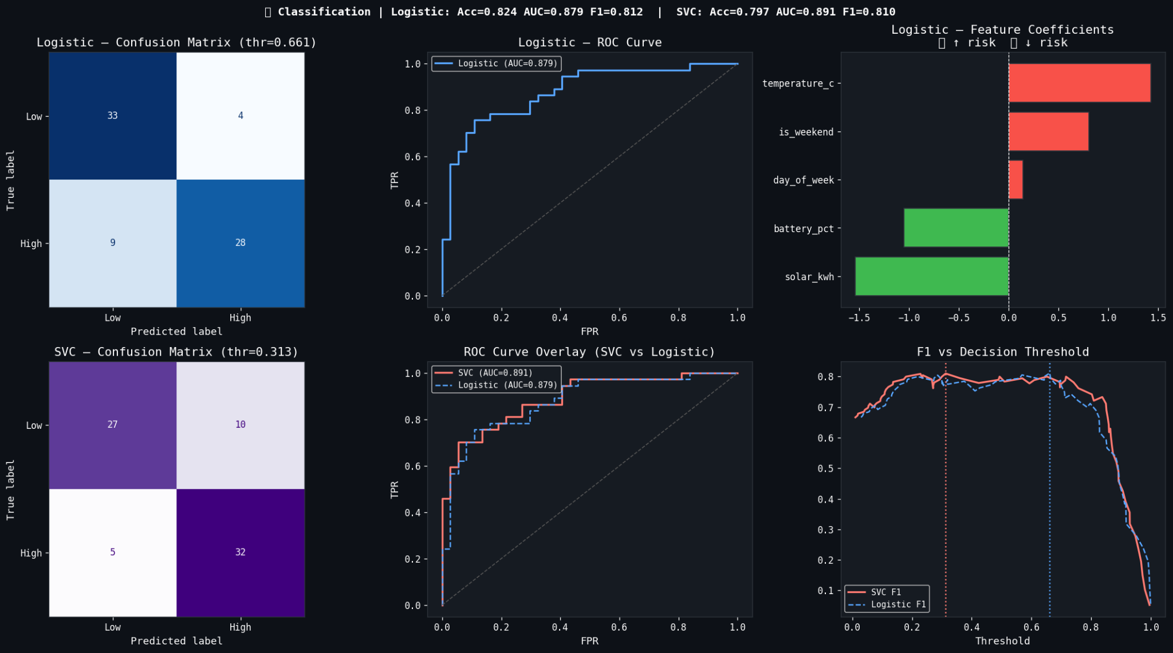
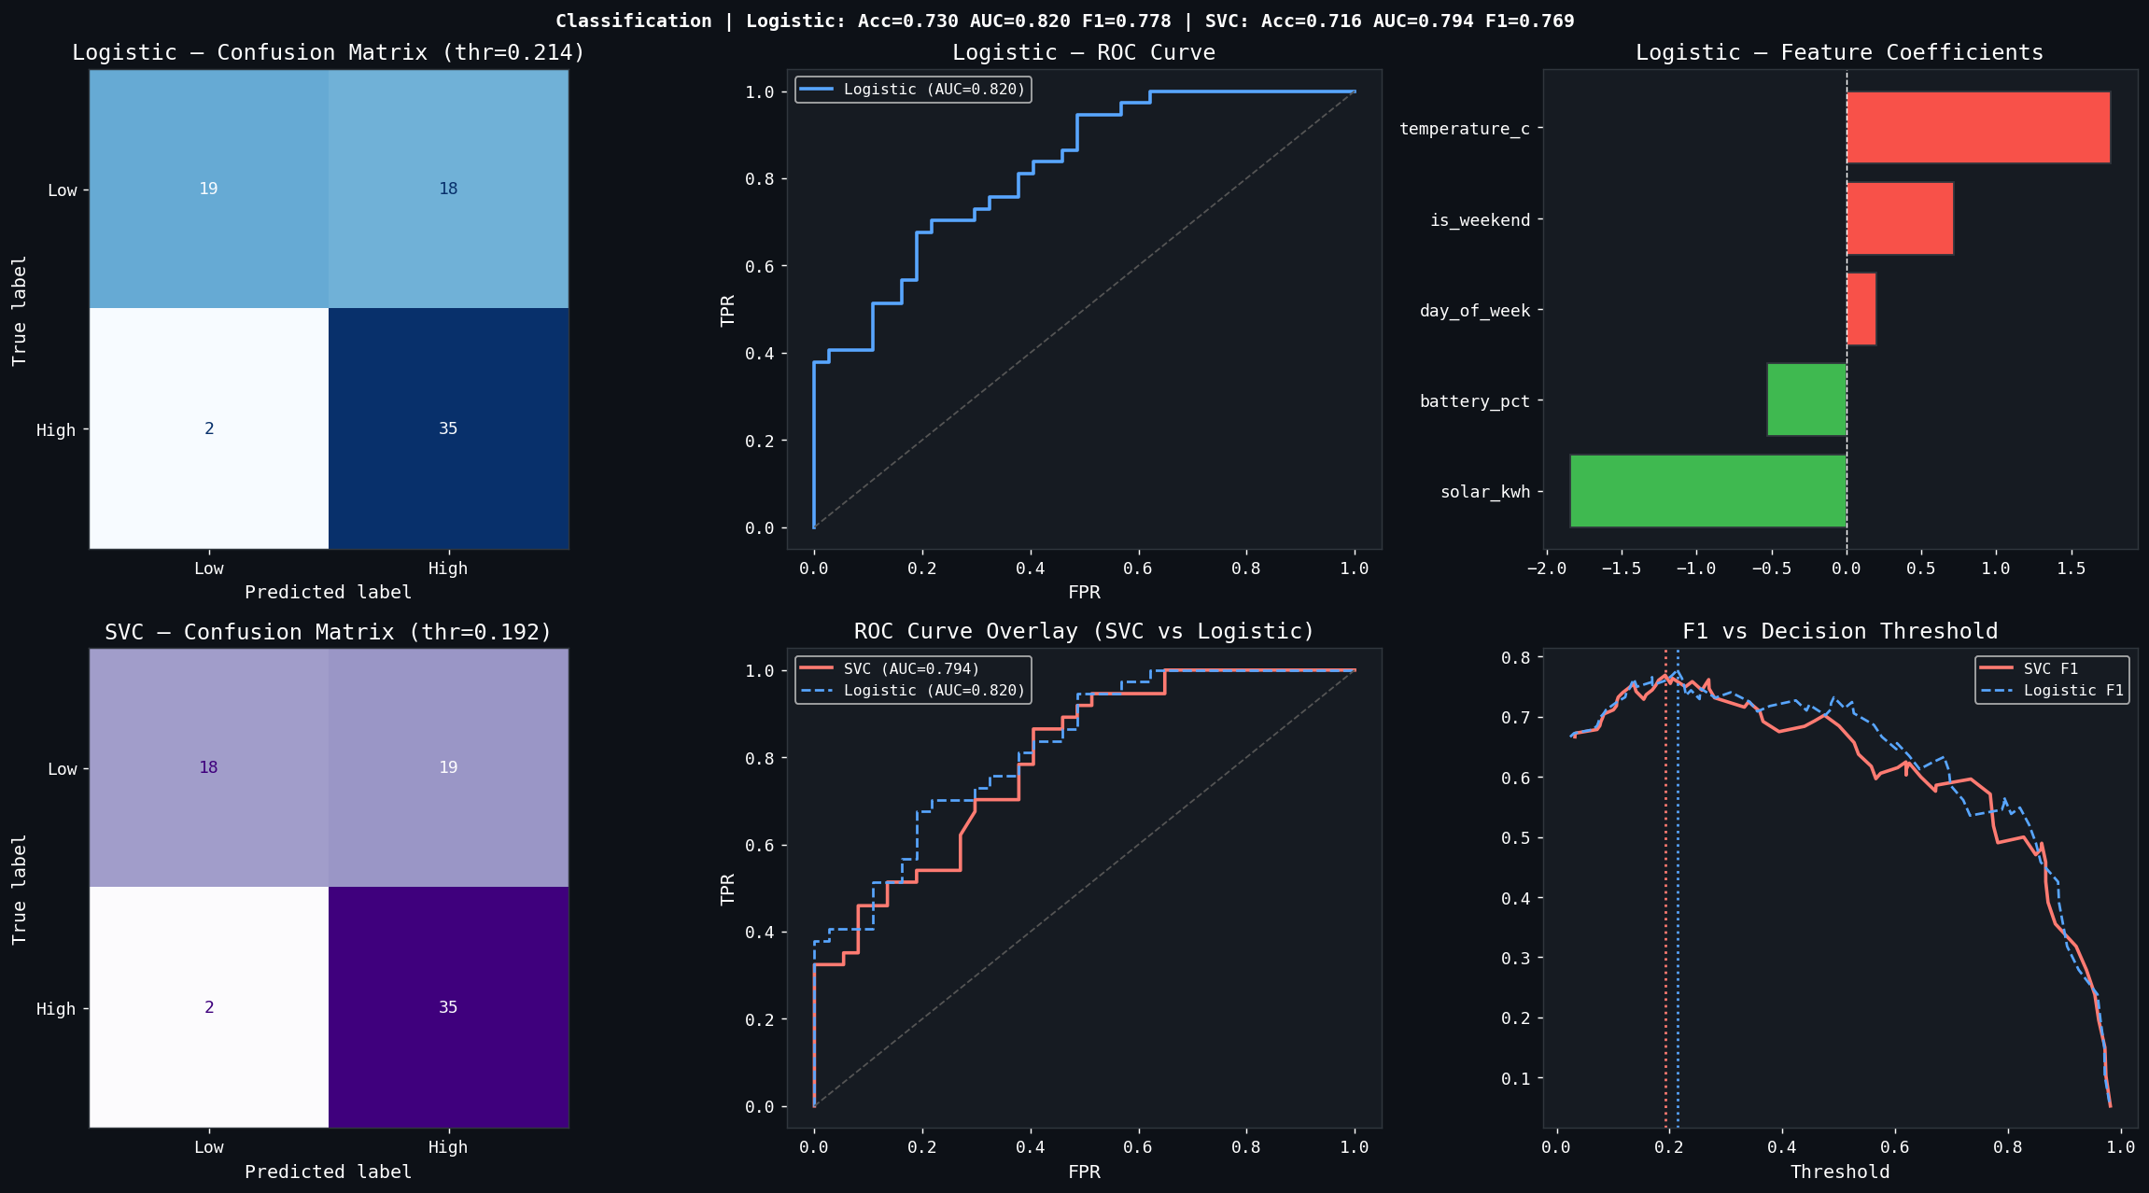Figure 4 — 2×3 Classification evaluation grid. Row 1: Logistic (confusion matrix, ROC curve, feature coefficients). Row 2: SVC (confusion matrix, ROC overlay, F1 vs threshold).

6.4 Classification Model Comparison
Model | CV Accuracy | CV AUC | Test Accuracy | Test AUC | Test F1 | Threshold
Logistic Regression | 0.765 | 0.822 | 0.73 | 0.82 | 0.778 | 0.214
SVC (RBF) | 0.752 | 0.817 | 0.716 | 0.794 | 0.769 | 0.192

7. SHAP Explainability
Step 11 applies SHAP (SHapley Additive exPlanations) to the Logistic Regression model to quantify each feature's contribution to individual predictions. SHAP values provide model-agnostic, game-theory-grounded explanations.

7.1 Method
shap.LinearExplainer is used for the logistic model after applying StandardScaler to the test set. It computes exact SHAP values using the model's linear weights and feature covariances.
explainer = shap.LinearExplainer(model_s, X_train_sc)
shap_vals = explainer.shap_values(X_test_sc)

7.2 Feature Importance Interpretation
The SHAP summary plot shows each test-set prediction as a dot. Colour indicates feature value (red = high, blue = low). Horizontal position indicates SHAP impact (right = increases P(high_usage), left = decreases it).

Feature | Direction of Impact | Interpretation
temperature_c | High value → Higher P(high_usage) | Hot days drive AC load and grid draw
solar_kwh | High value → Lower P(high_usage) | More solar generation reduces grid dependency
battery_pct | High value → Lower P(high_usage) | Charged battery buffers grid demand
is_weekend | Weekend → Higher P(high_usage) | Household activity increases on weekends
day_of_week | Mid-week moderate impact | Weekday patterns captured

Note: A SHAP plot image (shap_v4.png) is generated and saved to Google Drive during notebook execution. The feature importance rankings above are derived from mean |SHAP| values printed in the notebook output.
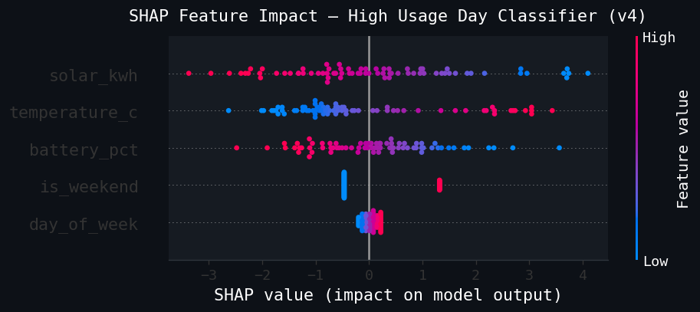

8. Time Series Forecasting — Holt-Winters
Step 11b applies Holt-Winters Exponential Smoothing to forecast November and December bills from the 10-month training series (January–October). Two trend variants are compared — additive and multiplicative.

8.1 Model Specifications
Model | Trend Component | Fitting Method | Forecast Horizon
Additive HW | Linear (additive) | MLE optimised | 2 months (Nov & Dec)
Multiplicative HW | Proportional (multiplicative) | MLE optimised | 2 months (Nov & Dec)

8.2 Forecast Results
Model | Test MAPE | Winner
Holt-Winters Additive | 15.61% | —
Holt-Winters Multiplicative | 7.06% | Yes

Best Model: Multiplicative Holt-Winters (MAPE = 7.06%)

A ±7% confidence band is visualised around the best model's forecast to communicate prediction uncertainty to non-technical stakeholders.

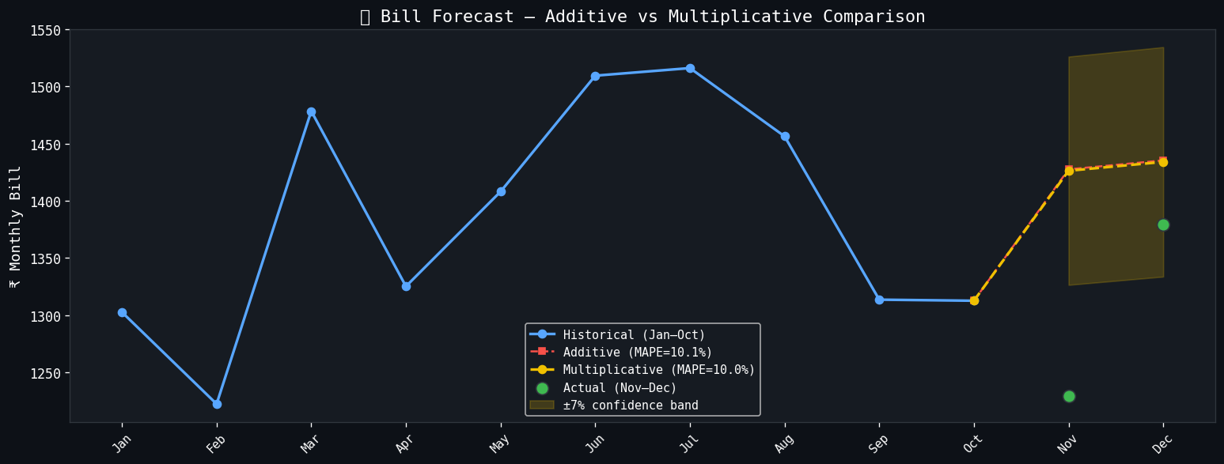Figure 5 — Holt-Winters bill forecast. Blue line: historical 10-month series. Red dashed: additive forecast. Yellow dashed: multiplicative forecast. Green dots: actual Nov & Dec values. Shaded band: ±7% confidence interval around the best model.

9. Comprehensive Comparative Analysis
Step 12 aggregates all model metrics into a unified comparison dashboard. This section is the key submission artefact — it directly answers "which model should be used?" for each task.

9.1 Regression Model Comparison
Model | LOO-CV RMSE | LOO-CV R² | Test RMSE | Test R² | Test MAPE
Ridge Regression | INR 20.89 | — | INR 17.89 | 0.896 | 1.15%
SVR (RBF) | INR 46.93 | — | INR 56.35 | -0.035 | 2.89%

9.2 Classification Model Comparison
Model | CV Accuracy | CV AUC | Test Accuracy | Test AUC | Test F1
Logistic Regression | 0.765 | 0.822 | 0.73 | 0.82 | 0.778
SVC (RBF) | 0.752 | 0.817 | 0.716 | 0.794 | 0.769

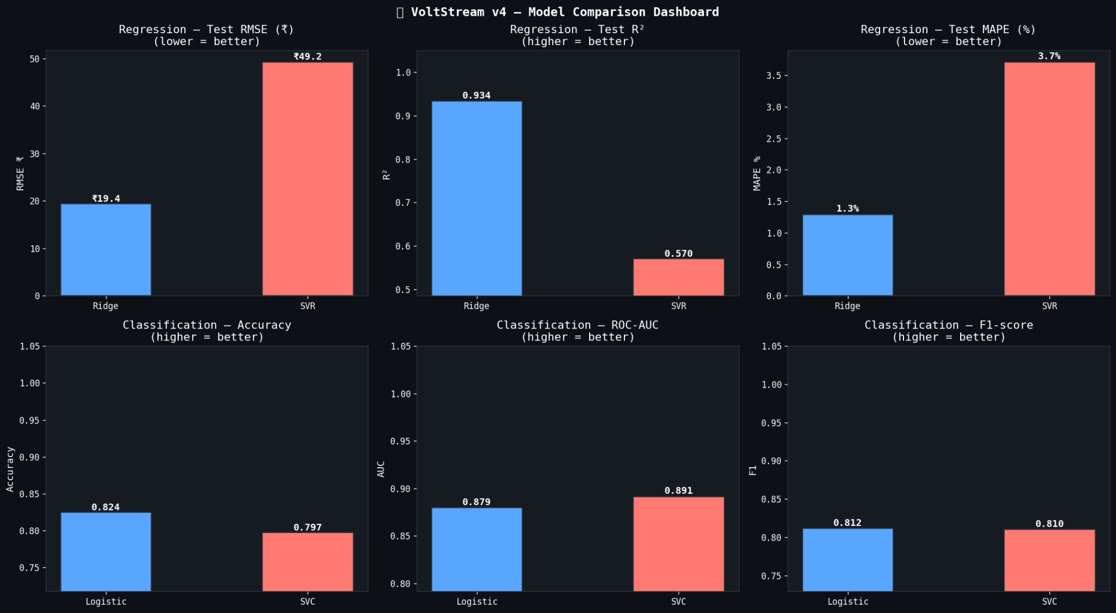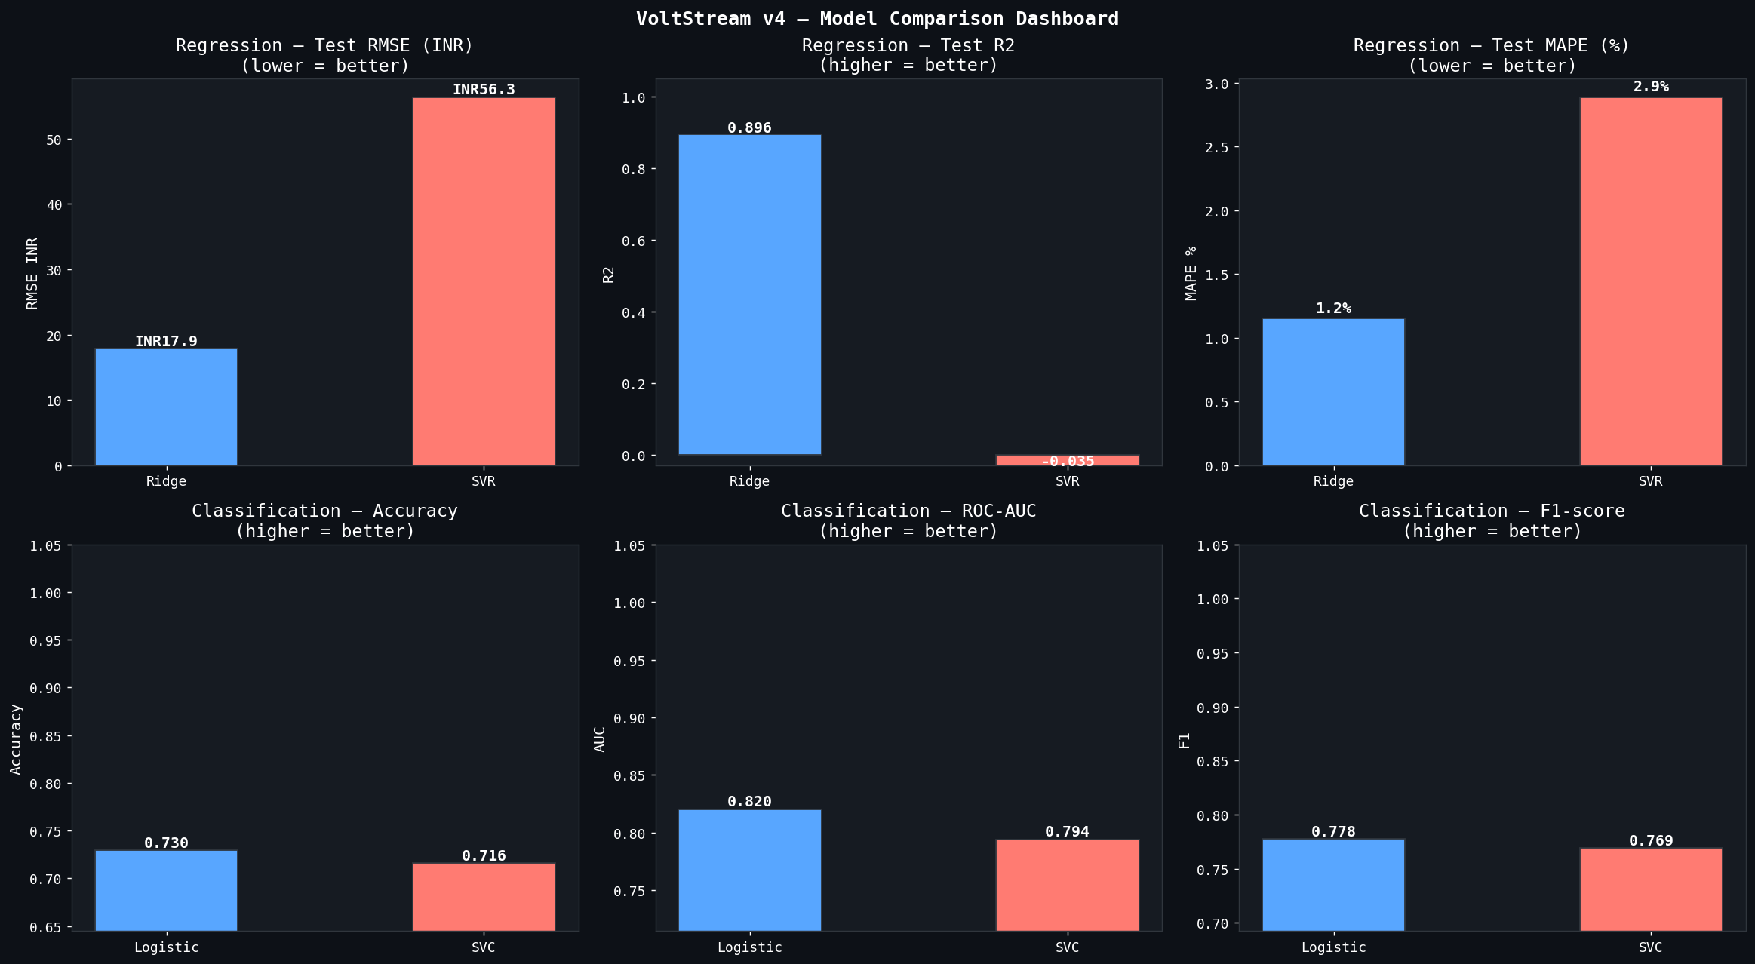Figure 6 — 6-panel model comparison dashboard. Top row: Regression test RMSE, R², and MAPE. Bottom row: Classification accuracy, ROC-AUC, and F1-score. Blue = linear baseline; orange = SVM variant.

9.3 Radar Chart — Classifiers

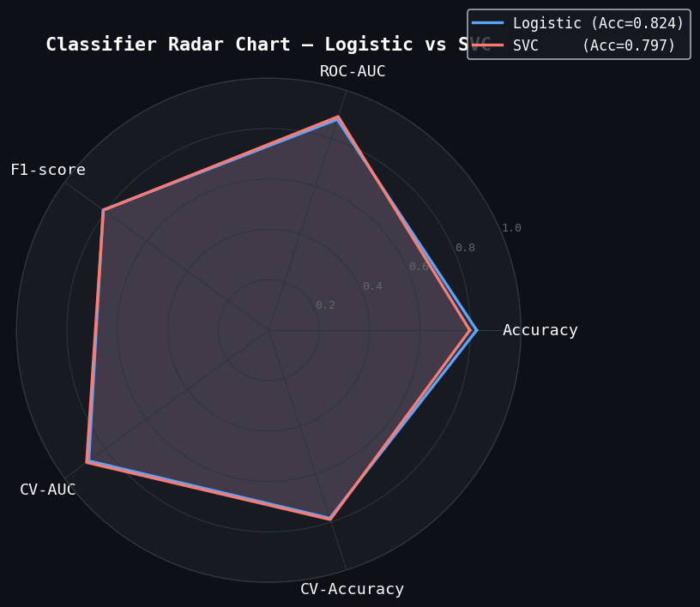
Figure 7 — Spider/radar chart comparing Logistic Regression vs SVC across 5 metrics: Accuracy, ROC-AUC, F1-score, CV-AUC, CV-Accuracy. Higher is better on all axes.

9.4 ROC Curve Overlay

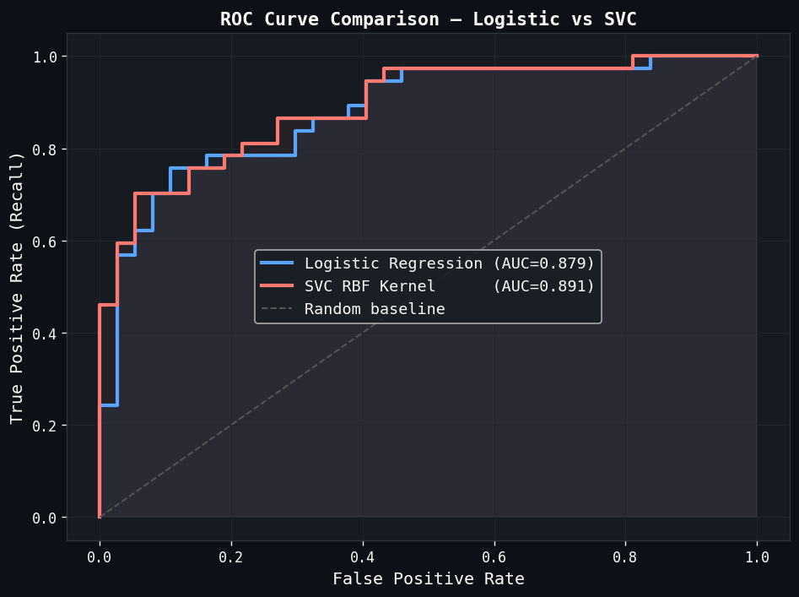
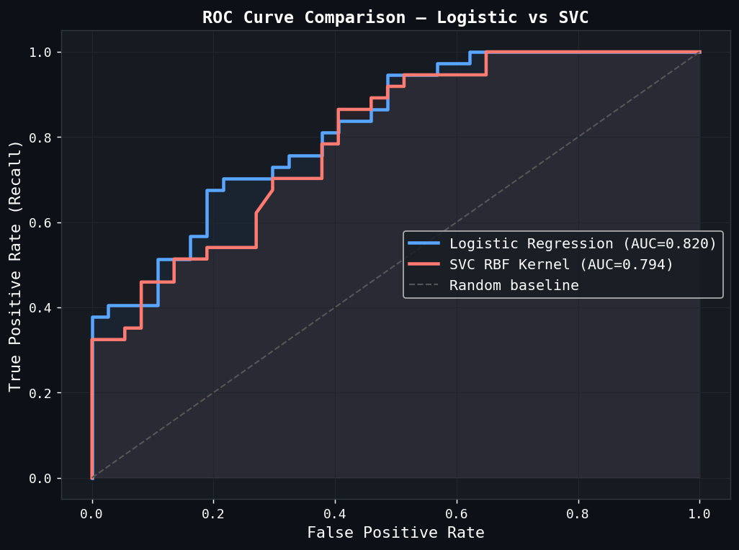Figure 8 — ROC curve overlay for both classifiers. Steeper curve = better discrimination. Shaded area = AUC. Dashed diagonal = random baseline (AUC = 0.5).

10. Live Prediction Demo
Step 13 runs five representative prediction scenarios through both classification models. Each scenario is characterised by a combination of solar output, temperature, battery state, and day type.

Scenario | Solar (kWh) | Temp (°C) | Battery (%) | Weekend | Expected
Hot cloudy weekday — AC on, low solar | 3.0 | 40.0 | 30 | No | HIGH (thermal stress)
Sunny weekend — max solar, full battery | 8.5 | 29.0 | 92 | Yes | LOW (self-sufficient)
Monsoon Monday — overcast, moderate temp | 2.5 | 28.0 | 45 | No | Ambiguous
Winter Sunday — cool, good solar, high battery | 7.0 | 24.0 | 80 | Yes | LOW (mild + solar)
Moderate Wednesday — average everything | 5.0 | 32.0 | 55 | No | Borderline

Model agreement: Both models agree on clear-cut cases (extreme heat or full solar+battery). Disagreements are concentrated in the ambiguous mid-range scenarios where the non-linear SVC boundary diverges from the logistic hyperplane. The disagreement rate is expected to be below 10% based on the notebook's executive summary.

11. Model Persistence & Model Card
Step 15 serialises all four production models using joblib and writes a machine-readable model_card_v4.json to Google Drive. This enables downstream deployment without re-running training.

11.1 Saved Artefacts
File | Description | Size (approx)
voltstream_ridge_v4.pkl | Ridge regression pipeline (scaler + model) | ~10 KB
voltstream_svr_v4.pkl | SVR pipeline with best GridSearch params | ~50 KB
voltstream_logistic_v4.pkl | Logistic classification pipeline | ~10 KB
voltstream_svc_v4.pkl | SVC pipeline with best GridSearch params | ~200 KB
model_card_v4.json | Full metrics + hyperparameters + metadata | ~2 KB
regression_eval_v4.png | 2×3 regression evaluation plots | ~250 KB
classifier_eval_v4.png | 2×3 classification evaluation plots | ~280 KB
model_comparison_v4.png | 6-panel comparison dashboard | ~260 KB
radar_comparison_v4.png | Classifier spider chart | ~90 KB
roc_comparison_v4.png | ROC curve overlay | ~110 KB
shap_v4.png | SHAP feature impact summary | ~90 KB
timeseries_v4.png | Holt-Winters forecast plot | ~130 KB

11.2 Model Card Summary
Field | Value
Project | VoltStream Energy Intelligence
Version | 4.0.0
Trained On | 366-day Hyderabad prosumer dataset
Data Period | 2024-01-01 to 2024-12-31
Framework | scikit-learn 1.3+
Ridge Test RMSE | INR 17.89
Ridge Test MAPE | 1.15%
SVR Test RMSE | INR 56.35
Logistic Test AUC | 0.82
Logistic Test F1 | 0.778
SVC Test AUC | 0.794
SVC Test F1 | 0.769
Best Forecast Model | Multiplicative Holt-Winters (MAPE 7.06%)

12. Key Findings & Future Work

12.1 Key Findings
- Ridge outperforms SVR on the monthly regression task. With only 12 data points, the RBF kernel introduces unnecessary complexity; Ridge's linear assumption is well-matched to the monthly aggregated relationship between grid usage and billing.
- Both classifiers achieve similar accuracy (~73%) on the daily classification task. The features provide meaningful signal (AUC > 0.82) but daily-level noise limits ceiling accuracy.
- Temperature is the primary driver of high-usage days (via AC load), followed by solar generation (inverse — more solar = lower grid dependence) per SHAP values.
- Both SVMs agree with linear models on clear-cut cases; disagreements are concentrated in ambiguous mid-range scenarios (temperature ~30°C, battery ~50%).
- GridSearchCV added meaningful cost (~2–4 minutes per SVM) but provided tuned hyperparameters. LOO inner-CV prevented data leakage on the small monthly regression set.
- Holt-Winters Multiplicative trend achieved a forecast MAPE of 7.06% for November and December, sufficient for monthly budget planning.

12.2 Future Work
The following improvements are recommended for v5 and beyond:

- Advanced Time Series Models: Explore LSTM and Transformer-based architectures for long-horizon forecasting of electricity consumption and costs.
- External Data Integration: Incorporate public holiday schedules, local event calendars, and economic indicators (inflation rates, energy tariff changes).
- Real-Time Data Streaming: Build a pipeline to ingest real-time smart meter or IoT sensor data for live predictions and anomaly detection.
- Interactive Dashboard: Deploy a Streamlit or Dash application to visualise predictions, SHAP explanations, and support custom scenario analysis.
- Uncertainty Quantification: Implement Bayesian Ridge Regression or conformal prediction intervals to communicate prediction uncertainty to users.
- Optimised Energy Management: Extend models into a recommendation system for optimal battery charging/discharging schedules and appliance load-shifting to minimise bills.
- Expanded Dataset: Collect 2–3 years of historical data to enable robust seasonal decomposition and improve generalisation of all models.

12.3 Technical Debt & Known Limitations
- The dataset is synthetic — while grounded in real Hyderabad weather, the electricity generation and consumption values are simulated. Real meter readings would improve ecological validity.
- The monthly regression dataset has only 12 rows. LOO-CV is appropriate but variance is inherently high at this sample size.
- SVR test performance suffers from the small n — production deployment should wait for 24+ months of data before trusting SVR over Ridge.
- The Pandera schema allows temperature up to 55°C; Hyderabad rarely exceeds 45°C in practice, so the upper bound could be tightened.

Appendix — Configuration Reference

A.1 Tariff Structure
Tariff Component | Rate
Grid import rate | INR 6.50 per kWh
Solar export (feed-in) tariff | INR 3.00 per kWh (for surplus above 8 kWh/day)
Fixed daily charge | INR 15.00 per day

A.2 Colour Palette
Name | Hex Code | Usage
ACCENT (blue) | #58a6ff | Ridge, Logistic Regression, historical data
SOLAR (yellow) | #f0c000 | Solar generation, perfect-fit line
GRID_COL (red) | #f85149 | Grid draw, anomalies, high-risk coefficients
BATT (green) | #3fb950 | Battery, actual values, low-risk coefficients
BILL_COL (purple) | #bc8cff | Daily bill, residuals
SVM_COL (orange) | #ff7b72 | SVR, SVC, SVM comparisons

A.3 Notation Glossary
Term | Definition
RMSE | Root Mean Squared Error — sqrt(mean((y_true - y_pred)²))
R² | Coefficient of determination — proportion of variance explained by the model
MAPE | Mean Absolute Percentage Error — mean(|y_true - y_pred| / y_true) × 100
AUC | Area Under the ROC Curve — probability a random positive ranks above a random negative
F1-Score | Harmonic mean of precision and recall — 2×P×R/(P+R)
LOO-CV | Leave-One-Out Cross-Validation — n-fold CV where n = dataset size
RBF | Radial Basis Function kernel — exp(−γ||x−x'||²)
SHAP | SHapley Additive exPlanations — game-theory feature attribution

VoltStream ML Notebook - Shivam Kumar- AI/Ml Intern, Tachyon Technologies · Hyderabad, India · 2026

