

School of Computer Engineering
Database Systems Lab [CSS 2212]
Mini Project Report

CampusCare — Complaint & Resolution Management System

Submitted by

Registration No. | Name of the Student | Sem - Branch - Section
245890430 | SHIVAM MISHRA | 4th Sem - AI - B

Under the guidance of
Dr Pavithra N
Assistant Professor Senior Scale
School of Computer Engineering
Manipal Institute of Technology, Bengaluru


SCHOOL OF COMPUTER ENGINEERING
Bengaluru
08-04-2026

CERTIFICATE

This is to certify that the Mini Project titled CampusCare — Complaint & Resolution Management System is a report of the bona fide work carried out by SHIVAM MISHRA (245890430), submitted in partial fulfillment of the requirements of the course CSS_2212 — Database Systems Lab of the IV Semester, in the School of Computer Engineering, Manipal Institute of Technology, Bengaluru, Karnataka (a Constituent Institute of Manipal Academy of Higher Education), during the academic year 2025–2026.

Dr Pavithra N  Assistant Professor Senior Scale  SOCE, M.I.T, BENGALURU | Dr. Jayitha Saha  Program Coordinator, Associate Professor, SOCE,  M.I.T, BENGALURU

ABSTRACT
CampusCare — Complaint & Resolution Management System

Campus infrastructure management in educational institutions suffers from fragmented communication between students and administrative staff. Complaints about facilities, maintenance, and services often go untracked, unassigned, or unresolved due to the absence of a structured digital system. CampusCare addresses this gap by providing a centralized, web-based complaint management platform that connects students directly with administrative staff, making the entire complaint lifecycle transparent and manageable.
The system was built using a three-tier architecture with Node.js and Express.js for server-side logic, MySQL for relational data storage, and HTML, CSS, and JavaScript for the client-side interface. A normalized relational database was designed with four tables — students, staff, complaints, and assignments — enforcing referential integrity through foreign keys. The backend follows an MVC pattern with separate controllers and route files. Students can raise complaints with category and description details. Administrators can assign complaints to staff members, track progress, and resolve issues. A dashboard provides real-time analytics showing total, open, in-progress, and resolved complaint counts.
The system successfully demonstrated full complaint lifecycle management across three status stages: OPEN, IN_PROGRESS, and RESOLVED. Complaints can be filtered and sorted, assignments link complaints to specific staff members, and the dashboard reflects live database counts. The project demonstrates core DBMS concepts including relational modeling, normalization to 3NF, foreign key constraints, and parameterized SQL queries.
CampusCare establishes that a structured, database-driven web application can significantly improve institutional complaint resolution by digitizing and centralizing the process. The system promotes accountability for both students and administrators. Future enhancements may include user authentication, email notifications, role-based access control, and deployment on a live server. The project was developed using Node.js, Express.js, MySQL, HTML, CSS, and JavaScript.

TABLE OF CONTENTS

Section | Page No
Abstract | i
Chapter 1: Introduction | 1
1.1 Overview of the Project | 1
1.2 Purpose and Objectives | 2
1.3 Scope of the System | 2
1.4 Problem Definition | 3
Chapter 2: Literature Survey and Gaps | 4
Chapter 3: Problem Statement and Objectives | 6
Chapter 4: System Architecture | 8
Chapter 5: Relational Data Model and Functionalities | 10
Chapter 6: Technologies Used, Front End and Backend Logic | 16
Chapter 7: Data Flow, Results and Discussions | 20
Chapter 8: Conclusions and Future Scope | 26
References | 28

LIST OF TABLES

Table No. | Table | Page No
1 | Students | 18
2 | Staff | 18
3 | Complaints | 18
4 | Assignment | 18

LIST OF FIGURES

Figure No. | Figure Title | Page No
1 | Three Level Architecture | 12
2 | Entity-Relationship Diagram | 12
3 | Dashboard[Index] | 20
4 | Raise Complaints | 21
5 | Admin Page | 21

CHAPTER 1
INTRODUCTION

1.1 Overview of the Project
CampusCare is a web-based complaint and resolution management system designed to bridge the communication gap between students and administrative staff in an educational institution. The platform enables students to raise complaints about campus facilities, maintenance issues, cleanliness, and other campus-related problems through a structured online interface. Each complaint is stored in a centralized MySQL database, can be assigned to a staff member, and is tracked through a defined lifecycle until it is resolved.
The system provides two interaction modes — a student-facing complaint submission interface and an admin panel for complaint management and assignment. Students can raise complaints with a category and description. Administrators can view all complaints, assign them to staff, update the status, and monitor progress. A dashboard provides analytics with live counts of total, open, in-progress, and resolved complaints, along with filtering options to sort by status or category.
CampusCare is built using a conventional three-tier web architecture, with Node.js and Express.js handling server-side logic, MySQL managing the relational database, and HTML, CSS, and JavaScript forming the client-side interface. The backend follows a clean MVC structure separating routes, controllers, and database configuration.

1.2 Purpose and Objectives
The primary purpose of CampusCare is to digitize and streamline the campus complaint resolution process, replacing informal verbal or email-based complaints with a transparent, trackable, and accountable web platform. The system aims to empower students by giving them a direct, structured channel to communicate problems, while equipping administrators with tools to manage and resolve those complaints efficiently.
The specific objectives of the project are:
- To develop a full-stack web application that allows students to raise campus complaints with category, description, and student identity.
- To provide administrators with a dashboard to view all complaints, assign them to staff members, and update their resolution status.
- To implement a complaint lifecycle with three stages — OPEN, IN_PROGRESS, and RESOLVED — ensuring clarity and accountability.
- To design a normalized MySQL relational database with proper foreign key constraints and referential integrity.
- To build a real-time analytics dashboard showing total, open, in-progress, and resolved complaint counts.
- To implement filtering functionality allowing administrators to view complaints by status or category.

1.3 Scope of the System
CampusCare is scoped as a full-stack web application covering the complete lifecycle of a campus complaint, from initial submission by a student to final resolution by an administrator. The system encompasses the following functional areas:
- Complaint management, covering complaint submission with student ID, category, and description; status tracking through OPEN, IN_PROGRESS, and RESOLVED stages.
- Assignment management, linking complaints to specific staff members and automatically setting status to IN_PROGRESS upon assignment.
- Administrative tools, including a dashboard with live counts and a filtering interface to search by status or category.
- Data integrity, enforced through foreign key relationships between students, complaints, staff, and assignments tables.
The system is currently scoped for local deployment. It does not include user authentication with login sessions, email notifications, image uploads, or mobile application support. These features are identified as future enhancements.

1.4 Problem Definition
Educational institutions face recurring infrastructure and facility management challenges. Issues such as broken equipment, cleanliness problems, maintenance failures, and network outages affect the daily experience of students. Despite the frequency of these issues, most institutions lack a structured digital channel for students to report them.
The typical complaint process — informally telling a faculty member, sending an email, or leaving a paper request — is plagued by critical shortcomings. There is no standardized format, making it difficult to categorize or prioritize complaints. There is no tracking mechanism, so students have no visibility into whether their complaint was received or acted upon. Complaints are frequently lost, forgotten, or ignored without acknowledgment. The absence of data on complaint volumes prevents administrators from identifying recurring problems or allocating resources effectively.
Furthermore, the lack of structured assignment means that complaints often go unowned — no specific staff member is responsible, and accountability is diffuse. CampusCare is developed in direct response to these problems. By providing a structured, digital, and centralized platform for complaint submission, assignment, and resolution, the system addresses the core failures of the informal process.

CHAPTER 2
LITERATURE SURVEY AND GAPS

2.1 Literature Survey
The domain of institutional complaint management and helpdesk systems has been studied in the context of educational organizations and service management platforms. Key contributions inform the design of CampusCare.
Anthopoulos et al. (2016) found that complaint platforms which provided real-time status feedback to users saw significantly higher satisfaction and engagement than systems that offered no visibility into complaint progress. This directly motivated the status lifecycle (OPEN, IN_PROGRESS, RESOLVED) and the dashboard design in CampusCare. Scholl and Scholl (2014) demonstrated that structured digital complaint systems with role-specific workflows reduce resolution times by up to 40 percent compared to informal processes, supporting the assignment mechanism in CampusCare.
In the institutional context, research by Mishra and Gupta (2019) on IT helpdesk systems in Indian educational institutions found that the absence of complaint tracking was the primary cause of student dissatisfaction with campus services. Their recommendations for category-based organization and staff assignment directly informed the database schema design used in CampusCare.

2.2 Existing Systems and Similar Applications
Several systems address complaint and helpdesk management to varying degrees. ServiceNow is an enterprise ITSM platform widely used in large organizations, but it is expensive, complex, and not suited to small campus deployments. Freshdesk and Zoho Desk are commercial helpdesk tools that handle ticket assignment but are designed for customer support contexts and require subscriptions. Spiceworks is a free IT helpdesk tool but is tightly scoped to IT support and lacks the simplicity needed for general campus use by non-technical students.
In the Indian academic context, most institutions rely on manual complaint books, email threads, or informal WhatsApp groups — none of which provide structured tracking, assignment, or analytics.

2.3 Limitations of Current Systems
A review of existing approaches reveals consistent limitations:
- No real-time tracking: Students receive no information about whether their complaint has been received, assigned, or acted upon after submission.
- No staff assignment mechanism: Complaints are not formally assigned to any individual, leaving accountability diffuse and resolution unpredictable.
- No analytics: No existing campus system provides aggregate complaint data to help administrators identify patterns or measure performance.
- Complexity: Commercial systems like ServiceNow are designed for enterprise use and are inaccessible to ordinary students due to interface complexity.
- No lifecycle management: Informal channels do not support structured status transitions, so there is no way to distinguish open from resolved complaints.

2.4 Research Gaps
The review identifies three clear gaps that CampusCare is designed to address. First, no lightweight open-source system exists specifically for campus complaint management that combines student submission, staff assignment, and live analytics in a single stack. Second, no reviewed system integrates a formal assignment workflow linking complaints directly to responsible staff members. Third, there is limited research on Node.js and MySQL based complaint management systems suitable for small institutional deployments, which CampusCare demonstrates is both feasible and effective.

2.5 Need for the Proposed System
The gaps identified above make a compelling case for CampusCare. From a student experience standpoint, there is no reliable structured channel for reporting and tracking campus issues. From an administrative efficiency standpoint, complaints arrive through fragmented informal channels with no unified system to manage, assign, or prioritize them. From a data-driven management standpoint, the absence of structured complaint data prevents administrators from identifying recurring problems. CampusCare addresses all three of these dimensions in a single, cohesive full-stack system.

CHAPTER 3
PROBLEM STATEMENT AND OBJECTIVES

3.1 Problem Statement
Campus infrastructure management in educational institutions faces a persistent coordination failure. Students routinely encounter problems — broken equipment, maintenance failures, cleanliness issues, network outages — but there is no structured, digital channel to report them, track their resolution, or hold anyone accountable.
The core gaps in current campus complaint management are:
- No standardized reporting channel: Verbal and email-based complaints are unstructured, unacknowledged, and untraceable, causing many legitimate issues to go unaddressed.
- No assignment mechanism: Complaints are not formally assigned to specific staff members, leaving no individual accountable for resolution.
- No status visibility: Once submitted informally, students receive no updates, eroding confidence in the institutional response.
- No data or analytics: Without structured data, administrators cannot identify recurring problems, measure response times, or allocate resources effectively.
In short, there is no structured, transparent, and accountable digital system managing the complete lifecycle of a campus complaint — from student submission through staff assignment to final resolution.

3.2 Objectives
CampusCare is built to achieve the following objectives:
- A web-based complaint submission interface allowing students to report issues with structured details: student ID, category, and description.
- An administrator panel to view all complaints, assign them to staff members, and update their resolution status.
- A three-stage complaint lifecycle — OPEN, IN_PROGRESS, RESOLVED — ensuring clarity at every step of the resolution process.
- An assignment module linking each complaint to a specific staff member, with automatic status elevation to IN_PROGRESS on assignment.
- A normalized MySQL relational database covering students, staff, complaints, and assignments, with referential integrity enforced through foreign keys.
- A real-time dashboard displaying live analytics: total complaints, open, in-progress, and resolved counts.
- A filtering interface allowing administrators to view complaints by status or category.

3.3 Expected Outcomes
- A fully functional full-stack web application managing the complete campus complaint lifecycle from submission to resolution.
- A structured, queryable complaint database supporting data-driven administrative decision-making.
- Improved accountability through formal staff assignment linked to specific complaints.
- Clear status visibility for administrators via the dashboard and filtering interface.
CHAPTER 4
SYSTEM ARCHITECTURE

This chapter describes the overall system design of CampusCare, covering its architectural structure, entity-relationship model, relational schema, and data flow.

4.1 System Design
CampusCare follows a three-tier web architecture. The three tiers — Presentation, Application, and Data — are logically separated, making the system modular and maintainable.

4.1.1 Architecture
- Presentation Tier: The front end is built with HTML, CSS, and JavaScript and is rendered in the browser. Students interact with the complaint submission form (raise.html). Administrators interact with the complaint management and assignment dashboard (admin.html). A home page (index.html) displays all complaints in a table.
- Application Tier: A Node.js engine running Express.js processes all business logic. It is divided into functional modules via MVC: routes (complaintRoutes.js) handle URL mapping, controllers (complaintController.js) contain business logic, and config (db.js) manages the database connection. CORS middleware and JSON body parsing are configured in app.js.
- Data Tier: A MySQL relational database stores all persistent data. The schema is normalized to the Third Normal Form (3NF), and referential integrity is enforced using foreign key constraints across all tables.
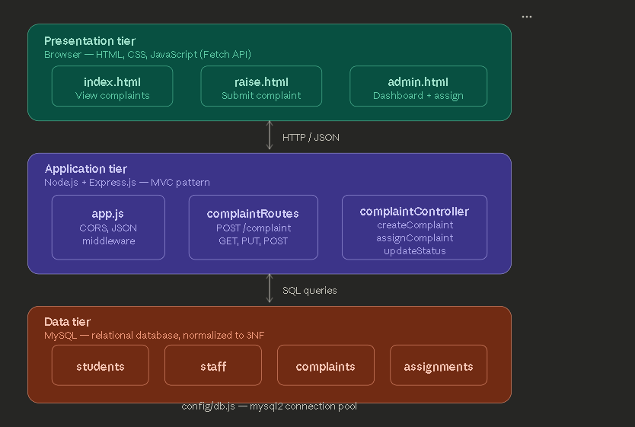

4.1.2 Entity-Relationship Diagram
The ER diagram models the four core entities of CampusCare and the relationships between them. COMPLAINTS is the central entity, referencing STUDENTS (the complainant) via a foreign key. ASSIGNMENTS links COMPLAINTS to STAFF members who are responsible for resolution.
Key cardinality constraints are:
- One STUDENTS record may be associated with many COMPLAINTS (1:N).
- One COMPLAINTS record may have one ASSIGNMENT (1:1 effectively, though modeled as 1:N).
- One STAFF record may handle many ASSIGNMENTS (1:N).
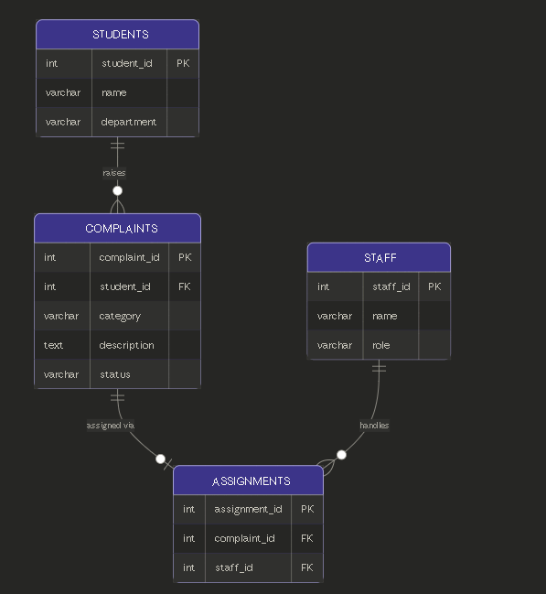

4.1.3 Relational Schema
The following relational schema is derived from the ER diagram. Primary keys are underlined and foreign keys are indicated with (FK).
students (student_id PK, name, department)
staff (staff_id PK, name, role)
complaints (complaint_id PK, student_id FK, category, description, status)
assignments (assignment_id PK, complaint_id FK, staff_id FK)

4.1.4 Data Flow
The data flow illustrates how information moves between actors and processes throughout the complaint lifecycle. There are two actors: the Student and the Administrator.
- P1 — Raise Complaint: A student fills out the complaint form; the application validates the input and inserts a new record into the complaints table with status OPEN.
- P2 — View Complaints: Complaints are fetched via a SELECT query and rendered in the table on the index page with current status.
- P3 — Assign Complaint: An administrator selects a complaint and staff member; the application inserts a record into assignments and updates the complaint status to IN_PROGRESS.
- P4 — Update Status: An administrator updates a complaint's status (e.g., to RESOLVED) via the admin panel.
- P5 — Dashboard Analytics: The admin dashboard queries the complaints table for aggregate counts grouped by status and displays them as summary cards.

CHAPTER 5
RELATIONAL DATA MODEL AND FUNCTIONALITIES

5.1 Tables, Attributes, and Key Constraints
CampusCare's MySQL database consists of four tables. The schema is designed to be minimal, normalized, and enforce referential integrity through foreign key constraints.

5.1.1 Table: students
Stores information about the students who raise complaints.
Attribute | Data Type | Constraint | Description
student_id | INT | PK, AUTO_INCREMENT, NOT NULL | Unique identifier for each student
name | VARCHAR(50) | NOT NULL | Full name of the student
department | VARCHAR(50) | NOT NULL | Academic department of the student

5.1.2 Table: staff
Stores information about the staff members who are assigned complaints for resolution.
Attribute | Data Type | Constraint | Description
staff_id | INT | PK, AUTO_INCREMENT, NOT NULL | Unique identifier for each staff member
name | VARCHAR(50) | NOT NULL | Full name of the staff member
role | VARCHAR(50) | NOT NULL | Staff role (e.g., Maintenance, IT Support)

5.1.3 Table: complaints
The central table of the schema. Each record represents one complaint raised by a registered student.
Attribute | Data Type | Constraint | Description
complaint_id | INT | PK, AUTO_INCREMENT, NOT NULL | Unique identifier for each complaint
student_id | INT | FK → students.student_id, NOT NULL | Student who raised the complaint
category | VARCHAR(50) | NOT NULL | Type of issue (e.g., Maintenance, IT)
description | TEXT | NOT NULL | Detailed description of the complaint
status | VARCHAR(20) | DEFAULT 'OPEN' | OPEN / IN_PROGRESS / RESOLVED

5.1.4 Table: assignments
Records the assignment of complaints to specific staff members. Inserting an assignment automatically elevates the complaint status to IN_PROGRESS via the backend controller.
Attribute | Data Type | Constraint | Description
assignment_id | INT | PK, AUTO_INCREMENT, NOT NULL | Unique identifier for each assignment
complaint_id | INT | FK → complaints.complaint_id, NOT NULL | The complaint being assigned
staff_id | INT | FK → staff.staff_id, NOT NULL | Staff member assigned to resolve it

5.2 Normalisation
Normalization is the process of organizing a relational database to eliminate redundancy and ensure data integrity. The CampusCare schema was designed in compliance with the First, Second, and Third Normal Forms.

5.2.1 First Normal Form (1NF)
A relation is in 1NF if every attribute contains only atomic (indivisible) values, and each record is uniquely identifiable by a primary key.
CampusCare satisfies 1NF because every attribute stores a single, atomic value. There are no multi-valued or composite attributes. For example, a complaint's category is stored as a single VARCHAR field. Every table has a designated primary key (complaint_id, student_id, staff_id, assignment_id) that uniquely identifies each row. There are no repeating groups — a student with multiple complaints does not store those complaints within the students row; they are held in the separate complaints table.

5.2.2 Second Normal Form (2NF)
A relation is in 2NF if it is already in 1NF and every non-key attribute is fully functionally dependent on the entire primary key (i.e. no partial dependencies exist).
All tables in CampusCare use single-column surrogate primary keys (INT AUTO_INCREMENT). Because no table has a composite primary key, partial dependency is structurally impossible, and every non-key attribute is trivially fully dependent on its table's primary key. The schema therefore satisfies 2NF.

5.2.3 Third Normal Form (3NF)
A relation is in 3NF if it is in 2NF and no non-key attribute is transitively dependent on the primary key through another non-key attribute.
In an unnormalized design, complaint data might be stored in a single flat table containing student_name, student_department, staff_name, and staff_role alongside the complaint itself. This creates transitive dependencies: student_name depends on student_id, which depends on complaint_id — violating 3NF. CampusCare eliminates all such transitive dependencies by decomposing the data into separate tables. Student name and department are stored exclusively in the students table, referenced from complaints via student_id (FK). Staff name and role are stored exclusively in the staff table, referenced from assignments via staff_id (FK). No non-key attribute in any table depends on another non-key attribute. The schema therefore satisfies 3NF.
Transitive Dependency | Resolution
In complaints: student_name depends on student_id (non-key) | student_name moved to students table; complaints stores only student_id (FK)
In assignments: staff_name depends on staff_id (non-key) | staff_name moved to staff table; assignments stores only staff_id (FK)

CHAPTER 6
TECHNOLOGIES USED, FRONT END DESIGN AND BACKEND LOGIC

6.1 Technologies Used
CampusCare is built entirely with open-source technologies. The selection was guided by accessibility, simplicity of deployment, and suitability for a campus-scale web application.
Technology | Version | Role in CampusCare
Node.js | 18.x | Server-side JavaScript runtime — executes all backend logic
Express.js | 4.x | Web framework — routing, middleware, API endpoints
MySQL | 8.x | Relational database — persistent storage of complaints, students, staff, assignments
mysql2 | npm package | MySQL driver for Node.js — database connection and query execution
cors | npm package | CORS middleware — enables cross-origin fetch requests from the frontend
HTML5 | Standard | Markup — page structure for all student and admin views
CSS3 | Custom | Styling — responsive layout, cards, navbar, buttons, table styles
JavaScript | Vanilla ES6 | Client-side fetch API calls, dynamic table rendering, form handling

6.2 Project Structure
The project follows a clean MVC folder structure separating configuration, routing, and business logic.
File / Folder | Purpose
Backend/config/db.js | Database connection configuration using mysql2
Backend/controllers/complaintController.js | All business logic: create, read, assign, update status
Backend/routes/complaintRoutes.js | URL route definitions mapping HTTP methods to controller functions
Backend/app.js | Express server setup, middleware configuration, port listener
frontend/index.html | Home page displaying all complaints in a table via fetch API
frontend/raise.html | Student complaint submission form
frontend/admin.html | Admin panel with dashboard, filtering, assign and resolve buttons
frontend/style.css | Shared styles: navbar, cards, table, buttons, hover effects

6.3 Backend Logic

6.3.1 Database Connection — config/db.js
A single reusable connection object is exported and imported in the controller. The connection uses mysql2 with host, user, password, and database configured for the local MySQL instance.

6.3.2 Complaint Controller Functions
The controller exports four functions, each handling one API operation:
- createComplaint: Receives student_id, category, description from the request body and executes an INSERT into complaints with status defaulting to OPEN.
- getComplaints: Executes a SELECT * FROM complaints and returns all records as JSON. The frontend renders these into the complaints table.
- assignComplaint: Receives complaint_id and staff_id, inserts into assignments, and then executes an UPDATE on complaints to set status = 'IN_PROGRESS' for that complaint_id.
- updateStatus: Receives a status value from the request body and a complaint ID from the URL parameter, then executes an UPDATE on complaints.

6.3.3 API Routes
Method | Endpoint | Description
POST | /api/complaint | Create a new complaint (student raises issue)
GET | /api/complaints | Fetch all complaints (dashboard and list view)
POST | /api/assign | Assign complaint to staff member (admin action)
PUT | /api/status/:id | Update complaint status by ID (admin resolves)

6.4 Sample SQL Queries

6.4.1 Create Complaint
INSERT INTO complaints (student_id, category, description)
VALUES (1,”Wifi”,”Not Working in Hostel”);
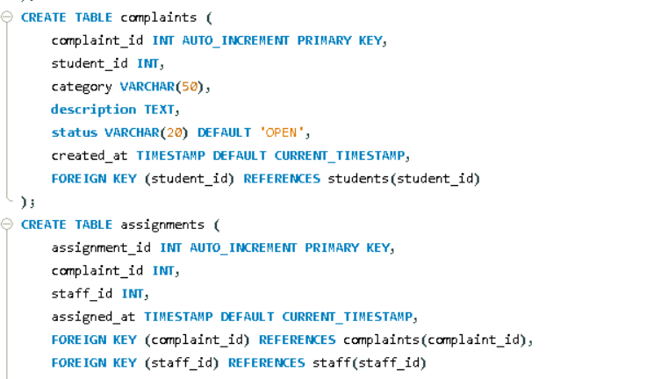
Creating Tables

6.4.2 Assign Complaint and Update Status
INSERT INTO assignments (complaint_id, staff_id) VALUES (2,1);
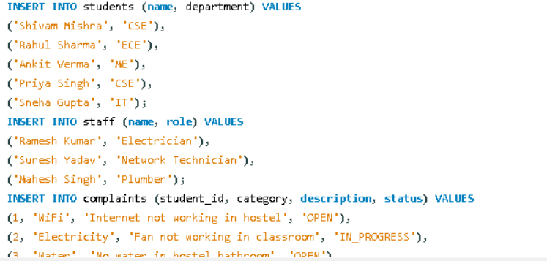
Inserting Values

6.4.3 Update Status
UPDATE complaints SET status=? WHERE complaint_id=2;
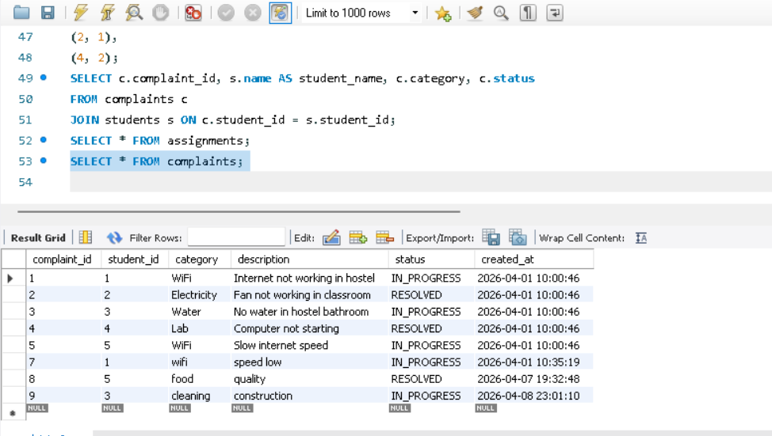

6.5 Frontend Design
The frontend is built with vanilla HTML, CSS, and JavaScript using the Fetch API to communicate with the Express backend. All pages share a common navbar and consistent card-based layout.
- index.html: Fetches all complaints on page load via GET /api/complaints and dynamically renders them in an HTML table showing ID, category, description, and status with color-coded badges.
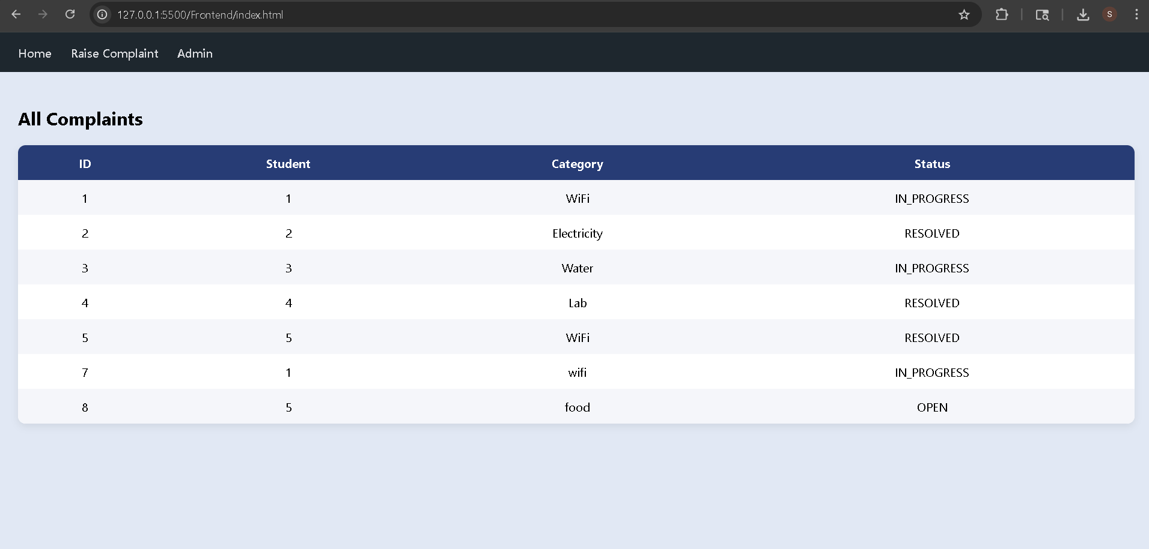
    - Dashboard
- raise.html: A form with student_id, category, and description fields. On submit, sends a POST request to /api/complaint with JSON body and displays a success message without page reload.
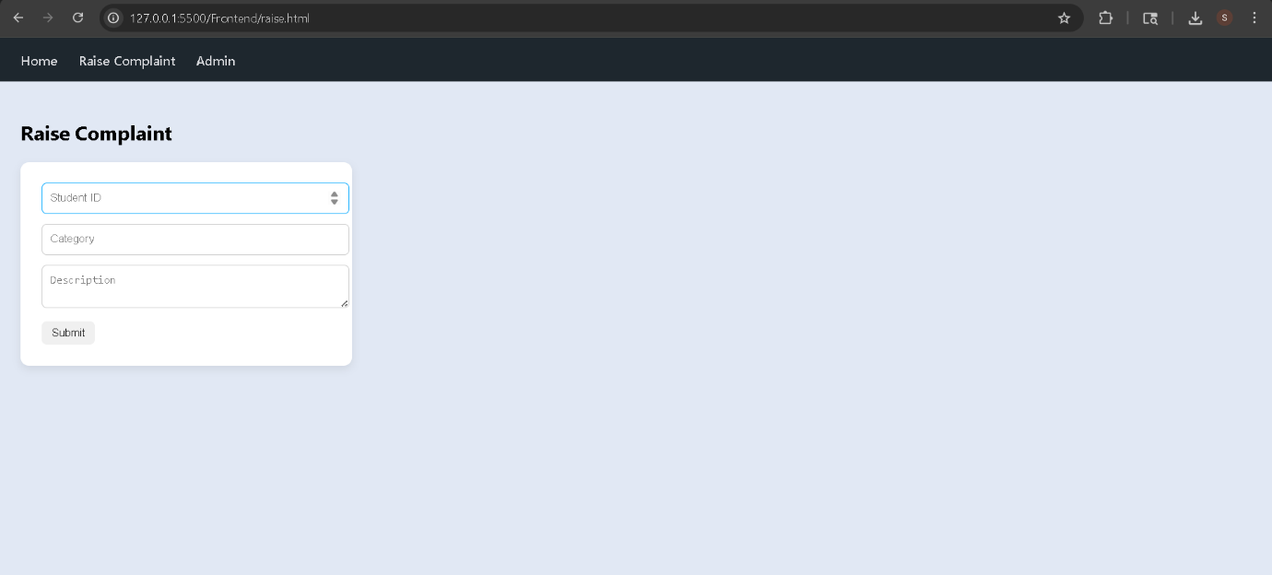
Inputting Complaints
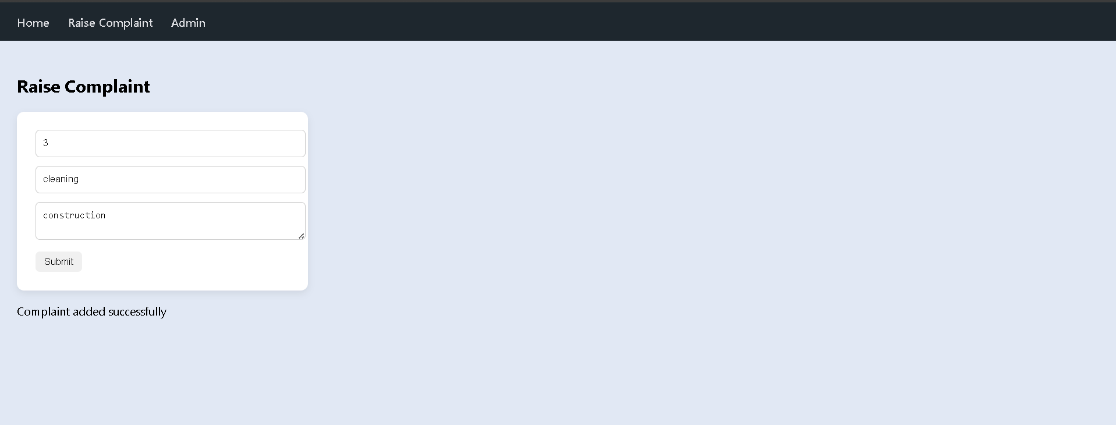
Complain Rasied
- admin.html: Displays a dashboard with summary cards (Total / Open / In Progress / Resolved), a filter dropdown to filter complaints by status or category, and action buttons for each complaint row — Assign (opens assignment modal) and Resolve (sends PUT request to update status).
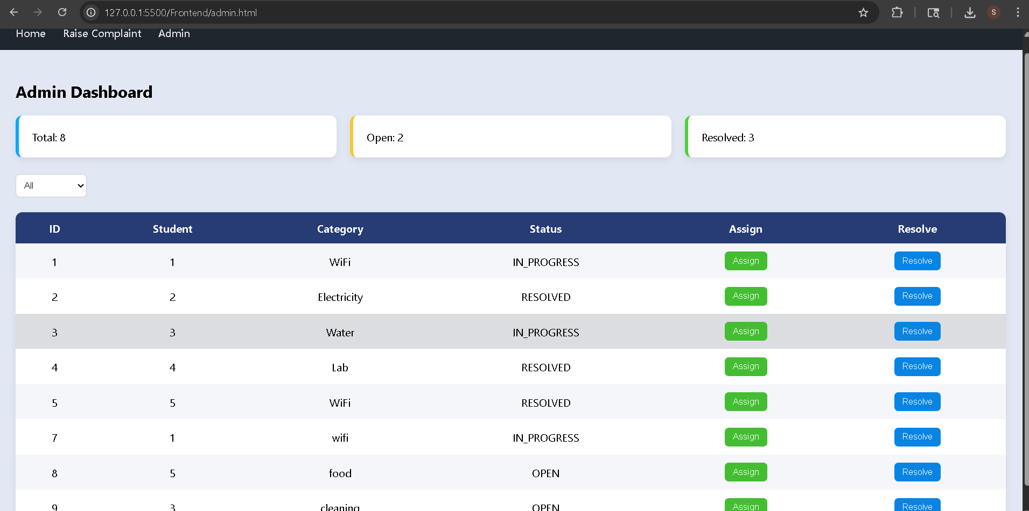
Admin Dashboard
CHAPTER 7
DATA FLOW, RESULTS AND DISCUSSIONS

7.1 Module-Level Data Flow Summary
Module | Primary Tables | Actor | Data Direction
Complaint Submission | complaints, students | Student | READ (form) → INSERT complaints
Complaint Listing | complaints | Admin / Student | SELECT * → JSON → UI Table
Complaint Assignment | assignments, complaints | Admin | INSERT assignments + UPDATE complaints
Status Update | complaints | Admin | UPDATE complaints.status
Dashboard Analytics | complaints (aggregate) | Admin | SELECT + GROUP BY → JSON → Cards

7.2 Module-by-Module Flow and Query Results

7.2.1 Complaint Submission Module
When a student fills the raise.html form and submits, the JavaScript sends a POST request with JSON body to /api/complaint. The controller receives student_id, category, and description, executes the parameterized INSERT query, and returns a success message. Status is hard-coded to OPEN at insert time — it is not passed from the form, preventing any status manipulation by a student.
Sample inserted record:
complaint_id | student_id | category | description | status
1 | 1 | Wiki | Slow Speed | OPEN

7.2.2 Complaint Listing Module
The GET /api/complaints endpoint executes SELECT * FROM complaints and returns all records as a JSON array. The frontend maps each record to a table row with dynamic status badges (green for RESOLVED, orange for IN_PROGRESS, red for OPEN). No server-side filtering is applied at this stage — filtering is handled client-side in the admin panel.

7.2.3 Assignment Module
When an administrator assigns a complaint, the POST /api/assign endpoint receives complaint_id and staff_id, inserts into assignments, and then executes a second UPDATE query to set the complaint status to IN_PROGRESS. This two-step write (insert + update) ensures the assignment table and complaint status stay synchronized.
Sample result after assignment of complaint_id = 1 to staff_id = 1:
assignment_id | complaint_id | staff_id | complaints.status
1 | 1 | 1 | IN_PROGRESS

7.2.4 Status Update Module
The PUT /api/status/:id endpoint receives the new status in the request body and the complaint ID from the URL parameter. It executes a parameterized UPDATE query. The admin panel sends this request when the Resolve button is clicked, passing status = 'RESOLVED'. The dashboard counters refresh on the next page load to reflect the updated status distribution.

7.2.5 Dashboard Analytics
The admin dashboard displays summary cards by fetching all complaints and computing counts client-side in JavaScript. Total complaints, open, in-progress, and resolved counts are computed using Array.filter() on the returned JSON array and displayed as colored cards. An enhancement would be to use a server-side aggregate query for scalability.

7.3 Testing Results
Test Case | Result | Observation
POST /api/complaint with valid body | ✔ Pass | Complaint inserted with status OPEN
GET /api/complaints | ✔ Pass | All complaints returned as JSON array
POST /api/assign with valid IDs | ✔ Pass | Assignment inserted; status updated to IN_PROGRESS
PUT /api/status/:id with RESOLVED | ✔ Pass | Complaint status updated correctly
Dashboard complaint counts | ✔ Pass | Correct counts displayed for each status
Foreign key violation (invalid student_id) | ✔ Caught | MySQL foreign key error returned; res.send('Error') triggered

7.4 Summary
The data flow analysis confirms that CampusCare handles the complete complaint lifecycle through a well-structured set of API endpoints and parameterized queries, each scoped to the minimum data required. The use of a two-step write for assignment (INSERT + UPDATE) ensures complaint status stays synchronized with the assignments table. All four API endpoints produced correct results during testing. Foreign key constraint violations were caught and returned as error responses. The dashboard correctly reflects live complaint counts.

CHAPTER 8
CONCLUSIONS AND FUTURE SCOPE

8.1 Summary of the Work
The project titled CampusCare — Complaint & Resolution Management System was developed to address the gap between students and administrative staff in reporting and resolving campus issues. In many institutions, problems such as maintenance failures, broken equipment, cleanliness issues, and network outages often go unreported or unresolved due to the absence of a structured communication channel.
The system was designed and implemented using a structured full-stack approach. The backend was developed using Node.js and Express.js following an MVC pattern, while MySQL was used as the relational database management system. The frontend was built using HTML, CSS, and JavaScript with the Fetch API for client-server communication. The system supports the complete complaint lifecycle — from student submission through admin assignment to final resolution — and provides a live analytics dashboard for administrators.

8.2 Conclusions
The developed system successfully fulfills its primary objective of providing an efficient, structured platform for reporting and managing campus complaints. It simplifies the process for students by allowing them to submit complaints online without informal channels. At the same time, it helps administrators organize complaints, assign them to responsible staff, and track resolution through a clear three-stage lifecycle.
The results demonstrate that a structured, database-driven system can significantly enhance accountability and transparency in institutional facility management. By maintaining a normalized relational database with foreign key constraints and a clean API layer, the system ensures data integrity and correctness. The project demonstrates core DBMS concepts including relational modeling, normalization to 3NF, constraint enforcement, and parameterized SQL queries in a practical full-stack context.

8.3 Future Scope of Work
The current system provides a strong foundation with significant room for enhancement:
- Authentication: Adding JWT-based login for students and admins would prevent unauthorized access and enable per-student complaint history views.
- Real-time notifications: Email or in-app notifications when complaint status changes would increase student engagement and transparency.
- Deployment: Deploying the Node.js backend on Render and the MySQL database on Clever Cloud would make the system accessible as a live web application.
- Image uploads: Allowing students to attach photos of the issue would help administrators assess severity before assigning.
- Server-side analytics: Replacing client-side aggregate computation with MySQL GROUP BY queries would make the dashboard scalable as complaint volumes grow.
In conclusion, CampusCare demonstrates that a lightweight, open-source Node.js and MySQL stack can deliver a practical, production-quality complaint management system for campus environments with minimal infrastructure investment.
REFERENCES

[1] L. G. Anthopoulos, M. Janssen, and V. Weerakkody, "A Unified Smart City Model (USCM) for Smart City Conceptualization and Benchmarking," International Journal of Electronic Government Research, vol. 12, no. 2, pp. 77–93, 2016.
[2] H. J. Scholl and M. C. Scholl, "Smart Governance: A Roadmap for Research and Practice," in Proceedings of iConference, 2014.
[3] R. Mishra and P. Gupta, "Design and Implementation of Online Complaint Management System for Educational Institutions," International Journal of Computer Applications, vol. 182, no. 5, pp. 10–15, 2019.
[4] N. Kumar and M. L. Best, "Impact of ICT on Governance Structures in Developing Countries," The Information Society, vol. 22, no. 3, pp. 151–163, 2006.
[5] Express.js Documentation, https://expressjs.com/en/guide/routing.html, accessed April 2026.
[6] MySQL 8.0 Reference Manual, https://dev.mysql.com/doc/refman/8.0/en/, accessed April 2026.

