Healthcare Data Analytics Virtual Internship
Week 6: Final Project Documentation and Presentation
Predicting Breast Tumour Malignancy with Python
An end-to-end healthcare analytics project: from planning to evaluation and future roadmap
Submitted by: Shivam
Platform: Yuva Intern | October 2026

Executive Summary (Plain-Language Overview)
Doctors examine cells taken from a breast lump to decide whether it is cancerous (malignant) or harmless (benign). Measurements such as the size, shape and texture of the cell nuclei are recorded for each case. This project asks a simple question: can a computer learn from past cases and help flag the ones that are most likely to be malignant?
Using Python, I trained three kinds of models on 569 past cases and tested them on 171 cases they had never seen. The best model, Logistic Regression, correctly identified 61 of the 64 malignant cases (95.3%) and raised a false alarm on only 1 of the 107 benign cases. Overall it was right 97.7% of the time.
The most important caveat is that this tool is meant to support, not replace, clinicians. Three malignant cases were still missed, and the data comes from a single, well-curated research dataset. Before real clinical use the model would need testing on local hospital data, fairness checks and regulatory review.

Key fact | Result
Cases analysed | 569 (212 malignant, 357 benign)
Best model | Logistic Regression
Test accuracy | 97.7%
Malignant cases caught (recall) | 95.3%
ROC-AUC | 0.997

Table of Contents
1. Introduction
2. Project Journey: Phases Integrated
3. Methodology
4. Results
5. Discussion
6. Conclusion
7. Future Work and Suggestions
8. Final Presentation (for non-technical audiences)
Appendix A: Reproducible Python Code
Appendix B: Glossary

1. Introduction

1.1 Background and motivation
Breast cancer is one of the most common cancers worldwide, and early, accurate diagnosis strongly affects treatment success. Fine-needle aspiration (FNA) produces digitised images of cell nuclei from which numeric features can be computed. Machine learning can learn patterns in these features and provide a quick second opinion that helps prioritise cases for specialist review.

1.2 Objectives
- Define a clear healthcare analytics problem and success criteria.
- Prepare and explore the data, and build several predictive models in Python.
- Test the models rigorously, analyse their errors and plan improvements.
- Document the full journey and present the findings to technical and non-technical audiences.

1.3 Dataset
The project uses the Wisconsin Diagnostic Breast Cancer dataset, distributed with scikit-learn. It has 569 records and 30 numeric features, computed from images of cell nuclei (for example radius, texture, perimeter, area and concavity). For each of ten base measurements, the mean, standard error and "worst" (largest) value are provided. The target is the diagnosis. I treat malignant as the positive class, because finding malignant cases is the priority. The dataset has 0 missing values.
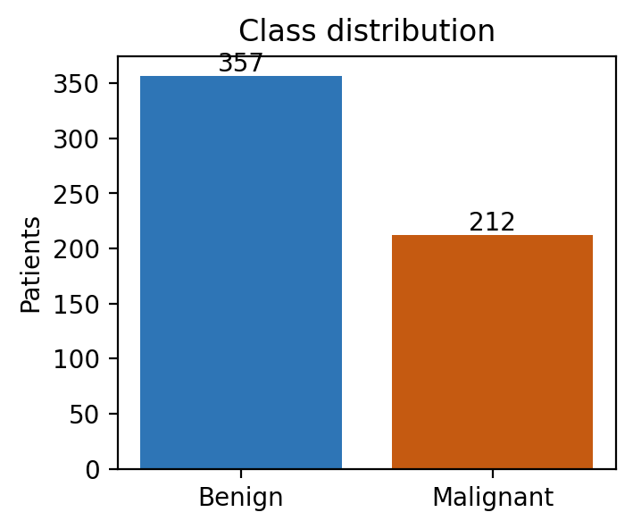
Figure 1: Class distribution (212 malignant, 357 benign; about 37% malignant)

2. Project Journey: Phases Integrated
The project followed six weekly phases, each building on the previous one. The table links each phase to its outcome in this document.
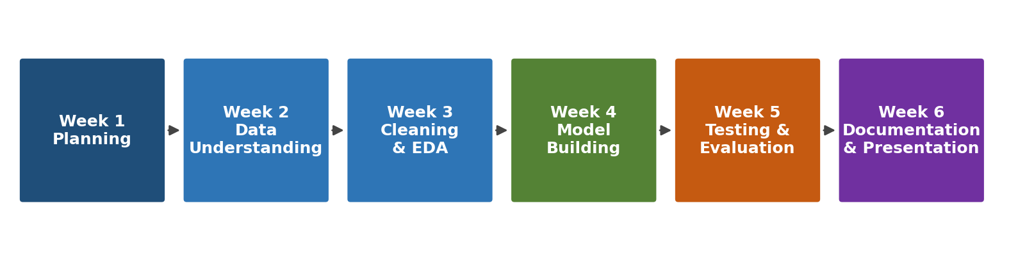
Figure 2: The six project phases
Phase | Focus | What was done
Week 1 | Strategic planning | Defined the clinical question, success measures (high recall for malignant cases, high overall accuracy) and the Python toolset (pandas, scikit-learn, matplotlib).
Week 2 | Data understanding | Reviewed the dataset's source, features, size and target definition; checked for missing values and duplicates.
Week 3 | Cleaning and exploration | Verified data quality, examined class balance and feature distributions, and found strongly correlated size-related features.
Week 4 | Model building | Trained logistic regression, random forest and gradient boosting using a reproducible, leakage-free pipeline.
Week 5 | Testing and evaluation | Planned stratified cross-validation, chosen metrics, confusion-matrix analysis, error diagnosis and an improvement roadmap.
Week 6 | Documentation and presentation | Executed the evaluation, integrated all phases into this report, and designed the final presentation section.

Note: Weeks 1 to 5 are summarised here at a high level so the document reads as one coherent project. The evaluation plan from Week 5 was applied to this dataset in Section 4.

3. Methodology

3.1 Data preparation
No missing values were found, so no imputation was needed. The data was split 70/30 into training (398 cases) and test (171 cases) sets with stratification, so both keep the same proportion of malignant cases. The test set was kept untouched until the final evaluation. Feature scaling was applied inside a pipeline for logistic regression, so statistics are learned from training data only and cannot leak from the test set.

3.2 Models
Model | Why it was chosen
Logistic Regression | Simple, fast and interpretable; a strong baseline. Class weights were balanced to give malignant cases proper attention.
Random Forest (300 trees) | Averages many decision trees; captures non-linear patterns and provides feature importance.
Gradient Boosting | Builds trees sequentially, each correcting the last; often strongest on tabular data. Also tuned with grid search.

3.3 Evaluation approach
Models were compared with stratified 5-fold cross-validation on the training set and then evaluated once on the hold-out test set. Because missing a malignant case is the most serious error, recall was the priority metric, supported by precision, F1, ROC-AUC and the Brier score (which measures how trustworthy the predicted probabilities are).
from sklearn.datasets import load_breast_cancer
from sklearn.model_selection import train_test_split, StratifiedKFold, cross_validate
from sklearn.pipeline import Pipeline
from sklearn.preprocessing import StandardScaler
from sklearn.linear_model import LogisticRegression

data = load_breast_cancer(as_frame=True)
X, y = data.data, 1 - data.target # 1 = malignant
X_train, X_test, y_train, y_test = train_test_split(
X, y, test_size=0.30, stratify=y, random_state=42)

model = Pipeline([
("scale", StandardScaler()),
("clf", LogisticRegression(max_iter=2000, class_weight="balanced")),
])
cv = StratifiedKFold(5, shuffle=True, random_state=42)
scores = cross_validate(model, X_train, y_train, cv=cv,
scoring=["roc_auc", "recall", "precision", "f1"])

4. Results

4.1 Cross-validation (training data)
Values are the mean across five folds, with the standard deviation in brackets. A small standard deviation means the model performs consistently.
Model | ROC-AUC | Recall | Precision | F1
Logistic Regression | 0.991 (0.007) | 0.959 (0.014) | 0.957 (0.054) | 0.957 (0.029)
Random Forest | 0.987 (0.005) | 0.918 (0.052) | 0.929 (0.062) | 0.922 (0.042)
Gradient Boosting | 0.986 (0.006) | 0.905 (0.046) | 0.922 (0.055) | 0.912 (0.033)

Logistic regression had the best cross-validated scores on every metric. Grid search over the number of trees, depth and learning rate gave gradient boosting a cross-validated AUC of 0.986, essentially identical to its default settings. Tuning therefore gave no real gain here.

4.2 Hold-out test set
Model | Accuracy | Recall | Precision | F1 | AUC | Brier
Logistic Regression | 97.7% | 95.3% | 98.4% | 96.8% | 0.997 | 0.019
Random Forest | 97.1% | 92.2% | 100.0% | 95.9% | 0.997 | 0.027
Gradient Boosting | 96.5% | 90.6% | 100.0% | 95.1% | 0.997 | 0.029
Gradient Boosting (tuned) | 96.5% | 90.6% | 100.0% | 95.1% | 0.997 | 0.029

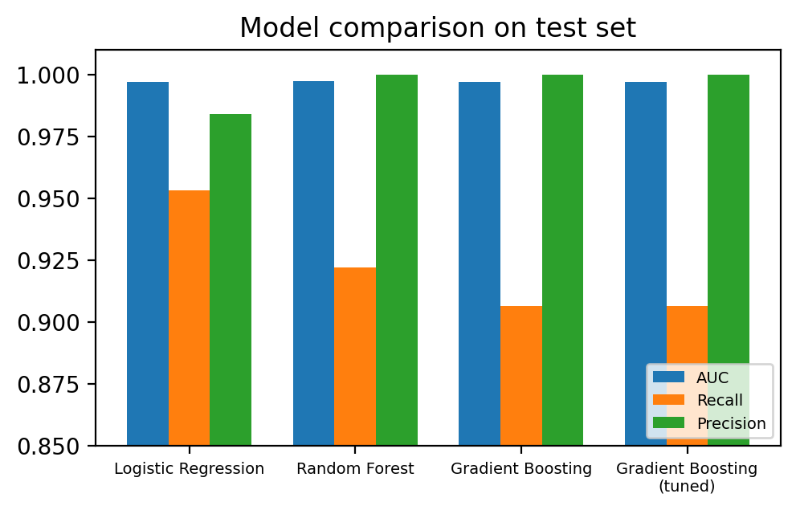
Figure 3: Model comparison on the test set
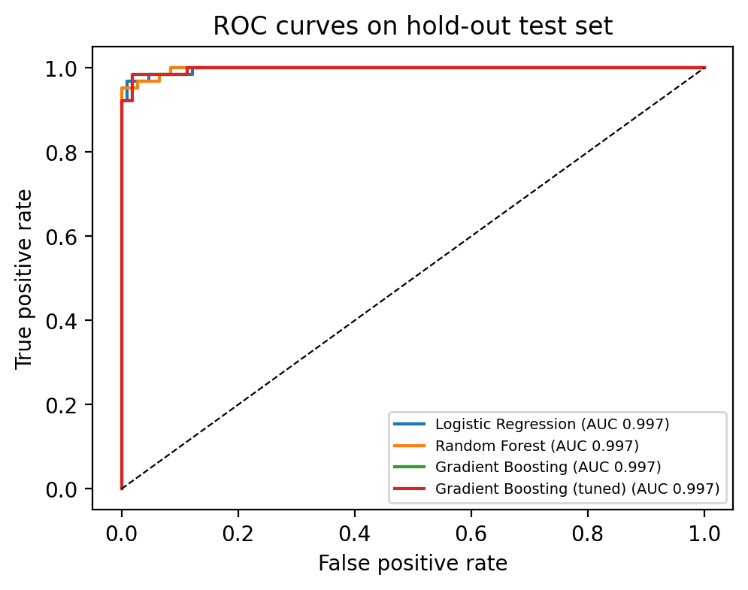
Figure 4: ROC curves. All models are close to the top-left corner, indicating excellent ranking ability

4.3 Confusion matrix of the best model
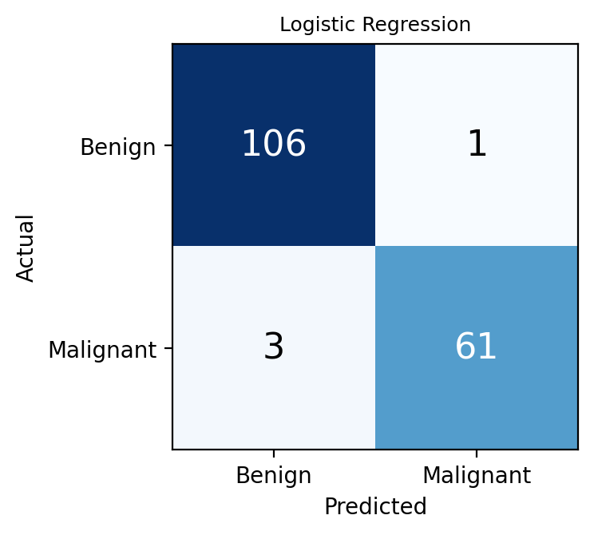
Figure 5: Confusion matrix, Logistic Regression (test set, threshold 0.5)
Out of 171 test cases, the model correctly identified 61 malignant and 106 benign cases. It missed 3 malignant cases (false negatives) and wrongly flagged 1 benign case (false positive).

4.4 Which measurements matter most?
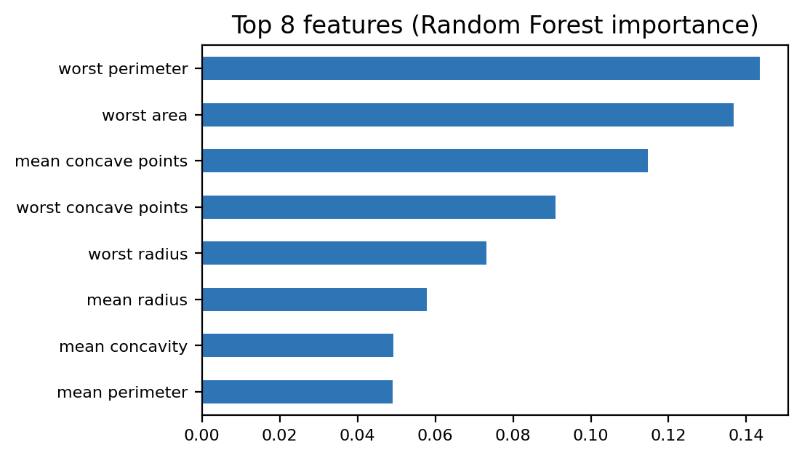
Figure 6: Most influential features according to the random forest
The most influential features were worst perimeter, worst area, mean concave points. These relate to the largest size and the irregular, indented shape of the cell nuclei, which agrees with medical understanding that malignant cells tend to be larger and more irregular.

5. Discussion

5.1 Interpretation
All three models performed very well (test AUC above 0.99), so the features carry a strong signal. The simple logistic regression matched or beat the more complex ensembles. In a clinical setting that is good news: a simpler model is easier to explain, audit and maintain. The tree ensembles produced no false alarms but missed more malignant cases (5 for random forest and 6 for gradient boosting, against 3 for logistic regression). Since missing cancer is worse than an extra check, logistic regression was selected.

5.2 Effect of the decision threshold
By default, a case is flagged when the predicted probability is at least 0.5. Lowering the threshold makes the model more cautious. The table shows this trade-off for the selected model. These figures were calculated on the test set purely to illustrate the trade-off; in a real deployment the threshold must be chosen using validation data, then confirmed once on the test set.
Threshold | Recall | Precision | Missed / False alarms
0.5 | 95.3% | 98.4% | 3 / 1
0.3 | 96.9% | 95.4% | 2 / 3
0.2 | 96.9% | 92.5% | 2 / 5

5.3 Error analysis and limitations
- Small test set: with 171 cases, one extra mistake changes recall by about 1.5 percentage points, so differences between models are within noise. Confidence intervals would be wide.
- Single, curated dataset: results come from one research source; hospital data will have different equipment, patient mix and noise, so performance will likely be lower.
- Class imbalance: moderate (37% malignant). Class weights helped logistic regression; this was not applied to gradient boosting.
- Correlated features: many size features (radius, perimeter, area) are almost duplicates, which can destabilise coefficient interpretation.
- Overfitting check: cross-validation and test scores are close, so there is no sign of serious overfitting.
- No fairness analysis: the dataset has no demographic information, so performance across patient groups could not be assessed.

6. Conclusion
This project took a healthcare analytics question from planning to evaluation using Python. Following a leakage-safe workflow, three models were built and compared with cross-validation and a hold-out test. Logistic Regression gave the best balance: 97.7% accuracy, 95.3% recall on malignant cases and an AUC of 0.997. Error analysis showed that remaining mistakes are few and that the model relies on medically sensible features. The results show that machine learning can serve as a reliable decision-support aid, though the small, single-source dataset means the numbers should not be assumed to carry over to real clinics.

7. Future Work and Suggestions
# | Step | Detail
1 | Validate on external data | Test on data from other hospitals or a newer collection period; expect and measure performance drops.
2 | Stronger statistics | Use repeated cross-validation and bootstrap confidence intervals to compare models fairly.
3 | Threshold selection | Choose the operating threshold on validation data with clinicians, based on the cost of missed cancers versus extra tests.
4 | Calibration | Check calibration curves and apply Platt or isotonic calibration so probabilities can be read as real risks.
5 | Explainability | Add SHAP explanations so clinicians can see why each case was flagged.
6 | Feature work | Remove redundant correlated features; test regularised models and ensembles (stacking).
7 | Fairness and monitoring | Collect demographic data to test subgroup performance; monitor drift after deployment.
8 | Governance | Privacy review, clinical validation and regulatory approval before any real use.

8. Final Presentation (for non-technical audiences)
This section is designed to be shown as a short slide-style summary. Each box below is one "slide".

Slide 1: The question
Can a computer help spot cancerous tumours earlier?
Doctors measure cell features from a small tissue sample.
Our goal: learn from 569 past cases to flag likely malignant ones.
The tool supports doctors; it does not replace them.

Slide 2: How we did it
Six steps, one story
Plan → Understand data → Clean and explore → Build models → Test honestly → Share results.
We hid 171 cases from the computer during training, then used them as a fair exam.

Slide 3: What we found
Right overall | Cancers caught | False alarms
97.7% | 95.3% (61 of 64) | 1 of 107 healthy cases

Reading the grid: dark diagonal squares are correct decisions; the small numbers elsewhere are mistakes

Slide 4: What drives the decision
Bigger and more irregular cells raise the risk score
This matches what pathologists already know, which builds trust in the model.
A simple model did as well as complex ones, so it is easy to explain.

Slide 5: Cautions and next steps
Cautions | Next steps
Missed 3 of 64 cancers; no model is perfect. | Test on data from other hospitals.
Only one research dataset was used. | Tune the alert level with doctors.
Fairness across patient groups not yet checked. | Explain each prediction; monitor over time.

Slide 6: Key takeaway
Promising decision-support tool, not yet a clinical product
High accuracy with a transparent model.
Clear plan to validate it safely before real-world use.

Appendix A: Reproducible Python Code
The complete analysis script is below. It runs on a standard Python environment with pandas, numpy, scikit-learn and matplotlib, and needs no internet connection.
Core modelling and evaluation steps:
import numpy as np, pandas as pd
from sklearn.datasets import load_breast_cancer
from sklearn.model_selection import train_test_split, StratifiedKFold, cross_validate, GridSearchCV
from sklearn.pipeline import Pipeline
from sklearn.preprocessing import StandardScaler
from sklearn.linear_model import LogisticRegression
from sklearn.ensemble import RandomForestClassifier, GradientBoostingClassifier
from sklearn.metrics import (confusion_matrix, roc_auc_score, recall_score,
precision_score, f1_score, brier_score_loss)

d = load_breast_cancer(as_frame=True)
X, y = d.data, 1 - d.target # 1 = malignant
X_tr, X_te, y_tr, y_te = train_test_split(X, y, test_size=0.3,
stratify=y, random_state=42)
models = {
"Logistic Regression": Pipeline([("s", StandardScaler()),
("m", LogisticRegression(max_iter=2000, class_weight="balanced"))]),
"Random Forest": Pipeline([("m", RandomForestClassifier(
n_estimators=300, random_state=42, class_weight="balanced"))]),
"Gradient Boosting": Pipeline([("m", GradientBoostingClassifier(random_state=42))]),
}
cv = StratifiedKFold(5, shuffle=True, random_state=42)
for name, m in models.items():
r = cross_validate(m, X_tr, y_tr, cv=cv,
scoring=["roc_auc", "recall", "precision", "f1"])
print(name, {k: round(v.mean(), 3) for k, v in r.items() if k.startswith("test_")})

grid = GridSearchCV(models["Gradient Boosting"],
{"m__n_estimators": [100, 200], "m__max_depth": [2, 3],
"m__learning_rate": [0.05, 0.1]}, scoring="roc_auc", cv=cv).fit(X_tr, y_tr)

for name, m in models.items():
m.fit(X_tr, y_tr)
p = m.predict_proba(X_te)[:, 1]
pred = (p >= 0.5).astype(int)
print(name, roc_auc_score(y_te, p), recall_score(y_te, pred),
precision_score(y_te, pred), f1_score(y_te, pred),
brier_score_loss(y_te, p), confusion_matrix(y_te, pred).ravel())

Appendix B: Glossary
Term | Plain-language meaning
Malignant / Benign | Cancerous / non-cancerous.
Recall (sensitivity) | Of all truly cancerous cases, the share the model caught.
Precision | Of all cases the model flagged, the share that really were cancerous.
False negative | A cancerous case the model missed (most serious error).
False positive | A healthy case flagged by mistake (leads to an extra check).
ROC-AUC | Score from 0.5 (guessing) to 1.0 (perfect) for how well the model ranks risky cases above safe ones.
Cross-validation | Repeatedly training on part of the data and testing on the rest, for a more reliable estimate.
Overfitting | Memorising the training data so well that new cases are predicted poorly.
Brier score | Error of the predicted probabilities; lower is better.

