WEEK 1 • R DATA ANALYST INTERNSHIP
Data Cleaning & Preliminary Analysis
Titanic Passenger Dataset

Project | Details
Internship Task | Week 1 — Data Cleaning and Preliminary Analysis with R
Analyst | Shivam Nakoti
Dataset | Titanic passenger data — 891 records × 12 columns
Core tools | R, dplyr, ggplot2, tidyr
Deliverables | Cleaned data workflow, R code, statistics, correlations, visual analysis

Prepared as a professional internship submission report

1. Executive Summary
This report documents a complete Week 1 data-analytics workflow in R using the publicly available Titanic passenger dataset. The work focuses on data inspection, missing-value treatment, duplicate checking, outlier detection, normalization, categorical encoding, descriptive statistics, correlation analysis, and preliminary visual exploration.
The raw dataset contains 891 passenger records and 12 variables. Three fields contain missing values: Age (177), Cabin (687), and Embarked (2). Rather than deleting large portions of the dataset, the cleaning strategy uses median imputation for Age, mode imputation for Embarked, and a CabinKnown indicator before removing the highly sparse Cabin text field. Potential Fare and Age outliers are flagged using the IQR method rather than automatically deleted, because extreme fares may represent legitimate first-class passengers.
Preliminary analysis shows a strong difference in survival by sex and passenger class. Overall survival was 38.4%; the survival rate was approximately 74.2% for female passengers versus 18.9% for male passengers. First-class passengers also had a much higher survival rate than third-class passengers. These findings are descriptive and should not be interpreted as causal conclusions.

Submission Checklist
- Public dataset identified and documented.
- Missing values audited and handled with justified methods.
- Duplicate records checked.
- Outliers detected using the IQR method.
- Numerical variables normalized using min-max scaling.
- Categorical variables converted/encoded for analysis.
- Descriptive statistics and correlations documented.
- Visual evidence included for major preliminary findings.
- R code supplied in both the report appendix and a separate .R file.

2. Dataset Selection & Understanding
The Titanic dataset was selected because it satisfies the task requirements: it is publicly available, contains both numerical and categorical variables, and includes realistic data-quality issues such as missing values. It also supports meaningful preliminary analysis without requiring a machine-learning model.

Public Source
A public GitHub CSV mirror of the standard Titanic training dataset was used as the reproducible download source:
https://github.com/datasciencedojo/datasets/blob/master/titanic.csv
The dataset contains the standard 891 passenger records and the fields PassengerId, Survived, Pclass, Name, Sex, Age, SibSp, Parch, Ticket, Fare, Cabin, and Embarked.

Data Dictionary
Variable | Type | Meaning
PassengerId | Numeric / ID | Unique passenger identifier
Survived | Binary | 0 = did not survive, 1 = survived
Pclass | Categorical | Passenger ticket class: 1, 2, or 3
Name | Text | Passenger name
Sex | Categorical | Passenger sex
Age | Numeric | Passenger age in years
SibSp | Numeric | Siblings/spouses aboard
Parch | Numeric | Parents/children aboard
Ticket | Text | Ticket identifier
Fare | Numeric | Passenger fare
Cabin | Text | Cabin identifier; highly sparse
Embarked | Categorical | Port of embarkation: C, Q, S

Initial Dataset Profile
Metric | Result
Rows | 891
Columns | 12
Duplicate rows | 0
Missing Age | 177 (19.9%)
Missing Cabin | 687 (77.1%)
Missing Embarked | 2 (0.2%)
Survivors | 342 (38.4%)
Non-survivors | 549 (61.6%)

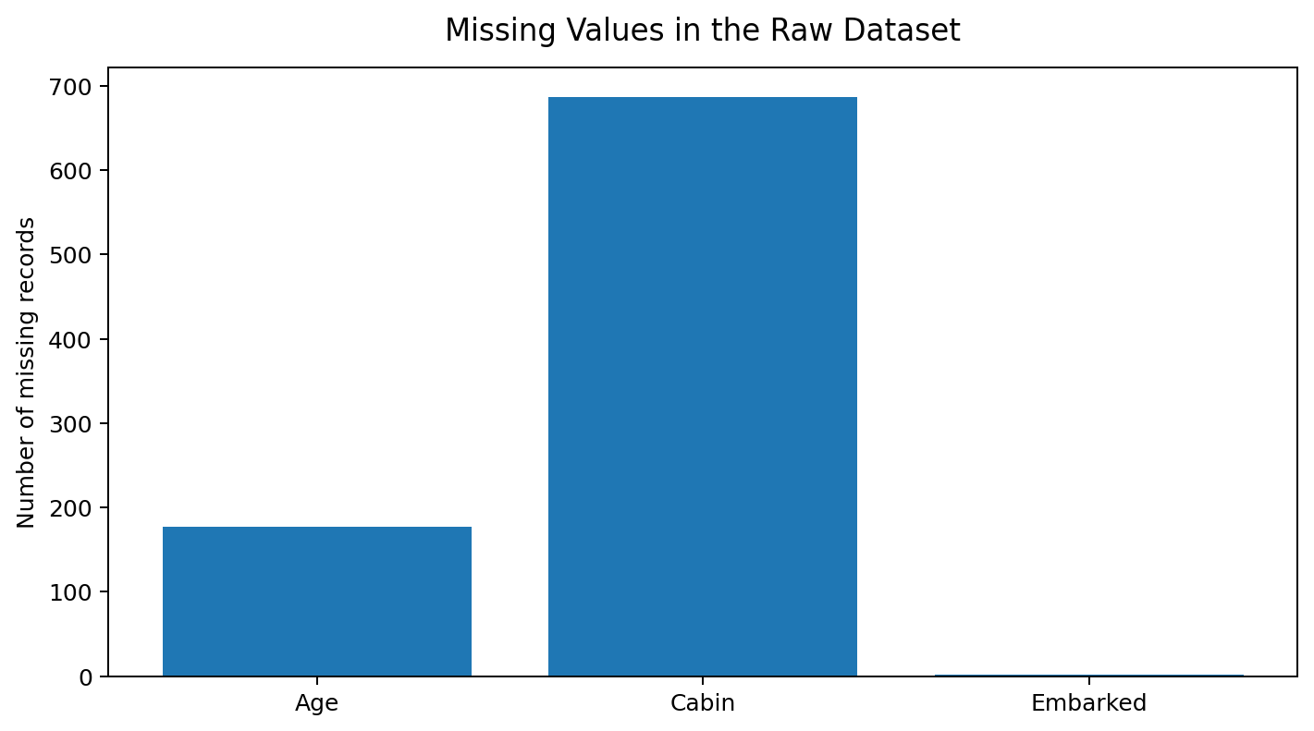
Figure 1. Missing-value profile of the raw dataset.

3. Data Cleaning & Preprocessing
The cleaning process was designed to retain as much information as possible while making each treatment explicit and reproducible. The sequence below can be rerun from the supplied R script.

3.1 Missing Values
Column | Missing | Treatment | Reason
Age | 177 | Median imputation | Keeps all passenger records and is less sensitive to extreme ages than the mean.
Cabin | 687 | Create CabinKnown; drop raw Cabin | 77.1% missing makes direct imputation unreliable.
Embarked | 2 | Mode imputation (S) | Only two missing records; mode is simple and appropriate for this categorical field.

R Code — Missing Values
missing_summary <- data.frame(
Column = names(titanic),
Missing = sapply(titanic, function(x) sum(is.na(x))),
Missing_Percent = round(sapply(titanic, function(x) mean(is.na(x))*100), 2)
)
cleaned$Age[is.na(cleaned$Age)] <- median(cleaned$Age, na.rm = TRUE)
mode_embarked <- names(sort(table(cleaned$Embarked), decreasing = TRUE))[1]
cleaned$Embarked[is.na(cleaned$Embarked)] <- mode_embarked
cleaned$CabinKnown <- ifelse(is.na(cleaned$Cabin), "No", "Yes")
cleaned$Cabin <- NULL

3.2 Duplicate Check
A complete-row duplicate check returned zero duplicate records. No records were removed for duplication.
sum(duplicated(titanic)) # Expected output: 0

3.3 Outlier Detection
The IQR method was selected because it is robust to skewed variables such as Fare. The analysis flags potential outliers instead of automatically deleting them. This is important because a high fare can be a valid observation rather than an error.
fare_q1 <- quantile(cleaned$Fare, 0.25)
fare_q3 <- quantile(cleaned$Fare, 0.75)
fare_upper <- fare_q3 + 1.5 * IQR(cleaned$Fare)
cleaned$Fare_Outlier <- cleaned$Fare > fare_upper

3.4 Normalization
Min-max normalization converts selected numeric variables to the 0–1 range. This is useful when variables with different scales will later be used together in a model or distance-based method.
minmax <- function(x) (x - min(x, na.rm=TRUE)) /
(max(x, na.rm=TRUE) - min(x, na.rm=TRUE))
cleaned$Age_Normalized <- minmax(cleaned$Age)
cleaned$Fare_Normalized <- minmax(cleaned$Fare)

3.5 Categorical Encoding
Categorical fields are converted to factors for analysis. One-hot encoding is demonstrated with model.matrix so that categorical variables can also be represented numerically when required by downstream models.
cleaned$Sex <- factor(cleaned$Sex)
cleaned$Embarked <- factor(cleaned$Embarked)
cleaned$Pclass <- factor(cleaned$Pclass)
encoded <- model.matrix(
~ Sex + Embarked + Pclass + CabinKnown - 1,
data = cleaned
)

4. Exploratory & Preliminary Analysis

4.1 Overall Survival
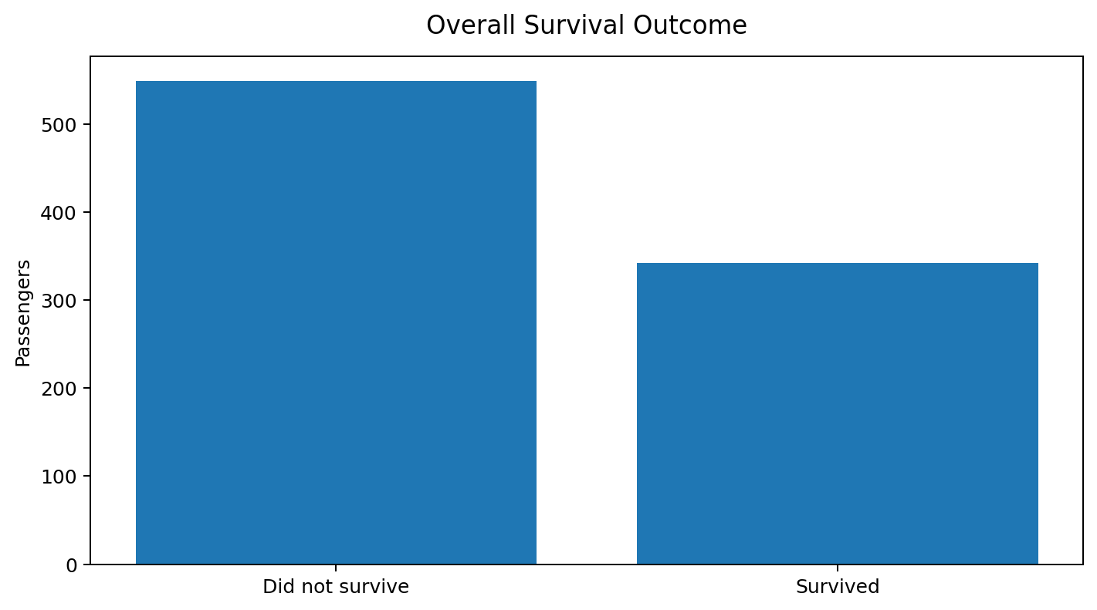
Figure 2. Overall survival outcome: 342 survived and 549 did not survive.
The overall survival rate is 38.4%. This provides a baseline against which subgroup survival rates can be compared.

4.2 Survival by Sex
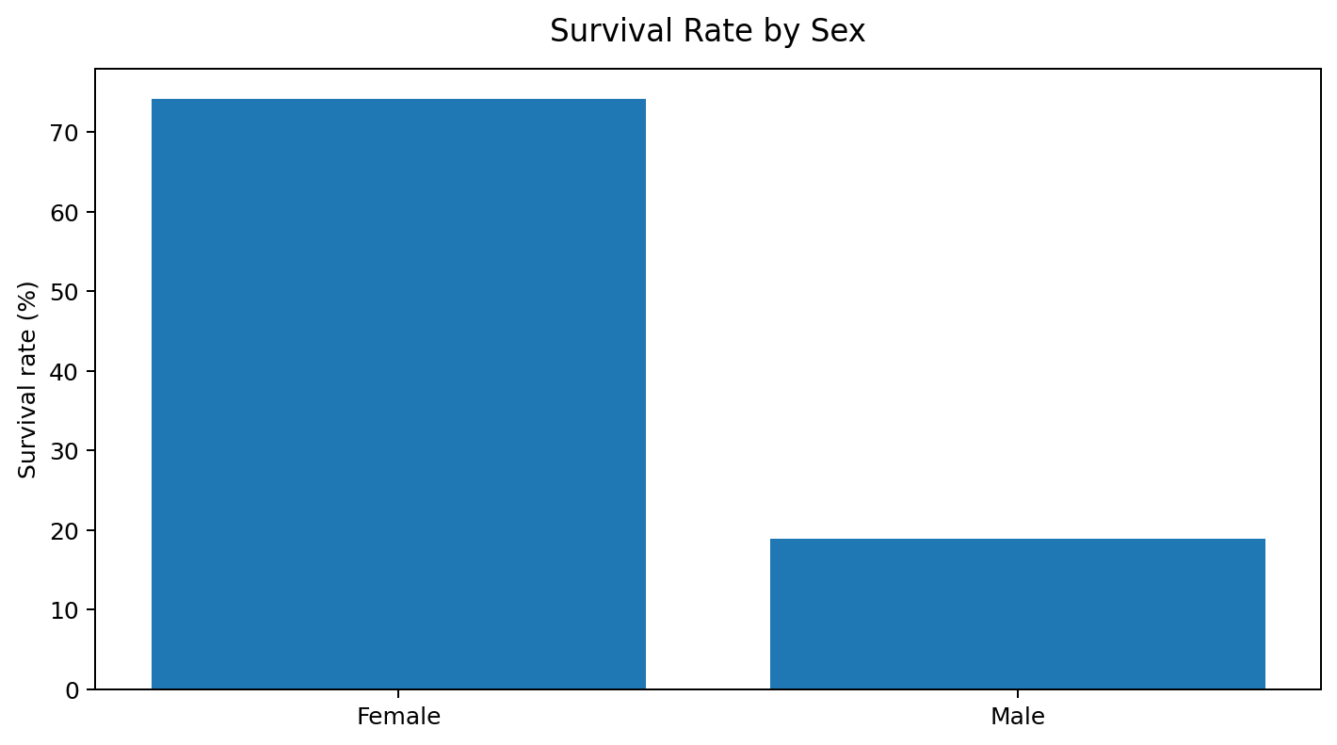
Figure 3. Female passengers had a substantially higher observed survival rate than male passengers.
Sex | Passengers | Survivors | Survival Rate
Female | 314 | 233 | 74.2%
Male | 577 | 109 | 18.9%

The difference is large: the observed survival rate for female passengers was about four times the rate for male passengers. This is an association in the dataset, not a causal claim.

4.3 Survival by Passenger Class
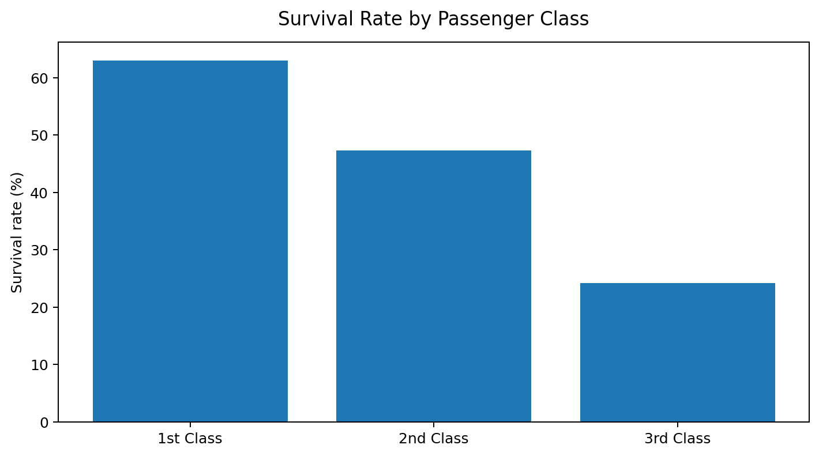
Figure 4. Survival rate decreases from first class to third class.
Class | Passengers | Survivors | Survival Rate
1st | 216 | 136 | 63.0%
2nd | 184 | 87 | 47.3%
3rd | 491 | 119 | 24.2%

4.4 Survival by Port
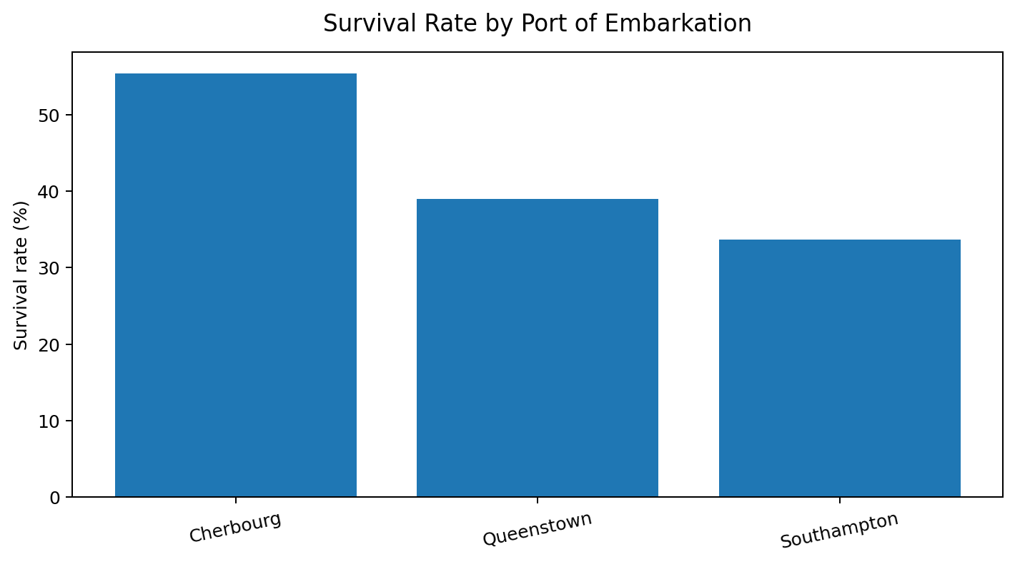
Figure 5. Preliminary survival comparison by port of embarkation.
Port | Passengers* | Survivors | Survival Rate
Cherbourg (C) | 168 | 93 | 55.4%
Queenstown (Q) | 77 | 30 | 39.0%
Southampton (S) | 644 | 217 | 33.7%

*The two records with missing Embarked values are excluded from this subgroup table.

5. Descriptive Statistics & Correlation

5.1 Descriptive Statistics
Measure | Value | Interpretation
Rows | 891 | Passenger observations before preprocessing
Survival rate | 38.38% | Share of passengers with Survived = 1
Mean age | 29.70 years | Average recorded passenger age
Median age | 28 years | Middle age after considering available age records
Mean fare | 32.20 | Average fare
Median fare | 14.45 | Fare distribution is right-skewed
Age range | 0.42–80 | Wide age coverage
Fare range | 0–512.33 | Includes high-fare observations

5.2 Correlation Analysis
Correlation is used here as a screening tool to understand linear relationships among selected numeric variables. It does not prove causation and can be affected by nonlinear patterns and variable coding.
Variable pair | Approx. Pearson correlation | Reading
Survived ↔ Pclass | −0.34 | Higher class number (3rd class) is associated with lower survival.
Survived ↔ Fare | +0.26 | Higher fares are moderately associated with survival.
Survived ↔ Age | −0.08 | Weak negative linear association.
Survived ↔ SibSp | −0.04 | Very weak linear association.
Survived ↔ Parch | +0.08 | Weak positive linear association.

The R script calculates the correlation matrix directly from the cleaned data. The values above are included as preliminary interpretation and should be regenerated from the script when the analysis is rerun.

R Code — Correlation Matrix
correlation_data <- cleaned %>%
select(Survived, Age, SibSp, Parch, Fare)
cor(correlation_data, use = "complete.obs")

6. Key Initial Insights
Overall outcome: 342 of 891 passengers survived, giving a baseline survival rate of 38.4%.
Sex effect in the data: Female survival was 74.2% compared with 18.9% for male passengers.
Class gradient: Observed survival was 63.0% in first class, 47.3% in second class, and 24.2% in third class.
Port comparison: Cherbourg shows the highest observed survival rate among the three ports, at 55.4%.
Data quality: Cabin is the most incomplete field, with 687 missing values, so direct imputation would introduce substantial uncertainty.
Outliers: Fare contains legitimate high-value observations; therefore, the workflow flags them instead of deleting them automatically.
Preprocessing readiness: After imputation and encoding, the dataset is suitable for further exploratory analysis or a later predictive-modeling phase.

Business/Data-Analyst Interpretation
From an analyst perspective, the main lesson is that data preparation materially affects the reliability of downstream analysis. A simple missing-value count reveals that Cabin is unsuitable for direct imputation, while Age requires a defensible numeric treatment. Similarly, outlier detection should not be confused with error removal: unusual values can contain genuine business or operational information.

Limitations
- The dataset represents a historical event and should not be generalized to modern populations.
- Observed associations do not establish causality.
- Median/mode imputation simplifies the missing-data mechanism and can reduce natural variance.
- Cabin information is heavily incomplete, so the analysis retains only whether a cabin value was known.
- The report focuses on preliminary analysis rather than predictive modeling.

7. Reproducibility & How to Run
The accompanying file titanic_week1_analysis.R contains the full executable R workflow. The code is written so the dataset can be downloaded directly from the public source URL. The following steps reproduce the analysis.
1. Install R and RStudio (or another R environment).
2. Open titanic_week1_analysis.R.
3. Run the package installation/loading section.
4. Run the dataset import section and verify that 891 rows are loaded.
5. Run the cleaning sections in order.
6. Run the EDA and correlation sections to reproduce the tables and plots.
7. The script exports titanic_cleaned.csv and titanic_encoded.csv to the current working directory.

Suggested Project Folder
Shivam_Titanic_R_Data_Analysis/
├── Week1_Titanic_R_Data_Analysis.docx
├── titanic_week1_analysis.R
├── titanic_cleaned.csv # generated after running the R script
├── titanic_encoded.csv # generated after running the R script
└── README.txt

Submission Description (200+ words)
This report presents my Week 1 Data Analyst Internship task on Data Cleaning and Preliminary Analysis using R. "
I selected the publicly available Titanic passenger dataset because it contains both numerical and categorical variables "
and includes realistic data-quality issues such as missing values. The raw dataset contains 891 passenger records and 12 "
variables including passenger class, sex, age, family-related variables, fare, cabin and embarkation port.
The analysis begins with dataset inspection using dimension checks, structure inspection, summaries and a missing-value audit. "
The missing-value analysis identified 177 missing Age values, 687 missing Cabin values and 2 missing Embarked values. "
I used median imputation for Age, mode imputation for Embarked and created a CabinKnown indicator before removing the highly "
sparse Cabin text field. I also checked for duplicate records and used the IQR method to identify potential outliers in numeric "
variables such as Fare and Age. Potential outliers were flagged rather than automatically deleted because extreme values can "
represent valid observations.
For preprocessing, I converted categorical variables to factors and demonstrated one-hot encoding with model.matrix. "
I also applied min-max normalization to Age and Fare so the variables can be compared on a common 0-to-1 scale. Exploratory "
analysis was then performed using descriptive statistics, survival-rate comparisons, visualizations and a correlation matrix.
The preliminary results show an overall survival rate of 38.4%. Female passengers had a substantially higher observed survival "
rate than male passengers, and first-class passengers had a higher survival rate than second- and third-class passengers. "
The analysis demonstrates a complete and reproducible R workflow from raw-data inspection to cleaned data and initial insights.

Appendix A — Full R Code
# ============================================================
# Week 1 - Data Cleaning and Preliminary Analysis with R
# Dataset: Titanic passenger data (891 rows, 12 columns)
# Author: Shivam Nakoti
# ============================================================
# 1. Packages
packages <- c("dplyr", "ggplot2", "tidyr")
new_packages <- packages[!(packages %in% installed.packages()[,"Package"])]
if(length(new_packages)) install.packages(new_packages)
lapply(packages, library, character.only = TRUE)
# 2. Load publicly available data
url <- "https://raw.githubusercontent.com/datasciencedojo/datasets/master/titanic.csv"
titanic <- read.csv(url, stringsAsFactors = FALSE)
# 3. Initial inspection
dim(titanic)
names(titanic)
str(titanic)
summary(titanic)
head(titanic)
# 4. Missing-value audit
missing_summary <- data.frame(
Column = names(titanic),
Missing = sapply(titanic, function(x) sum(is.na(x))),
Missing_Percent = round(sapply(titanic, function(x) mean(is.na(x)) * 100), 2)
)
print(missing_summary)
# 5. Duplicate check
sum(duplicated(titanic))
# 6. Data cleaning
cleaned <- titanic
# Age: median imputation (robust to extreme values)
cleaned$Age[is.na(cleaned$Age)] <- median(cleaned$Age, na.rm = TRUE)
# Embarked: mode imputation
mode_embarked <- names(sort(table(cleaned$Embarked), decreasing = TRUE))[1]
cleaned$Embarked[is.na(cleaned$Embarked)] <- mode_embarked
# Cabin is too sparse for direct imputation. Preserve useful information
# through a binary indicator and remove the sparse raw text column.
cleaned$CabinKnown <- ifelse(is.na(cleaned$Cabin), "No", "Yes")
cleaned$Cabin <- NULL
# Convert categorical fields to factors
cleaned$Sex <- factor(cleaned$Sex)
cleaned$Embarked <- factor(cleaned$Embarked)
cleaned$Pclass <- factor(cleaned$Pclass,
levels = c(1,2,3),
labels = c("1st", "2nd", "3rd"))
cleaned$CabinKnown <- factor(cleaned$CabinKnown)
# 7. Outlier detection using IQR
fare_q1 <- quantile(cleaned$Fare, 0.25)
fare_q3 <- quantile(cleaned$Fare, 0.75)
fare_iqr <- IQR(cleaned$Fare)
fare_upper <- fare_q3 + 1.5 * fare_iqr
cleaned$Fare_Outlier <- cleaned$Fare > fare_upper
age_q1 <- quantile(cleaned$Age, 0.25)
age_q3 <- quantile(cleaned$Age, 0.75)
age_iqr <- IQR(cleaned$Age)
age_lower <- age_q1 - 1.5 * age_iqr
age_upper <- age_q3 + 1.5 * age_iqr
cleaned$Age_Outlier <- cleaned$Age < age_lower | cleaned$Age > age_upper
cat("Fare upper IQR limit:", fare_upper, "\n")
cat("Potential Fare outliers:", sum(cleaned$Fare_Outlier), "\n")
cat("Potential Age outliers:", sum(cleaned$Age_Outlier), "\n")
# 8. Normalization (min-max scaling)
minmax <- function(x) (x - min(x, na.rm=TRUE)) /
(max(x, na.rm=TRUE) - min(x, na.rm=TRUE))
cleaned$Age_Normalized <- minmax(cleaned$Age)
cleaned$Fare_Normalized <- minmax(cleaned$Fare)
# 9. Encoding categorical variables (one-hot encoding)
encoded <- model.matrix(~ Sex + Embarked + Pclass + CabinKnown - 1,
data = cleaned)
encoded <- as.data.frame(encoded)
head(encoded)
# 10. Descriptive statistics
numeric_summary <- cleaned %>%
summarise(
Passengers = n(),
Survival_Rate = mean(Survived) * 100,
Mean_Age = mean(Age),
Median_Age = median(Age),
Mean_Fare = mean(Fare),
Median_Fare = median(Fare)
)
print(numeric_summary)
# 11. Survival analysis
survival_by_sex <- cleaned %>%
group_by(Sex) %>%
summarise(
Passengers = n(),
Survivors = sum(Survived),
Survival_Rate = mean(Survived) * 100
)
print(survival_by_sex)
survival_by_class <- cleaned %>%
group_by(Pclass) %>%
summarise(
Passengers = n(),
Survivors = sum(Survived),
Survival_Rate = mean(Survived) * 100
)
print(survival_by_class)
survival_by_port <- cleaned %>%
group_by(Embarked) %>%
summarise(
Passengers = n(),
Survivors = sum(Survived),
Survival_Rate = mean(Survived) * 100
)
print(survival_by_port)
# 12. Correlation analysis
correlation_data <- cleaned %>%
select(Survived, Age, SibSp, Parch, Fare)
print(cor(correlation_data, use = "complete.obs"))
# 13. Visualizations
ggplot(cleaned, aes(x = Sex, fill = factor(Survived))) +
geom_bar(position = "fill") +
labs(title = "Survival Proportion by Sex",
x = "Sex", y = "Proportion", fill = "Survived")
ggplot(cleaned, aes(x = Pclass, fill = factor(Survived))) +
geom_bar(position = "fill") +
labs(title = "Survival Proportion by Passenger Class",
x = "Passenger Class", y = "Proportion", fill = "Survived")
ggplot(cleaned, aes(x = Fare)) +
geom_histogram(bins = 30) +
labs(title = "Fare Distribution", x = "Fare", y = "Count")
# 14. Export cleaned data
write.csv(cleaned, "titanic_cleaned.csv", row.names = FALSE)
write.csv(encoded, "titanic_encoded.csv", row.names = FALSE)

Appendix B — Source & Submission Notes
Dataset source: public GitHub mirror of the standard Titanic training CSV. The report uses the dataset for educational data-cleaning and exploratory-analysis purposes.
Important: the GitHub project URL field on the internship portal is separate from the dataset source. If the portal requires a personal GitHub project URL, upload the supplied R script and this report (or the full project folder) to a repository under your own GitHub account and paste that repository URL in the portal.

