WEEK 4 — FINAL REPORT
Comprehensive Data Analysis, Reporting & Presentation
Integration of Data Preparation • Visualization • Statistics • Predictive Modeling

Student | Shivam Nakoti
Week 1 | Titanic — data cleaning and exploratory analysis
Week 2 | Diamonds — visualization and insight communication
Week 3 | Iris — statistical analysis and predictive modeling
1. Executive Summary
This final-week report consolidates the analytical skills developed across the first three weeks into one coherent data-analysis workflow. Week 1 established data quality and exploratory analysis using a public Titanic dataset, including missing-value treatment, duplicate checks, IQR-based outlier detection, descriptive statistics and correlation. Week 2 focused on communicating patterns visually using the ggplot2 diamonds dataset through distributions, relationships, category comparisons, spread and trend analysis. Week 3 extended the workflow into formal statistical reasoning and predictive modeling with the iris dataset, including hypothesis testing, correlation, normality assessment, logistic regression, train-test evaluation, ROC/AUC and cross-validation. The final outcome is a reproducible, evidence-based workflow that moves from data preparation to insight discovery, statistical validation and prediction.
2. Objectives
- Integrate data preparation, visualization, statistical analysis and predictive modeling into a single analytical narrative.
- Demonstrate that chart selection and statistical testing should be driven by the analytical question.
- Evaluate predictive performance using appropriate validation and classification metrics.
- Translate technical findings into clear conclusions, practical implications and recommendations.
- Maintain reproducibility by documenting R code and analytical decisions.
3. Integrated Analytical Workflow
The workflow follows a practical sequence: first understand and clean the data, then explore it visually, next test important relationships statistically, and finally build and validate a predictive model where the problem supports it. This order reduces the risk of modeling poor-quality data and makes the final conclusions easier to explain.
1. Prepare | 2. Explore | 3. Visualize | 4. Test & Model | 5. Communicate
Missing values, duplicates, outliers | Distributions & relationships | Charts and trends | Tests, regression, CV | Insights, limits, recommendations
4. Week 1 — Data Preparation & Exploratory Analysis
The Titanic dataset was used as the foundation for data-quality practice. The analysis began by profiling missing values and checking for duplicate observations. Missing numeric values were handled using a robust central-value approach, while categorical gaps were addressed using the most frequent category. Descriptive statistics were then used to understand the range and central tendency of numeric variables. An IQR rule was applied to flag unusually high or low fare values rather than automatically deleting them. Correlation analysis provided an initial view of relationships between numeric fields. The main lesson from this stage is that data cleaning is not simply a technical step: the decisions made here directly affect the reliability of later visualizations and models.
# Missing values
colSums(is.na(titanic))
# Remove exact duplicates
titanic <- distinct(titanic)
# IQR-based outlier identification
Q1 <- quantile(titanic$Fare, .25, na.rm = TRUE)
Q3 <- quantile(titanic$Fare, .75, na.rm = TRUE)
IQR_value <- IQR(titanic$Fare, na.rm = TRUE)

5. Week 2 — Visualization & Insight Communication
The diamonds dataset was used to demonstrate how visual design can turn a large table into a readable analytical story. The histogram highlighted the right-skewed price distribution. The scatter plot showed a strong positive relationship between carat and price while allowing comparison across cut categories. The bar chart provided a quick comparison of average price by cut, the box plot showed variation across clarity levels, and the line chart summarized the upward trend in average price across ordered carat ranges. These visualizations demonstrate that no single chart is sufficient for every question; the best chart is the one that makes the intended pattern easiest to interpret.
Price distribution
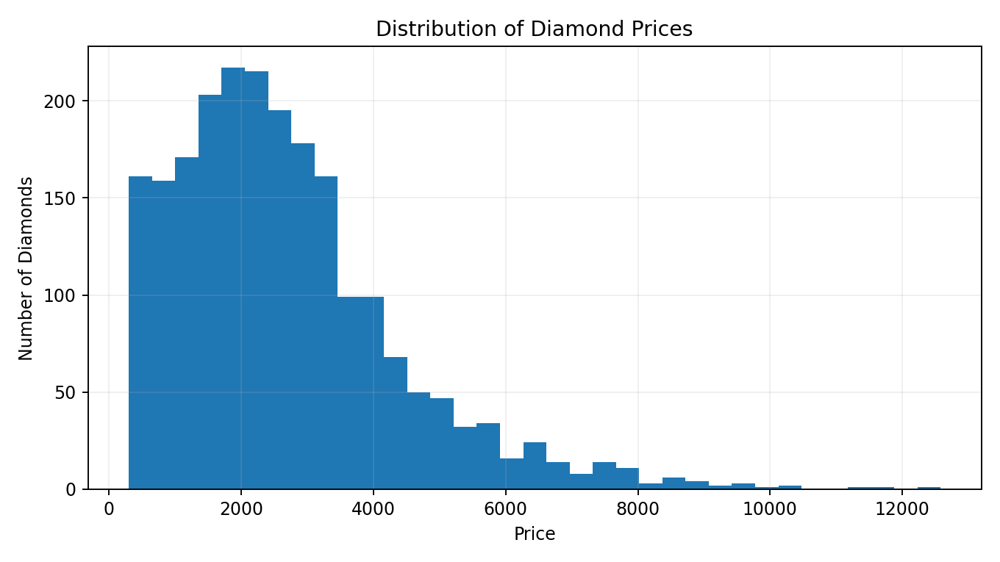
Carat-price relationship
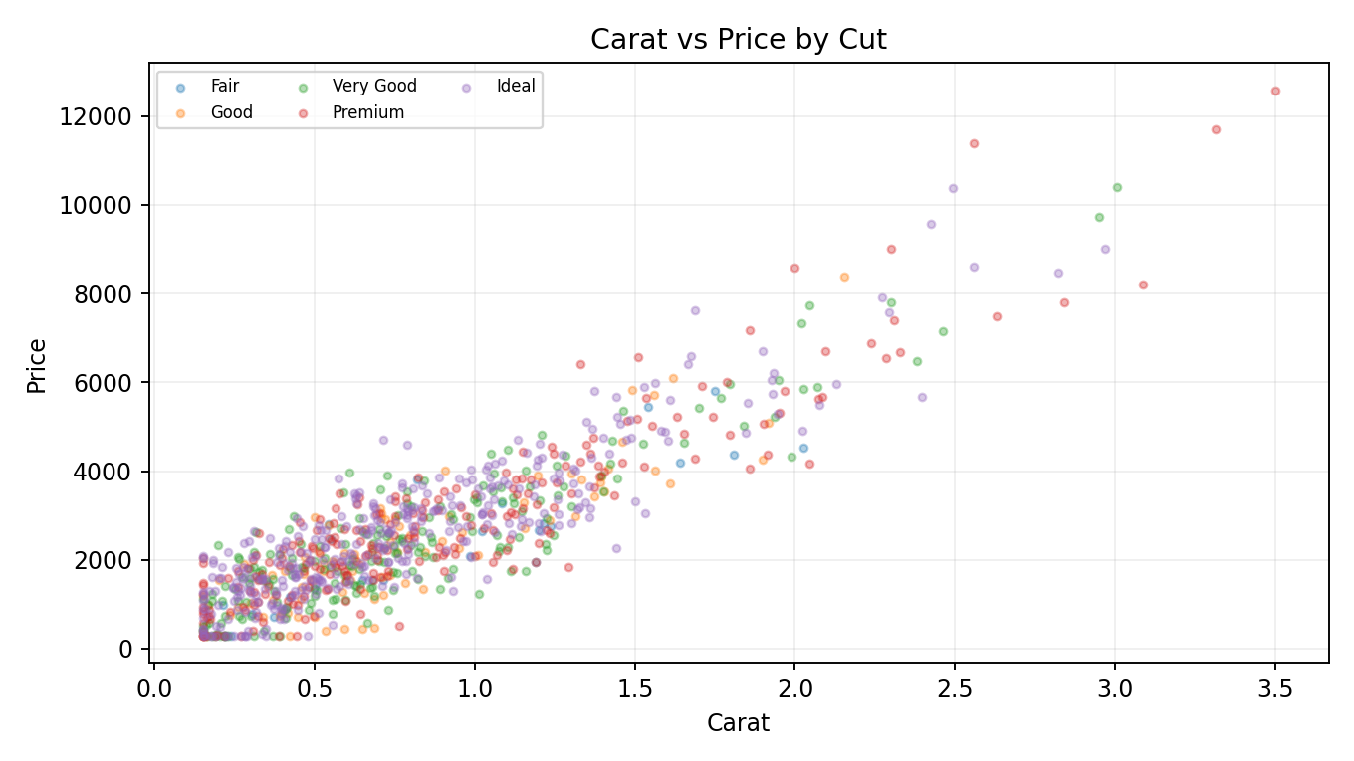
Average price by cut
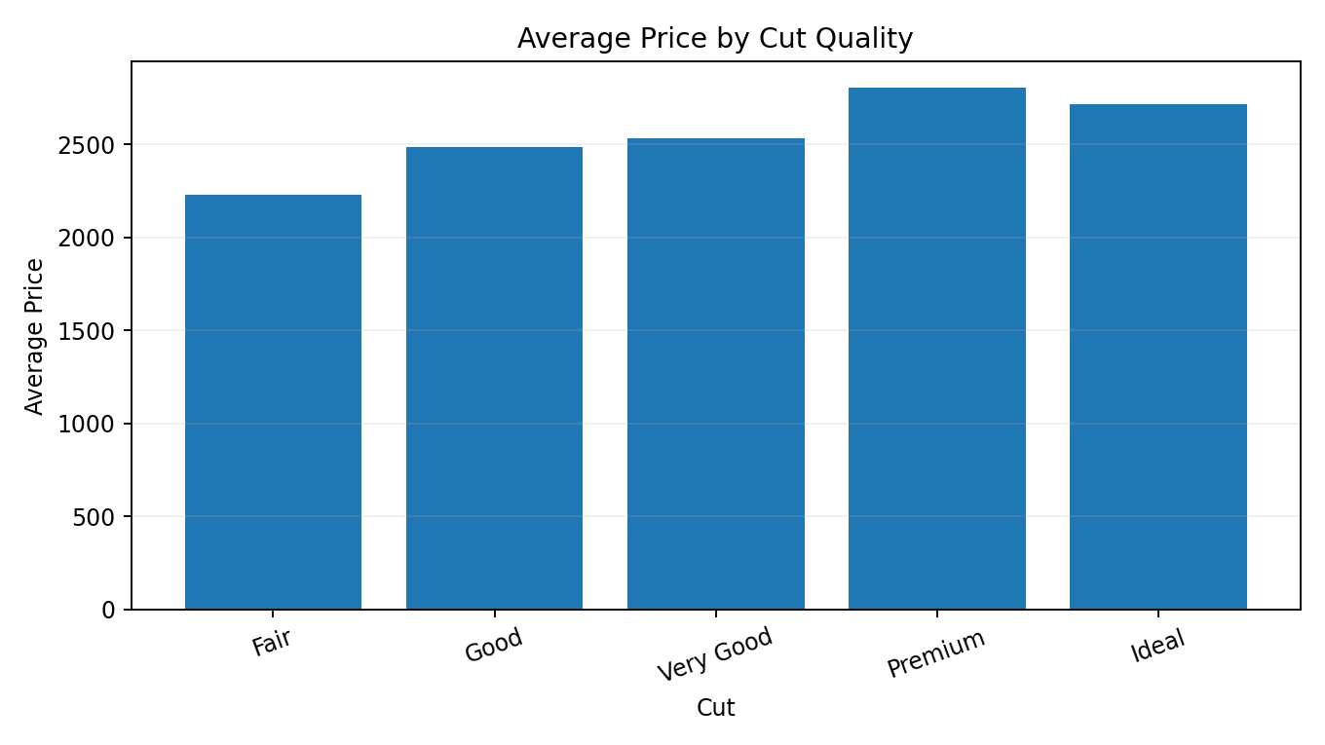
Price spread by clarity
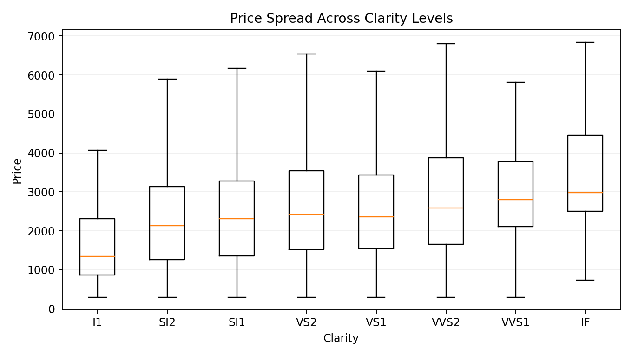
Average price trend
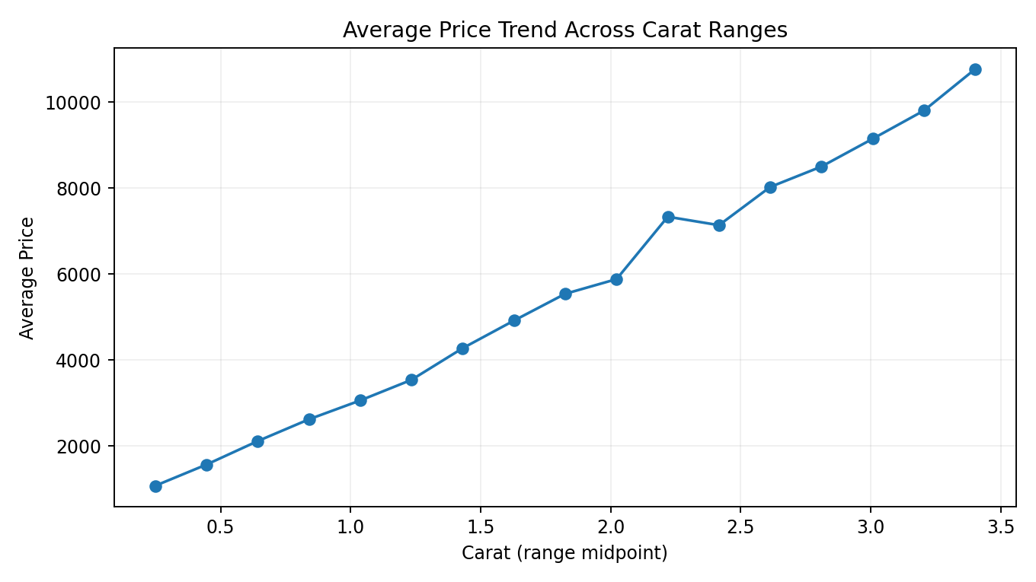
6. Week 3 — Statistical Analysis & Predictive Modeling
The iris dataset was used to move from descriptive analysis into formal statistical reasoning and classification. A Welch t-test was used to compare groups, Pearson correlation tested the association between selected numeric variables, and the Shapiro-Wilk test was used to examine a normality assumption. For prediction, the target was converted into a binary classification problem: setosa versus other species. A logistic regression model used the four measured flower features as predictors. The data were split into training and testing sets, and the model was evaluated using a confusion matrix and metrics including accuracy, precision, recall and F1. ROC/AUC and 5-fold cross-validation were added to reduce the chance of relying on a single train-test split.
Class distribution
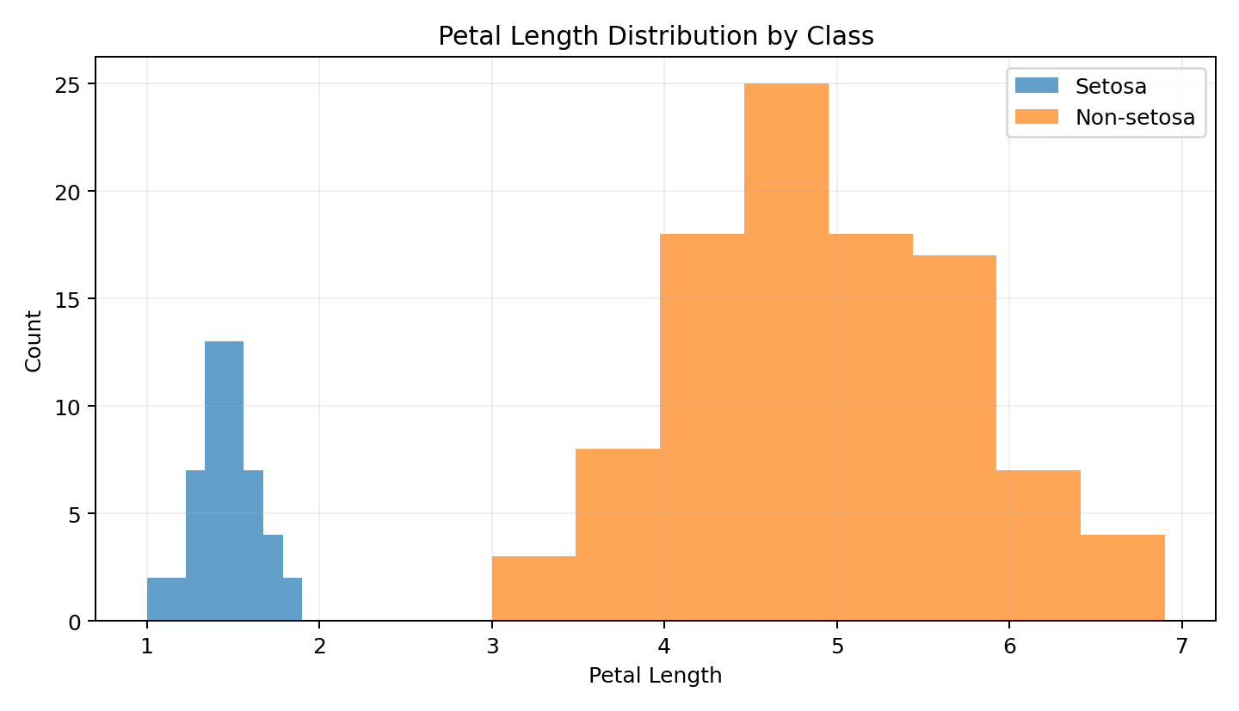
Confusion matrix
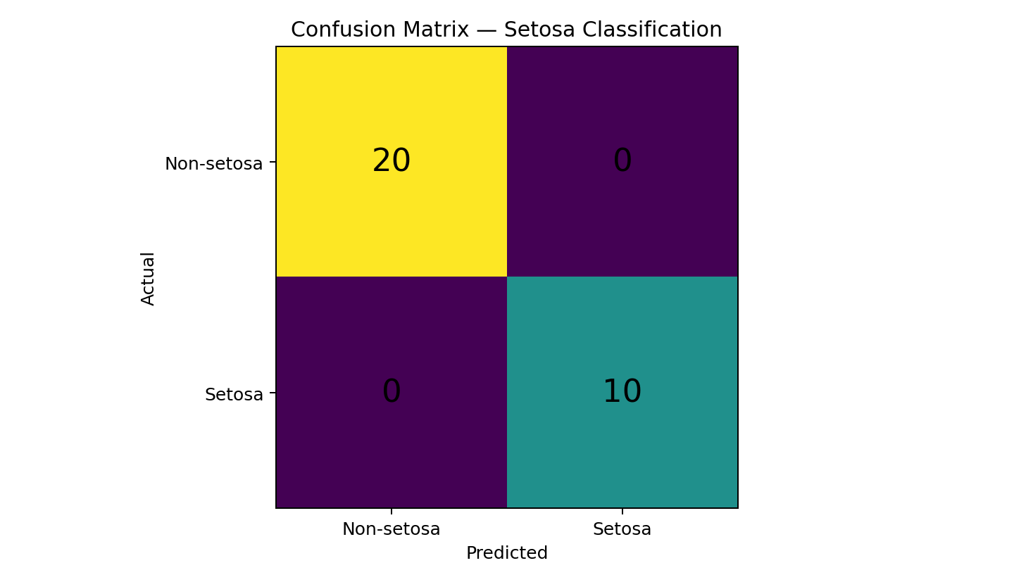
ROC curve
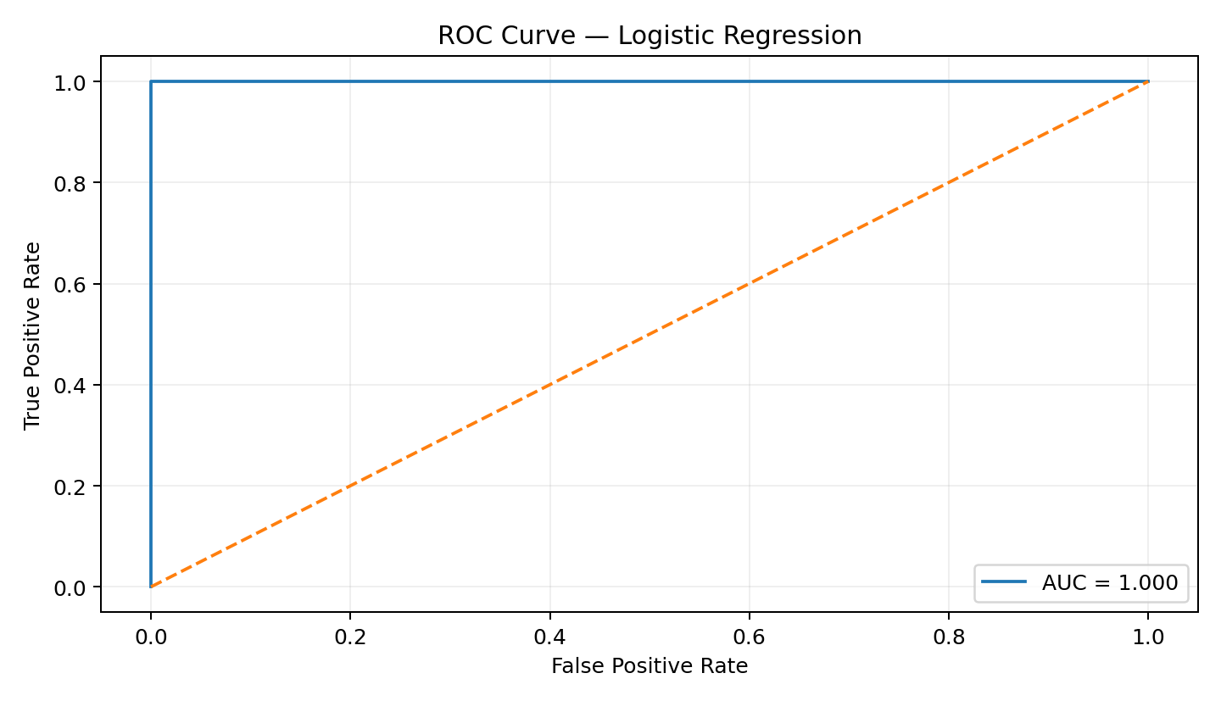
Cross-validation performance
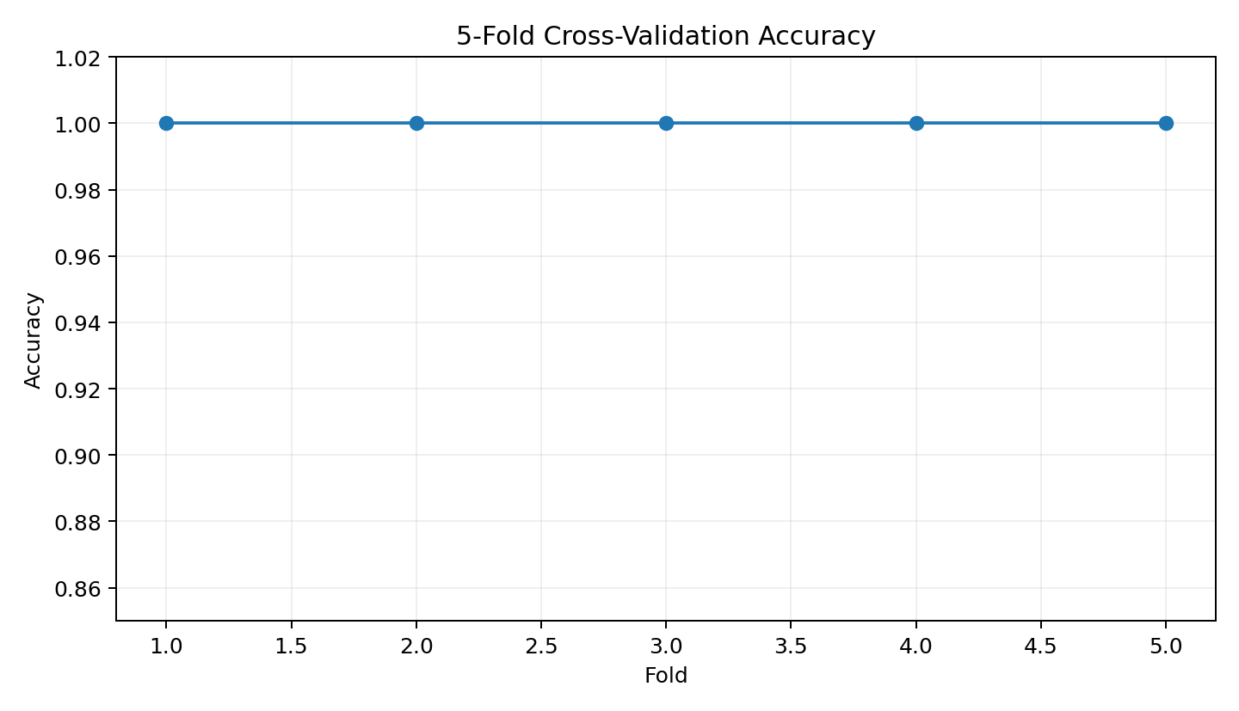
Model diagnostic / residual view
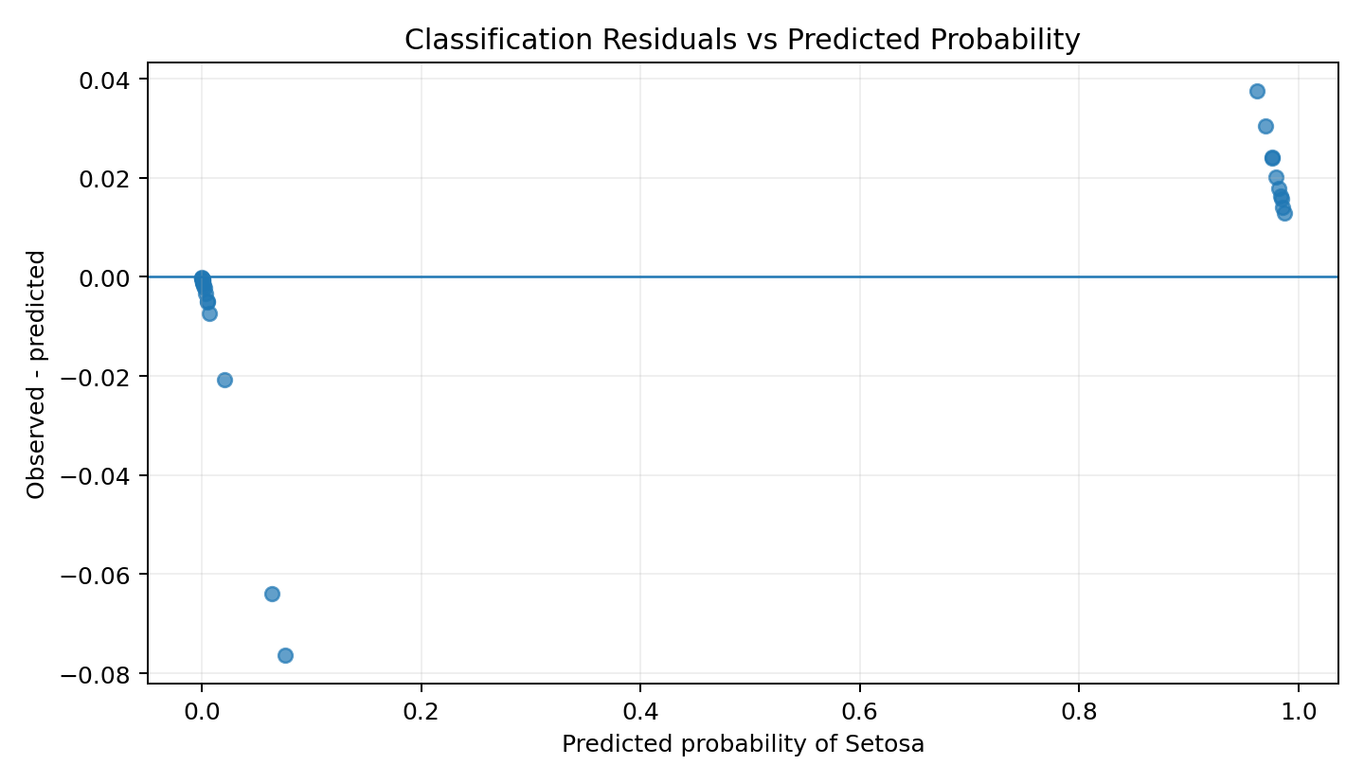
7. Comparative Findings
Stage | Dataset | Main Method | Key Learning
Week 1 | Titanic | Cleaning + EDA | Reliable analysis starts with data quality.
Week 2 | Diamonds | ggplot2 visualization | Chart choice determines how clearly patterns are communicated.
Week 3 | Iris | Statistics + logistic regression | Statistical evidence and validation strengthen conclusions.
8. Discussion & Practical Implications
Across the three stages, the strongest recurring theme is that analytical conclusions should be supported by multiple forms of evidence. Cleaning identifies data-quality risks before they propagate. Visualization makes patterns visible and accessible to non-technical audiences. Statistical tests add a formal framework for judging whether observed relationships are consistent with a stated hypothesis. Predictive modeling then asks a different question: how well can the observed features classify a future or unseen observation? For practical analytics work, these stages should not be treated as isolated assignments. They form a reusable workflow for business questions such as customer analysis, risk assessment, performance monitoring and operational forecasting.
9. Challenges and Limitations
- The three weeks used different public datasets, so the final report integrates the methods as a common analytical workflow rather than pretending they represent one business dataset.
- Outlier detection identifies unusual observations but does not automatically prove that they are erroneous.
- Descriptive relationships should not be interpreted as causal relationships without an appropriate experimental or causal design.
- A single train-test split can vary with random sampling; cross-validation provides a more stable estimate but does not eliminate all modeling uncertainty.
- Predictive performance depends on feature quality, class balance, data representativeness and assumptions behind the selected model.
10. Recommendations & Future Work
- Use domain-specific validation rules before removing or transforming unusual records.
- Add feature engineering and model comparison when predictive accuracy is a primary objective.
- Use repeated cross-validation or a separate holdout set for higher-confidence model evaluation.
- Build an interactive dashboard in a tool such as Power BI when stakeholders need filtering and monitoring.
- Automate the R workflow so that data refresh, cleaning, visualization and model evaluation can be reproduced consistently.
11. Reproducibility — R Code
The companion R script supplied with this report consolidates representative code from all three analytical stages. It is organized into clearly labeled sections so an evaluator can trace the progression from cleaning to visualization, statistical testing and predictive modeling.
# WEEK 4 - Comprehensive Data Analysis Reporting
# Shivam Nakoti
# This script consolidates the methods used across Weeks 1-3.
# Packages
library(tidyverse)
library(ggplot2)
library(dplyr)
library(scales)
library(caret)
library(pROC)
# ============================================================
# WEEK 1: Titanic - Data Preparation and Exploratory Analysis
# ============================================================
# Public Titanic CSV
titanic <- read.csv("titanic.csv", stringsAsFactors = FALSE)
# Missing-value profile
colSums(is.na(titanic))
# Remove exact duplicate rows
titanic <- distinct(titanic)
# Basic cleaning / imputation example
titanic$Age[is.na(titanic$Age)] <- median(titanic$Age, na.rm = TRUE)
titanic$Embarked[is.na(titanic$Embarked) | titanic$Embarked == ""] <-
names(sort(table(titanic$Embarked), decreasing = TRUE))[1]
# Descriptive statistics
summary(titanic)
# Correlation among selected numeric variables
num_vars <- titanic %>% select(where(is.numeric))
cor(num_vars, use = "pairwise.complete.obs")
# IQR outlier rule for Fare
Q1 <- quantile(titanic$Fare, .25, na.rm = TRUE)
Q3 <- quantile(titanic$Fare, .75, na.rm = TRUE)
IQR_value <- IQR(titanic$Fare, na.rm = TRUE)
fare_outliers <- titanic %>%
filter(Fare < Q1 - 1.5*IQR_value | Fare > Q3 + 1.5*IQR_value)
# ============================================================
# WEEK 2: Diamonds - Visualization and Insight Communication
# ============================================================
data("diamonds", package = "ggplot2")
# Distribution
ggplot(diamonds, aes(price)) +
geom_histogram(bins = 40, fill = "#2F6BFF", color = "white") +
scale_x_continuous(labels = comma) +
theme_minimal()
# Relationship
ggplot(diamonds, aes(carat, price, color = cut)) +
geom_point(alpha = .25, size = 1) +
scale_y_continuous(labels = comma) +
theme_minimal()
# Category comparison
cut_summary <- diamonds %>%
group_by(cut) %>%
summarise(avg_price = mean(price), .groups = "drop")
ggplot(cut_summary, aes(reorder(cut, avg_price), avg_price)) +
geom_col(fill = "#FF7A00") +
coord_flip() +
scale_y_continuous(labels = comma) +
theme_minimal()
# Spread
ggplot(diamonds, aes(clarity, price)) +
geom_boxplot(alpha = .75) +
scale_y_continuous(labels = comma) +
theme_minimal()
# Trend
trend <- diamonds %>%
mutate(carat_range = cut(carat, breaks = seq(0, 5, .25),
include.lowest = TRUE)) %>%
group_by(carat_range) %>%
summarise(avg_price = mean(price), .groups = "drop") %>%
filter(!is.na(avg_price))
ggplot(trend, aes(carat_range, avg_price, group = 1)) +
geom_line(linewidth = 1) +
geom_point() +
theme_minimal() +
theme(axis.text.x = element_text(angle = 45, hjust = 1))
# ============================================================
# WEEK 3: Iris - Statistical Analysis and Predictive Modeling
# ============================================================
data(iris)
# Hypothesis testing
t_test <- t.test(Sepal.Length ~ Species, data = iris %>%
filter(Species %in% c("setosa", "versicolor")))
print(t_test)
# Correlation
cor_test <- cor.test(iris$Sepal.Length, iris$Petal.Length)
print(cor_test)
# Normality check
shapiro_test <- shapiro.test(iris$Sepal.Length)
print(shapiro_test)
# Binary classification: setosa vs non-setosa
model_data <- iris %>%
mutate(target = ifelse(Species == "setosa", 1, 0)) %>%
select(Sepal.Length, Sepal.Width, Petal.Length, Petal.Width, target)
set.seed(42)
train_idx <- createDataPartition(model_data$target, p = .80, list = FALSE)
train <- model_data[train_idx, ]
test <- model_data[-train_idx, ]
model <- glm(target ~ Sepal.Length + Sepal.Width + Petal.Length + Petal.Width,
data = train, family = binomial())
prob <- predict(model, newdata = test, type = "response")
pred <- ifelse(prob >= .5, 1, 0)
cm <- confusionMatrix(
factor(pred, levels = c(0,1)),
factor(test$target, levels = c(0,1)),
positive = "1"
)
print(cm)
roc_obj <- roc(test$target, prob)
print(auc(roc_obj))
# 5-fold cross-validation
ctrl <- trainControl(method = "cv", number = 5,
classProbs = TRUE,
summaryFunction = twoClassSummary)
cv_data <- iris %>%
mutate(target = factor(ifelse(Species == "setosa", "setosa", "other"),
levels = c("setosa", "other"))) %>%
select(Sepal.Length, Sepal.Width, Petal.Length, Petal.Width, target)
set.seed(42)
cv_model <- train(target ~ ., data = cv_data,
method = "glm", family = "binomial",
metric = "ROC", trControl = ctrl)
print(cv_model)
# ============================================================
# WEEK 4: Reporting
# ============================================================
# Recommended workflow:
# 1. Validate data quality before analysis.
# 2. Use visualization to discover patterns.
# 3. Use statistical tests to assess evidence.
# 4. Build and validate a predictive model.
# 5. Translate results into clear, non-technical recommendations.

12. Conclusion
This final report demonstrates a complete data-analytics mindset rather than a collection of unrelated charts. The work starts by making data trustworthy, continues by discovering and communicating patterns, and then applies statistical and predictive techniques to test and operationalize those findings. The combination of R, tidyverse tools, ggplot2 and model-evaluation techniques provides a reproducible foundation for future analytics projects. The most important outcome is the ability to select an appropriate method for a question, explain the result clearly, acknowledge limitations and translate technical evidence into practical recommendations.
13. Submission Description (200+ words)
This final-week project presents a comprehensive data analysis workflow developed across the previous three weeks of the R Data Analyst internship. The objective was to combine data preparation, exploratory analysis, visualization, statistical reasoning and predictive modeling into one structured report that can be understood by both technical and non-technical audiences. In Week 1, a public Titanic dataset was analyzed with a focus on data quality. Missing values, duplicate records and potential outliers were examined, followed by descriptive statistics and correlation analysis. This stage established the importance of preparing and validating data before drawing conclusions. Week 2 focused on data visualization using the ggplot2 diamonds dataset. Histogram, scatter plot, bar chart, box plot and line chart techniques were used to communicate distributions, relationships, category differences, variability and trends. Week 3 extended the work into statistical analysis and predictive modeling using the iris dataset. Hypothesis testing, correlation and normality checks were performed, followed by logistic regression for binary classification. The predictive model was evaluated using a train-test split, confusion matrix, accuracy, precision, recall, F1 score, ROC/AUC and cross-validation. The final report integrates these methods into a repeatable analytical process: prepare the data, explore it, visualize patterns, test important relationships, build a suitable model, validate performance and communicate the findings. The project also documents limitations and recommendations for future improvement. Overall, the work demonstrates how R can support an end-to-end data analytics workflow while keeping the analysis reproducible, interpretable and focused on evidence-based decision making.

