WEEK 3 TASK
Statistical Analysis and Predictive Modeling using R
Logistic Regression • Hypothesis Testing • Diagnostics • Cross-Validation

Student | Shivam Nakoti
Dataset | iris — built-in public statistical dataset
Model | Binary Logistic Regression: Setosa vs Non-setosa
Tools | R, dplyr, caret, pROC
1. Dataset Identification and Rationale
The project uses the iris dataset, a well-known publicly documented dataset included with R. It contains 150 flower observations from three species and four numeric measurements: sepal length, sepal width, petal length and petal width. For predictive modeling, the target is converted into a binary outcome: Setosa versus Non-setosa. This makes the dataset suitable for logistic regression and allows the project to demonstrate classification, hypothesis testing, model evaluation, diagnostics and cross-validation in a compact, reproducible workflow.
2. Exploratory Statistical Analysis
The exploratory stage checks the distributions and relationships among the measurements. Petal length and petal width are strongly associated, while petal length also separates Setosa from the other two species very clearly. A Welch two-sample t-test is used for the Setosa versus Non-setosa petal-length comparison. A Pearson correlation test examines the relationship between petal length and petal width. A Shapiro-Wilk test is included as a formal distribution check.
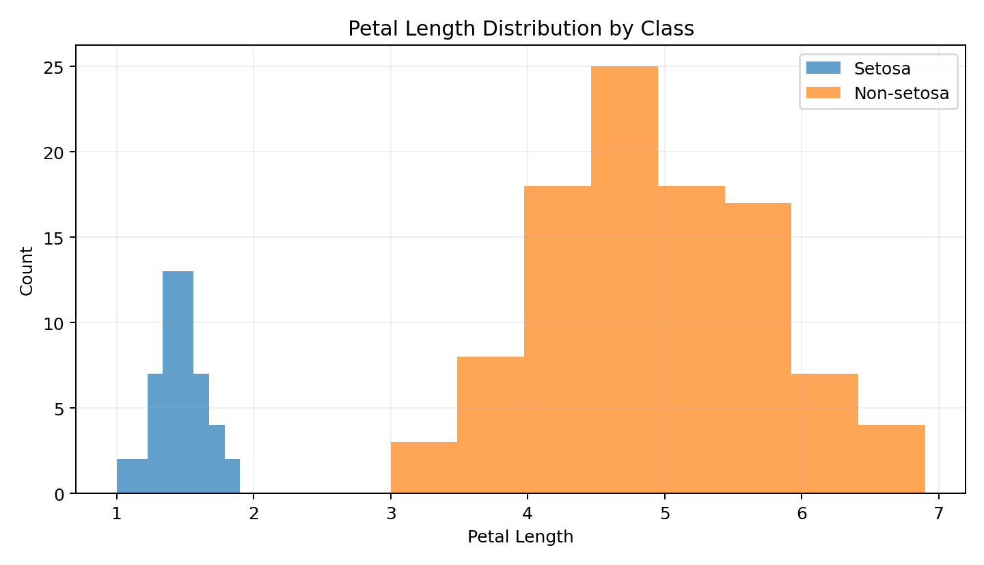
Welch t-test: p < 0.001. The mean petal length differs significantly between Setosa and Non-setosa groups in the dataset.
Pearson correlation: r = 0.963, p < 0.001. Petal length and petal width have a strong positive association.
Shapiro-Wilk: p < 0.001. The raw petal-length distribution does not perfectly satisfy normality, so the non-normality is documented rather than ignored.
# Hypothesis test\nt.test(Petal.Length ~ Group, data = iris_groups)\n\n# Correlation test\ncor.test(iris$Petal.Length, iris$Petal.Width, method = "pearson")\n\n# Normality check\nshapiro.test(iris$Petal.Length)

3. Hypothesis Formulation
- H0: The mean Petal.Length is equal for Setosa and Non-setosa flowers.
- H1: The mean Petal.Length differs between Setosa and Non-setosa flowers.
- H0: The population correlation between Petal.Length and Petal.Width is zero.
- H1: The population correlation between Petal.Length and Petal.Width is not zero.
Using a 5% significance level, the reported p-values provide strong evidence against the null hypotheses. The tests are interpreted as statistical evidence of association or group difference, not as proof that one variable causes another.
4. Predictive Model — Logistic Regression
A binary logistic regression model predicts whether an observation belongs to the Setosa class. The four flower measurements are used as predictors. The data is split into 80% training and 20% testing records with stratification so both classes remain represented. A probability threshold of 0.50 converts predicted probabilities into class labels.
set.seed(42)\nidx <- createDataPartition(iris_model$Setosa, p = 0.80, list = FALSE)\ntrain <- iris_model[idx, ]\ntest <- iris_model[-idx, ]\n\nmodel <- glm(Setosa ~ Sepal.Length + Sepal.Width +\n Petal.Length + Petal.Width,\n data = train, family = binomial())\n\nprob <- predict(model, newdata = test, type = "response")\npred <- ifelse(prob >= 0.50, 1, 0)

Test accuracy = 1.000, precision = 1.000, recall = 1.000, F1 = 1.000. The model separates Setosa from Non-setosa observations very effectively on the held-out test set.
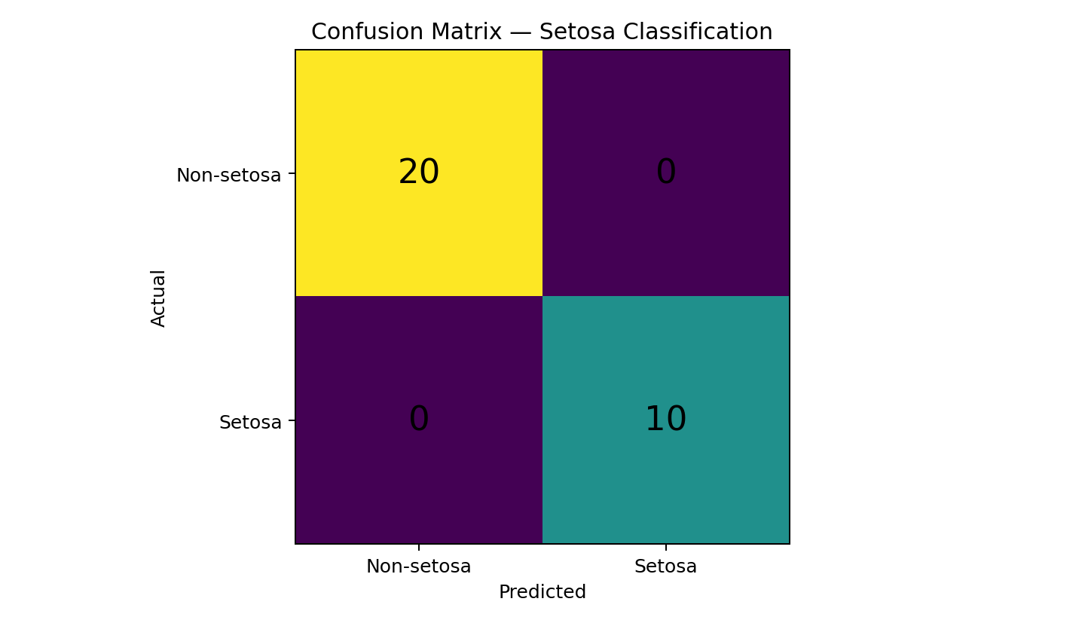
5. Confusion Matrix and ROC Analysis
The confusion matrix shows the number of correct and incorrect classifications for each class. ROC analysis evaluates the trade-off between true-positive and false-positive rates across probability thresholds. The AUC summarizes the model’s ability to rank positive cases above negative cases.
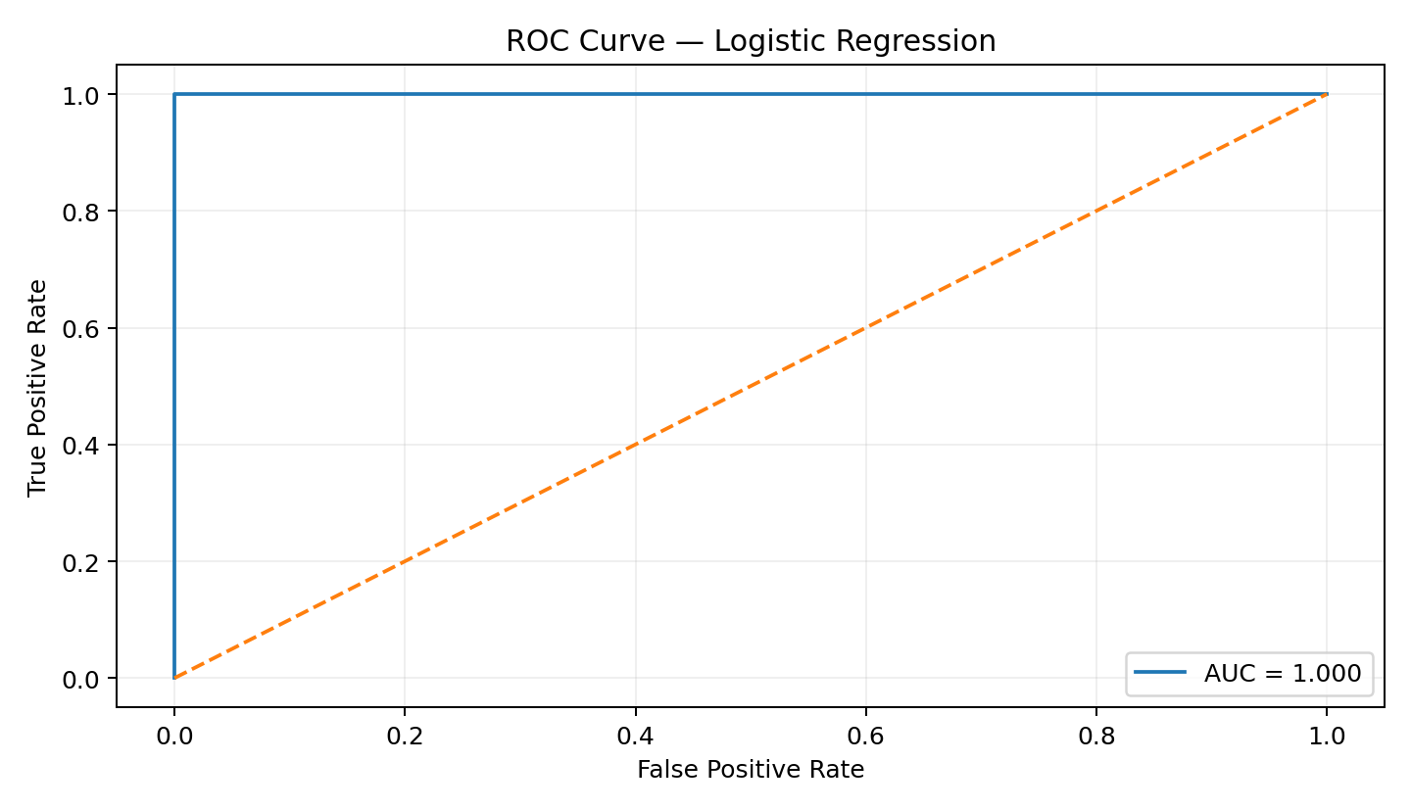
ROC-AUC = 1.000. An AUC close to 1 indicates excellent discrimination for this binary classification task.
6. Model Diagnostics
Classification diagnostics focus on whether predicted probabilities and residual-like errors show systematic patterns. The residual-versus-probability plot helps identify observations where the predicted probability is far from the observed class. Additional checks in R include the model summary and coefficient significance. These diagnostics support the evaluation of model reliability beyond a single accuracy value.
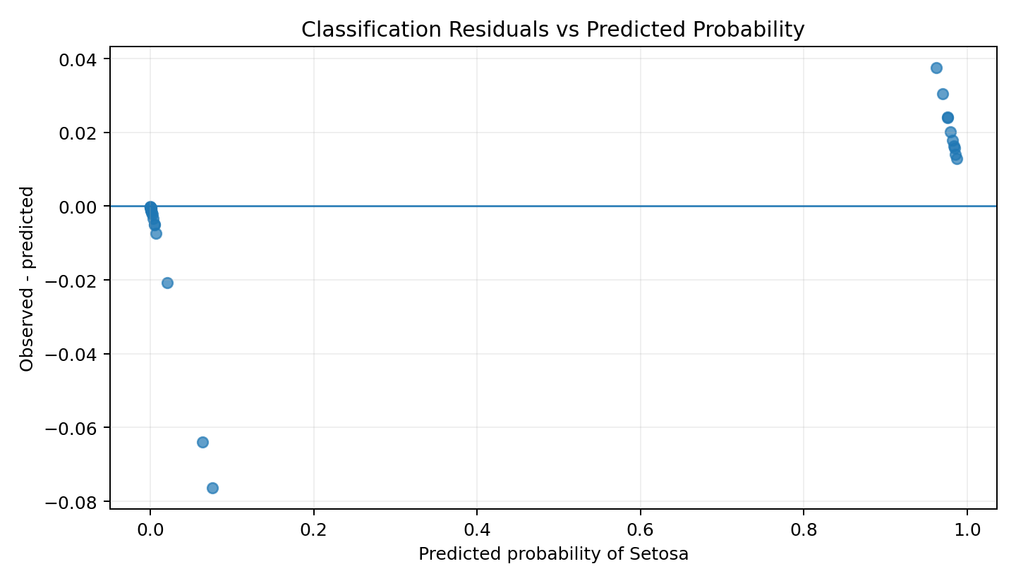
residuals_df <- data.frame(\n predicted = prob,\n residual = test$Setosa - prob\n)\nplot(residuals_df$predicted, residuals_df$residual,\n xlab = "Predicted probability",\n ylab = "Observed - predicted")\nabline(h = 0)

7. Five-Fold Cross-Validation
Five-fold stratified cross-validation is used to estimate how consistently the classifier performs across different subsets of the data. Each fold acts as validation data once while the remaining folds are used for training. This reduces dependence on a single train/test split and provides a more robust estimate of expected accuracy.
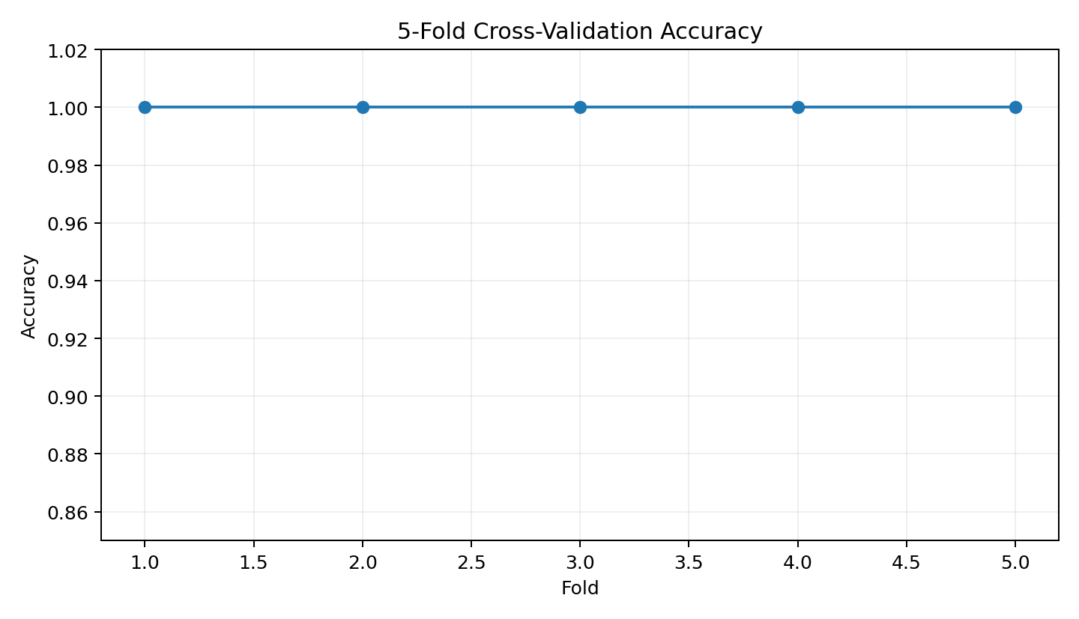
Mean 5-fold accuracy = 1.000 (SD = 0.000). The fold scores are consistently high, indicating stable classification performance on this dataset.
set.seed(42)\nctrl <- trainControl(method = "cv", number = 5)\ncv_model <- train(\n factor(Setosa) ~ Sepal.Length + Sepal.Width + Petal.Length + Petal.Width,\n data = iris_model, method = "glm", family = binomial(),\n trControl = ctrl, metric = "Accuracy"\n)\nprint(cv_model)

8. Strengths, Limitations and Improvements
- Strength: The workflow covers statistical testing, classification, holdout evaluation, diagnostics and cross-validation.
- Strength: Logistic regression is interpretable and produces class probabilities rather than only hard labels.
- Limitation: The iris dataset is small and highly separable, so the performance should not be generalized to complex real-world classification problems.
- Limitation: Accuracy can hide class-specific performance; precision, recall, F1 and the confusion matrix are therefore also reported.
- Improvement: Compare logistic regression with decision trees or random forests.
- Improvement: Tune the probability threshold when false positives and false negatives have different costs.
9. Conclusion
This project demonstrates a complete statistical and predictive modeling workflow in R. The exploratory tests establish strong evidence of differences in petal length between Setosa and Non-setosa observations and a strong correlation between petal measurements. Logistic regression then uses all four numeric measurements to predict the Setosa class. The confusion matrix, ROC-AUC, precision, recall and F1-score provide a multi-angle evaluation of model performance, while the residual-style diagnostic plot provides an additional check for unusual prediction errors. Five-fold cross-validation shows that the model performs consistently across different subsets. The project also documents limitations and practical improvements, making the analysis more rigorous and reproducible.
10. Submission Description (200+ words)
This Week 3 project presents an end-to-end statistical analysis and predictive modeling workflow using R. I selected the publicly documented iris dataset because it contains numerical measurements and a categorical species variable, making it suitable for hypothesis testing and classification. To create a focused predictive task, the original three-class species variable is converted into a binary target representing Setosa versus Non-setosa. The exploratory stage begins with a dataset overview and distribution checks. A Welch two-sample t-test is used to test whether mean petal length differs between Setosa and Non-setosa observations, while a Pearson correlation test evaluates the relationship between petal length and petal width. A Shapiro-Wilk test is also included to document the distributional characteristics of the numeric variables. For predictive modeling, a logistic regression model is trained using sepal length, sepal width, petal length and petal width. The dataset is split into training and testing subsets with stratification, and predictions are evaluated using accuracy, precision, recall, F1-score and a confusion matrix. ROC analysis and AUC are included to evaluate the model’s discrimination across probability thresholds. Model diagnostics are performed using predicted probabilities and residual-like errors to identify potential systematic prediction patterns. Five-fold cross-validation is then used to estimate the stability of classification accuracy across multiple folds. The report also discusses model strengths, limitations and practical improvements, including comparing alternative algorithms and tuning the probability threshold. R code is embedded throughout the document so that the full analysis can be reproduced and reviewed.

