Project Requirement:
Weather Prediction Microservice – Summary
- Predict next 3 days’ high/low temps for a given city
- Show predictions:
  - 🌧️ Rain → Carry umbrella
  - ☀️ >40°C → Use sunscreen
  - 💨 Wind >10mph → Too windy!
  - ⛈️ Thunderstorm → Don’t step out!
- User input city, view results via UI or Postman
- Offline mode + works if API fails
- No DB / 3rd-party libs
- Follow SOLID, 12-Factor, HATEOAS
- Include Swagger, TDD/BDD, secured API key
- CI/CD with Jenkins, Dockerized service on port 8080
- Deliverables: Code + Uber Jar + README (with diagram & patterns)

Repo Link: https://github.com/shivamnamdeo0101/weather-app
BE: http://48.194.32.29:8081/api/weather-cache/forecast?city=london
BE Swagger: http://48.194.32.29:8081/swagger-ui/index.html
FE: http://57.152.95.75:3001/
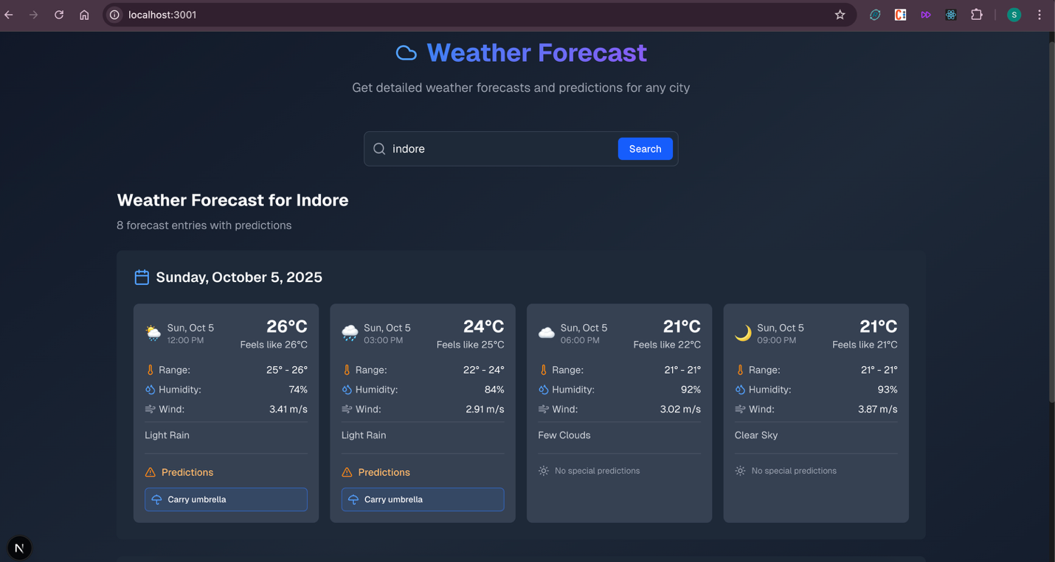

GitHub Workflow - https://github.com/shivamnamdeo0101/weather-app/blob/main/.github/workflows/docker-image.yml
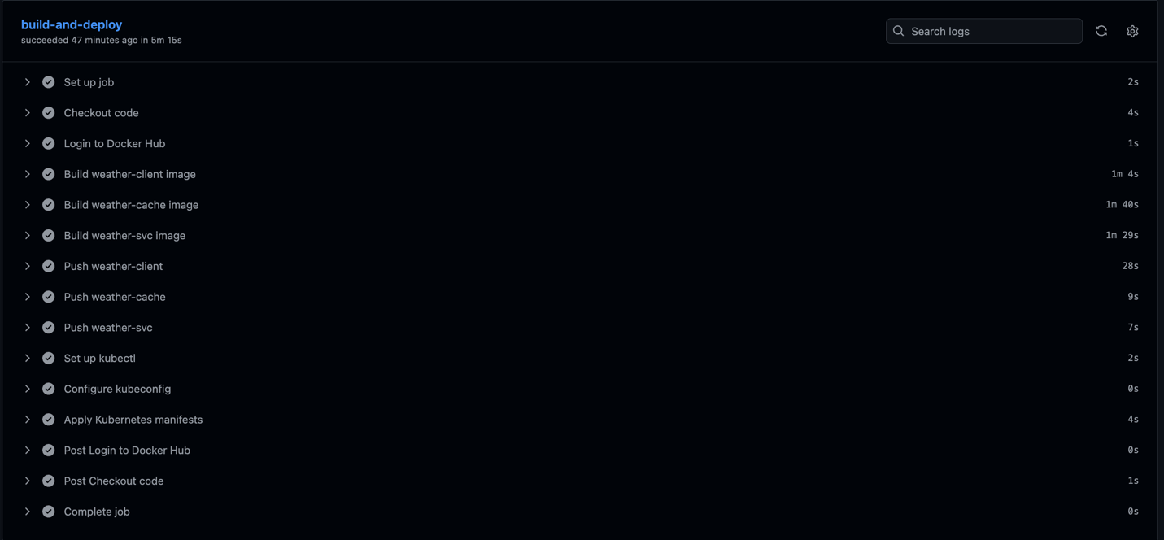
Weather Prediction

1. Project Overview
Title: Weather Prediction Microservice
Objective: Predict next 3 days’ high/low temps for a city & provide alerts (rain, heat, wind, storm).

2. Features
- Input city → get 3-day forecast
- Predictions:
  - Rain → "Carry umbrella"
  - Temp >40°C → "Use sunscreen lotion"
  - Wind >10 mph → "Too windy!"
  - Thunderstorm → "Don't step out!"
- Offline mode / API fallback / last 1 hours latest for all and 20min latest of Most active cities

3. Technical Details
- Backend: Java/Spring Boot
- Frontend: React / HTML UI
- API: OpenWeatherMap forecast
- Port: 8081
- Redis DB only / no 3rd-party libs for core logic for Rate Limiter sliding window

4. Design Principles
- SOLID, 12-Factor, HATEOAS
- Design Patterns: Strategy, Factory, Adapter

5. Security & Performance
- API key protected via environment variables
- Minimal API calls, caching offline data
- Production ready: logging & error handling

6. Testing
- Unit (JUnit / Jest), Integration, Behavior testing

7. CI/CD & Deployment
- Jenkins pipeline → build & test
- Dockerized service:
docker build -t weather-app .
docker run -p 8080:8080 weather-app

8. Documentation
- Swagger/OpenAPI: /swagger-ui/index.html
- README.md: setup, tech stack, usage
- Sequence/Flow Diagram via draw.io

9. Deliverables
- Source code (backend + frontend)
- Uber Jar (weather-service.jar)
- Dockerfile
- Jenkins scripts
- README.md + Reference doc + diagram

✅ You can select all, copy, and paste directly into Word, then adjust fonts, headings, or bullet styles if needed.
If you want, I can also make a super compact one-page version that fits neatly on a single Word page for HR submission. Do you want me to do that?

JMeter Testing - Throughput
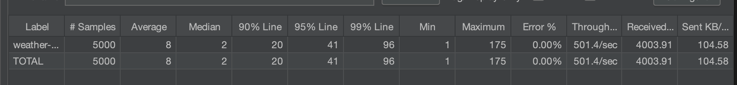

Schedular refreshing HOT/Medium active cities
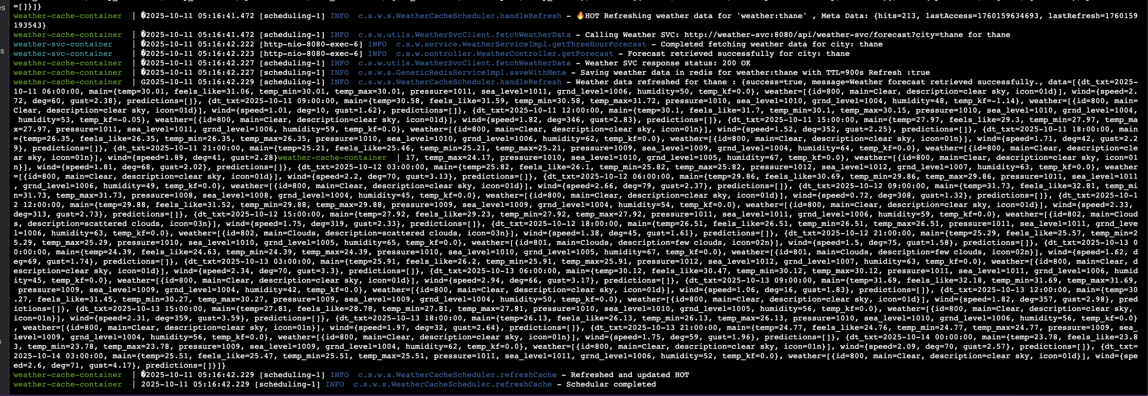
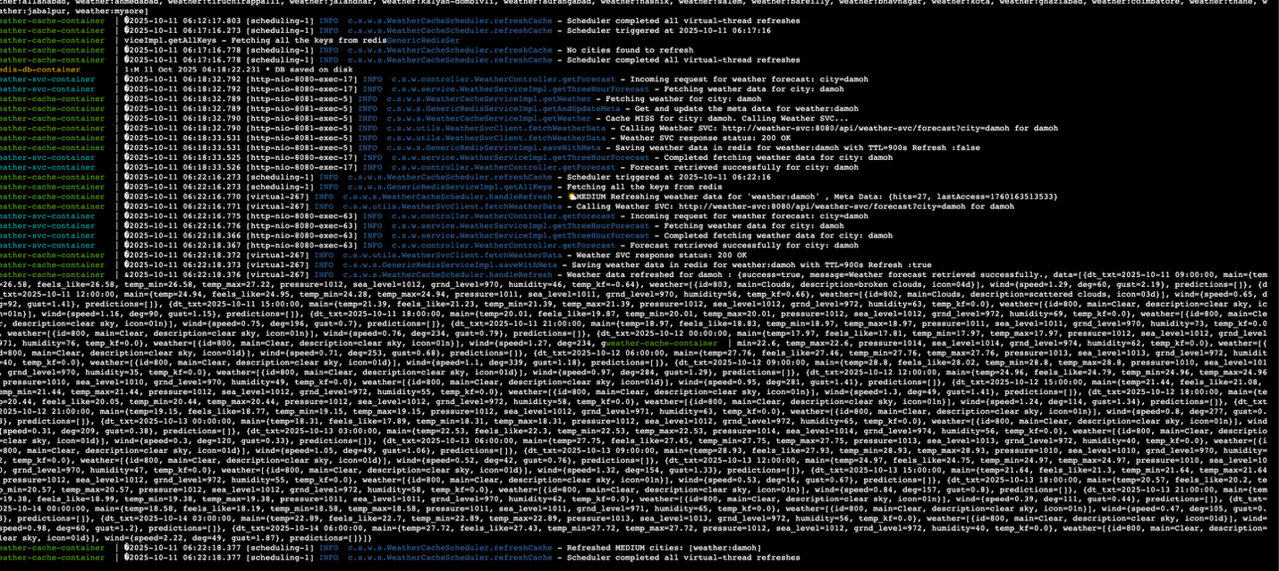
No cities for schedular

On-Demand Refreshing Active + Medium Active Cities
