**SQL_ASSIGNMENT_1**

**Problem Statements :**

1. **Design the complete database + schema + tables for the diagram shown above using appropriate data type for every column along with any contraints (checks + PK) mentioned in the task description and load the below data into the requisite tables.**



**-- NEW DATABASE CREATED**

CREATE DATABASE BIKESTORES;

USE DATABASE BIKESTORES;

**-- NEW SCHEMA CREATED**

CREATE OR REPLACE SCHEMA PRODUCTION;

CREATE OR REPLACE SCHEMA SALES;

**-- TABLE CREATION IN SALES SCHEMA**

CREATE OR REPLACE TABLE SALES.STORES

(

STORE_ID INT IDENTITY(1,1) ,

STORE_NAME VARCHAR(25),

PHONE VARCHAR(25),

EMAIL VARCHAR(30),

STREET VARCHAR(30),

CITY VARCHAR(15),

STATE VARCHAR(5),

ZIP_CODE INT ,

PRIMARY KEY (STORE_ID)

);

CREATE OR REPLACE TABLE SALES.STAFFS

(

STAFF_ID INT,

FIRST_NAME VARCHAR(15),

LAST_NAME VARCHAR(15),

EMAIL VARCHAR(50) ,

PHONE VARCHAR(20) ,

ACTIVE TINYINT,

STORE_ID INT ,

MANAGER_ID INT,

PRIMARY KEY (STAFF_ID)

);

CREATE OR REPLACE TABLE SALES.CUSTOMERS

(

CUSTOMER_ID INT IDENTITY(1,1),

FIRST_NAME VARCHAR(15),

LAST_NAME VARCHAR(15),

PHONE VARCHAR(20),

EMAIL VARCHAR(50),

STREET VARCHAR(50),

CITY VARCHAR(50),

STATE CHAR(10),

ZIP_CODE INT,

PRIMARY KEY(CUSTOMER_ID)

);

CREATE OR REPLACE TABLE SALES.ORDERS

(

ORDER_ID INT,

CUSTOMER_ID INT,

ORDER_STATUS INT,

ORDER_DATE VARCHAR(10),

REQUIRED_DATE VARCHAR(10),

SHIPPED_DATE VARCHAR(10),

STORE_ID INT,

STAFF_ID INT,

PRIMARY KEY(ORDER_ID)

);

CREATE OR REPLACE TABLE SALES.ORDER_ITEMS

(

ORDER_ID INT,

ITEM_ID INT,

PRODUCT_ID INT,

QUANTITY INT,

LIST_PRICE DECIMAL(10,2),

DISCOUNT DECIMAL(4,2),

PRIMARY KEY(ORDER_ID,ITEM_ID)

);

**-- TABLE CREATION IN PRODUCTION SCHEMA**

CREATE OR REPLACE TABLE PRODUCTION.CATEGORIES

(

CATEGORY_ID INT,

CATEGORY_NAME VARCHAR(50),

PRIMARY KEY(CATEGORY_ID)

);

CREATE OR REPLACE TABLE PRODUCTION.BRANDS

(

BRAND_ID INT,

BRAND_NAME VARCHAR(50),

PRIMARY KEY(BRAND_ID)

);

CREATE OR REPLACE TABLE PRODUCTION.PRODUCTS

(

PRODUCT_ID INT,

PRODUCT_NAME VARCHAR(100),

BRAND_ID INT,

CATEGORY_ID INT,

MODEL_YEAR INT,

LIST_PRICE DECIMAL(10,2),

PRIMARY KEY(PRODUCT_ID)BIKESTORESBIKESTORES.PRODUCTIONBIKESTORES.SALES

);

CREATE OR REPLACE TABLE PRODUCTION.STOCKS

(

STORE_ID INT,

PRODUCT_ID INT,

QUANTITY INT,

PRIMARY KEY(STORE_ID, PRODUCT_ID)

);

**FINAL OUTPUT IS:**

1. **Once the table has got created , there is a requirement of FOREIGN KEY implementation coming into picture where one needs to add(ALTER TABLE COMMAND) below foreign key on the table mentioned pointing to another table (READ ABOUT FOREIGN KEY) as :**

**-- SALES.STAFFS (STORE_ID) -> SALES.STORES(STORIED)**

ALTER TABLE SALES.STAFFS

ADD FOREIGN KEY(STORE_ID) REFERENCES SALES.STORES(STORE_ID);

**-- SALES.STAFFS (MANAGER_ID) -> SALES.STAFFS (STAFF_ID)**

ALTER TABLE SALES.STAFFS

ADD FOREIGN KEY(MANAGER_ID) REFERENCES SALES.STAFFS(STAFF_ID);

**-- PRODUCTION.PRODUCTS (CATEGORY_ID) -> PRODUCTION.CATEGORIES (CATEGORY_ID)**

ALTER TABLE PRODUCTION.PRODUCTS

ADD FOREIGN KEY(CATEGORY_ID) REFERENCES PRODUCTION.CATEGORIES(CATEGORY_ID);

**-- PRODUCTION.PRODUCTS(BRAND_ID) -> PRODUCTION.BRANDS (BRAND_ID)**

ALTER TABLE PRODUCTION.PRODUCTS

ADD FOREIGN KEY(BRAND_ID) REFERENCES PRODUCTION.BRANDS(BRAND_ID);

**-- SALES.ORDERS (CUSTOMER_ID) -> SALES.CUSTOMERS (CUSTOMER_ID)**

ALTER TABLE SALES.ORDERS

ADD FOREIGN KEY(CUSTOMER_ID) REFERENCES SALES.CUSTOMERS(CUSTOMER_ID);

**-- SALES.ORDERS(STORE_ID) -> SALES.STORES (STORE_ID)**

ALTER TABLE SALES.ORDERS

ADD FOREIGN KEY(STORE_ID) REFERENCES SALES.STORES(STORE_ID);

**-- SALES.ORDERS (STAFF_ID) -> SALES.STAFFS (STAFF_ID)**

ALTER TABLE SALES.ORDERS

ADD FOREIGN KEY(STAFF_ID) REFERENCES SALES.STAFFS(STAFF_ID);

**-- SALES.ORDER_ITEMS(ORDER_ID) -> SALES.ORDERS (ORDER_ID)**

ALTER TABLE SALES.ORDER_ITEMS

ADD FOREIGN KEY(ORDER_ID) REFERENCES SALES.ORDERS(ORDER_ID);

**-- SALES.ORDER_ITEMS (PRODUCT_ID) -> PRODUCTION.PRODUCTS (PRODUCT_ID)**

ALTER TABLE SALES.ORDER_ITEMS

ADD FOREIGN KEY(PRODUCT_ID) REFERENCES PRODUCTION.PRODUCTS(PRODUCT_ID);

**-- PRODUCTION.STOCKS (STORE_ID) -> SALES.STORES (STORE_ID)**

ALTER TABLE PRODUCTION.STOCKS

ADD FOREIGN KEY(STORE_ID) REFERENCES SALES.STORES(STORE_ID);

**-- PRODUCTION.STOCKS (PRODUCT_ID) -> PRODUCTION.PRODUCTS (PRODUCT_ID)**

ALTER TABLE PRODUCTION.STOCKS

ADD FOREIGN KEY(PRODUCT_ID) REFERENCES PRODUCTION.PRODUCTS(PRODUCT_ID);

1. **Does any of the table has missing or NULL value ? If yes which are those and what are their counts ?**

**Sales.Customer - Column(PHONE) is having NULL values.**

**Sales.Orders - Column(SHIPPED_DATE) is having NULL values.**

1. **Does the datasets has any DUPLICATE(identical rows) ? If yes – can you just keep the first record and remove all rest if its possible without using any JOINS or WINDOW function.**

SELECT COUNT(*) AS TOT_ROWS FROM SALES.CUSTOMERS; **-- 1445**

SELECT COUNT(DISTINCT FIRST_NAME, LAST_NAME, PHONE, EMAIL, STREET, CITY, STATE, ZIP_CODE) AS TOT_DISTINCT_ROWS

FROM SALES.CUSTOMERS; **--1445**

SELECT COUNT(*) AS TOT_ROWS FROM SALES.ORDERS**; -- 1615**

SELECT COUNT(DISTINCT ORDER_ID, CUSTOMER_ID, ORDER_STATUS, ORDER_DATE, REQUIRED_DATE, SHIPPED_DATE, STORE_ID,STAFF_ID) AS TOT_DISTINCT_ROWS

FROM SALES.ORDERS; **-- 1615**

SELECT COUNT(*) AS TOT_ROWS FROM SALES.ORDER_ITEMS; **-- 4722**

SELECT COUNT(DISTINCT ORDER_ID, ITEM_ID, PRODUCT_ID, QUANTITY, LIST_PRICE,DISCOUNT) AS TOT_DISTINCT_ROWS

FROM SALES.ORDER_ITEMS; **-- 4722**

SELECT COUNT(*) AS TOT_ROWS FROM SALES.STAFFS; **-- 10**

SELECT COUNT(DISTINCT STAFF_ID, FIRST_NAME, LAST_NAME, EMAIL, PHONE, ACTIVE, STORE_ID, MANAGER_ID) AS TOT_DISTINCT_ROWS

FROM SALES.STAFFS; **-- 10**

SELECT COUNT(*) AS TOT_ROWS FROM SALES.STORES; **-- 3**

SELECT COUNT(DISTINCT STORE_NAME, PHONE, EMAIL, STREET, CITY, STATE, ZIP_CODE) AS TOT_DISTINCT_ROWS

FROM SALES.STORES; **-- 3**

SELECT COUNT(*) AS TOT_ROWS FROM PRODUCTION.BRANDS; **-- 9**

SELECT COUNT(DISTINCT BRAND_ID,BRAND_NAME) AS TOT_DISTINCT_ROWS

FROM PRODUCTION.BRANDS; **-- 9**

SELECT COUNT(*) AS TOT_ROWS FROM PRODUCTION.CATEGORIES; **-- 7**

SELECT COUNT(DISTINCT CATEGORY_ID,CATEGORY_NAME) AS TOT_DISTINCT_ROWS

FROM PRODUCTION.CATEGORIES; **-- 7**

SELECT COUNT(*) AS TOT_ROWS FROM PRODUCTION.PRODUCTS; **-- 321**

SELECT COUNT(DISTINCT PRODUCT_ID, PRODUCT_NAME, BRAND_ID, CATEGORY_ID, MODEL_YEAR, LIST_PRICE) AS TOT_DISTINCT_ROWS

FROM PRODUCTION.PRODUCTS; **-- 321**

SELECT COUNT(*) AS TOT_ROWS FROM PRODUCTION.STOCKS; **-- 939**

SELECT COUNT(DISTINCT STORE_ID, PRODUCT_ID, QUANTITY) AS TOT_DISTINCT_ROWS

FROM PRODUCTION.STOCKS; **-- 939**

**Therefore, this dataset has no Duplicate (Identical Rows).**

1. **How many unique tables are present in each schema and under each table how many records are having ? (Write SQL Script for the same – I don’t need answer like 3/5/4 etc)**

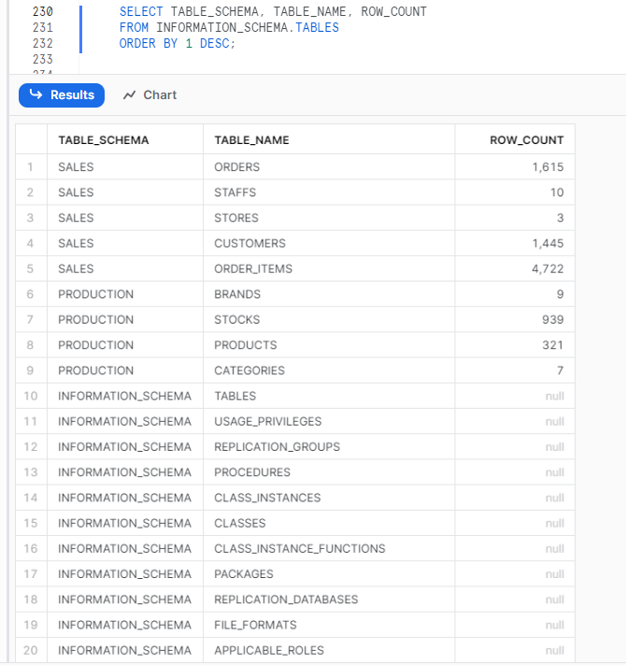

1. **How many total serving customer BikeStore has ?**

1. **How many total orders are there ?**

1. **Which store has the highest number of sales ?**

1. **Which month the sales was highest and for which store ?**

1. **How many orders each customer has placed (give me top 10 customers)**

1. **Which are the TOP 3 selling product ?**

1. **Which was the first and last order placed by the customer who has placed maximum number of orders ?**

1. **For every customer , which is the cheapest product and the costliest product which the customer has bought.**

1. **Which product has orders more than 200 ?**

There is no product who has more than 200 orders

1. **Add a column TOTAL_PRICE with appropriate data type into the sales.order_items.**

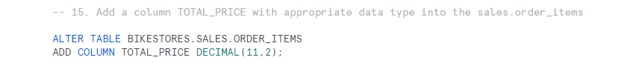

1. **Calculate TOTAL_PRICE = quantity * list price and Update the value for all rows in the sales.order_items table.**



1. **What is the value of the TOTAL_PRICE paid for all the sales.order_items ?**

**THANK YOU**